Framework Wizard
Requirements Document

Version 0.180.17
07 Jun 2006THIS SPECIFICATION IS PROVIDED “AS IS” WITH NO WARRANTIES WHATSOEVER, INCLUDING ANY WARRANTY OF MERCHANTABILITY, NONINFRINGEMENT, FITNESS FOR ANY PARTICULAR PURPOSE, OR ANY WARRANTY OTHERWISE ARISING OUT OF ANY PROPOSAL, SPECIFICATION OR SAMPLE.

A license is hereby granted to copy and reproduce this specification for internal use only.
No other license, express or implied, by estoppel or otherwise, to any other intellectual property rights is granted herein.
Intel disclaims all liability, including liability for infringement of any proprietary rights, relating to use of information in this specification. No license, express or implied, by estoppel or otherwise, to any intellectual property rights is granted herein.
This specification is an intermediate draft for comment only and is subject to change without notice. Readers should not design products based on this document.
† Third party brands and names are the property of their respective owners.
Copyright © Intel Corporation, 2006.

Overview
This document provides the Minimum Requirements and the Design Specification for the first implementation of the Framework Wizard (Wizard) tool. The tool will be the primary interface between developers and the build infrastructure. It must provide an easy to use interface that can handle multiple file types, and hide the complex XML configuration file formats from developers. The primary goal for this Wizard is to provide developers with multiple choice dialogs that lead them through configuration of new, stand-alone modules, groups of modules and platforms. These dialogs must provide the developer with applicable choices (for a PEIM module, the developer can select from presented library classes that support PEI only, and not DXE libraries.) While several of the features of the Wizard may give the appearance of and IDE, the Wizard is not an IDE. It is a somewhat “smart” interface to the developer’s workspace environment.
The Wizard is to be used for development of modules, groups of modules or platforms. A separate tool, the Create Distribution Package (CreateDistribution) tool, is provided to bundle the modules, groups of modules or platforms into a distribution file. The Package tool will also be used to manage the Installation, Upgrade and Removal of packages from the Workspace.
- At a high level, the Wizard must support the following:
- Modification of Module Surface Area (MSA) files
    - Must support Defining GUIDs, PPIs, PROTOCOLs and PCDs
- Modification of the Surface area Package Description (SPD) file
- Modification of the Framework Platform Description (FPD) file
    - Pick and chose drivers to add to a platform
      - For each driver, define library instances and what values and types of PCD are used by the driver
Workflow
This section describes the expected workflow for Module Developers, Platform Integrators and folks that create Distribution packages.

Module Development Process Model
Note this is the expected process, which is not necessarily that the tools have to support. For example, while the process model states that a developer will add the module’s information before the MSA is created (step 3a below,) it will not be required. The Wizard should Prompt the user when a new module creation task is requested, but the developer can defer entering the data into an SPD file until a later date.
- Module developers will install the MDK/EDK from either a self-installing JAR file (both will be available on TianoCore.org in public area) or from a checkout from a SCM, where someone has already done the installation from the JAR file on their local system and imported it to the SCM.
- Existing Module Development/Maintenance in an Existing Package
- Module developer works on existing code.
- Module developers working on an existing module only need to work on their code and update the MSA/SPD files as changes to the code require.
- They may need to update an existing package level FPD file, if there is one setup for the package, to do testing, or the module has been used in a platform.
- Module Developer repeats steps a-c until “done.”
3) Create New Module in an Existing Package
- Module Developer will need to create an entry (MsaFile) in the Package’s SPD file. The first pass will require the name of the module, a GUID (tool will have a GenGUID button,) the Version and the location (in the existing package’s directory tree) where the module’s MSA file will exist
- Wizard will use this data to start completing the MSA file.
- Module developer will have to enter as much information as they have about the module they plan to develop into the MSA file’s forms in the Wizard.
- Module developer can then start writing their code.
- Module developer can update the MSA at any time during the code creation process, adding additional source files and other entries.
- Wizard will auto-complete, where possible, entries into the SPD file.
- Module developer, once the developer is ready to do testing, must open up the package’s FPD file and add the module data from the SPD into the FPD as well as query the user for:
  - Library Instance usage
  - PCD usage
  - Module Specific Build Options
- Module Developer will open up an command window and execute ant in the Existing Package’s root directory (the location where the SPD file is located.)
- Module developer will then fall back to step #2 of the Module Development Process.
4) Create Module in a New Package (this is NOT a distribution package, refer to the “Create Distribution Package Process Model below.)
- Module Developer will create a new SPD file, giving the name of the package, a GUID (tool will have a GenGUID button,) the Version and the location in the WORKSPACE directory tree where the package’s SPD file will be located.
- Module Developer will complete as much of the SPD Header section as they can, then save the file.
- Module Developer will decide if they want to create a package level FPD file for testing.
- Module Developer will then fall back to step #3 of the Module Development Process.

Platform Integration Process Model
- The Platform Integrator will checkout the code tree from a SCM.
- Existing Platform Development/Maintenance
  - Platform Integrator will modify FLASH information section of the FPD file.
  - Platform Integrator will modify FPD file as necessary to add/update/remove modules from the Platform
    - Platform Integrator will modify FPD file as necessary to add/update/remove PCD Entries as each Module is added.
    - Platform Integrator will select the Library Instances for each Library Class that an added module needs. HOWEVER, since this platform definition already has one or more modules selected, the Wizard should be able to determine (if there is more than one library instance that satisfies a library class) the “most used” library instance for a given library class and present that option as the most likely candidate to use. “Most likely” library instance just means that the library instance is highlighted in the drop down selection of library instances for that class. Also, note that a valid selection of a library instance may be “Not Selected,” meaning that the PI has decided to wait until later to select a library instance. The build should FAIL IMMEDIATELY if this entry is used.
  - Platform Integrator will open a command window and change to the directory where the FPD file is located. Typing “ant” will start a build, with the output being placed in the directory specified in the global build option, OutputDirectory.
  - Platform Integrator will repeat steps a through d as needed.
- Create a New Platform
  - Platform Integrator will create a new FPD file, giving the name of the platform, a GUID (tool will have a GenGUID button,) the Version and the location in the WORKSPACE directory tree where the platform’s FPD file will be located. NOTE: Since a Platform usually has platform specific modules, the Module Developers will probably create a single Platform package (SPD) in the WORKSPACE. While not required, it is recommended that the FPD file be located in separate directory from any SPD file as this Platform package (SPD) file. This is usually a policy decision. For these MINIMUM Requirements, the one and only one FPD file may exist in a directory.
  - Platform Integrator will complete the FLASH information section of the FPD file.
  - Platform Integrator will add Modules from the available modules in the WORKSPACE
  - Wizard will move the modules into the correct locations within a FPD file - and auto complete as much of the FPD file as possible, based on the information in the Module’s SPD and FPD file. (Modules must always be associated to an SPD file.)
  - Platform Integrator will be required to complete the following entries:
    - For each library class used by the platform’s modules
      - Global Library Instances (the wizard will automatically populate the libraries library elements for all modules that use a library class)
      - Platform Integrator may override global Library instances by selecting individual Module Library Instances (these library instances override the global instances)
    - PCD Usage
    - Build Options
      - Global Build Options
      - Platform Integrator may override global Build Options by selecting individual module build options
  - Platform Integrator will open a command (terminal or x-term) window and change to the directory where the FPD file is located. Typing “ant” will start a build, with the output being placed in the directory specified in the global build option, OutputDirectory.
  - Platform Integrator will then fall back into step #2 of the Platform Integration Process.

Distribution Package Creation Process Model
- The people responsible for creating Distribution packages will check out a copy of the tree from a SCM.
- Run the CreateDistribution application
  - Using this application, the user will select the name of the package(s) that will be put into a distribution package.
  - User will select whether to create a Source or Binary distribution package.
  - CreateDistribution application will verify:
    - Package has RePackage element set to true if it exists. If the element does not exist, then RePackage is default to FALSE, which means you would get error message.
    - All MSA files in the SPD files are within the SPD file’s directory structure.
  - User will be required to select information that will be kept for reduced information FPD, SPD and MSA files.
  - Application will query the user for Manifest information
  - Application will query the user for the output file location
  - Application will generate an FDP file based on information it received
  - User should test the FPD installation, using a clean EDK/MDK installation, and the Wizard to install, update and/or remove the distribution package.
  - User should complete all steps required by their organization to publish and distribute the FPD file, which can be distributed in any method they want.
- Repeat steps 1 - 2 of the Distribution Package Creation Process as needed.

Design Rules and Requirements

High Level Rules and Requirements
To present a consistent look and feel to development, modules will be built in the context of a platform.
One of the primary goals of R9 is to provide IHVs with a method for distributing stand-alone EFI/Framework modules, EFI/Framework modules are normally included as part of a platform. Building a module in the context of a platform is required, however the a full platform build is not required. A module’s platform need not specify any other modules, nor does the platform have to specify anything at all regarding “flash” storage hardware. We have included new tools, such as EfiRom and FlashMap to allow easy creation of images and platforms.
Platform BIOS developers, on the other hand, need to know specific details of the storage mechanism and layout. The re-design of the EFI/Framework provides additional flexibility and allows for generalization of individual module design. Platform BIOS developers will ultimately determine how to put the individual modules (using either source level compile and link or binary link options) together to create a the firmware image for a specific platform.
The remaining parts of this section describe the requirements for the Wizard to support the new re-design of the EFI/Framework layout. (The tool is designed to support both EFI 1.0 and UEFI 2.0 architecture specifications, along with other industry standards.)

Visible Changes Between Apr-06 release and Jun-06 Release
- The ModuleEditor program has been replaced by the FrameworkWizard. Additionally, the creation/modification of the Surface Area Package Description (SPD) files has been moved from the PackageEditor to the Wizard. Now, the CreateDistribution tool is only responsible for creating distribution packages from a WORKSPACE.
- The Wizard supports creation and modification of Framework Platform Definition (FPD) files. These FPD files now contain additional information about PCD entries that are dynamic, while the complete PCD information is now under the Module Surface Area entries in the FPD.
- The Wizard supports installation, update and removal of distribution packages from the workspace.
- The Wizard automatically comes up in full edit mode. You will not be required to select “Update” before editing previously completed entries.
- The Wizard provides multiple tree views of the content of the WORKSPACE. The left panel of the application window provides either a Package List -> Module view or a Platform List -> Module view. Both views are created when the application starts., and are refreshed any time SPD or FPD files (containing modified data) are saved.
- The MBD files are no longer required - library instance data for each module will need to be added into any Framework Platform Description file (FPD) that uses the module. The Build information in the MBD file will also move the FPD files.
- The Library Instance information MAY be entered into a RecommendedInstance attribute in the MSA/SPD file.
- The Tool Chain Definition File (WORKSPACE/Tools/Conf/tools_def.txt,) is changing to provide more flexibility. User defined tool chains are now supported, with some additional properties that can classify the tool chains to a vendor “Family.” Three different tool chain families are supported: Gnu (GCC,) Intel (INTC) and Microsoft (MSFT.)
- Library Classes may only be defined in the context of the Surface Area Package Description. To add a library class, the developer must place a single header file in the $WORKSPACE/$PACKAGE/Include/Library directory. Other header files may be included, however they must be referenced within the single library header.

Design Rules and Guidelines
The following section defines rules for development, as well as rules that will be followed by build tools. Exceptions, as permitted, are noted at the end of the rule.

Naming Convention
- RULE: Everything: directories, file names, program names, variable names, etc. is CASE SENSITIVE. It is the developer’s responsibility to ensure that the correct case is used for all newly created elements of the EFI/Framework (modules, packages and/or platforms.)
- RULE: Directory Names MUST start with an Uppercase Alpha Character, followed by zero or more lowercase characters and/or numbers and/or uppercase characters. The only special characters: underscore “_” and hyphen “-“ characters, are allowed in directory names.
- RULE: Architecture directories MUST be named Ia32, X64, Ipf or Ebc. Directory names: ia32, iA32, IA32, x64, IPF, ipf, EBC or ebc will not be automatically recognized by the build tools. NOTE: The XML SupportedArchitectures enumerated data type is used within the tools for flow control. They will never be interpreted as directory names.
- RULE: When specifying a path in the source files (such as in the #include lines, like #include <Ia32/MyCode.h>) with directory separators, the directory separator MUST be a single forward slash “/” character between the directory names.
- RULE: The Tool Chain properties must follow the format documented in the tools definition section of this document.
- RULE: System Environment Variables MUST be ALL UPPERCASE, with underscore “_” characters permitted. Example: %XML_BEANS_HOME%
- GUIDELINE: User Defined Environment Variables, or portions of constructed variables SHOULD start with an Upper case letter.
Example: $MyToolChain
- GUIDELINE: For User Defined Properties and constructed properties, the property Should start with an Upper Case Character. Constructed properties are for combining user defined tags with application specific attributes.
Constructed Example: MyToolChain_IA32_ASM_LINKER
- RULE: Flags for tool chains are specified in text files in the Tools/Conf directory. For User Defined tool chain tags, the build tools will first look for a file: MyToolChain_tools.txt. If that file is not found, the build tools will look for the appropriate TOOL_CHAIN_FAMILY_tools.txt. (See following sections for a description of the valid tool chain families.) These files contain the default settings for each tool.
- RULE: Provided Tools must ignore any content provided in <UserExtensions> sections of MSA, SPD and/or FPD files. These sections are available for third party custom extensions.

Directory Structure & WORKSPACE
Description: The FrameworkDatabase.db file tracks the location of package (SPD) and platform (FPD) files relative to the WORKSPACE environment variable. The package (SPD) files track the location of the module description (MSA) files by recording the location of the MSA file relative to the SPD file. The MSA files record the location of a module’s source files by recording the location of the files relative to the MSA file.
- RULE: All WORKSPACE content must be within a directory tree with the WORKSPACE (identified as the top most node, or directory of the tree.) EXCEPTION: OUTPUT from a build is allowed to be placed outside of the WORKSPACE.
- RULE: All package content MUST be within the package’s directory structure. Use of .. to reference a directory above the current directory is NOT permitted.
- RULE: Multiple WORKSPACE directories are permitted on a development system, however module and platform development can only be performed within a single given WORKSPACE (the developer cannot use modules and platforms outside of the WORKSPACE directory tree) at any one instant in time.
- RULE: The Wizard works on content within a single valid WORKSPACE. Developers can switch between WORKSPACES, but may modify content only in the current (active) WORKSPACE.
- RULE: Newly created package (SPD) files are automatically added to the WORKSPACE without using the CreateDistribution tool to create a distribution package.
- RULE: Distribution packages can be installed, updated or removed from the active WORKSPACE using the Wizard.
- RULE: Newly created platform (FPD) files are automatically added to the WORKSPACE without using the CreateDistribution tool to create a distribution package.
- RULE: The CreateDistribution tool MUST be used to create distribution packages within a WORKSPACE. A developer cannot just copy a directory tree from one WORKSPACE to another without manually editing the FrameworkDatabase file for the new WORKSPACE (No tools have been provided to manually modify the FrameworkDatabase.db file. There are multiple configuration files that must be updated when installing, updating or removing packages in a WORKSPACE. NOTE: Use the CLONE function of the Wizard to copy a package from one WORKSPACE to another WORKSPACE.
- RULE: The Wizard MUST provide a method for cloning modules, packages, platforms and/or tool chain definitions within a WORKSPACE or to different a different WORKSPACE. The Wizard can also be used to clone an entire WORKSPACE to another directory structure.
- RULE: Before creating a new module, a package file (SPD) MUST exist so that valid content can be added to the SPD file. Adding a module to an existing platform file when creating a new module is optional.

Environment
- RULE: The Wizard will NOT change any System Environment Variables. Changing of System Environment Variables must be done by the developer outside of the Wizard, using either a command line or through operating system specific tools.
- RULE: The Wizard will not automatically detect information about a developer’s system configuration. The tool will provide the developer with browse capabilities outside of the WORKSPACE when setting up tool configurations.
- RULE: The Wizard has no inherent knowledge of the best known settings for tool command line options. It is the responsibility of the developer to define options for third party assemblers, compilers and linkers. Framework tool options are pre-defined in the build tools, however the Framework tools may be used as stand-alone applications. The developer using Framework tools as stand-alone applications should view the help information integrated into each of these tools for the setting of tool options in on a command line.

Build Infrastructure
- RULE: Module Identification is based on Package GUID, Package Version, Module GUID and finally Module Version.
- RULE: Each PACKAGE must have a UNIQUE GUID/Version pair within the WORKSPACE. No two packages with the same Package GUID and Package Version can exist within a WORKSPACE. Attempting to clone/install two packages with identical GUID and Versions will not be allowed by the package installation/update/removal functions of the Wizard.
- RULE: Each MODULE or LIBRARY instance must have a UNIQUE GUID/Version pair within a single PACKAGE in the WORKSPACE. When specifying instances of modules or libraries, the module or library must have a unique GUID/Version pair within a package. It is permissible to have duplicate GUID/Version pairs, provided they are in different packages.
- RULE: When presenting information to the developer the Wizard will only check the Version if there is a duplicate GUID within a package. The configuration files, MSA, SPD and/or FPD files will Always specify GUID and VERSION information; the GUID/Version pairs are used to identify unique entries.
- RULE: If a GUID is not found, or there are duplicate GUID/Version entries in a single package, then the BUILD BREAKS with ERROR (the Package tool must prevent the later case.)
- RULE: Each PLATFORM must have a UNIQUE GUID/Version pair within the WORKSPACE
- RULE: For Library Class Declarations (SPD files) - the public Library Header MUST be added to the Package\Include\Library directory.
- RULE: For Library Modules - the Library Module code must reside in the Package\Library directory.
- RULE: All public header files should reside in the PACKAGE\Include directory tree.
- RULE: All platform (FPD) files must specify the tool chain families that will be used to generate binary files.
- RULE: The directory name for the module, library, package or platform does NOT have to match “Basename” values in the MSA, SPD or FPD files.
- RULE: The FeatureFlag Attribute is a string, where the developer will enter values that will be processed using RPN notation, from Left to Right.
Value1 Value2 Operation1 . . . ValueN OperationN

- GUIDELINE: Package Help Text (Abstract and Description) must provide an adequate description of the contents, so that a developer can understand the differences between different versions of a Package.
- GUIDELINE: Package GUID values should change with major changes to the content of the package.
- GUIDELINE: Package Version values should change with minor changes and/or bug fixes in the content of the package.
Features and Requirements
This section provides the a bullet list of the minimum requirements and features that are needed for the first release of the R9 Framework on TianoCore.org. Note, that while some features, such as localization support may not be deemed necessary, they are simple to implement from the start, and more difficult to implement at a later date.

- Wizard Source Code may not be provided as part of the public release of EDK 2.0 - we are deferring that decision until after the licensed customers have reviewed the content.
- Localization Support based on locale (support for English - default, French and Simplified Chinese will be provided initially.)
- If we do NOT provide source for building the Wizard (we should) then we need to figure out a way to provide user defined localization.
- Localization support is for application text / mnemonics only.
- Localization of the XML forms data is not supported.
- The wizard must support accessibility features, such as no mouse.
- The wizard must conform to the “Java Look & Feel Guidelines” by Sun Microsystems Inc.
- The Wizard must adapt to changes in the XML Schema that defines the surface area of modules, packages and platforms.
- The Wizard will be provided as a stand-alone Java Executable (JAR) file, without needing to install software other than Java (except that the EDK/MDK must be installed and initialized to access the SurfaceArea.jar file.)
- The Wizard must execute on Microsoft Windows, Linux and MAC OS X operating systems.
- The developer must be running a window manager capable of displaying a graphical user interface.
- There are NO command line options for this wizard.
- The wizard must ensure that it working within a valid WORKSPACE
- The wizard must ensure that the WORKSPACE has been initialized (edksetup has been run.)
- The Wizard must support having one MSA, one SPD and one FPD file open simultaneously.
- The Wizard must also support updating the FrameworkDatabase.db file transparent to the user.
- The wizard must support editing of a single file pair (SPD and MSA file.) Since the MSA and SPD files are closely coupled, they will probably need to be updated at the same time. Being able to switch between the SPD and the MSA file, and the ability to use copy and paste, will minimize potential data entry errors. An Additional tab should be provided for Platform Definition (FPD) files, as one of those may also need to be opened by the developer when modifying SPD or MSA files.
- The Wizard MAY need to open an SPD file any time a NEW MSA file is requested by the developer (the developer should be presented with an option to open or create an SPD when they create a new module.) The Entry for the MSA file MUST exist in the SPD file before an MSA file can be created.
- The Wizard must be capable of updating the SPD/MSA files - the developer must be able to copy and paste information from one open file to another open file.
- The wizard must present valid entries as drop down menu items, scroll down menus or check boxes for preconfigured data. For FPD files, we will want to scope the PCD entries in the SPD files of the Modules added to the platform. We will also want provide Library Instance information for the library classes required for modules (and other libraries - since a library can require another library class.)
- The user must be able to open a Framework file by either clicking on the displayed name in the Tree View, or through the open dialog box.
- The wizard must support standard text edit features, such as cut, copy and paste.
- The wizard must allow the user to configure preferences that are persistent for the wizard. (Future, initial release - will be per WORKSPACE.)
- The wizard must present all possible tags (both required and optional) in a user friendly manner. Required elements should be suffixed with an asterisk “*” character.
- The wizard must allow the user to edit all fields that are not computed without any additional steps (other than to position the cursor within the field.)
- The wizard must type check all data as it is type into the entry fields. When the user changes fields (using TAB, Mouse or Keyboard shortcut) or selects a different item from the Tree-View, the application needs to validate the data just entered, prior to changing the focus of the screen. If the data is not valid, a error dialog needs to popup with an appropriate error message, informing the user of the error. When the user acknowledges the error with one of two options, 1) fix - the user will be returned to the field (with a hint as to what’s wrong by the label) for correction, or 2) - ignore, the data is left as it is, with the wrong data and focus is changed. When the user tries to save the form (Save, Save As or Save All) another Error message will allow the user to either fix all errors (one at a time) or ignore the errors and just save the document(s.)
- The wizard must present valid entries as drop down menu items, scroll down menus or check boxes for preconfigured data. Example, LibraryClass selection in an MSA file should be a drop down menu of valid defined classes that match the target EFI component type of the Module: PEIM Component will only show LibraryClass entries on the system that are related to PEIMs.
- When Creating a new Module, the developer MUST select a package to add the module before any other data can be entered into the MSA file.
- The Developer will be given Cancel options for every step, so that they may abort changing of data at any time.
- The entry data will be persistent throughout the course of changing between forms. The developer MUST not have to select any special buttons to record data. (No DONE button is required.)
- The Save or Save As actions will cause the data to be written to a file. If the developer selects Save, and there is no open file, the Save As dialog will open.
- The Close menu item will check to see if any data in the opened file has been changed, and if it has, it will prompt the developer to SAVE, SAVE AS or CANCEL.
- The Exit menu item will check to see if any data in the opened file has been changed, and if it has, it will prompt the developer to SAVE, SAVE AS or CANCEL.
- If a developer opens an MSA (File -> Open, or double click) they will be able to edit the Module Header. However, if they chose to edit an SPD file Module Name, the Wizard can prompt the developer to determine if the Wizard should update the ModuleName field in the MSA file. If the developer is trying to perform a copy type operation, then the Clone Module Surface Area feature of the Wizard should be used.
- NOTE: Filenames of SPD, MSA or FPD files do NOT have to match the PackageName, ModuleName or PlatformName. The File -> Save As feature is for storing the file under a different name - this should only be available for MSA and SPD files after a NEW operation. FPD files can always use the File -> Save As feature.
- A Platform (FPD) file operation of Save As must update the FrameworkDatabase.db file automatically.
- An Package (SPD) file operation of Save As must update the FrameworkDatabase.db file automatically.

Future Development
- Stubs for the following future work must be include
- The wizard must support editing of multiple files. More than one MSA, SPD and FPD file may be open at any one instant in time.
- The Wizard will keep track of MSA/SPD file pairs in the multiple file open instance.
- Wizard will provide two template C files, one ModuleName.c and another, ModuleName.h file with some information (parsed from the MSA file) added.
- The Wizard will provide an option to the Platform Integrator to “automatically” update ModuleGuid and/or ModuleVersion attributes, if they have been specified and either of these two values get changed in the SPD/MSA files.
- The Wizard must be capable of updating the SPD/MSA pair when a change in the SPD file requires a change in the MSA file that the Wizard is aware of (such as changing the ModuleGuid.)
- Localization of future implementation of Status Color Codes and Indicators (for Section complete, Section Incomplete, Section not viewed.)
- The wizard must present valid entries as drop down menu items, scroll down menus or check boxes for preconfigured data. Example, LibraryClass selection in an MSA file should be a drop down menu of valid defined classes that match the target EFI component type of the Module: PEIM Component will only show LibraryClass entries on the system that are related to PEIMs.
- The wizard must support page setup and print capabilities.
- The wizard must support both Standard (form displays only required elements) and Advanced (form displays required and optional elements.)
- The wizard must support Find and Find Next within the context of the Form-Edit window only. (It will not support Find and Find Next within all open files.)
- View Doxygen output from source files (permitting a developer to read the documentation included as part of a source file.)
- View Doxygen output from all sources files belong to a single module.
- Document selection, Contents, Index and Search support for documentation included as part of the EDK.
- Ant Builds
- Progress bar indicators for Clone and Build features.
- Code Size estimation (heuristics for code size on a module basis)
- Additional Administrative functions.
- Execution of the edksetup.bat file.
- Support standard text editing capabilities (for modifying source code.)
- Support for inserting statements (PPI and PROTOCOL) into the auto-generated C source code files.
- Support for automatically updating EDK from a website.
- Merging multiple Modules into a single module (combining MSA files into a single MSA file and archiving the original MSA files.)
- Support for Find and Find Next across multiple files.
- Support Search and Replace within the context of the View-Edit window.
- Support Search and Replace across multiple files.
- Library Class Selection
  - The developer will be allowed to select the module components from the list of available modules on the platform, however they will NOT be required to select the library instances as they add modules to the platform. After all modules have been added, the tool will scan all of the MSA files to determine all of the LIBRARY CLASSES that are needed, and present this list to the platform developer (per below.) The platform developer can “globally” assign Library Instances to each of the Library Classes required.
  - The wizard must provide the developer with a list of Library Instances that can be used “globally” which is to say, the Wizard must scan all MSA files to determine what Library Classes are required by every module. The Wizard will parse this list to determine
1) If there is only one library instance that supports a library class, then the wizard will automatically complete the library instance entries for every module that uses that library class;
2) If more than one instance supports the library class and more than one module uses the library class, the developer will be presented with “global” setting of the library instances - every module using that class will be completed using the global library instances with an option to change the library instance on a per module basis;
3) If more than one instance supports the library class and only one module uses the library class, the developer will be presented with the list of library instances that may be selected for the individual library.
NOTE: There can be ONE and ONLY ONE Library Instance defined for a Module Library Class.
  - The wizard must provide the developer with the option to specify a different (with respect to the global definition) library instance for every module.
- Create <ModuleName>_<arch>.c template files.
Configuration Requirements
- The WORKSPACE is the “root” element for the Framework.
- The Framework Database must always be located in the WORKSPACE\Tools\Conf directory. The Framework Database contains “records” that include the location, relative to the WORKSPACE, of package (SPD) files.
- The SPD files must be placed in the package’s “root” directory. The location of the SPD file defines the branch that will parsed for module and library MSA files. The SPD file contains “records” that include the location, relative to the SPD file, of MSA files that are associated with the SPD
- The MSA files are leaf files that belong to an SPD file and must be within the directory hierarchy of the SPD.
- The Platform Description files (.FPD) are special instances of a package. Normally, a platform requires custom modules, and as such, these modules must be part of a package (defined in the SPD file.) To provide scoping capabilities, the FPD files should reside in the same directory as the Platform SPD file.
- The Framework Database also contains a list of Platform (FPD) files.
- The Output of a build will be underneath a Build directory. The Build directory should be created in the directory where the FPD file is located. The following is a high level, simplified diagram of the WORKSPACE directory layout.
WORKSPACE Directory
Edksetup.bat
Platform Package
Platform .SPD and .FPD files
Tools Directory
Package Foo
BarFoo.spd
Build Directory
FDF, Microcode and Apriori.msa files
Platform Module
.MSA file
Module FooA
Module FooB
MSA file
Conf Directory
Framework Database, tools_def.txt
Bin Directory
Executables and Shell wrappers of Java Apps
- Policy Administration - the wizard provides an administrative menu item that permits setting policies for module and package creations. Currently only one policy rule has been defined. The Policy is maintained a section of the Framework Database.
- Package Creation Policy - The wizard will allow an administrator to restrict the creation of packages. There are three states for this policy - No Restriction, Single and Multiple. No Restriction means that a module developer can create a new package for new modules. Single means that there is pre-defined package that All new modules must be added to, while Multiple means that there is a restricted list of packages that the module developer will be allowed to add a module to. The wizard will provide a radio box selection for this policy.
- The wizard must provide the administrator with a list of PACKAGES in the WORKSPACE that are marked as read-only, that can be specified for either the Single or Multiple states.

Create new Module Surface Area Description (.MSA) files.
- After the developer selects the module type, the Wizard must present choice lists that are pertinent only to the module type selected, these choices must include (but are not limited to) Library Classes, Protocols, Ppis, Guids and Pcds.
- The developer must associate the module with an existing, or create a new, package (SPD) file, before creating the MSA file.
- The MSA file MUST be associated with an SPD file. The Framework Build infrastructure does not permit unassociated MSA files.
- The wizard must update the SPD file from changes made to an MSA.
- The wizard must automatically add pertinent PCD information into the SPD file.
- The developer must be given the option to associate the module with an existing, or create a new, platform (FPD) file.
- The wizard must update the FPD file.
- The Framework Build infrastructure does not require associating a module to an FPD file, however the association is required if a the developer plans to build the module.
- The wizard must update the Framework Database file if a new package (SPD) or Platform (FPD) file is created.
- The Wizard must create basic <ModuleName>.c and <ModuleName>.h files
- The Wizard must create a build.xml file.
- The developer can select the directory name in which to create the module.
- If the new module is of type Library, make certain the directory, Package\Library exists (create the directory, Library if it does not exist.)
- Assist the developer in setting up the developer’s target build architecture (Architecture Independent, or any combination of IA32, X64, IPF or EBC)
- Modify the MSA file to include <Arch> elements.

Create new Surface Area Package Description (.SPD) files.
- When creating a new SPD file, the wizard must update the Framework Database file.

Create new Framework Platform Description (.FPD) files.
- When creating a new FPD file, the wizard must update the Framework Database file.
- The wizard will allow the Platform developer to specify either a flash definition file (FDF) or generate a flash definition in the FDP file. (This is form driven from the XMLSchema.)
- The Wizard should assist the developer in creating the Flash definition (XML,) if the developer is not using a Flash Definition (FDF) file.
- Setup the developer’s target build type: “DEBUG,” “RELEASE” or “BOTH.” (NEW XMLSchema Element for FPD Header, <BuildTarget> with the enumerated data type.)
- The wizard must provide the developer with a selection list of modules to include, and automatically add them to the correct section (SEC, PEI_CORE, PEIM, DXE_CORE, DXE_DRIVERS, OTHER_COMPONENTS) While none of these sections are required, the developer can only add modules to one of these sections; the developer cannot add a module outside of these sections.
- As a developer adds a module to the platform from the list of available modules, the will be required to complete the Library Instance Data for each module. (As part of the initialization, the Wizard must scan the SPD files to determine what LibraryClass declarations are valid in the WORKSPACE, then scan the MSA files to determine what Library Instances support each library class. - As the module is added to the platform, the MSA file will be scanned and the required library classes will be determined ALONG WITH any “Recommended” Library Instance {being added to the LibraryClass section of the MSA file}. The rules are:
  - 1) If there is only one library instance that supports a required library class, then the wizard will automatically complete the library instance entries for the new module;
  - 2) If there is more than one library instance that supports a required library class, then the wizard will present the list of library instances that supports the class, the selection drop down should have any “Recommmended” instances highlighted.
  - 3) If there are no library instances that support the required library class - the wizard needs to popup a WARNING Dialog box!
NOTE: There can be ONE and ONLY ONE Library Instance defined for a Module Library Class.
- The Wizard must permit the platform developer to define FPD PCD Build Definitions.
- The Wizard must provide the platform developer with easy configuration of PCD entries.
- The Wizard must provide the platform developer with an easy means of publishing PCD availability (and automatically update the FPD file.)
- During Platform creation/modification, the Wizard must be able to provide help text from existing definitions - using the mouse hover capabilities to provide Abstract information, and the Description data as a menu option on a (right) mouse click.
- During Platform creation/modification, the Wizard must provide drag & drop capability for adding/removing modules from a platform definition.

Create new ANT Build (.XML) files.
- Normally, the wizard will auto-generate a build.xml file for modules and platforms, however, if the developer wants to customize a build.xml file, the wizard will provide a template build.xml file that the developer can complete on their own. The wizard will NOT provide any template assistance in completing the custom build.xml file.

Import (Migrate) an existing INF file to a new MSA file.
- The wizard must automatically detect additional files declared in the include statements in the INF files - IFF they provide the original EFI_SOURCE environment variable.
- When migrating an INF file to a new MSA file (opening an INF file automatically creates a new MSA file, however no SPD nor FPD file will be associated with the new MSA until the developer hits Save (note for INF files, the save action will open the Save As dialog box.) Prior to Saving the new file, the SPD and FPD Dialog boxes normally associated with the New function are opened.
- If a developer choose to migrate an existing INF configured module by opening a new MSA file, the Wizard will use the Import menu item to fetch the INF/DSC/ENV files associated with the existing module.

Import (Migrate) an existing DSC file to a new FPD file.
- The wizard must automatically detect additional files declared in the include statements in the DSC files - IFF they provide the original EFI_SOURCE environment variable.
- If a developer choose to migrate an existing DSC configured module by opening a new FPD file, the Wizard will use the Import menu item to fetch the DSC/ENV/INF files associated with the existing module, and will attempt to resolve INF Guid values to previously migrated MSA Guid values.
- The Wizard must be capable of automatically opening pertinent, additional DSC/INF/ENV files within the directory structure of the migration source (INF/DSC) file.

Development Environment
- Setup the developer’s tool chain definitions (Multiple tool chain definitions are permitted)
- The wizard should be capable of letting the developer change WORKSPACE (however, before changing the WORKSPACE, all open files must be closed, and any file with changes pending must give the developer the option to save, discard or cancel.)

Basic Capabilities
- Modify existing MSA files.
- Modify existing SPD files.
- Modify existing FPD files.
- Clone existing MSA file to a new <ModuleName>.msa file within the same directory, includes updating the Guid/Version and updating the SPD file.
- Clone an existing Module to a new directory/module, includes either updating Guid/Version or adding to a different package using existing Guid/Version and updating the SPD file.
- Clone existing SPD file to a new <PackageName>.spd file within the same directory - requires updating either the Guid/Version and updating the Framework Database.
- Clone an existing package to a new directory, copying the entire directory structure, updating the Guid or Version and updating the Framework Database.
- Clone existing FPD file to a new <PlatformName>.fpd file within the same directory.
- Clone existing Platform directory structure to a new directory within the WORKSPACE, updating the Guid or Version and updating the Framework Database.
- Clone an existing WORKSPACE to a new location (includes copying the entire directory structure to a new directory tree.
- Clone an existing tool definition file to a new tool definition file within the active WORKSPACE.
- Clone an existing tool definition file to a new WORKSPACE.
- The wizard must be capable of taking “Human Readable Form Style Sheet” data and converting it into XML that will be saved as the configuration files. It must also be capable of converting the XML data and placing it into the “Form Style Sheet” for further editing.
- In the ADVANCED VIEW, after the assignment, the developer will be given the option to override each library instance on a module by module basis.

Not required for this Wizard
These are System Environment Variables, and as stated previously, the Wizard is not capable of modifying the system environment.
- Set the Active Workspace (Environment variable: WORKSPACE)
- Set the “Active Platform” target (Environment variable: ACTIVE_PLATFORM) NOTE See below WORKSPACE/Tools/Conf/target.txt.
- Set the “Active Tool Chain” (Environment variable: TOOLS_DEF)
- Initialize a WORKSPACE (execute the edksetup.bat file)
- Provide Build button for executing ANT on selected Platform Files.

Modification of Text Configuration Files

Build Tool Changes
The Build Tools must automatically detect and build appropriate output using the following.
Parse the target.txt file (DEBUG/RELEASE/BOTH targets can be specified in the target.txt file - DEBUG and RELEASE are tags to permit different compiler.)
Parse TOOLS_DEF file to get a list of tools by TAG and ARCH.
Parse the FPD file for supported ARCH types.

WORKSPACE/Tools/Conf/target.txt
This file is used to store the “CONTEXT” of the BUILD Target for the developer. It will also be used as persistent storage for the “CONTEXT” Build Platform. Exactly what and how the last item will be stored, and the nature of the command-line tools that will be needed to maintain this file are to be defined. We will also need to define how this file is used.

WORKSPACE/Tools/Conf/tools_def.txt
The following file format is used for defining a tool chain set to be used for compiling images. Note that tools_def.txt is created from the tools_def.template file the first time the edksetup script is executed. Developers are encouraged to generate one or more of their own files (which can be any filename.txt) using the Wizard Tool Chain Configuration menu. Setting the TOOLS_DEF environment variable to filename.txt will override the default use of tools_def.txt. NOTE: The file, TagName_tools.txt is being removed. The tools_def.txt file will be created the first time the edksetup script is run from the template, Tools/Conf/tools_def.template file. This file contains default values for all vendors, and should be edited before running any other files.

Note: Three TagNames have been pre-defined, MSFT, GCC and INTC. The developer may choose to create their own TagName identifiers, however they must also create a TagName_tools.txt file that contains the default flags for each of the ARCH_TOOLCODE specified in this file.
Table 1 Tool Chain Configuration Scheme
IDENTIFIER = TagName | This value is used as “Help Text” by the Wizard.
Host Tool Chain (Tools used to build the Framework Tools)
HOST_ARCH = IA32 | X64 | IPF | This value is the architecture of the development system
TagName_HOST_CC = /usr/bin/gcc | This is the fully qualified path and name of the compiler used for generating FrameworkTools executables, i.e., GenSection.exe
TagName_HOST_DLINK = /usr/bin/ld | This is the fully qualified path and name of the dynamic linker used for generating FrameworkTools executables
TagName_HOST_SLINK = /usr/bin/ar | This is the fully qualified path and name of the static linker used for generating FrameworkTools executables.
TagName_HOST_ASL = /usr/bin/intel/iasl | This is the fully qualified path and name of the ACPI Assembler. The output of this assembler is architecture independent, so it only needs to be specified once.
TagName_HOST_CC_FLAGS =  string | Add Compiler Arguments here
TagName_HOST_DLINK_FLAGS = string | Add Dynamic Linker Flags here
TagName_HOST_SLINK_FLAGS = string | Add Static Linker Flags here
TagName_HOST_ASL_FLAGS = string | Add ACPI Flags here
The remainder of the file uses the following nomenclature to specify different tools, note that * means all
TARGET_TagName_ARCH_ToolCode_Attribute
Target = BUILD | RELEASE | * for both
TagName = User defined tag name - any Word string
ARCH = IA32 | X64 | IPF | EBC
ToolCode = CC, SLINK, DLINK, PP, ASM, ASMLINK, ASL, UserDefined
Attribute = NAME, PATH, DPATH, SPATH, EXT, FLAGS, FAMILY
Target_TagName_ARCH_*_FAMILY = GCC | INTC | MSFT
Target_TagName_IA32_*_PATH = /path/to/all/executables
Target_TagName_IA32_CC_DPATH = /path/to/mspdb71.dll (NOTE: Only required for the Microsoft IA32 Compiler
Target_TagName_ARCH_CC_NAME = compiler executable name
Target_TagName_ARCH_SLINK_NAME = static linker executable name
Target_TagName_ARCH_DLINK_NAME = dynamic linker executable name
Target_TagName_ARCH_ASM_PATH - /path/to/assembler
Target_TagName_ARCH_ASM_NAME = assembler executable name
Target_TagName_ARCH_ASMLINK_PATH = /path/to/assembly linker
Target_TagName_ARCH_ASMLINK = assembly linker executable name
Target_TagName_ARCH_ASM_EXT = .s
Example: Of ASM_EXT
*_MSFT_IA32_ASM_EXT = .asm
*_GCC_IA32_ASM_EXT = .s
Target_TagName_ARCH_PP = preprocessor executable name
Multiple TagName definitions are allowed for each ARCH.
Using Multiple TagName definitions will build the output code for EACH TagName Tool

Tool Flags configuration (BUILD OPTIONS)
All Tags are to be kept in the Tools Definition file. The format for specifying different flags is:
TARGET_TagName_ARCH_TOOLCODE_FLAG = All Flags on a Single Line per Tool

You only need to specify the flags for ARCH tools you have defined in the Filename.txt file above. The following table shows the format for this file. Note, if X64 or IPF have not been defined in the TOOLS_DEF file, then any lines starting with X64 and/or IPF are ignored. MSFT, INTC and GCC files have been specified as a reference.

NOTE: The tools processing the TagName.txt and the tools_def.txt files are case sensitive, to make sure that case sensitivity is preserved.

DEBUG_MSFT_IA32_CC_FLAGS = "/nologo", "/W3", "/WX", "/GX", "/Gy", "/Gs-", "/c"
DEBUG_MSFT_IA32_SLINK_FLAGS = "/NOLOGO"
DEBUG_MSFT_IA32_DLINK_FLAGS = "/NOLOGO", "/IGNORE:4086", "/MAP", "/OPT:REF","/DLL"
DEBUG_MSFT_IA32_ASM_FLAGS = "/nologo", "/W3", "/WX", "/c", "/coff", "/DEFI32"
DEBUG_MSFT_IA32_ASMLINK_FLAGS =
DEBUG_MSFT_IA32_PP_FLAGS = "/P"

RELEASE_INTC_X64_CC_FLAGS = "/nologo", "/W3", "/WX", "/GX", "/Gy", "/Gs-", "/c"
RELEASE_INTC_X64_SLINK_FLAGS = "/NOLOGO"
RELEASE_INTC_X64_DLINK_FLAGS = "/NOLOGO", "/IGNORE:4086", "/OPT:REF","/DLL"
RELEASE_INTC_X64_ASM_FLAGS = "/nologo", "/W3", "/WX", "/c", "/coff", "/DEFI32"
RELEASE_INTC_X64_ASMLINK_FLAGS =
RELEASE_INTC_X64_PP_FLAGS = "/P"

RULE: If the Arch is supported in the FPD, for eacj tool chain been specified for an Arch in the TOOLS_DEF file (the TagName portion of the tool specification) build directory will be TARGET\TagName\ARCH.

Example 1:
TARGET = BOTH is specified in the target.txt file.
MSFT_IA32_CC, BOB_IA32_CC and GCC_IA32_CC are specified in the TOOLS_DEF file.
No tools are specified for X64, IPF or EBC.
The FPD file has support for IA32, X64, IPF and EBC.

The Platform Build directory tree will look like the following, output in the bottom directory:
DEBUG\MSFT\IA32
DEBUG\MSFT\FV
DEBUG\GCC\IA32
DEBUG\GCC\FV
DEBUG\BOB\IA32
DEBUG\BOB\FV

RELEASE\MSFT\IA32
RELEASE\MSFT\FV
RELEASE\GCC\IA32
RELEASE\GCC\FV
RELEASE\BOB\IA32
RELEASE\BOB\FV

Example 2:
TARGET = DEBUG is specified in the target.txt file.
Only one tool chain tag name is defined: BOB_IA32_CC, BOB_X64_CC and BOB_IPF_CC are specified in the TOOLS_DEF file.
The FPD file has support for IA32, X64, IPF and EBC.

The Build directory tree will look like the following, output in the bottom directory:
DEBUG\BOB\IA32
DEBUG\BOB\X64
DEBUG\BOB\IPF
DEBUG\BOB\FV

NOTE: The output directory for a firmware binary image is FV, which will be created under the TagName Directory, a the FV directory is a sibling of the ARCH directory.

Framework Wizard GUI
The following section covers the functionality of the FrameworkWizard as viewed by the User. The FrameworkWizard is a stand-alone Java Graphical User Interface (GUI.) It must support localization as well as provide for both keyboard and mouse events. The following section contains screen shots from the GUI preliminary design and text sections covering the high level functionality needed behind the scenes.
Screen Shots are provided as a means to provide feedback on the look and feel of this application. Additionally, this section covers the User Experience and explains the functions of the menu options

Initialization
During initialization, before the main screen is displayed, the following Splash Screen will be displayed. As soon as the main frame of the application starts, the splash screen will close automatically.
Figure 1 Splash Screen
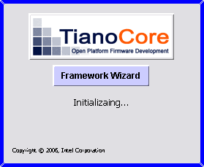

Step 1 - Workspace Validation
The system environment variable, WORKSPACE must be validated.
While WORKSPACE is not valid, do the following:
If a WORKSPACE variable has not been specified or the WORKSPACE is not valid, a Dialog browser will query the user for a valid workspace. The following error messages and conditions will be used.
The environment variable is displayed in the title as shown below.
If the Workspace is null - the error message, “WORKSPACE Environment Variable Is Not Defined” will be displayed (as shown below.)
If the Workspace is defined, but it does not exists - the error message, “WORKSPACE Environment Variable Is Not Valid” will be displayed.
If the Workspace is defined, but it is not a directory - the error message, “WORKSPACE Environment Variable Is Not a Directory” will be displayed.
If the Workspace is defined, but the %WORKSPACE%\Tools\Conf\FrameworkDatabase.db file is not found - the error message, “WORKSPACE Environment Variable Is Invalid” will be displayed.

Figure 2 Workspace Selection (showing ERROR)
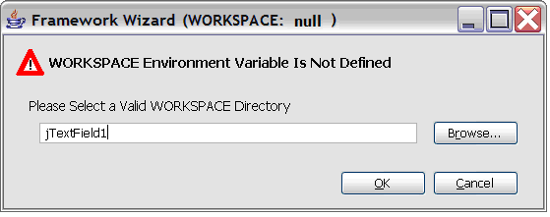

NOTE: This does not change the System Environment Variable, WORKSPACE, it only applies to where the Wizard will manage modification and file creations.

Once the WORKSPACE has been validated, additional initialization proceeds as follows.

Step 2 - Validate Tools have been built
The application will determine if the WORKSPACE has been initialized - if the file, WORKSPACE\Tools\Jars\SurfaceArea.jar exists, the WORKSPACE is assumed to be initialized.

Step 3 - Get Wizard Preferences
The application will determine if a language, other than the default, has been selected, and will load the appropriate resource definitions. The initial localization will support: English - default (en_US,) French (fr_FR_EURO) and Simplified Chinese (zh_CN) These localization resources will be supported in files that define the different keys for the localized values. String and Mnemonic keys are defined in the resource bundles. Strings are provided for menu labels, button labels and tool tips text. Initially, the localization preference will be stored in the Framework Database file.
NOTE: when the tool is first started, it will attempt to read the System environment variables to obtain information, such as locale, however the developer may have specified a different locale during a previous session. The Tools/Conf/.wizpref.xml file contains all preferences, in the <Preferences> section.
NOTE: XML Tag definitions and “Style sheets” used for Form completion will only be available in English (en_US.)

Step 4 - Get XMLSchema and create the “Style Sheets”
The application will scan either the WORKSPACE\Tools\Jars\SurfaceArea.jar or the WORKSPACE\Tools\XMLSchema\*.xsd files or both to obtain information about required and optional elements of all Framework XML Configuration files.
- Generate Forms for each file type, FrameworkDatabase, FPD, SPD and MSA, for each Major Element (defined as the top level XML elements) for each type, Standard (showing only required elements ) and Advanced (showing required and optional elements)

Step 5 - Get WORKSPACE Information
The application will scan the WORKSPACE and build an internal “database” of information. The Scan is performed by:
- Open the WORKSPACE\Tools\Conf\FrameworkDatabase.db file and locate ALL SPD and FPD files.
- Open every SPD file and: locate ALL MSA files, Setup a master table of MODULE TYPE / LIBRARY CLASS / LIBRARY INSTANCES (with the library instance data recorded as below.) At the same time, setup a master table for each type: PCDs, PPIs, GUIDS and PROTOCOLS recording MODULE TYPE and INSTANCE information.
  - Library table can be determined by parsing all of the MSA files for all ComponentType set to LIBRARY to generate a list of LibraryClasses from the ALWAYS_PRODUCED Usage attribute in the LibraryClass elements and they are classified by the ModuleType. The current MdePkg library classes by module type are listed in Appendix A. The real table should keep the following:
    - From SPD
      - PackageName, PackageGuid, PackageVersion, PackageAbstract, PackageDescription
    - From MSA
      - ModuleName, ModuleGuid, ModuleVersion, ModuleAbstract and ModuleDescription, LibraryClasses
      - CONSUMED should also be tracked, as it can be used for dependency analysis.
  - PROTOCOLS, GUID, PPIS and PCDs should be done in a similar manner, where the MSA files are scanned for ModuleType and ALWAYS_PRODUCED or SOMETIMES_PRODUCED usage attributes.
  - Special note for PCDs, the Token must be unique to the package, however we can generate unique tokens for the WORKSPACE, for completing the FPD file if two or more PcdEntry’s have the same Token, but are not identical in the rest of the SPD file’s description.
  - Also need to track the SOMETIMES_CONSUMED and ALWAYS_CONSUMED to use for dependency analysis.
- Parse the target.txt file and the TOOLS_DEF file to ensure that they exist.
Once this initialization has completed, close the Splash Screen and start the Main Application display.

Application - Main Screen
NOTE: In the following screen shots, only the items that are in BLACK will be provided as part of the Minimum Requirements. Items that are grayed out are targeted for a future release.
The main application will default to a size of 600x400 (WxH) for the entire Frame. The application will automatically adjust to size up to 1920x1200.
The Main Screen will open with the left Tree View collapsed and the right Form Edit window empty as shown below.
Figure 3 Main Screen on Application Startup
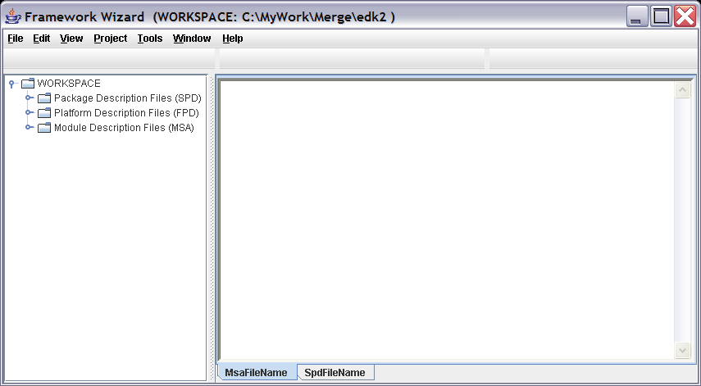
The Main Frame (screen) menu items are File, Edit, View, Project, Tools, Window and Help.

Three tool bars may be optionally displayed (in the diagram below, the tool bars are present, but do not have icons added at this time.)

The LEFT Panel is the Tree View section, and will be resizable from 145 to 200 pixels, with a default (startup) size of 155 wide. This panel displays a tree view of the top level elements of an XML schema for the focus document in the right panel. If the right panel has two sections, the tree view will add another file under the appropriate section (MSA, SPD or MSA) The Form-Edit Window, active pane is determined by the focus of the document in the Tree View window.

Figure 4 Main Screen View of Tree expansion
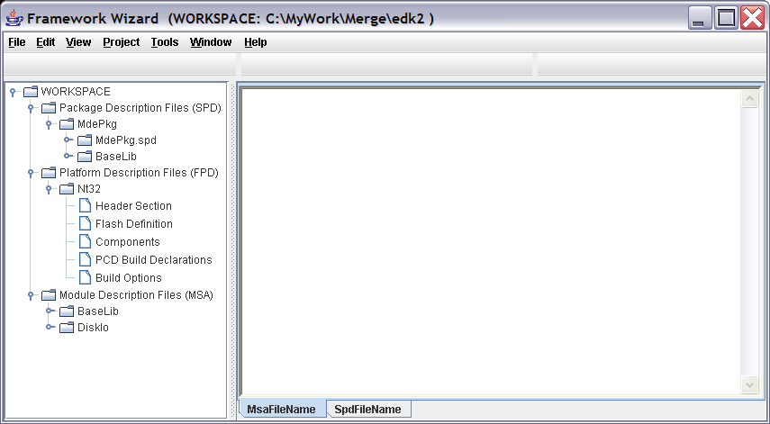

The RIGHT Panel is the Form-Edit window and is resizable from 415 to 1920 pixels in wide, with a default (startup) size of 425 wide. This Panel may be split horizontally or vertically into two Panes. The active pane (focused pane) will have a white background, while the inactive pane will have a grey background. The content of a Form-Edit pane is one of the following: Typical Elements, Advanced Elements, Text (from INF, DSC or ENV files) or XML (the MSA, SPD or FPD file as it will be written out to the file.) When split vertically, the panes will be resizable up to a 25%/75% split. When split horizontally, the panes will be automatically resizable up to a 30%/70% split.
All forms will be anchored to the base point of the top left of the Panel. Per the Java Look & Feel Design Guidelines, this is also noted as location x=0, y=0 for a pane and/or panel.

Each Pane will automatically scroll the contents horizontally and vertically, up to a height of 64000 pixels, and width of 1920 pixels.

Opening an MSA file by double clicking the name of the file will automatically open the file and switch to the Header Section’s Form-Edit section, as shown below.

Figure 5 Main Window Showing Open File
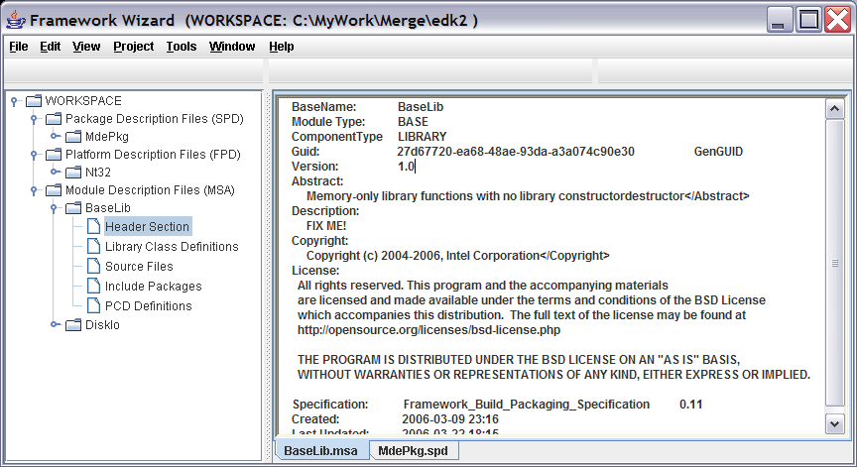

Tool Bars (FUTURE REQUIREMENT!)
Initially, three Tool Bars are defined, File, Edit and Window. Java Look and Feel Icons will be used for each of these tool bars, and will be linked to menu actions. Graphics for these tool bar items are available free of charge from Sun Microsystems, under the terms and conditions of the Sun License which will be provided in the images directory.

The File toolbar will display: New, Open, Save, Save As, Save All, Page Setup, Print, Import and Properties.

The Edit toolbar will display: Undo, Redo, Cut, Copy, Paste, Delete, Find and Find Next.

The Window toolbar will display: Split Vertical, Split Horizontal, Tab View, Source and XML.

Frame Layers
The following diagram shows the basic layers of the application. As files are opened and closed, they will be set visible in the appropriate window.
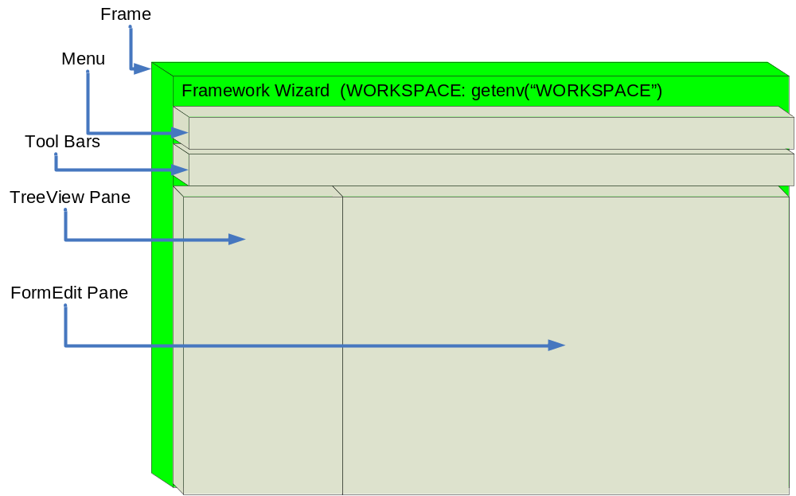

File Menu
The following screen shot shows the drop down for the Main Screen File Menu.
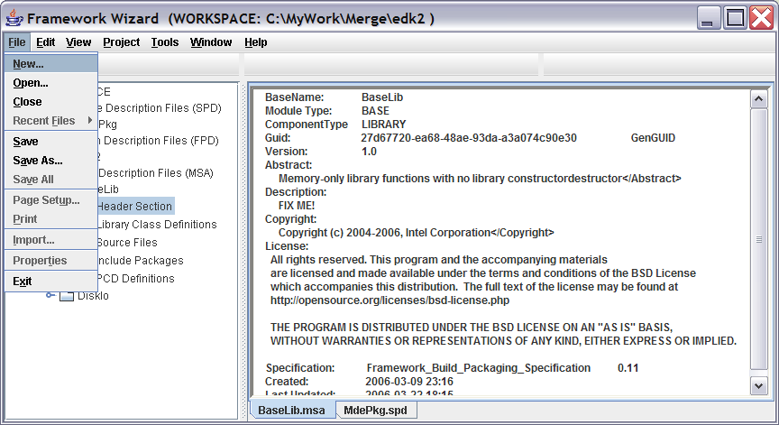

New Menu Item
The New Menu Item pops up a Dialog Box that lets the user select between one of the following.
Module Surface Area Description file
Surface Area Package Description file
Framework Platform Description file
Custom build.xml file
Buttons at the bottom are Next or Cancel

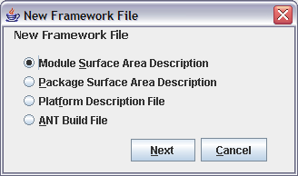

New Module Surface Area
When a user selects New MSA, another Dialog box appears that requires the user to select from a radio box one of the following:
Add to existing Surface Area Package Description (default) - SPD
Create a new Surface Area Package Description - SPD
There is a field after these radio boxes that will perform one of two options, depending on the Add / Create Selection.
Add - A drop down selection of the existing SPD files in the Workspace.
Create - Field is editable with a new SPD File name.

Buttons at the bottom are OK or Cancel.

(Graphic will be provided later.)

Once the OK button is selected, another Dialog box appears that requires the user to select from a Yes/No radio box group:

Associate Module to a Package Platform Build: Yes (default) or No

Buttons at the bottom are OK or Cancel.

YES
If Yes was selected, another Dialog box appears asking another radio box selection for:
Add to existing Package Platform Build (FPD)
Create a New Package Platform Build
There is a field after these radio boxes that will perform one of two options, depending on the Add / Create Selection.
Add - A drop down selection of the existing SPD files in the Workspace.
Create - Field is editable with a new SPD File name.

NO
Fall through.

(Graphic will be provided later.)

New MSA File (Document Heading)

FILE: MSA
Form Name: Module Surface Area Header
FUNCTION: NEW
HOW I GOT HERE:
Menu Item File -> New -> Module Surface Area Description
SPD File New or Open
Edit <MsaFileList>
NOTE: If the SPD Entry was completed (loose focus on MsaFileList Filename entry) before allowing the developer to select the Module Tab in the Form Edit Window
Form Edit window Tab Selection

Refer the to MSA File Header Form in the Sytle Sheet Definitions section below.

The “Style Sheet” which contains the appropriate elements for the highlighted Header Section will be displayed in the right Form-Edit pane.

As the user completes each section, they will can click on the next section of the XML Schema that they wish to complete.

NOTE: For new MSA files, two source files, <ModuleName>.c and <ModuleName>.h will be created and automatically inserted into the <SourceFiles> element section.
NOTE: For new MSA files, a standard ANT build.xml file is generated.

Refer to the MSA Section of additional features.

New Surface area Package Description
When a user selects New SPD, another Dialog box appears
Create - Field is editable with a new SPD File name.

(Graphic will be provided later.)

Additionally, the Dialog box requires the user to select from a Yes/No radio box group:

Create a new Package Platform Build: Yes (default) or No

YES
Create - Field is editable with a new FPD File name.

NO
Fall through.

Buttons at the bottom are OK or Cancel.

Once the OK button is selected, the Application will open a “Style Sheet” for the SPD file type, showing the top level elements of the XML Schema as a tree view in the Tree View pane. The Header Section will be highlighted.

Refer to the SPD Section for additional features.

New Framework Platform Description
When a user selects New FPD, another Dialog box appears
Create - Field is editable with a new FPD File name.

(Graphic will be provided later.)

Buttons at the bottom are OK or Cancel.

Once the OK button is selected, the Application will open a “Style Sheet” for the FPD file type, showing the top level elements of the XML Schema as a tree view in the Tree View pane. The Header Section will be highlighted.

Refer to the FPD Wizard Section for additional features.

Custom ANT Build File
When a user selects New ANT Build Description, no new Dialog boxes appear.

Once the NEXT button is selected, the Application will open a “Generic Module Build.xml file” in the Form-Edit pane. The Tree View pane will be left blank. The custom build.xml file has no templates, nor forms - the file is 100% XML, and the user must know how to edit XML directly. The entire Form-Edit pane is a single, file and should be manipulated as such.

Open Menu Item

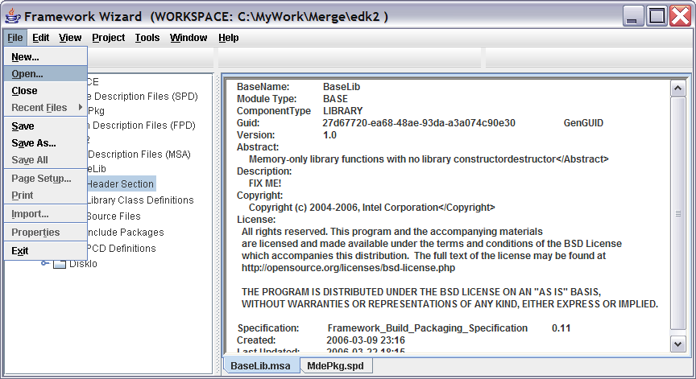

Selecting the Open Menu Item starts a File Chooser Dialog box.

Open Dialog (File Chooser Dialog)
The Open Dialog should start the user in WORKSPACE directory, and default looking for .msa files.

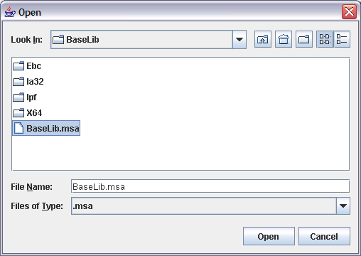

If the Cancel button is selected, the Dialog box closes and focus returns to the main application.

If the Open button is selected, the Dialog box closes after returning the file name to the main application. The following actions take place before any text:
The File is read into a buffer.
OPEN: Edit MSA File (Document Heading)
FILE: MSA
Form Name: Module Surface Area Header
FUNCTION: OPEN
HOW I GOT HERE:
File -> Open -> File Browser
OR
Double click Module name in Tree View ( Modules, Package <MsaFileList><Filename>, or Platform <FrameworkModules><$Component><ModuleSa><Filename> )
Module Tab in Form Edit window.

Refer the to MSA File Header Form in the Style Sheet Definitions section below.

Close Menu Item
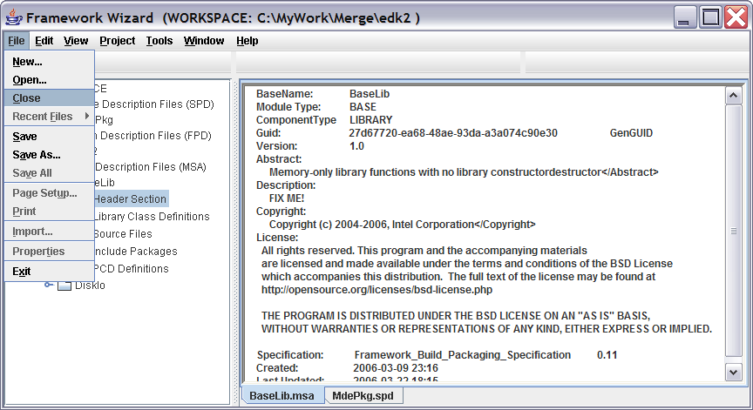
The Close function will close the focused file, and if there are pending changes, then the user will be prompted with a dialog box with SAVE, DISCARD and CANCEL buttons.
If the SAVE button is selected, and the focused file exists, the file will be saved, and the application container will be closed.

Recent Files Menu (FUTURE IMPLEMENTATION)
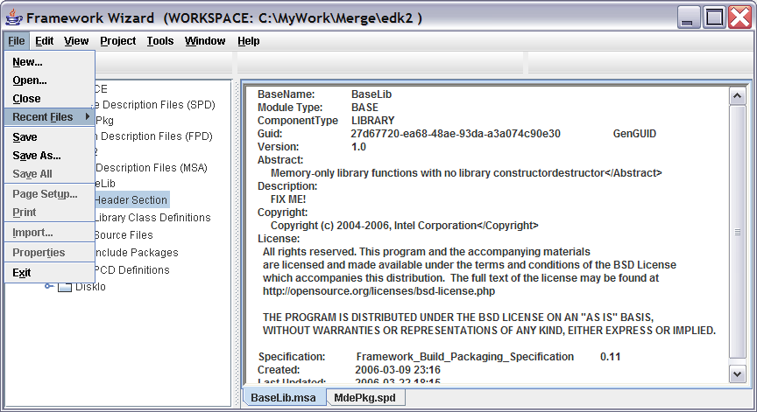
The application will track up to a user defined number of the last files created or opened by this wizard. This information will be stored in a properties file in the Tools/Conf directory. The properties file will be a hidden XML file.

Save Menu Item
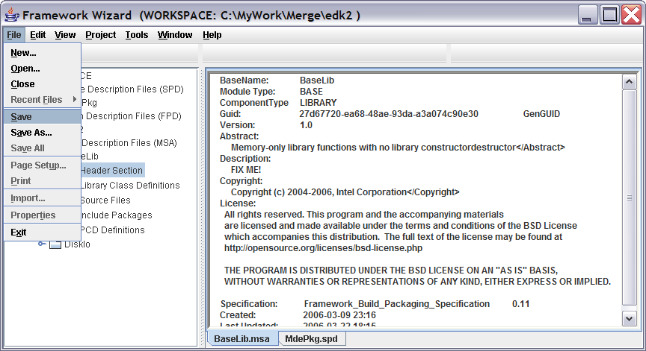
If the file is an existing file (not a new file,) the file that is under focus will be saved, overwriting the existing file if and only if the file’s buffer has been modified. If the buffer has not been modified, then the action returns without doing anything.

Save As Menu Item
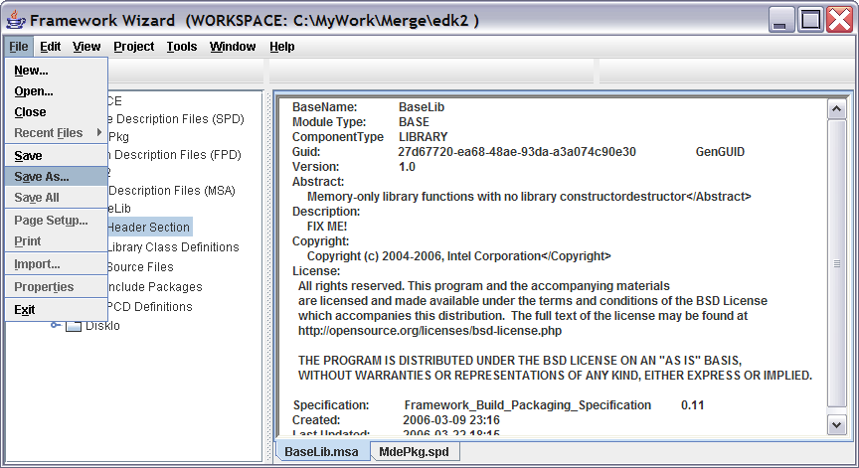
Selecting the Save As… file menu option will popup the Save As Dialog box, shown below.

Save As Dialog
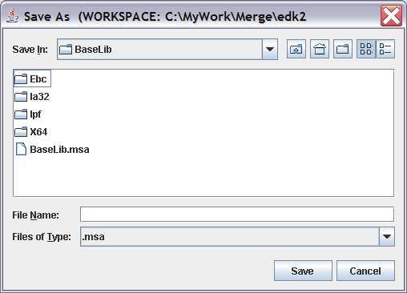

Save All Menu Item (FUTURE IMPLEMENTATION)
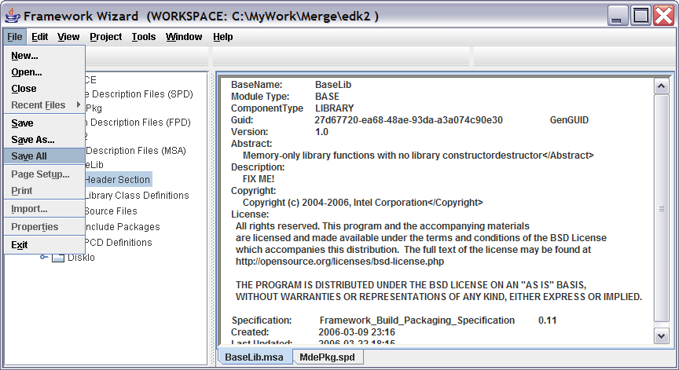

For every file that is in an edit buffer, if the file is an existing file (not a new file,) the file that is under focus will be saved, overwriting the existing file if and only if the file’s buffer has been modified. If the buffer has not been modified, then the action returns without doing anything. (This is most relevant when a new MSA file is created along with new SPD and FPD files.)

Page Setup Menu Item (FUTURE IMPLEMENTATION)
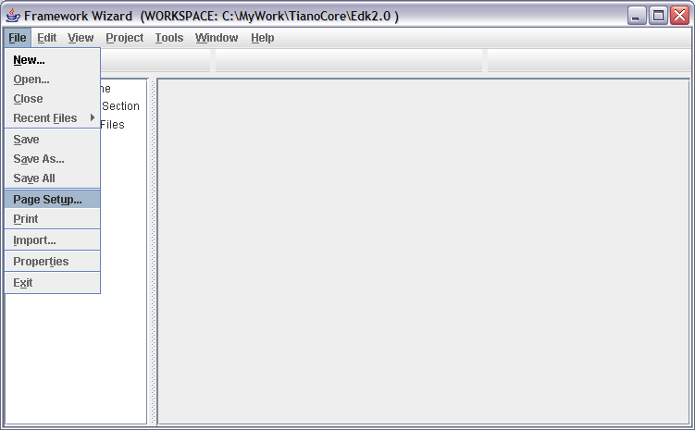

Page Setup Dialog Box
This implements the java.awt.print class.

<PAGE SETUP DIALOG GRAPHIC TO BE PROVIDED LATER>

Print Menu Item (FUTURE IMPLEMENTATION)
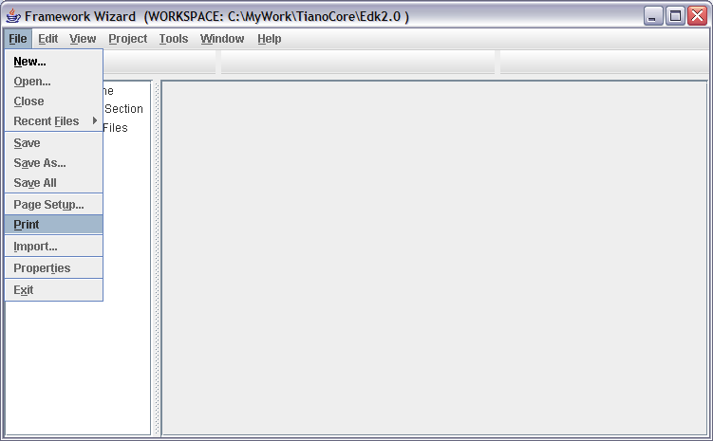

Print Dialog Box
This implements the javax.print class.

<PRINT DIALOG GRAPHIC TO BE PROVIDED LATER>

Import Menu Item (FUTURE IMPLEMENTATION)

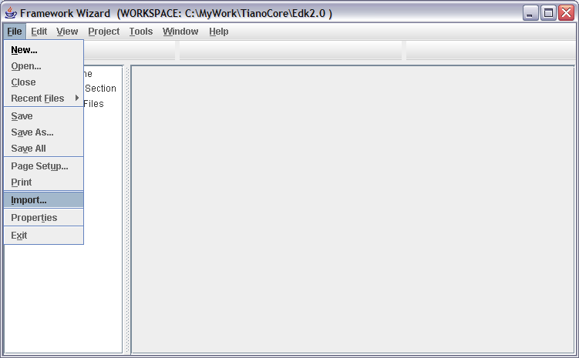

Import Dialog Box

<IMPORT DIALOG GRAPHIC TO BE PROVIDED LATER>

This is another Open Dialog box which permits developers to open INF or DSC files. This is only used during a migration scenario. An imported file is read into a buffer and any relevant information that can be used to complete entries in an MSA or FPD file are inserted into the appropriate sections of the “Style Sheet.”

Properties Menu Item (FUTURE IMPLEMENTATION)

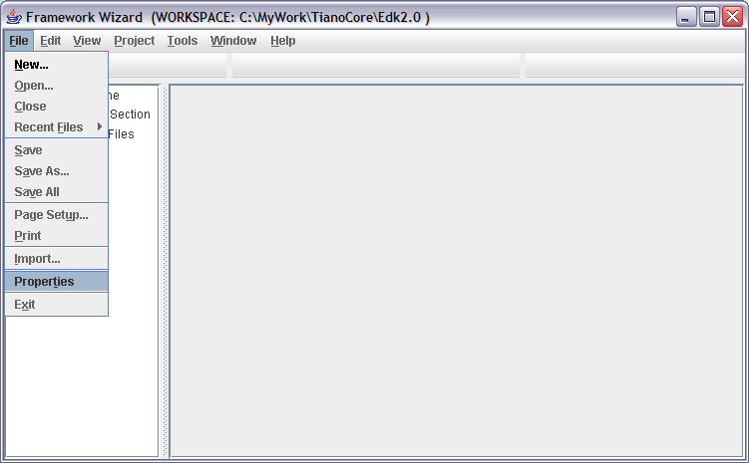

Properties Dialog Box
TBD
<PROPERTIES DIALOG GRAPHIC TO BE PROVIDED LATER>

Exit Menu Item
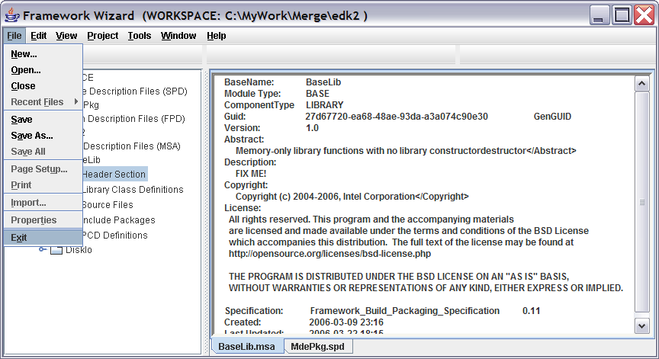
All edit buffers are check to see if un-saved modifications are pending. If they are, for each file (associated with the edit buffer) the user will be given the choice of SAVE, DISCARD or CANCEL. If an edit buffer is not associated with file, the SAVE feature will use the Save As Dialog box.
If all edit buffers have no pending data, the application closes.

Edit Menu
Standard text editing drop downs, with standard mnemonics and keyboard short cuts. Since these functions are standard to the industry, not special descriptions will be provided for each of the functions. The only exception is that initially, the Find and Find Next fields are relevant to the focused document only.
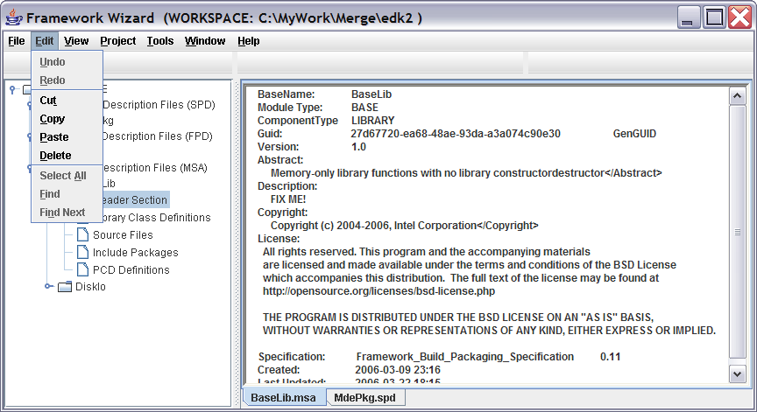

Note, only Cut, Copy, Paste and Delete will be implemented for the initial release. The remaining functions will be implemented in a future release.

View Menu
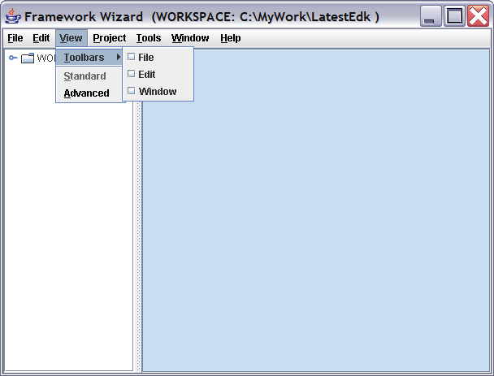

Toolbars Menu (FUTURE IMPLEMENTATION)
The toolbars selection provides for three toolbars. If the item is checked, then the toolbar will be displayed, if the item is unchecked, the toolbar will be hidden.
<SCREEN SHOT W/TOOL BAR GRAPHIC TO BE PROVIDED LATER>

Standard Menu Item (FUTURE IMPLEMENTATION)
This is the default “view” for the forms displayed in the Form-View window. Only required elements of the XML Schema will be displayed in the form
<SCREEN SHOT GRAPHIC TO BE PROVIDED LATER>

Advanced Menu Item
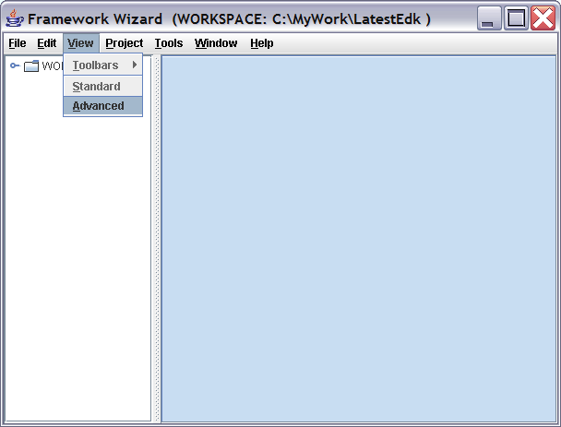
All elements of the XML Schema in the Form-View window are displayed - both required and optional. Required elements noted in the real Form-View display with an asterisk “*” character.

Project Menu
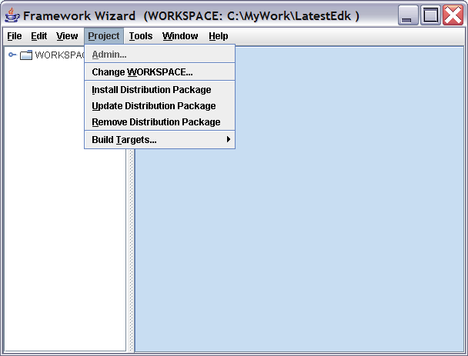

Admin Menu Item (FUTURE IMPLEMENTATION)
This will popup a Dialog box so that an administrator can set the policies for projects.
The default policy is that a developer may create SPD files when they create MSA files.
The Single policy restricts developers from creating SPD files, only administrators can do that. Additionally, new MSA files can only be added to a single SPD file.
The Multiple policy restricts developers from creating SPD files, only administrators can do that. Additionally, new MSA files can only be added to one of a specified list of SPD files.

<ADMIN GRAPHIC TO BE PROVIDED LATER>

Change Workspace Menu Item
This allows the developer to change the active WORKSPACE for the Application. If any files are open when the user selects this item must be closed, with files that have pending changes popping up the SAVE, DISCARD, CANCEL dialog. If any data has yet to be saved, the Save As Dialog will open if the SAVE button is selected. Once the files have been cleaned up, the WORKSPACE Chooser popup Dialog will open.

NOTE The WARNING would not normally appear. This would only appear if the developer selected OK, but the WORKSPACE entered is not valid.
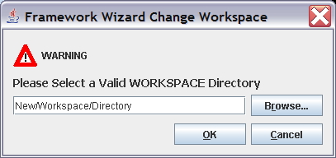

Install Distribution Package
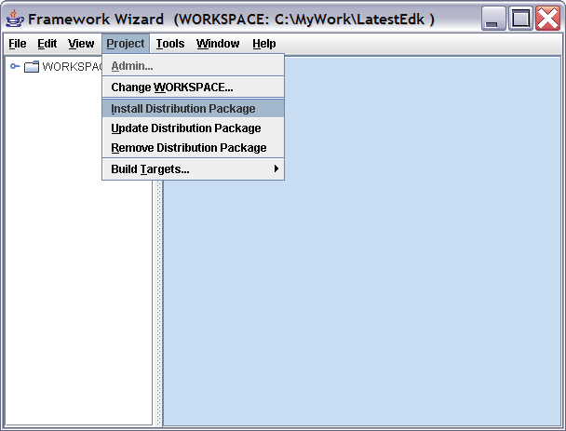
Figure 6 Install Distribution Package Menu Item
This option will popup a dialog box, which will let the user browse for the location of the Framework Distribution Package (FDP) file. There will also be a browser that will allow the user to select, where in the WORKSPACE, the package should be installed.
Prior to installing, the FrameworkDatabase must be checked to see if the package already exists. The PackageGuid and/or PackageVersion must be different, otherwise the developer will be given an option to either update (replace) or cancel installation.
In all cases (except CANCEL) the FrameworkDatabase will be updated.
Update Distribution Package
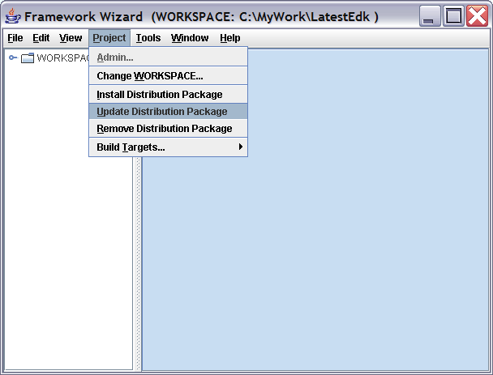
Figure 7 Update an Already Installed Distribution Package
The menu item popup a dialog to locate the distribution package FDP file.
The tool will read the Framework Database and replace an installed package with the contents of the FDP file. Tests, in order are:
Does GUID exist?
No - Check Package Name
If Package Name does not exists, Popup Dialog with, could not find a matching Package Name to update. You may need to install this package instead.
IFF ONE Package Name values match, Proceed to Directory Location Validation.
IFF More than one Package Name value matches, Popup Dialog with, Found more than one Package Name installed. Show list of Package Names and Abstracts (hidden values will be GUID/Version) User selects, then proceed to Directory Location Validation.
Yes - If number of GUID values is 1, Proceed to Directory Location Validation.
If number of GUID values is more than one, check the package name IFF more than one Package Name value matches, Popup Dialog with, Found more than one Package Name installed. Show list of Package Names and Abstracts (hidden values will be GUID/Version) User selects, then proceed to Directory Location Validation. If only one Package Name value matches, go directly to the Directory Location Validation
Directory Location Validation
The content of the directory of a previously installed package will be deleted from secondary (near) storage and replaced with the content of the distribution package after verifying that the user wants to it there.
If the user does not want to place the update in the same location, the distribution package will be installed in the user selected location (or the default location as specified in the distribution package) and the original package directory will be removed.
In all cases (except CANCEL) the FrameworkDatabase will be updated.
Distribution Package Removal
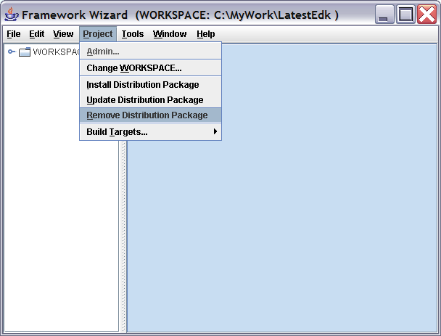
Figure 8 Remove Distribution Package
The tool will read the FrameworkDatabase file and the developer will select the package to remove. Selecting the package will popup another dialog showing the name, location and version of the package to be removed, along with a warning that all content in the directory will be deleted. If the developer clicks REMOVE button, then the directory is removed and the FrameworkDatabase file is updated. If the developer clicks CANCEL, the developer is redirected to the main application window.

Build Targets Menu
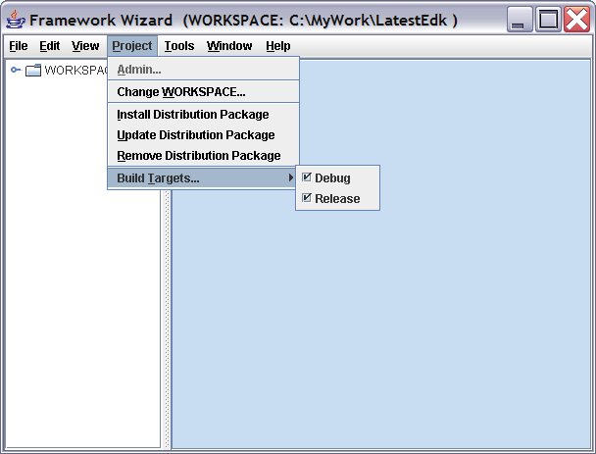
This allows the developer to select either DEBUG, RELEASE or both. The results of this selection are stored in the WORKSPACE\Tools\Conf\target.txt file.

Tools Menu
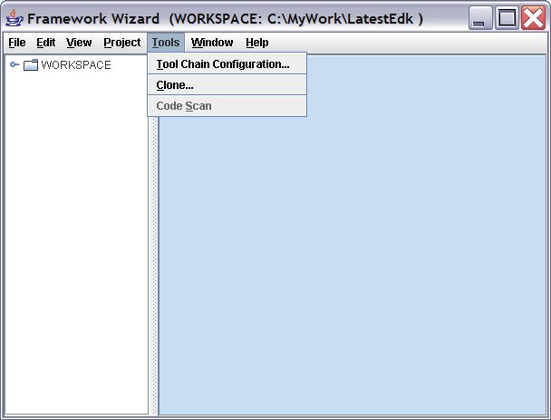

Tool Chain Configuration Item
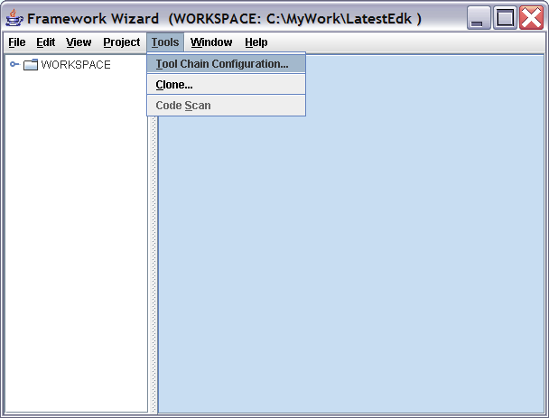
This selection will popup Dialog boxes that will help the developer complete a tool definition file. The default, tools_def.txt, and default_tools_def.txt files are configured during WORKSPACE installation. However, the dialog boxes permit browsing for text files within the context of the WORKSPACE.

Additional functionality in future releases may include setting up standard options for user selected tool chain tags.

NOTE see Table 1 Tool Chain Configuration on the required content of this Dialog box to text file mapping.

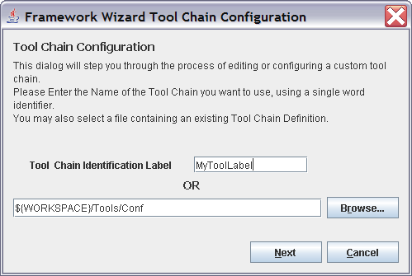
Figure 9 Tool Chain Configuration Start Screen

Clone Menu Item
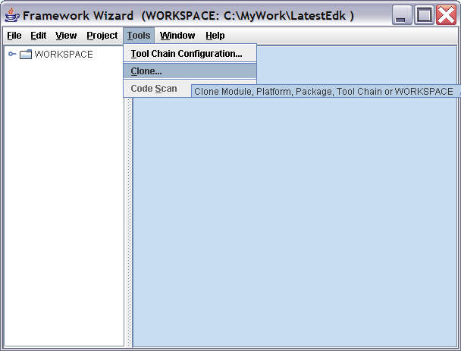
Selecting the Clone item will popup a Dialog to lead the developer through the steps of cloning a Module to a new Module within the same WORKSPACE, cloning a package to a new package within the same WORKSPACE, cloning a WORKSPACE to a new WORKSPACE and cloning a tool chain definition to a new tool chain definition.
This option will also permit cloning an existing Module in one WORKSPACE to a new Module in a different WORKSPACE, along with adding that module to a new or existing package in the target WORKSPACE.

Cloning a package from one workspace to another is NOT permitted. It is recommended that the package be installed using the Install Distribution Package item in the Tools menu.

<CLONE GRAPHIC TO BE PROVIDED LATER>

Code Scan (WILL BE PROVIDED LATER)
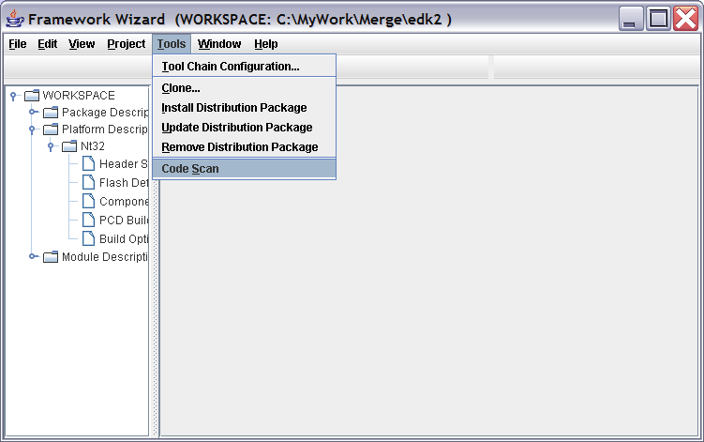
Executing the menu item will automatically scan the source files listed in an MSA <SourceFiles> section, and provide completion data for different sections of the MSA and SPD files. Duplicate entries in an MSA file are not permitted, so the application will merge the existing with those found during the scan. This function may not be available until a later release.
[Check with Andrew and Mike on design]
<CODE SCAN DIALOG GRAPHIC TO BE PROVIDED LATER>

Window Menu
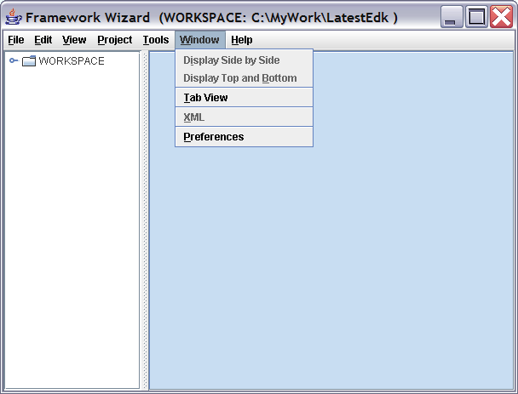
This permits the developer to split the Form-View window into two different panes, Display Top and Bottom, Display Side by Side or tabbed. This is so that an SPD file can be viewed at the same time as an MSA file. It may also be useful for view FPD and SPD files simultaneously.

ONLY the Tab View will be provided in the initial release, so that MSA and its associated SPD file can be open at the same time.

XML Menu Item (FUTURE IMPLEMENTATION)
TBD

<SCREEN SHOT GRAPHIC TO BE PROVIDED LATER>

Preferences Menu Item
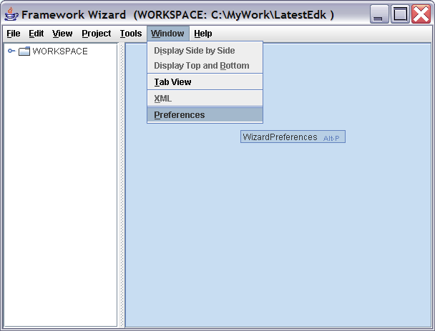
This is used to store information about the application, including the locale selection for language display as well as the last (configurable) N number of files that have been opened. This data is stored in an XML file, Tools/Conf/.wizpref.xml.

<PREFERENCES POPUP DIALOG GRAPHIC TO BE PROVIDED LATER>

Help Menu
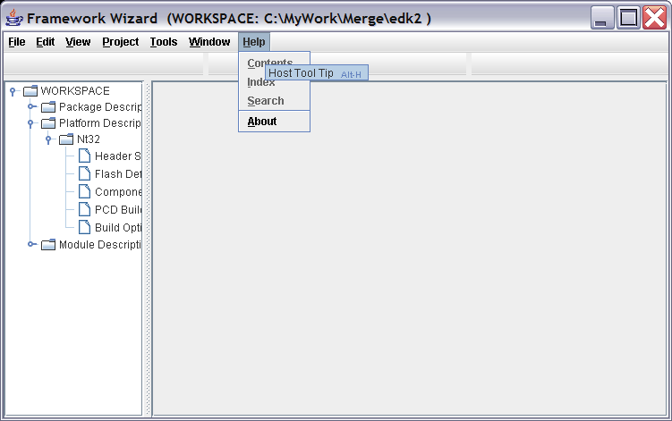

TBD

<ALL GRAPHIC TO BE PROVIDED LATER>

Style Sheet Definitions

MSA File Header Form
This defines what data needs to be displayed and gathered for the MSA Header. The Field Names are listed in the order that they appear on the screen.
HEADING: Module Surface Area Header
SECTION: <MsaHeader>

Field Name: Module Name *
Field Help: A one word reference
Field Type: string [xs:NCName, 64 char max]
FUTURE Field Option: This name may come from SPD.<MsaFileList><Filename> if the developer just completed adding an MsaFileList entry in the SPD after requesting a new MSA file.
XML Tag: <ModuleName>
Note: Since developer has to define this in the SPD.<MsaFileList><Filename:ModuleName> before they get to this form, it should be auto completed from the SPD.<MsaFileList><Filename:ModuleName> that was added
NOTE: Mouse,Tab, <CR> or <CR><LF> to move to the next field

Field Name: Guid *
Field Type: string [GuidType]
Field Option: This value should come from the SPD.<MsaFileList><Filename:GuidValue>
XML Tag: <GuidValue>
Other Element: A Button to auto-generate (and replace) the contents of this field.
FUTURE Note: Since this value may have been defined in the SPD file <MsaFileList><Filename:ModuleGuid> it could be auto completed if the developer just completed adding the entry in the SPD file.
NOTE: If the developer changes the value of the Guid in this form, the SPD file must be updated SPD by the developer. <MsaFileList><Filename:ModuleGuid>.
NOTE: Mouse/Tab to move to next field

Field Name: Module Type *
Field Type: ModuleTypeDef enum selection (Pull down list)
XML Tag: <ModuleType>
NOTE: Mouse/Tab to move to next field

Field Name: Component Type *
Field Type: FrameworkComponentTypes enum selection (Pull down list)
XML Tag: <ComponentType>
NOTE: Mouse/Tab to move to next field

Field Name: Abstract *
Field Help: One Sentence Description
Field Type: string [Sentence, 2048 char max. show only one line, w/autoscroll enabled.]
Field Option: A <CR> or <CR><LF> should terminate the entry and change the focus to the next field.
XML Tag: <Abstract>

Field Name: Description *
Field Help: Detailed Description of this Module
Field Type: string [paragraph, 32k char max. - display 4 lines, w/autoscroll enabled if more lines are entered.]
Field Option: Allow entering <CR> or <CR><LF> into this field, so that the developer can format this entry with tabs and line-feeds.
XML Tag: <Description>

Field Name: Module Version *
Field Type: string [xs:decimal, 16 char max]
Field Option: This value might come from the SPD. <MsaFileList><Filename:ModuleVersion>
XML Tag: <Version>
FUTURE Note: Since this value might have been defined in the SPD.<MsaFileList><Filename:ModuleVersion> by the developer before they get to this form, we might be able to auto completed this field.
NOTE: If the developer changes the value of the Version in this form, the developer must update the SPD.<MsaFileList><Filename:ModuleVersion>.

Field Name: Copyright *
Field Type: string [Paragraph, 2048 char max. - display 4 lines, w/autoscroll enabled if more lines are entered.]
XML Tag: <Copyright>
Field Option: if this is a NEW MSA, and the developer has already added it to the SPD file, copy the SPD file Copyright as the “default” value into this field. The developer can overwrite the contents.

Field Name: License *
Field Type: string [ Paragraph, 4096 char max. - display 11 lines, w/autoscroll turned on]
XML Tag: <License>
Field Option: if this is a NEW MSA, and the developer has already added it to the SPD file, copy the SPD file License as the “default” value into this field. The developer can overwrite the contents.

Field Name: Supported Architectures
Field Type: CheckBox of Supported Architectures
Field Help: If no boxes are checked, then all architectures are supported - INCLUDING any new architectures added in the future.
XML Tag: IF ANY BOXES ARE CHECKED <SupportedArchitectures>
NOTE: This element is a list so the following example is valid:
<SupportedArchitectures>IA32 X64</SupportedArchitectures>

Field Name: Source Code Module*
Field Type: Radio Box, Yes or No (Default is YES)
XML Tag: <BinaryModule>
NOTE: Field question is the reverse of the data field.
<BinaryModule>false</BinaryModule> is the default.

Field Name: Specification *
Field Type: string [ xs:normalizedString ] FIXED, NOT Changeable
Filed Option: AUTO COMPLETE - Not Changeable by the developer.
Field Value: FRAMEWORK_BUILD_PACKAGING_SPECIFICATION 0x00000052
XML Tag: <Specification>

MSA File Library Class Form
Wizard needs to display the fields, then an ADD Button to add the entry to a table of entires below the Add Button. The table of entries should contain at least 10 lines before autoscrollbars appear. NOTE, changing the height of the wizard should increase the number of lines in the table that get displayed. For REMOVE, the developer should highlight a line in the table, then hit the delete key.
HEADING: Module Surface Area Library Class Definitions
SECTION: <LibraryClass>

For LIBRARY MODULES:
Field Name: Library Classes *
Field Type: Drop Down selection: List from WORKSPACE Library Classes that are in SPD files.
XML Tag: <LibraryClass>

Field Name: Library Class Usage *
Field Type: Drop Down selection: from LibraryUsage data type
XML Tab: <Library:Usage>

Field Name: Recommended Library Instance
Field Type: Drop Down selection: List of WORKSPACE Library Instances that PRODUCE the class.
XML Tag: <LibraryClass:RecommendedInstanceGuid> AND <LibraryClass:RecommendedInstanceVersion>
NOTE: In the table, just display the Library Instance’s ModuleName.

Field Name: Supported Architectures
Field Type: CheckBox of Supported Architectures
Field Help: If no boxes are checked, then all architectures are supported - INCLUDING any new architectures added in the future.
XML Tag: IF ANY BOXES ARE CHECKED <LibraryClass:SupArchList>

FUTURE: Field: Feature Flag
Field Type: String
XML Tag: <LibraryClass:FeatureFlag>
For ALL other MODULES:
Field Name: Library Classes *
Field Type: Drop Down selection: List from WORKSPACE Library Classes that are in SPD files.
XML Tag: <LibraryClass> AND <LibraryClass:Usage=”ALWAYS_CONSUMED”>

Field Name: Recommended Library Instance
Field Type: Drop Down selection: List of WORKSPACE Library Instances that PRODUCE the class.
XML Tag: <LibraryClass:RecommendedInstanceGuid> AND <LibraryClass:RecommendedInstanceVersion>

MSA File Source Files Form
Wizard needs to display the fields. An add button should appear below the entry field. A table (list) of entries should contain at least 10 lines before autoscrollbars appear. NOTE, changing the height of the wizard should increase the number of rows in the table that get displayed. For REMOVE, the developer should highlight an entry in the table, then hit the delete key. NOTE: changing the width of the wizard should increase the number of columns in the table that get displayed. The cell should display just the filename, minus the path which is still kept in memory.
HEADING: Module Surface Area Source File List
SECTION: <SourceFiles>

Field Name: Filename *
Field Type: Single text field, so that the developer could type in the (Relative to the MSA file) Path and Filename.
Field Option: Browse Button
Field Note: Multiple files may be selected via the Browse button. These selected files would appear as a line of space separated relative path and file names. Relative Path is NOT indicated with the ./ indicator, just filename.txt for files in the same directory as the MSA file, or DirName+/filename.txt for multiple file selections.
XML Tag: <Filename>

Field Name: Supported Architectures
Field Type: CheckBox of Supported Architectures
Field Help: If no boxes are checked, then all architectures are supported - INCLUDING any new architectures added in the future.
XML Tag: IF ANY BOXES ARE CHECKED <Filename:SupArchList>

FUTURE: Field: Feature Flag
Field Type: String
XML Tag: <Filename:FeatureFlag>
NOTE: Whether we display the following depends on the tools_def.txt contents and the Supported Architectures List in MSA Header/SPD Header.

Field: File Type
Field Type: String (Word, NCName)
XML Tag: <Filename:FileType>

Field: Tool Chain Tag Name
Field Type: DROP DOWN SELECTION: From tools_def.txt (or active one) *_TagName_ARCH_*_* from the Tag Names defined in the tools_def.txt, Supported Architectures list in the MSA/SPD Header and whether the tool is valid (is installed on the system.)
XML Tag: <Filename:ToolChainFamily>
Field: User Defined Tool Command
Field Type: DROP DOWN SELECTION From tools_def.txt (or active one) *_*_ARCH_CMDCODE_* (IFF a user defined CMDCODE name is specified and exists on the system and is not one of the reserved command words, CC, ASM, SLINK, DLINK, PP, ASL, ASMLINK?)
XML Tag: <Filename:ToolCommand>
Field: Tool Chain Family:
Field Type: DROP DOWN Multiple choice SELECTION From tools_def.txt (or active one) From tools_def.txt (or active one) *_*_ARCH_*_FAMILY= from the Tag Names defined in the tools_def.txt, Supported Architectures list in the MSA/SPD Header and whether the tools are valid (is installed on the system.)
XML Tag: <Filename:ToolChainFamily>
<ADD BUTTON HERE>
Table of added entries follows.

THE FOLLOWING SECTION ARE COMMENTS FROM ANDREW THAT HAVE NOT BEEN FORMATTED, NOR HAVE CHANGES TO THE SCHEMA BEEN INCORPORATED (THE SCHEMA CHANGES HAVE NOT BEEN CHECKED IN EITHER!)

Library Class:

From a driver point of view a library usage is ALWAYS_CONSUMED. Given the way libraries work it’s not possible to sometimes consume a library as the constructor is called or not based on how the driver was complied. You end up needing to use a feature flag to conditionally consume a library. From a library point of view you either produce or consume a library. A library consume a library the same way as a driver.
UI:
We don’t want to support adding a library class from this screen so we don’t need the buttons.
If component type != LIBRARY then Usage should be grayed out and be set to ALWAYS_CONSUMED. If component type == LIBRARY then ALWAYS_CONSUMED and ALWAYS_PRODUCED are options.

Source Files:
We don’t need GUID, Path, File Type, Tool Chain, or Override ID. All we need is File Name and Architecture type.

Includes:
We should remove the Includes level and make it the Package level (remove Package Name level). So the right window should be called Package.
All we need is Package Name and Specific Arch. Remove package type, Usage, and Update Data

Hobs:
Remove Name, C-Name, Hob Enable, and Override ID.
Start with Hob Type.
If GUID_EXTENSION is picked allow a pull down list of GUIDs from package as the 2nd entry. If values other than GUID_EXTENSION are picked grey out this selection.
The 3rd selection is Usage.

Ppis:
Remove Guid, Enable Feature, Feature Flag, and Override ID.
We can do Ppi Type or make two screens one for PPI and the other for PPI Notify.
C_Name should be a pull down list of PPI’s base names defined in the packages supported by this module.
Last question is Usage

Protocol:

Same comment as PPI in that it’s O.K. to make protocol and protocol notify separate screens and get rid of the button.
All we need is C_Name (Use Name in the UI) and Usage. Remove GUID, Enable Feature, Feature Flag, and Override ID.

Guid:
Same as Protocol. All we need is C_Name (should be name) and Usage. Bonus points for a pull down list of the valid GUIDs

Externs:

Component Types: Module Type: Base, SEC, PEI Core, Peim, Dxe Core, Dxe Driver, Dxe Runtime Driver, Dxe SAL Driver, DXE SMM Driver, Tools, UEFI Driver, UEFI Application, & User Defined
Special Functions: (need to work on the name)
    - Module Entry Point
    - Module Unload Image (Only valid if Module Type is Dxe Driver, Dxe Runtime Driver, Dxe SAL Driver, DXE SMM Driver, UEFI Driver, UEFI Application or User Defined)
    - ExitBootServicesCallBack (Only valid if Module Type is Dxe Driver, Dxe Runtime Driver, Dxe SAL Driver, DXE SMM Driver, UEFI Driver, UEFI Application or User Defined)
    - SetVirtualAddressMapCallback (Only valid if Runtime Driver, Dxe SAL Driver, or DXE SMM Driver)
Library:
  - Constructor
  - Destructor

UEFI Driver (only valid for DXE Driver, UEFI Application, and User Defined)
    - Driver Binding
    - Component Name
    - Driver Configuration
    - Driver Diagnostic
UserDefined
Specification (autogen will default these items if they are not present. I’m not sure where this is currently in the schema)
EFI_SPECIFICATION_VERSION=0x0002000 for UEFI 2.0
EFI_SPECIFICATION_VERSION=0x0001001 for EFI 1.10
EDK_RELEASE_VERSION=0x00010000 for EDK
EDK_REALESE_VERSION=0x00020000 for EDK 2/R9

Other:

Events
The event is either a member of the Event Group list or a GUID.
So remove Guid. Start with a pick list of all the GUIDs (if too hard we can let user type in C name, but if we are going to valid the GUID we might as well generate the pick list.).
If we do the pick list we can start it with the base names of the UEFI 2.0 GUIDs that are in Event Group. This way we don’t need event group.
The 2nd item is Usage.
We don’t need Guid or Override ID.

Variable

Remove Override ID. Don’t allow generation of GUID. It would be good to reuse the GUID pick list from the set of packages (.SDP files) consumed by this module. I would also move Usage up to be under GUID. Usage should be required.
BootMode
Remove GUID and Overrid ID. Usage should be required.

System Table

Entry should be a GUID. Remove Override ID. Usage should be required.

DataHub

Data Hub Record is a GUID so these should be combined. Remove GUID GEN and Override ID. A pick list of value GUIDs is the best UI. If we don’t have the picklist you can support entering the base name of the GUID free format.

Formsets
Remove Override ID. Name and Guid are the same thing. This is just like DataHub. There should be no GUID Gen on this form.

Filename

We should be able to specify an FFS file name. The FFS filename is the GUID in the .MSA file. So it would be GUID and usage. In this case a pick list of GUID based on MSA file name would be a Good idea.

SPD
The highlighting of file types and starting the file browser in the right location are optional for the first implementation.

We need to enter the header data
We need to support adding Library Class
- ClassName
- Path in package to Library Class .h
  - Would be good to start file browser in Include/Library of the package and highlight .h files in some way.
We need to support adding a .MSA
- Add the .msa file path and name relative to the package
  - Would be good to start the file browser in the package root and highlight .msa files in some way.
We need to support adding the package include file for a given module type <IncludeHeader>
- ModuleType
- Include file
  - It would be good to start the file browser in package Include and highlight .h files some way.
We need to support adding a GUID definition
- Guid Base Name
- Guid C_Name (default should be gEfi{Guid Base Name}Guid)
- GUID value
  - Enter GUID value (copy from a specification) – Cut paste supported
  - Generate a GUID value
We need to support adding a Protocol definition
- Protocol Base Name
- Protocol C_Name (default should be gEfi{Guid Base Name}ProtocolGuid)
- GUID value
  - Enter GUID value (copy from a specification) – Cut paste supported
  - Generate a GUID value
We need to support adding a PPI definition
- PPI Base Name
- PPI C_Name (default should be gEfi{Guid Base Name}PpiGuid)
- GUID value
  - Enter GUID value (copy from a specification) – Cut paste supported
  - Generate a GUID value

We need to support adding a PCD definition
- C Name
- Token Space GUID – Default value is the package GUID
- Token # - Free format
- Set of ItemType
  - Feature Flag must always be by it’s self.
  - FixedAtBuild, Patchable, Dynamic, or Dynamic can support 1-4 of these
- DataumType – pick list
- Optional – Default Value

Platform (.FPD)

Add a MSA file.
For each MSA file make a list of:
- Library classes required. UI will display a fixed list of library class next to a pick list of library instances of that class from the work space. The library instance info will default to following values:
  - If only one library instance for the class exists in the workspace make this the default answer
  - If a library instance for the class exists in the <GlobalLibraryInstance> use this instance as a default
  - Otherwise default to not selected
- PCD Entries required. UI will display a fixed list of PCD types next to the information about the PCD entry.
  - Save the PCD Type
  - If the .MSA file uses the PCD entry in it’s Dynamic form the platform must decide if the FixedAtBuild, PatchableInModule, or Dynamic form will be used. This updates the PCD type that was saved.
  - If the PCD entry is Dynamic of DynamicEx add it to the <GlobalPcdFixedValue> section.
  - If the PCD entry is Feature Flag, Fixed At Build, or Patchable get data from the user
    - If <GlobalPcdFixedValue> has a value for this setting make it the default in the UI
    - If there is a default value in the .MSA make it the default value in the UI
    - If there is not a default in the .MSA use the default value from the .SPD
    - If no default the UI will start with no default data value.
    - Note: Most PCD types are fixed size so size information should only be asked if it’s the pointer type.
- This algorithm implies that Dynamic and DynamicEx data must be filled in before the .FPD is saved. I’m O.K. if we force values to be filed in the first time we pick a PCD entry with an .MSA file to be dynamic or dynamicEx. This could be done with a pop up menu. If you want to wait until a save and force the section to filled out I’m O.K. with that too.
- We need a screen that lets you edit the dynamic and dynamicEx data. Dynamic is the common case so we should optimize for that. The GUID’s and token numbers are implied so we should not prompt the user for this information.

Global Information

We should add optional <GlobalLibraryInstance> and <GlobalPcdFixedValue> sections. This information is used to pick default answers to library instance and PCD value resolution when we edit .MSA files. At some phase II we can allow the tool to edit these values directly.
Dynamic PCD information should be in it’s own section like we discussed and <GlobalPcdFixedValue> only contains information about FeatureFlag, Fixed at build, and Patchable PCD entries.

Description of Changes to the XMLSchema

Global Changes
Removed OverrideId attribute from all attributeGroup definitions.

New XMLSchemna File: WizardPreferences.xsd
This file will be used for maintaining information about how the Wizard application acts. It will store the Policy information, along with the Preference data (such as locale and last 9 files opened.)
Main element: <WizPref>
<Policy> and <SpdCreation>
This will be used for Administrative content for governing how the Wizard will handle normal developer action, as defined above.

<Policy>
<SpdCreation Mode=”UNRESTRICTED”/>
OR
<SpdCreation Mode=”SINGLE|MULTIPLE”>
<File Guid=”…” Version=”…”>PackageDirectory/SpdFilename.spd</File>
<File Guid=”…” Version=”…”>PackageDirectory/SpdFilename2.spd</File>
</SpdCreation>
</Policy>

Note: The 2nd+ entries are only valid for Mode=”Multiple” If the Mode is set to Single, only the first <File> entry is presented as an option to the developer when attaching an MSA to a Package. At least one <File> element must be specified if Single or Multiple Mode values are set.
<Preferences> and <Locale>
This section will be used to store Wizard application configuration data.

<Preferences>
<Locale>us_EN</Locale> {0,1}
<MostRecentFiles> {0,1}
<NumberToTrack></NumberToTrack> {1}
<LastOpened></LastOpened> {0,1}
<File Seq=0”>/path/and/filename.ext</File> {1,n}
</MostRecentFiles>
</Preferences>

Framework Database File
The following changes are being made to the XMLSchema for the Framework Database.
Removed Elements
<ModuleList> This section is no longer required. New policy requires that modules be associated with a package.

Element Name Change
<PlatformDescriptions> is being renamed to <PlatformList>

Element Modifications
<Package> sub-element: <InstalledDate> goes from {1} to {0,1}
<Package> sub-element: <CreateDate> {0,1} is new
<Package> sub-element: <ModifiedDate> {0,1} is new
<Package PackageName=”…”> new attribute PackageName, Type: BaseNameConvention, Use=required
<Package PackageGuid=”…”> new attribute PackageGuid, Type GuidType, Use=required
<Package PackageVersion=”…”> new attribute PackageVersion, Type VersionDataType, Use=”required
<Package Type=”…”> rename PackageType attribute to just Type (so as not to confuse the datatype, PackageType with the attribute name.)
<Path> is being deleted.
<File> is being added: Type=DirectoryNamingConvention which actually is Directory and filename together.
Deleting <PackageName> <Guid> <Version> and <PackageType> sub-elements from <Package>
Deleting AttributeGroup: PackageNameAttributes

Framework Platform Description (.FPD) Files
The FPD files are changing as follows. Additionally, the since the MBD files are being removed from the XML Schema, the Library Instance and Build Options information from the MBD files must be migrated into the FPD files.

Adding Elements
To <FpdHeader> adding <GuidValue>, <Version> and <Specification>

To <ModuleSA> adding attributes:
PackageName (required)
PackageGuid (required)
PackageVersion (optional)
Binary (optional Boolean, default=false)
ModuleName (required)
ModuleGuid (required)
ModuleVersion (optional)

To <ModuleSA> adding Optional Element <BuildOptions> Since we are removing the MBD files, and the MSA files should be Build independent descriptions (save for ARCH specific files) the BuildOptions can be specified here.

Surface Area Package Description (.SPD) Files
The SPD files are changing as follows.
Changing Elements:
In <SpdHeader> Changed name from <Guid> to <GuidValue>

Modules Surface Area (MSA) Description Files
Library Module Description tags are being removed from the XML Schema. Library will no longer receive special consideration, they will be treated as any other module. Elements that were specific to the Library MSA files are being added as optional elements to the component MSA schema.
NOTE: The Wizard must be able to present the correct forms based on the <ComponentType> selected.

Modules Build Description (MBD) Files
ALL Module Build Description files are being removed from the XML Schema

Framework XML Schema

SurfaceArea.xsd
Tools/Conf/FrameworkDatabase.db file (DB)
<FrameworkDatabase>
<FdbHeader> ... </FdbHeader> [1]
<PackageList> ... </PackageList> [1]
<PlatformList> ... </PlatformList> [0..1]
</FrameworkDatabase>

PackageDirectory/PackageFilename.spd (SPD)
<PackageSurfaceArea>
<SpdHeader> ... </SpdHeader> [1]
<LibraryClassDeclarations> ... </LibraryClassDeclarations> [0..1]
<MsaFiles> ... </MsaFiles> [1]
<PackageHeaders> ... </PackageHeaders> [0..1]
<GuidDeclarations> ... </GuidDeclarations> [0..1]
<ProtocolDeclarations> ... </ProtocolDeclarations> [0..1]
<PpiDeclarations> ... </PpiDeclarations> [0..1]
<PcdDeclarations> ... </PcdDeclarations> [0..1]
</PackageSurfaceArea>

ModuleDirectory/ModuleFilename.msa (MSA)
<ModuleSurfaceArea>
<MsaHeader> ... </MsaHeader> [1]
<LibraryClassDefinitions> ... </LibraryClassDefinitions> [0..1]
<SourceFiles> ... </SourceFiles> [1]
<Protocols> ... </Protocols> [0..1]
<Events> ... </Events> [0..1]
<Hobs> ... </Hobs> [0..1]
<PPIs> ... </PPIs> [0..1]
<Variables> ... </Variables> [0..1]
<BootModes> ... </BootModes> [0..1]
<SystemTables> ... </SystemTables> [0..1]
<DataHubs> ... </DataHubs> [0..1]
<Formsets> ... </Formsets> [0..1]
<Guids> ... </Guids> [0..1]
<Externs> ... </Externs> [0..1]
<PcdCoded> ... </PcdCoded> [0..1]
</ModuleSurfaceArea>

PlatformDirectory/PlatformFilename.fpd (FPD)
<FrameworkPlatformDescription>
<PlatformHeader> ... </PlatformHeader> [1]
<Flash> ... </Flash> [0..1]
<FrameworkModules> ... </FrameworkModules> [0..1]
<DynamicPcdBuildDefinitions> ... </DynamicPcdBuildDefinitions> [0..1]
<BuildOptions> ... </BuildOptions> [0..1]
</FrameworkPlatformDescription>

FrameworkHeaders.xsd
Note: Specification in the Headers is the Title and Version number (example): Framework_Build_Packaging_Specification 0.51
<FdbHeader>
<DatabaseName> ... </DatabaseName> [1]
<GuidValue> ... </GuidValue> [1]
<Version> ... </Version> [1]
<CreatedDate> ... </CreatedDate> [1]
<UpdatedDate> ... </UpdatedDate> [0..1]
<Abstract> ... </Abstract> [1]
<Description> ... </Description> [1]
<Copyright> ... </Copyright> [1]
<License> ... </License> [1]
<Specification> ... </Specification> [1]
</FdbHeader>

<SpdHeader>
<PackageName> BaseNameConvention </PackageName> [1]
<GuidValue> ... </GuidValue> [1]
<Version> ... </Version> [1]
<Abstract> ... </Abstract> [1]
<Description> ... </Description> [1]
<Copyright> ... </Copyright> [1]
<License> ... </License> [1]
<CreatedDate> ... </CreatedDate> [1]
<E-Mail> ... </E-Mail> [0..1]
<ModifiedDate> ... </ModifiedDate> [0..1]
<URL> ... </URL> [0..1]
<Type> PackageType </Type> [1]
<ReadOnly> ... </ReadOnly> [0..1]
<RePackage> ... </RePackage> [0..1]
<Specification> ... </Specification> [1]
</SpdHeader>

<MsaHeader>
<ModuleName> xs:NCName </ModuleName> [1]
<ModuleType> ... </ModuleType> [1]
<ComponentType> ... </ComponentType> [1]
<GuidValue> ... </GuidValue> [1]
<Version> ... </Version> [1]
<Abstract> ... </Abstract> [1]
<Description> ... </Description> [1]
<Copyright> ... </Copyright> [1]
<License> ... </License> [1]
<CreatedDate> ... </CreatedDate> [1]
<ModifiedDate> ... </ModifiedDate> [0..1]
<SupportedArchitectures> list of: SupportedArchitectures </SupportedAcrhitectures> [1]
<Specification> ... </Specification> [1]
</MsaHeader>

<PlatformHeader>
<PlatformName> PlatformNamingConvention </PlatformName> [1]
<GuidValue> ... </GuidValue> [1]
<Version> ... </Version> [1]
<Abstract> ... </Abstract> [1]
<Description> ... </Description> [1]
<Copyright> ... </Copyright> [1]
<License> ... </License> [1]
<CreatedDate> ... </CreatedDate> [1]
<ModifiedDate> ... </ModifiedDate> [0..1]
<BuildTarget> BuildTargets </BuildTarget> [1]
<Specification> ... </Specification> [1]
</PlatformHeader>

FrameworkDataElements.xsd
<Abstract> Sentence </Abstract>

<AntCmd>
<Id> xs:int </Id> [0..1]
<ExecutionOrder> list of: xs:normalizedString </ExecutionOrder> [1]
</AntCmd>

<AntTask Id=" xs:int [1]">
Start Choice [1]
<AntCmd> ... </AntCmd> [1]
<Filename> ... </Filename> [1]
End Choice
</AntTask>

<BaseName> BaseNameConvention </BaseName>

<BootModes
Guid=”GuidType”
BootModeName=”BootModeNames”
Usage=”BootModeUsage”
EnableFeature=”true|false”
FeatureFlage=”xs:normalizedString” >
Start Sequence [1..*]
<BootMode/> [1]
End Sequence
</BootModes>

<BuildOptions ToolChainFamilies=" xs:normalizedString (pattern =
((INTC)|(MSFT)|(GCC)){1}(,((INTC)|(MSFT)|(GCC))){0,2}) [0..1] ?">
<UserDefinedAntTasks> ... </UserDefinedAntTasks> [0..1]
<ImageEntryPoint> ... </ImageEntryPoint> [0..*]
<OutputDirectory> ... </OutputDirectory> [0..1]
<Sections> … </Sections> [0..1]
<Ffs> ... </Ffs> [0..*]
<Filenames> ... </Filenames> [0..*]
Start Sequence [0..1]
<Option> [0..*] xs:normalizedString </Option>
End Sequence
</BuildOptions>

<C_Name> C_Name </C_Name>

<ComponentName> C_Name </ComponentName>

<ComponentType> FrameworkComponentTypes </ComponentType>

<ConditionalExpression ConditionalTarget=" ConditionalTarget [0..1]">
<Condition> xs:normalizedString </Condition> [1..*]
</ConditionalExpression>

<Constructor> C_Name </Constructor>

<Copyright> Sentence </Copyright>

<CreatedDate> DateType </CreatedDate>

<DatabaseName> BaseNameConvention </DatabaseName>

<DataHubs>
Start Sequence [1..*]
<DataHubRecord> [1] xs:normalizedString </DataHubRecord>
End Sequence
</DataHubs>

<DefaultValue> xs:normalizedString </DefaultValue>

<Description> Paragraph </Description>

<Destructor> C_Name </Destructor>

<DriverBinding> C_Name </DriverBinding>

<DriverConfig> C_Name </DriverConfig>

<DriverDiag> C_Name </DriverDiag>

<E-Mail> E-Mail </E-Mail>

<Events>
<CreateEvents> [0..1]
Start Sequence [1..*]
<Event> [1]
<C_Name> ... </C_Name> [1]
<GuidValue> ... </GuidValue> [0..1]
</Event>
End Sequence
</CreateEvents>
<SignalEvents> [0..1] ?
Start Sequence [1..*]
<Event> [1]
<C_Name> ... </C_Name> [1]
<GuidValue> ... </GuidValue> [0..1]
</Event>
End Sequence
</SignalEvents>
</Events>

<ExitBootServicesCallBack> C_Name </ExitBootServicesCallBack>

<Externs>
<PcdIsDriver> PcdDriverTypes </PcdIsDriver> [0..1]
Start Sequence [1..*]
<Extern> [1]
Start Choice [1]
Start Sequence [0..1] ?
<ModuleEntryPoint> ... </ModuleEntryPoint> [0..*]
<ModuleUnloadImage> ... </ModuleUnloadImage> [0..*]
End Sequence
Start Sequence [0..1] ?
<Constructor> ... </Constructor> [0..1]
<Destructor> ... </Destructor> [0..1]
End Sequence
Start Sequence [0..1] ?
<DriverBinding> ... </DriverBinding> [0..*]
<ComponentName> ... </ComponentName> [0..*]
<DriverConfig> ... </DriverConfig> [0..*]
<DriverDiag> ... </DriverDiag> [0..*]
End Sequence
Start Sequence [0..1] ?
<SetVirtualAddressMapCallBack>...</SetVirtualAddressMapCallBack> [0..*]
<ExitBootServicesCallBack> ... </ExitBootServicesCallBack> [0..*]
End Sequence
<UserDefined> C_Name </UserDefined> [0..*]
End Choice
</Extern>
<Specification> ... </Specification> [0..*]
End Sequence
</Externs>

<Ffs Type="xs:normalizedString [0..1]">
<Attribute Name="C_Name [0..1]" Value="C_Name [0..1]"> [0..*]
C_Name
</Attribute>
<Sections> ... </Sections> [0..1]
</Ffs>

<Filename ArchType="SupportedArchitectures [0..1]"> VariableConvention </Filename>

<Filenames>
<Filename> ... </Filename> [0..*]
</Filenames>

<Formsets>
Start Sequence [1..*]
<Formset> [1] ?
C_Name
</Formset>
End Sequence
</Formsets>

<Guid> GuidType </Guid>

<GuidDeclarations>
<Entry Name="xs:normalizedString [1]"> [1..*]
<C_Name> ... </C_Name> [1]
<GuidValue> ... </GuidValue> [1]
<FeatureFlag> C_Name </FeatureFlag> [0..*]
</Entry>
</GuidDeclarations>

<Guids>
Start Sequence [1..*]
<GuidEntry> [1] ?
Start Sequence [0..1]
<C_Name> ... </C_Name> [1]
<GuidValue> ... </GuidValue> [0..1]
<FeatureFlag> C_Name </FeatureFlag> [0..*]
<DefaultValue> ... </DefaultValue> [0..1]
<HelpText> ... </HelpText> [0..1]
End Sequence
</GuidEntry>
End Sequence
</Guids>

<GuidValue> GuidType </GuidValue>

<HelpText> Paragraph </HelpText>

<Hobs>
Start Sequence [1..*]
<Hob> [1]
<Name> xs:normalizedString </Name> [0..1]
<C_Name> ... </C_Name> [0..1]
<GuidValue> ... </GuidValue> [0..1]
</Hob>
End Sequence
</Hobs>

<ImageEntryPoint> C_Name </ImageEntryPoint>

<IncludeHeader> FileNameConvention </IncludeHeader>

<Includes>
Start Sequence [1..*]
<PackageName
Arch="SupportedArchitectures [0..1]"
PackageName="BaseNameConvention [1]"
PackageGuid="GuidType [1]"
PackageVersion="VersionDataType [1]"
Usage="PackageUsage [0..1]"
Type="PackageType [0..1]"/> [1] ?
End Sequence
</Includes>

<InstalledDate> DateType </InstalledDate>

<Libraries>
Start Sequence
<Library> xs:NCName </Library> [0..*]
End Sequence
</Libraries>

<LibraryClass Usage="LibraryUsage [1]"
RecommendedInstance=”xs:NCName [0..1]”
RecommendedInstanceGuid=”GuidType [0..1]> BaseNameConvention </LibraryClass>

<LibraryClassDeclaration>
Start Sequence [0..1]
<LibraryClass
RecommendedInstance=”xs:NCName [0..1]”
RecommendedInstanceGuid=”GuidType [0..1]> ... </LibraryClass> [1]
<IncludeHeader> ... </IncludeHeader> [1]
End Sequence
</LibraryClassDeclaration>

<LibraryClassDeclarations>
<LibraryClassDeclaration> ... </LibraryClassDeclaration> [1..*]
</LibraryClassDeclarations>

<LibraryClassDefinitions>
<!-- Mixed content -->
Start Sequence [1..*]
<LibraryClass> ... </LibraryClass> [1]
End Sequence
</LibraryClassDefinitions>

<License URL="xs:anyURI [0..1]"> Paragraph </License>

<ModifiedDate> DateType </ModifiedDate>

<Module>
<ModuleName> ... </ModuleName> [1]
<GuidValue> ... </GuidValue> [1]
<Version> ... </Version> [1]
<Path> ... </Path> [1]
</Module>

<ModuleEntryPoint> xs:normalizedString </ModuleEntryPoint>

<ModuleList>
Start Sequence [1..*]
<Module> ... </Module> [1..*]
End Sequence
</ModuleList>

<ModuleName> xs:NCName </ModuleName>

<ModuleType> ModuleTypeDef </ModuleType>

<ModuleUnloadImage> xs:normalizedString </ModuleUnloadImage>

<MsaFiles>
<MsaFile> [0..*] ?
Start Sequence [0..1]
<Filename> ... </Filename> [0..1]
<BuildOptions> ... </BuildOptions> [0..1]
End Sequence
</MsaFile>
</MsaFiles>

<OutputDirectory IntermediateDirectories="UCNameType (value comes from list:
{'MODULE'|'UNIFIED'}) [0..1]">
DirectoryNamingConvention
</OutputDirectory>

<PackageHeaders>
<IncludeHeader> ... </IncludeHeader> [1..*]
</PackageHeaders>

<PackageList>
Start Sequence [1..*]
<Package> [1] ?
Start Sequence [1..*]
<PackageName> ... </PackageName> [0..1]
<PackageGuid> ... </PackageGuid> [0..1]
<PackageVersion> ... </PackageVersion> [0..1]
<Filename> VariableConvention </Filename> [1]
<InstalledDate> ... </InstalledDate> [1]
End Sequence
</Package>
End Sequence
</PackageList>

<PackageName> BaseNameConvention </PackageName>

<Path> DirectoryNamingConvention </Path>

<PcdBuildDefinitons> <!-- Used on FPD ModuleSA ONLY -->
<PcdBuildData> [0..*] ?
<C_Name> ... </C_Name> [1]
<Token> ... </Token> [1]
<TokenSpaceGuid> GuidType </TokenSpaceGuid> [1]
<DatumType> PcdDataTypes </DatumType> [1]
<SkuGroup> ... </SkuGroup> [0..1]
Start Choice [0..1]
<HiiGroup> ... </HiiGroup> [0..1]
<VpdGroup> ... </VpdGroup> [0..1]
End Choice
<DatumSize> DatumSizeLimit </DatumSize> [1]
<Value> xs:normalizedString </Value> [0..1]
</PcdBuildData>
</PcdBuildDefinitions>

<PcdDeclarations> <!-- SPD File →
<PcdEntry> [1..*] ?
<C_Name> ... </C_Name> [1]
<Token> Token </Token> [1]
<TokenSpaceGuid> GuidType </TokenSpaceGuid> [1]
<DatumType> PcdDataTypes </DatumType> [1]
<ValidUsage> list of: PcdListType </ValidUsage> [1]
<DefaultValue> DefaultValue </DefaultValue> [0..1]
<HelpText> Paragraph </HelpText> [1]
</PcdEntry>
</PcdDefinitions>

<DynamicPcdBuildDefinitions>
<PcdBuildData> [0..*] ?
<C_Name> ... </C_Name> [1]
<Token> ... </Token>
<TokenSpaceGuid> GuidType </TokenSpaceGuid> [1]
<DatumType> PcdDataTypes </DatumType> [1]
Start Choice [0..1]
<HiiGroup> ... </HiiGroup> [0..1]
<VpdGroup> ... </VpdGroup> [0..1]
End Choice
<DatumSize> DatumSizeLimit </DatumSize> [1]
<Value> xs:normalizedString </Value> [0..1]
</PcdBuildData>
</DynamicPcdBuildDefinitons>

<SkuGroup>
Start Sequence
<SkuList> List of: SkuListType {HexByte} </SkuList> [1]
<SkuSet> List of: SkuListType {HexByte} </SkuSet> [1]
<SkuDataArrayEnable> ... </SkuDataArrayEnable> [1]
<SkuData> [0 .. *]
<Id> int </Id> [1]
<Value> xs:normalizedString </Value> [1]
</SkuData>
End Sequence
</SkuGroup>

<HiiGroup>
Start Sequence
<VariableName> ... </VariableName> [0..1]
<VariableGuid> ... </VariableGuid> [0..1]
<VariableOffset> ... </VariableOffset> [1]
End Sequence
</HiiGroup>

<VpdGroup>
Start Sequence
<VpdOffset> ... </VpdOffset> [1]
End Sequence
</VpdGroup>

<PcdCoded> <!-- Used in MSA files only →
<PcdData> [1..*] ?
<C_Name> ... </C_Name> [1]
<Token> HexDoubleWordDataType </Token> [1]
<TokenSpaceGuid> GuidType </TokenSpaceGuid> [1]
<DefaultValue> xs:normalizedString </DefaultValue> [0..1]
<HelpText> ... </HelpText> [1]
</PcdData>
</PcdCoded>

<Platform>
<PlatformName> PlatformNamingConvention </PlatformName> [1]
<Filename> DirectoryNamingConvention </Filename> [1]
<InstalledDate> DateType </InstalledDate> [0..1]
</Platform>

<PpiDeclarations>
<Entry Name="xs:normalizedString [1]"> [1..*]
<C_Name> ... </C_Name> [1]
<GuidValue> ... </GuidValue> [1]
<FeatureFlag> xs:normalizedString </FeatureFlag> [0..*]
</Entry>
</PpiDeclarations>

<PPIs>
<Ppi> [0..*] C_Name </Ppi>
<PpiNotify> [0..*] C_Name </PpiNotify>
</PPIs>

<ProtocolDeclarations>
<Entry Name="xs:normalizedString [1]"> [1..*]
<C_Name> ... </C_Name> [1]
<GuidValue> ... </GuidValue> [1]
<FeatureFlag> C_Name </FeatureFlag> [0..*]
</Entry>
</ProtocolDeclarations>

<Protocols>
Start Sequence [1..*]
<Protocol
Guid="GuidType [0..1]"
Usage="ProtocolUsage [1]"
FeatureFlag="C_Name [0..1]"
ArchType="list of: SupportedArchitectures [0..1]"> [0..*]
C_Name
</Protocol>
<ProtocolNotify
Guid="GuidType [0..1]"
Usage="ProtocolNotifyUsage [1]"
FeatureFlag="C_Name [0..1]"
ArchType="list of: SupportedArchitectures [0..1]"> [0..*]
C_Name
</ProtocolNotify>
End Sequence
</Protocols>

<ReadOnly> xs:boolean </ReadOnly>

<RePackage> xs:boolean </RePackage>

<Sections>
<Section> [0..*]
<Filenames> ... </Filenames> [0..1]
<Args> ArgsType </Args> [0..1]
<OutFile> FileNameConvention </OutFile> [0..1]
<OutputFileExtension> xs:string </OutputFileExtension> [0..1]
<ToolName> ToolType </ToolName> [0..1]
</Section>
<Sections> [0..*]
Start Sequence [1..*]
<Section> [1]
<Filenames> ... </Filenames> [0..1]
<Args> ArgsType </Args> [0..1]
<OutFile> FileNameConvention </OutFile> [0..1]
<OutputFileExtension> xs:string </OutputFileExtension> [0..1]
<ToolName> ToolType </ToolName> [0..1]
</Section>
End Sequence
</Sections>
</Sections>

<SetVirtualAddressMapCallBack> C_Name </SetVirtualAddressMapCallBack>

<SourceFiles>
<Filename
Arch="SupportedArchitectures [0..1]"
FileGuid="GuidType [0..1]"
FileVersion="VersionDataType [0..1]"
FileType="UCNameType (value comes from list:
{'CCODE'|'CHEADER'|'ASMHEADER'|'ASM'|'UNI'|'TXT'|'DXS'|'BMP'|'VFR'|'BINARY'|'FV'|'FFS'|'EFI'}) [0..1]"
UserDefinedFileType="xs:string [0..1]"> [1..*]
DirectoryNamingConvention
</Filename>
</SourceFiles>

<Specification
SpecVersion="xs:normalizedString [1]"
SpecGuid="GuidType [0..1]"
ArchType="list of: SupportedArchitectures [0..1]"> xs:normalizedString
</Specification>

<SystemTables>
Start Sequence [1..*]
<SystemTable> [1]
<Entry> xs:normalizedString </Entry> [0..1]
</SystemTable>
End Sequence
</SystemTables>

<Token Target=” C_Name [0..1]”> HexDoubleWordDataType </Token>

<UpdatedDate> DateType </UpdatedDate>

<URI> xs:anyURI </URI>

<URL> xs:anyURI </URL>

<UserDefinedAntTasks>
Start Sequence [1..*]
<AntTask> ... </AntTask> [1]
End Sequence
</UserDefinedAntTasks>

<VariableGuid> VariableGuidType </VariableGuid>

<VariableName> xs:normalizedString </VariableName>

<Variables>
Start Sequence [1..*]
<Variable> [1] ?
<String> xs:normalizedString </String> [1]
<GuidValue> ... </GuidValue> [1]
<ByteOffset> HexWordDataType </ByteOffset> [0..1] ?
<BitOffset> xs:int (0 <= value <= 8) </BitOffset> [0..1] ?
<OffsetBitSize> xs:int (0 <= value <= 7) </OffsetBitSize> [0..1] ?
</Variable>
End Sequence
</Variables>

<Version> xs:normalizedString </Version>

<VpdEnable> xs:boolean </VpdEnable>

FrameworkPlatformDataElements.xsd

<Disable> xs:string </Disable>

<Enable> xs:string </Ensable>

<Flash MicrocodeFile="FileNameConvention [0..1]">
Start Choice [1]
<FlashDefinition> FlashData </FlashDefinition> [1]
<FlashDefinitionFile> FileNameConvention </FlashDefinitionFile> [1]
End Choice
<FvImages> ... </FvImages> [0..*]
</Flash>

<FlashDeviceImage Name="xs:string [1]">
Start All [1]
<RawData
Name="xs:string [1]"
Region="xs:string [1]"
SubRegion="xs:string [1]"> [0..1]
Start Sequence [0..1]
<Data> xs:string </Data> [1]
End Sequence
</RawData>
<File
Name="xs:string [1]"
Region="xs:string [1]"
SubRegion="xs:string [0..1]"
Optional="xs:boolean [0..1]"/> [0..1]
End All
</FlashDeviceImage>

<FlashDeviceInfo
Name="BlockNameType [1]"
Size="HexAddressType [1]"
Flags="HexAddressType [0..1]">
<Blocks> [1]
<Block
Name="BlockNameType [1]"
Size="HexAddressType [1]"
Flags="HexAddressType [0..1]"> [1..255]
BlockNameType
</Block>
</Blocks>
<Regions> [1]
<Region
Name="xs:string [1]"
Size="HexAddressType [1]"
Flags="HexAddressType [0..1]"
Alignment="HexAddressType [0..1]"
Attributes="xs:string [1]"
AreaType="EfiFvAreaType [1]"> [1..*]
Start All [1]
<SubRegions> [1]
Start Sequence [0..*]
<SubRegion
CreateHob="xs:boolean [1]"
Name="xs:string [1]"
Size="HexAddressType [1]"
Attributes="xs:string [1]"
AreaType="EfiFvAreaType [1]"
NameGuid="xs:string [1]"
AreaTypeGuid="xs:string [0..1]"
FileSystemGuid="xs:string [0..1]"> [1]
xs:string
</SubRegion>
End Sequence
</SubRegions>
End All
</Region>
</Regions>
</FlashDeviceInfo>

<FlashDeviceOverrideImage>
<Name> NameConvention </Name> [0..1]
<File> FvImageOverrideFileType </File> [0..*]
</FlashDeviceOverrideImage>

<FlashDeviceOverrideInfo>
<Name> UCNameType </Name> [0..1]
<FlashSize> FlashSize </FlashSize> [0..1]
<BaseAddress> HexAddressType </BaseAddress> [0..1]
<OutputDirectory> DirectoryNamingConvention </OutputDirectory> [0..1]
<MicrocodeFile> FileNameConvention </MicrocodeFile> [0..1]
<Block> BlockNameType </Block> [0..255]
<Region> RegionDataType </Region> [0..*]
</FlashDeviceOverrideInfo>

<FrameworkModules>
<SEC> Components </SEC> [0..1]
<PEI_CORE> Components </PEI_CORE> [0..1]
<PEIM> Components </PEIM> [0..1]
<DXE_CORE> Components </DXE_CORE> [0..1]
<DXE_DRIVERS> Components </DXE_DRIVERS> [0..1]
<OTHER_COMPONENTS> Components </OTHER_COMPONENTS> [0..1]
</FrameworkModules>

<FvImage Type="xs:string [0..1]">
<FvImageNames> ... </FvImageNames> [1..*]
<FvImageOptions> ... </FvImageOptions> [0..1]
</FvImage>

<FvImageNames> xs:string </FvImageNames>

<FvImageOptions>
<NameValue> ... </NameValue> [0..*]
</FvImageOptions>

<FvImages>
<NameValue> ... </NameValue> [0..*]
<FvImage> ... </FvImage> [0..*]
</FvImages>

<ModuleSA>
Start Sequence [0..1]
<Libraries> ... </Libraries> [0..1]
<Externs> ... </Externs> [0..1]
<PcdBuildDefinitions> ... </PcdBuildDefinitions> [0..1]
<BuildOptions> ... </BuildOptions> [0..1]
End Sequence
</ModuleSA>

<NameValue
Name="xs:string [1]"
Value="xs:string [1]"> xs:string </NameValue>

<PlatformList>
Start Sequence [1..*]
<Platform> ... </Platform> [1]
End Sequence
</PlatformList>

Refer to XML schema checked into SVN for Attribute and Data Types.

FrameworkDataAttributes.xsd
Refer to XML schema checked into SVN for Attribute and Data Types.

FrameworkDataTypes.xsd
Refer to XML schema checked into SVN for Attribute and Data Types.

NamingConvention.xsd
Refer to XML schema checked into SVN for Attribute and Data Types.

WizardPreferences.xsd
The following XML schema is used for storing a User’s Wizard Preferences.
<WizPref>
Start All [0..1]
<Policy> ... </Policy> [1]
<Preferences> ... </Preferences> [1]
End All
</WizPref>

<Policy>
<SpdCreation> [1]
Start Sequence [0..1]
<File GuidValue="GuidType [1]" Version="VersionDataType [1]"> [0..*]
FileNameConvention
</File>
End Sequence
</SpdCreation>
</Policy>

<Preferences>
Start All [0..1]
<Locale> xs:string </Locale> [1]
<MostRecentFiles> [0..1]
<NumberToTrack> xs:int </NumberToTrack> [0..1]
<LastOpened> xs:int </LastOpened> [0..1]
<File Seq="xs:int [1]"> [0..*] DirectoryNamingConvention </File>
</MostRecentFiles>
End All
</Preferences>
Appendix A

MdePkg Library classes by ModuleType
BASE:
BaseLib ./BaseLib/BaseLib.msa
BaseMemoryLib ./BaseMemoryLib/BaseMemoryLib.msa
BaseMemoryLib ./BaseMemoryLibMmx/BaseMemoryLibMmx.msa
BaseMemoryLib ./BaseMemoryLibRepStr/BaseMemoryLibRepStr.msa
BaseMemoryLib ./BaseMemoryLibSse2/BaseMemoryLibSse2.msa
CacheMaintenanceLib ./BaseCacheMaintenanceLib/BaseCacheMaintenanceLib.msa
DebugLib ./BaseDebugLibNull/BaseDebugLibNull.msa
IoLib ./BaseIoLibIntrinsic/BaseIoLibIntrinsic.msa
PcdLib ./BasePcdLibNull/BasePcdLibNull.msa
PciCf8Lib ./BasePciCf8Lib/BasePciCf8Lib.msa
PciExpressLib ./BasePciExpressLib/BasePciExpressLib.msa
PciLib ./BasePciLibCf8/BasePciLibCf8.msa
PciLib ./BasePciLibPciExpress/BasePciLibPciExpress.msa
PeCoffGetEntryPointLib ./BasePeCoffGetEntryPointLib/BasePeCoffGetEntryPointLib.msa
PeCoffLib ./BasePeCoffLib/BasePeCoffLib.msa
PerformanceLib ./BasePerformanceLibNull/BasePerformanceLibNull.msa
PrintLib ./BasePrintLib/BasePrintLib.msa
SmbusLib ./BaseSmbusLib/BaseSmbusLib.msa
TimerLib ./BaseTimerLibLocalApic/BaseTimerLibLocalApic.msa
PEI_CORE:
PeiCoreEntryPoint ./PeiCoreEntryPoint/PeiCoreEntryPoint.msa
PEIM:
BaseMemoryLib ./PeiMemoryLib/PeiMemoryLib.msa
DebugLib ./BaseDebugLibReportStatusCode/BaseDebugLibReportStatusCode.msa
HobLib ./PeiHobLib/PeiHobLib.msa
IoLib ./PeiIoLibCpuIo/PeiIoLibCpuIo.msa
MemoryAllocationLib ./PeiMemoryAllocationLib/PeiMemoryAllocationLib.msa
PcdLib ./PeiPcdLib/PeiPcdLib.msa
PeiCoreLib ./PeiCoreLib/PeiCoreLib.msa
PeiServicesTablePointerLib ./PeiServicesTablePointerLib/PeiServicesTablePointerLib.msa
PeiServicesTablePointerLib ./PeiServicesTablePointerLibMm7/PeiServicesTablePointerLibMm7.msa
PeimEntryPoint ./PeimEntryPoint/PeimEntryPoint.msa
ReportStatusCodeLib ./PeiReportStatusCodeLib/PeiReportStatusCodeLib.msa
ResourcePublicationLib ./PeiResourcePublicationLib/PeiResourcePublicationLib.msa
SmbusLib ./PeiSmbusLib/PeiSmbusLib.msa
DXE_CORE:
DxeCoreEntryPoint ./DxeCoreEntryPoint/DxeCoreEntryPoint.msa
HobLib ./DxeCoreHobLib/DxeCoreHobLib.msa
DXE_DRIVER:
DxeServicesTableLib ./DxeServicesTableLib/DxeServicesTableLib.msa
HiiLib ./HiiLib/HiiLib.msa
HobLib ./DxeHobLib/DxeHobLib.msa
IoLib ./DxeIoLibCpuIo/DxeIoLibCpuIo.msa
MemoryAllocationLib ./DxeMemoryAllocationLib/DxeMemoryAllocationLib.msa
PcdLib ./DxePcdLib/DxePcdLib.msa
ReportStatusCodeLib ./BaseReportStatusCodeLibNull/BaseReportStatusCodeLibNull.msa
ReportStatusCodeLib ./DxeReportStatusCodeLib/DxeReportStatusCodeLib.msa
SmbusLib ./DxeSmbusLib/DxeSmbusLib.msa
UefiBootServicesTableLib ./UefiBootServicesTableLib/UefiBootServicesTableLib.msa
UefiDecompressLib ./BaseUefiDecompressLib/BaseUefiDecompressLib.msa
UefiRuntimeServicesTableLib ./UefiRuntimeServicesTableLib/UefiRuntimeServicesTableLib.msa
DXE_SMM_DRIVER:
DxeSmmDriverEntryPoint ./DxeSmmDriverEntryPoint/DxeSmmDriverEntryPoint.msa
UEFI_DRIVER:
BaseMemoryLib ./UefiMemoryLib/UefiMemoryLib.msa
DebugLib ./UefiDebugLibConOut/UefiDebugLibConOut.msa
DebugLib ./UefiDebugLibStdErr/UefiDebugLibStdErr.msa
DevicePathLib ./UefiDevicePathLib/UefiDevicePathLib.msa
DevicePathLib ./UefiDevicePathLibDevicePathProtocol/UefiDevicePathLibDevicePathProtocol.msa
UefiDriverEntryPoint ./UefiDriverEntryPoint/UefiDriverEntryPoint.msa
UefiDriverModelLib ./UefiDriverModelLib/UefiDriverModelLib.msa
UefiLib ./UefiLib/UefiLib.msa

