**# Title:**

FPDT generic Host firmware and microcontroller boot performance records.

**# Status:**

Draft

**# Document:**

ACPI Specification 6.next

**# License:**

SPDX-License-Identifier: CC-BY-4.0

**# Submitter:**

* Intel (Ankit Sinha)
* Ampere (Rob Gough, Harb Abdulhamid)
* Arm (Jose Marinho)
* TianoCore Community (<https://www.tianocore.org>)

**# Summary of the change**

Define the performance records for Generic Host firmware components and microcontrollers.

**# Benefits of the change**  
Enable Platform Firmware to represent the boot performance of different Host firmware components – allows for finer granularity of the Host boot performance characterization.

Enable microcontroller boot performance to be presented in a standard manner.

**# Impact of the change**For systems that implement the FPDT table, the boot firmware must record the system counter at the required events (for the present firmware stages) and handoff the information along the boot path.

Knowledge of the new tables must be added to an OS that intends to consume the new performance records.

**# Detailed description of the change [normative updates]**

* Insertions highlighted
* Removals in ~~red~~
* New cross-reference in purple

**5.2.24. Firmware Performance Data Table (FPDT)**

This section describes the format of the Firmware Performance Data Table (FPDT), which provides sufficient information to describe the platform initialization performance records. This information represents the boot performance data relating to specific tasks within the firmware boot process. The FPDT includes only those mileposts that are part of every platform boot process:

* End of reset sequence (Timer value noted at beginning of platform boot firmware initialization - typically at reset vector)
* Handoff to OS Loader

This information represents the firmware boot performance data set that would be used to track performance of each UEFI phase, and would be useful for tracking impacts resulting from changes due to hardware/software configuration.

All timer values are express in 1 nanosecond increments. For example, if a record indicates an event occurred at a timer value of 25678, this means that 25.678 microseconds have elapsed from the last reset of the timer measurement. All timer values will be required to have an accuracy of +/- 10%.

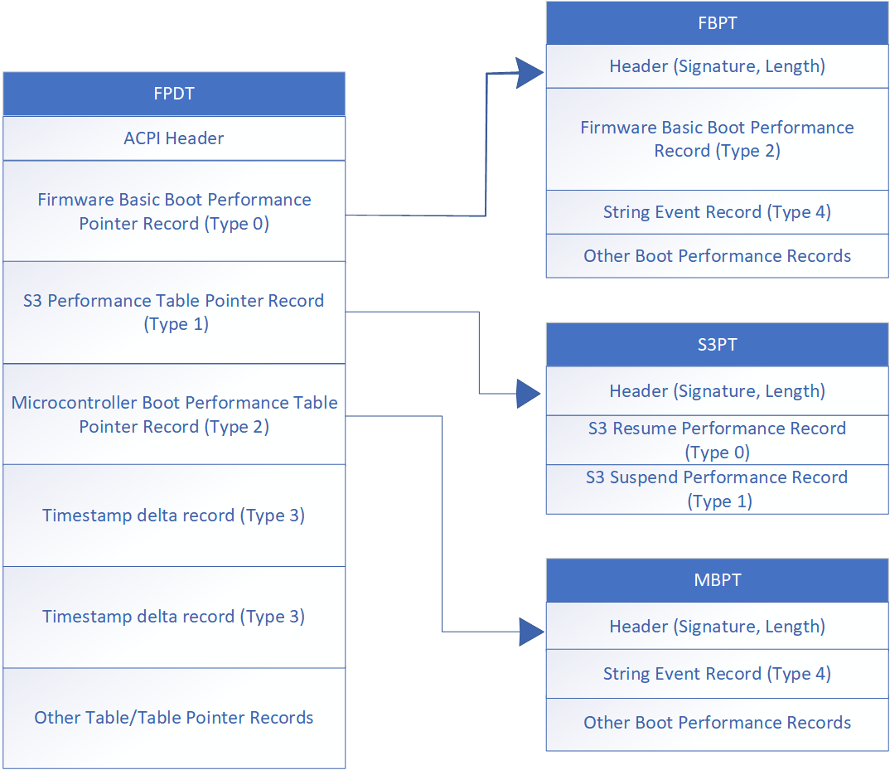

*Fig. 5.8 FPDT Hierarchy Structure*

| *Table 5.106****Firmware Performance Data Table (FPDT) Format*** | | | |
| --- | --- | --- | --- |
| **Field** | **Byte Length** | **Byte Offset** | **Description** |
| **Header** |  |  |  |
| - Signature | 4 | 0 | ‘FPDT’ Signature for the Firmware Performance Data Table. |
| - Length | 4 | 4 | The length of the table, in bytes, of the entire FPDT. |
| - Revision | 1 | 8 | The revision of the structure corresponding to the signature field for this table. For the Firmware Performance Data Table conforming to this revision of the specification, the revision is 1. |
| - Checksum | 1 | 9 | The entire table, including the checksum field, must add to zero to be considered valid. |
| - OEMID | 6 | 10 | An OEM-supplied string that identifies the OEM. |
| - OEM Table ID | 8 | 16 | An OEM-supplied string that the OEM uses to identify this particular data table. |
| - OEM Revision | 4 | 24 | An OEM-supplied revision number. |
| - Creator ID | 4 | 28 | The Vendor ID of the utility that created this table. |
| - Creator Revision | 4 | 32 | The revision of the utility that created this table. |
| Performance Records | – | 36 | A set of FPDT Performance Records, as defined in Table 5-112. [Section 5.2.26.4](https://uefi.org/specs/ACPI/6.5/05_ACPI_Software_Programming_Model.html#interleave-structure) |

**5.2.24.1. Performance Record Format**

A performance record is comprised of a sub-header including a record type and length, and a set of data. The format of the data is specific to the record type. In this manner, records are only as large as needed to contain the specific type of data to be conveyed.

Note that unless otherwise specified, multiple records are permitted for a given type, because some events may occur multiple times during the boot process.

| *Table 5.107****Performance Record Structure*** | | | |
| --- | --- | --- | --- |
| **Field** | **Byte Length** | **Byte Offset** | **Description** |
| Performance Record Type | 2 | 0 | This value depicts the format and contents of the performance record. |
| Record Length | 1 | 2 | This value depicts the length of the performance record, in bytes. |
| Revision | 1 | 3 | This value is updated if the format of the record type is extended. Any changes to a performance record layout must be backwards-compatible in that all previously defined fields must be maintained if still applicable, but newly defined fields allow the length of the performance record to be increased. Previously defined record fields must not be redefined, but are permitted to be deprecated. |
| Data | – | 4 | The content of this field is defined by the Performance Record Type definition. |

**5.2.24.2. FPDT Performance Record Types**

The table below describes the various records contained within the FPDT, and their corresponding Record Types.

| *Table 5.108****FPDT Performance Record Types*** | | |
| --- | --- | --- |
| **Record Type Value** | **Type** | **Description** |
| 0x0000 | Host Firmware ~~Basic~~ Boot Performance Pointer Record | Record containing a pointer to the Host Firmware ~~Basic~~ Boot Performance Table. |
| 0x0001 | S3 Performance Table Pointer Record | Record containing a pointer to the S3 Performance Table. |
| 0x0002 | Microcontroller Boot Performance Table Pointer Record | Record containing a pointer to the Microcontroller Boot Performance Table. |
| 0x0003 | Timestamp Delta Record | Table describing the time deltas between different controllers in the system (Table 5.119). The time delta of the Host, relative to the reference controller, is also represented in this table. |
| 0x000~~2~~4 - 0x0FFF | Reserved | Reserved for ACPI specification usage. |
| 0x1000 - 0x1FFF | Reserved | Reserved for Platform Vendor usage. |
| 0x2000 - 0x2FFF | Reserved | Reserved for Hardware Vendor usage. |
| 0x3000 - 0x3FFF | Reserved | Reserved for platform firmware Vendor usage. |
| 0x4000 - 0xFFFF | Reserved | Reserved for future use |

**5.2.24.3. Runtime Performance Record Types**

The table below describes the various Runtime Performance records and their corresponding Record Types. These records are not contained within the FPDT~~;~~, they are referenced by their respective pointer records in the FPDT.

| *Table 5.109****~~Runtime~~ Performance Event Record Types*** | | |
| --- | --- | --- |
| **Record Type Value** | **Type** | **Description** |
| 0x0000 | Basic S3 Resume Performance Record | Performance record describing minimal firmware performance metrics for S3 resume operations. |
| 0x0001 | Basic S3 Suspend Performance Record | Performance record describing minimal firmware performance metrics for S3 suspend operations. |
| 0x0002 | Host Firmware ~~Basic~~ Boot Performance Data Record | Performance record showing basic performance metrics for critical phases of the firmware boot process. |
| 0x0003 | Microcontroller Boot Performance Data Record | Performance record describing the boot process of a microcontroller (Table 5.117). |
| 0x0004 | String Event Record | Performance record used to represent generic Host firmware events (Table 5.120). |
| 0x000~~3~~5 - 0x0FFF | Reserved | Reserved for ACPI specification usage. |
| 0x1000 - 0x1FFF | Reserved | Reserved for Platform Vendor usage. |
| 0x2000 - 0x2FFF | Reserved | Reserved for Hardware Vendor usage. |
| 0x3000 - 0x3FFF | Reserved | Reserved for platform firmware Vendor usage. |
| 0x4000 - 0xFFFF | Reserved | Reserved for future use |

**5.2.24.4. Firmware Basic Boot Performance Table Pointer Record**

The Host Firmware ~~Basic~~ Boot Performance Table Pointer Record contains a pointer to the Firmware Basic Boot Performance Table. The Firmware Basic Boot Performance Table itself exists in a range of memory described as ACPI AddressRangeReserved in the system memory map. The record pointer is a required entry in the FPDT for any system, and the pointer must point to a valid static physical address. Only one of these records will be produced.

| *Table 5.110****Firmware Basic Boot Performance Table Pointer Record*** | | | |
| --- | --- | --- | --- |
| **Field** | **Byte Length** | **Byte Offset** | **Description** |
| Performance Record Type | 2 | 0 | 0 - Firmware Basic Boot Performance Table Pointer Record |
| Record Length | 1 | 2 | 16 - This value depicts the length of the performance record, in bytes. |
| Revision | 1 | 3 | 1 - Revision of this Performance Record |
| *Reserved* | 4 | 4 | Reserved |
| FBPT Pointer | 8 | 8 | 64-bit processor-relative physical address of the Firmware Basic Boot Performance Table |

**5.2.24.5. S3 Performance Table Pointer Record**

The S3 Performance Table Pointer Record contains a pointer to the S3 Performance Table. The S3 Performance Table itself exists in a range of memory described as ACPI AddressRangeReserved in the system memory map. The record pointer is a required entry in the FPDT for any system supporting the S3 state, and the pointer must point to a valid static physical address. Only one of these records will be produced.

| *Table 5.111****S3 Performance Table Pointer Record*** | | | |
| --- | --- | --- | --- |
| **Field** | **Byte Length** | **Byte Offset** | **Description** |
| Performance Record Type | 2 | 0 | 1 - S3 Performance Table Pointer Record |
| Record Length | 1 | 2 | 16 - This value depicts the length of the performance record, in bytes. |
| Revision | 1 | 3 | 1 - Revision of this Performance Record |
| *Reserved* | 4 | 4 | Reserved |
| S3PT Pointer | 8 | 8 | 64-bit processor-relative physical address of the S3 Performance Table |

**5.2.24.6. Microcontroller Boot Performance Table Pointer Record**

The Microcontroller Boot Performance Table Pointer contains a pointer to the Microcontroller Boot Performance Table. The Microcontroller Boot Performance Table itself exists in a range of memory described as ACPI AddressRangeReserved in the system memory map. The record pointer is a required entry in the FPDT for any system, and the pointer must point to a valid static physical address. Only one of these records will be produced.

| *Table 5.112****Microcontroller Boot Performance Table Pointer Record*** | | | |
| --- | --- | --- | --- |
| **Field** | **Byte Length** | **Byte Offset** | **Description** |
| Performance Record Type | 2 | 0 | 1 – Microcontroller Boot Performance Table Pointer Record |
| Record Length | 1 | 2 | 16 - This value depicts the length of the performance record, in bytes. |
| Revision | 1 | 3 | 1 - Revision of this Performance Record |
| *Reserved* | 4 | 4 | Reserved |
| MBPT Pointer | 8 | 8 | 64-bit processor-relative physical address of the Microcontroller Boot Performance Table |

**5.2.24.7. Timestamp Delta Record**

The Timestamp Delta Record is used to describe start time deltas between components logging Boot Performance Event Records, when such time deltas exist. Platforms containing multiple controllers with timestamp clock sources starting from zero at different points in time must publish this record to correlate events logged using disparate event timer sources.

| *Table 5.113****Timestamp Delta Record*** | | | |
| --- | --- | --- | --- |
| **Field** | **Byte Length** | **Byte Offset** | **Description** |
| Performance Record Type | 2 | 0 | 3 – Timestamp Delta Record |
| Record Length | 1 | 2 | The size in bytes of this table. |
| Revision | 1 | 3 | 1 |
| *Reserved* | 4 | 4 | Reserved |
| TimestampDomainID | 8 | 8 | Platform-specific identifier for each unique controller in the system on a separate timestamp domain. |
| Timestamp Delta | 8 | 16 | The delta between this timestamp domain and the first recorded timestamp domain |

**5.2.24.~~6~~8. Host Firmware ~~Basic~~ Boot Performance Table**

The Host Firmware ~~Basic~~ Boot Performance Table resides outside of the FPDT. It includes a header, defined in [Table 5.11](https://uefi.org/specs/ACPI/6.5/05_ACPI_Software_Programming_Model.html#firmware-basic-boot-performance-table-header)4, and one or more Performance Records.

All event entries will be overwritten during the platform runtime firmware S4 resume sequence. The Host Firmware ~~Basic~~ Boot Performance Table must include the Firmware Basic Boot Performance Data Record. Other entries are optional.

| *Table 5.11~~3~~4****Firmware Basic Boot Performance Table Header*** | | | |
| --- | --- | --- | --- |
| **Field** | **Byte Length** | **Byte Offset** | **Description** |
| Signature | 4 | 0 | ‘FBPT’ is the signature to use. |
| Length | 4 | 4 | Length of the Host Firmware ~~Basic~~ Boot Performance Table. This includes the header and allocated size of the subsequent records. This size would at minimum include the size of the header and the Firmware Basic Boot Performance Data Record. |

**5.2.24.~~7~~9. Host Firmware ~~Basic~~ Boot Performance Data Record**

The Host Firmware ~~Basic~~ Boot Performance Data Record contains timer information associated with final OS loader activity, as well as data associated with boot time starting and ending information.

| *Table 5.11~~3~~5****Host******Firmware ~~Basic~~ Boot Performance Data Record*** | | | |
| --- | --- | --- | --- |
| **Field** | **Byte Length** | **Byte Offset** | **Description** |
| Performance Record Type | 2 | 0 | 2 – Host Firmware ~~Basic~~ Boot Performance Data Record. Only one of these records will be produced. |
| Record Length | 1 | 2 | 48 - This value depicts the length of the performance record, in bytes. |
| Revision | 1 | 3 | 2 - Revision of this Performance Record |
| *Reserved* | 4 | 4 | Reserved |
| CPU Reset End | 8 | 8 | Timer value logged at the beginning of firmware image execution. This may not always be zero or near zero. |
| OS Loader LoadImage Start | 8 | 16 | Timer value logged just prior to loading the OS boot loader into memory. For non-UEFI compatible boots, this field must be zero. |
| OS Loader StartImage Start | 8 | 24 | Timer value logged just prior to launching the currently loaded OS boot loader image. For non-UEFI compatible boots, the timer value logged will be just prior to the INT 19h handler invocation. |
| ExitBootServices Entry | 8 | 32 | Timer value logged at the point when the OS loader calls the ExitBootServices function for UEFI compatible firmware. For non-UEFI compatible boots, this field must be zero. |
| ExitBootServices Exit | 8 | 40 | Timer value logged at the point just prior to the OS loader gaining control back from the ExitBootServices function for UEFI compatible firmware. For non-UEFI compatible boots, this field must be zero. |

**5.2.24.10. Microcontroller Boot Performance Table (MBPT)**

The Microcontroller Boot Performance Table resides outside of the FPDT, in a memory location pointer to by the Microcontroller Boot Performance Table Pointer Record. It includes a header, defined in Table 5.116 , and one or more performance records.

| *Table 5.116****Microcontroller Boot Performance Table Header*** | | | |
| --- | --- | --- | --- |
| **Field** | **Byte Length** | **Byte Offset** | **Description** |
| Signature | 4 | 0 | ‘MBPT’ is the signature to use. |
| Length | 4 | 4 | Length of the Microcontroller Boot Performance Table. This includes the header and allocated size of the subsequent records. This size would at minimum include the size of the header. |
| ControllerID | 8 | 8 | Name string or numeric ID for the Microcontroller |
| TimestampDomainID | 8 | 16 | Platform-specific identifier for each unique controller in the system on a separate timestamp domain. |

**5.2.24.11. String Event Record**

The GUID Event Record and String Event Record are generic performance records used by Host Firmware or Microcontrollers to log boot progress events. Each entry is identified by its GUID or string and is responsible for its own list of Progress Identifiers. Other Performance Records can be interspersed within these records, notably when logging other events occurring in chronological order.

| *Table 5.117****String Event Record*** | | | |
| --- | --- | --- | --- |
| **Field** | **Byte Length** | **Byte Offset** | **Description** |
| Performance Record Type | 2 | 0 | 4 – String Event Record. Multiple records of this type can exits. |
| Record Length | 1 | 2 | 60 |
| Revision | 1 | 3 | 1 – Revision of this Performance Record |
| ControllerID | 8 | 4 | Name string or numeric ID of the controller |
| TimestampDomainID | 8 | 12 | The timestamp domain ID, matching table 5.113 |
| Timestamp | 8 | 20 | Timestamp record of the event |
| GUID | 16 | 28 | GUID of the module logging the event |
| NameString | 24 | 44 | ASCII string describing this event. Padding supplied at the end if necessary, with null characters (0x00). |