

Library Instruction manual

Author(s): Sui Qiang
Date: 03/12/2026
Version: V1.0

- 将下载的文件路径添加到matlab路径下
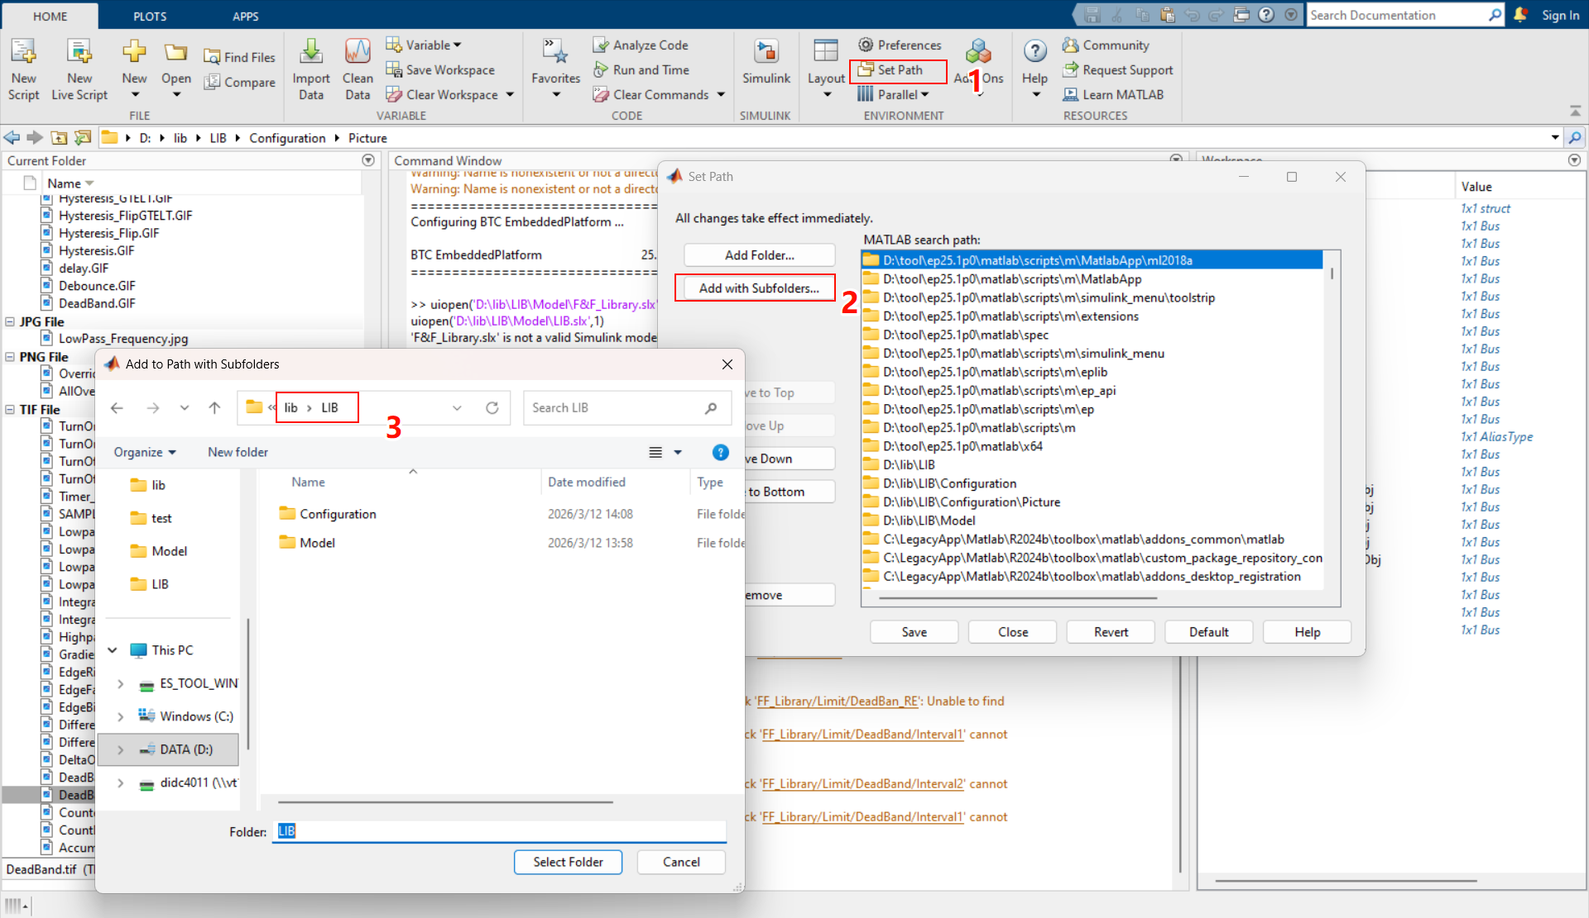
2.在Matlab中运行脚本slblocks
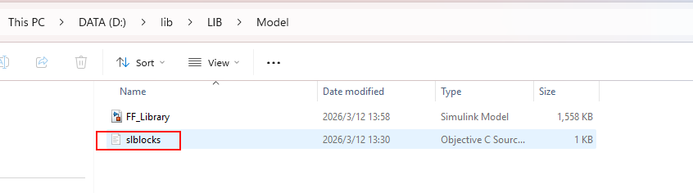
3.打开模型后刷新Library Browser后出现FF_Block
