####################################################

环境的准备
- 关闭虚拟机的SELinux
[root@server ~]# setenforce 0 #修改当前运行模式
[root@server ~]# getenforce #查看当前运行模式
Permissive
[root@server ~]# vim /etc/selinux/config #永久修改
SELINUX=permissive
- 设置虚拟机防火墙
[root@server ~]# yum -y remove firewalld
[root@server ~]# rpm -q firewalld

构建基本的DNS服务器
虚拟机A：负责解析lol.com
[root@server ~]# yum -y install bind bind-chroot
[root@server ~]# cp -p /etc/named.conf /root
[root@server ~]# vim /etc/named.conf
options {
directory "/var/named";
};
zone "lol.com" IN { #声明负责的域名
type master; #声明本机为权威主DNS服务器
file "lol.com.zone"; #指明地址库文件名称
};
]# cd /var/named
]# cp -p named.localhost lol.com.zone
]# ls -l lol.com.zone
]# vim lol.com.zone
此处省略一万字………
NS server
server A 192.168.88.240
www A 1.2.3.4
]# systemctl restart named

虚拟机B：测试
]# echo nameserver 192.168.88.240 > /etc/resolv.conf
]# cat /etc/resolv.conf
]# nslookup www.lol.com

分离解析
- 当收到客户机的DNS查询请求的时候
能够区分客户机的来源地址
为不同类别的客户机，提供不同的解析结果（IP地址）
为客户端提供最近的服务器

牛老师(北京南站)-达外酒店-》高德地图---》北京南站大街88号
- 赵老师(首都机场)-达外酒店-》高德地图---》机场大街98号
客户端(IP地址)-FQDN-》DNS服务器---》解析结果

- 分离解析配置
  - 客户端必须找到自己的类型
  - 由上到下依次匹配，匹配立即停止
  - 所有的zone都必须在view内
view "haha" {
match-clients { 192.168.88.2; 192.168.8.0/24; };
zone "12306.cn" IN {
…… 地址库1;
}; };
view "xixi" {
match-clients { any; };
zone "12306.cn" IN {
…… 地址库2;
}; };

- 环境及需求
权威DNS：server.tedu.cn 192.168.88.240
负责区域：lol.com
A记录分离解析 —— 以 www.lol.com为例
192.168.88.2或者192.168.7.0/24----->192.168.4.100
any----->1.2.3.4

虚拟机A：
[root@server /]# vim /etc/named.conf
options {
directory "/var/named";
};
view "haha" {
match-clients { 192.168.88.2; 192.168.7.0/24; };
zone "lol.com" IN {
type master;
file "lol.com.zone";
};
};
view "xixi" {
match-clients { any; };
zone "lol.com" IN {
type master;
file "lol.com.other";
};
};

]# cd /var/named/
]# vim lol.com.zone
此处省略一万字……..
NS server
server A 192.168.88.240
www A 192.168.4.100
]# cp -p lol.com.zone lol.com.other
]# vim lol.com.other
此处省略一万字……..
NS server
server A 192.168.88.240
www A 1.2.3.4
[root@server named]# systemctl restart named

四、多域名分离解析环境及需求
客户端必须找到自己的类别
由上到下依次匹配，匹配及停止
所有的zone都必须在view内
每一个view中，zone个数要一致
每一个view中，zone负责的域名要一致

例子：
- view "haha" {
- match-clients { 192.168.88.2; 192.168.7.0/24; };
- zone "lol.com" IN {
- type master;
- file "lol.com.zone";
- };
- zone "qq.com" IN {
- type master;
- file "qq.com.zone";
- };
- };
- view "xixi" {
- match-clients { any; };
- zone "lol.com" IN {
- type master;
- file "lol.com.other";
- };
- zone "qq.com" IN {
- type master;
- file "qq.com.other";
- };
- };

权威DNS：server.tedu.cn 192.168.88.240
负责区域：lol.com qq.com
A记录分离解析 —— 以 www.lol.com www.qq.com为例
192.168.88.2 -- www.lol.com --->192.168.4.100
any--- www.lol.com -->1.2.3.4

192.168.88.2--www.qq.com--->192.168.4.200
any-- www.qq.com --->10.20.30.40

虚拟机A：
[root@server named]# vim /etc/named.conf
options {
directory "/var/named";
};
view "haha" {
match-clients { 192.168.88.2; 192.168.7.0/24; };
zone "lol.com" IN {
type master;
file "lol.com.zone";
};
zone "qq.com" IN {
type master;
file "qq.com.zone";
};
};
view "xixi" {
match-clients { any; };
zone "lol.com" IN {
type master;
file "lol.com.other";
};
zone "qq.com" IN {
type master;
file "qq.com.other";
};
};

2.建立地址库文件
]# cd /var/named/
]# cp -p named.localhost qq.com.zone
]# vim qq.com.zone
此处省略一万字……..
NS server
server A 192.168.88.240
www A 192.168.4.200
]# cp -p qq.com.zone qq.com.other
]# vim qq.com.other
此处省略一万字……..
NS server
server A 192.168.88.240
www A 10.20.30.40
[root@server named]# systemctl restart named

- 针对来源地址定义acl列表(了解内容)
若地址比较少，也可以不建立列表

options {
directory "/var/named";
};
acl "test" { 192.168.88.2; 192.168.7.0/24; };
view "nsd" {
match-clients { test; };
zone "lol.com" IN {
此处省略一万字……..

五、多类别分离解析
- 注意事项
客户端必须找到自己的类型
由上到下依次匹配，匹配及停止
所有的zone都必须在view
每一个view中，zone个数要一致
每一个view中，zone负责的域名要一致

- 案例：
权威DNS：server.tedu.cn 192.168.88.240
负责区域：lol.com qq.com
A记录分离解析 —— 以 www.lol.com www.qq.com为例

192.168.88.2 -- www.lol.com --->192.168.4.100
any--- www.lol.com -->1.2.3.4

192.168.88.2--www.qq.com--->192.168.4.200
192.168.88.3--www.qq.com--->192.168.4.10
any-- www.qq.com --->10.20.30.40

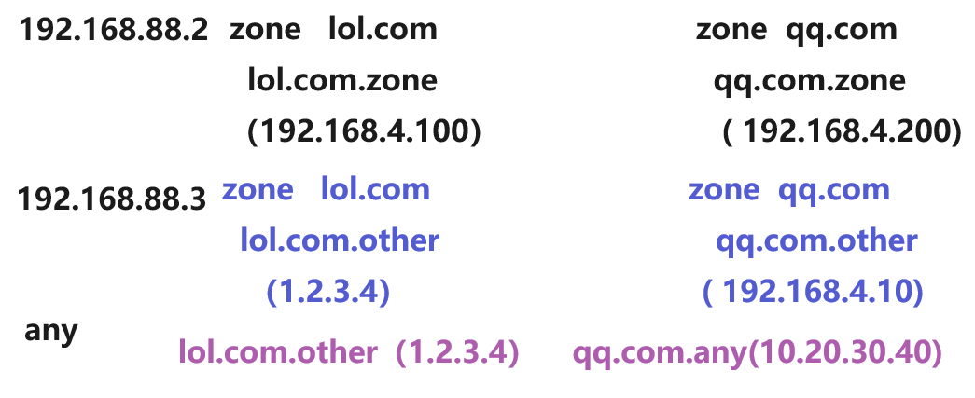

虚拟机A：
]# vim /etc/named.conf
options {
directory "/var/named";
};
view "haha" {
match-clients { 192.168.88.2; };
zone "lol.com" IN {
type master;
file "lol.com.zone";
};
zone "qq.com" IN {
type master;
file "qq.com.zone";
};
};
view "xixi" {
match-clients { 192.168.88.3; };
zone "lol.com" IN {
type master;
file "lol.com.other";
};
zone "qq.com" IN {
type master;
file "qq.com.other";
};
};
view "hehe" {
match-clients { any; };
zone "lol.com" IN {
type master;
file "lol.com.other";
};
zone "qq.com" IN {
type master;
file "qq.com.any";
};
};
[root@server /]# cd /var/named/
[root@server named]# vim qq.com.other
............
- NS server
- server A 192.168.88.240
- www A 192.168.4.10
[root@server named]# cp -p qq.com.other qq.com.any
[root@server named]# vim qq.com.any
- ............
NS server
server A 192.168.88.240
www A 10.20.30.40
[root@server named]# systemctl restart named

虚拟机C：指定DNS服务器
[root@pc3 ~]# echo nameserver 192.168.88.240 > /etc/resolv.conf

[root@pc3 ~]# nslookup www.lol.com
- [root@pc3 ~]# nslookup www.qq.com

- 案例：
权威DNS：server.tedu.cn 192.168.88.240
负责区域：lol.com qq.com dnf.com
- 192.168.88.2 -- www.lol.com --->192.168.4.100
- any--- www.lol.com -->1.2.3.4

- 192.168.88.2--www.qq.com--->192.168.4.200
- 192.168.88.3--www.qq.com--->192.168.4.10
- any-- www.qq.com --->10.20.30.40

- 192.168.88.3--www.dnf.com--->192.168.4.123
- any-- www.dnf.com --->6.7.8.9

- 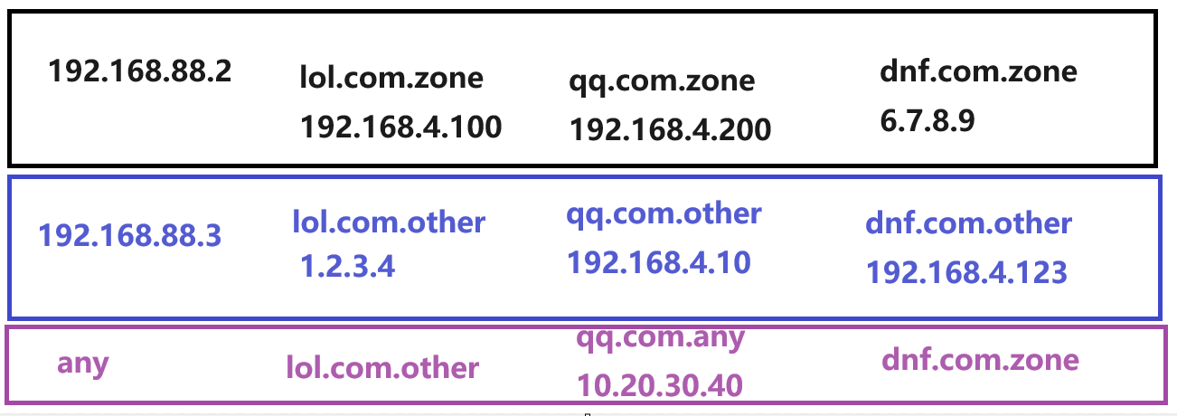
- 虚拟机A：
- ]# vim /etc/named.conf
- options {
- directory "/var/named";
- };
- view "haha" {
- match-clients { 192.168.88.2; };
- zone "lol.com" IN {
- type master;
- file "lol.com.zone";
- };
- zone "qq.com" IN {
- type master;
- file "qq.com.zone";
- };
- zone "dnf.com" IN {
- type master;
- file "dnf.com.zone";
- };
- };
- view "xixi" {
- match-clients { 192.168.88.3; };
- zone "lol.com" IN {
- type master;
- file "lol.com.other";
- };
- zone "qq.com" IN {
- type master;
- file "qq.com.other";
- };
- zone "dnf.com" IN {
- type master;
- file "dnf.com.other";
- };
- };
- view "hehe" {
- match-clients { any; };
- zone "lol.com" IN {
- type master;
- file "lol.com.other";
- };
- zone "qq.com" IN {
- type master;
- file "qq.com.any";
- };
- zone "dnf.com" IN {
- type master;
- file "dnf.com.zone";
- };
- };
- [root@server /]# cd /var/named/
- [root@server named]# cp -p qq.com.other dnf.com.zone
- [root@server named]# vim dnf.com.zone
- ............
- NS server
- server A 192.168.88.240
- www A 6.7.8.9
- [root@server named]# cp -p dnf.com.zone dnf.com.other
- [root@server named]# vim dnf.com.other
- ............
- NS server
- server A 192.168.88.240
- www A 192.168.4.123
- [root@server named]# systemctl restart named

- 案例：
权威DNS：server.tedu.cn 192.168.88.240
负责区域：lol.com qq.com
- 192.168.88.240 -- www.lol.com --->192.168.4.100
- any--- www.lol.com -->1.2.3.4

- 192.168.88.2--www.qq.com--->192.168.4.10
- any-- www.qq.com --->10.20.30.40

- 192.168.88.3--www.dnf.com--->192.168.4.123
- any-- www.dnf.com --->6.7.8.9
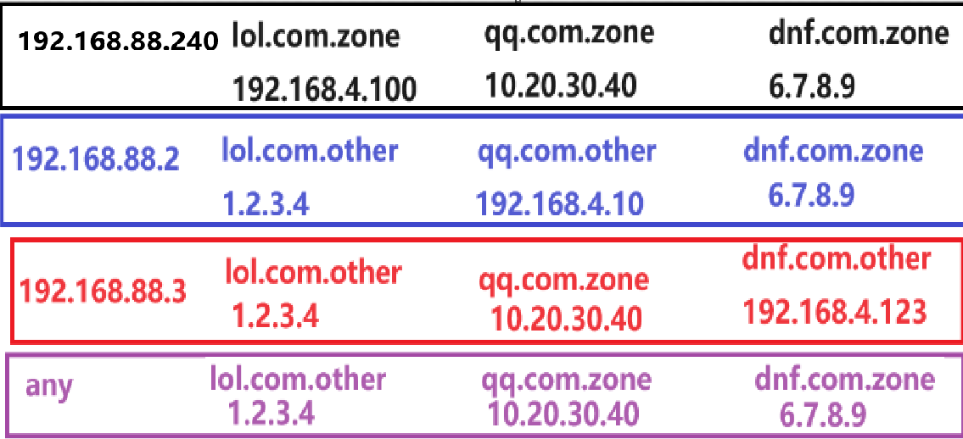
- 虚拟机A：
- ]# vim /etc/named.conf
- options {
- directory "/var/named";
- };
- view "haha" {
- match-clients { 192.168.88.240; };
- zone "lol.com" IN {
- type master;
- file "lol.com.zone";
- };
- zone "qq.com" IN {
- type master;
- file "qq.com.zone";
- };
- zone "dnf.com" IN {
- type master;
- file "dnf.com.zone";
- };
- };
- view "xixi" {
- match-clients { 192.168.88.2; };
- zone "lol.com" IN {
- type master;
- file "lol.com.other";
- };
- zone "qq.com" IN {
- type master;
- file "qq.com.other";
- };
- zone "dnf.com" IN {
- type master;
- file "dnf.com.zone";
- };
- };
- view "hehe" {
- match-clients { 192.168.88.3; };
- zone "lol.com" IN {
- type master;
- file "lol.com.other";
- };
- zone "qq.com" IN {
- type master;
- file "qq.com.zone";
- };
- zone "dnf.com" IN {
- type master;
- file "dnf.com.other";
- };
- };
- view "lele" {
- match-clients { any; };
- zone "lol.com" IN {
- type master;
- file "lol.com.other";
- };
- zone "qq.com" IN {
- type master;
- file "qq.com.zone";
- };
- zone "dnf.com" IN {
- type master;
- file "dnf.com.zone";
- };
- };
- [root@server /]# cd /var/named/
- [root@server named]# vim qq.com.zone
- ............
- NS server
- server A 192.168.88.240
- www A 10.20.30.40
- [root@server named]# systemctl restart named

