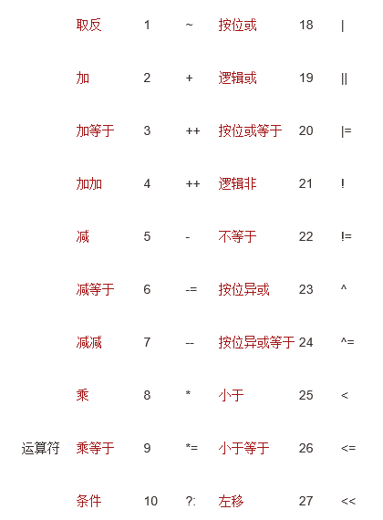

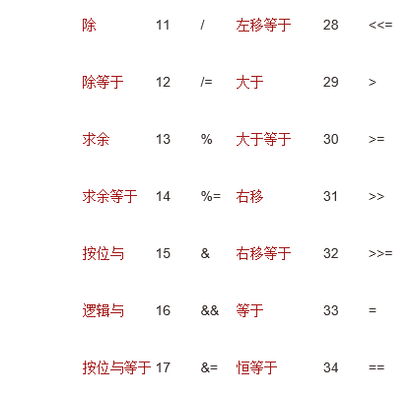

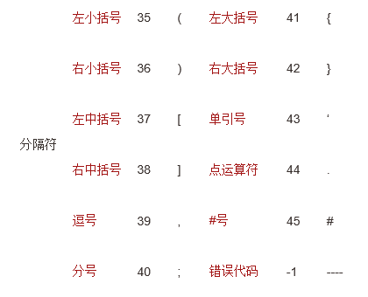

双引号“ 46 注释 //48

常数： 整型 48

实型 49

关键字：

|  |  |  |  |  |  |  |  |  |  |
| --- | --- | --- | --- | --- | --- | --- | --- | --- | --- |
| [abstract](http://baike.baidu.com/item/abstract) | 50 | [assert](http://baike.baidu.com/item/assert) | 51 | [boolean](http://baike.baidu.com/item/boolean) | 52 | break | 53 | [byte](http://baike.baidu.com/item/byte) | 54 |
| case | 55 | [catch](http://baike.baidu.com/item/catch) | 56 | [char](http://baike.baidu.com/item/char) | 57 | [class](http://baike.baidu.com/item/class) | 58 | const | 59 |
| continue | 60 | [default](http://baike.baidu.com/item/default) | 61 | [do](http://baike.baidu.com/item/do) | 62 | [double](http://baike.baidu.com/item/double) | 63 | [else](http://baike.baidu.com/item/else) | 64 |
| [enum](http://baike.baidu.com/item/enum) | 65 | [extends](http://baike.baidu.com/item/extends) | 66 | [final](http://baike.baidu.com/item/final) | 67 | [finally](http://baike.baidu.com/item/finally) | 68 | float | 69 |
| [for](http://baike.baidu.com/item/for) | 70 | goto | 71 | [if](http://baike.baidu.com/item/if) | 72 | [implements](http://baike.baidu.com/item/implements) | 73 | [import](http://baike.baidu.com/item/import) | 74 |
| [instanceof](http://baike.baidu.com/item/instanceof) | 75 | [int](http://baike.baidu.com/item/int) | 76 | [interface](http://baike.baidu.com/item/interface) | 77 | long | 78 | native | 79 |
| new | 80 | [package](http://baike.baidu.com/item/package) | 81 | [private](http://baike.baidu.com/item/private) | 82 | [protected](http://baike.baidu.com/item/protected) | 83 | [public](http://baike.baidu.com/item/public) | 84 |
| [return](http://baike.baidu.com/item/return) | 85 | [strictfp](http://baike.baidu.com/item/strictfp) | 86 | [short](http://baike.baidu.com/item/short) | 87 | [static](http://baike.baidu.com/item/static) | 88 | [super](http://baike.baidu.com/item/super) | 89 |
| [switch](http://baike.baidu.com/item/switch) | 90 | [synchronized](http://baike.baidu.com/item/synchronized) | 91 | [this](http://baike.baidu.com/item/this) | 92 | [throw](http://baike.baidu.com/item/throw) | 93 | [throws](http://baike.baidu.com/item/throws) | 94 |
| [transient](http://baike.baidu.com/item/transient) | 95 | try | 96 | [void](http://baike.baidu.com/item/void) | 97 | [volatile](http://baike.baidu.com/item/volatile) | 98 | [while](http://baike.baidu.com/item/while) | 99 |

标识符：100