[ct]Answers to End of Section and Review Exercises for Chapter 10

[1]Exercises 10.1
1. The leaf nodes are 5, 6, 7, and 8.
2. The interior nodes are 2, 3, and 4.
3. Node 7 has one sibling, node 8.
4. The height of the tree is 2.
5. There are 4 nodes in level 2.
6. This is both a general tree and a binary tree.

[1]Exercises 10.2
1. In a perfectly balanced tree, each level is filled with nodes except for the last one. A complete binary tree is a perfectly balance binary tree in which the nodes in the last level are filled in from left to right.
2. The nodes in the last level of a complete binary tree are filled in from left to right, but the last level might not be completely filled. The last level in a full binary tree is completely filled.
3. A full binary tree of height 5 contains 255 nodes.
4. A compete binary tree with 125 nodes has a height of 4.
5. There are 2^{L} nodes in level L of a full binary tree.

[1]Exercises 10.3
1. The heap property for a min heap states that each node below a given node is greater than or equal to that node. Thus, the minimum value is at the root.
2. The items in a binary search tree are constrained so that each item in the left subtree of a given node is less than the item in that node, whereas each item in the right subtree is greater than or equal to the item in that node.
3. Infix: 3 * 5 + 4. Prefix: + * 3 5 4. Postfix: 3 5 * 4 +.
4. Expression trees for parts a, b, and c:

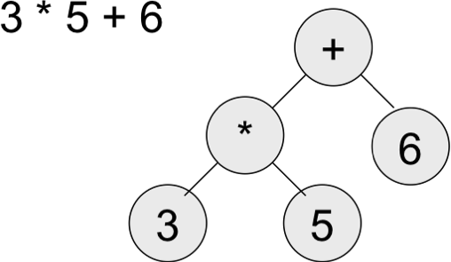
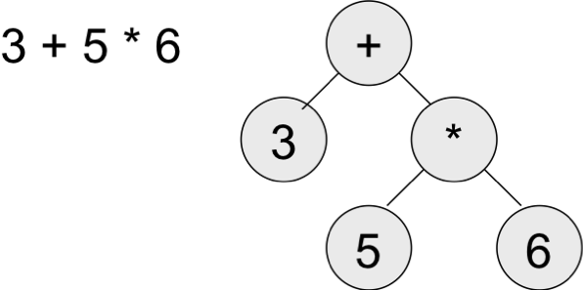
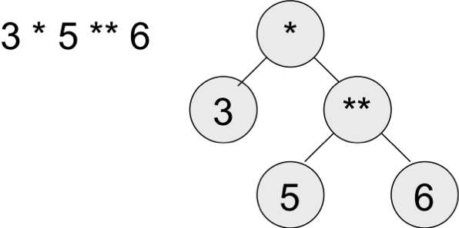

[1]Exercises 10.4
1. When items arrive for insertion into search tree in close to ascending or descending order, the shape of the tree becomes stretched out either to the left or to the right. As the tree’s shape becomes less bushy, subsequent searches and insertions begin to take close to linear time.
2. An array-based sorted bag supports worst-case logarithmic searches, whereas a binary search tree –based sorted bag supports worst-case linear searches. An array-based sorted bag supports average-case linear insertions and removals, whereas a binary search tree-based sorted bag supports worst-case linear insertions and removals.

[1]Exercises 10.5
1. The parent of the node at index 12 is at index 5. The node’s left child is at index 25 and its right child is at index 26.
2. An array-based binary tree is also a complete binary tree. It must be, so that parents and children can be located by dividing or multiplying a given node’s index by 2.

[1]Exercises 10.6
1. The insertion and removal operations for heaps are both logarithmic in the worst case, whereas these operations are linear in the worst case for binary search trees.
2. Lists always have an advantage over arrays when the number of items to be inserted cannot be known ahead of time. In that case, a list automatically grows during insertions, whereas the programmer must write complex code to build a larger array.
3. The heap sort performs n insertions into a heap and n removals from a heap to accomplish the sort. Each insertion and removal is worst-case O(log n). Thus, the running time of heap sort is O(n log n).

[1]Answers to Review Questions
1. b
2. b
3. b
4. a
5. b
6. b
7. a
8. c
9. b
10. b

