[ct]Answers to End of Section and Review Exercises for Chapter 12

[1]Exercises 12.1
1. Here is the graph.

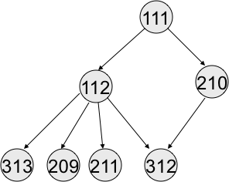

2. 10.
3. Point to point configuration supports linear-time insertions and removals, whereas star supports constant-time insertions and removals.

[1]Exercises 12.2
1. Here is the matrix.

 | 0 | 1 | 2 | 3 | 4
0 | 0 | 1 | 2 | 0 | 0
1 | 0 | 0 | 0 | 2 | 0
2 | 0 | 0 | 0 | 1 | 3
3 | 0 | 0 | 0 | 0 | 2
4 | 0 | 0 | 0 | 0 | 0

2. Here is the list.

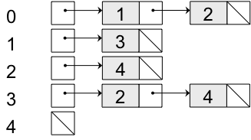

3. The adjacency matrix supports constant-time searches for an edge between two vertices, whereas the adjacency list supports linear-time (with its edges) searches for an edge. The adjacency list supports linear-time (with its edges) return of neighboring vertices, whereas the adjacency matrix supports linear-time (with all of the vertices in the graph) return of neighboring vertices.

[1]Exercises 12.3
1. A D E B C.
2. A D B E C.
3. A breadth-first traversal of a graph visits all the immediate neighbors of the start vertex. The traversal then visits all the immediate neighbors of these vertices, and so on, until all of the vertices reachable from the start vertex have been visited.

[1]Exercises 12.4
The algorithm to build and return the shortest path between two vertices first runs the single-source shortest path algorithm with the source vertex. The algorithm then gathers the ancestors of the destination vertex from the grid by adding that vertex’s immediate parent to a list, then that parent’s parent, and so on, until the source vertex is reached. The contents of the list are then reversed to obtain the desired path.

[1]Answers to Review Questions
1. b
2. b
3. b
4. a
5. b
6. a
7. b
8. c
9. b
10. a

