# Project 2 Orderbook analysis

Jiao Li, Luyi Yin, Qian Gao, Rong Xia, Tianshu Bao, Wei Guan, Zhen Zeng

* Names are listed by alphabetical order, these authors contributed equally to this work.

## data files

* message file:

file name: TICKER_Year-Month-Day_StartTime_EndTime_message_LEVEL.csv

columns: Time,Type,Order ID,Size,Price,Direction

* orderbook file:

file name: TICKER_Year-Month-Day_StartTime_EndTime_orderbook_LEVEL.csv

columns: 10 levels of Ask/Bid Price and Szie

## Data preprocessing

### time

Looking into the time field, we noticed below information,

34200.004241176 seconds = 570 minutes; 9 hours 30 minutes; 9:30 am

57599.913117637 seconds = 960 minutes; 16 hours 4:00 pm

So the message file timestamp ranges from 9:30am to 4:00pm

To make it straightforward, we converted it to range from 0 to 23400 seconds, by subtracting 34200 seconds from the time field

df_msg[**'Time'**] = df_msg[**'Time'**] - 34200.

### price

Original price in data file is multplied by 10000. We divided it by 10000 to make it consistent with real price.

df_msg[**'Price'**] = df_msg[**'Price'**] / 10000.

### message and order alignment

We noticed the message file and orderbook file have exactly the same number of lines. So we assume message file lines to orderbook file lines are one to one mapping. e.g orderbook reflect the 10 levels information at the corresponding time point of message file.

So message and order are already aligned, we simply horizontally concatename the 2 files.

df = pd.concat([df_msg, df_orderbook], axis=1)

### use HD5 to improve performance

We store preprocessed data as HD5 format. This can significantly improve read performance during our data loading.

## Data analysis

### Analysis of order type distribution

* All order types

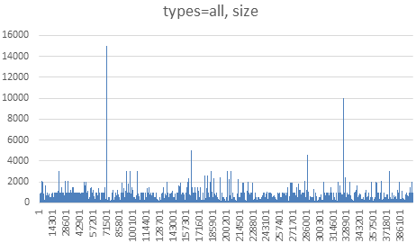

* New limit order

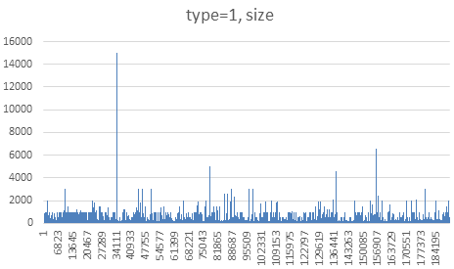

* partial deletion of a limit order

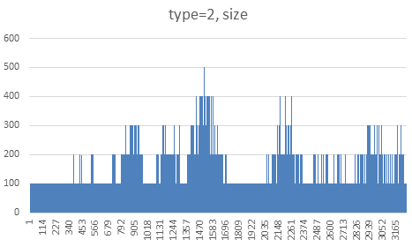

* Total deletion of a limit order

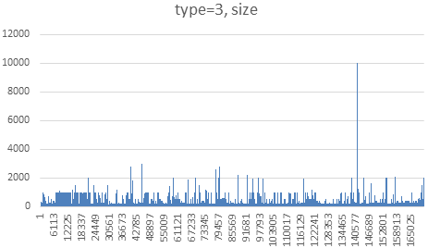

* Execution of visible limit order

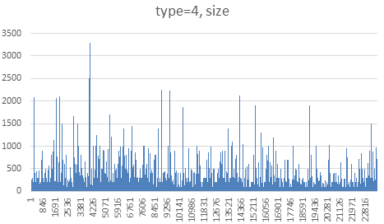

* Execution of hidden limit order

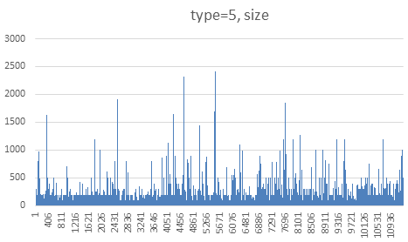

From above charts, we can see different types have different distributions, which we think it's possible to construct variables from. But to simplify our analysis, we haven't differentiate by types in regression.

### Variables

We researched by reading some papers and though of some by intuition. Below are some of the variables we created.

Ask_VWAP : average of Ask Price at level i * Size at level i

Bid_VWAP : average of Bid Price at level i * Size at level i

Mid_Price_STD_10 : standard deviation of 10 seconds mid price

Mid_Price_STD_50 : standard deviation of 50 seconds mid price

Spread : Ask price 1 – Bid price 1

Spread_STD_50 : Spread standard deviation of 50 seconds

Return_Pct : (current mid Price - previous second mid Price ) / previous mid price

Return_STD_5 : standard deviation of return of 5 seconds

Return_STD_10 : standard deviation of return of 10 seconds

Return_STD_50 : standard deviation of return of 50 seconds

Slope : difference between mean of level 1 to 5 and mean of level 6 to 10

Curve : difference between mean of level 4 to 7 and mean of level 1->3, 6->10

Average spread: average spread of all levels

Y: (next second mid price – current second mid price)/current second mid price

### Model

We used python statsmodels API, which is a full-featured python statisical package. From this package, we choosed to use OLS, because it provided implementations for R-squared, t, P etc.

model = sm.OLS(y, X_df, missing=**'drop'**).fit()

OLS Regression Results

================================================================================

Dep. Variable: Mid_Price_Change_Pct R-squared: 0.025

Model: OLS Adj. R-squared: 0.022

Method: Least Squares F-statistic: 8.183

Date: Sun, 01 Jul 2018 Prob (F-statistic): 4.19e-83

Time: 23:30:11 Log-Likelihood: 1.9404e+05

No. Observations: 23349 AIC: -3.879e+05

Df Residuals: 23275 BIC: -3.873e+05

Df Model: 74

Covariance Type: nonrobust

=======================================================================================

coef std err t P>|t| [0.025 0.975]

---------------------------------------------------------------------------------------

Orig_Idx 4.087e-11 5.57e-11 0.734 0.463 -6.83e-11 1.5e-10

Time_Interval_End -1.093e-07 7.47e-07 -0.146 0.884 -1.57e-06 1.35e-06

Time 1.09e-07 7.47e-07 0.146 0.884 -1.36e-06 1.57e-06

Mid_Price -9.15e-05 8.88e-06 -10.302 0.000 -0.000 -7.41e-05

Ask_Price_1 -8.38e-05 1.09e-05 -7.695 0.000 -0.000 -6.25e-05

Ask_Size_1 -5.59e-10 1.2e-09 -0.467 0.641 -2.91e-09 1.79e-09

Bid_Price_1 -9.92e-05 9.47e-06 -10.479 0.000 -0.000 -8.06e-05

Bid_Size_1 2.947e-10 1.38e-09 0.214 0.831 -2.41e-09 3e-09

Ask_Price_2 7.09e-05 3.13e-05 2.262 0.024 9.46e-06 0.000

Ask_Size_2 1.321e-09 1.37e-09 0.962 0.336 -1.37e-09 4.01e-09

Bid_Price_2 0.0001 2.5e-05 5.177 0.000 8.05e-05 0.000

Bid_Size_2 -2.675e-10 1.01e-09 -0.265 0.791 -2.24e-09 1.71e-09

Ask_Price_3 5.836e-05 3.45e-05 1.690 0.091 -9.33e-06 0.000

Ask_Size_3 1.431e-09 1.12e-09 1.281 0.200 -7.58e-10 3.62e-09

Bid_Price_3 -3.879e-05 2.86e-05 -1.356 0.175 -9.49e-05 1.73e-05

Bid_Size_3 -1.525e-10 9.19e-10 -0.166 0.868 -1.95e-09 1.65e-09

Ask_Price_4 -7.155e-05 3.78e-05 -1.895 0.058 -0.000 2.45e-06

Ask_Size_4 -1.477e-09 1.02e-09 -1.441 0.150 -3.49e-09 5.32e-10

Bid_Price_4 6.141e-05 3.06e-05 2.008 0.045 1.46e-06 0.000

Bid_Size_4 6.176e-10 1.01e-09 0.614 0.539 -1.36e-09 2.59e-09

Ask_Price_5 2.715e-05 3.89e-05 0.697 0.486 -4.92e-05 0.000

Ask_Size_5 9.731e-10 1.42e-09 0.683 0.495 -1.82e-09 3.77e-09

Bid_Price_5 -0.0002 3.37e-05 -4.559 0.000 -0.000 -8.76e-05

Bid_Size_5 -2.28e-09 1.07e-09 -2.128 0.033 -4.38e-09 -1.8e-10

Ask_Price_6 8.325e-05 3.97e-05 2.097 0.036 5.42e-06 0.000

Ask_Size_6 -8.247e-10 1.44e-09 -0.572 0.567 -3.65e-09 2e-09

Bid_Price_6 -6.835e-06 3.62e-05 -0.189 0.850 -7.78e-05 6.41e-05

Bid_Size_6 -1.52e-09 8.94e-10 -1.700 0.089 -3.27e-09 2.33e-10

Ask_Price_7 1.782e-05 3.99e-05 0.447 0.655 -6.04e-05 9.6e-05

Ask_Size_7 2.755e-09 1.3e-09 2.127 0.033 2.17e-10 5.29e-09

Bid_Price_7 0.0001 3.82e-05 2.844 0.004 3.38e-05 0.000

Bid_Size_7 2.486e-09 9.8e-10 2.537 0.011 5.66e-10 4.41e-09

Ask_Price_8 -7.463e-05 4.26e-05 -1.752 0.080 -0.000 8.89e-06

Ask_Size_8 -8.051e-10 1.58e-09 -0.511 0.609 -3.89e-09 2.28e-09

Bid_Price_8 2.016e-05 3.96e-05 0.510 0.610 -5.74e-05 9.77e-05

Bid_Size_8 -8.544e-10 8.52e-10 -1.003 0.316 -2.52e-09 8.15e-10

Ask_Price_9 -2.067e-05 4.31e-05 -0.480 0.631 -0.000 6.37e-05

Ask_Size_9 -2.079e-09 1.58e-09 -1.314 0.189 -5.18e-09 1.02e-09

Bid_Price_9 -2.986e-05 4.13e-05 -0.723 0.470 -0.000 5.11e-05

Bid_Size_9 3.677e-11 8.3e-10 0.044 0.965 -1.59e-09 1.66e-09

Ask_Price_10 4.176e-05 2.83e-05 1.473 0.141 -1.38e-05 9.73e-05

Ask_Size_10 -7.841e-10 1.38e-09 -0.567 0.571 -3.5e-09 1.93e-09

Bid_Price_10 5.995e-06 1.84e-05 0.325 0.745 -3.01e-05 4.21e-05

Bid_Size_10 -7.968e-10 9.8e-10 -0.813 0.416 -2.72e-09 1.12e-09

---------------------------------------------------------------------------------------

Ask_Size_Mean -1.585e-12 3.9e-10 -0.004 0.997 -7.65e-10 7.62e-10

Bid_Size_Mean -2.243e-10 2.88e-10 -0.780 0.436 -7.88e-10 3.39e-10

Ask_Slope 5.533e-10 8.13e-10 0.681 0.496 -1.04e-09 2.15e-09

Bid_Slope -2.373e-10 6.07e-10 -0.391 0.696 -1.43e-09 9.53e-10

Ask_Curve 5.694e-10 6.53e-10 0.872 0.383 -7.1e-10 1.85e-09

Bid_Curve 8.878e-11 4.86e-10 0.183 0.855 -8.63e-10 1.04e-09

Avg_Spread 5.096e-06 2.41e-06 2.115 0.034 3.73e-07 9.82e-06

Mid_Price_STD_10 -4.508e-05 2.23e-05 -2.017 0.044 -8.89e-05 -1.27e-06

Mid_Price_STD_50 1.534e-05 1.07e-05 1.438 0.150 -5.57e-06 3.63e-05

Spread 1.54e-05 1e-05 1.533 0.125 -4.29e-06 3.51e-05

Spread_STD_50 6.796e-05 3.62e-05 1.878 0.060 -2.99e-06 0.000

Return_Pct 0.0292 0.007 4.225 0.000 0.016 0.043

Return_STD_5 -0.0150 0.015 -0.974 0.330 -0.045 0.015

Return_STD_10 0.0275 0.023 1.184 0.236 -0.018 0.073

Return_STD_50 -0.0281 0.027 -1.022 0.307 -0.082 0.026

Ask_Price_Total -1.841e-18 1.06e-17 -0.173 0.863 -2.27e-17 1.9e-17

Ask_Size_Total 5.537e-19 9.38e-18 0.059 0.953 -1.78e-17 1.89e-17

Bid_Price_Total -2.375e-06 9.27e-06 -0.256 0.798 -2.05e-05 1.58e-05

Bid_Size_Total 3.62e-06 9.28e-06 0.390 0.696 -1.46e-05 2.18e-05

Ask_Price_1_chg_10 -0.0266 0.009 -2.878 0.004 -0.045 -0.008

Bid_Price_1_chg_10 -0.0069 0.008 -0.891 0.373 -0.022 0.008

Ask_Price_2_chg_10 0.0114 0.013 0.871 0.384 -0.014 0.037

Bid_Price_2_chg_10 -0.0074 0.011 -0.692 0.489 -0.028 0.014

Ask_Price_3_chg_10 -0.0367 0.014 -2.540 0.011 -0.065 -0.008

Bid_Price_3_chg_10 0.0336 0.012 2.762 0.006 0.010 0.058

Ask_Price_4_chg_10 0.0468 0.016 2.984 0.003 0.016 0.078

Bid_Price_4_chg_10 -0.0399 0.013 -3.140 0.002 -0.065 -0.015

Ask_Price_5_chg_10 -0.0261 0.016 -1.594 0.111 -0.058 0.006

Bid_Price_5_chg_10 0.0438 0.014 3.155 0.002 0.017 0.071

Ask_Price_6_chg_10 0.0028 0.017 0.167 0.868 -0.030 0.035

Bid_Price_6_chg_10 -0.0200 0.015 -1.326 0.185 -0.050 0.010

Ask_Price_7_chg_10 -0.0005 0.017 -0.029 0.977 -0.033 0.032

Bid_Price_7_chg_10 -0.0146 0.016 -0.918 0.359 -0.046 0.017

Ask_Price_8_chg_10 0.0016 0.018 0.090 0.928 -0.033 0.037

Bid_Price_8_chg_10 -0.0012 0.016 -0.073 0.942 -0.033 0.031

Ask_Price_9_chg_10 0.0217 0.018 1.203 0.229 -0.014 0.057

Bid_Price_9_chg_10 0.0231 0.017 1.348 0.178 -0.010 0.057

Ask_Price_10_chg_10 0.0012 0.012 0.093 0.926 -0.023 0.025

Bid_Price_10_chg_10 -0.0080 0.012 -0.653 0.514 -0.032 0.016

Ask_VWAP 2.075e-05 2.29e-05 0.905 0.365 -2.42e-05 6.57e-05

Bid_VWAP 8.439e-06 1.98e-05 0.427 0.669 -3.03e-05 4.72e-05

Ask_VWAP_Pct 0.0009 0.009 0.099 0.921 -0.016 0.018

Bid_VWAP_Pct 0.0120 0.008 1.544 0.123 -0.003 0.027

==============================================================================

Omnibus: 6376.500 Durbin-Watson: 1.991

Prob(Omnibus): 0.000 Jarque-Bera (JB): 708853.173

Skew: -0.017 Prob(JB): 0.00

Kurtosis: 29.993 Cond. No. 1.01e+16

==============================================================================

We sorted it by P value, and highlighted those <0.05

|  |  |  |  |  |  |  |  |
| --- | --- | --- | --- | --- | --- | --- | --- |
| **independent var** | **coef** | **std-err** | **t** | **P>|t|** | **[0.025** | **0.975]** | **Column2** |
| Mid_Price | -9.15E-05 | 8.88E-06 | -10.302 | 0 | 0 | -7.41E-05 |  |
| Ask_Price_1 | -8.38E-05 | 1.09E-05 | -7.695 | 0 | 0 | -6.25E-05 |  |
| Bid_Price_1 | -9.92E-05 | 9.47E-06 | -10.479 | 0 | 0 | -8.06E-05 |  |
| Bid_Price_2 | 0.0001 | 2.50E-05 | 5.177 | 0 | 8.05E-05 | 0 |  |
| Bid_Price_5 | -0.0002 | 3.37E-05 | -4.559 | 0 | 0 | -8.76E-05 |  |
| Return_Pct | 0.0292 | 0.007 | 4.225 | 0 | 0.016 | 0.043 |  |
| Bid_Price_4_chg_10 | -0.0399 | 0.013 | -3.14 | 0.002 | -0.065 | -0.015 |  |
| Bid_Price_5_chg_10 | 0.0438 | 0.014 | 3.155 | 0.002 | 0.017 | 0.071 |  |
| Ask_Price_4_chg_10 | 0.0468 | 0.016 | 2.984 | 0.003 | 0.016 | 0.078 |  |
| Bid_Price_7 | 0.0001 | 3.82E-05 | 2.844 | 0.004 | 3.38E-05 | 0 |  |
| Ask_Price_1_chg_10 | -0.0266 | 0.009 | -2.878 | 0.004 | -0.045 | -0.008 |  |
| Bid_Price_3_chg_10 | 0.0336 | 0.012 | 2.762 | 0.006 | 0.01 | 0.058 |  |
| Bid_Size_7 | 2.49E-09 | 9.80E-10 | 2.537 | 0.011 | 5.66E-10 | 4.41E-09 |  |
| Ask_Price_3_chg_10 | -0.0367 | 0.014 | -2.54 | 0.011 | -0.065 | -0.008 |  |
| Ask_Price_2 | 7.09E-05 | 3.13E-05 | 2.262 | 0.024 | 9.46E-06 | 0 |  |
| Bid_Size_5 | -2.28E-09 | 1.07E-09 | -2.128 | 0.033 | -4.38E-09 | -1.80E-10 |  |
| Ask_Size_7 | 2.76E-09 | 1.30E-09 | 2.127 | 0.033 | 2.17E-10 | 5.29E-09 |  |
| Avg_Spread | 5.10E-06 | 2.41E-06 | 2.115 | 0.034 | 3.73E-07 | 9.82E-06 |  |
| Ask_Price_6 | 8.33E-05 | 3.97E-05 | 2.097 | 0.036 | 5.42E-06 | 0 |  |
| Mid_Price_STD_10 | -4.51E-05 | 2.23E-05 | -2.017 | 0.044 | -8.89E-05 | -1.27E-06 |  |
| Bid_Price_4 | 6.14E-05 | 3.06E-05 | 2.008 | 0.045 | 1.46E-06 | 0 |  |
| Ask_Price_4 | -7.16E-05 | 3.78E-05 | -1.895 | 0.058 | 0 | 2.45E-06 |  |
| Spread_STD_50 | 6.80E-05 | 3.62E-05 | 1.878 | 0.06 | -2.99E-06 | 0 |  |
| Ask_Price_8 | -7.46E-05 | 4.26E-05 | -1.752 | 0.08 | 0 | 8.89E-06 |  |
| Bid_Size_6 | -1.52E-09 | 8.94E-10 | -1.7 | 0.089 | -3.27E-09 | 2.33E-10 |  |
| Ask_Price_3 | 5.84E-05 | 3.45E-05 | 1.69 | 0.091 | -9.33E-06 | 0 |  |
| Ask_Price_5_chg_10 | -0.0261 | 0.016 | -1.594 | 0.111 | -0.058 | 0.006 |  |
| Bid_VWAP_Pct | 0.012 | 0.008 | 1.544 | 0.123 | -0.003 | 0.027 |  |
| Spread | 1.54E-05 | 1.00E-05 | 1.533 | 0.125 | -4.29E-06 | 3.51E-05 |  |
| Ask_Price_10 | 4.18E-05 | 2.83E-05 | 1.473 | 0.141 | -1.38E-05 | 9.73E-05 |  |
| Ask_Size_4 | -1.48E-09 | 1.02E-09 | -1.441 | 0.15 | -3.49E-09 | 5.32E-10 |  |
| Mid_Price_STD_50 | 1.53E-05 | 1.07E-05 | 1.438 | 0.15 | -5.57E-06 | 3.63E-05 |  |
| Bid_Price_3 | -3.88E-05 | 2.86E-05 | -1.356 | 0.175 | -9.49E-05 | 1.73E-05 |  |
| Bid_Price_9_chg_10 | 0.0231 | 0.017 | 1.348 | 0.178 | -0.01 | 0.057 |  |
| Bid_Price_6_chg_10 | -0.02 | 0.015 | -1.326 | 0.185 | -0.05 | 0.01 |  |
| Ask_Size_9 | -2.08E-09 | 1.58E-09 | -1.314 | 0.189 | -5.18E-09 | 1.02E-09 |  |
| Ask_Size_3 | 1.43E-09 | 1.12E-09 | 1.281 | 0.2 | -7.58E-10 | 3.62E-09 |  |
| Ask_Price_9_chg_10 | 0.0217 | 0.018 | 1.203 | 0.229 | -0.014 | 0.057 |  |
| Return_STD_10 | 0.0275 | 0.023 | 1.184 | 0.236 | -0.018 | 0.073 |  |
| Return_STD_50 | -0.0281 | 0.027 | -1.022 | 0.307 | -0.082 | 0.026 |  |
| Bid_Size_8 | -8.54E-10 | 8.52E-10 | -1.003 | 0.316 | -2.52E-09 | 8.15E-10 |  |
| Return_STD_5 | -0.015 | 0.015 | -0.974 | 0.33 | -0.045 | 0.015 |  |
| Ask_Size_2 | 1.32E-09 | 1.37E-09 | 0.962 | 0.336 | -1.37E-09 | 4.01E-09 |  |
| Bid_Price_7_chg_10 | -0.0146 | 0.016 | -0.918 | 0.359 | -0.046 | 0.017 |  |
| Ask_VWAP | 2.08E-05 | 2.29E-05 | 0.905 | 0.365 | -2.42E-05 | 6.57E-05 |  |
| Bid_Price_1_chg_10 | -0.0069 | 0.008 | -0.891 | 0.373 | -0.022 | 0.008 |  |
| Ask_Curve | 5.69E-10 | 6.53E-10 | 0.872 | 0.383 | -7.10E-10 | 1.85E-09 |  |
| Ask_Price_2_chg_10 | 0.0114 | 0.013 | 0.871 | 0.384 | -0.014 | 0.037 |  |
| Bid_Size_10 | -7.97E-10 | 9.80E-10 | -0.813 | 0.416 | -2.72E-09 | 1.12E-09 |  |
| Bid_Size_Mean | -2.24E-10 | 2.88E-10 | -0.78 | 0.436 | -7.88E-10 | 3.39E-10 |  |
| Orig_Idx | 4.09E-11 | 5.57E-11 | 0.734 | 0.463 | -6.83E-11 | 1.50E-10 |  |
| Bid_Price_9 | -2.99E-05 | 4.13E-05 | -0.723 | 0.47 | 0 | 5.11E-05 |  |
| Ask_Price_5 | 2.72E-05 | 3.89E-05 | 0.697 | 0.486 | -4.92E-05 | 0 |  |
| Bid_Price_2_chg_10 | -0.0074 | 0.011 | -0.692 | 0.489 | -0.028 | 0.014 |  |
| Ask_Size_5 | 9.73E-10 | 1.42E-09 | 0.683 | 0.495 | -1.82E-09 | 3.77E-09 |  |
| Ask_Slope | 5.53E-10 | 8.13E-10 | 0.681 | 0.496 | -1.04E-09 | 2.15E-09 |  |
| Bid_Price_10_chg_10 | -0.008 | 0.012 | -0.653 | 0.514 | -0.032 | 0.016 |  |
| Bid_Size_4 | 6.18E-10 | 1.01E-09 | 0.614 | 0.539 | -1.36E-09 | 2.59E-09 |  |
| Ask_Size_6 | -8.25E-10 | 1.44E-09 | -0.572 | 0.567 | -3.65E-09 | 2.00E-09 |  |
| Ask_Size_10 | -7.84E-10 | 1.38E-09 | -0.567 | 0.571 | -3.50E-09 | 1.93E-09 |  |
| Ask_Size_8 | -8.05E-10 | 1.58E-09 | -0.511 | 0.609 | -3.89E-09 | 2.28E-09 |  |
| Bid_Price_8 | 2.02E-05 | 3.96E-05 | 0.51 | 0.61 | -5.74E-05 | 9.77E-05 |  |
| Ask_Price_9 | -2.07E-05 | 4.31E-05 | -0.48 | 0.631 | 0 | 6.37E-05 |  |
| Ask_Size_1 | -5.59E-10 | 1.20E-09 | -0.467 | 0.641 | -2.91E-09 | 1.79E-09 |  |
| Ask_Price_7 | 1.78E-05 | 3.99E-05 | 0.447 | 0.655 | -6.04E-05 | 9.60E-05 |  |
| Bid_VWAP | 8.44E-06 | 1.98E-05 | 0.427 | 0.669 | -3.03E-05 | 4.72E-05 |  |
| Bid_Slope | -2.37E-10 | 6.07E-10 | -0.391 | 0.696 | -1.43E-09 | 9.53E-10 |  |
| Bid_Size_Total | 3.62E-06 | 9.28E-06 | 0.39 | 0.696 | -1.46E-05 | 2.18E-05 |  |
| Bid_Price_10 | 6.00E-06 | 1.84E-05 | 0.325 | 0.745 | -3.01E-05 | 4.21E-05 |  |
| Bid_Size_2 | -2.68E-10 | 1.01E-09 | -0.265 | 0.791 | -2.24E-09 | 1.71E-09 |  |
| Bid_Price_Total | -2.38E-06 | 9.27E-06 | -0.256 | 0.798 | -2.05E-05 | 1.58E-05 |  |
| Bid_Size_1 | 2.95E-10 | 1.38E-09 | 0.214 | 0.831 | -2.41E-09 | 3.00E-09 |  |
| Bid_Price_6 | -6.84E-06 | 3.62E-05 | -0.189 | 0.85 | -7.78E-05 | 6.41E-05 |  |
| Bid_Curve | 8.88E-11 | 4.86E-10 | 0.183 | 0.855 | -8.63E-10 | 1.04E-09 |  |
| Ask_Price_Total | -1.84E-18 | 1.06E-17 | -0.173 | 0.863 | -2.27E-17 | 1.90E-17 |  |
| Bid_Size_3 | -1.53E-10 | 9.19E-10 | -0.166 | 0.868 | -1.95E-09 | 1.65E-09 |  |
| Ask_Price_6_chg_10 | 0.0028 | 0.017 | 0.167 | 0.868 | -0.03 | 0.035 |  |
| Time_Interval_End | -1.09E-07 | 7.47E-07 | -0.146 | 0.884 | -1.57E-06 | 1.35E-06 |  |
| Time | 1.09E-07 | 7.47E-07 | 0.146 | 0.884 | -1.36E-06 | 1.57E-06 |  |
| Ask_VWAP_Pct | 0.0009 | 0.009 | 0.099 | 0.921 | -0.016 | 0.018 |  |
| Ask_Price_10_chg_10 | 0.0012 | 0.012 | 0.093 | 0.926 | -0.023 | 0.025 |  |
| Ask_Price_8_chg_10 | 0.0016 | 0.018 | 0.09 | 0.928 | -0.033 | 0.037 |  |
| Bid_Price_8_chg_10 | -0.0012 | 0.016 | -0.073 | 0.942 | -0.033 | 0.031 |  |
| Ask_Size_Total | 5.54E-19 | 9.38E-18 | 0.059 | 0.953 | -1.78E-17 | 1.89E-17 |  |
| Bid_Size_9 | 3.68E-11 | 8.30E-10 | 0.044 | 0.965 | -1.59E-09 | 1.66E-09 |  |
| Ask_Price_7_chg_10 | -0.0005 | 0.017 | -0.029 | 0.977 | -0.033 | 0.032 |  |
| Ask_Size_Mean | -1.59E-12 | 3.90E-10 | -0.004 | 0.997 | -7.65E-10 | 7.62E-10 |  |

### Correlation

factor vs Mid_Price_Change_Pct correlations

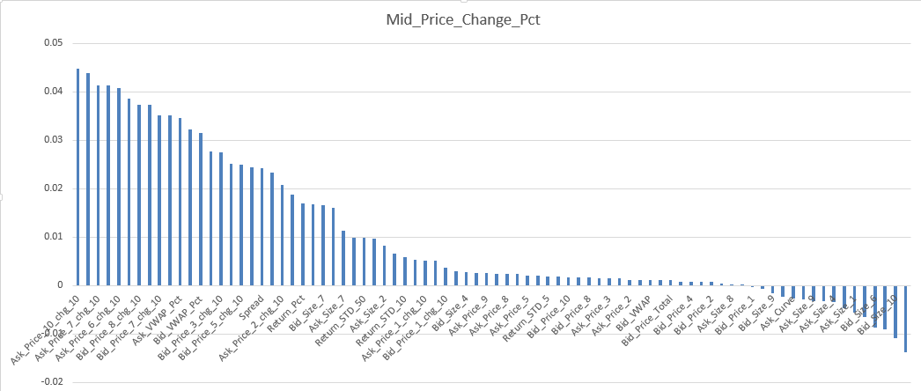

### Prediction vs Actual value

x-axis: prediction

y-axis: actual value

