THIS IS THE TITLE

Christian Taljard

1511768

CMM008

Table of Contents

Section 1 – Benefits of ITIL 3

Introduction to ITSM and ITIL 3

General benefits of ITIL 3

ITIL benefits specific to McKinsey Oil Pumps Company 3

# Section 1 – Benefits of ITIL

Since the late 1980’s organisations are increasingly adopting the concept that IT functions should focus on delivering reliable and consistent IT services which is in line with business needs and expectations. Ensuring these optimised services are delivered is the essence of IT Service Management (ITSM) {REF2} {REF3) .

While there are more than one way to adopt the concept of ITSM the IT Infrastructure Library (ITIL) has a proven track record {REF2} and is the approach most widely adapted worldwide among organisations implementing ITSM {REF6}. ITIL is a set of best practice guidelines that describes what an organisation must consider to actualize ideal IT service delivery {REF4}. Since inception the library has evolved to continue reflecting indusrty best practice, the latest iteration is ITIL v3 which was published in 2007 {REF3}.

## General benefits of ITIL

cost savings, risk management and streamlining of IT operations

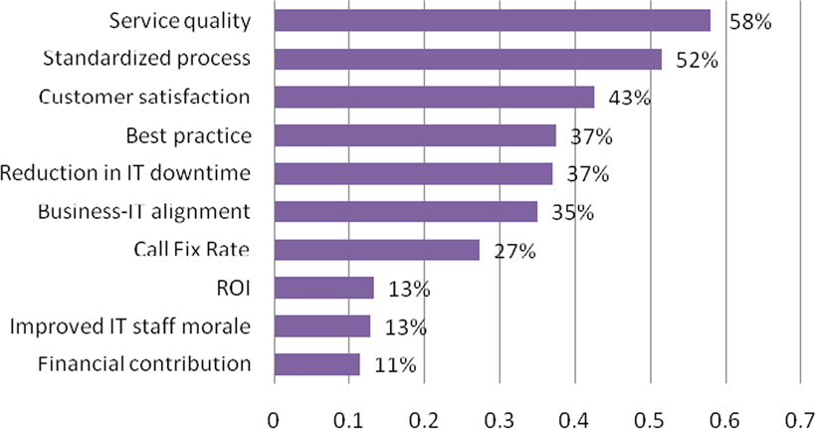

Percentages of companies that have realized a benefit

Service Quality

Standarized process

Customer Satisfaction

1. Stronger alignment between IT and the business
2. Improved service delivery and customer satisfaction
3. Reduced costs through improved utilization of resources

## General benefits of ITIL

Then, describe some of the generic benefits of ITIL that almost any company would gain from its use (one paragraph).

## ITIL benefits specific to McKinsey Oil Pumps Company

Finally, describe 2 – 4 specific benefits ITIL will bring to the company based on your reading of the case study (2/4 paragraphs). Refer to five relevant success and/or critical success factors that make ITIL implementation a success.

* 12 point font
* 1.5 line spacing
* 12 point font

1.5 line spacing

* Your name in either the Header or Footer of each page
* Page number centred in footer of each page
* Title Page containing: a title for your report (of your choosing – make it relevant); your name and matriculation number; Module number
* Table of Contents