INTERNAL REVIEW DRAFT · v4 full integration (main text + embedded Figure 1–5 / Table 1 + complete Supplementary Information) · 2026-10-31
正文初稿 V4 · 审阅版（全量整合）：Figure 1–5 与 Table 1 已嵌入正文引用处；文末附完整补充材料（Supplementary Fig. S1–S3、Table S1–S3、Supplementary Note 全文，编号与正文分列）。投稿请以 00_投稿包 为准。
Title and authors
Discrimination transports, calibration does not: calibration drift in severity scoring across 187 intensive-care units
Junzhi Chu¹, Tiantian Zhang²*
¹ First Clinical Medical College, Zhejiang Chinese Medical University, Hangzhou, Zhejiang, China
² Xianju People's Hospital, Zhejiang Southeast Campus of Zhejiang Provincial People's Hospital, Affiliated Xianju's Hospital, Hangzhou Medical College, Xianju, Taizhou, Zhejiang, China
Corresponding author: Tiantian Zhang, Xianju People's Hospital, Xianju, Taizhou, Zhejiang, China. Email: tiantian4634@163.com
---
Abstract
Severity scores are often assumed to transport between hospitals. In a secondary analysis of eICU-CRD (30,796 patients aged ≥65 years from 187 hospitals) we examined whether such scores discriminate and calibrate alike across centres. Discrimination was moderate and nearly constant (pooled AUC 0.732 for SOFA; per-centre AUC 0.649–0.812), whereas calibration varied substantially: between-centre I² was 75.4% and the observed-to-expected mortality ratio ranged from 0.69 to 1.54, a 2.2-fold spread. Calibration slopes ranged from 0.72 to 1.64, indicating drift in the risk gradient. Drift persisted after adjustment for measured case-mix, strengthened with centre size, and was temporally unstable (split-half r = 0.586). At a decision threshold of 0.20, mortality among patients flagged high-risk ranged from 15% to 52%, and net benefit was negative in 17–22% of centres. Naive local recalibration proved harmful at small sample sizes: with 25 local patients it performed worse than no recalibration (success rate 15.5% versus 21.4%), and even at 200 patients only 34.3% of resamples met the pre-specified ±10% criterion, a threshold never reached. Empirical-Bayes shrinkage of the local calibration offset reversed this, outperforming naive recalibration at 25 patients (24.3% versus 15.5%; two-sided P = 3.7 × 10⁻¹¹²) and transferring to MIMIC-IV without refitting. Discrimination transports; calibration does not.
Keywords. Intensive care · Calibration · Severity score · External validation · Data drift · Empirical Bayes
---

Introduction
Acute severity scores such as the Sequential Organ Failure Assessment (SOFA) [1], the Oxford Acute Severity of Illness Score (OASIS) [2] and the Simplified Acute Physiology Score II (SAPS-II) [3] are used across intensive care units (ICUs) to quantify illness severity, to benchmark units against one another, and increasingly to inform decisions about the level of care a patient should receive. Their use rests on an assumption that is rarely examined: that a given score means the same thing about the probability of death in one hospital as it does in another.
Discrimination is the property that is usually reported. A score that ranks sicker patients above healthier ones will retain most of that ability when it is carried from one population to another, and a pooled area under the receiver operating characteristic curve (AUC) is a standard feature of validation studies. Calibration — whether the predicted probability of death matches the observed probability — is the property that determines what a risk estimate actually means at the bedside, and it has long been recognised as the more fragile of the two [4]. Poorly calibrated algorithms can be misleading and harmful in clinical decision-making, and calibration has been described as the Achilles heel of predictive analytics [5]. Even so, calibration is assessed less consistently than discrimination in published validation studies [6], and where it is assessed the finding is typically that it does not transport.
Most published work on calibration failure addresses one of two settings. The first is temporal: within a single environment, calibration deteriorates as clinical practice, data capture and patient mix change, and a substantial methodological literature now exists on detecting such drift [7] and on updating models once it has been detected [8,9]. The second is a single transfer: a model developed in one centre is applied to one other centre or population, where miscalibration is observed and locally corrected [10]. What has received much less attention is the spatial dimension: how far calibration differs simultaneously across many centres in a health system that routinely uses the same score, and how large that between-centre component is relative to the others. This matters because the practical response to inter-centre variation is assumed to be local recalibration, and because benchmarking systems that compare hospitals depend on the premise that the underlying risk adjustment is comparable across them [11].
Two questions follow that have not, to our knowledge, been answered together. First, quantitatively: when a severity score is used in 100 or more hospitals at once, how much of the variation in observed-to-expected mortality is real between-centre variation, how much is explained by measured case-mix, and how much is the fluctuation one would expect from sampling alone? Second, operationally: if a hospital does decide to recalibrate locally, how many of its own patients does it need before the recalibration improves rather than degrades its predictions?
We addressed both questions using the eICU Collaborative Research Database (eICU-CRD), a multicentre database covering 187 hospitals, together with MIMIC-IV as a second, single-centre database for testing whether parameters estimated in one database can be used in another. We quantified between-centre variation in calibration for three established severity scores, tested how much of it measured case-mix could explain, decomposed it into components attributable to centre size and to calendar year, translated it into consequences at four decision thresholds, and evaluated local recalibration as a function of the number of locally available patients, together with an empirical-Bayes shrinkage alternative.
---
Results
Cohort and study setting
The eICU-CRD cohort comprised 30,796 patients from 187 hospitals, of whom 3,901 (12.7%) died in hospital; 103 hospitals met the pre-specified centre-level eligibility criterion of ≥ 100 patients and ≥ 10 in-hospital deaths and entered the centre-level analyses (Fig. 1). The MIMIC-IV cohort comprised 8,579 patients from one academic centre, of whom 1,654 (19.3%) died (Table 1; Supplementary Table S1).
Figure 1
Flow of participants from eICU-CRD and MIMIC-IV into the analysis. Left, estimation cohort (eICU-CRD v2.0, 208 hospitals). 200,859 unit stays → first ICU stay per patient (139,367) → age ≥65 years (71,734; ages >89 recorded as 90) → ICU length of stay ≥24 h (50,138) → medical or medical–surgical ICU (31,307) → exclusion of deaths within 24 h of ICU admission (7) and of missing hospital outcome status (363) and of missing albumin, height and weight (141) → analysis cohort of 30,796 patients from 187 hospitals (3,901 in-hospital deaths, 12.7%). A centre was eligible for the between-centre analyses if it contributed ≥100 patients and ≥10 deaths, leaving k = 103 centres. Right, external application (MIMIC-IV v3.1). 94,458 ICU stays → first ICU stay per patient (65,366) → age ≥65 years (35,499; age at admission = anchor_age + (admission year − anchor year)) → ICU length of stay ≥24 h (28,607) → first stay in a medical or medical–surgical ICU (8,629) → exclusion of deaths within 24 h of ICU admission (35) and of missing albumin, height and weight (15) → analysis cohort of 8,579 patients (1,654 in-hospital deaths, 19.3%). MIMIC-IV comprises a single centre (Beth Israel Deaconess Medical Center); the eICU-derived model was applied to it without refitting. Notes. (i) The exclusion of patients missing all of albumin, height and weight (n = 141 in eICU, n = 15 in MIMIC-IV) is carried over from the source data-extraction protocol so that cohorts remain comparable with related work from the same research group. This study analyses none of albumin, height or weight, so the step affects neither the analysis cohort nor any result; it is reported here only for full transparency about the extraction pipeline. (ii) The threshold of ≥100 patients and ≥10 deaths per centre was prespecified to permit stable estimation of a calibration intercept in each centre; centres below the threshold contributed to the pooled model but not to the centre-level analyses.
Table 1. Between-centre variation in discrimination and calibration across 103 intensive-care units, by severity score
 | SOFA | OASIS | SAPS-II
Hospitals included, k | 103 | 103 | 103
Pooled model AUC (95% CI) | 0.732 (0.720–0.745) | 0.728 (0.715–0.741) | 0.761 (0.751–0.771)
Per-centre AUC, 10th / median / 90th percentile | 0.649 / 0.738 / 0.812 | 0.666 / 0.729 / 0.813 | 0.683 / 0.762 / 0.844
Between-centre variance (τ²) | 0.131 | 0.165 | 0.109
Between-centre heterogeneity, I² (%) | 75.4 | 79.8 | 70.4
Observed-to-expected mortality ratio, 10th / median / 90th percentile | 0.69 / 0.96 / 1.54 | 0.71 / 1.03 / 1.57 | 0.69 / 1.02 / 1.49
Calibration slope, 10th / median / 90th percentile | 0.720 / 1.088 / 1.639 | 0.734 / 1.104 / 1.681 | 0.753 / 1.039 / 1.509
Each score was fitted as a single-score pooled logistic model across the full eICU-CRD cohort (30,796 patients, 3,901 in-hospital deaths), and the calibration-in-the-large offset and calibration slope were then derived separately in each of the 103 hospitals meeting the pre-specified eligibility criterion of ≥ 100 patients and ≥ 10 in-hospital deaths. AUC, area under the receiver operating characteristic curve; O/E, observed-to-expected mortality ratio; τ², between-centre variance estimated by the DerSimonian–Laird method; I², proportion of total variation attributable to between-centre heterogeneity. 95% confidence intervals for the pooled AUC were obtained by cluster bootstrap, resampling the 187 hospitals with replacement and taking all of each sampled hospital's patients (1,000 replicates; percentile interval; random seed 20261019). The standardisation parameters of the pooled model were held fixed across replicates. Percentiles in the other rows are the 10th and 90th percentiles across hospitals and are measures of spread, not confidence intervals. No hypothesis test was performed for any entry in this table; the values are descriptive estimates. The narrow confidence intervals around the pooled AUC (width ≈ 0.025) contrast with the 2.2-fold spread in the observed-to-expected ratio, which is the comparison this table is intended to make.
Calibration varies widely across centres while discrimination does not
For SOFA, the pooled model discriminated moderately (AUC 0.732) and this varied little between hospitals: the per-hospital AUC ranged from 0.649 to 0.812 (median 0.738), a spread of 0.16 (Fig. 2). Calibration, in contrast, varied substantially (Fig. 3, Table 1). Between-hospital heterogeneity in the calibration-in-the-large offset was high (I² = 75.4%, between-centre variance τ² = 0.131), and the observed-to-expected (O/E) mortality ratio ranged from 0.69 to 1.54 across hospitals (10th to 90th percentile; median 0.96); a 2.2-fold spread (Fig. 3).
Figure 2
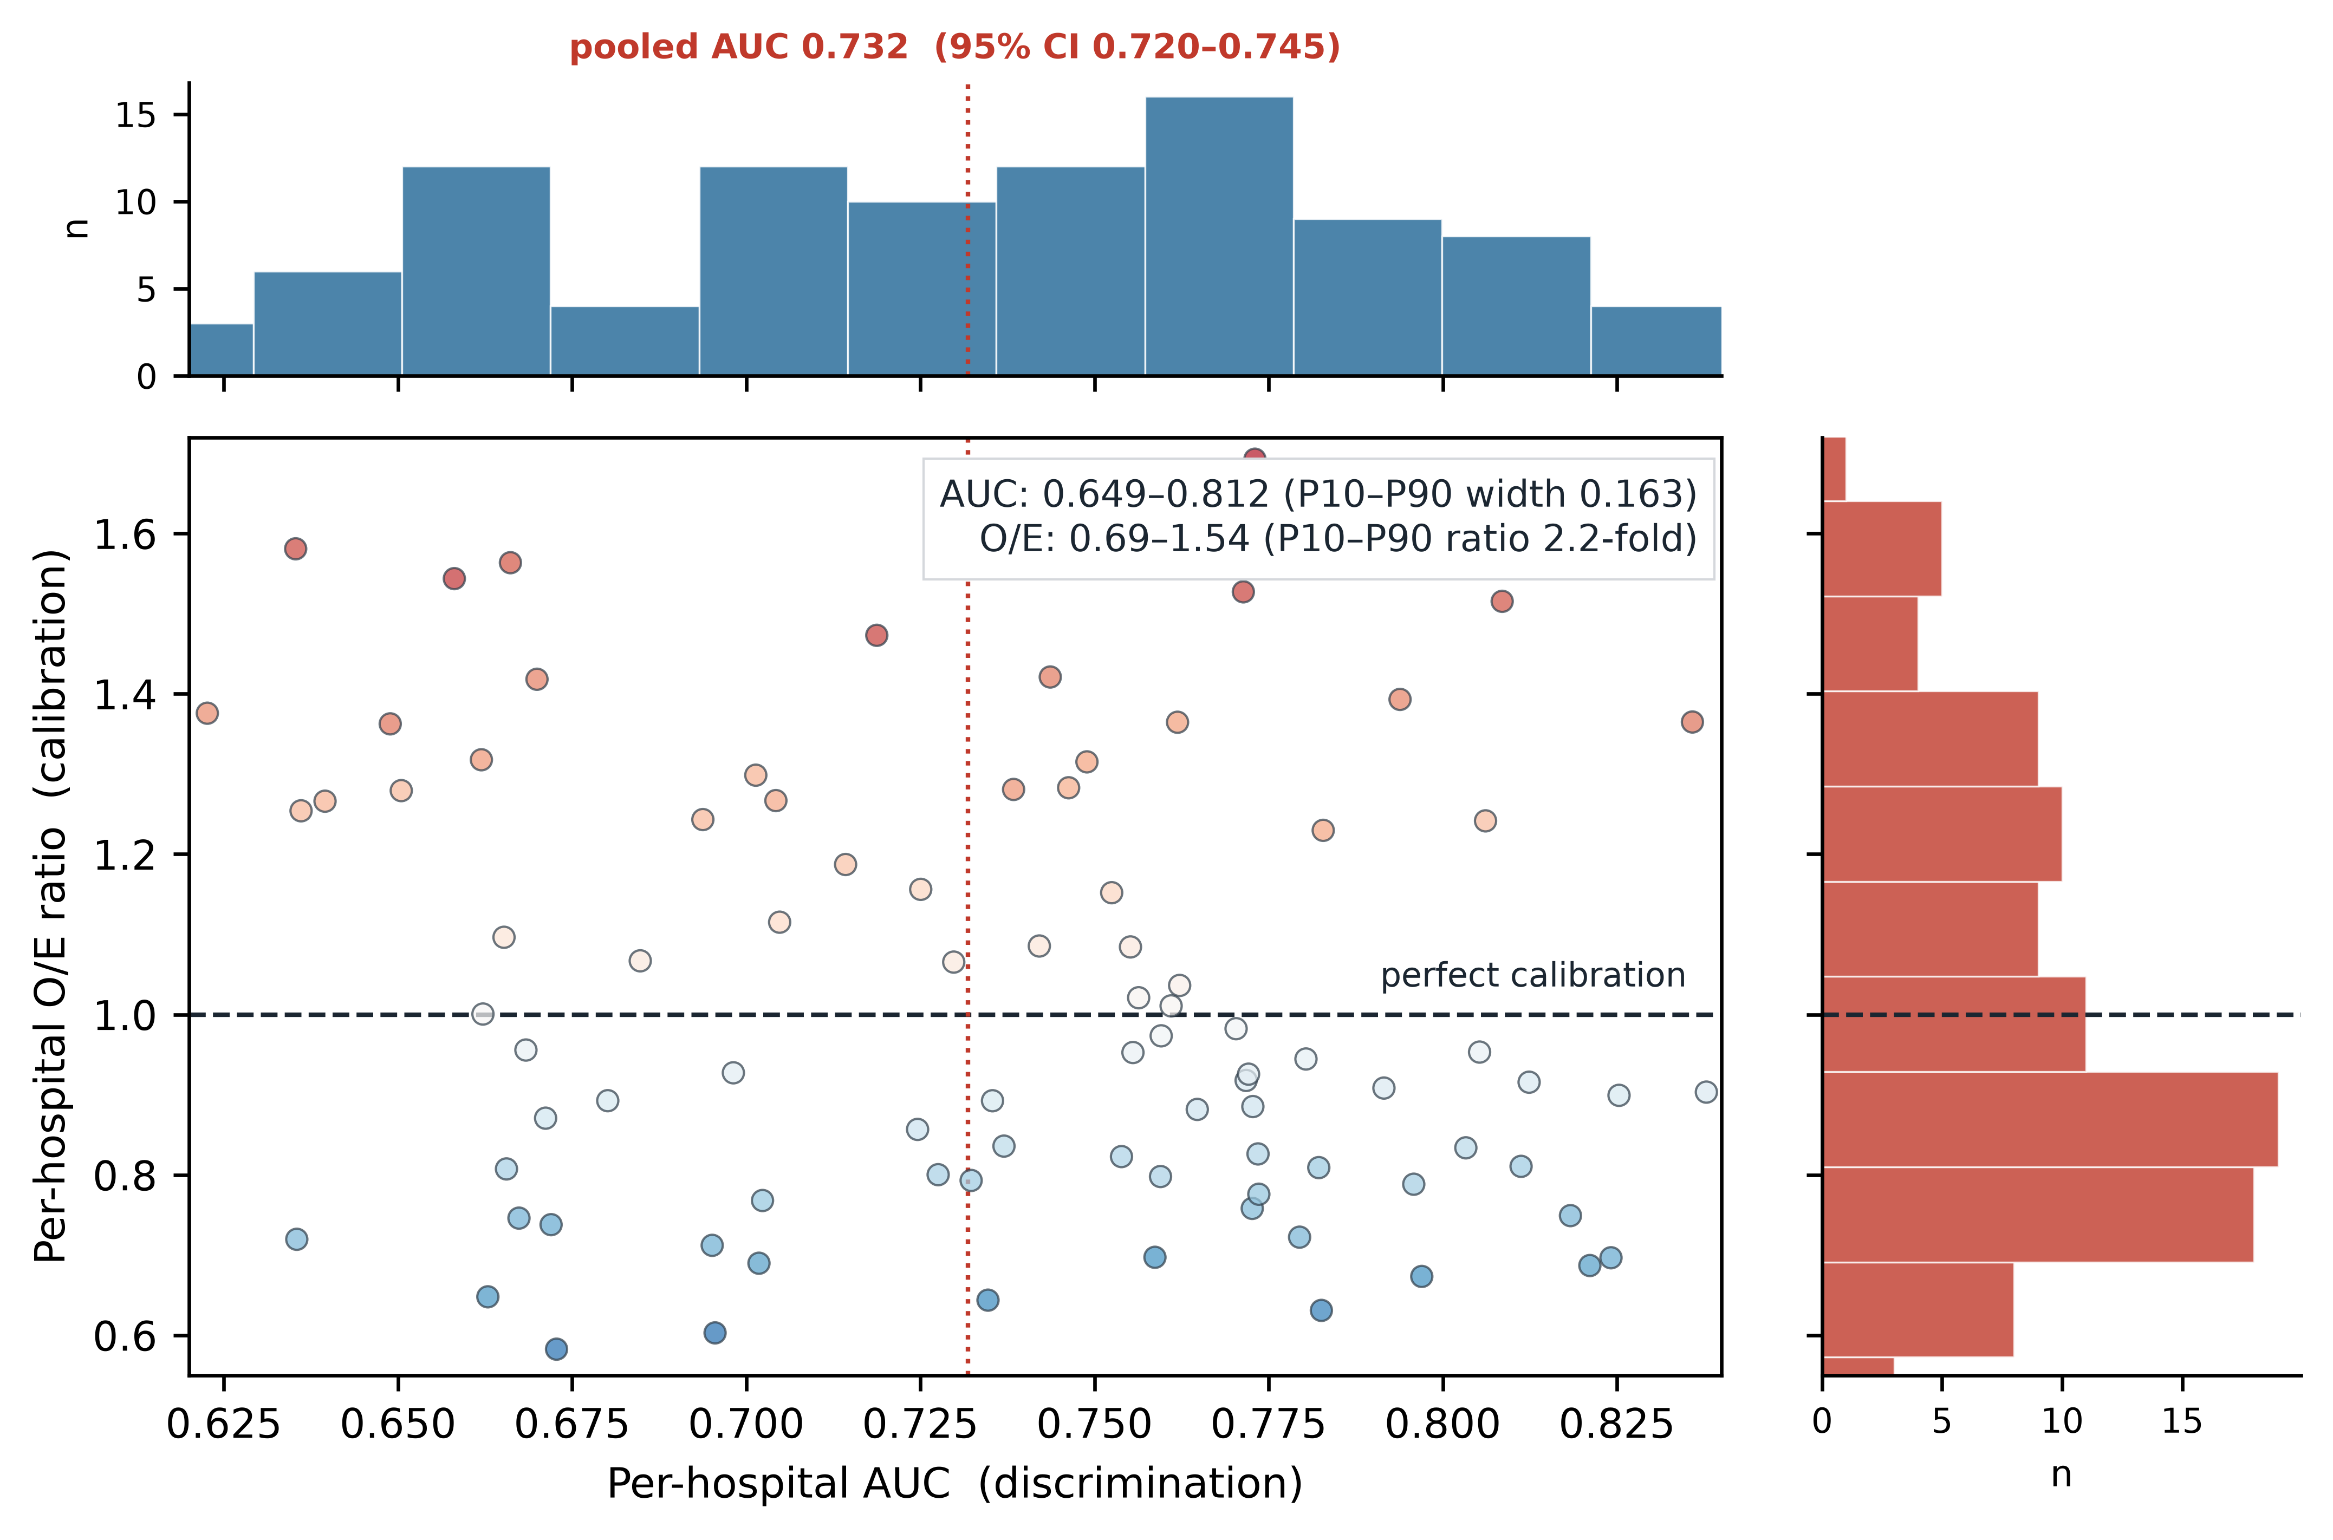
Discrimination transports across centres; calibration does not. SOFA-based model, 103 eICU centres. Each point is a centre: x = its AUC (discrimination), y = its observed-to-expected ratio (calibration). The horizontal dashed line marks perfect calibration (O/E = 1); the dotted vertical line marks the pooled AUC (0.732). Marginal histograms show each marginal distribution. Per-centre AUC ranged from 0.649 to 0.812 (a spread of 0.16), whereas per-centre O/E ranged from 0.69 to 1.54 (a 2.2-fold spread) — calibration varies far more than discrimination. Point colour encodes a_{h} (blue < 0, red > 0).
Figure 3
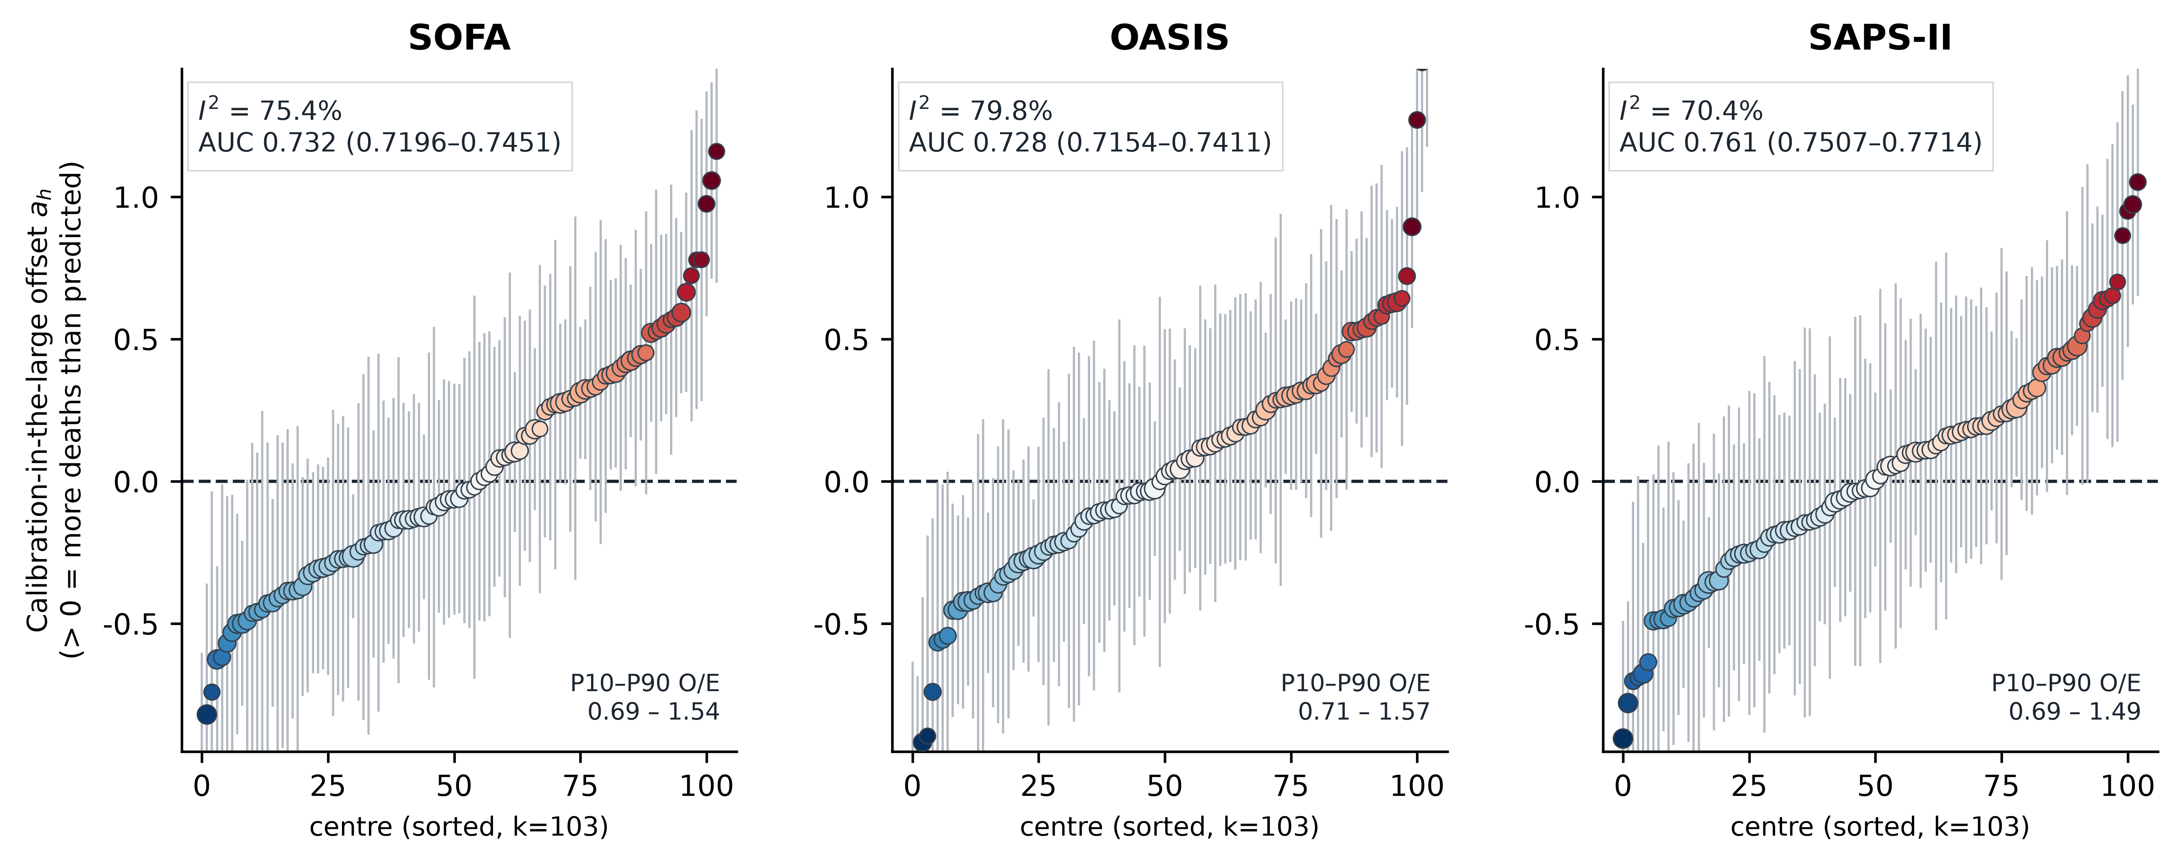
Between-centre drift in calibration intercept for three acute-severity scores. Each panel shows one severity score fitted as a single-predictor logistic model on the full eICU-CRD cohort (30,796 patients; 3,901 in-hospital deaths) and then applied to each of 103 centres (≥100 patients and ≥10 deaths). Points are centres sorted by their calibration-in-the-large offset a_{h} (solving meanexpit(logit(hat p)+a_{h})=observed mortality); a_{h} > 0 indicates more deaths than the model predicts. Bars are 95% CIs (delta method); point size is proportional to log(n). Colour encodes a_{h} (blue = lower than predicted, red = higher). Heterogeneity (I²) was estimated by random-effects meta-analysis (DerSimonian–Laird). Between-centre I² exceeded 70% for all three scores (SOFA 75.4%, OASIS 79.8%, SAPS-II 70.4%), with observed-to-expected (O/E) ratios spanning approximately 2.2-fold across centres (P10–P90: 0.69–1.54 for SOFA). The drift is therefore a property of the setting rather than of any one score.
The pattern was not specific to SOFA. OASIS (pooled AUC 0.728; I² = 79.8%; O/E 0.71–1.57) and SAPS-II (pooled AUC 0.761; I² = 70.4%; O/E 0.69–1.49) showed heterogeneity of comparable magnitude (Table 1, Fig. 3). Because all three scores are established, widely used instruments fitted with the same pipeline, this consistency indicates that between-centre calibration drift is a property of the setting rather than of any single instrument.
Drift was not confined to a systematic offset. The per-hospital calibration slope (intercept free) ranged from 0.720 to 1.639 (10th–90th percentile; median 1.088): the risk gradient itself differs between hospitals, not merely the baseline event rate.
For the descriptive analyses in this section and the four that follow, the reported quantities are estimates, not tests: no hypothesis test was performed on the between-centre variation, the differences between scores, or the case-mix comparisons; ranges are 10th and 90th percentiles across hospitals, not confidence intervals.
Measured case-mix does not explain the drift
We next asked whether the measured case-mix of each hospital explains its offset. We fitted a ladder of nested models (M1: the score alone; M2: the score with age and sex; M3: the score with age, sex, comorbidity burden and invasive ventilation) and recomputed the between-centre heterogeneity at each step (Supplementary Fig. S1). Adding age and sex raised the pooled AUC by only 0.009 (0.732 to 0.741) and left I² essentially unchanged (75.4% to 75.2%). Adding comorbidity burden and invasive ventilation raised the AUC by a further 0.011 (to 0.752) and lowered I² to 70.1%, a reduction of 5.2 percentage points; τ² fell from 0.131 to 0.106.
Because M3 also carries a smaller analysis set (27,236 patients, 97 hospitals, against 30,796 and 103 for M1 and M2), refitting the M1 model on exactly those patients and hospitals gave I² = 73.49%: of the 5.2-percentage-point fall from M1 to M3, 1.9 points are attributable to the analysis set and 3.4 to the covariates (Supplementary Fig. S1).
Measured case-mix therefore accounts for only a small share of the between-centre variation: four clinically relevant covariates, added together, explain around 5 percentage points of I² against a baseline of 75%. The remaining variation is reported here as residual between-hospital variation. It is not attributed to any particular cause; unmeasured differences in case-mix (disease spectrum, referral patterns, pre-ICU course) and in care organisation would each produce the same pattern, and this study is not designed to distinguish them.
A single-centre model sits mid-distribution among centres
Applying the eICU-fitted SOFA model to MIMIC-IV, discrimination was preserved (AUC 0.722 versus 0.732 within eICU), but calibration shifted: observed mortality was 19.3% against a model prediction of 16.5%, giving an O/E ratio of 1.17 and a calibration offset of a = +0.221 (Supplementary Fig. S2). MIMIC-IV's higher recorded Charlson index (3.5 vs 0.9) reflects more complete ICD coding, not case-mix difference; the model has no comorbidity term.
That offset placed MIMIC-IV at the 66th percentile of the 103 eICU hospitals: a single-centre development cohort is no outlier here, it sits inside the multicentre distribution — consistent with the general observation that a model developed in one centre systematically mis-estimates risk in another, without any centre being unusual.
Drift strengthens rather than shrinks with centre size
If apparent between-centre variation were driven by sampling noise, the smallest hospitals (whose offsets are least precisely estimated) should show the highest apparent heterogeneity. The opposite was observed (Fig. 4a). Stratifying the 103 centres into tertiles by sample size, I² rose from 56.7% in the smallest tertile (36 centres; median 145 patients) to 69.8% in the middle tertile (33 centres; median 225 patients) and 83.9% in the largest (34 centres; median 386 patients). The absolute between-centre variance followed the same pattern, rising from τ² = 0.093 to 0.117 to 0.143.
Figure 4
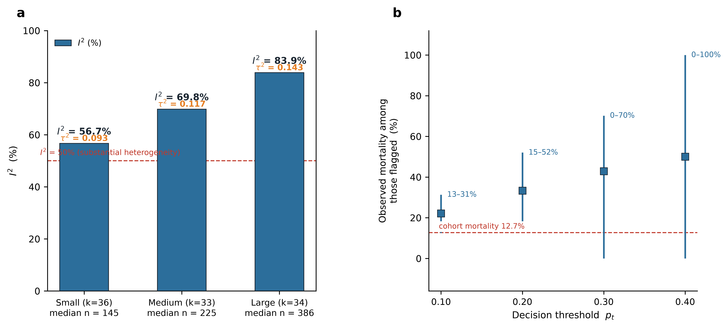
(a) Between-centre heterogeneity by centre size. Centres were split into tertiles by sample size; bars are I² and the orange line is the between-centre variance τ². Heterogeneity increased with centre size (small: I² 56.7%, τ² 0.093; medium: 69.8%, 0.117; large: 83.9%, 0.143). Had the apparent drift been driven by sampling noise, the least precisely estimated (small) centres would have shown the greatest heterogeneity; the opposite was observed, indicating that the between-centre variation is real. (b) Clinical impact of the same decision threshold in different centres. For each threshold p_{t}, points are the median and bars the P10–P90 range of the observed mortality among patients the model classified as high risk (112 centres with ≥100 patients — the net-benefit calculation is defined for all of them, including the 9 centres below the ≥10-death criterion used for the primary between-centre analyses); the red dashed line is the overall cohort mortality (12.7%). At p_{t} = 0.20 the observed mortality among flagged patients ranged from 15% to 52% (3.5-fold). Model-guided escalation yielded negative net benefit in 6.2%, 17.0%, 21.4% and 22.3% of centres at p_{t} = 0.10, 0.20, 0.30 and 0.40 respectively — i.e. in up to one in five centres the model performed worse than treating everyone.
The variation is therefore a genuine between-hospital difference rather than an artefact of imprecise estimation in small samples. The 84 hospitals below the centre-level threshold are smaller and less severely ill (median 47 patients, 9.0% mortality versus 224 and 12.7%; Supplementary Table S4).
Calibration offset is not a stable attribute of a hospital
eICU-CRD covers only the calendar years 2014 and 2015, so year-to-year stability was assessed by splitting each hospital's patients by year. Of the 103 eligible centres, 88 contributed ≥ 50 patients and ≥ 5 in-hospital deaths in each year (Supplementary Fig. S3).
The two years' offsets correlated only moderately (Pearson r = +0.586; P = 2.0 × 10⁻⁹, two-sided test of r = 0 across 88 hospitals; Spearman ρ = +0.563), so that a hospital's offset in 2014 explained about a third of the variance in its 2015 offset. The median absolute difference between the two years was 0.331 (10th–90th percentile 0.12–0.83). Decomposing the variance, the within-hospital (temporal) component was 0.102 against a total between-hospital variance of 0.246, so that 41.6% of the apparent between-centre variance was a within-centre, year-to-year component. There was also a systematic downward shift between the two years (mean −0.149; t = −3.09 across 88 hospitals, P = 0.002, two-sided).
Because only two consecutive years are available, this analysis addresses year-to-year stability and does not support any statement about a long-term temporal trend.
Drift changes what a risk threshold means at the bedside
We next quantified the drift's consequence for threshold-based decisions. For each hospital and each of four decision thresholds, we computed net benefit and the observed mortality among patients whose predicted risk exceeded the threshold (Fig. 4b; Supplementary Table S1).
At a decision threshold of 0.20, the median proportion of patients flagged as high-risk was 12.8%, and the observed mortality among those patients ranged from 15% to 52% (10th to 90th percentile; median 33.3%); a 3.5-fold spread for the same model and the same threshold. Net benefit was positive in the median hospital (+0.021) but was negative in 17.0% of centres (positive in the remainder), meaning acting on the model would have been worse than treating everyone as high-risk. Negative net benefit rose from 6.2% at threshold 0.10 to 21.4% at 0.30 and 22.3% at 0.40.
Naive local recalibration carries a small-sample penalty
The findings above raise the obvious question: why not recalibrate the score using local data? We examined this directly, drawing m patients from each hospital for local recalibration and using the remainder for evaluation, with 100 resampling attempts per (hospital, m) cell, for centres with at least 200 patients and at least 2m in all (m ∈ {0, 25, 50, 100, 200}; Fig. 5a).
Figure 5
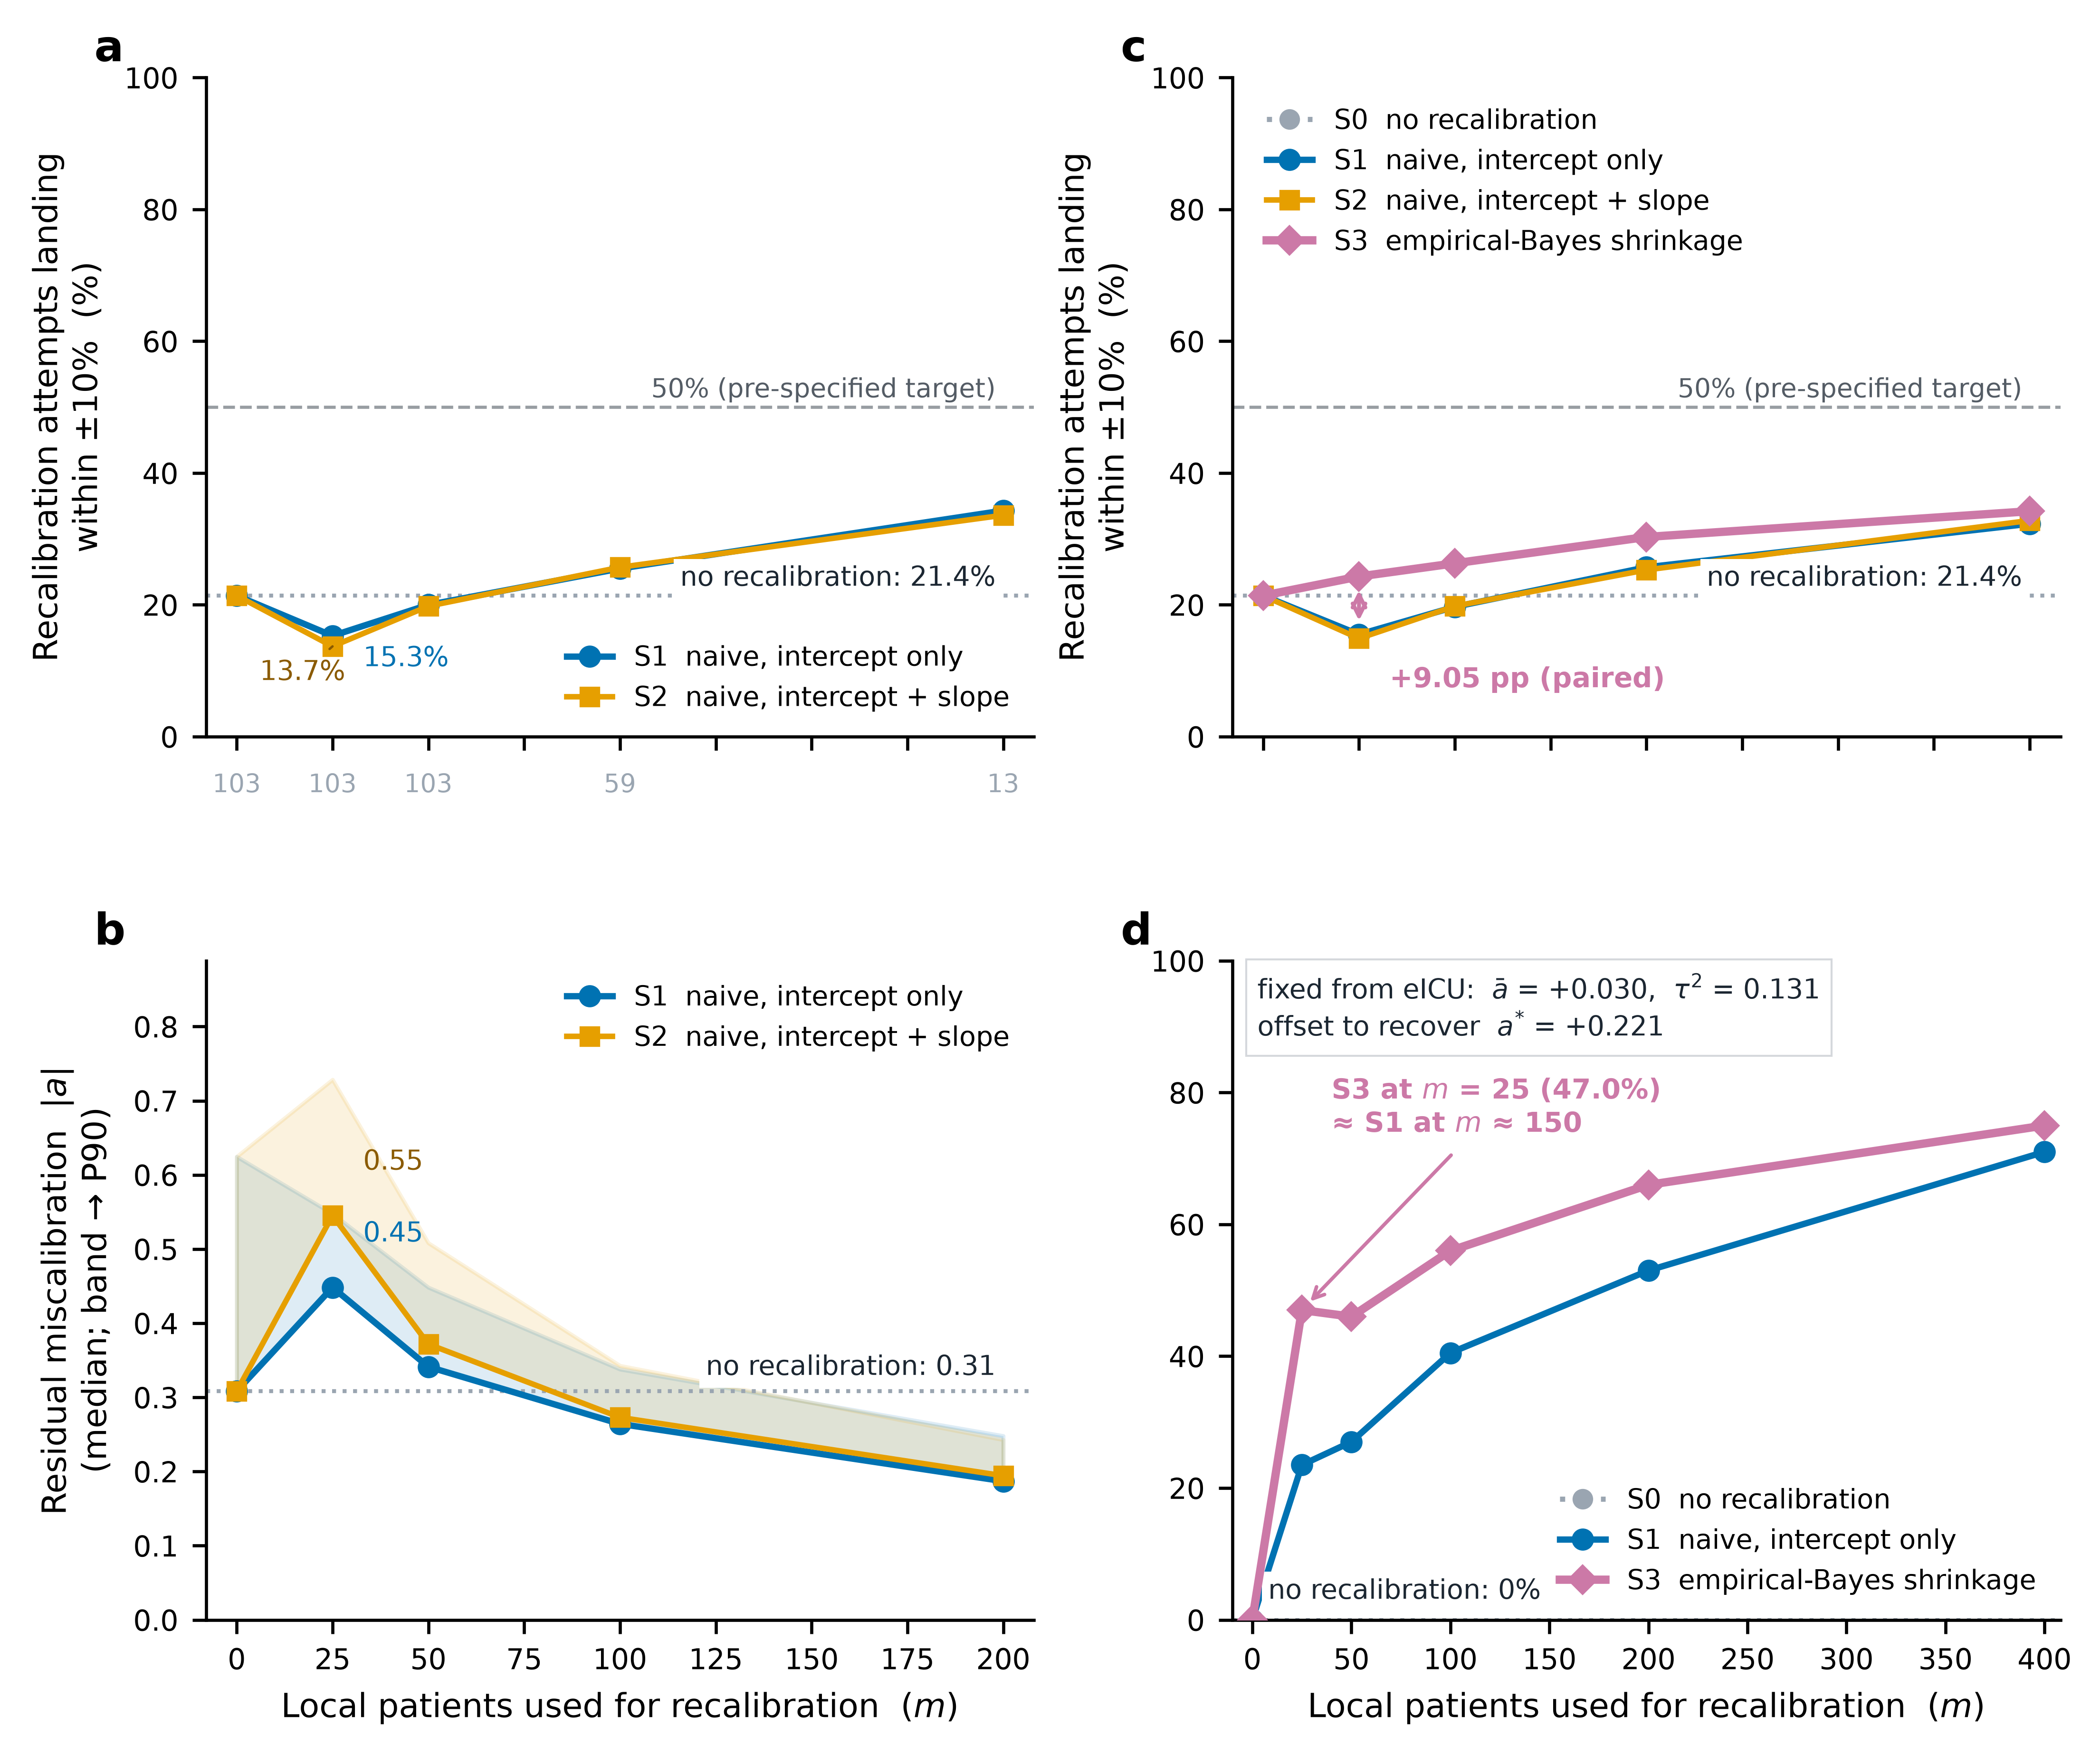
(a) Learning-curve analysis: for each m, m patients per centre were drawn for local recalibration and the remainder for evaluation (n≥ 2m; 100 repeats per centre-m cell). y axis: proportion of attempts with residual O/E within ±10% for S1 (intercept only) and S2 (intercept + slope); dotted line, no recalibration; dashed line, the 50% target; k, the number of contributing centres. With 25 local patients, naive recalibration was worse than no recalibration at all (21.4% → 15.3%); the 50% target was never reached. (b) Residual miscalibration |a| (median; band → P90). (c) Empirical-Bayes (EB) shrinkage removes the penalty: 103 centres; 200 paired resamples per centre-m cell; ā and per-centre SEs were leave-one-centre-out cross-fitted, so no centre's evaluation data entered its own shrinkage parameters. S0, no recalibration; S1/S2, naive; S3, EB shrinkage, â_EB=ā+λ(â_ML-ā), λ=τ²/(τ²+SE²). At m = 25 the success rate rose from 15.5% to 24.3% (paired difference +9.05 percentage points, Wilcoxon P = 3.7×10⁻¹¹²), surpassing no recalibration (21.4%); median λ 0.234/0.374/0.536/0.712 (m = 25/50/100/200), and residual |a| fell from 0.44 (naive) to 0.26. (d) Shrinkage parameters estimated once from eICU transfer to a different database: MIMIC-IV treated as a single new centre; ā = +0.030 and τ² = 0.131 fixed from eICU, never re-estimated; the offset to recover, â = +0.221. EB shrinkage outperformed naive recalibration at every m (at m = 25: 47.0% vs 23.5%, +23.5 percentage points, Wilcoxon P = 6.3×10⁻⁷); the small dip at m = 50 (47.0% → 46.0%) is within Monte-Carlo error (200-draw SE ≈ 3.5 pp); 25 patients with shrinkage matched the success rate naive recalibration reached only with ≈150 patients — a six-fold smaller local requirement. Notes. The contributing-centre set shrinks with m; the S0 line is the within-m benchmark — the no-recalibration rate at that same m (not a learning effect). Panels a–b use 100 resampling attempts (15.3% at m = 25), panels c–d 200 paired attempts (15.5%); both are correct independent draws — comparisons are within, not between, panels. MIMIC-IV is a single-centre database: panel d tests whether the shrinkage parameters transfer across databases and does not constitute multicentre external validation, which can only be evaluated within eICU itself (panel c). ---
The answer was counter-intuitive. Re-estimating the intercept on 25 local patients made calibration worse than not recalibrating at all: the proportion of resampling attempts landing within ±10% of perfect O/E fell from 21.4% (no recalibration) to 15.3%, and the median residual |a| rose from 0.308 to 0.448 (Fig. 5b). Naive recalibration injects estimation noise that outweighs the signal at small sample sizes. Success improved gradually with m (20.0% at 50 patients, 25.5% at 100, and 34.3% at 200), but the pre-specified criterion of a 50% success rate was never reached within 200 local patients, which is reported here as a negative finding. Under the prespecified ±20% band the same strategies rose steeply (S1: 30.6% at 25 and 62.8% at 200) while the penalty against no recalibration (41.7%) persisted at 25 (Supplementary Table S5).
Estimating a second parameter did not help. Re-estimating both intercept and calibration slope was worse than intercept-only at every sample size; at m = 25 the success rate was 13.7% and the median residual |a| was 0.545, against 15.3% and 0.448 for the intercept-only strategy.
The number of hospitals contributing to each cell is reported throughout, because the requirement n ≥ 2m progressively removes smaller centres: 103 centres at m ≤ 50, 59 at m = 100, and 13 at m = 200.
Empirical-Bayes shrinkage removes the small-sample penalty
We then tested whether shrinking each offset toward the pooled mean recovers small-sample performance (Fig. 5c). Four strategies were compared on identical draws: no recalibration (S0), naive intercept-only (S1), naive intercept plus slope (S2), and empirical-Bayes shrinkage of the intercept (S3), with the shrinkage target and between-centre variance estimated by leave-one-centre-out cross-fitting. The shrinkage weight λ is a reliability weight: when SE² dominates τ², λ→0 and the local estimate collapses to the pooled mean; when τ² dominates, λ→1 and it is retained.
At 25 local patients, shrinkage achieved a ±10% success rate of 24.3% against 15.5% (naive recalibration) and 21.4% (no recalibration), outperforming both at the sample size at which naive recalibration is harmful (Fig. 5c). Paired on identical draws, the difference between S3 and S1 at m = 25 was +9.05 percentage points (19,678 paired (hospital, replicate) observations; two-sided Wilcoxon signed-rank test, P = 3.7 × 10⁻¹¹²). At m = 100 the paired difference was +4.65 percentage points. The shrinkage weight adapted to local sample size as expected, with median λ of 0.234, 0.374, 0.536 and 0.712 at m = 25, 50, 100 and 200 respectively; the strategy shrinks hardest precisely where the local estimate is least reliable.
The pre-specified criterion for this analysis was met (at m = 25, S3 exceeded S1; at m ≥ 100, S3 was not worse than S1 by more than 5 percentage points).
The learning-curve and shrinkage analyses use independent resampling schemes (100 attempts per cell vs 200 paired draws); comparisons are made within, not between, panels.
Shrinkage parameters transfer across databases
To test whether the shrinkage parameters generalise beyond the database in which they were estimated, we treated MIMIC-IV as a single new centre and fixed the shrinkage target (ā = +0.030) and between-centre variance (τ² = 0.131) at their eICU values, never re-estimating them on MIMIC-IV (Fig. 5d). The true offset to recover was â = +0.221.
At 25 local patients drawn from MIMIC-IV, naive recalibration achieved a ±10% success rate of 23.5%, whereas shrinkage achieved 47.0%; a paired difference of +23.5 percentage points (two-sided Wilcoxon signed-rank test across 200 paired resampling attempts, P = 6.3 × 10⁻⁷). Shrinkage outperformed naive recalibration at every sample size: +19.0 points at 50 patients (P = 4.1 × 10⁻⁶), +15.5 at 100 (P = 3.8 × 10⁻⁶), +13.0 at 200 (P = 6.0 × 10⁻⁵), and +4.0 at 400 (P = 0.059, not significant at α = 0.05, two-sided).
Expressed in terms of local data requirement, 25 local patients combined with shrinkage reached the success rate that naive recalibration attained only with roughly 150 local patients (naive: 40.5% at 100 and 53.0% at 200; interpolation ≈ 152); an approximately six-fold reduction. That comparison crosses resampling schemes (Fig. 5c vs 5d) and is illustrative. The advantage narrows as the local sample grows, since naive estimators become adequate with more data.
The pre-specified criterion for this analysis was met (at m = 25, S3 exceeded both S1 and S0).
This analysis tests whether the shrinkage parameters transfer across databases. It is not multicentre external validation of the strategy, which can only be evaluated within eICU itself, as reported above. The two are reported separately and are not conflated.
The between-centre variance depends on the estimation framework
The between-centre variance τ² underlying every result above was estimated by DerSimonian–Laird. As a pre-specified analysis we re-estimated it under three further frameworks: Paule–Mandel, restricted maximum likelihood (REML), and a one-stage random-intercept multilevel logistic model fitted to patient-level data (Supplementary Table S2).
The three two-stage estimators agreed closely: τ² = 0.1312 (DerSimonian–Laird), 0.1261 (Paule–Mandel) and 0.1299 (REML), a relative range of 3.9%, within the pre-specified 25% bound. The one-stage multilevel estimate did not agree: fitted to 26,436 patients across 103 centres, it gave τ² = 0.0648, 50.1% below the median of the two-stage estimates, exceeding the pre-specified 50% bound. An independent marginal-likelihood calculation (τ² = 0.0706) corroborated the multilevel value. This second clause of the pre-specified criterion was therefore not met, and is reported as a negative finding.
A plausible mechanism is that the two-stage calibration offsets are computed with the calibration slope fixed at 1, whereas the observed per-hospital slopes range from 0.720 to 1.639 (10th to 90th percentile). Variation in slope would be absorbed into the intercept under a fixed-slope model, inflating the apparent between-centre intercept variance. This mechanism is offered as an explanation of the disagreement, not as an established finding.
The principal conclusions do not depend on which estimate is used. I² is computed from Q and the standard errors and is independent of τ², so the heterogeneity of 75.4% is unaffected, as are the direction and magnitude of the discrimination–calibration dissociation. To test the empirical-Bayes result directly, we re-ran it holding τ² fixed at each of three candidate values (0.1312, DerSimonian–Laird; 0.0706, marginal likelihood; 0.0648, multilevel) on the same resampling draws used above, giving three parallel sensitivity tables (Supplementary Table S3). At m = 25 the shrinkage strategy outperformed naive recalibration under all three values of τ² (+9.1, +6.7 and +6.5 percentage points respectively; all P < 10⁻⁵⁹), so the pre-specified criterion was met.
Two consequences follow, and both are reported. First, the size of the advantage depends on τ²: at 25 local patients it fell from +9.1 to +6.7 to +6.5 percentage points as τ² decreased, because a smaller τ² implies heavier shrinkage toward the pooled mean, which pulls remote centres back further than the data warrant. Second, the advantage shrinks as the local sample grows, and at 200 patients it is no longer statistically detectable for the two smaller values of τ² (+0.2 percentage points, P = 0.83, and +0.2, P = 0.89; two-sided Wilcoxon signed-rank test, α = 0.05), while remaining at +2.0 percentage points (P = 0.035) under DerSimonian–Laird. Shrinkage is therefore a strategy for small local samples, not a general replacement for naive estimation.
Note on the comparison above. The primary analysis estimated τ² separately within each leave-one-centre-out fold, whereas the table above holds τ² fixed at each candidate point value; the two analyses therefore differ slightly (by 0.1–0.2 percentage points at m ≥ 50, and not at all at m = 25), which reflects that design difference. The naive column agrees exactly with the primary analysis at every sample size, confirming that the resampling draws and the naive estimates are identical across the two.
Note on the multilevel value. The multilevel τ² used here is 0.0648, the square of the maximum a posteriori standard deviation (0.2545) reported in Supplementary Table S2; the two are one and the same value. Maximum a posteriori estimation of a variance component is sensitive to initialisation, and repeated fits give standard deviations in the range 0.247–0.255 (τ² 0.061–0.065). A sensitivity run at τ² = 0.0610 gave a success rate of 21.6% rather than 21.7% at 25 local patients, an immaterial difference; that run is retained in the repository so the difference can be inspected.
---
Discussion
In 103 hospitals using the same scores and the same pipeline, a SOFA-based model discriminated consistently (per-centre AUC 0.649–0.812) while its calibration varied by more than twofold (observed-to-expected mortality 0.69–1.54; between-centre I² = 75.4%). Measured case-mix explains little of it, the variation grew in the most precisely estimated centres, a hospital's offset in one year explained a third of its offset in the next, and at a decision threshold of 0.20 the observed mortality among patients flagged high-risk ranged from 15% to 52%, with net benefit negative in 17.0% of centres. The natural response — recalibrate locally — turned out to carry a penalty: at 25 local patients it was worse than no recalibration. Shrinkage toward the pooled mean removed that penalty, and its parameters, estimated once, worked in a second database without refitting.
Relation to prior work on calibration drift. The closest antecedents treat calibration drift as a temporal phenomenon within one environment: Han et al. detected increasing miscalibration over time with online stochastic gradients and adaptive windows [7], and Zhang et al. countered it with lifelong machine learning across four tumour datasets [12]. Both suit their question and neither is contradicted here. The present study addresses the orthogonal spatial question at a rarely attempted scale: 103 centres observed simultaneously, allowing variance partitioning [10,13]. From the opposite direction the same verdict emerges: a MIMIC-IV-developed model applied without recalibration to 208 eICU hospitals lost external calibration faster than discrimination as feature complexity grew (calibration slope 1.007 → 0.417), while a single aggregate score stayed intact [14]. A clinical corollary: the two sources are not interchangeable. A hospital offset of which 41.6% of the variance is temporal in those two consecutive years cannot be fully corrected by a permanent recalibration, however large the sample used to fit it, and a hospital-to-hospital difference that persists after case-mix adjustment cannot be explained by improvement over time. Separating them would need multi-year data, which eICU-CRD does not provide.
Relation to the model-updating literature. A mature methodological literature describes how to evaluate and update a prediction model, including when recalibration is appropriate [8,9,15,16], and empirical comparisons of update strategies exist [17,18]. Those recommendations read: if calibration there is poor, recalibrate — assuming a local sample large enough to be reliable. Our findings qualify rather than contradict them. Formal minimum sample sizes exist for external validation [19] but address estimate precision, not whether recalibration improves decisions. We found that with 25 local patients naive recalibration lowered the proportion of resamples reaching ±10% accuracy from 21.4% to 15.3%, that estimating a second parameter (the calibration slope) made it worse still, and that a 50% success rate was not reached even at 200 patients. That missing quantity — how many local patients are needed before recalibration helps rather than harms — appears to govern its value.
The shrinkage result and its limits. Empirical-Bayes shrinkage toward the pooled mean recovered small-sample performance (24.3% versus 15.5% at 25 patients) and transferred to MIMIC-IV with parameters fixed from eICU. Two qualifications stand. First, the advantage belongs to small local samples: at 200 patients it fell to between +0.2 and +2.0 points depending on the estimator of the between-centre variance, and was no longer statistically detectable for the smaller of those. Second, its magnitude depends on τ², on which the estimation frameworks disagree: the one-stage multilevel estimate fell 50.1% below the two-stage values (analysis K). A plausible mechanism, presented as such rather than as a finding: two-stage offsets are computed with the slope fixed at 1, so slope variation (observed range 0.720–1.639) is absorbed into the intercept. The framework uncertainty also bounds the scope: with the one-stage τ² = 0.0648 the 25-patient gain narrows from +9.1 to +6.5 points and is undetectable at 200 (Supplementary Table S3) — the guidance for small local samples under any plausible τ². Transfer also shows why shrinkage survives imperfect targets: the MIMIC-IV target (+0.030) sat ≈ 1.5 τ below the true offset (+0.221), yet with a raw local SE of ~0.5 at 25 patients (λ ≈ 0.33) variance reduction outweighed target bias.
Consequences for benchmarking. Benchmarking systems for ICU care are expanding internationally [20,21]. The premise that observed-to-expected ratios are comparable requires active verification: 0.69 in one hospital and 1.54 in another under the same model is not a difference a benchmark can safely interpret. The variation is only partly temporal and unexplained by measured case-mix, so neither a stable unit-level adjustment nor one-off recalibration resolves it. Post-deployment monitoring and lifecycle governance of clinical models [22] gains from treating centre-specific calibration as a quantity to monitor rather than assume. Negative net benefit speaks only to the treat-all comparator at that threshold, not to clinical worth in general: the same model may be beneficial at another threshold or decision.
Centre selection and among-centre variation. The eligibility screen over-represents larger, more acute hospitals — the exclusion removes the smaller and less severely ill centres (Supplementary Table S4) — so variation across all 187 cannot be settled within the prespecified design; plausibly it is larger, since small centres drift more and are detected less. Why the largest centres show the most heterogeneity remains unresolved: care-practice diversity and detection limits are candidates, while similar SOFA dispersion across tertiles (SD 2.7/3.2/3.1) argues against case-mix width alone.
Reporting standards. The data are clustered by hospital — the structure TRIPOD-Cluster [23] addresses and TRIPOD+AI [24] extends — and are reported with STROBE [25] and its RECORD extension for routinely collected data [26], because no prediction model was developed or deployed for patient-level decisions: the pooled model served model served as a measurement instrument for quantifying drift, and the object of study is the between-centre variation itself. The elements TRIPOD-Cluster emphasises — clustering level, centres per estimate, centre-level eligibility, resampling design — are all reported here; the standards were matched to the study object, not avoided.
Limitations. First, both databases were collected for other purposes, as is inherent in secondary use. Two consequences follow, both of the design rather than of the analysis. Misclassification in the underlying records (severity scores, comorbidity coding, recorded discharge status) cannot be detected here, and its direction and magnitude remain unquantified. And because eICU-CRD covers only 2014–2015, we could not assess how cohort eligibility or coding practices changed over time. The year-to-year analysis addresses stability across two consecutive years only; the study quantifies the spatial component of drift and provides no evidence on longer-term temporal trends. The 41.6% temporal share is specific to those two years, not a portable constant. The exclusion of patients missing all of albumin, height and weight (141 in eICU-CRD, 15 in MIMIC-IV) was inherited from the source extraction protocol; none of these variables is analysed, but if missingness relates to centre characteristics it could introduce selection bias beyond the 0.46% excluded, and this cannot be assessed from the retained data. Second, MIMIC-IV is a single centre, so the external analysis tests whether the shrinkage parameters transfer across databases; it is not multicentre external validation of the strategy, which can only be evaluated within eICU itself.Third, the variation unexplained by measured case-mix is described as residual between-hospital variation. Unmeasured differences in disease spectrum, referral patterns and pre-ICU course would produce the same pattern; this study cannot attribute the variation to any of them, and no quality-of-care conclusion is drawn. Fourth, the two databases record comorbidity differently: the mean Charlson index in MIMIC-IV (3.5) far exceeds eICU-CRD (0.9) through more complete ICD coding rather than case-mix. This systematic difference in recording practice may extend to other unmeasured dimensions (disease spectrum, referral pattern, pre-ICU course), so the MIMIC-IV offset cannot be attributed wholly to either. Because the external SOFA model contains no comorbidity term, this does not affect any result here, but it limits how far the cohorts can be compared on measured case-mix. The case-mix ladder uses only complete cases (comorbidity missing in 11.6% of eICU patients); the direction of bias is unknown. Fifth, we studied three scores and one pooled specification; others may behave differently. Sixth, the empirical-Bayes parameters were estimated in one database and transferred to a second; generalisation to other systems and score families remains open. Seventh, the cohort is restricted to patients aged ≥ 65 years in medical or medical–surgical ICUs, so the estimates describe an elderly medical-ICU population and may not transport to younger or surgical populations.
Conclusion. Discrimination transports; calibration does not, and the difference is large enough to change what a risk threshold means in different hospitals. Local recalibration is not the assumed remedy unless a centre has several hundred of its own patients, and shrinkage toward the pooled mean makes it useful far sooner. What this study offers is a statistical recalibration strategy and a measurement of how much local data it needs — not a clinical recommendation.
---
Methods
We performed a retrospective secondary analysis of two publicly available, de-identified, multicentre critical-care databases: the eICU Collaborative Research Database (eICU-CRD v2.0) and MIMIC-IV v3.1. Neither database was collected for the purpose of this study, and no new data were generated. The study is reported in accordance with the STROBE statement. The study protocol was not registered; the analysis plans written before each analysis was executed are reproduced verbatim as Supplementary Item S1 (together with their file timestamps, an explicit disclosure of one timestamp defect, and a classification of analyses as descriptive or confirmatory).
The research question was whether an acute severity score means the same thing about mortality risk in different hospitals, and, if it does not, what it takes to recalibrate it locally.
Data sources
Both datasets are third-party, publicly available databases obtained under their respective data use agreements through PhysioNet (https://physionet.org/).
eICU-CRD v2.0 [27] contains data from 208 hospitals in the United States for the period 2014–2015, comprising 200,859 intensive-care unit (ICU) stays. Access required credentialed application and attestation of the PhysioNet data use agreement.
MIMIC-IV v3.1 [28] contains data from Beth Israel Deaconess Medical Center, a single academic medical centre, comprising 94,458 ICU stays. Access required completion of CITI "Data or Specimens Only" training and a data use agreement.
No patient-level records from either database are redistributed by this study. All database access was read-only; no script written for this study modified a database.
Cohort construction
The step-wise inclusion and exclusion criteria are shown in Figure 1, and the counts reported there are taken from the extraction stage's own count reports (cohort/eicu_counts.json, cohort/mimic_counts.json) rather than re-derived, so that Figure 1 reflects the actual pipeline rather than a reconstruction. Full details are given in cohort/README.md.
eICU-CRD. Of 200,859 unit stays across 208 hospitals, we retained the first ICU stay per patient (139,367), restricted to patients aged ≥ 65 years (71,734) with an ICU length of stay ≥ 24 h (50,138) and admitted to a medical ICU or medical–surgical ICU (31,307). We then excluded deaths within 24 h of ICU admission (n = 7), stays with an unknown hospital outcome status (n = 363), and stays in which albumin, height and weight were all missing (n = 141). The resulting cohort comprised 30,796 patients from 187 hospitals, of whom 3,901 (12.7%) died. The final exclusion step was carried over from the source data-extraction protocol so that cohorts remain comparable with related work from the same research group; this study analyses neither albumin, height nor weight, so the step affects neither the cohort entering any analysis nor any reported result. It is reported here for transparency about the extraction pipeline.
MIMIC-IV. Of 94,458 ICU stays, we retained the first ICU stay per patient (65,366), restricted to patients aged ≥ 65 years (35,499; age at admission = anchor_age + (admission year − anchor year); ages above 89 are censored similarly in both databases (recorded as 91 in MIMIC-IV)), with ICU length of stay ≥ 24 h (28,607), whose first ICU stay was in a medical ICU or medical–surgical ICU (8,629). Deaths within 24 h of ICU admission (n = 35) and stays in which albumin, height and weight were all missing (n = 15) were excluded. The resulting cohort comprised 8,579 patients, of whom 1,654 (19.3%) died.
Centre-level eligibility. For centre-level analyses a hospital had to contribute ≥ 100 patients and ≥ 10 in-hospital deaths; a hospital with no events cannot support an estimable calibration offset. This criterion was pre-specified. 103 of 187 hospitals met it. Hospitals below the threshold continued to contribute to the pooled model.
Potential sources of bias
Four sources were considered.
Selection. Restricting to ICU stays of at least 24 h and to medical ICUs removes short stays and non-medical units, so the cohort does not describe all ICU admissions. Deaths within 24 h of ICU admission were excluded because such patients cannot in principle have the severity of illness captured by a score computed over the first ICU day; this removes 7 patients in eICU-CRD and 35 in MIMIC-IV.
Information. The scores and the outcome are taken from the source databases' own records and were not re-adjudicated. Any misclassification in the underlying records would attenuate or distort the apparent calibration, and cannot be detected here.
Leakage. In the shrinkage analysis, each hospital's shrinkage parameters were estimated from the remaining hospitals only (leave-one-centre-out cross-fitting), so no hospital's evaluation data enter its own shrinkage parameters. In the resampling analyses the local calibration set and the evaluation set are disjoint by construction.
Confounding of the between-centre comparison. No causal comparison between hospitals is made or intended. Differences between hospitals are reported descriptively, and unmeasured differences in disease spectrum, referral patterns and pre-ICU course could each produce the observed pattern.
Study size and missing data
No sample size calculation was performed. This secondary analysis used all patients meeting the eligibility criteria described above. The number of hospitals entering the centre-level analyses was therefore a property of the data rather than of a design decision; the pre-specified eligibility threshold (≥ 100 patients and ≥ 10 in-hospital deaths per hospital) was fixed before any analysis was run and is reported for every cell.
Missing data were negligible and are reported in full. In the eICU-CRD cohort the three severity scores, age, sex, invasive ventilation and in-hospital death were complete in every patient (0% missing), so no imputation was performed. Charlson comorbidity index was missing in 3,560 of 30,796 patients (11.6%) in eICU-CRD (2,807 of 26,436, 10.6%, within the 103-centre analysis subset) and in 3 of 8,579 patients (0.04%) in MIMIC-IV. Comorbidity index enters only the descriptive case-mix ladder (model M3), which therefore uses complete cases: n = 27,236 and 97 hospitals, against n = 30,796 and 103 hospitals for M1 and M2. Because that analysis is descriptive and no confirmatory conclusion rests on it, we did not impute. All analyses other than the case-mix ladder use the complete-case set defined by the eligibility criteria; that set has no missing values on any analysis variable.
Note on the exclusion step. The exclusion of stays in which albumin, height and weight were all missing (141 patients in eICU-CRD, 15 in MIMIC-IV) is a cohort-eligibility filter inherited from the source extraction protocol; it is not a within-analysis missing-data decision, and it does not affect any analysis variable used here.
Severity scores
Three established severity scores were used exactly as supplied by the source extraction protocols: the Sequential Organ Failure Assessment (SOFA) [1], the Oxford Acute Severity of Illness Score (OASIS) [2], and the Simplified Acute Physiology Score II (SAPS-II) [3]. This study did not recompute the scores, and their derivation is documented in the source protocols. Analysis was restricted to patients with a non-missing value for the score being analysed; all three scores were complete in both cohorts.
Validity of the variable definitions. SOFA, OASIS and SAPS-II are established, previously published and externally validated scores, used here exactly as supplied by the source extraction protocols; their components and weights are those of the original publications and are not modified in this study. In-hospital death is a discharge status recorded in the source databases rather than a derived outcome, and no case-finding algorithm was applied to it. Age, sex, invasive ventilation and Charlson comorbidity index were taken as supplied. No code list or phenotype algorithm was developed for this study; where a variable required a derived definition, that definition is given above in full (the calibration offset, its standard error (SE), and the calibration slope).
Pooled models
For each score we fitted a pooled logistic regression across the full cohort, with the score standardised (z-score) before fitting. Models were fitted in scikit-learn (LogisticRegression, C = 1.0, i.e. L2 penalty, maximum 5,000 iterations).
Justification of the penalised estimator. The penalty was verified to be immaterial for this design: refitting all seven pooled models without the penalty changed no predicted probability by more than 2.2 × 10⁻⁴ and changed no AUC by more than 1.3 × 10⁻⁶ (observed range: M1 SOFA, M1 OASIS, M1 SAPS-II, M2, and the three M3 models). The refits used n = 30,796 patients for M1/M2 and n = 27,236 for M3, the latter reflecting complete-case exclusion on comorbidity and ventilation. This is consistent with a penalty term that is negligible relative to the log-likelihood at this sample size with one to five predictors. Both the penalised and unpenalised refits are recoverable from the repository.
The case-mix models M2 and M3 additionally included age and sex, and comorbidity burden and invasive ventilation respectively, entered as covariates on the same standardised scale.
Centre-level calibration measures
Two per-hospital quantities were derived for each pooled model.
Calibration-in-the-large offset (a_{h}). For hospital h with fitted probabilities p and observed mortality ŷ, we solved for a_{h} such that the mean of expit(logit(p) + a_h) equals ŷ, by bisection over [−12, 12] to a tolerance of 10⁻⁴. a_{h} = 0 indicates that the hospital's observed mortality matches the model's expectation; a_{h} > 0 indicates higher observed than predicted mortality. This is a calibration-in-the-large (intercept) measure with the calibration slope fixed at 1.
The standard error of a_{h} follows the delta method on the calibration-in-the-large definition: a_{h} enters through ȳ, the hospital's observed mortality rate, whose derivative is dȳ/da_{h} = w̄ (the mean of p(1 − p)); se(a_{h}) = sqrt(ȳ(1 − ȳ)/n_h) / w̄, with a numerical floor of 10⁻⁹ inside both factors and n_{h} the hospital's sample size.
Calibration slope (b_{h}). Within each hospital we fitted logit(y) = α_h + β_h logit(p̂) with a free intercept and retained β_{h}. All 103 slopes per score converged; none exceeded |β_{h}| = 5 (largest 2.24, SOFA). Slopes above 1 indicate a steeper risk gradient than the pooled model implies, below 1 a compressed one.
Quantitative variables and cut-points. All three scores, age and comorbidity burden were analysed as continuous variables and standardised before fitting; they were not categorised. Cut-points used in this study were fixed in advance and are not data-driven: the four decision thresholds (0.10, 0.20, 0.30, 0.40), chosen to span the operating range of usual risk-stratification decisions, and the hospital-eligibility threshold (≥ 100 patients and ≥ 10 in-hospital deaths).
The remaining cut-points were likewise fixed in the analysis plans written before execution (Supplementary Note, Prespecified analysis plans): the local recalibration sample sizes (m ∈ {0, 25, 50, 100, 200} and, for the external analysis, {0, 25, 50, 100, 200, 400}), the resampling attempt counts (100 for the learning-curve analysis, 200 for the shrinkage analyses), and the centre-size tertile boundaries (hospitals split into three groups of 36, 33 and 34 hospitals, ranges 100–181, 184–280 and 289–987 patients).
Between-centre heterogeneity
For each score, per-hospital offsets were pooled by random-effects meta-analysis. Heterogeneity was summarised by I² [29], defined as max(0, (Q − (k − 1))/Q) × 100, where Q is the fixed-effect Cochran statistic computed with weights 1/SE². The between-centre variance τ² was estimated by the DerSimonian–Laird method [30]. Because DerSimonian–Laird predates current guidance [31], τ² was additionally re-estimated under three further frameworks as a pre-specified analysis (analysis K): Paule–Mandel, restricted maximum likelihood (REML), and a one-stage random-intercept multilevel logistic model fitted to patient-level data (statsmodels BinomialBayesMixedGLM, Laplace/maximum a posteriori). Analyses A–H and J used the DerSimonian–Laird estimate; sensitivity of the principal conclusion to this choice is reported with analysis K.
Weighting. Two weighting schemes appear in this work and are not interchangeable. The fixed-effect weights (1/SE²) are used to compute Q and hence τ², as DerSimonian–Laird specifies. The random-effects weights (1/(SE² + τ²)) are used for the pooled mean and its standard error, which is the maximum likelihood estimate under the hierarchical model a_h ~ N(ā, τ² + SE²). The distinction matters for the shrinkage analysis below and is set out in Supplementary Item S1.6.
Case-mix ladder
To test whether measured case-mix explains between-centre calibration drift, the same pipeline was applied to three nested models: M1 (the score alone), M2 (score + age + sex), and M3 (score + age + sex + comorbidity burden + invasive ventilation). Reduction in I² across the ladder quantifies the share of drift attributable to the measured covariates.
Temporal stability within hospitals
eICU-CRD covers only 2014–2015, so temporal stability was assessed as a split-half comparison of the two calendar years. Of the 103 eligible hospitals, 88 contributed ≥ 50 patients and ≥ 5 deaths in each year. We report the Pearson correlation between the two years' a_{h}, the median absolute difference |Δa_{h}|, the ratio of within-hospital (temporal) variance to total between-hospital variance, and the mean year-over-year drift. Because only two years are available, this analysis addresses year-to-year stability and not a long-term temporal trend.
Centre size and clinical impact
Size stratification. Hospitals were split into tertiles by sample size, and I² and τ² were recomputed within each tertile. If apparent heterogeneity were driven by sampling noise, the stratum with the least precise estimates (smallest hospitals) should show the highest apparent heterogeneity.
Clinical impact. For decision thresholds 0.10, 0.20, 0.30 and 0.40, each hospital's net benefit was computed as TP/n − (FP/n) × (p_t/(1 − p_t)) together with the observed mortality among patients flagged above the threshold (positive predictive value). n is the centre's entire cohort, not only flagged patients; the implicit comparator is treat-all at the same threshold.
Local recalibration learning curve (analysis E)
For each m ∈ {0, 25, 50, 100, 200}, every centre-eligible hospital subject to n ≥ 2m was used: m patients were randomly drawn as a local recalibration set and the remaining patients served as the evaluation set; centres that did not satisfy n ≥ 2m at a given m were excluded from that cell and k is reported for every cell. Each (hospital, m) cell was resampled 100 times, as pre-specified. The plan had additionally stated a centre-level filter of n ≥ 200; in the executed pipeline this filter took effect only at m ≥ 100, because n ≥ 2m already implies it there, so the cells with m ≤ 50 also include centres with 100–199 patients (44 centres). This implementation deviation is disclosed in the Supplementary Note (analysis P2) together with a sensitivity run restricted to centres with n ≥ 200: no success rate changed by more than 1.1 percentage points (S1 at m = 0, 21.4% → 20.3%; at m = 50, 20.0% → 21.1%; the cells with m = 100 and 200 are identical by construction), and the pre-specified criterion was unaffected. Two strategies were compared: re-estimating only the intercept, and re-estimating both intercept and calibration slope.
The primary measure was the proportion of resampling attempts whose residual absolute deviation from perfect observed-to-expected ratio was within ±10% (|O/E − 1| ≤ 0.10), computed for each resampling attempt and then averaged across hospitals; a secondary measure used ±20%. Success rates are not computed from the median residual O/E, because the resampling error is unbiased and its median therefore converges to 1; such a statistic measures unbiasedness rather than accuracy.
Empirical-Bayes shrinkage (analysis I)
We evaluated four strategies on the same (hospital, m, replicate) draws: S0, no recalibration; S1, naive re-estimation of the intercept only; S2, naive re-estimation of intercept plus calibration slope; and S3, empirical-Bayes shrinkage of the intercept [32]
> a_EB = ā + λ · (a_MLE − ā), with λ = τ² / (τ² + SE²)
Both ā and τ² were estimated by leave-one-centre-out cross-fitting, so that no hospital's own evaluation data entered its shrinkage parameters. λ decreases as SE² grows relative to τ², so the shrinkage weight adapts to local sample size; it is strongest exactly where the local estimate is least trustworthy.
Empirical-Bayes shrinkage target. ā is estimated with random-effects weights Σ(a/(SE²+τ²)) / Σ(1/(SE²+τ²)), not with the fixed-effect weights used to compute Q and τ². The reason is that λ above is derived from the hierarchical model a ~ N(ā, τ² + SE²), under which the maximum likelihood estimate of ā is precisely the random-effects weighted mean; using a fixed-effect mean (the estimate implied by τ² = 0) while using a λ that assumes τ² > 0 would make the two halves of the estimator rest on mutually contradictory assumptions. This specification was settled after the initial analyses, is disclosed as a post-hoc correction in Supplementary Item S1.6, and is not a change to any pre-specified criterion. Re-running analyses A–D after the change reproduced every pre-existing field exactly.
Resampling. Each (hospital, m) cell was resampled 200 times, using explicitly seeded numpy.random.Generator instances (20261019 + replicate × 9973 + hospital_index × 131).
Comparison. Strategies were compared by paired differences in success rate on identical draws, using the two-sided Wilcoxon signed-rank test across paired (hospital, replicate) observations (normal approximation).
Transfer of the shrinkage parameters to a second database (analysis J)
To test whether the shrinkage parameters generalise beyond the database in which they were estimated, MIMIC-IV was treated as a single new centre, and ā and τ² were fixed at their eICU values (ā = +0.030, τ² = 0.131) and never re-estimated on MIMIC-IV. The external model was the eICU-fitted SOFA pooled model, applied using eICU's standardisation parameters. The true offset to recover, â = +0.221, was computed once from the full MIMIC-IV cohort (observed 19.3% versus predicted 16.5%, O/E = 1.17). For each m ∈ {25, 50, 100, 200, 400} subject to n ≥ 2m, m patients were drawn as the local calibration set and the remainder served as evaluation, 200 times per cell, with the same seed construction as above.
This analysis tests whether the shrinkage parameters transfer across databases. It is not multicentre external validation of the strategy, which can only be evaluated within eICU itself (analysis I). The two are reported separately throughout and are not conflated.
Analysis framework and inferential status
Analyses were assigned to one of two inferential tiers, and the assignment is reported in the manuscript so that readers can weight the findings accordingly. This classification was fixed after the analyses were completed and is disclosed as such; it is not a claim that all analyses were confirmatory.
Descriptive / exploratory tier. The magnitude of between-centre variation in calibration, its comparison across three severity scores, its relation to measured case-mix, its year-to-year stability within a given centre, its relation to centre size, and its clinical consequences at fixed decision thresholds were estimated without pre-specified hypothesis tests. These are reported as estimates with interval bounds, not as tests of a hypothesis, and no claim of statistical significance is attached to them.
Confirmatory tier (pre-specified criterion). Four analyses (E, I, J, K) were each planned with an explicit criterion and with an explicit instruction for the case in which that criterion was not met:
• Analysis E — local recalibration learning curve. Criterion: report the smallest local sample
size m at which the success rate reaches 50%, and state so if none is reached. Not met — the threshold was never reached within m = 200.
• Analysis I — empirical-Bayes shrinkage versus naive recalibration. Criterion: at m = 25 the
shrinkage strategy must exceed naive recalibration, and at m ≥ 100 it must not be worse by more than 5 percentage points. Met.
• Analysis J — transfer of the shrinkage parameters to a second database. Criterion: at
m = 25 shrinkage must exceed both naive recalibration and no recalibration. Met.
• Analysis K — agreement of τ² across estimation frameworks. Criterion: a relative range across
the three two-stage estimators below 25%, and the one-stage multilevel estimate within 50% of their median. Partly met — the first clause was met (3.9%), the second was not (the multilevel τ² was 50.1% lower).
Two of the four pre-specified criteria were not met, and both are reported as negative findings. They are not reframed after the fact: analysis E is reported as showing that naive local recalibration has a small-sample penalty that persists to 200 patients, and analysis K is reported as a genuine disagreement between two-stage and one-stage estimators, together with a proposed mechanism and a sensitivity analysis demonstrating that the principal conclusion is unaffected.
Multiplicity. Because the confirmatory analyses were four in number and were each defined by a single pre-specified criterion evaluated once on the full cohort, no formal adjustment for multiple comparisons was applied. The descriptive analyses involve no hypothesis testing. Readers should interpret the interval bounds in the descriptive tier as measures of precision, not as tests.
Statistical reporting
Every reported P value is accompanied by the name of the test used to produce it, the number of observations entering that test, whether the test was one- or two-sided, and the comparison being made. Where two groups are compared on identical resampling draws, the comparison is paired and the two-sided Wilcoxon signed-rank test is used because the paired differences are not assumed normal. The pre-specified α level was 0.05 and all reported tests are two-sided. Group sizes are given for every analysis. Descriptive statistics are medians with the 10th and 90th percentiles for skewed quantities, and ± indicates a standard error where stated. Analyses A–H report prespecified descriptive estimates, and the bounds reported are 10th and 90th percentiles rather than confidence intervals. Analysis K applied a prespecified agreement criterion to point estimates rather than a formal hypothesis test; the criterion is reported as met or not met. No P value in this manuscript is reported only as "significant"; each is given as a number.
Uncertainty in pooled performance estimates
Confidence intervals for the pooled AUC of each score were obtained by cluster bootstrap, resampling hospitals with replacement and taking all patients of each sampled hospital, so that the hospital — the level at which the variation of interest arises — is the unit of resampling. Treating patients as independent would ignore within-hospital correlation and understate the uncertainty. Standardisation parameters of the pooled model were held fixed across replicates so that only sampling variation, and not variation in the scale of the predictor, enters the interval. One thousand replicates were used with the pre-specified random seed (20261019), and the reported interval is the 2.5th to 97.5th percentile of the replicate distribution.
Percentile ranges reported elsewhere (the 10th and 90th percentiles of the per-hospital AUC, observed-to-expected ratio and calibration slope) are spreads across hospitals, not confidence intervals, and are not presented as tests of any hypothesis.
Software, seed and reproducibility
Analyses were performed in Python 3.14 with pandas 3.0.5, NumPy 2.5.1, scikit-learn 1.9.0, SciPy 1.18.0, statsmodels 0.14.6, Matplotlib 3.11.0 and DuckDB 1.5.6 (read-only queries against the PhysioNet catalogue). Exact versions are pinned in requirements.txt.
The global random seed was 20261019; all resampling used explicitly seeded numpy.random.Generator instances with deterministic, derived seeds, so every resampling-based number is bit-reproducible. Analyses A–D, K are deterministic given the input data. The analysis plans for all analyses were written before execution and are reproduced in Supplementary Item S1.
The complete analysis and figure-generation code, all derived result files, the prespecified plans, and this document are publicly archived with a DOI (see Data Availability). Patient-level records are not redistributed, under the terms of the PhysioNet data use agreements; the centred-level summary table (103 centres × 3 scores) on which Figures 3–5 depend is included, and contains no patient identifiers, no dates and no free text.
Ethics
This study is a retrospective secondary analysis of publicly available, fully de-identified data and involves no identifiable human participants. The MIMIC-IV database was approved by the Institutional Review Boards of the Massachusetts Institute of Technology and Beth Israel Deaconess Medical Center, and access to the eICU Collaborative Research Database was approved by the Institutional Review Board of the Massachusetts Institute of Technology (Boston, MA). All records in both databases are de-identified in accordance with the HIPAA Safe Harbor provisions; therefore, neither additional ethical approval nor individual informed consent was required for this secondary analysis, which was conducted in accordance with the Declaration of Helsinki and relevant guidelines and regulations. Access to both databases was obtained under the respective PhysioNet data use agreements, with completion of the required human-subjects training; the data were extracted by T.T.Z. (PhysioNet record ID 68897765).
Use of a large language model
This statement is required by the target journal and must be retained.
> During the preparation of this work the authors used a large language model–based coding assistant > (OpenCode) to draft and debug analysis scripts, to generate figures, and to assist with > English-language drafting. After using this tool, the authors reviewed and edited the content as needed, > verified every reported number against the underlying result files, and take full responsibility for the > content of the publication. No large language model was used as an author, and none satisfies the > journal's authorship criteria.
Reporting guidelines
The study is reported in accordance with the Strengthening the Reporting of Observational Studies in Epidemiology (STROBE) statement [25] and its extension for routinely collected health data, the REporting of studies Conducted using Observational Routinely-collected Health Data (RECORD) statement [26]. The Transparent Reporting of a multivariable prediction model for Individual Prognosis Or Diagnosis (TRIPOD) was not used, because no prediction model was developed or deployed for clinical use: the pooled model served only as a measurement instrument for quantifying calibration drift, and the study reports heterogeneity and a recalibration strategy rather than the performance of a model intended for clinical decision-making.
Data Availability
This is a retrospective secondary analysis of two publicly available, de-identified critical-care databases. The eICU Collaborative Research Database (eICU-CRD v2.0) and MIMIC-IV (v3.1) are available from PhysioNet (https://physionet.org/) to investigators who complete the required training and sign the data use agreement. Neither database may be redistributed, and no patient-level records are reproduced here.
The complete analysis and figure-generation code, the prespecified analysis plans and their timestamps, all derived result files, and a centre-level summary table containing no patient identifiers (one row per eligible centre, for each of the three severity scores) are openly available at https://github.com/tiantian4634/cross-centre-calibration-drift-icu and archived at Zenodo (https://doi.org/10.5281/zenodo.23479141). Every number reported in this article can be reproduced from these materials by an investigator with credentialed access to the two source databases: the analysis scripts read only locally cached centre-level artefacts and require no database credentials.
All database access during this study was read-only, and no script written for this study modified a database.
---
References
[1] Vincent, J. L. et al. The SOFA (Sepsis-related Organ Failure Assessment) score to describe organ dysfunction/failure. Intensive Care Med. 22, 707–710 (1996).
[2] Johnson, A. E. W., Kramer, A. A. & Clifford, G. D. A new severity of illness scale using a subset of Acute Physiology and Chronic Health Evaluation data elements shows comparable predictive accuracy. Crit. Care Med. 41, 1711–1718 (2013).
[3] Le Gall, J. R., Lemeshow, S. & Saulnier, F. A new Simplified Acute Physiology Score (SAPS II) based on a European/North American multicenter study. JAMA 270, 2957–2963 (1994).
[4] Van Calster, B., Nieboer, D., Vergouwe, Y., De Cock, B., Pencina, M. J. & Steyerberg, E. W. A calibration hierarchy for risk models was defined: from utopia to empirical data. J. Clin. Epidemiol. 74, 167–176 (2016).
[5] Van Calster, B., McLernon, D. J., van Smeden, M., Wynants, L. & Bossuyt, P. M. M. Calibration: the Achilles heel of predictive analytics. BMC Med. 18, 88 (2020).
[6] Miao, Q. et al. Miscalibration of lung allocation models leads to inaccurate waitlist mortality predictions. Am. J. Transplant. 23, 245–252 (2023).
[7] Han, K. et al. Detection of calibration drift in clinical prediction models to inform model updating. J. Biomed. Inform. 111, 103611 (2021).
[8] Binuya, M. A. E., Engelhardt, E. G., Schröder, C. P., de Vries, E. G. E. & Braat, C. H. M. Methodological guidance for the evaluation and updating of clinical prediction models: a systematic review. BMC Med. Res. Methodol. 22, 317 (2022).
[9] Ensor, J., Snell, K. I. E., Martin, G. P., Sperrin, M. & Riley, R. D. Individual participant data meta-analysis for external validation, recalibration, and updating of a flexible parametric prognostic model. Stat. Med. 40, 3720–3733 (2021).
[10] Riley, R. D. et al. External validation of prognostic models: what, why, how, when and where? Clin. Kidney J. 15, 469–472 (2022).
[11] Moreno, R. P., Metnitz, P. G. H., Almeida, E., Jordan, B. et al. SAPS 3—From evaluation of the patient to evaluation of the intensive care unit. Part 2: Development of a prognostic model for hospital mortality at ICU admission. Intensive Care Med. 31, 1345–1355 (2005).
[12] Zhang, Z. et al. A novel lifelong machine learning-based method to eliminate calibration drift in clinical prediction models. Artif. Intell. Med. 125, 102256 (2022).
[13] Zhang, Z. et al. Clinical transportability, calibration drift, and local updating of a B-mode ultrasound radiomics-clinical prediction model. Gland Surg. 15, 1274 (2026). doi:10.21037/gs-2026-0217
[14] Yamamoto, R. et al. Observation-process features are associated with larger domain shift in sepsis mortality prediction: a cross-database evaluation using MIMIC-IV and eICU-CRD. medRxiv 2026.04.05.26350209 (2026). doi:10.64898/2026.04.05.26350209
[15] Gehringer, C. K., Martin, G. P., Sperrin, M., Welch, C. & Riley, R. D. How to develop, validate, and update clinical prediction models using multinomial logistic regression. J. Clin. Epidemiol. 170, 114–126 (2024).
[16] Ogero, M. et al. Recalibrating prognostic models to improve predictions of in-hospital child mortality in resource-limited settings. Paediatr. Perinat. Epidemiol. 37, 257–269 (2023).
[17] Schnellinger, E. M. & Yang, W. Comparison of dynamic updating strategies for clinical prediction models. Diagn. Progn. Res. 5, 20 (2021).
[18] Tanner, K. T. & Keogh, R. H. Dynamic updating of clinical survival prediction models in a changing environment. Diagn. Progn. Res. 7, 14 (2023).
[19] Riley, R. D., Debray, T. P. A., Collins, G. S., Archer, L. et al. Minimum sample size for external validation of a clinical prediction model with a binary outcome. Stat. Med. 40, 4230–4251 (2021).
[20] Salluh, J. I. F., Quintairos, A., Dongelmans, D. A., Fujii, T. et al. How to establish and run a national ICU benchmarking registry. Curr. Opin. Crit. Care 32, 523–530 (2026). doi:10.1097/mcc.0000000000001411
[21] Moser, A., Reinikainen, M., Jakob, S. M., Selander, T. A. et al. Mortality prediction in intensive care units including premorbid functional status improved performance and internal validity. J. Clin. Epidemiol. 142, 55–63 (2022).
[22] El Arab, R. A., Mustafa, M. H., Almagharbeh, W. T., Saleem, N. H. et al. Beyond model development in healthcare AI: post-development robustness, post-deployment monitoring, and lifecycle governance. Healthcare 14, 1459 (2026). doi:10.3390/healthcare14111459
[23] Riley, R. D. et al. Transparent reporting of multivariable prediction models developed or validated using clustered data (TRIPOD-Cluster): explanation and elaboration. BMJ 380, e071058 (2023).
[24] Collins, G. S. et al. TRIPOD+AI statement: updated guidance for reporting clinical prediction models that use regression or machine learning methods. BMJ 385, e078378 (2024).
[25] von Elm, E., Altman, D. G., Egger, M., Pocock, S. J., Gøtzsche, P. C. & Vandenbroucke, J. P. The Strengthening the Reporting of Observational Studies in Epidemiology (STROBE) statement: guidelines for reporting observational studies. Ann. Intern. Med. 147, 573–577 (2007).
[26] Benchimol, E. I., Smeeth, L., Guttmann, A., Harron, K. et al. The REporting of studies Conducted using Observational Routinely-collected health Data (RECORD) statement. PLoS Med. 12, e1001885 (2015).
[27] Pollard, T. J., Johnson, A. E. W., Raffa, J. D., Celi, L. A., Mark, R. G. & Badawi, O. The eICU Collaborative Research Database, a freely available multi-center database for critical care research. Sci. Data 5, 180178 (2018).
[28] Johnson, A. E. W. et al. MIMIC-IV, a freely accessible electronic health record dataset. Sci. Data 10, 1 (2023).
[29] Higgins, J. P. T. & Thompson, S. G. Quantifying heterogeneity in a meta-analysis. Stat. Med. 21, 1539–1558 (2002).
[30] DerSimonian, R. & Laird, N. Meta-analysis in clinical trials. Control. Clin. Trials 7, 177–188 (1986).
[31] Veroniki, A. A. et al. Methods to estimate the between-study variance and its uncertainty in meta-analysis. Res. Synth. Methods 7, 55–79 (2016).
[32] Efron, B. & Morris, C. Data analysis using Stein's estimator and its generalizations. J. Am. Stat. Assoc. 70, 311–319 (1975).
Author contributions
Author contributions. Tiantian Zhang conceived and designed the study, extracted the data, performed all statistical analyses, wrote the analysis code, generated the figures, drafted and revised the manuscript, and supervised the project. Junzhi Chu contributed to the study design, interpreted the clinical findings, and drafted and revised the manuscript. Both authors approved the final version of the manuscript and agree to be accountable for all aspects of the work in accordance with the journal's authorship criteria.
Additional Information
Competing interests. The author(s) declare no competing interests.
Funding. This research received no external funding. The article processing charge was covered by the authors' institution.
---

Supplementary Information
Integrated review draft — SI figures, tables and the note are numbered separately from the main article, exactly as in the submission file.

Supplementary Figure S1. Case-mix ladder: between-centre heterogeneity across nested models.
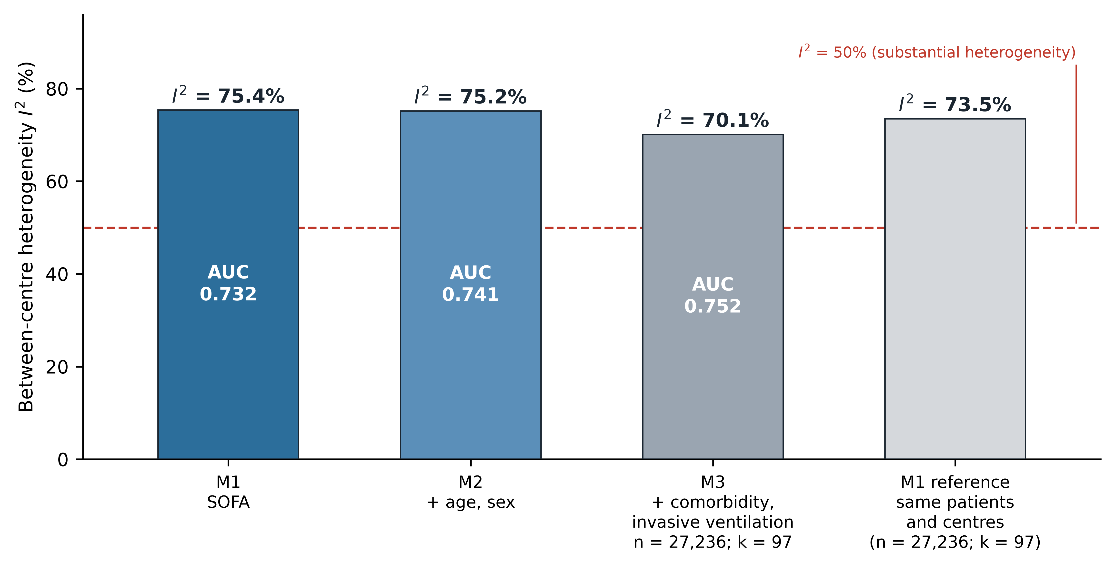
Supplementary Fig. S1. Measured case-mix barely reduces between-centre heterogeneity. Successive adjustment of the SOFA-based model: M1 = SOFA alone; M2 = + age, sex; M3 = + comorbidity burden (Charlson) + invasive ventilation. Bars show between-centre I² (random-effects meta-analysis, DerSimonian–Laird); numbers inside bars are the corresponding pooled AUCs. Adding age, sex, comorbidity burden and ventilation status raised the AUC by only 0.020 (0.732 → 0.752) while I² fell by just 5 percentage points (75.4% → 70.1%). The red dashed line marks the conventional threshold for substantial heterogeneity (I² = 50%). Note: unmeasured case-mix (disease spectrum, referral patterns, socioeconomic status, pre-hospital course) cannot be excluded as a contributor. The remaining variation is therefore reported descriptively as residual between-hospital variation and is NOT attributed to differences in quality of care.

Supplementary Figure S2. Position of the single-centre MIMIC-IV cohort within the eICU-CRD distribution of calibration offsets.
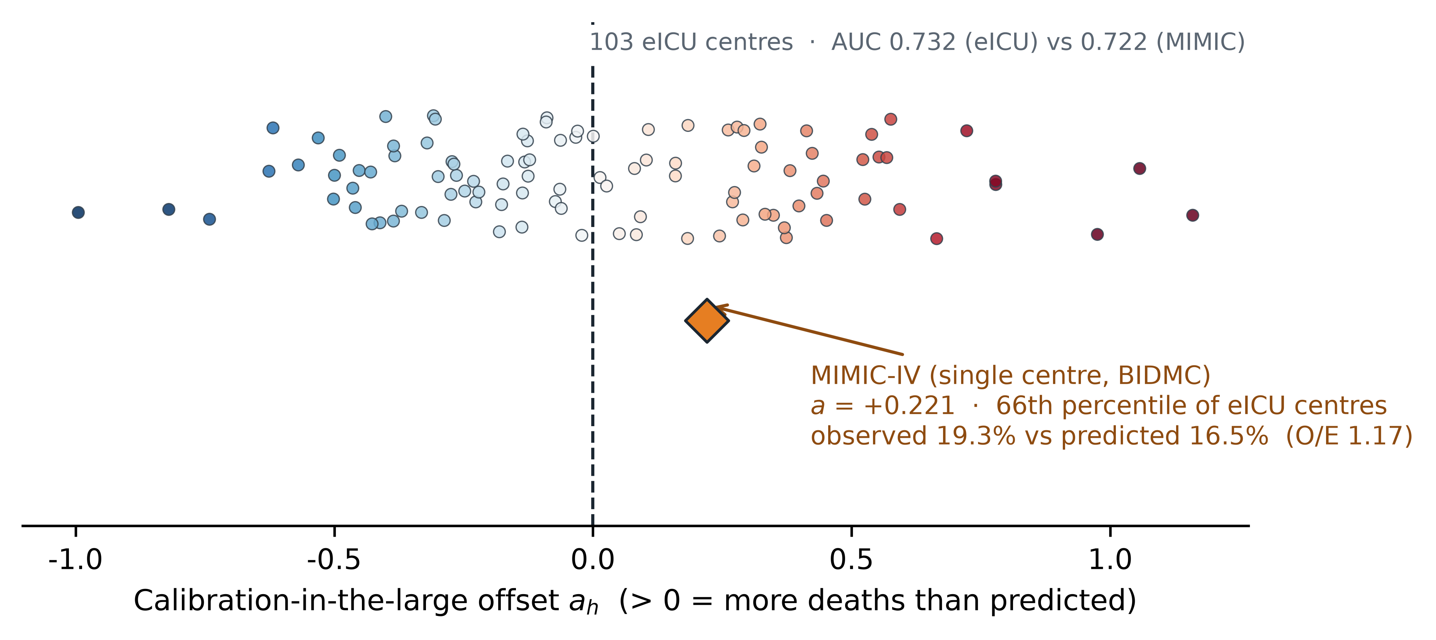
Supplementary Fig. S2. Position of a single-centre development cohort within the multicentre distribution. The eICU-derived SOFA model (full-cohort coefficients) was applied to MIMIC-IV (8,579 patients, 1,654 deaths, 19.3%). MIMIC-IV is shown as the orange diamond; the grey points are the 103 eICU centres. MIMIC-IV had an AUC of 0.722 (0.732 within eICU), observed mortality 19.3% versus predicted 16.5% (O/E 1.17), and a calibration offset a of +0.221 — the 66th percentile of the eICU distribution. The single-centre cohort is therefore not an outlier; the systematic miscalibration commonly observed when transporting a single-centre model reflects ordinary between-centre drift rather than an anomalous development cohort.

Supplementary Figure S3. Year-to-year stability of the calibration offset within hospitals.
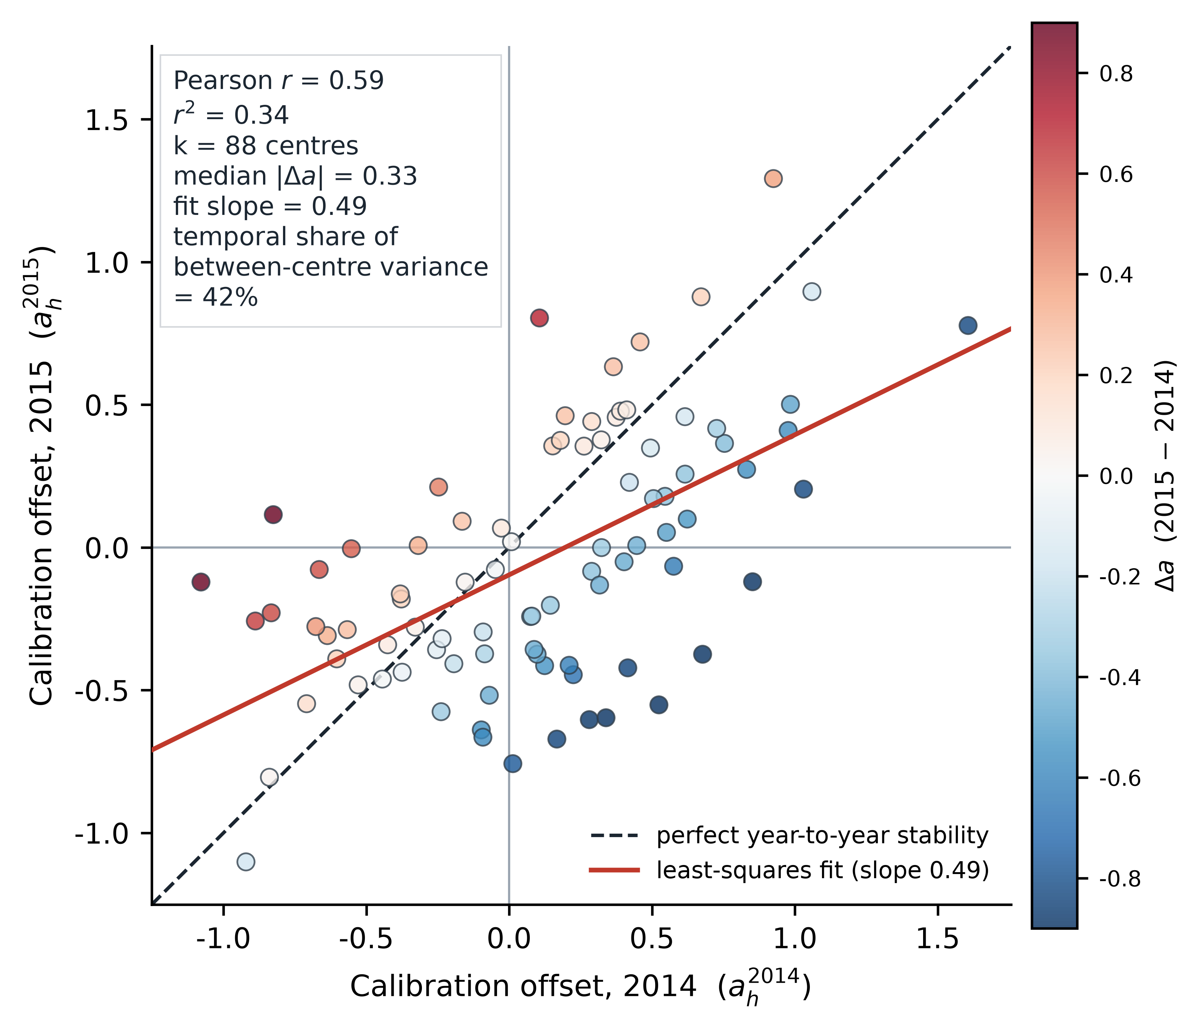
Supplementary Fig. S3. A centre's calibration offset is not a stable centre property. eICU-CRD covers 2014–2015; 88 centres contributed ≥50 patients and ≥5 deaths in each year. Each point is a centre: x = its calibration offset in 2014, y = its offset in 2015; colour = change (Delta a = 2015 − 2014). The dashed line is the identity line. The two years correlated at Pearson r = 0.586 (r² ≈ 34%; Spearman ρ = 0.563, P = 1.2×10⁻⁸); the median within-centre |Delta a| was 0.331 (P90 0.831). Variance decomposition attributed 41.6% of the total between-centre variance to the within-centre temporal component. A centre's offset estimated in one year explains only about a third of its offset in the next — any strategy relying on a one-off, fixed per-centre recalibration is inherently fragile.

Supplementary Table S1. Cohort characteristics.
Characteristic | eICU-CRD (all) | eICU-CRD (103 centres) | MIMIC-IV
Patients, n | 30,796 | 26,436 | 8,579
Hospitals, n | 187 | 103 | 1
Male, n (%) | 15,538 (50.5) | 13,396 (50.7) | 4,338 (50.6)
Age, years, mean (SD) | 77.0 (7.7) | 76.9 (7.7) | 77.7 (8.3)
Charlson comorbidity index, mean (SD) | 0.9 (1.3) | 0.9 (1.3) | 3.5 (2.5)
Missing data, n (%)
└ Severity scores (SOFA / OASIS / SAPS-II) | 0 (0) | 0 (0) | 0 (0)
└ Age, sex, invasive ventilation | 0 (0) | 0 (0) | 0 (0)
└ In-hospital death (outcome) | 0 (0) | 0 (0) | 0 (0)
└ Charlson comorbidity index | 3,560 (11.6) | 2,807 (10.6) | 3 (0.04)
Invasive ventilation, n (%) | 6,683 (21.7) | 6,134 (23.2) | 2,062 (24.0)
SOFA score, mean (SD) | 4.3 (3.2) | 4.4 (3.3) | 5.5 (3.5)
OASIS score, median [IQR] | 27 [22–34] | 27 [22–35] | 33 [28–39]
SAPS-II score, median [IQR] | 35 [28–45] | 35 [28–45] | 41 [34–51]
ICU death, n (%) | 2,325 (7.5) | 2,094 (7.9) | 1,014 (11.8)
In-hospital death, n (%) | 3,901 (12.7) | 3,486 (13.2) | 1,654 (19.3)

Legend. Continuous variables are summarised as mean (SD) where the distribution was approximately symmetric in the full eICU-CRD cohort and as median [interquartile range] otherwise; the same summary is used for that row in all three columns. Percentages are column percentages and may not sum to 100 because of rounding. eICU-CRD (103 centres) is the subset of patients contributing to the centre-level analyses. Missing data are reported for every analysis variable; all variables except the Charlson comorbidity index are complete, so no imputation was performed. Comorbidity index enters only the descriptive case-mix analysis, which uses complete cases; every other analysis uses a set with no missing values.

Supplementary Table S2. Between-centre variance estimated under four frameworks.
Estimation framework | τ² | I², % | Pooled mean (ā) | Relative difference from two-stage median
DerSimonian–Laird (two-stage) | 0.1312 | 75.35 | +0.030 | —
Paule–Mandel (two-stage) | 0.1261 | 75.35 | +0.0304 | −3.9%
REML (two-stage) | 0.1299 | 75.35 | +0.0301 | −1.0%
One-stage multilevel logistic | 0.0648 | — | +0.0745 | −50.1%

Legend. Two-stage estimates were obtained by random-effects meta-analysis of the 103 hospital-level calibration offsets. The one-stage estimate was obtained by fitting a random-intercept logistic regression to patient-level data (26,436 patients, 103 groups) by maximum a posteriori estimation; τ² is the square of the estimated random-effect standard deviation. Maximum a posteriori estimation of a variance component is sensitive to initialisation; repeated fits give standard deviations of 0.247–0.255 (τ² 0.061–0.065), and an independent marginal-likelihood calculation gave τ² = 0.0706. Pooled mean ā is reported with random-effects weights for the two-stage frameworks. The pre-specified criterion required the relative range across the three two-stage estimators to be < 25% (observed 3.9%, met) and the one-stage estimate to lie within 50% of their median (observed −50.1%, not met); the disagreement is reported as a negative finding.

Supplementary Table S3. Sensitivity of the empirical-Bayes result to the choice of between-centre variance.
Local patients (m) | τ² = 0.1312 (DL) | τ² = 0.0706 (marginal likelihood) | τ² = 0.0648 (multilevel)
25 | 15.5% → 24.3% (+9.1, P = 2.3 × 10⁻¹¹³) | 15.5% → 21.9% (+6.7, P = 2.7 × 10⁻⁶⁴) | 15.5% → 21.7% (+6.5, P = 1.3 × 10⁻⁶⁰)
50 | 19.7% → 26.4% (+6.7, P = 1.4 × 10⁻⁶¹) | 19.7% → 24.3% (+4.6, P = 1.6 × 10⁻²⁹) | 19.7% → 23.8% (+4.2, P = 1.4 × 10⁻²⁴)
100 | 25.7% → 30.4% (+4.7, P = 1.2 × 10⁻¹⁸) | 25.7% → 27.7% (+2.0, P = 4.6 × 10⁻⁴) | 25.7% → 27.6% (+1.9, P = 0.001)
200 | 32.3% → 34.4% (+2.0, P = 0.035) | 32.3% → 32.6% (+0.2, P = 0.832) | 32.3% → 32.5% (+0.2, P = 0.889)

Legend. Each cell gives the success rate of naive local recalibration → that of empirical-Bayes shrinkage, with the difference in percentage points and the two-sided Wilcoxon signed-rank P value across paired (hospital, replicate) observations; α = 0.05. Two hundred resampling attempts were used per cell, on the same draws for all three values of τ², so that the columns differ only in the variance used for shrinkage. The three candidate values were chosen to span the range produced by the estimation frameworks compared in Supplementary Table S2: 0.1312 (DerSimonian–Laird, used in all primary analyses), 0.0706 (marginal likelihood) and 0.0648 (one-stage multilevel). The pre-specified criterion — that shrinkage exceed naive recalibration at m = 25 — was met under all three values (all P < 10⁻⁵⁹). The magnitude of the advantage depends on τ² and the advantage is not statistically detectable at m = 200 for the two smaller values, which is why the strategy is described as one for small local samples rather than a general replacement for naive estimation.

Supplementary Table S4. Characteristics of the eligible (103) and excluded (84) centres, all 187 hospitals.
Centre group | Centres, k | Patients per centre, median (IQR) | Mortality, median | SOFA, mean | Ventilated, %
Eligible (≥100 patients and ≥10 deaths) | 103 | 224 (166–306) | 12.7% | 4.39 | 23.2
Excluded (below that threshold) | 84 | 47 (19–78) | 9.0% | 3.48 | 12.6

Legend. All 187 hospitals that contribute patients to the pooled model were characterised from the analysis cohort; means are patient-weighted within each group of centres. The excluded 44.9% of centres are smaller and less severely ill on average; how their calibration offsets behave cannot be estimated within the prespecified centre-level framework, and the direction of any resulting difference in the between-centre variance is discussed in the main text.

Supplementary Table S5. Success rates under the prespecified ±20% band (|O/E − 1| ≤ 0.20), secondary measure.
Analysis | Strategy | m = 25 | m = 50 | m = 100 | m = 200 | m = 400
E (learning curve, naive) | S1 | 30.6% | 39.3% | 48.9% | 62.8% | —
E (learning curve, naive) | S2 | 30.2% | 38.7% | 48.8% | 62.1% | —
I (shrinkage, eICU) | S1 | 31.0% | 38.3% | 48.4% | 59.9% | —
I (shrinkage, eICU) | S2 | 30.4% | 38.2% | 48.2% | 59.8% | —
I (shrinkage, eICU) | S3 | 47.9% | 51.0% | 56.4% | 61.4% | —
J (transfer, MIMIC-IV) | S1 | 42.0% | 49.5% | 71.5% | 84.5% | 97.0%
J (transfer, MIMIC-IV) | S3 | 82.0% | 80.0% | 85.0% | 89.0% | 98.0%

Legend. The prespecified 50% target applies only to the ±10% band; this table reports the ±20% secondary band named in the prespecified analysis plan and Methods. Under ±20%, naive recalibration at 25 patients remains worse than no recalibration on eICU (30.6% versus 41.7%), the empirical-Bayes advantage is undiminished (47.9% versus 31.0%; transfer 82.0% versus 42.0%), and rates converge at larger m as in the primary band. The no-recalibration benchmark is a centre-level residual and is independent of m: 21.4% (±10%) and 41.7% (±20%).

Supplementary Table S6. Variable definitions and coding.
Variable | Source | Definition (units) | Coding
stay identifier | eICU-CRD / MIMIC-IV native | database stay/patient identifier, used only for pairing and first-stay logic | identifier (no clinical meaning)
hospital | eICU-CRD native (de-identified) | contributing hospital of the unit stay; drives the centre-level analyses | identifier
age | eICU native record; MIMIC-IV derived | age at ICU admission, years | numeric; eICU records ages >89 as 90, MIMIC-IV censors them (91 at anchor year)
sex | both native | recorded sex | male = 1, female = 0
SOFA | derived per published score | Sequential Organ Failure Assessment from native physiology/laboratory items; components per the published definition | integer 0–24; standardised (z-score) in pooled models
OASIS | derived per published score | Oxford Acute Severity of Illness Score from admission variables | integer in published range; standardised
SAPS-II | derived per published score | Simplified Acute Physiology Score II | integer in published range; standardised
invasive ventilation | eICU-CRD / MIMIC-IV native as supplied | recorded invasive ventilation during the stay | 1 = yes, 0 = no
hospital death | eICU-CRD (hospital discharge outcome); MIMIC-IV native | death before hospital discharge of the index admission | 1 = died, 0 = survived
ICU death | eICU-CRD (unit discharge outcome); MIMIC-IV native | death before ICU discharge | 1 = died, 0 = survived
Charlson index | derived from coded diagnoses (published weights) | comorbidity burden | numeric; missing in 11.6% (eICU-CRD) and 0.04% (MIMIC-IV); complete cases in model M3
albumin, height, weight | eICU-CRD / MIMIC-IV native | used only for the extraction rule (excluded when all three are missing: 141 eICU-CRD, 15 MIMIC-IV; Figure 1) | not analysed in this study

Legend. All variables are taken or derived from the two source databases and were used as supplied except where a derived definition is given in Methods (the calibration offset, its standard error, the calibration slope, and age at admission for MIMIC-IV). Derived scores follow the published component definitions of the respective scores. Coding is repeated here for reader convenience; this table changes no reported result, and patient-level values are not redistributed (Data Availability statement).

Supplementary Note
Prespecified analysis plans: index, chronology and disclosures
Manuscript: Discrimination transports, calibration does not: calibration drift in severity scoring across 187 intensive-care units
Prepared 2026-10-19. This supplement contains, verbatim, the analysis plans that were written before the corresponding analyses were executed, together with file-system timestamps, an explicit disclosure of one timestamp defect, and an English summary of each plan.
Note on language. The original plans are reproduced in their original language (Chinese), unaltered, because they are the primary record of what was specified before what was computed. Translating them at this stage would break the chain between plan and result. An English summary of each plan is provided below so that the content is accessible to readers of the submitted manuscript. The bracketed file names throughout this supplement (chronology table and P0–P6 headings) are likewise the verbatim file names of the public repository, retained unaltered: file names are identifiers, not prose, and each name can be checked directly against the repository linked in Data Availability.
S1.1 Chronology
# | Plan file | Written | Result file | Result written | Interval
P0 | 路B_预注册.md (feasibility probe) | 2026-10-19 06:25:26 | probe output (I² = 75.2%, 112 centres) | same run | —
P1 | 分析计划_预注册.md (analyses A–D) | 2026-10-19 06:34:11 | drift_results.json | 06:34:27 | 16 s
P2 | 学习曲线_预注册.md (analysis E) | see S1.2 | learning_curve_raw.csv | 07:06:05 | see S1.2
P3 | 分析计划_第二批.md (analyses F–H) | 2026-10-19 07:38:50 | batch2_results.json | 07:38:53 | 3 s
P4 | 分析计划_分析I.md (analysis I) | 2026-10-19 07:56:49 | shrinkage_raw.csv | 08:12:05 | 15 min
P5 | 分析计划_分析J.md (analysis J) | 2026-10-19 09:41:03 | mimic_external_summary.json | 09:41:43 | 40 s
P6 | 分析计划_分析K.md (analysis K) | 2026-10-19 10:43:49 | tau2_framework.json | 10:43:54 | 5 s

Six of the seven plans carry file-system timestamps that are demonstrably earlier than the outputs they govern, several by seconds.
S1.2 Disclosure of a timestamp defect (plan P2)
We disclose this rather than conceal it, because it is exactly the kind of defect this supplement exists to surface.
What happened. The content of 学习曲线_预注册.md is generated programmatically from the module docstring of analysis_learning_curve.py. That docstring has never been edited. However, a caching feature was later added to the script for development speed, and the script rewrites the plan file on every run. This refreshed the file's modification time to 2026-10-19 11:16:14, which is later than the output it governs (learning_curve_raw.csv, 07:06:05). The modification time of P2 is therefore no longer admissible as evidence of precedence.
What still supports precedence. The run that first produced learning_curve_raw.csv at 07:06:05 executed, by program order, the write of the plan file before entering any computation. The plan therefore existed, in the content reproduced in this supplement, no later than 07:06:05.
Remediation. (i) A provenance note was appended to the plan file itself, recording the defect and the supporting argument. (ii) The writing of every plan file was changed to be idempotent — an existing plan is never overwritten — so that file timestamps can no longer be disturbed by re-runs. This was applied to all seven analysis scripts.
S1.3 Classification of analyses: exploratory versus confirmatory
This classification was fixed after the analyses were complete and is reported for transparency. It is not a claim that the plans in S1.1 were all confirmatory.
Class | Analyses | Basis | Outcome
Exploratory / descriptive | A, B, C, D, F, G, H | No pre-specified threshold; magnitudes estimated and described | Results reported as descriptive estimates with no hypothesis test
Confirmatory (pre-specified criterion) | E, I, J, K | Each plan stated an explicit criterion and an explicit instruction for the case where it was not met | E: criterion not met (success rate never reached 50%) — reported as such. I, J: criterion met. K: criterion not met (two-stage and one-stage τ² differ by ~2-fold) — reported as such

Two of the four pre-specified criteria were not met, and both are reported in the manuscript as negative findings rather than being reframed post hoc. In particular:

• Analysis E pre-specified "report the smallest m at which the success rate reaches 50%; if none is
reached, state so." The answer was no such m exists within 200 local patients, which is reported.

• Analysis K pre-specified agreement between two-stage and one-stage estimators of τ² (relative range
< 25%, and within 50% of the meta-analytic median). This was not achieved (the multilevel estimate was 50.1% lower than the two-stage median), and the disagreement is reported together with a proposed mechanism and a sensitivity analysis of the main conclusion.
The primary descriptive findings (heterogeneity magnitude, its relation to measured case-mix, its temporal instability and its clinical consequences) are estimates, not tests, and are presented as such.
S1.4 English summaries of the plans
P0 — Feasibility probe (路B_预注册.md)
Question: does the calibration of an acute-severity score vary across individual centres? Design: pooled logistic model (SOFA + age + sex) fitted on the full eICU-CRD cohort; per-centre calibration-in-the-large offset a_{h}; between-centre heterogeneity by random-effects meta-analysis. Pre-specified criterion: I² > 50% AND ≥ 100 centres with ≥ 100 patients → the research direction is viable. Outcome: met (I² = 75.2%, 112 centres).
P1 — Analyses A–D (分析计划_预注册.md)
A–B: per-centre drift quantified for SOFA, OASIS and SAPS-II, including per-centre calibration slope. C: a case-mix ladder (M1 = score; M2 = + age, sex; M3 = + comorbidity, invasive ventilation) testing whether I² falls as covariates are added. D: positioning of the single-centre MIMIC-IV cohort within the eICU distribution. Wording red line: variation not explained by measured case-mix must be termed residual between-hospital variation and must not be attributed to quality of care.
P2 — Analysis E, learning curve (学习曲线_预注册.md)
For each centre (n ≥ 200) and each m ∈ {0, 25, 50, 100, 200}, requiring n ≥ 2m, m patients were drawn for local recalibration and the remainder used for evaluation; each (centre, m) cell repeated 100 times. Two strategies compared: intercept-only, and intercept plus calibration slope. Pre-specified criterion: report the smallest m at which the success rate reaches 50%; if none is reached, state so. Outcome: not met — the success rate never reached 50% within 200 patients.
Implementation note (added 2026-10-21 during the submission-quality review). The executed pipeline applied the n ≥ 2m rule to all 103 centre-eligible hospitals; the centre-level filter of n ≥ 200 stated in the plan took effect only at m ≥ 100, so the cells with m = 0, 25 and 50 also include 44 centres with 100–199 patients. A sensitivity run restricted to centres with n ≥ 200 changed no success rate by more than 1.1 percentage points (S1: m = 0, 21.4% → 20.3%; m = 25, 15.3% → 15.9%; m = 50, 20.0% → 21.1%; S2 changes ≤ 0.3 points; cells with m ≥ 100 are identical by construction), and the pre-specified criterion was unaffected in either setting: the success rate never reached 50%. The reproduction script analysis_learning_curve_filter_check.py and its output learning_curve_filter_sensitivity.json are included in the repository.
P3 — Analyses F–H (分析计划_第二批.md)
F: split-half temporal stability — per-centre offset in 2014 versus 2015 (centres contributing ≥ 50 patients and ≥ 5 deaths in each year), reported as correlation, median |Δa| and the temporal share of between-centre variance. G: stratification of heterogeneity by centre size tertiles. H: clinical impact — per-centre net benefit and positive predictive value at decision thresholds 0.10–0.40. Wording red line: a low split-half correlation indicates that the apparent between-centre variation contains an unstable component; it must not be described as unstable quality of care.
P4 — Analysis I, shrinkage (分析计划_分析I.md)
Compares four strategies — no recalibration (S0), naive intercept-only (S1), naive intercept plus slope (S2), and empirical-Bayes shrinkage (S3), a_{EB} = ā + λ(a_{MLE} − ā) with λ = τ²/(τ² + SE²) — with ā and τ² estimated by leave-one-centre-out cross-fitting so that no centre's evaluation data enters its own shrinkage parameters. Pre-specified criterion: at m = 25 the ±10% success rate of S3 must exceed S1, and at m ≥ 100 S3 must not be worse than S1 by more than 5 percentage points. Outcome: met.
P5 — Analysis J, cross-database transfer of the shrinkage parameters (分析计划_分析J.md)
MIMIC-IV (8,579 patients) treated as a single new centre; the shrinkage target ā = +0.030 and τ² = 0.131 were fixed from eICU and never re-estimated on MIMIC-IV; the true offset to recover was â = +0.221. Pre-specified criterion: at m = 25 the ±10% success rate of S3 must exceed both S1 and S0. Outcome: met. Wording red line: MIMIC-IV is a single-centre database; this analysis tests transfer of the shrinkage parameters across databases and is not multicentre external validation of the strategy.
P6 — Analysis K, τ² estimation framework (分析计划_分析K.md)
The between-centre variance τ² re-estimated under four frameworks — DerSimonian-Laird, Paule-Mandel, REML (two-stage random-effects meta-analysis) and a one-stage random-intercept multilevel logistic model fitted on patient-level data. Pre-specified criterion: relative range of τ² across the three two-stage estimators < 25%, and the multilevel estimate within 50% of their median. Outcome: first clause met (range 3.9%); second clause not met (multilevel τ² = 0.065, i.e. 50.1% lower). Reported as a disagreement, with a proposed mechanism (the fixed-slope two-stage estimator absorbing part of the between-centre slope variation) and a sensitivity analysis showing that the main conclusion holds under all three τ² values.
S1.5 Why no prospective registry registration is claimed
This study is a retrospective secondary analysis of already-public databases. All analyses were executed before this supplement was assembled, so no prospective registry entry (OSF or otherwise) can honestly be claimed, and none is. The plans reproduced here constitute the authors' contemporaneous record of analysis specification. For transparency we note that a registry entry made at this stage would be a post-hoc registration and would carry none of the protections that prospective registration provides.
Two criteria pre-specified in this supplement (P2 and P6) were not met, and are reported as negative findings in the manuscript.
S1.6 Disclosure: a post-hoc correction to the weighting of the shrinkage target
This is disclosed rather than quietly applied, and it affects the numeric values of analyses I and J.
What was wrong. The empirical-Bayes shrinkage estimator is written in the plans as a_EB = ā + λ(a_MLE − ā) with λ = τ²/(τ² + SE²). The shrinkage intensity λ came from the hierarchical model a_h ~ N(ā, τ² + SE²), but the shrinkage target ā had been estimated with fixed-effect weights (1/SE²), which is the estimate implied by τ² = 0. The two halves of the estimator therefore rested on mutually contradictory assumptions.
Why the corrected value is the right one. Under the hierarchical model that λ assumes, the maximum likelihood estimate of ā is the random-effects weighted mean Σ(a_h/(SE²+τ²)) / Σ(1/(SE²+τ²)). The same programme already used random-effects weights for the pooled standard error seRE and for the pooled mean reported in analysis K, so the fixed-effect value was additionally internally inconsistent with quantities reported elsewhere in the same manuscript.
Does this violate the pre-specified plans? The plans specify what ā and τ² are ("estimated leave-one-centre-out" for analysis I; "fixed from eICU, never re-estimated on MIMIC-IV" for analysis J) but they do not specify the weighting scheme used to compute ā. No pre-specified criterion is changed by this correction, and no threshold is moved. The correction resolves an ambiguity in the plans; it is not a deviation from them.
Effect on the results.
Analysis J (MIMIC-IV), S3 success rate (±10%) | ā fixed-effect (original) | ā random-effects (corrected)
m = 25 | 53.5% | 47.0%
m = 50 | 49.0% | 46.0%
m = 100 | 55.0% | 56.0%
m = 200 | 68.5% | 66.0%
m = 400 | 75.0% | 75.0%

The pre-specified criterion for analysis J (at m = 25, S3 must exceed both S1 and S0) is met under both values and is therefore not affected. The paired advantage over naive recalibration at m = 25 falls from +30.0 to +23.5 percentage points (P = 6.3 × 10⁻⁷). Because the corrected success rate at m = 25 now sits below naive recalibration at m = 200, the comparative statement about the reduction in local sample size is reported from the corrected values throughout.
A pre-existing inconsistency is reported for transparency. Under the original fixed-effect value the analyses all reported smaller standard errors of the pooled estimate than were actually used; this did not affect any point estimate reported outside analyses I and J, and no descriptive result in analyses A–H or K changes.
Not changed. All descriptive results (A–H and K) are unaffected: they depend on τ² and I², whose estimators were already using the correct fixed-effect weights for Q. Re-running analysis A–D after the correction reproduced every pre-existing field exactly, with the random-effects mean added as a new field.
S1.7 Specification details left open in the plans
These are recorded for completeness. Neither carries any degrees of freedom that could have been resolved in a direction favourable to the findings, and no pre-specified threshold is affected.
# | Left unspecified in the plan | What was done | Why this is not consequential
1 | Number of resamples in analysis I. The plan for analysis I fixes the four strategies, the leave-one-centre-out design, the metrics and the criterion, but never states how many times each (centre, m) cell is resampled. (Analysis J's plan does state it explicitly — 200 — and the learning-curve plan states 100; both were followed.) | 200 resamples per cell | More resamples reduce Monte-Carlo error in every arm equally. A different count would change the precision of the estimate, not its direction, and cannot move a strategy relative to the pre-specified threshold.
2 | Which paired test. The plans for analyses I and J specify a paired, two-sided comparison of success rates without naming the test. | Wilcoxon signed-rank test, two-sided | Selected as the standard paired non-parametric test and stated as such in Methods. A paired t-test on a 19,678-pair difference that is plainly non-normal would be the less appropriate choice; neither test can reverse a difference of the size observed (e.g. +9.05 percentage points).

3 | Two success rates for naive recalibration (15.3% vs 15.5%). The learning-curve plan (analysis E) fixes 100 resampling attempts per (centre, m) cell; the shrinkage plans (analyses I and J) fix 200 paired draws. Both plan provisions were followed. | Both reported; comparisons are within-panel | The two rates are computed on independent draws, so the 0.2-point difference is Monte-Carlo error, not discordance. Panels a–b and c–d of Figure 5 each state their own resampling scheme, and the body text now discloses the scheme difference in one sentence.

4 | ±20% secondary band unreported in v3. The prespecified plans (analyses E–J) define a secondary success band | O/E − 1 | ≤ 0.20 for optional co-reporting; the original submission reported only the primary ±10% rate. | Reported now in Supplementary Table S5 | The plan's wording commits to co-reporting ("alongside"). All raw resampling draws were retained, so the band was recomputed verbatim from the stored draws with no new sampling. Conclusions on the naive penalty and the EB advantage are unchanged in direction and survive under the looser band; convergence at larger m is faster, as expected.
5 | Centre-inclusion comparison (post-hoc, exploratory). The prespecified centre-level eligibility (≥100 patients, ≥10 deaths) excludes 84 of 187 centres; the plans prescribe no comparison of eligible versus excluded centres. | Supplementary Table S4, labelled post-hoc/exploratory | A comparison was computed from the retained analysis cohort only (no re-derivation). Excluded centres are smaller and less severely ill; the direction of the possible effect on the between-centre variance is discussed in the main text. No primary number changes.

The wording of both plans, unaltered, is reproduced in this item so that a reader can verify what was and was not specified.

