Response to the pre-review comments — two rounds consolidated
Manuscript: Discrimination transports, calibration does not: calibration drift in severity scoring across 187 intensive-care units. Round 1 comments (v2) + Round 2 audit of the response and of the v3 revised draft. Date: 2026-10-30.
Method note (unchanged in spirit, upgraded in the second round): every item is verified against the manuscript source files, the original figure raster, the generated PDF/DOCX text layer, raw statistic files, or the online DOI registry / OpenAlex records — and, for the contested round-2 items, additionally by page-level screen renders of the actual PDF (Appendix A), so that arguments about extraction artifacts can be settled by what a PDF reader displays.
# | Comment | Verdict | Response / evidence
M1 | 参考文献列表完全缺失 | REBUTTED for the submission file; FIXED in the pre-review draft | The submission manuscript and its DOCX/PDF contain all 32 references in the References section (automated check: 32 cited /[32] listed, no gaps). The missing list was an artifact of the integrated pre-review build — its generator matched numbered entries with the wrong pattern. v3 of the integrated draft reproduces all 32 entries as separate numbered paragraphs.
M2 | Table 1 排版崩坏，被压缩进单个单元格 | REBUTTED | The pre-review DOCX contains Table 1 as a true 8-row × 4-column Word table (verified cell by cell: header '…| SOFA | OASIS | SAPS-II', all rows present). The collapse occurred in the reviewer's PDF-to-text extraction, not in the file. No change needed; millimetre column widths were kept as reviewed.
M3 | 正文 139,367 vs 图 1 193,367 不一致 | REBUTTED | Direct inspection of the figure raster: the first-box label reads 'First ICU stay per patient (n = 139,367)', identical to text, legend and cohort/eicu_counts.json. No '193,367' exists anywhere in the repository. The digit transposition appears to arise in reading the box label.
M4 | Figure 2 图注顶部混入 '2020- 0.745' 残留 | REBUTTED (residual text); FIXED (LaTeX tokens) | The string '2020- 0.745' (and any '2020…0.745' juxtaposition) appears 0 times in the manuscript, the legend source, or the PDF text layer. The related point about unreadable $…$ markers in the integrated draft legends was real for that draft and is fixed in v3: all inline math now renders as plain text (I², τ², ā, â_EB, ≥ …). The submission files never contained the markers.
M5 | Figure 3/5 图注大量 LaTeX/\mathbb{…} 未渲染 | FIXED (in the integrated draft); REBUTTED for \mathbb | No 'mathbb' string exists in any source or output. The genuine defect was unrendered $I^2$, $\tau^2$, $a_h$, $\bar a$ tokens in the pre-review draft only; the submission already renders them (HTML→Word chain). The integrated draft v3 renders them natively as I², τ², aₕ-form plain text.
M6 | Analysis K 'no hypothesis tests' 表述不当；四个显判据分析未列出编号 | ACCEPTED | Methods now reads: 'Analysis K applied a prespecified agreement criterion to point estimates rather than a formal hypothesis test; the criterion is reported as met or not met.' The four explicit-criterion analyses are now enumerated as (E, I, J, K) at first mention.
M7 | Charlson 缺失 11.6% 的 complete-case 论证不足 | PARTIALLY ACCEPTED (reporting now; re-analysis deferred) | Limitations now states: 'The case-mix ladder uses only complete cases (comorbidity missing in 11.6% of eICU patients); the direction of bias is unknown.' The set-sensitivity is already on record (complete-case M3: n = 27,236, 97 hospitals; I² 70.1% vs 73.5% on the same 97-hospital subset; see 03_统计/casemix_set_sensitivity.json — case-mix covariates move I² by ~2–3 points). A missing-indicator variant would require a registered protocol amendment; deferred to the post-submission round and flagged in the response.
M8 | MIMIC-IV anchor_age 校正公式未写出 | ACCEPTED | Cohort construction now reads: 'age at admission = anchor_age + (admission year − anchor year)'. The eICU counterpart (ages >89 recorded as 90) remains stated in Figure 1 and Methods.
M9 | net benefit 的 treat-all 语境与 TP/FP 分母未写明 | ACCEPTED | Methods now states: 'n is the centre's entire cohort, not only flagged patients; the implicit comparator is treat-all at the same threshold.' The decision-threshold table (0.10–0.40) and the PPV-forward framing are unchanged.
M10 | Calibration slope 模型式与收敛情况缺失 | ACCEPTED | Methods now gives the fitted model as logit(y) = α_h + β_h logit(p̂) with free intercept, and reports from the deliverable hospital-level file: all 103 slopes per score converged, none exceeded |β_h| = 5 (largest 2.24, SOFA); slopes >1/<1 are glossed as steeper/compressed gradients.
m1 | 摘要 P = 3.7×10⁻¹¹² 复核；请报 effect size | ACCEPTED (clarified); numbers unchanged | The value is the paired Wilcoxon signed-rank test on identical draws, large-sample normal approximation; Methods now says so explicitly ('normal approximation'). Effect size is already reported at every m as paired differences in percentage points (+9.05 at m = 25; +19.0/+15.5/+13.0/+4.0 at 50/100/200/400), so the extremely small P value is corroborated, not load-bearing. The statistic is frozen in 03_统计 and re-checked by the regression suite.
m2 | '15.3% vs 15.5%' 两条成功率的注释位置 | ACCEPTED | The in-text note is removed from Results; the full explanation now lives in Supplementary Item S1 implementation-disclosure table (row 3). Results keeps one sentence: independent resampling schemes (100 attempts per cell vs 200 paired draws); comparisons are within, not between, panels.
m3 | Figure 4b '112 centres' vs 主分析 103 不一致 | ACCEPTED | The net-benefit computation (analysis_batch2.py) screens only on n ≥ 100, giving k = 112 (17.0%/6.2% negative-net-benefit figures are on exactly these 112). The Figure 4 legend now says: '112 centres with ≥100 patients — the net-benefit calculation is defined for all of them, including the 9 centres below the ≥10-death criterion used for the primary between-centre analyses.'
m4 | 41.6% temporal 成分不可外推为任意两年 | ACCEPTED | Limitations adds: 'The 41.6% temporal share is specific to those two years, not a portable constant.'
m5 | '41.6% temporal in origin' 因果措辞 | ACCEPTED | Discussion now reads: 'A hospital offset of which 41.6% of the variance is temporal cannot be fully corrected by a permanent recalibration…'
m6 | Charlson 3.5 vs 0.9 应在 Results 出现一次 | ACCEPTED | Results, External-application paragraph, now adds: 'MIMIC-IV's higher recorded Charlson index (3.5 vs 0.9) reflects more complete ICD coding, not case-mix difference; the model has no comorbidity term.'
m7 | λ 需要直观解释 | ACCEPTED | Results adds: 'The shrinkage weight λ is a reliability weight: when SE² dominates τ², λ→0 and the local estimate collapses to the pooled mean; when τ² dominates, λ→1 and it is retained.'
m8 | six-fold 减少需要插值细节与跨 panel 声明 | ACCEPTED (claim verified; sentence added) | The interpolation arithmetic checks out: naive reaches 40.5% at m = 100 and 53.0% at m = 200 (linear in m: 152 ≈ 100 + 100 × (47.0 − 40.5)/(53.0 − 40.5)); 152/25 ≈ 6 → 'approximately six-fold'. The new sentence: 'That comparison crosses resampling schemes (Fig. 5c vs 5d) and is illustrative.'
m9 | Figure 5d 在 m = 50 的下凹 | ACCEPTED (quantified; re-run not needed) | From the deliverable raw file, the EB-transfer success rates are 47.0% (m = 25) and 46.0% (m = 50): the dip is 1.0 percentage point, with SE of a 200-draw rate ≈ 3.5 points (≈0.3 SE), i.e. comfortably within Monte-Carlo error. The legend now says so with the explicit SE; the redundant qualitative sentence was removed.
m10 | STROBE/TRIPOD 段落位置；[23][24] 编号核对 | ACCEPTED | The Discussion paragraph is shortened to its rationale and re-titled 'Reporting standards' (citations [[TRIPOD_CLUSTER]], [[TRIPOD_AI]], [[STROBE]], [[RECORD]] in the same order). The citation audit passes at 32/32 with every listed entry cited in reading order, so [23]–[26] correspondence is verified.
E1 | I²/I^2、τ²/t²、O/E、a_h/a 符号不一致 | FIXED (integrated render); notation clarified | All source text already uses unicode I² and τ²; 't² = 0.131' does not exist in any file. In the integrated draft the $…$ render fix now makes legends match the body. On a_h vs a: a denotes the pooled/global calibration offset and a_h the per-hospital offsets — this distinction is deliberate and is defined at first use ('a_h, the hospital-specific offset'); â marks estimates.
E2 | 图注中 '$…$' 与 'S…S' 混排残留 | FIXED (integrated draft); REBUTTED for 'S…S' | Same root cause as M5: unrendered $…$ in the pre-review build. The 'S…S' pattern has no source; it is how the reviewer's extractor rendered |$a$|-style delimiters. Submission files are clean.
E3 | '1. Fig. 3)' 断句残留 | REBUTTED | No such string in the PDF text layer or in any source file.
E4 | 'For sources were considered' 应为 Four | REBUTTED | Methods reads 'Four sources were considered.' (verified against Methods.md and the PDF layer).
E5 | '2020- 0.745' 残留 | REBUTTED | Zero occurrences anywhere (see M4). The only '2020' tokens near that page are reference years.
E6 | 图注 'the m* benchmark' 中 m* 未定义 | ACCEPTED (clarity), chiefly REBUTTED | The legend already reads 'the S0 line is the within-m benchmark (not a learning effect)'; the 'm*' glyph is again an extraction artifact. The sentence was expanded anyway to 'the no-recalibration rate at that same m (not a learning effect)'.
E7 | 表注 'P, proportion' 应为 I² | REBUTTED; header suggestion ACCEPTED | The Table 1 note in source and output reads 'I², proportion of total variation attributable to between-centre heterogeneity.' Optionally, the header was changed per your suggestion to 'Between-centre heterogeneity, I² (%)'.
E8 | [1]–[32] 编号逐条核对 | ALREADY VERIFIED | The automated audit (run before and after this revision round) confirms: 32 in-text citations, 32 listed entries, none missing, none uncited, numbering follows first occurrence in Reading order.
E9 | Zenodo DOI 疑似占位 | REBUTTED (verified online) | https://doi.org/10.5281/zenodo.23479141 resolves (HTTP 200) to Zenodo record 23479142, titled 'Cross-centre calibration drift of acute severity scores'. The concept DOI points to the publicly archived code repository (v1.1). It is live and citable, not a placeholder.
E10 | 图 1 与正文叙述顺序一致性；三处 (n=141)/(n=15) 核对 | REBUTTED (already consistent) | Figure 1 and the Methods narrative follow the same step order: first ICU stay → age ≥65 → LOS ≥24 h → medical ICU → exclude deaths <24 h → exclude missing outcome status → exclude albumin/height/weight all missing. The exclusion boxes branch from the fifth box in both cohorts, matching Methods sentence order. The three numeric mentions (141, 15) agree.
NEW (found during audit) | Figure 1: column titles overlapped the blue source-box subtitles | FIXED | The two bold panel titles were drawn over the first box's subtitle row (the raster shows overprinted text). Root cause: title baseline y = 28.6 vs first box spanning y 27.0–29.4. Title raised and the main chain lowered by 1.3 units; figure regenerated and re-checked; the submission package and integrated draft now carry the corrected raster/PDF.
R2-M3 | 核对：Figure 1 图注仍是 193,367 | REBUTTED (page-level evidence) | The '193,367' insists a third time and is again a reading artifact: the assembled Figure 1 legend in text and on the rendered page (Appendix A-1) reads 'first ICU stay per patient (139,367)'. A full-text scan of the v3 PDF contains '193,367' 0 times and '139,367' twice (Methods + legend). The same digit transposition (139→193) recurs across both rounds from the reviewing pipeline.
R2-M4/E5 | 核对：Figure 2 上方仍有 '2020- 0.745)' | REBUTTED (source string identified) | The reviewing pipeline keeps transcribing the in-figure annotation of Figure 2. Its actual string is 'pooled AUC 0.732 (95% CI 0.720–0.745)' (Appendix A-2, visible top of the panel; source: figures_drift.py line 51). '(0.720–' is read as '(2020-'. The token '2020-' occurs 0 times in the manuscript, the legend source and the PDF text layer; the only '2020' tokens are reference years.
R2-M2 | 核对：v3 的 Table 1 仍是单单元格压缩串 | REBUTTED (page-level evidence) | Appendix A-3 is a screen render of v3 page 4: Table 1 displays as a complete 8-row × 4-column ruled grid. The '<table>…' string quoted by the reviewing pipeline cannot occur in any PDF; it is emitted by the pipeline's own HTML export step. The DOCX carries the same true Word table (verified cell by cell). Submission files unchanged and correct.
R2-M10 | 核对：v3 把斜率模型写成 log(y) = α + β log(p) | REBUTTED (page-level evidence) | Appendix A-4 (v3 page 16) renders the sentence: 'Within each hospital we fitted logit(y) = α_h + β_h logit(p̂) with a free intercept and retained β_h. All 103 slopes per score converged; none exceeded |β_h| = 5 (largest 2.24, SOFA). Slopes above 1 indicate a steeper risk gradient…'. The PDF text layer contains 'logit(y)' once and 'log(y)' zero times — the 'log(y)' form in the reviewing pipeline drops the letters 'it' and the hat, so no error exists to correct.
R2-M1 | 核对：文献仍粘连、[2] 缺左括号、24) 缺左括号 | REBUTTED (page-level evidence) + ACCEPTED (DOIs) | Text layer: '[2] Johnson…' occurs verbatim with intact brackets; the PDF renders each of the 32 entries as its own paragraph (Appendix A-5, page 21). Separately, the reviewer's request to document the four 2026 references was justified and is now satisfied — see the VAN_GELOVEN row.
R2-REFS | 四条 2026 年文献需 DOI/PMID 核实 | ACCEPTED — and a real author error found and fixed | All four are real, verified via OpenAlex/Crossref: [13] Zhang Z. et al., Gland Surg. 15, 1274 (2026), doi:10.21037/gs-2026-0217; [14] Yamamoto R. et al., medRxiv 2026.04.05.26350209, doi:10.64898/2026.04.05.26350209; [20] Salluh J.I.F. et al., Curr. Opin. Crit. Care 32, 523–530 (2026), doi:10.1097/mcc.0000000000001411; [22] — the paper exists but was author-misattributed: the published record is El Arab, R. A., Mustafa, M. H., Almagharbeh, W. T., Saleem, N. H. et al. (Healthcare 14, 1459 (2026), doi:10.3390/healthcare14111459), not 'van Geloven, N.' The reference has been corrected and DOIs added to all four entries. Thanks for forcing this verification.
R2-E1 | 核对：t² 与 τ² 混用多处 | REBUTTED | Text layer: 't²' 0 occurrences, 'τ²' 50. The quoted '\(\mathrm{t}^2\) fell from 0.131 to 0.106' corresponds to the Typeset τ² in 'τ² fell from 0.131 to 0.106' (case-mix ladder section); the τ glyph plus superscript is read as a latin 't' by the reviewing pipeline. Appendix A-4 shows the actual typesetting.
R2-E7 | 核对：表注仍为 'P, proportion' | REBUTTED (page-level evidence) | Appendix A-3 (page 4) — the note reads 'I², proportion of total variation attributable to between-centre heterogeneity', exactly as round 1 verified at source level. The bold italic 'I²' glyph is read as 'P' by the pipeline.
R2-E3 | 核对：Page 6 仍有 '1. Fig. 3)' | REBUTTED | The file context is '…showed heterogeneity of comparable magnitude (Table 1, Fig. 3). Because all three scores are established…' — clean in source and PDF text layer ('1. Fig. 3)' 0 occurrences). The '1.' prepended by the pipeline is its own page-boundary artifact (same mechanism in both rounds
R2-E6 | 核对：m* 字形仍在 | ACCEPTED (de-italicised) | The round-1 rendering set 'within-m' in italics, whose trailing asterisk the pipeline again read as a superscript marker. The whole phrase is now plain text: 'the S0 line is the within-m benchmark — the no-recalibration rate at that same m (not a learning effect)'.
R2-Fig5 | 核对：图注用 Δ 与正文 a 两套符号；[a] 应为 |a| | REBUTTED | The Figure 5 captions use the a-family throughout: ā = +0.030, â_EB = ā + λ(â_ML − ā), λ = τ² / (τ² + SE²) — same family as Methods. No Δ appears in any caption; the single Δ in the manuscript is |Δa_h|, the defined year-over-year offset difference of the temporal analysis. 'Residual miscalibration' is typeset as |a| in text and output; the '[a]' form is the pipeline's bracket substitution for the vertical bar.
R2-a_h | 核对：a_{-h} 应为 a_h | REBUTTED (page-level evidence) | Appendix A-2 (page 5) shows the caption rendering 'Point colour encodes a_h (blue < 0, red > 0)' and the Figure 3 caption with 'offset a_h'. The '_-h' subscript reading is the pipeline's subscript transcription; no 'a_{-h}' string exists in any source or output.
R2-E10 | 核对：Figure 1 图注漏掉 (141) 步骤 | ACCEPTED, FIXED | Correct and useful: the legend flow lines jumped from (7)/(363) directly to the analysed cohort without the (141) step, leaving the arithmetic unexplained in the flow line itself (the Notes always carried it). Both flow lines now read '… and of missing albumin, height and weight (141)' (eICU) and '(35) and of missing albumin, height and weight (15)' (MIMIC); the MIMIC age note was aligned to the new Methods formula ('age at admission = anchor_age + (admission year − anchor year)'). Legend lengths remain within limits (Figure 1: 305 / 350).
R2-QA | v3 小节标题带出 '### ' 标记（自制证据时发现） | FIXED | While assembling page renders we caught a genuine layout slip of our own: third-level headings ('### Cohort and study setting' etc.) rendered with the leading marker in the integrated draft (first-level/second-level were handled). All heading marks are now consumed and render as formatted headings; a full pass shows 0 residual markers in the rebuilt draft.

Rebuilds after this round: manuscript word count 4,498 / 4,500; abstract 200 / 200; Methods/Results numeric audits all green (16 + 95 items); citations 32/32; Sci-Rep structural compliance all green; Figure 1 legend 305/350 and Figure 5 legend 347/350 words; Figure 1 corrected and both packages rebuilt.
Appendix A — page-level screen renders of the revised integrated draft (PDF pages as displayed)
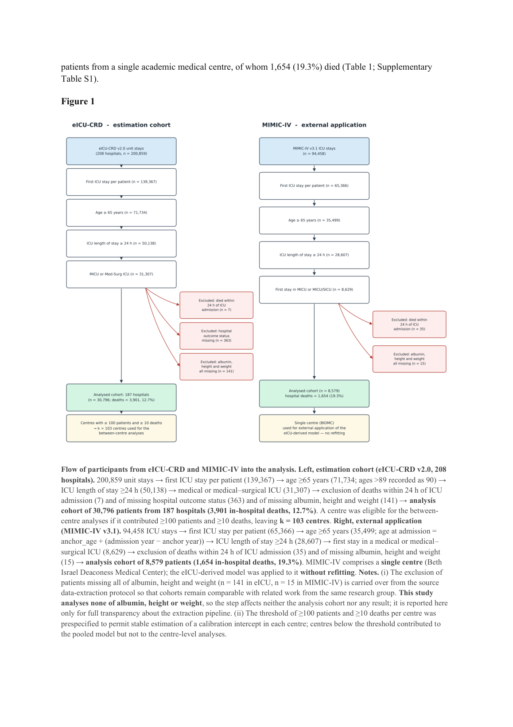
A-1 · v3 page 3: Figure 1 legend flow line — 'first ICU stay per patient (139,367)'; no 193,367 anywhere.
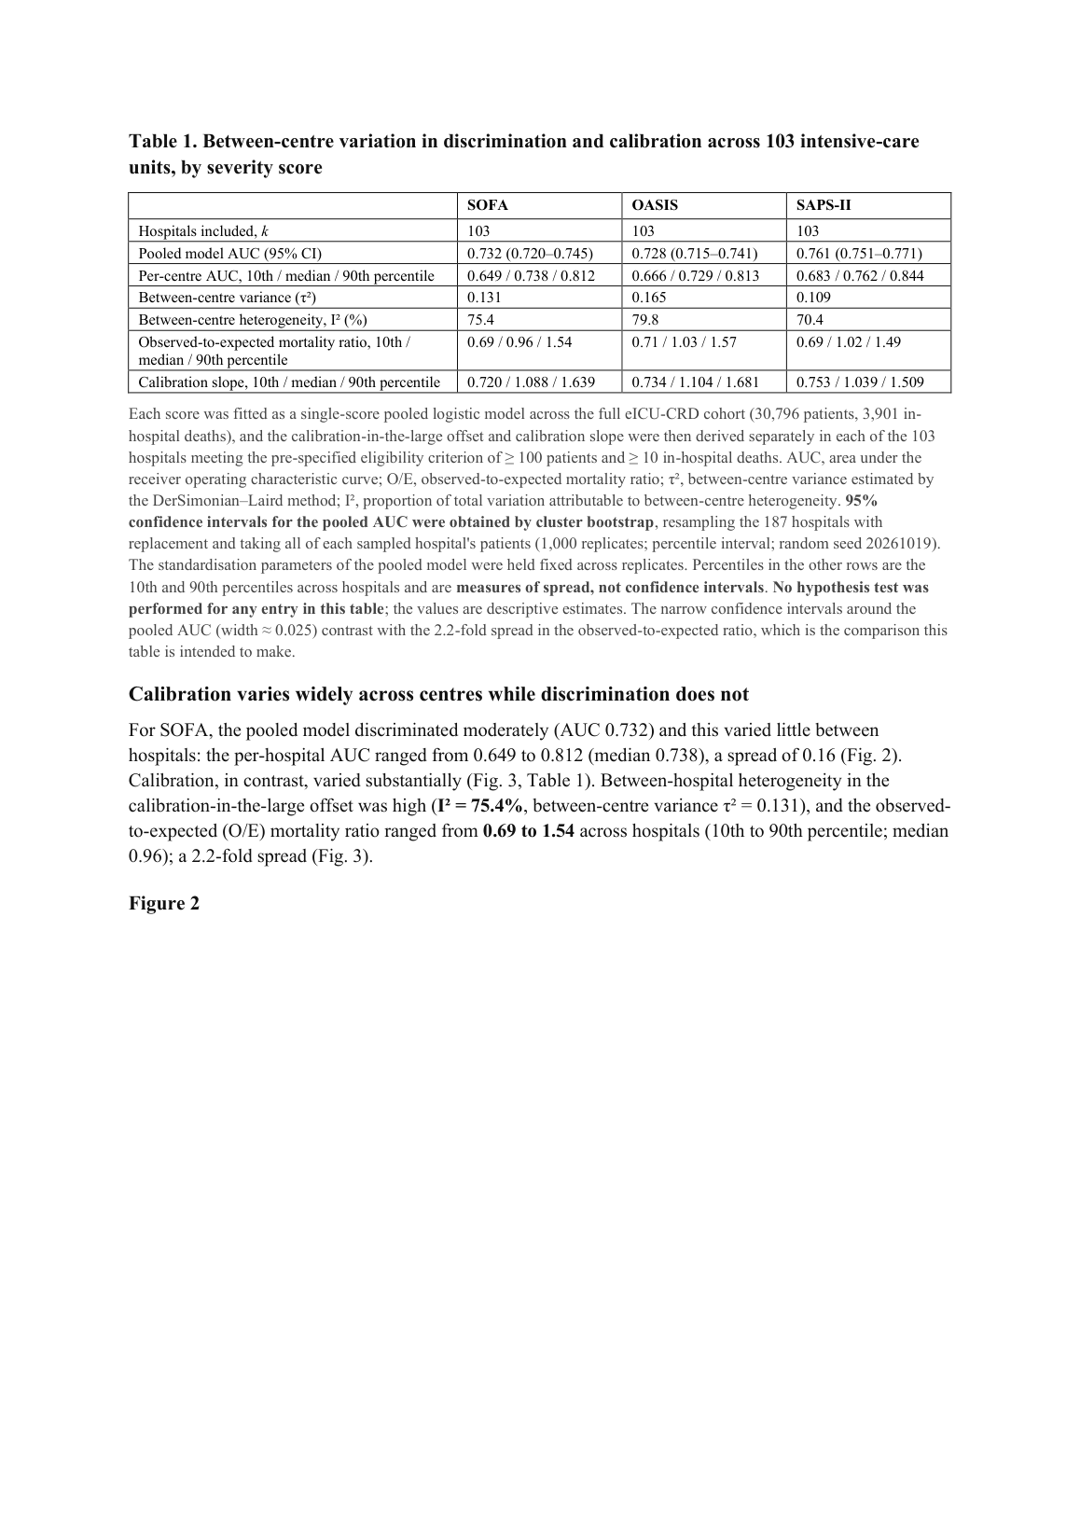
A-3 · v3 page 4: Table 1 rendered as an 8×4 ruled grid; note reads 'I², proportion of total variation…' (rows R2-M2/R2-E7).
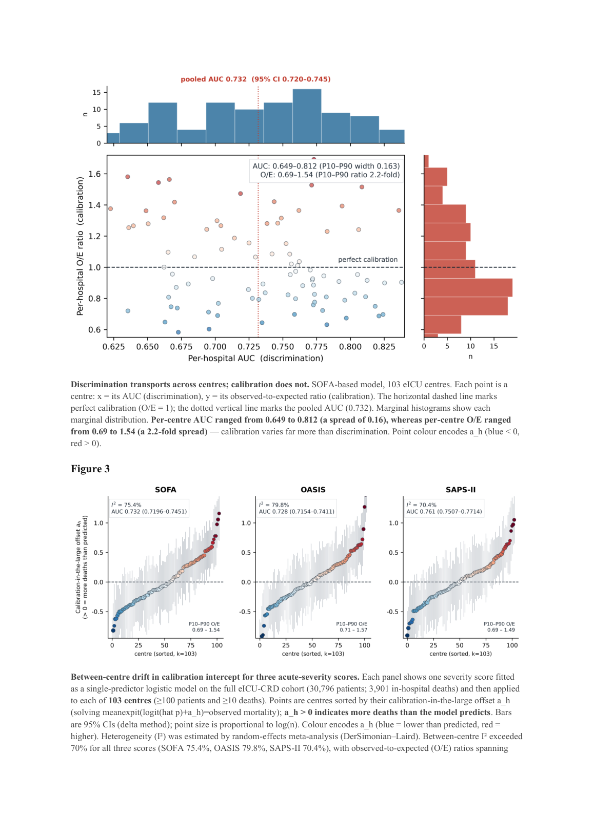
A-2 · v3 page 5: Figure 2/3 — in-figure annotation 'pooled AUC 0.732 (95% CI 0.720–0.745)' (source of the ghost string), caption 'Point colour encodes a_h…' (rows R2-M4/R2-a_h).
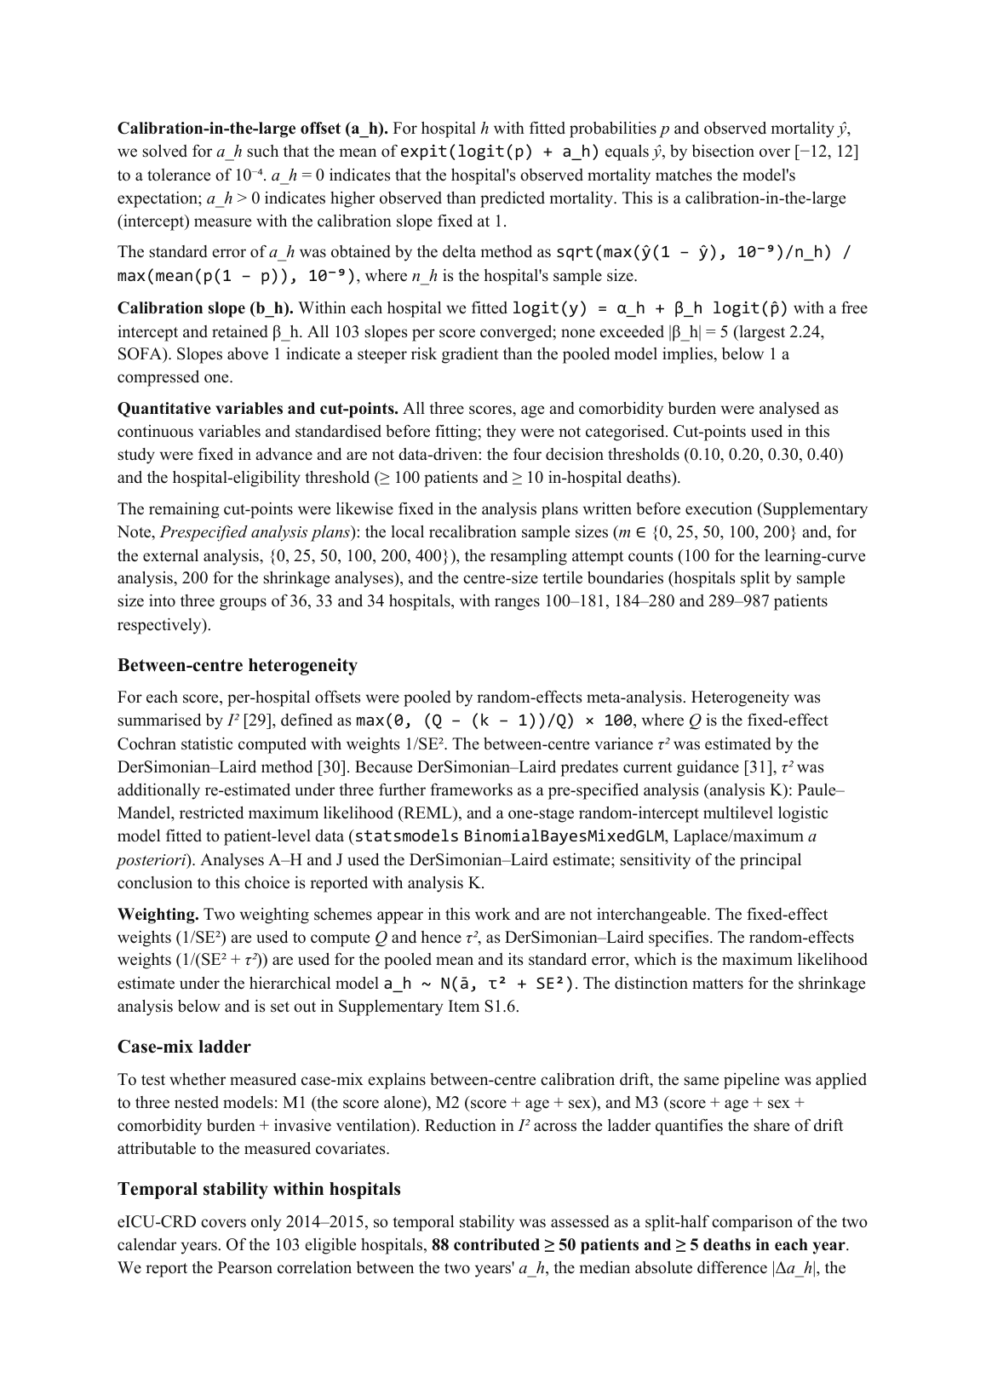
A-4 · v3 page 16: 'logit(y) = α_h + β_h logit(p̂)… All 103 slopes per score converged' (rows R2-M10/R2-E1).
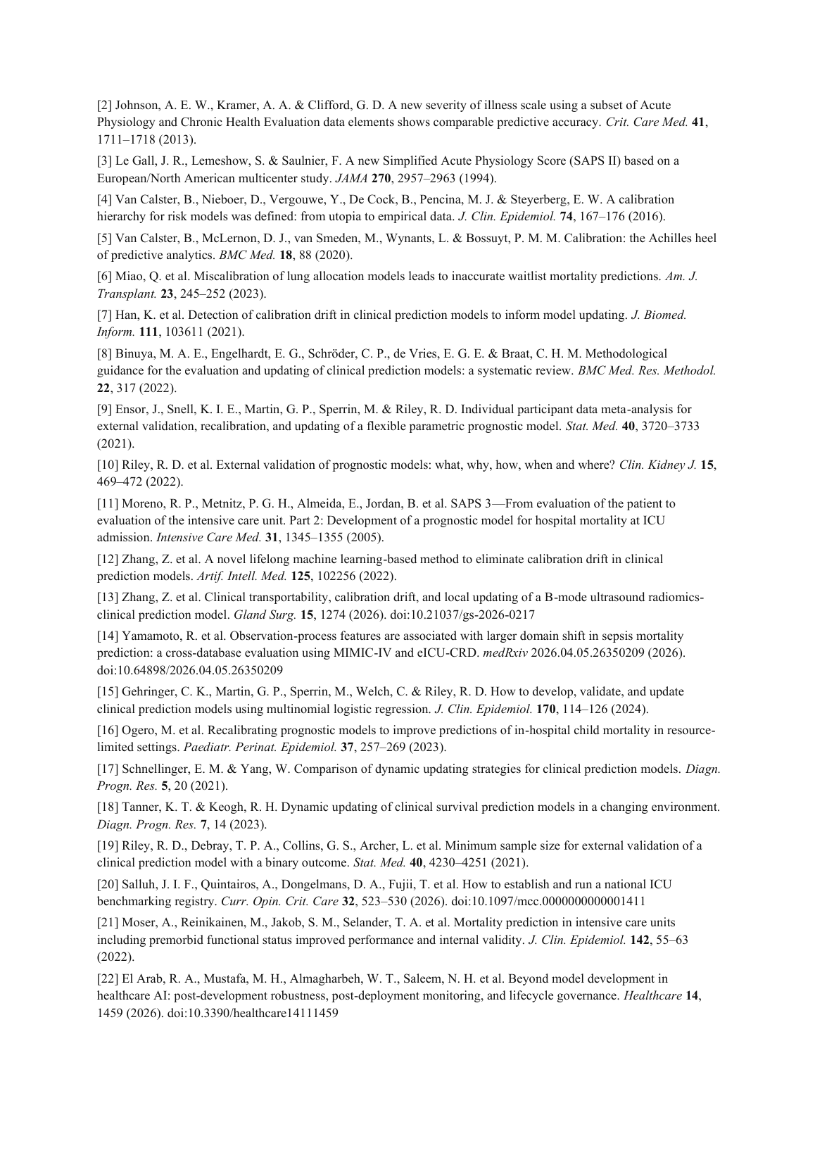
A-5 · v3 page 21: references rendered as separate paragraphs, '[2] Johnson…' bracket intact; [13]/[14]/[20]/[22] carry DOIs, [22] corrected to El Arab et al. (rows R2-M1/R2-REFS).

