**实验报告10**

**学号：** 117060400227 **姓名**：夏田田**班级：** 应用统计学2班 **指导老师：林卫中**

**实验名称**： 网络爬虫和自动化

1、方波绘制

算法实现：

import numpy as np

import matplotlib.pyplot as plt

def squareWave(x,n):

f = np.zeros((x.shape[0]),)

k = 1

while k <= n:

f = f + (8*np.sin((2*k-1)*x)/((2*k-1)*np.pi))

k = k + 1

return f

x = np.linspace(0.0,2*np.pi,100)

y = squareWave(x,8)

plt.plot(x,y)

plt.show()

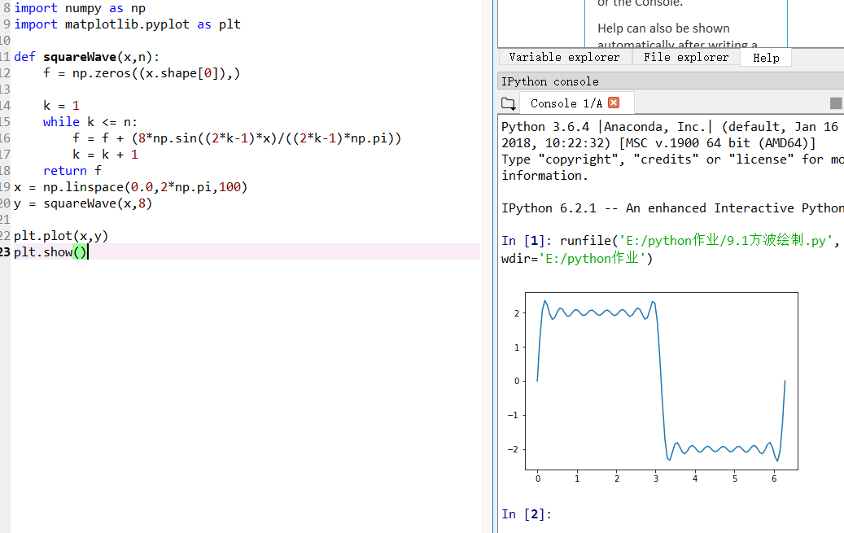

1. 中国大学排名

import requests

from bs4 import BeautifulSoup

allUniv = []

def getHTMLText(url):

try:

r = requests.get(url, timeout=30)

r.raise_for_status()

r.encoding = 'utf-8'

return r.text

except:

return ""

def fillUnivList(soup):

data = soup.find_all('tr')

for tr in data:

ltd = tr.find_all('td')

if len(ltd)==0:

continue

singleUniv = []

for td in ltd:

singleUniv.append(td.string)

allUniv.append(singleUniv)

def printUnivList(num):

print("{:^4}{:^10}{:^5}{:^8}{:^10}".format("排名","学校名称","省市","总分","培养规模"))

for i in range(num):

u=allUniv[i]

print("{:^4}{:^10}{:^5}{:^8}{:^10}".format(u[0],u[1],u[2],u[3],u[6]))

def main():

url = 'http://www.zuihaodaxue.cn/zuihaodaxuepaiming2016.html'

html = getHTMLText(url)

soup = BeautifulSoup(html, "html.parser")

fillUnivList(soup)

printUnivList(10)

main()

