**实验报告10**

**学号：** 117060400227 **姓名**：夏田田**班级：** 应用统计学2班 **指导老师：林卫中**

**实验名称**： 网络爬虫和自动化

1. 按照省份输出中国大学排名

import requests

from bs4 import BeautifulSoup

allUniv = []

def getHTMLText(url):

try:

r = requests.get(url, timeout=30)

r.raise_for_status()

r.encoding = 'utf-8'

return r.text

except:

return ""

def fillUnivList(soup):

data = soup.find_all('tr')

for tr in data:

ltd = tr.find_all('td')

if len(ltd)==0:

continue

singleUniv = []

for td in ltd:

singleUniv.append(td.string)

allUniv.append(singleUniv)

def printUnivList(province):

print("{:^4}{:^10}{:^5}{:^8}{:^10}".format("排名","学校名称","省市","总分","培养规模"))

for u in allUniv:

if province in u[2]:

print("{:^4}{:^10}{:^5}{:^8}{:^10}".format(u[0],u[1],u[2],u[3],u[6]))

def main():

url = 'http://www.zuihaodaxue.cn/zuihaodaxuepaiming2018.html'

html = getHTMLText(url)

soup = BeautifulSoup(html, "html.parser")

fillUnivList(soup)

printUnivList('江西')

main()

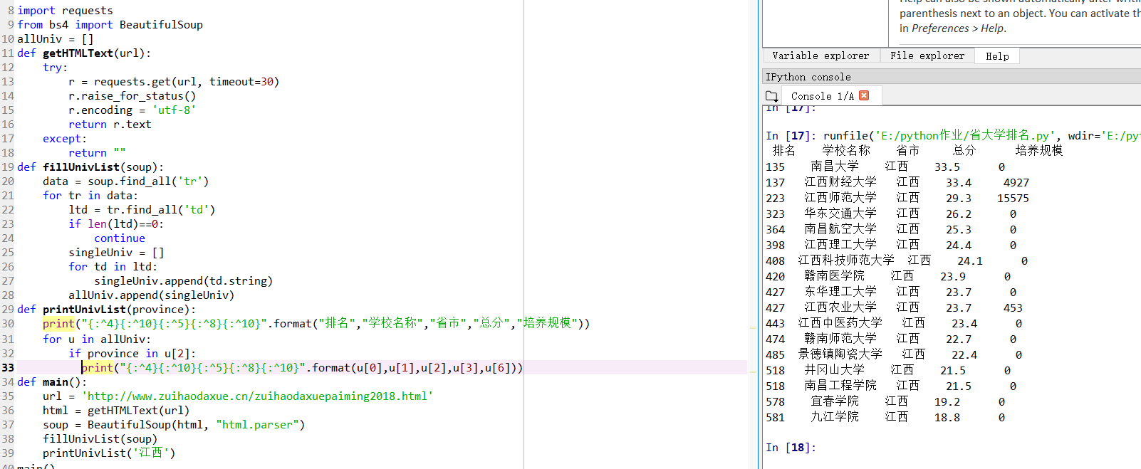

2、美国大学排名

import requests

import re

from bs4 import BeautifulSoup

allUniv=[]

def getHTMLText(url):

send_headers = {

"User-Agent": "Mozilla/5.0 (Windows NT 10.0; Win64; x64) AppleWebKit/537.36 (KHTML, like Gecko) Chrome/61.0.3163.100 Safari/537.36",

"Connection": "keep-alive",

"Accept": "text/html,application/xhtml+xml,application/xml;q=0.9,image/webp,image/apng,*/*;q=0.8",

"Accept-Language": "zh-CN,zh;q=0.8"}

try:

r = requests.get(url, headers=send_headers)

r.raise_for_status()

print(r.status_code)

r.encoding = 'utf-8'

return r.text

except:

return ""

def fillUnivList(soup):

data = soup.find_all('div',{'class':re.compile('shadow-dark')})

for div in data:

singleUniv = []

div1 = div.find('div',{'style':'margin-left: 2.5rem;'})

rank = div1.get_text().strip()

singleUniv.append(rank.split(' ')[0])

div2 = div.find('div',{'class':'block-normal text-small'})

singleUniv.append(div2.string.strip())

ldiv = div.find_all('div',{'style':'padding-right: 0.5rem;'})

singleUniv.append(ldiv[0].strong.string)

singleUniv.append(ldiv[1].strong.string)

allUniv.append(singleUniv)

def printUnivList():

print("{:<6}{:<20}{:<6}{:<10}".format("排名","学校名称","学费","培养规模"))

for u in allUniv:

print("{:<6}{:<20}{:<10}{:<10}".format(u[0],u[1],u[2],u[3]))

def main():

url = 'https://www.usnews.com/best-colleges/rankings/national-universities'

html = getHTMLText(url)

soup = BeautifulSoup(html,'html.parser')

fillUnivList(soup)

printUnivList()

main()

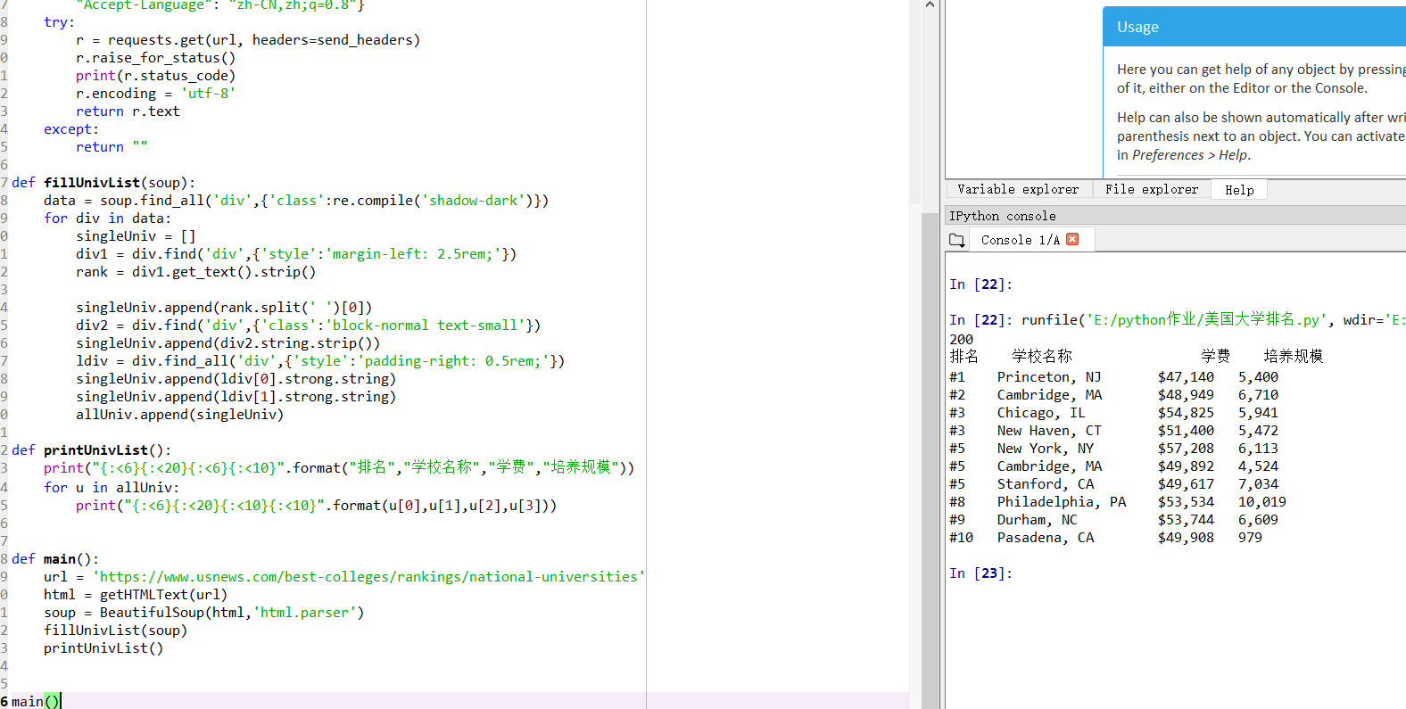

3、百度图片爬取

def downloadImageFile(imgUrl, destUrl, fname=''):

local_filename = imgUrl.split('/')[-1]

print('Download Image File={}'.format(local_filename))

try:

r = requests.get(imgUrl, stream=True)

r.raise_for_status()

if len(fname) == 0:

fname = local_filename

print('fname={}'.format(fname))

with open(destUrl + "/" + fname, 'wb') as f:

for chunk in r.iter_content(chunk_size=1024):

if chunk:

f.write(chunk)

f.flush()

f.close()

return r.status_code

except:

return r.status_code

def getImg(html):

imgre = re.compile('"objURL":"(.*?)"')

imglist = re.findall(imgre,html)

return imglist

def download(urls,path):

index = 1

for url in urls:

print("Download Image from page:{}".format(url))

status = downloadImageFile(url,path,str(index)+".jpg")

try:

if str(status)[0] == '4':

print("未下载成功{}".format(url))

continue

except Exception as e:

print("未下载成功{}".format(url))

index += 1

page = 'https://image.baidu.com/search/index?tn=baiduimage&ipn=r&ct=201326592&cl=2&lm=-1&st=-1&fm=result&fr=&sf=1&fmq=1528336948156_R&pv=&ic=0&nc=1&z=&se=1&showtab=0&fb=0&width=&height=&face=0&istype=2&ie=utf-8&word=%E6%9D%A8%E5%B9%82'

html= getHTMLText(page,'utf-8')

download(getImg(html),'E:/python作业/百度图片')

