**第九章作业**

**学号：** 117060400227 **姓名**：夏田田**班级：** 应用统计学2班 **指导老师：林卫中**

**实验名称**： 科学计算和可视化

1. 解方程 $Ax=b$，其中： $$A=\left[\begin{matrix}1 & 0.5 & 5 \\ 2.3 & 2 & 3 \\ 4 & 1 & 1.7\end{matrix}\right], b={\left[\begin{matrix}1 & 2 & 3\end{matrix}\right]}^{T}$$

**算法实现：**

import numpy as np

from numpy.linalg import inv

A = np.array([[1,0.5,5],[2.3,2,3],[4,1,1.7]])

b = np.array([[1,2,3]])

c = np.transpose(b)

x = np.matmul(inv(A),np.transpose(b))

print(x)

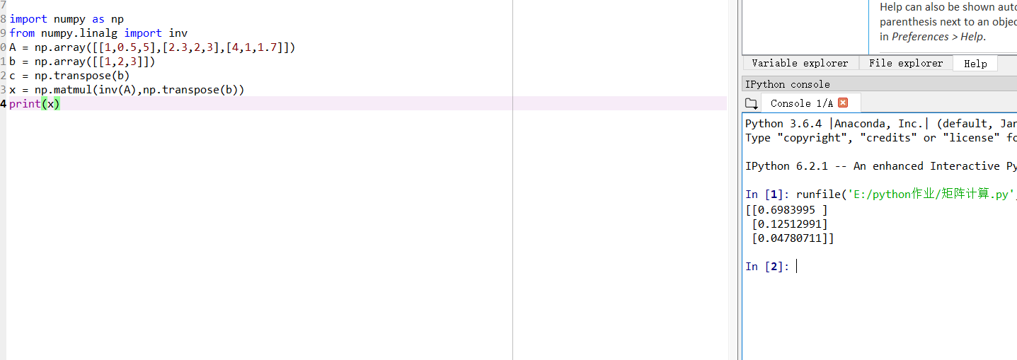

1. 绘制一副自己的人物肖像的手绘效果图

算法实现：

from PIL import Image

import numpy as np

vec_el = np.pi/2.2

vec_az = np.pi/4

depth = 50.

im = Image.open('E:\\python作业\\么么.jpg').convert('L')

a= np.asarray(im).astype('float')

grad = np.gradient(a)

grad_x, grad_y = grad

grad_x = grad_x*depth/100.

grad_y = grad_y*depth/100.

dx = np.cos(vec_el)*np.cos(vec_az)

dy = np.cos(vec_el)*np.sin(vec_az)

dz = np.sin(vec_el)

A = np.sqrt(grad_x**2 + grad_y**2 + 1.)

uni_x = grad_x/A

uni_y = grad_x/A

uni_z = 1./A

a2 = 255*(dx*uni_x + dy*uni_y +dz*uni_z)

a2 = a2.clip(0,255)

im2 = Image.fromarray(a2.astype('uint8'))

im2.save('么么3.jpg')

