**Case1：**

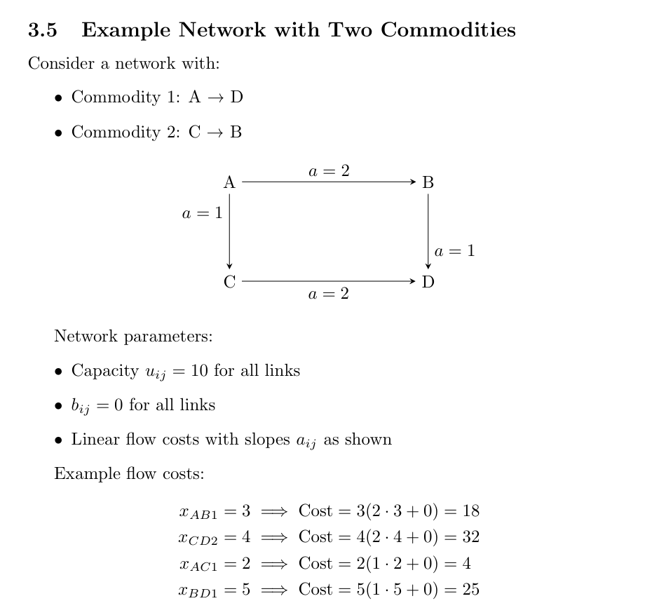

Then, assume that the commodity flow from A to D is 10, and the commodity flow from C to B is also 10.

Since the objective function contains quadratic terms, MINLP (Mixed-Integer Nonlinear Programming) is used to solve the problem.

**Case2：**

In the digital book 《Network Flow Problems: From Shortest Path to Multicommodity Flow》, the primal formulation of shortest path problem can be transferred to dual formulation:

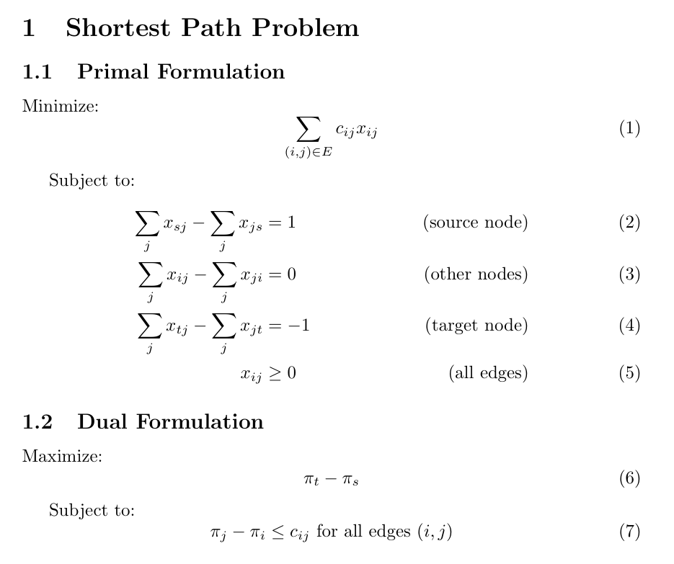

But, I can’t understand the step 4:

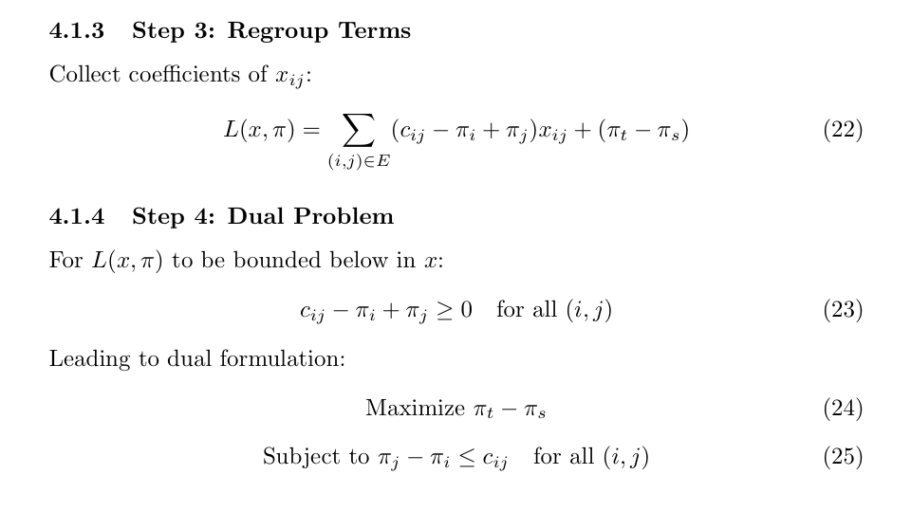

So in the case 2, an example was used to attempt to demonstrate.

The network is shown as follows. In the diagram, a represents the fixed link travel cost (which does not change with increasing link flow). A simple flow is considered from point A to point D.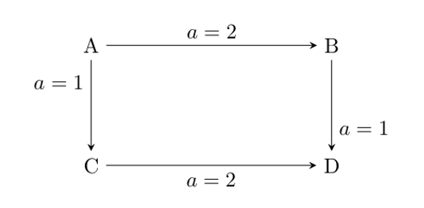

So, the object fuction is :

$$z=c13x13+c34x34+c12x12+c24x24$$

Subject to:

$$x13+x12=1$$

$$x12=x24$$

$$x13=x34$$

$$x34+x24=1$$

By relaxing the equality constraints, the Lagrangian function can be written as:

$$L\left(x,λ\right)=c13​x13​+c34​x34​+c12​x12​+c24​x24​+λ1​\left(x13​+x12​-1\right)+λ2​\left(x12​-x24​\right)+λ3​\left(x13​-x34​\right)+λ4​\left(x34​+x24​-1\right)$$

$$= x13\left(c13+λ1+λ3\right)+x12\left(c12+λ1+λ2\right)$$

$$+x24\left(c24-λ2+λ4\right)+x34\left(c34-λ3+λ4\right)-λ1​-λ4$$

Further, based on Step 4, the dual problem can be written as:

$$L\left(λ\right)=-λ1​-λ4$$

Subject to:

$$c13+λ1+λ3≥0$$

$$c12+λ1+λ2≥0$$

$$c24-λ2+λ4≥0$$

$$c34-λ3+λ4≥0$$

According to the results obtained from solving Case 2 in GAMS, the outcome is as follows:

$$λ1=0 λ2=c24 λ3=c34 λ4=0$$

$$x13\left(c13+λ1+λ3\right)=x13\left(c13+c34\right),then x13=0$$

$$x12\left(c12+λ1+λ2\right)=x12(c12+c24),then x12=0$$

$$x24\left(c24-λ2+λ4\right)=x24×0 ,then x24=1$$

$$x34\left(c34-λ3+λ4\right)=x34×0 ,then x34=1$$

This result clearly does not satisfy the Complementary Slackness Conditions.

**Case3：**

In case3, the network is shown :

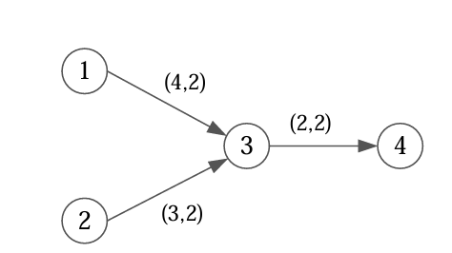

Then, assume that the commodity flow from node 1 to node 4 is 4 in time 1, and the commodity flow from node 2 to node 4 is also 4 in time 1.

In case 3, the waiting arc is expressed as (i, i, t, t+1), where virtual nodes are not used to represent the waiting. For example, the waiting arc at node 2 can be written as (2, 2, t, t+1).

**Case4：**

Generate a corresponding virtual node for each real node:

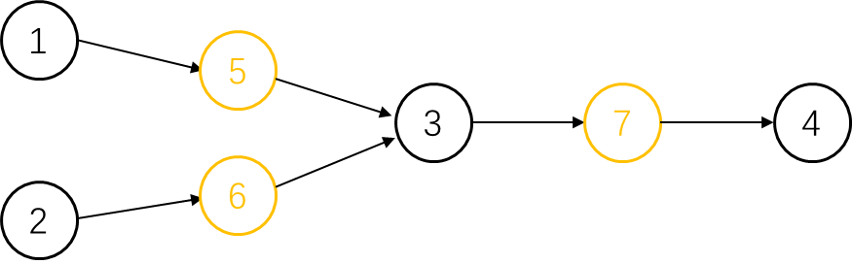

In case 4, the waiting arc is expressed as (i, i, t, t+1), where virtual nodes are used to represent the waiting. For example,

For example, the waiting at node 1 should occur at node 5. Due to the uncertainty of waiting time, the waiting arc is actually represented by (i, i, t, t+1).

**From a comparison between case 3 and case 4, it seems that the role of virtual nodes is not particularly significant when considering waiting generated only by flow capacity constraints. However, when there are more active elements beyond the waiting arcs, the importance of virtual nodes becomes crucial. For example, in scenarios such as the number of people entering a bus or subway station at the same time (as referenced in 'Capacitated Transit Service Network Design with Boundedly Rational Agents'), or in the case of pick-up arcs.**