Wenlan Tian

COP3530

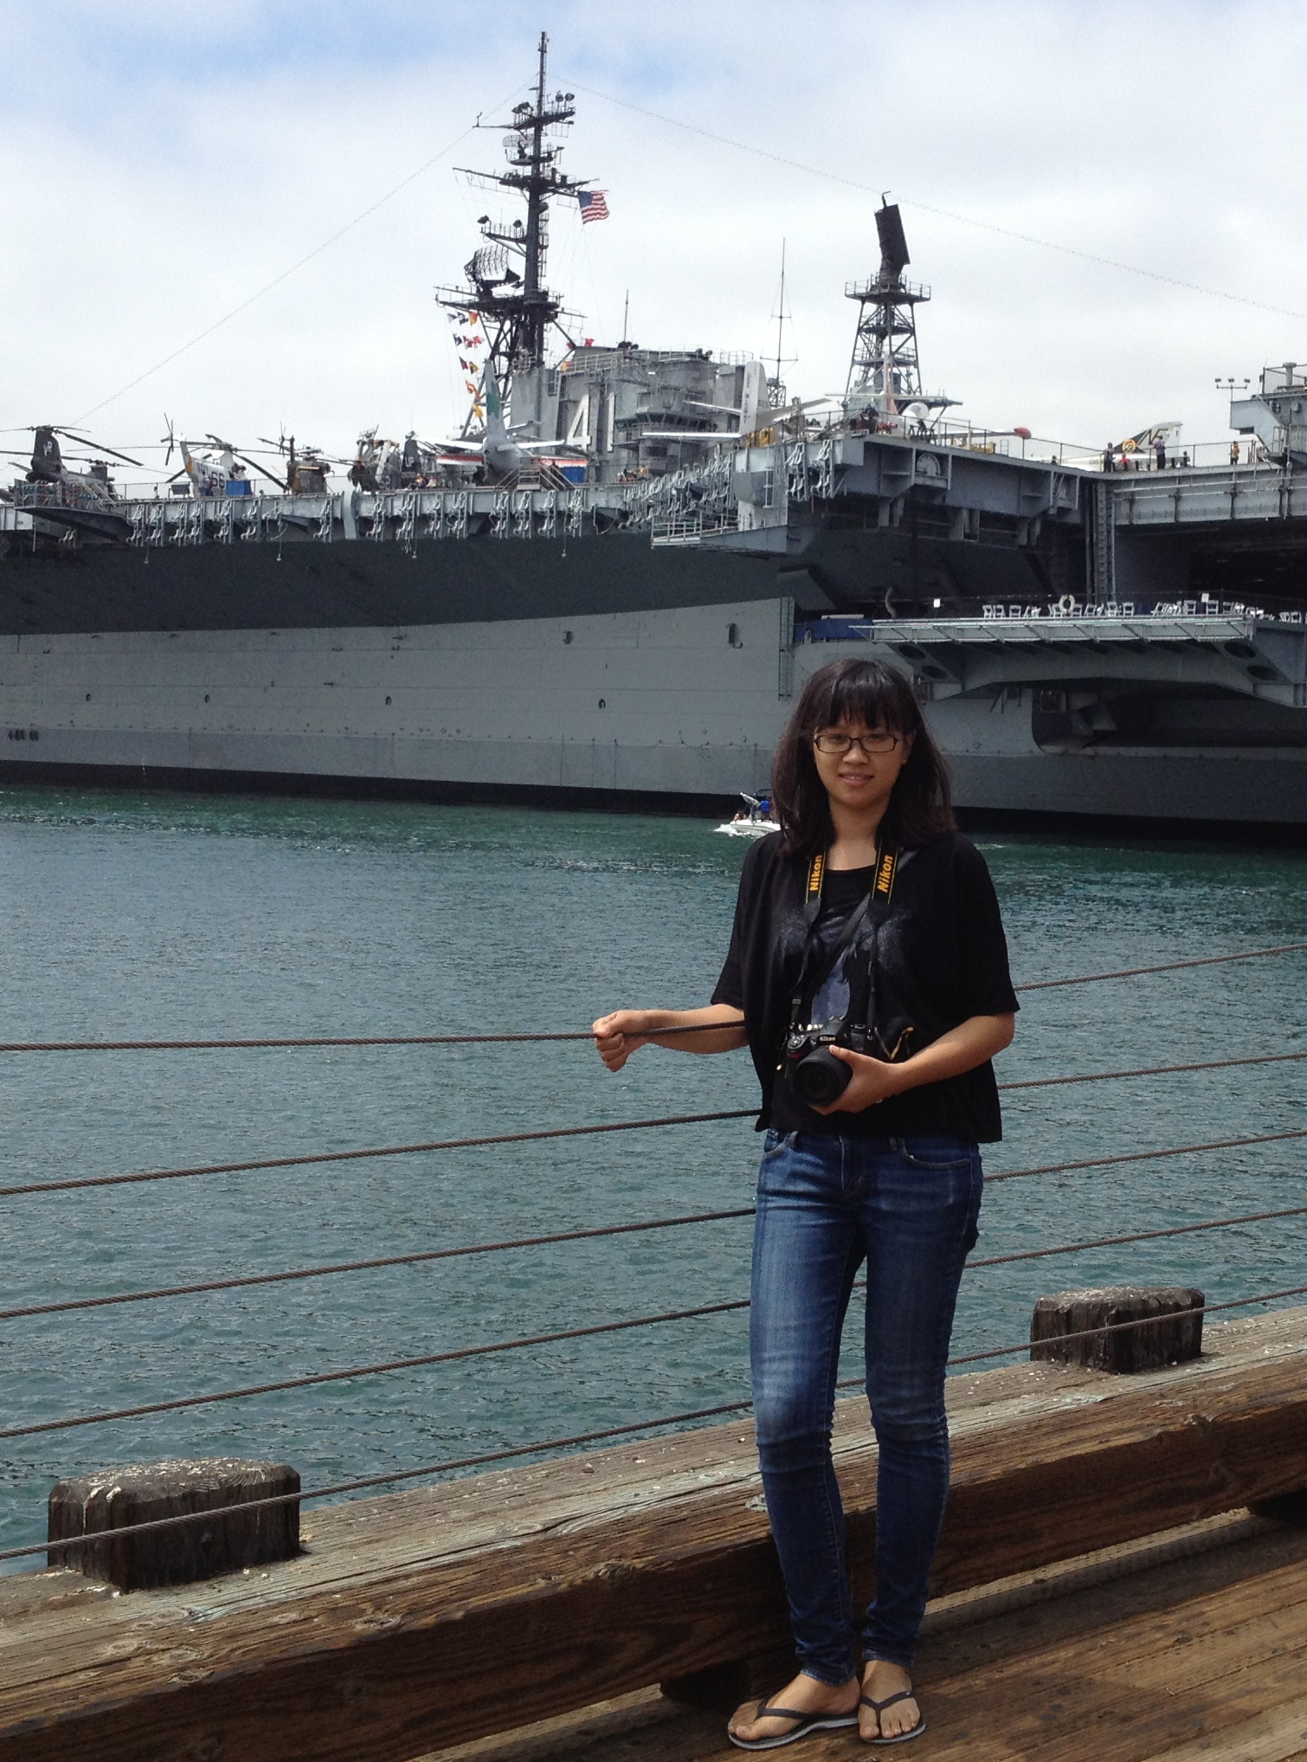

Preferred name: Wenlan (pronounce: whatever you want)

ALL ABOUT ME

I was born in Suzhou, a historical city in China in 1987. It has 2,500 years history, famous for the special insights, like rivers, ancient style buildings and streets, private gardens, and sweet dessert. Our dialect is considered the most beautiful language in China. People in my hometown are usually calm and optimistic. So I am.

In 2006, I went to Nanjing Forestry University, majored in ornamental horticulture. In my junior, I decided to study in united state for a graduate degree. One reason is that US has a good education, and another reason is that I want to take a look at a different country. From then on, I studied very hard, and prepared for the language tests. Luckily, I was admitted by UF for a PhD degree in Environmental horticulture in 2010. My research is about genetics and genomics in a crop called jatropha, which has great potential for biodiesel production. However, after three to four years study, I realized that RESEARCH was not the same as what I thought. I do not like to wash those bottles, tubes; do not like read and write papers; and the most importantly, I feel that research cannot make practical application in a short time. That makes me rethink the meaning of doing research, and what I really want to do.

I like electronic devices and all new technology, such as mp3, CD player, iPods, camera, cell phones, kindle, PDAs, pads, laptops, etc, To me, they are arts. Thus, I’m planning to change my career to computer science area. I studied the programming fundamental 2 during the past semester. This was the first time I really started to programming. I feel I really love coding because it made me THINK. I was thinking how to solve the problem when I was walking, driving, sleeping, etc. When the program runs without bugs, I feels so happy and proud. Biology is more like memorizing, but coding is more related to logically thinking. My dream is to develop a product, which can change the world or make life easier.

My parents are the most important people for me. They always support me to do whatever I want, unlike other traditional Chinese parents. I hope they will be proud of me one day. I have a boyfriend in Boston. We’ve been dated more than 6 years. He is always my best support whenever I meet a difficulty. I hope we can get married soon and have two cute kids.

I like to go to Zumba and hip-hop fitness classes when I have time. I love traveling, and I’m willing to experience the different cultures all around the world. I want to know how people in different countries live, what they eat, etc. I want to try everything I never tried, I want to skydiving in Switzerland, Bungee jumping in new Zealand, scuba diving in great barrier reef. I have been to Spain, Thailand, and Australia besides United States. I hope one day, I can travel to all the countries around the world with my family.

COURSE EXPECTATION

Why are you taking this class?

Data structure and algorithms are the most important basis for computer science, soft engineering. If I want to study and work on these areas, the first thing is to know these theories.

What do you hope to get out of this course?

I want to know the basic concepts, and know how to implement them using programming language.

What should an instructor expect from you?

I’m a self-discipline person. I will go the classes, make notes, study after class and finish all the assignments on time. I will always keep thinking about those functions and how to implement them in a better way. I will ask questions and discuss them with the classmates, TAs and the instructor.

What do you expect from an instructor?

I expect the instructor could explain these concepts, problems clearly, and willing to answer questions. It would be great if the instructor could make the course interesting. Well-organized slides, and posted in advance. Also, post the assignments and projects on time.

What makes a course "excellent?"

First, the instructor should make the class more interesting, so the students will not get bored.

Second, all the important contents should be covered. If they are related to industry, it would be even better.

Third, the instructor should intriguer the student to think by themselves.

PROGRAMMING BACKGROUND

How long have you been programming?

I would say four months that I took the cop3503 in the past summer.

How much programming experience do you have? [Note: this is *not* the same as the preceding question! Consider two programmers who have been "programming for 1 semester." One may have done all of the assigned homework in their intro programming course, while the other also independently wrote several substantial programs, studied the art of programming, &c.]

I took the cop3503 in the past summer that we did four projects and two homeworks. Before that, I have used a little bit unix command, perl script and java for my research, but I did not learn them systematically.

What is the most complicated program you have written from scratch? How long was it? What language did you use?

In the COP3503 class, we implemented a set, multiset using generic programming in a proper class hierarchy. We also wrote a program to read a xml file. Because it’s my first time to do programming, it took me about one week to finish each project.

What programming languages are you proficient in?

I’m really new to programming. If I must say one, that should be C++.

What is your favorite programming language and why?

I learned a little bit java by myself and I think it is very useful because I heard it is used a lot in industry nowadays.