Wealth Radar: Systematic Funds and Equity-Sector News Sentiment
Name: Tianxiang Feng
zID: z5642794
Course: FINS5545
Assessment: Project B
Title: Wealth Radar: Systematic Funds and Equity-Sector News Sentiment

Introduction and value proposition
Wealth Radar is a prototype dashboard for investors which visualizes systematic multi-asset funds and news based sentiment analysis across equity sectors. It was created to help non-technical investors understand and draw insights from quantitative investment results. The data from the backtest model can be downloaded in multiple CSV files, charts and model outputs but does not distinguish which fund has a better risk-return relationship, highlight the risks that are the most relevant or whether a more complex model adds to decision making. Thus, Wealth Radar presents this data, enabling relative performance and drawdown analysis, current target positions, and backtesting how equity portfolios are affected by sentiment signals.
The results of the primary test suggest that the combined equal-weight fund yielded the best risk-adjusted return, with an annualized return of 18.29%, annualized volatility of 21.46%, and a Sharpe ratio of 0.89. This result is surprising because it suggests that a simple, transparent rule is hard to beat and that more advanced rules do not yield important benefits. The combined minimum-variance fund had lower volatility and drawdown, but produced only a 5.07% annualized return. The sentiment-tilted equity fund slightly underperformed its equal-weight equity benchmark as well. The crypto minimum-variance extension had an annualized return of 21.28%, volatility of 62.17%, and maximum drawdown of 75.60%. The performance was an improvement over the basic minimum-variance strategy, though still with a very high risk profile.
For investors that want to compare transparent rules-based funds without reading market data and model code, Wealth Radar displays historical growth, drawdowns, risk-adjusted return, and current target portfolio positions for the compared funds on one screen. Wealth Radar also displays a news market sentiment score for ten U.S. equity sectors and a fund allocation simulator. The most important part of the dashboard, which cannot be done easily with a series of separate figures, is tying model results into the full progression of the investor's experience: seeing what funds there are, risk assessments, trying it, and looking for insights in sentiment signals.
The key analysis is applied to 50 U.S. stocks, 10 cryptocurrencies, and news headlines on the 50 stocks. The two main products are equity-plus-crypto funds: one equal weight fund and one long-only minimum variance fund. Two additional crypto-only products show that the same logic can be applied to a seven-days-a-week trading environment. A separate experiment looks at the impact of adapting an equal-weight equity fund with a slight tilt towards sector-sentiment. Sentiment analysis is performed on equities only; no cryptocurrency news was included in the database.
These figures should be viewed as historical out-of-sample simulations, not predictions nor advice to invest, and Wealth Radar makes no guarantee that any individual rule will outperform going forward. Wealth Radar uses them to illustrate a systematic, reproducible process for building, testing and presenting fund strategies. The real power of the product comes not from displaying the fund with the highest return, but from transparent backtesting, clear explanation of risks, sentiment analysis and an app to help the user digest the information.

Data and modelling overview
The dataset spans 2020 to 2023, containing daily OHLCV fields (open, high, low, close, volume), adjusted close, ticker, and sector information for 50 large-cap U.S. stocks belonging to ten different sectors. The crypto price dataset consists of daily price data of 10 cryptocurrencies. However, cryptocurrencies trade on a seven-day calendar. The news dataset has the date, ticker, sector, headline, URL, and publisher associated with the news headlines of the equity market. These datasets are loaded through the src/data_access.py helper and the market data is cut off as of December 31, 2023.
Daily simple returns for each asset class are calculated from their adjusted close prices. The daily simple return is defined as the adjusted close of the current day divided by the adjusted close on the previous day, less one. Adjusted closes are used as they are closer to the actual returns one would receive given common changes to the stock price. Sort this first by ticker and then by date. If we were to mix different assets together before calculating the returns, the percentages would no longer make sense across different tickers or trading calendars.
An important modeling issue is that equities trade on weekdays, while cryptocurrencies trade all days of the week. The equity trading calendar is used as a common investment calendar for equity-plus-crypto funds, with the crypto returns compounded over the weekends, and then sampled on the next available trading day of the equity market. Indeed, weekend returns are not ignored, but rather aligned with the dates when the returns of all funds can be compared against equity returns.
Standalone crypto funds continue to maintain the seven-day trading calendar for cryptocurrencies, without the trading frequency assumptions of equity only funds, because, for crypto-only portfolios, it is more practical to assume daily monitoring by crypto investors when observing prices for cryptocurrencies. Combined fund and equity-only fund metrics are annualized using 252 observations per year. Crypto-only fund metrics are annualized using 365 observations per year, given that annualized returns, volatility, and Sharpe ratios are more comparable to the trading frequency of each fund series.
All Sharpe ratios here assume a risk-free rate of zero, and this analysis ignores any transaction costs, management fees, taxes, market impact, or slippage. With these assumptions, comparisons become easier, as each fund uses the same simplified cost structure, but these numbers are best seen as gross historical simulations rather than as predictions of real fund performance.

Funds and out-of-sample backtest design
The portfolio tests use a walk-forward out-of-sample backtest with monthly rebalancing. In a walk-forward OOS backtest, the model uses the first estimation window of historical data to estimate portfolio weights, and the model is then rolled through time applying the portfolio weights to future returns, which are not part of the estimation window. For both combined and equity-only funds, the first estimation window is 252 observations of daily returns. The first live return is on 29 January 2021. For crypto-only funds, the first estimation window contains 365 days of prior daily observations, with live returns beginning on January 31, 2021.

The importance of this design is that it avoids look-ahead bias, because the weights for the return on a given date t can only be formed from information prior to date t, which means that the model isn't using the return being earned on date t to pick its weights, making it a more realistic backtest versus in-sample testing where a model could potentially use information from the past to pick its weights for the same data period.
The simplest benchmark is the equal-weight strategy, where the same weight is assigned to all eligible assets at each rebalance. In the case of the combined fund, all 60 assets have approximately the same weight of 1.67%. In the case of the crypto-only equal-weight fund, all 10 cryptocurrencies have the same weight of 10%. Equal-weighting is appealing because of its simplicity and transparency: it is easy to explain, requires no estimates of covariance or expected return, and thus provides a baseline against which more complicated asset allocation methods can be compared.
The minimum-variance portfolio employs a time window of past returns to estimate the covariance matrix, and computes long-only weights that minimize the variance of the portfolio, subject to the weights adding up to 1 and being non-negative. The strategy has no short exposure and utilizes a fully invested fund. This strategy attempts to reduce risk of a portfolio by overweighting assets with lower volatility or lower correlation with the other assets in the portfolio.
However, minimum variance does not necessarily outperform an equally weighted portfolio, and is highly sensitive to the covariance matrix that is estimated, which is unstable if the sample window is small or has changing correlations. This is especially true in a crypto context, where the number of assets is small and their prices are volatile. Even in a long-only context, the optimizer could concentrate all weights into the few assets from the covariance matrix solution that appear to reduce portfolio risk. Consequently, the minimum-variance results should be seen within this context, and should not be measured in terms of volatility alone, but also considering return, Sharpe ratio, drawdown, and concentration risk.
ssAnnualized return is wealth growth compounded over the course of the entire live backtest period. Annualized volatility is the standard deviation of daily returns, with 252 observations per year for equity-calendar funds and 365 observations per year for crypto-only funds. The Sharpe ratio assumes a risk-free rate of zero. The maximum drawdown is the largest loss in net asset value from the previous peak. These should be used together, as no one measure tells the complete story of a fund's performance.

4. Out-of-sample fund results and fact sheets
Table 1. Out-of-sample performance of combined and crypto-only funds
Fund | Annualised return | Annualised volatility | Sharpe ratio | Maximum drawdown | Observations
Combined equal weight | 18.29% | 21.46% | 0.89 | -27.16% | 735
Combined minimum variance | 5.07% | 12.77% | 0.45 | -15.42% | 735
Crypto equal weight | 16.14% | 78.87% | 0.59 | -81.60% | 1,065
Crypto minimum variance | 21.28% | 62.17% | 0.62 | -75.60% | 1,065

Note: Combined funds cover 29 January 2021 to 29 December 2023 and use 252-day annualisation on the equity trading calendar. Crypto-only funds cover 31 January 2021 to 31 December 2023 and use 365-day annualisation on the native seven-day calendar. Sharpe ratios assume a zero risk-free rate. Source: `results/tables/performance_metrics.csv`.
Table 1 summarizes the out-of-sample performance of the combined funds and crypto-only funds. The most important conclusion from these results is that the combined equal-weight fund had the best risk-adjusted performance among all these combinations, with an annualized return of 18.29%, an annualized volatility of 21.46%, and a Sharpe ratio of 0.89. In this case, a simple allocation between equities and cryptocurrencies performed better. The fund's maximum drawdown was worse than the combined minimum-variance fund, but the return more than made up for the extra volatility.
The combined minimum-variance fund has substantially lower risk than the combined equal-weight fund, but at the cost of substantial underperformance. The minimum-variance fund had annualized volatility of 12.77%, maximum drawdown of -15.42%, annualized return of 5.07%, and Sharpe ratio of 0.45. Its volatility and maximum drawdown were lower, but its return and Sharpe ratio were also much lower. In other words, the strategy improved the smoothness of the return path, but did not improve its risk-return trade-off. Less volatility does not guarantee better performance.
The crypto-only funds have a few different properties. The annualized return of the crypto equal-weight fund was 16.14% while the volatility was 78.87% and the maximum drawdown was -81.60%. Its annualized return was close to the combined equal-weight fund, but its volatility and drawdown were much worse. This means that, for most investors, holding the strategy throughout the sample period would have been very difficult. The crypto minimum-variance fund still outperforms the crypto equal-weight fund, achieving a higher 21.28% annualized return, a lower 62.17% annualized volatility, and a smaller -75.60% maximum drawdown, while being vastly more risky than the combined funds. Consequently, the crypto minimum variance fund cannot be seen as a better fund just because it has a higher annualized return.
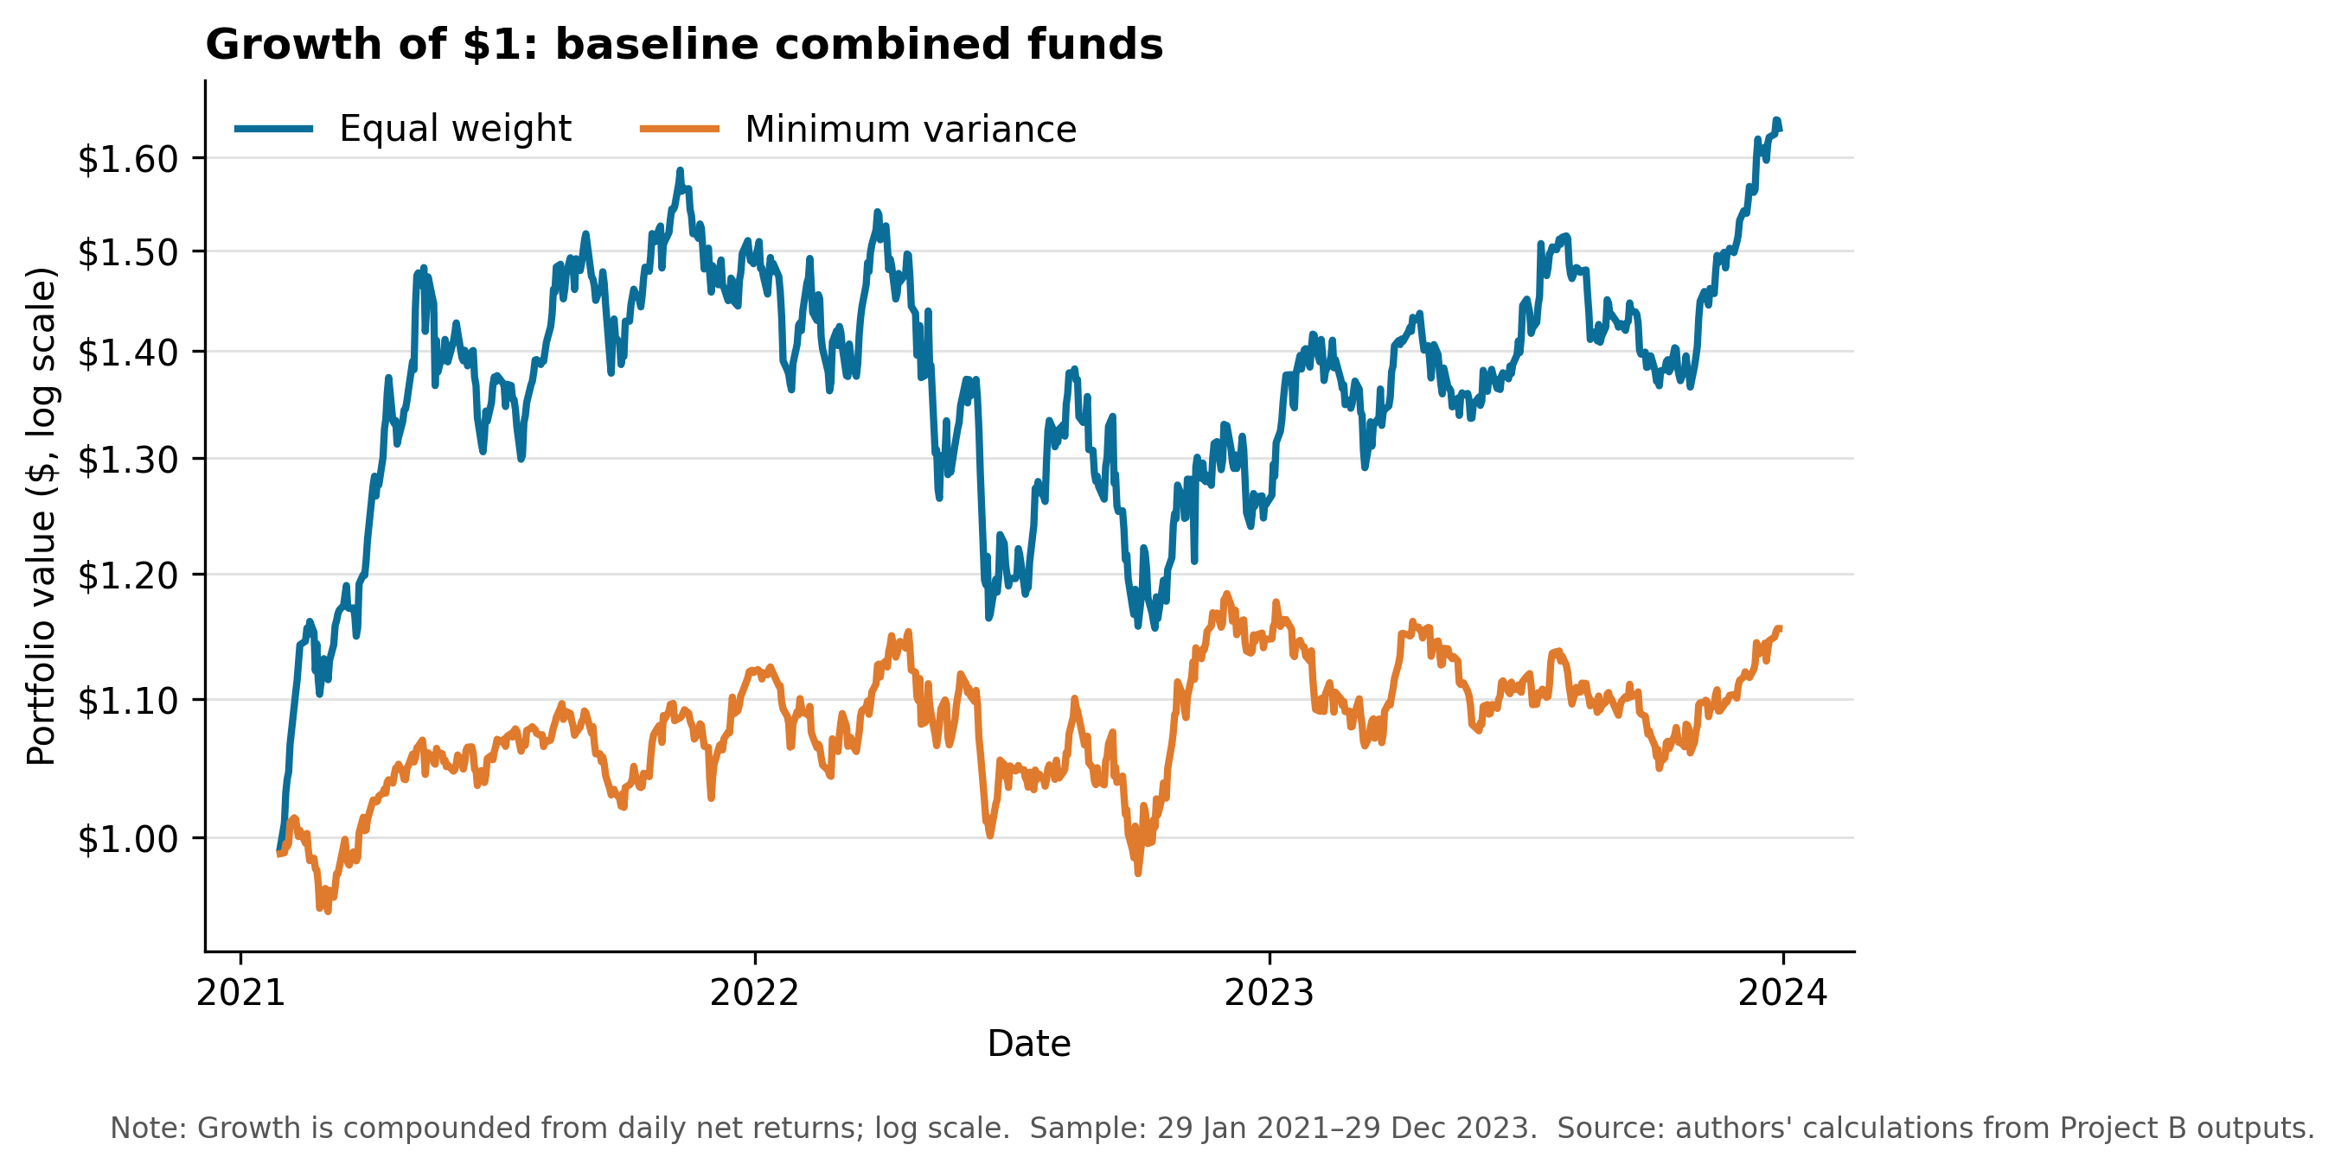
Figure 1. Growth of $1 for the combined funds. The equal-weight fund finishes at $1.63, compared with $1.16 for minimum variance. Equal weight experiences larger fluctuations, but its greater cumulative return compensates for the additional volatility over this sample. Minimum variance provides a smoother path but does not recover the return gap by December 2023.
In Figure 1, $1 grew to about $1.63 in the equally-weighted fund and $1.16 in the minimum-variance fund. Thus, while the minimum-variance fund maintained lower short-term volatility, the equally-weighted fund actually generated stronger cumulative returns by the end of 2023, in line with the finding in Table 1 that the equally-weighting strategy delivered stronger risk-adjusted performance over the full period.
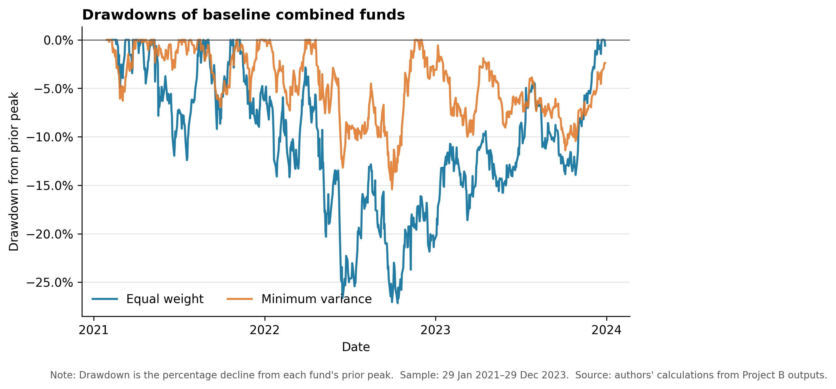
Figure 2. Drawdowns for the combined funds. The risk reduction from minimum variance is visible in the shallower worst drawdown of 15.42%, compared with 27.16% for equal weight. The figure also shows that lower volatility is not equivalent to higher performance: the more defensive fund spends long periods below its previous peak while producing a lower terminal value.
For drawdowns (Figure 2), the maximum drawdown of the minimum-variance fund is less severe, which does confirm a reduction in downside risk, but, as the figure shows, mere reduction in drawdown is not enough. The minimum-variance fund consistently underperformed prior peaks and did not close the gap with the equal-weight fund. This indicates that a more conservative strategy is not necessarily better for investors if it sacrifices too many returns in the process.
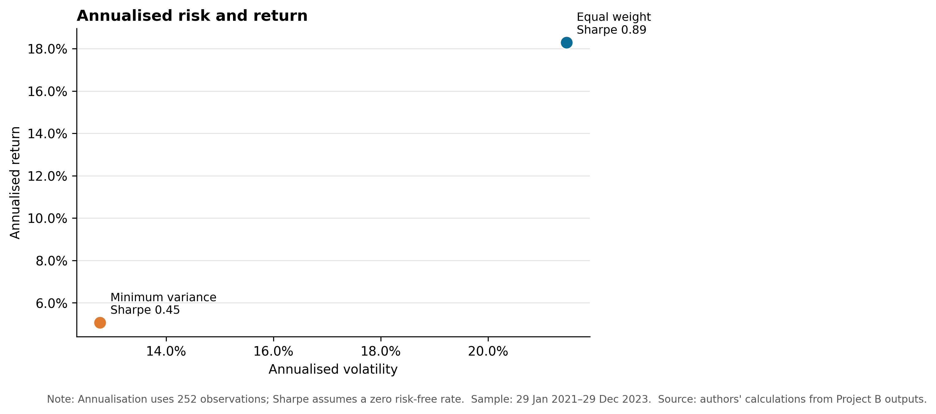
Figure 3. Annualised risk and return for the combined funds. Minimum variance moves the portfolio down and left in risk-return space. Volatility falls by 8.69 percentage points, but annualised return falls by 13.23 percentage points. Its Sharpe ratio of 0.45 is roughly half the equal-weight fund's 0.89. For this sample, equal weight gives the stronger trade-off between return and total risk.
Figure 3 shows annualized risk against the annualized return. The minimum variance fund, being that it moves down and to the left, has lower volatility and lower annualized return. Although this is the goal of the strategy, the decrease in return was larger than the decrease in risk. The equal-weight fund is therefore further up the chart, having a higher Sharpe ratio, and hence is more preferred in the combined-fund case.s
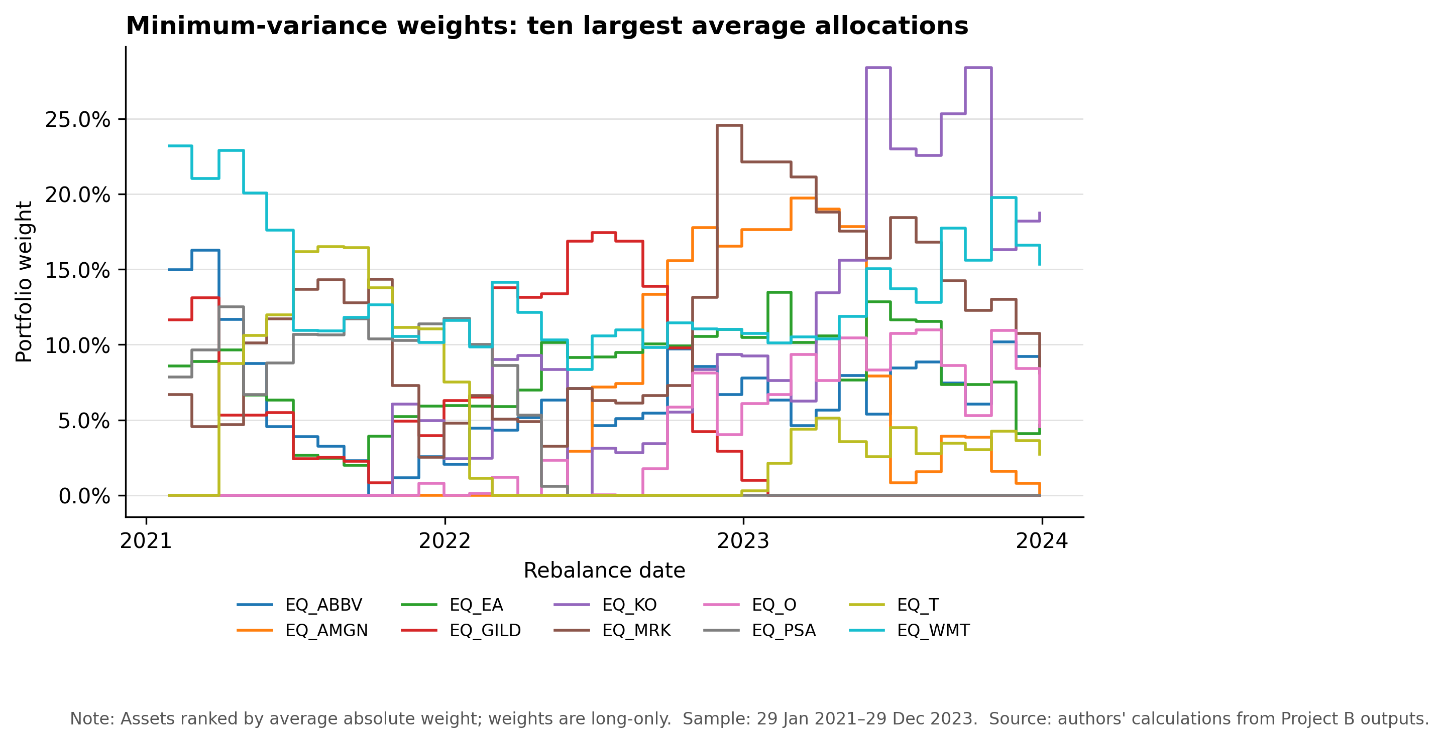
Figure 4. Largest minimum-variance allocations over time. The chart reports the ten assets with the highest average absolute weights because plotting all 60 assets would be unreadable. Weights vary substantially across monthly rebalances, which reflects changing covariance estimates. At the final rebalance, the largest positions are Coca-Cola (18.74%), Walmart (15.33%), Visa (9.72%), AbbVie (8.62%), and Merck (8.13%). This concentration contrasts with the stable 1.67% allocation in every asset under equal weight and suggests that turnover and estimation sensitivity require further testing.
This figure also shows that the minimum-variance fund is not as diversified as the equal-weight fund. The equal-weight fund effectively gives one-sixtieth, or 1.67%, to each of the 60 assets in the portfolio, while the minimum-variance fund holds larger positions in a smaller number of assets. This suggests the minimum-variance fund is relatively sensitive to its covariance estimates, and motivates investigating turnover and concentration in a more direct way in subsequent versions of the project.
Visually, the fact sheets show different risk profiles rather than a simple return-based ranking. The combined equal-weight fund led on risk-adjusted performance. The combined minimum-variance fund was lower risk but failed to provide adequate return. The crypto-only funds appear to have provided higher return with greater risk, with both crypto-only funds showing much larger volatility and drawdowns than the combined funds. When displayed to an investor, the fund which returns the most may not be the fund which is most suitable for a given investor.

5. Sector sentiment index
The objective of the sector sentiment index is to aggregate the sentiment from single stock news headlines into sector-level sentiment indices. The first step in the sector sentiment pipeline is to remove duplicate headlines by comparing the ticker, date, and title of the headline while retaining the text of the news headline. This is important because the scoring of VADER is sensitive to the use of punctuation, capitalization, negation, and emphatic uses of language. A headline receives a compound sentiment score, and the mean score is averaged at the ticker-day and sector-day levels. This two-step aggregation also prevents a given company from having an outsized impact on the sector sentiment result simply due to the number of news articles available on a given day.
Time handling is also important: dates attached to every news item are normalized into a calendar representation and, if not on a trading day, mapped to the next available equity trading day. The signal is then lagged by one trading day, meaning that any information pertaining to day t is assumed to be first available on day t+1. This is a conservative assumption since it ensures that the model does not exploit any available news information when trading the portfolio beforehand. Days without sector news are not counted, since "no news" is not the same as "neutral news."
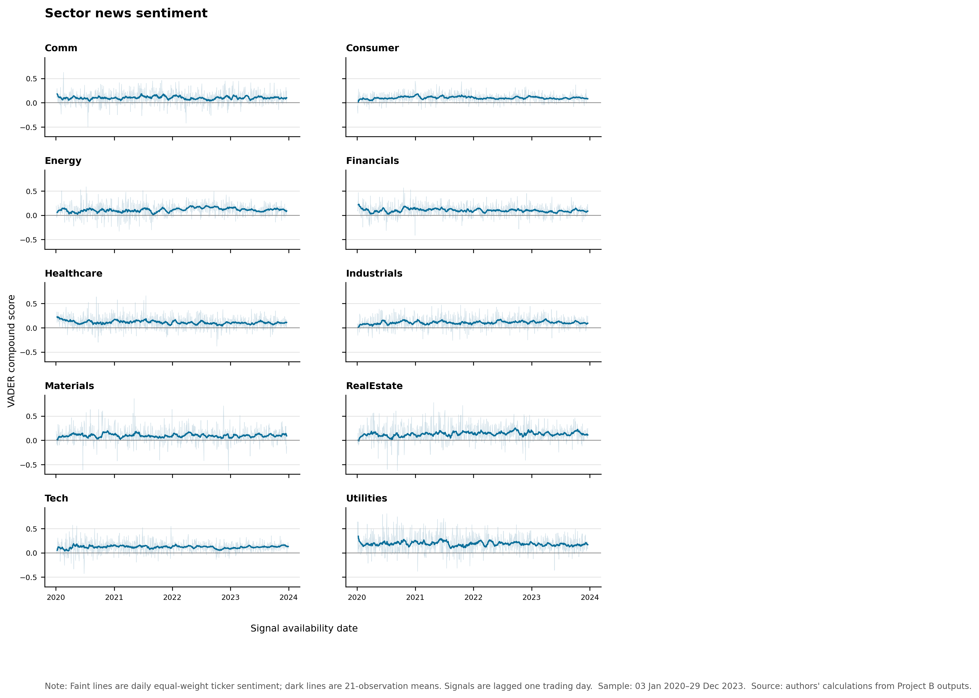
Figure 5. Lagged sector news sentiment. Faint lines show the daily equal-weight ticker index and dark lines show a 21-observation rolling mean for presentation. Daily scores are noisy, while the rolling lines reveal slower changes in tone. Average scores are positive in every sector over the sample; Utilities has the highest mean score (0.184), followed by Real Estate (0.133) and Technology (0.119). These levels should not be interpreted as causal forecasts. They partly reflect VADER's general-language lexicon and differences in headline coverage across sectors.
Though day-to-day sentiment scores are highly variable, the chart shows that the average across the sector provides a signal. Because sentiment fluctuates, a rolling average of 21 observations gives a better indication of sentiment changes than day-to-day headlines could provide. This index is merely a descriptive signal, not a causal predictor. VADER is a general-purpose language sentiment model, and so may not capture the specific semantic structure of financial news headlines. For example, a word that is considered negatively in conversation may not have negative connotations in the world of finance.
The project does not attach sentiment as the crypto dataset does not contain any news headlines, news events related to tickers, or sector classifications. That said, extending the equity sentiment signals to crypto would require making assumptions that would not be borne out by the data. This is also why we have only used the sentiment index on the equity universe and the sentiment-fusion experiment has been limited to equities.

6. Sentiment fusion before/after comparison
This sentiment fusion experiment tests whether one-day-lagged sector sentiment improves performance of a simple equity-only portfolio. Both funds share the same initial 50-stock universe, 252-observation initial window, month-end rebalancing, and live sample period from 29 January 2021 to 29 December 2023. The base fund allocated 2% to each constituent stock.

At each rebalance date, the augmented fund computes sector scores based on the last 21 observations of sector sentiment prior to the rebalance, maps these scores to stocks, de-means these sector scores among eligible stocks, and finally scales the sector scores into a capped tilt. The weight of each stock cannot deviate more than 0.5 percentage points from its initial base weight. As a result, the sentiment signal's influence on the weights is bounded. The resulting portfolio is a long-only, fully invested portfolio.
As shown in Table 2, as well as in Figure 6 and Figure 7, performance was not improved with sentiment tilt. The base equity fund had a return of 12.74%, a volatility of 16.18%, and a Sharpe ratio of 0.82 on an annualized basis. The sentiment-tilted fund has an annualized return of 12.14%, annualized volatility of 16.06%, and a Sharpe ratio of 0.79. The sentiment tilt slightly lowered volatility and the maximum drawdown but the lower return lowered the risk-adjusted performance. This negative result is also useful in that it shows that adding a VADER-based sector sentiment signal does not automatically improve the portfolio.
Table 2. Equity sentiment-fusion comparison
Fund | Annualised return | Annualised volatility | Sharpe ratio | Maximum drawdown | Observations
Base equity equal weight | 12.74% | 16.18% | 0.82 | -20.32% | 735
Sentiment-tilted equity | 12.14% | 16.06% | 0.79 | -20.06% | 735

Note: Both funds cover 29 January 2021 to 29 December 2023 and use 252-day annualisation. Source: `results/tables/sentiment_fusion_metrics.csv`.
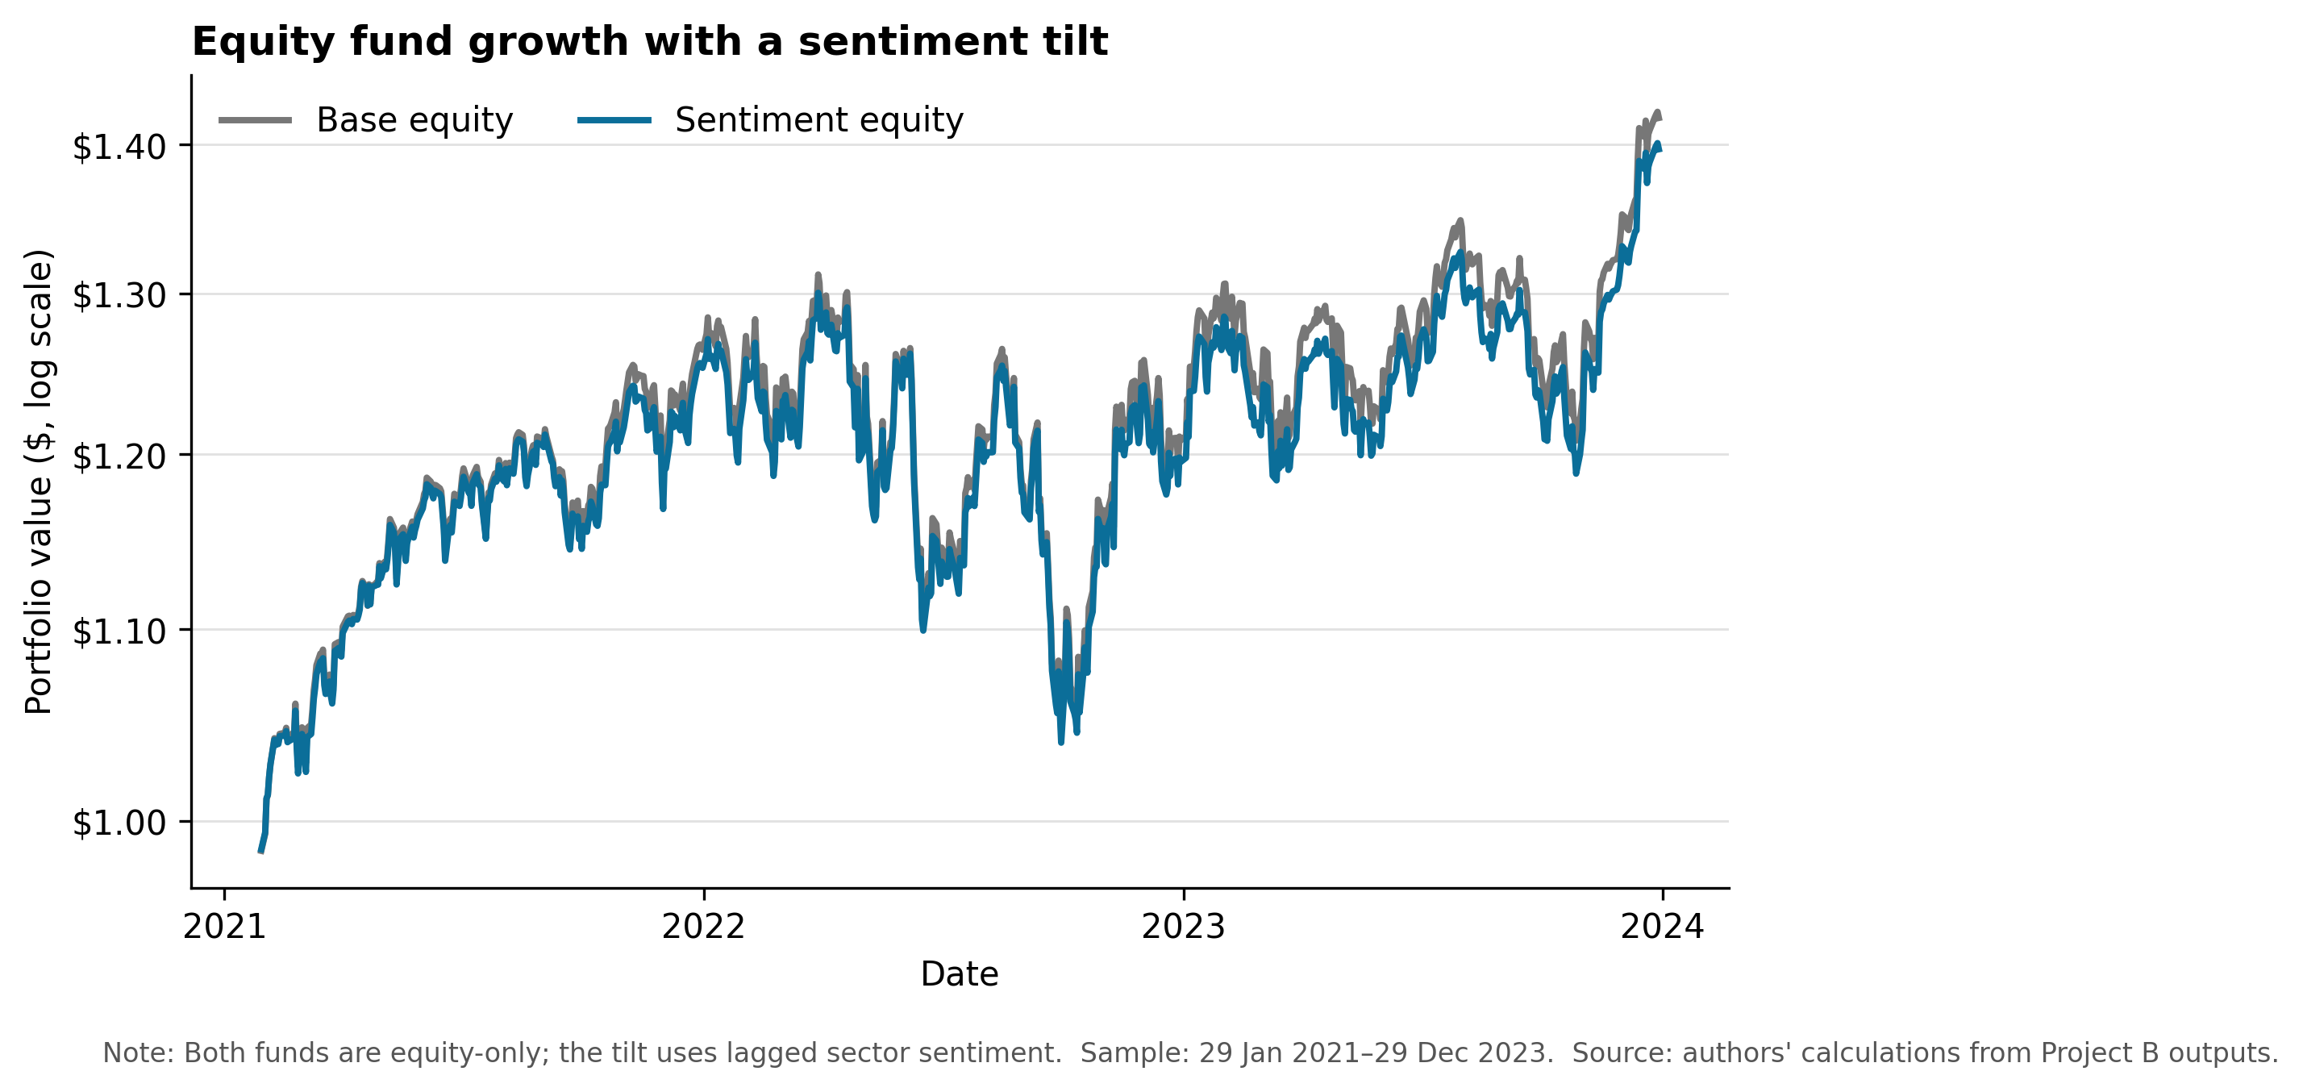
Figure 6. Growth of $1 before and after the sentiment tilt. The paths remain close because the tilt is deliberately capped. The augmented fund ends below the base fund, consistent with its annualised return being 0.60 percentage points lower. The chart provides no evidence that this simple VADER sector signal adds return over the test period.
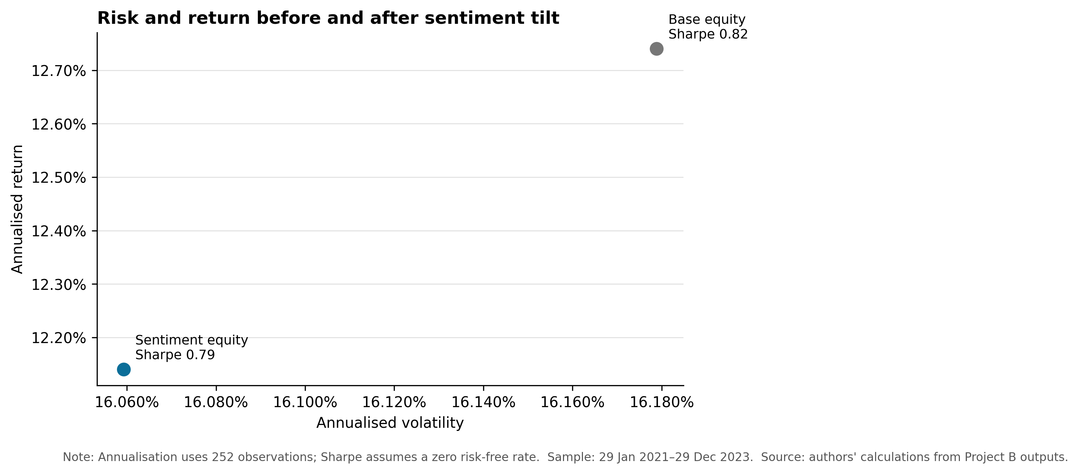
Figure 7. Risk and return before and after the sentiment tilt. The augmented fund reduces volatility by 0.12 percentage points and improves maximum drawdown by 0.26 percentage points, but its Sharpe ratio falls from 0.82 to 0.79. The result is economically small and negative on risk-adjusted performance. Retaining this outcome is more informative than retuning the rule until it appears successful, because the unfavourable comparison shows the limits of a general-language headline score and a simple sector overlay.

7. Crypto-only fund extension and innovation
The crypto-only extension expands Wealth Radar beyond the combined portfolios required by the assignment, applying the same backtest rules to a different market calendar instead of restricting crypto to the equity-market trading-day calendar. For both crypto-only funds, we only use cryptocurrency returns, take into account the native seven-day crypto calendar, use a rolling window of 365 observations, rebalance at the last available calendar day of each month, and annualize the results with 365 days.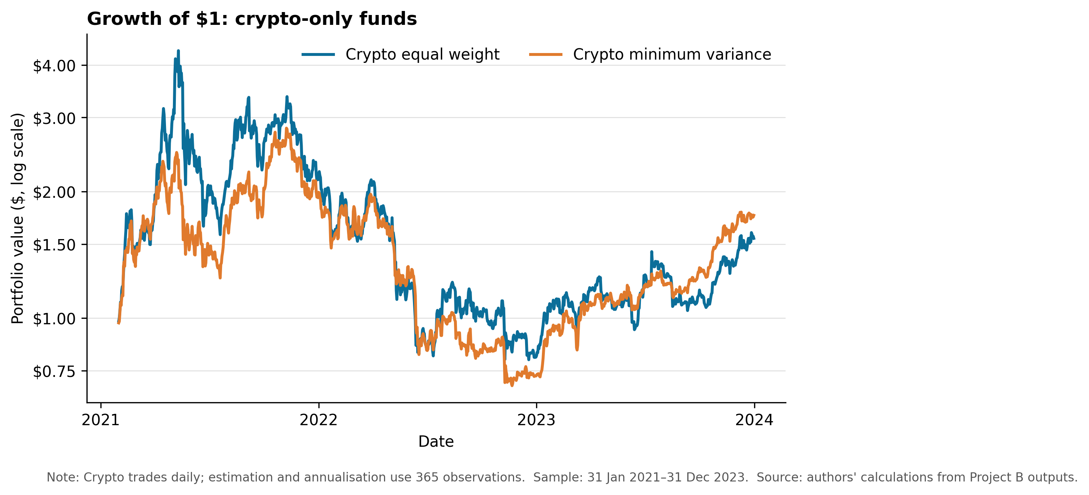s
Figure 8. Growth of $1 for crypto-only funds. Both strategies rise sharply in 2021, lose most of those gains during 2022, and recover partially in 2023. Crypto equal weight finishes at $1.55, while crypto minimum variance finishes at $1.76. The minimum-variance strategy therefore improves terminal wealth and reduces volatility relative to crypto equal weight, but both paths involve losses that are much larger than those of the combined funds.
Looking at Table 1, the crypto minimum variance had the highest annualized return rate at 21.28%. However, it did not outperform the combined equal-weight fund from a risk standpoint, as its volatility of 62.17% was almost three times that of the combined equal-weight fund's 21.46% volatility. Its maximum drawdown of -75.60% was worse than the combined equal-weight fund's -27.16%, and its Sharpe ratio of 0.62 was lower than the equal-weight fund's 0.89. Given the target weights of approximately 52.40% TRX, 39.58% BTC, 8.03% ETH, and negligible other assets, the fund is highly concentrated at the last rebalance. Thus, instead of showing that crypto minimum variance is the best overall fund, the extension shows calendar-aware design, covariance instability, fund concentration, and the potential for concentration risk in a small crypto universe.

8. Streamlit app and investor journey
Wealth Radar is hosted on a Streamlit application designed for consumer use. The application has six pages: Overview, Fund comparison, Fund fact sheets, Allocation simulator, Sentiment analytics, and Sentiment fusion. In short, these pages enable users to navigate from the overall fund performance to pages showing risk, return, drawdowns, target positions, asset allocation, or sentiment analysis.
The overview and fund comparison pages enable users to visualize comparisons between the historical growth, drawdowns, Sharpe ratios, and risk/return trade-off of different funds. The fund fact sheets page provides detailed information about each fund such as annualized return, volatility, Sharpe ratio, maximum drawdown, sample dates and number of observations, and most recent target positions. This shows that a fund returning the most is not automatically the most favorable fund, as risk management and position concentration also need to be taken into account.
The Allocation simulator allows users to combine available funds into an allocation, track the hypothetical past performance of the allocation, and provides summary statistics. The simulator assumes the daily return of each fund is pre-computed and that the user's weightings sum to 100%. The crypto-only allocations use 365-day annualisation, while the combined fund allocations use common equity-calendar observations and 252-day annualisation. The Sentiment analytics and Sentiment fusion pages link the VADER-based sentiment analysis to portfolio performance. Notably, the sentiment-tilted equity fund did not outperform the base equity fund with this sample.
The app in production does not download raw data, run VADER, or re-run backtests during an app session. Instead, the app reads committed CSV and PNG output files in the results folder. This is done to ensure that the historical fund results displayed do not change and to make deployment and reproduction of the app easier.

9. Critical reflection
Reproducibility and auditability are prioritized over model size, and the equal-weight benchmark is hard to beat. It also avoids the covariance estimation error and lack of diversification that may otherwise affect performance. Minimum variance reduces volatility. However, highly concentrated weights and low returns in the full sample and the crypto-only sample suggest that the covariance matrix may be unstable. Even with long-only constraints, the model can assign most of the capital to a few investments, showing this estimation problem.
Additionally, calendar differences limit comparability. Combined funds employ the calendar of the equity markets such that crypto returns over the weekend are held over until the next equity trading day's observation, whilst crypto-only funds employ a seven-day trading calendar. Their measures thus have different observation frequencies and cannot be understood to be the same daily return processes. While the same dates are used in fund family comparisons drawn from the allocation simulator, those comparisons should still be interpreted with caution.
The sentiment experiment was an association test, not a causal experiment. Although VADER is interpretable, it has a general-purpose lexicon that is not designed explicitly for the finance domain. It may therefore miss phrases specific to finance such as liability, beat, miss, or downgrade. In the absence of the actual intraday publication time of the news, the pipeline employs a conservative set of date rules that adds a day of lag. Though this minimizes look-ahead bias, it may also lose useful information. The index is conditional on news coverage: days on which there is no news in a sector are excluded.
These performance measures do not take into account transaction costs, turnover, bid-ask spreads, market impact, taxes, management fees, etc. Monthly rebalancing and time-varying minimum-variance portfolio weights can incur substantial implementation costs. Finally, the live period from 2021 to 2023 is still too short to conclude whether a strategy is persistent. Results can depend on the rolling window, rebalancing dates, covariance estimator, or market regimes.

10. Three concrete recommendations

10.1 Add transaction costs and turnover analysis
The next version should additionally calculate portfolio turnover at each rebalance and deduct asset-class-specific transaction costs from realized returns. This would allow side-by-side presentation of gross and net performance. This will be particularly important for minimum-variance portfolios (since weights depend on covariance estimates) and crypto asset portfolios (whose spreads and execution conditions differ greatly from large US equities).

10.2 Improve the finance meaning of sentiment
The sentiment model should be compared against a finance-domain lexicon or other finance-domain NLP model and the results reported on a human-annotated set of headlines rather than assuming that a complex model does better. The new index will also keep the ticker-day and equal-weight sector aggregations that this paper used, so that performance change can be disentangled from aggregation design change.

10.3 Test robustness across windows, rebalance dates, and regimes
The portfolio and sentiment-fusion rules should be re-applied over multiple pre-specified estimation windows, alternative month-end or month-start rebalance dates, and alternative subperiods to capture different market regimes. The goal of this robustness check is not to find the best-performing specification, but to determine whether fund rankings and risk characteristics are consistent across reasonable specifications.

11. AI workflow reflection
There was an AI workflow to create this project. Here are the seven steps: review requirements, backtest baseline, create figures, standalone sentiment analysis, sentiment fusion, create Streamlit app, crypto extension. You can read the log of what the AI did in ai/prompt_log_part_b.md. I found this approach useful and it made it easier to inspect the pipeline as opposed to having one long prompt that included data cleaning, modeling, plotting, and the app deployment.
AI was useful for helping me implement the project plan as Python functions, developing schema and portfolio weight checks, and preparing code for reproducible plots and Streamlit. I still had to run the code locally myself and check the outputs. For example, the issue with the first sentiment run was that price dates were timezone-naive but news timestamps were timezone-aware, causing mismatches. I also noticed that some log-scale growth charts in the UI were displayed in scientific notation and updated them to dollar amounts. When tested individually, the Streamlit pages worked, and the hand-in checker passed 21 checks after receiving the required outputs.
In this case, generated code should not be trusted without review, because it models multiple risks including covariance instability, ignoring trading costs, a subjective choice of sentiment window and tilt cap, using a general-English model VADER, and differences in trading calendars for equities and cryptocurrencies. I kept the negative sentiment-fusion result instead of tuning the model until it looked better, because this felt more honest and separated evidence from performance-driven model selection.
AI did not replace my own interpretation of the results. It helped generate subsets of code and actual measurement results, but the conclusion rests on financial judgement. I had to get a sense of what was driving return to risk, including volatility, drawdown, concentration, and implementation cost, to understand why crypto minimum variance did not dominate combined equal weight as an asset allocation, and why I should not think of the sentiment result as a success.

12. References and methods notes
12. References and methods notes
This report relies mainly on project-provided data, repository artefacts, and generated outputs rather than external factual claims. The analysis is based on the FINS5545 Project B brief, the provided project data-access helper, the portfolio construction code, the sentiment and fusion implementation, the reproduction pipeline, the Streamlit app, and the generated CSV and PNG outputs.
- FINS5545 Project B brief, PROJECT_BRIEF.md.
- Provided project data-access helper, src/data_access.py.
- Return and portfolio implementation, src/features.py and src/portfolios.py.
- Sentiment and fusion implementation, src/sentiment.py and src/fusion.py.
- Reproduction pipeline, scripts/run_part_b.py.
- Main performance output, results/tables/performance_metrics.csv.
- Fusion output, results/tables/sentiment_fusion_metrics.csv.
- Sector sentiment output, results/data/sector_sentiment_index.csv.
- AI workflow record, ai/prompt_log_part_b.md.

