**百融云创决策引擎MySQL安装手册**

# mysql的安装

## 1.1创建文件夹

## 1.2上传安装介质

## 1.3安装包解压缩

1. 执行cd /data/install-tools/mysql_5.7.32/install_packge

2. 执行sudo tar -zxvf mysql-5.7.32-linux-glibc2.12-x86_64.tar.gz -C /data

## 1.4修改文件夹名

1. 执行cd /data

2. 执行sudo mv mysql-5.7.32-linux-glibc2.12-x86_64 mysql_5.7.32

## 1.5在/usr/local/目录下创建到/data/mysql_5.7.32的软链接

1.执行cd /usr/local

2.执行sudo ln -s /data/mysql_5.7.32 mysql

## 1.6添加mysql用户，修改mysql目录权限，并用此用户执行mysql

1. 执行 useradd -r -g mysql mysql
2. sudo useradd -s /bin/false -M mysql
3. 执行cd /data
4. 执行sudo chown -R mysql:mysql mysql_5.7.32

## 1.6创建配置文件

1. 执行cd /etc

2. 执行sudo vim my.cnf创建配置文件

## 1.6复制以下内容到文件中,保存并退出

|  |
| --- |
| [mysqld]  # binlog  log-bin=/usr/local/mysql/logs/mysql-bin.log  expire-logs-days=14  max-binlog-size=500M  server-id=1  # GENERAL  basedir=/usr/local/mysql  datadir=/usr/local/mysql/data  socket=/usr/local/mysql/mysql.sock  user=mysql  default-storage-engine=InnoDB  character-set-server=utf8  lower_case_table_names=1  sql_mode='STRICT_TRANS_TABLES,NO_ZERO_IN_DATE,NO_ZERO_DATE,ERROR_FOR_DIVISION_BY_ZERO,NO_AUTO_CREATE_USER,NO_ENGINE_SUBSTITUTION'  explicit_defaults_for_timestamp=true  [mysqld_safe]  log-error=/usr/local/mysql/mysql-error.log  pid-file=/usr/local/mysql/mysqld.pid  [client]  socket=/usr/local/mysql/mysql.sock  [mysql]  default-character-set=utf8  socket=/usr/local/mysql/mysql.sock |

## 1.7修改mysql配置文件权限

sudo chown -R mysql:mysql /etc/my.cnf

## 1.8初始化数据库

1. 执行cd /data/mysql_5.7.32

2. 执行sudo mkdir logs

3. 执行sudo chown -R mysql:mysql logs

4. 执行sudo touch mysql-error.log

5. 执行sudo chown mysql:mysql mysql-error.log

6. 执行sudo bin/mysqld --initialize --user=mysql --basedir=/usr/local/mysql

出现以下信息，代表成功，需要记录一下初始密码：

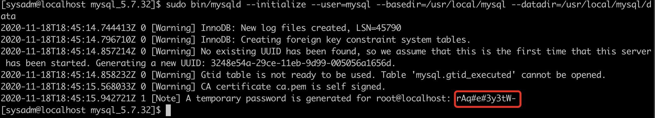

## 1.9配置mysql为系统服务,并启动mysql

1.执行sudo cp /usr/local/mysql/support-files/mysql.server /etc/init.d/mysqld

2.执行sudo service mysqld start

出现以下信息，代表成功：



## 1.10配置环境变量

1. 执行sudo vim /etc/profile

在profile文件后追加以下内容：

|  |
| --- |
| #mysql  export MYSQL_HOME=/usr/local/mysql  export PATH=$PATH:$MYSQL_HOME/bin |

2.执行source /etc/profile

## 1.11登录mysql，修改root密码

1.执行mysql -uroot -p，并输入之前记录下的初始密码登录mysql：

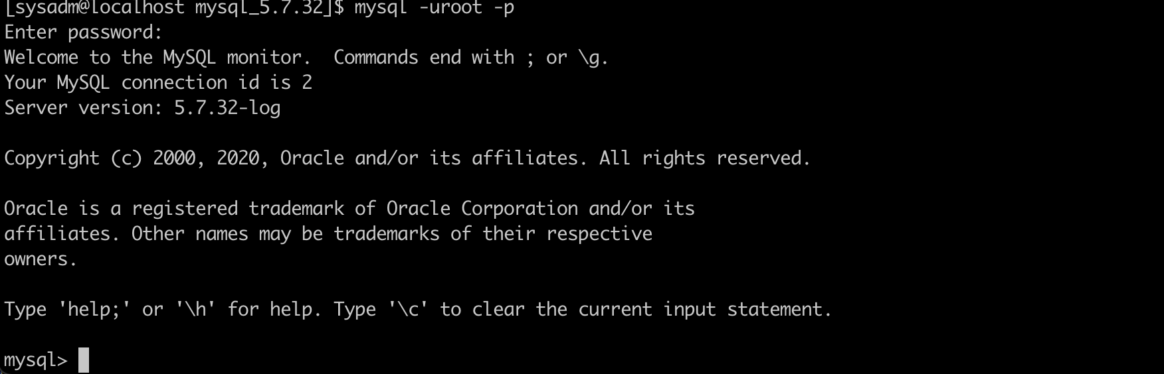

2.执行alter user 'root'@'localhost' identified by 'Dev123!@#' 重置密码：

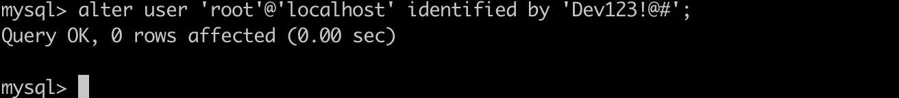

3.执行flush privileges;

## 1.12允许远程登录用户配置

grant all privileges on *.* to '新用户名'@'%' identified by '新密码';

|  |
| --- |
| 执行grant all privileges on *.* to 'root'@'%' identified by ' Dev123!@#';允许远程登录root用户  执行flush privileges;刷新  执行exit; ==>退出 |

## 1.13 mysql命令

1.启动命令：sudo service mysqld start

2.停止命令：sudo service mysqld stop

1.重启命令：sudo service mysqld restart