中建资本生产环境数据库集群部署文档
（V1.0）
建信融通有限责任公司
运维部
2020年11月

目 录
1 基础准备工作 3
2 安装redis集群 3
3 安装mysql集群 9
4 安装rabbitmq集群 13

基础准备工作
基础准备工作详细操作步骤，参考文档《中建资本生产环境部署文档》，包括下面几项内容：

- 防火墙
- Selinux
- 时间服务器（保证时间统一）
- 系统Limits限制
- 主机名

注意：以下内容因环境改变，实际部署会有不同，请根据实际情况灵活变动，切勿完全照搬

- 主机名
- IP地址
- 密码
- 安装路径
- 压缩包文件名

安装包等文件链接：

链接：https://pan.baidu.com/s/11lNuVRDxhk0_D1ALE6z7YQ
提取码：gigg
复制这段内容后打开百度网盘手机App，操作更方便哦

安装redis集群

创建操作系统用户(root)

# groupadd redis
# useradd -g redis redis
# passwd redis （根据环境自定义密码）

# mkdir /redis
# chown -R redis:redis /redis/

修改系统参数：
# vi /etc/sysctl.conf

添加一行：
# FOR REDIS
vm.overcommit_memory = 1

# sysctl -p

临时方法：
# echo never > /sys/kernel/mm/transparent_hugepage/enabled
永久方法：
将上面一条命令写入rc.local文件
# vi /etc/rc.d/rc.local

(备注：必须用root用户执行 没有权限)
切换到redis用户：
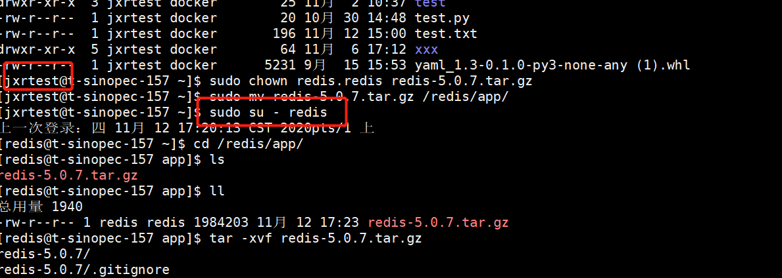

# su - redis
cd /redis

mkdir data app
mkdir -p data/redis
mkdir -p data/sentinel

cd /redis/app
tar -xvf redis-5.0.5.tar.gz
cd redis-5.0.5/
Make (使用当前Makefile编译文件)
make test

使用示例配置文件生成：
cat redis-5.0.5/redis.conf | grep -v "#" |grep -v "^$" > redis1.conf（备注：可删除）

Cd /redis/data/redis

vi redis.conf
！！！！！！注意 slave节点需要把备注的部分放开 ！！！！！！！
##############Master################
#bind 12.0.217.157
protected-mode yes
port 6379
requirepass 123456
masterauth 123456
maxmemory 2GB
tcp-backlog 511
timeout 0
tcp-keepalive 300
daemonize no
supervised no
pidfile /var/run/redis_1.pid
loglevel notice
logfile "/redis/data/redis1/redis.log"
databases 16
always-show-logo yes
save 10 1
stop-writes-on-bgsave-error yes
rdbcompression yes
rdbchecksum yes
dbfilename dump.rdb
dir /redis/data/redis1/
# 修改以下两个参数作为slave节点(备注：158, 159注释去掉 改成master节点的IP )
# replicaof 12.0.217.157 6379
# masterauth 123456
replica-serve-stale-data yes
replica-read-only yes
repl-diskless-sync no
repl-diskless-sync-delay 5
repl-disable-tcp-nodelay no
replica-priority 100
lazyfree-lazy-eviction no
lazyfree-lazy-expire no
lazyfree-lazy-server-del no
replica-lazy-flush no
appendonly yes
appendfilename "appendonly.aof"
appendfsync everysec
no-appendfsync-on-rewrite no
auto-aof-rewrite-percentage 100
auto-aof-rewrite-min-size 64mb
aof-load-truncated yes
aof-use-rdb-preamble yes
lua-time-limit 5000
slowlog-log-slower-than 10000
slowlog-max-len 128
latency-monitor-threshold 0
notify-keyspace-events ""
hash-max-ziplist-entries 512
hash-max-ziplist-value 64
list-max-ziplist-size -2
list-compress-depth 0
set-max-intset-entries 512
zset-max-ziplist-entries 128
zset-max-ziplist-value 64
hll-sparse-max-bytes 3000
stream-node-max-bytes 4096
stream-node-max-entries 100
activerehashing yes
client-output-buffer-limit normal 0 0 0
client-output-buffer-limit replica 256mb 64mb 60
client-output-buffer-limit pubsub 32mb 8mb 60
hz 10
dynamic-hz yes
aof-rewrite-incremental-fsync yes
rdb-save-incremental-fsync yes

Salve：
#bind 12.0.217.157
protected-mode yes
port 6379
requirepass 123456
masterauth 123456
maxmemory 2GB
tcp-backlog 511
timeout 0
tcp-keepalive 300
daemonize no
supervised no
pidfile /var/run/redis_1.pid
loglevel notice
logfile "/redis/data/redis1/redis.log"
databases 16
always-show-logo yes
save 10 1
stop-writes-on-bgsave-error yes
rdbcompression yes
rdbchecksum yes
dbfilename dump.rdb
dir /redis/data/redis1/
# 修改以下两个参数作为slave节点(备注：158, 159注释去掉 改成master节点的IP )
replicaof 12.0.217.157 6379
masterauth 123456
replica-serve-stale-data yes
replica-read-only yes
repl-diskless-sync no
repl-diskless-sync-delay 5
repl-disable-tcp-nodelay no
replica-priority 100
lazyfree-lazy-eviction no
lazyfree-lazy-expire no
lazyfree-lazy-server-del no
replica-lazy-flush no
appendonly yes
appendfilename "appendonly.aof"
appendfsync everysec
no-appendfsync-on-rewrite no
auto-aof-rewrite-percentage 100
auto-aof-rewrite-min-size 64mb
aof-load-truncated yes
aof-use-rdb-preamble yes
lua-time-limit 5000
slowlog-log-slower-than 10000
slowlog-max-len 128
latency-monitor-threshold 0
notify-keyspace-events ""
hash-max-ziplist-entries 512
hash-max-ziplist-value 64
list-max-ziplist-size -2
list-compress-depth 0
set-max-intset-entries 512
zset-max-ziplist-entries 128
zset-max-ziplist-value 64
hll-sparse-max-bytes 3000
stream-node-max-bytes 4096
stream-node-max-entries 100
activerehashing yes
client-output-buffer-limit normal 0 0 0
client-output-buffer-limit replica 256mb 64mb 60
client-output-buffer-limit pubsub 32mb 8mb 60
hz 10
dynamic-hz yes
aof-rewrite-incremental-fsync yes
rdb-save-incremental-fsync yes

启动redis:
/redis/app/redis-5.0.7/src/redis-server /redis/data/redis/redis.conf &

vi /redis/data/sentinel/sentinel.conf
sentinel.conf内容：
#########################################
port 26379
daemonize no
protected-mode no
pidfile /var/run/redis-sentinel.pid
logfile "/redis/data/sentinel/sentinel.log"
dir /redis/data/sentinel/
sentinel monitor jxrtMaster 12.0.217.157 6379 2
sentinel auth-pass jxrtMaster 123456
sentinel down-after-milliseconds jxrtMaster 30000
sentinel parallel-syncs jxrtMaster 1
sentinel failover-timeout jxrtMaster 180000
sentinel deny-scripts-reconfig yes
########################################
启动sentinel:

/redis/app/redis-5.0.7/src/redis-server /redis/data/sentinel/sentinel.conf --sentinel &

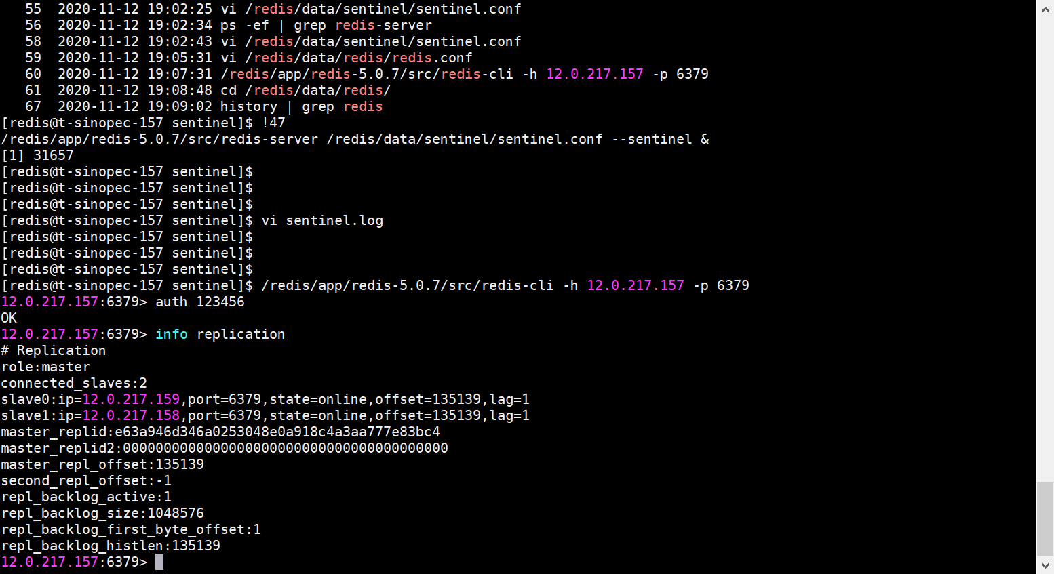
问题: 集群一开始没起来 需要把redis.conf和sentinel.conf全部改成主节点的

安装mysql集群
1.创建数据库用户，创建目录，绑定/etc/hosts解析
root用户操作：
mkdir -p /mysql/data/
mkdir -p /mysql/app/
mkdir -p /mysql/conf/
mkdir -p /mysql/log/binlog/
mkdir -p /mysql/log/relaylog/
mkdir -p /mysql/mysqlrouter/
chown -R mysql:mysql /mysql
useradd mysql
vi /etc/hosts
12.0.217.11 t-csceck8s-11
12.0.217.12 t-csceck8s-12
12.0.217.13 t-csceck8s-13

2.解压安装程序包
mysql用户操作：
cd /mysql/app
tar zxvf mysql-5.7.32-linux-glibc2.12-x86_64.tar.gz
ln -s mysql-5.7.32-linux-glibc2.12-x86_64 mysql

3.配置mysql用户环境变量
mysql用户操作：
vi ~/.bash_profile
PATH=$PATH:/mysql/app/mysql/bin:$HOME/bin
source ~/.bash_profile

4.上传mysql初始化参数文件并初始化
mysql用户操作：
touch /mysql/log/itpuxdb-error.err
mysqld --defaults-file=/mysql/conf/my.cnf --initialize --user=mysql --basedir=/mysql/app/mysql --datadir=/mysql/data #my.cnf文件单独发送
mysqld_safe --defaults-file=/mysql/conf/my.cnf --user=mysql &

5.修改root@localhost用户密码（root密码可以根据需求自己修改）
mysql用户操作：
--默认密码在错误日志里
more /mysql/log/itpuxdb-error.err --查找初始化root用户的密码
mysql -uroot -p -h127.0.0.1 -P 24801
mysql>set password=PASSWORD('root')
--配置可以远程登录
mysql>grant all privileges on *.* to 'root'@'%' identified by 'root' with grant option;
mysql>flush privileges

6.MySQL配置文件 MGR相关参数修改，添加修改如下参数
mysql用户操作：
vi /mysql/conf/my.cnf
server_id=513306 #这个参数要三个节点修改成不同的值
#bind_address= 0.0.0.0 #这个参数要注释掉，下边的参数是添加到参数文件最后即可
log_bin=/mysql/log/binlog/itpuxdb-binlog
log_bin_index=/mysql/log/binlog/itpuxdb-binlog.index
binlog_format=row
binlog_rows_query_log_events=on
binlog_checksum=none
slave-parallel-type=LOGICAL_CLOCK
slave-parallel-workers=4
slave_preserve_commit_order=1

gtid_mode=on
enforce_gtid_consistency=1
log-slave-updates=1
binlog_gtid_simple_recovery=1

relay_log=/mysql/log/relaylog/itpuxdb-relay.log
relay-log-index=/mysql/log/relaylog/itpuxdb-relay.index
master_info_repository=table
relay_log_info_repository=table

plugin_load="group_replication=group_replication.so"

transaction_write_set_extraction=XXHASH64
loose-group_replication_group_name="c7bf0f23-86cb-11ea-855f-000c29af7736"
loose-group_replication_start_on_boot=off
loose-group_replication_local_address="12.0.217.11:25801" #这个根据对应的主机IP修改 11节点的就写11的ip，12节点的就写12的ip
loose-group_replication_group_seeds="12.0.217.11:25801,12.0.217.12:25801,12.0.217.13:25801" #端口可以随便设，不跟系统端口冲突就可
loose-group_replication_bootstap_group=off
#group_replication_single_primary_mode=off
#group_replication_enforce_update_everywhere_checks=on
group_replication_ip_whitelist="12.0.217.0/24"

--三台机器都改完之后重启数据库
mysqladmin -uroot -p -h 127.0.0.1 -P 24801 shutdown
mysqld_safe --defaults-file=/mysql/conf/my.cnf --user=mysql &

6.配置mgr的第一个节点
217.11执行：
第一步：创建用于复制的用户（密码可以根据需求自定义）
mysql -uroot -p -h 127.0.0.1 -P 24801
set sql_log_bin=0;
create user repuser@'%' identified by 'repuser123';
grant replication slave,replication client on *.* to repuser@'%';
create user repuser@'127.0.0.1' identified by 'repuser123';
grant replication slave,replication client on *.* to repuser@'127.0.0.1';
create user repuser@'localhost' identified by 'repuser123';
grant replication slave,replication client on *.* to repuser@'localhost';
set sql_log_bin=1;

第二步：配置复制所使用的用户
change master to master_user='repuser', master_password='repuser123' for channel 'group_replication_recovery';

第三步：安装mysql group replication这个插件
install plugin group_replication soname 'group_replication.so'; #如果执行提示已安装可以跳过这步

第四步：初始化复制组
set global group_replication_bootstrap_group=on;
start group_replication;
set global group_replication_bootstrap_group=off;

select * from performance_schema.replication_group_members; --查询当前组成员及状态

7.配置mgr的第二个节点
第一步：创建用于复制的用户
mysql -uroot -p -h 127.0.0.1 -P 24801
set sql_log_bin=0;
create user repuser@'%' identified by 'repuser123';
grant replication slave,replication client on *.* to repuser@'%';
create user repuser@'127.0.0.1' identified by 'repuser123';
grant replication slave,replication client on *.* to repuser@'127.0.0.1';
create user repuser@'localhost' identified by 'repuser123';
grant replication slave,replication client on *.* to repuser@'localhost';
set sql_log_bin=1

第二步：配置复制所使用的用户
change master to
master_user='repuser',
master_password='repuser123'
for channel 'group_replication_recovery';
第三步：安装mysql group replication这个插件
install plugin group_replication soname 'group_replication.so';
第四步：加入前面创建好的复制组
start group_replication
select * from performance_schema.replication_group_members

8.配置mgr的其它节点
mysql -uroot -p -h 127.0.0.1 -P 24801
第一步：创建用于复制的用户
set sql_log_bin=0;
create user repuser@'%' identified by 'repuser123';
grant replication slave,replication client on *.* to repuser@'%';
create user repuser@'127.0.0.1' identified by 'repuser123';
grant replication slave,replication client on *.* to repuser@'127.0.0.1';
create user repuser@'localhost' identified by 'repuser123';
grant replication slave,replication client on *.* to repuser@'localhost';
set sql_log_bin=1

第二步：配置复制所使用的用户
change master to
master_user='repuser',
master_password='repuser123'
for channel 'group_replication_recovery';
第三步：安装mysql group replication这个插件
install plugin group_replication soname 'group_replication.so';
第四步：加入前面创建好的复制组
start group_replication
select * from performance_schema.replication_group_members --检查当前三个节点状态如果正常，则继续执行第9步

9.将groupreplication转换成innodbcluster (执行一遍)
root用户操作：
rpm -ivh /root/mysql-shell-8.0.15-1.el7.x86_64.rpm
mysql用户操作：
mysqlsh --uri root@12.0.217.11:24801
var cluster = dba.createCluster('dc',{adoptFromGR:true});

安装rabbitmq集群
12.0.217.157、12.0.217.158、12.0.217.159为本地测试服务器，请根据实际情况自行更改

注意：此集群需要搭配keepalived做高可用（待测试）

157上执行：
docker run -d -h mqnode1 --name mqnode1 \
--add-host mqnode2:12.0.217.158 \
--add-host mqnode3:12.0.217.159 \
-p 17772:5672 -p 17773:15672 -p 4369:4369 -p 25672:25672 \
-e RABBITMQ_NODENAME=rabbitmq@mqnode1 \
-e RABBITMQ_ERLANG_COOKIE='mqcluster' \
-e RABBITMQ_DEFAULT_USER=admin \
-e RABBITMQ_DEFAULT_PASS=rabbitmqq \
-v /home/jxrtest/rabbitmq:/var/lib/rabbitmq \
12.0.216.152/public/rabbitmq:v1

158上执行：
docker run -d -h mqnode2 --name mqnode2 \
--add-host mqnode1:12.0.217.157 \
--add-host mqnode3:12.0.217.159 \
-p 17772:5672 -p 17773:15672 -p 4369:4369 -p 25672:25672 \
-e RABBITMQ_NODENAME=rabbitmq@mqnode2 \
-e RABBITMQ_ERLANG_COOKIE='mqcluster' \
-e RABBITMQ_DEFAULT_USER=admin \
-e RABBITMQ_DEFAULT_PASS=rabbitmqq \
-v /home/jxrtest/rabbitmq:/var/lib/rabbitmq \
12.0.216.152/public/rabbitmq:v1
159上执行：
docker run -d -h mqnode3 --name mqnode3 \
--add-host mqnode1:12.0.217.157 \
--add-host mqnode2:12.0.217.158 \
-p 17772:5672 -p 17773:15672 -p 4369:4369 -p 25672:25672 \
-e RABBITMQ_NODENAME=rabbitmq@mqnode3 \
-e RABBITMQ_ERLANG_COOKIE='mqcluster' \
-e RABBITMQ_DEFAULT_USER=admin \
-e RABBITMQ_DEFAULT_PASS=rabbitmqq \
-v /home/jxrtest/rabbitmq:/var/lib/rabbitmq \
12.0.216.152/public/rabbitmq:v1

158节点：
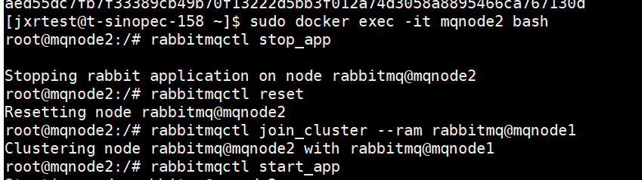
159节点：
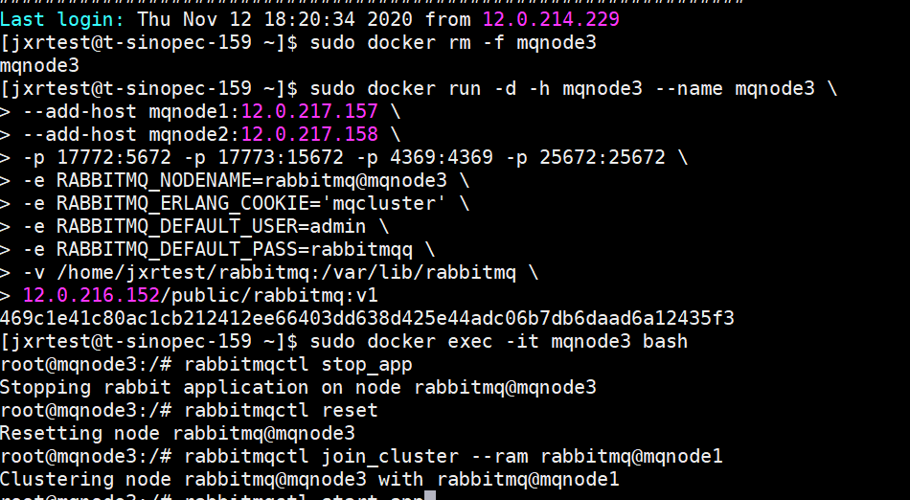
rabbitmqctl stop_app
rabbitmqctl reset
rabbitmqctl join_cluster --ram rabbitmq@mqnode1
rabbitmqctl start_app

//158 159其中一个执行即可
rabbitmqctl cluster_status

rabbitmqctl set_policy -p / ha-allqueue "^" '{"ha-mode":"all"}'
rabbitmqctl list_policies
rabbitmqctl list_vhosts

rabbitmqctl clear_policy -p / ha-all（备注暂时不用执行）

安装Mongo集群
创建mongo用户
# groupadd mongo
# useradd -g mongo mongo
# passwd mongo // jxrt123!

修改ulimit系统参数
# vi /etc/security/limits.conf
添加以下内容

mongo soft nofile 64000
mongo hard nofile 64000
mongo soft nproc 32000
mongo hard nproc 32000

检查系统是否已有rpm安装的mongo，不使用默认自动启动
# mv /etc/init.d/mongod /mongdb/
备注：新环境不用执行此命令

安装完成后，创建目录
# mkdir /mongodb
# chown -R mongo:mongo /mongodb
# su - mongo

$ cd /mongodb
$ mkdir app conf data log pid
cd /mongodb/conf
修改mongo.conf文件
$ vi mongo.conf

# mongod.conf

# for documentation of all options, see:
# http://docs.mongodb.org/manual/reference/configuration-options/

# where to write logging data.
systemLog:
destination: file
logAppend: true
logRotate: rename
path: /mongodb/log/mongod.log

# Where and how to store data.
storage:
dbPath: /mongodb/data/
journal:
enabled: true
directoryPerDB: true
# engine:
# mmapv1:
# wiredTiger:

# how the process runs
processManagement:
fork: true # fork and run in background
pidFilePath: /mongodb/pid/mongod.pid # location of pidfile

# network interfaces
net:
port: 37017
bindIp: 0.0.0.0 # Listen to local interface only, comment to listen on all interfaces.

#security:
#keyFile: /mongodb/conf/auth_rs.key

operationProfiling:
mode: slowOp
slowOpThresholdMs: 1000

#replication:
#replSetName: jxrtRS

#siharding:

## Enterprise-Only Options

#auditLog:

#snmp:

将文件解压到目录
tar xvf /data/install-tools/mongo/mongodb-linux-x86_64-rhel70-4.2.3.tgz -C /mongodb/app/

将目录的用户和组改为mongo

/mongodb/app
chown mongo.mongo mongodb-linux-x86_64-rhel70-4.2.3/

配置环境变量
vim ~/.bash_profile

MONGO_HOME=/mongodb/app/mongodb-linux-x86_64-rhel70-4.2.3
PATH=$PATH:$HOME/.local/bin:$HOME/bin:$MONGO_HOME/bin

source ~/.bash_profile

解决mongo用户权限不足登录警告问题

WARNING: /sys/kernel/mm/transparent_hugepage/enabled is ‘always’.
WARNING: /sys/kernel/mm/transparent_hugepage/defrag is ‘always’.

临时方法：
# echo never > /sys/kernel/mm/transparent_hugepage/enabled
# echo never > /sys/kernel/mm/transparent_hugepage/defrag
永久方法：
将上面两条命令写入rc.local文件
# vi /etc/rc.d/rc.local

启动服务
mongod --config /mongodb/conf/mongo.conf &
连接服务
mongo 127.0.0.1:37017
登录进去关服务的命令
use admin;
db.shutdownServer();

集群配置
修改三台服务器上的mongo.cnf文件

$ vi /mongodb/conf/mongo.conf （去掉replication部分的注释）

replication:
replSetName: jxrtRS

启动服务
mongod --config /mongodb/conf/mongo.conf &

在主节点运行以下命令初始化集群：

> rs.initiate( {
_id : "jxrtRS",
members: [
{ _id: 0, host: "12.0.217.11:37017" },
{ _id: 1, host: "12.0.217.12:37017" },
{ _id: 2, host: "12.0.217.13:37017" }
]
})

> rs.status(); --查看集群状态 （备注： 查看health = 1）

在primary节点上创建用户管理员账户：

db.getSiblingDB("admin").createUser(
{
user: "root",
pwd: "r00t@M0NG0",
roles: [ { role: "root", db: "admin" } ]
}
)

在primary节点上创建集群管理员账户：

db.getSiblingDB("admin").createUser(
{
"user" : "rsadmin",
"pwd" : "rs@dmin@M0NG0",
roles: [ { "role" : "clusterAdmin", "db" : "admin" } ]
}
)

创建应用账户
db.getSiblingDB("admin").createUser(
{
"user" : "ccbscf_app",
"pwd" : "ccbscf@M0NG0",
roles: [ { "role" : "readWriteAnyDatabase", "db" : "admin" } ]
}
)

连接串：mongo --host jxrtRS/12.0.217.157:37017,12.0.217.158:37017,12.0.217.159:37017 -uccbscf_app -p ccbscf@M0NG0 --authenticationDatabase admin

最后启用配置文件里的keyfile参数， 并使用 --auth 重启replicaSet
为Replica Set配置Enforce Keyfile Access Control

$ openssl rand -base64 756 > /mongodb/conf/auth_rs.key
$ chmod 400 /mongodb/conf/auth_rs.key
$ scp /mongodb/conf/auth_rs.key 12.0.217.158:/mongodb/conf
$ scp /mongodb/conf/auth_rs.key 12.0.217.159:/mongodb/conf

$ vi /mongodb/conf/mongo.conf （去掉security部分的注释）

security:
keyFile: /mongodb/conf/auth_rs.key

重启服务

使用 —auth 参数重启集群开始强制密码验证。

mongod --auth --config /mongodb/conf/mongo.conf & （备注： 先启动谁 谁就是master）

使用mongo客户端连接replica set进行测试

mongo --host jxrtRS/12.0.217.157:37017,12.0.217.158:37017,12.0.217.157:37017 -uroot -p r00t@M0NG0 --authenticationDatabase admin

