ITS simulation

Tianyi Zheng

11/10/2021

# Simulating datasets

# Senario 1: No pre-exisiting trend, but has level change

Simulate a constant observed outcome before intervention.

x=1:100  
S1TrueOutcomeBefore = data.frame(x, y=120)  
plot(S1TrueOutcomeBefore$x,S1TrueOutcomeBefore$y)

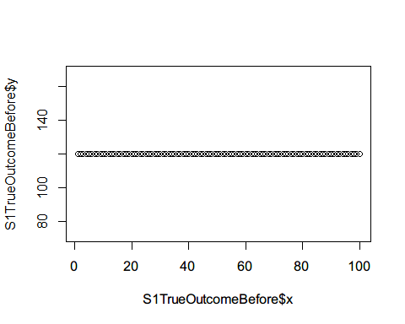

x=101:119  
S1CounterfactualBefore = data.frame(x, y=120)

Simulate sample of 20 from the observed population

S1SamplePopBefore20=c()  
i=1  
temp=data.frame()  
set.seed(0)  
for(i in 1:length(S1TrueOutcomeBefore$y)){  
 x=rep(i,20)  
 Individual=1:20  
 yindv=rnorm(20,S1TrueOutcomeBefore$y[i],10)  
 temp=data.frame(cbind(x,Individual,yindv))  
 S1SamplePopBefore20=rbind(S1SamplePopBefore20,temp)  
 i=i+1  
}  
#Individual level variation  
plot(S1SamplePopBefore20$x,S1SamplePopBefore20$yindv,ylim=c(0,200))

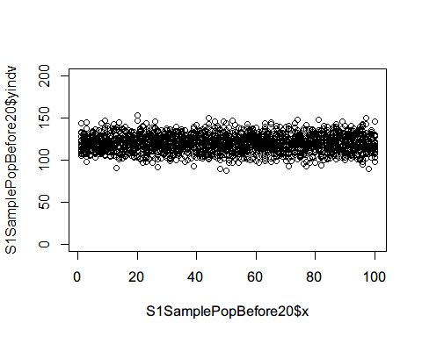

#Compute mean at each time point  
(S1SamplePopBefore20AGG<-S1SamplePopBefore20 %>%   
 group_by(x) %>%   
 summarise(y=mean(yindv)))

## # A tibble: 100 x 2  
## x y  
## <dbl> <dbl>  
## 1 1 120.  
## 2 2 121.  
## 3 3 119.  
## 4 4 118.  
## 5 5 123.  
## 6 6 119.  
## 7 7 118.  
## 8 8 119.  
## 9 9 120.  
## 10 10 121.  
## # ... with 90 more rows

plot(S1SamplePopBefore20AGG$x,S1SamplePopBefore20AGG$y,ylim=c(0,200))

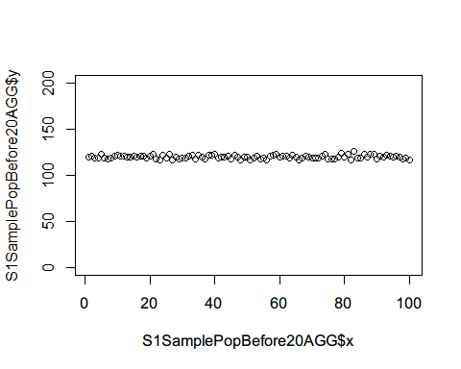 Simulate sample of 100 from the observed population

S1SamplePopBefore100=c()  
i=1  
temp=data.frame()  
set.seed(1)  
for(i in 1:length(S1TrueOutcomeBefore$y)){  
 x=rep(i,100)  
 Individual=1:100  
 yindv=rnorm(100,S1TrueOutcomeBefore$y[i],10)  
 temp=data.frame(cbind(x,Individual,yindv))  
 S1SamplePopBefore100=rbind(S1SamplePopBefore100,temp)  
 i=i+1  
}  
#Individual level variation  
plot(S1SamplePopBefore100$x,S1SamplePopBefore100$yindv,ylim=c(0,200))

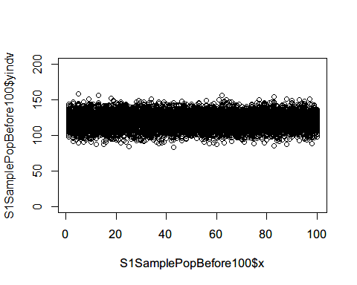

#Compute mean at each time point  
(S1SamplePopBefore100AGG<-S1SamplePopBefore100 %>%   
 group_by(x) %>%   
 summarise(y=mean(yindv)))

## # A tibble: 100 x 2  
## x y  
## <dbl> <dbl>  
## 1 1 121.  
## 2 2 120.  
## 3 3 120.  
## 4 4 121.  
## 5 5 120.  
## 6 6 120.  
## 7 7 118.  
## 8 8 120.  
## 9 9 120.  
## 10 10 120.  
## # ... with 90 more rows

plot(S1SamplePopBefore100AGG$x,S1SamplePopBefore100AGG$y,ylim=c(0,200))

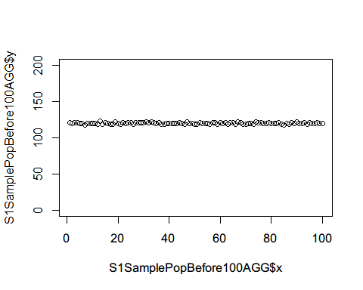

Simulate sample of 1000 from the observed population

S1SamplePopBefore1000=c()  
i=1  
temp=data.frame()  
set.seed(2)  
for(i in 1:length(S1TrueOutcomeBefore$y)){  
 x=rep(i,1000)  
 Individual=1:1000  
 yindv=rnorm(1000,S1TrueOutcomeBefore$y[i],10)  
 temp=data.frame(cbind(x,Individual,yindv))  
 S1SamplePopBefore1000=rbind(S1SamplePopBefore1000,temp)  
 i=i+1  
}  
#Compute mean at each time point  
(S1SamplePopBefore1000AGG<-S1SamplePopBefore1000 %>%   
 group_by(x) %>%   
 summarise(y=mean(yindv)))

## # A tibble: 100 x 2  
## x y  
## <dbl> <dbl>  
## 1 1 121.  
## 2 2 120.  
## 3 3 121.  
## 4 4 120.  
## 5 5 120.  
## 6 6 120.  
## 7 7 119.  
## 8 8 120.  
## 9 9 119.  
## 10 10 120.  
## # ... with 90 more rows

plot(S1SamplePopBefore1000AGG$x,S1SamplePopBefore1000AGG$y,ylim=c(0,200))

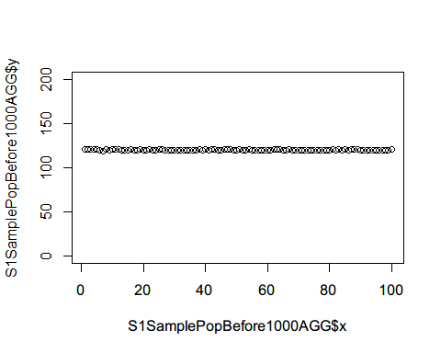 Compare variation across each sample size

var(S1SamplePopBefore20AGG$y)

## [1] 3.630824

var(S1SamplePopBefore100AGG$y)

## [1] 0.9586764

var(S1SamplePopBefore1000AGG$y)

## [1] 0.1307949

## Effect Size: 20

Simulate level changed time points after intervention.

x=101:200  
S1TrueOutcomeAfterE20 = data.frame(x, y=100)  
plot(S1TrueOutcomeAfterE20$x,S1TrueOutcomeAfterE20$y)

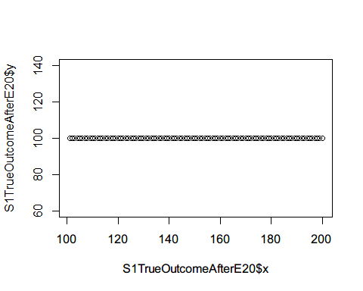

S1CounterfactualAfterE20=subset(S1TrueOutcomeAfterE20,x<120&x>100)

Simulate sample of 20 from the observed population

S1SamplePopAfterS20E20=c()  
i=1  
temp=data.frame()  
set.seed(3)  
for(i in 1:length(S1TrueOutcomeAfterE20$y)){  
 x=rep(i+100,20)  
 Individual=1:20  
 yindv=rnorm(20,S1TrueOutcomeAfterE20$y[i],10)  
 temp=data.frame(cbind(x,Individual,yindv))  
 S1SamplePopAfterS20E20=rbind(S1SamplePopAfterS20E20,temp)  
 i=i+1  
}  
#Individual level variation  
plot(S1SamplePopAfterS20E20$x,S1SamplePopAfterS20E20$yindv,ylim=c(0,200))

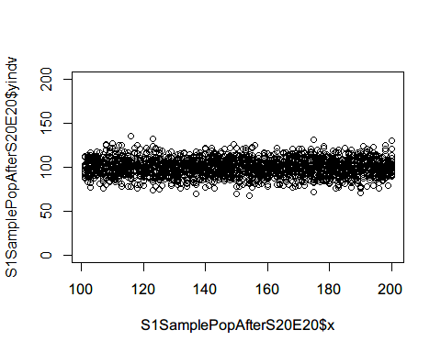

#Compute mean at each time point  
(S1SamplePopAfterS20E20AGG<-S1SamplePopAfterS20E20 %>%   
 group_by(x) %>%   
 summarise(y=mean(yindv)))

## # A tibble: 100 x 2  
## x y  
## <dbl> <dbl>  
## 1 101 98.3  
## 2 102 101.   
## 3 103 98.1  
## 4 104 103.   
## 5 105 101.   
## 6 106 101.   
## 7 107 97.4  
## 8 108 101.   
## 9 109 103.   
## 10 110 99.4  
## # ... with 90 more rows

plot(S1SamplePopAfterS20E20AGG$x,S1SamplePopAfterS20E20AGG$y,ylim=c(0,200))

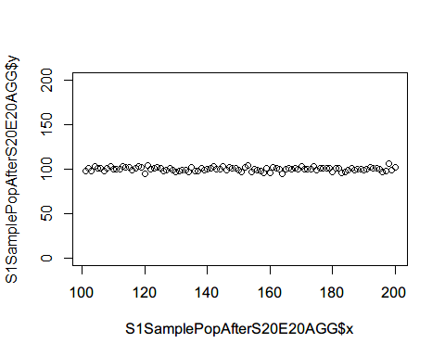

Simulate sample of 100 from the observed population

S1SamplePopAfterS100E20=c()  
i=1  
temp=data.frame()  
set.seed(4)  
for(i in 1:length(S1TrueOutcomeAfterE20$y)){  
 x=rep(i+100,100)  
 Individual=1:100  
 yindv=rnorm(100,S1TrueOutcomeAfterE20$y[i],10)  
 temp=data.frame(cbind(x,Individual,yindv))  
 S1SamplePopAfterS100E20=rbind(S1SamplePopAfterS100E20,temp)  
 i=i+1  
}  
#Individual level variation  
plot(S1SamplePopAfterS100E20$x,S1SamplePopAfterS100E20$yindv,ylim=c(0,200))

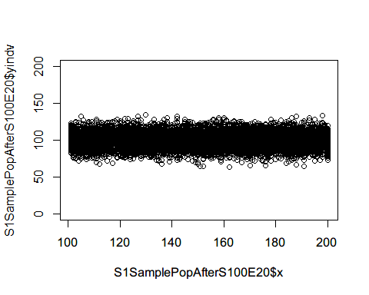

#Compute mean at each time point  
(S1SamplePopAfterS100E20AGG<-S1SamplePopAfterS100E20 %>%   
 group_by(x) %>%   
 summarise(y=mean(yindv)))

## # A tibble: 100 x 2  
## x y  
## <dbl> <dbl>  
## 1 101 101.   
## 2 102 99.2  
## 3 103 99.6  
## 4 104 99.2  
## 5 105 99.5  
## 6 106 99.9  
## 7 107 99.6  
## 8 108 99.9  
## 9 109 99.3  
## 10 110 99.4  
## # ... with 90 more rows

plot(S1SamplePopAfterS100E20AGG$x,S1SamplePopAfterS100E20AGG$y,ylim=c(0,200))

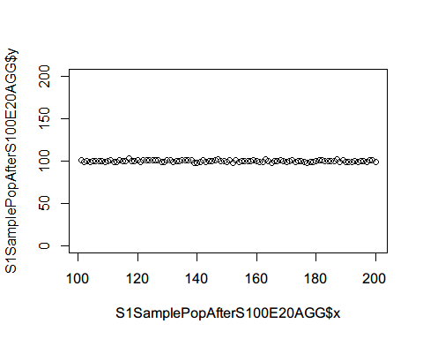 Simulate sample of 1000 from the observed population

S1SamplePopAfterS1000E20=c()  
i=1  
temp=data.frame()  
set.seed(5)  
for(i in 1:length(S1TrueOutcomeAfterE20$y)){  
 x=rep(i+100,1000)  
 Individual=1:1000  
 yindv=rnorm(1000,S1TrueOutcomeAfterE20$y[i],10)  
 temp=data.frame(cbind(x,Individual,yindv))  
 S1SamplePopAfterS1000E20=rbind(S1SamplePopAfterS1000E20,temp)  
 i=i+1  
}  
#Compute mean at each time point  
(S1SamplePopAfterS1000E20AGG<-S1SamplePopAfterS1000E20 %>%   
 group_by(x) %>%   
 summarise(y=mean(yindv)))

## # A tibble: 100 x 2  
## x y  
## <dbl> <dbl>  
## 1 101 100.   
## 2 102 101.   
## 3 103 100.   
## 4 104 99.8  
## 5 105 100.   
## 6 106 99.8  
## 7 107 99.8  
## 8 108 99.4  
## 9 109 100.   
## 10 110 100.   
## # ... with 90 more rows

plot(S1SamplePopAfterS1000E20AGG$x,S1SamplePopAfterS1000E20AGG$y,ylim=c(0,200))

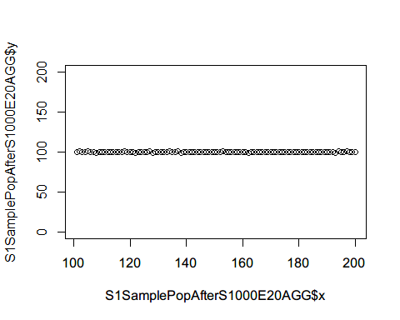

Combine before and after for size 20

S1SamplePopS20E20AGG<-rbind(S1SamplePopBefore20AGG,S1SamplePopAfterS20E20AGG)  
plot(x=1:200, y=rep(1,200), type="n", ylim=c(0,200),   
 xlab="time", ylab="mean of outcome")  
abline(v=100)  
points(S1SamplePopBefore20AGG$x, S1SamplePopBefore20AGG$y, pch=3, col=2,cex=0.7)  
points(S1SamplePopAfterS20E20AGG$x, S1SamplePopAfterS20E20AGG$y, pch=4, col=4,cex=0.7)

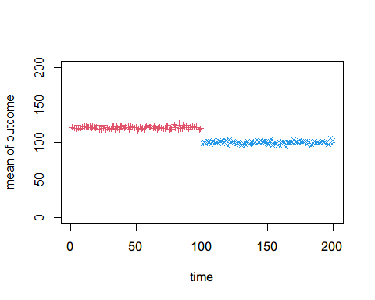 Combine before and after for size 100

S1SamplePopS100E20AGG<-rbind(S1SamplePopBefore100AGG,S1SamplePopAfterS100E20AGG)  
plot(x=1:200, y=rep(1,200), type="n", ylim=c(0,200),   
 xlab="time", ylab="mean of outcome")  
abline(v=100)  
points(S1SamplePopBefore100AGG$x, S1SamplePopBefore100AGG$y, pch=3, col=2,cex=0.7)  
points(S1SamplePopAfterS100E20AGG$x, S1SamplePopAfterS100E20AGG$y, pch=4, col=4,cex=0.7)

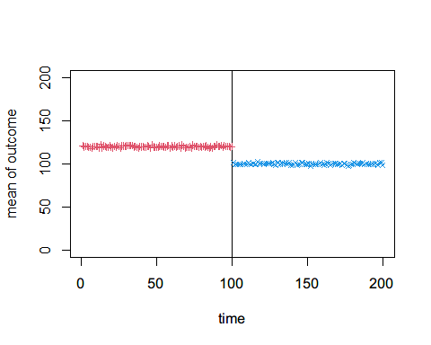

Combine before and after for size 1000

S1SamplePopS1000E20AGG<-rbind(S1SamplePopBefore100AGG,S1SamplePopAfterS1000E20AGG)  
plot(x=1:200, y=rep(1,200), type="n", ylim=c(0,200),   
 xlab="time", ylab="mean of outcome")  
abline(v=100)  
points(S1SamplePopBefore1000AGG$x, S1SamplePopBefore1000AGG$y, pch=3, col=2,cex=0.7)  
points(S1SamplePopAfterS1000E20AGG$x, S1SamplePopAfterS1000E20AGG$y, pch=4, col=4,cex=0.7)

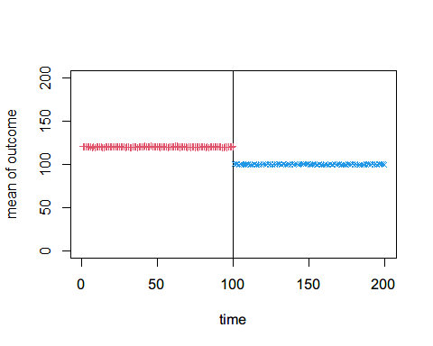

## Effect Size: 50

Simulate level changed time points after intervention.

x=101:200  
S1TrueOutcomeAfterE50 = data.frame(x, y=70)  
plot(S1TrueOutcomeAfterE50$x,S1TrueOutcomeAfterE50$y)

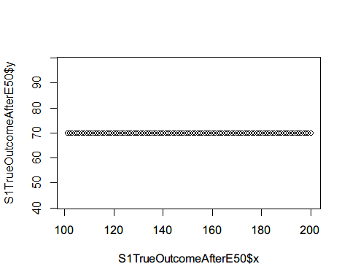

S1CounterfactualAfterE50=subset(S1TrueOutcomeAfterE50,x<120&x>100)

Simulate sample of 20 from the observed population

S1SamplePopAfterS20E50=c()  
i=1  
temp=data.frame()  
set.seed(6)  
for(i in 1:length(S1TrueOutcomeAfterE50$y)){  
 x=rep(i+100,20)  
 Individual=1:20  
 yindv=rnorm(20,S1TrueOutcomeAfterE50$y[i],10)  
 temp=data.frame(cbind(x,Individual,yindv))  
 S1SamplePopAfterS20E50=rbind(S1SamplePopAfterS20E50,temp)  
 i=i+1  
}  
#Individual level variation  
plot(S1SamplePopAfterS20E50$x,S1SamplePopAfterS20E50$yindv,ylim=c(0,200))

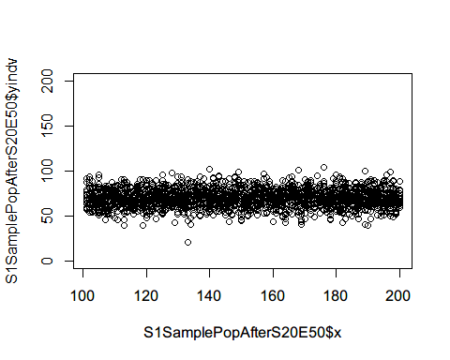

#Compute mean at each time point  
(S1SamplePopAfterS20E50AGG<-S1SamplePopAfterS20E50 %>%   
 group_by(x) %>%   
 summarise(y=mean(yindv)))

## # A tibble: 100 x 2  
## x y  
## <dbl> <dbl>  
## 1 101 71.9  
## 2 102 70.6  
## 3 103 68.6  
## 4 104 68.6  
## 5 105 69.8  
## 6 106 67.8  
## 7 107 69.1  
## 8 108 66.9  
## 9 109 72.1  
## 10 110 69.6  
## # ... with 90 more rows

plot(S1SamplePopAfterS20E50AGG$x,S1SamplePopAfterS20E50AGG$y,ylim=c(0,200))

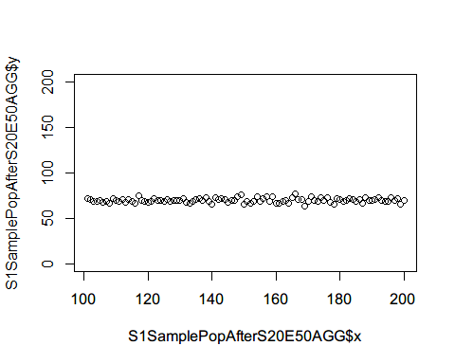

Simulate sample of 100 from the observed population

S1SamplePopAfterS100E50=c()  
i=1  
temp=data.frame()  
set.seed(7)  
for(i in 1:length(S1TrueOutcomeAfterE50$y)){  
 x=rep(i+100,100)  
 Individual=1:100  
 yindv=rnorm(100,S1TrueOutcomeAfterE50$y[i],10)  
 temp=data.frame(cbind(x,Individual,yindv))  
 S1SamplePopAfterS100E50=rbind(S1SamplePopAfterS100E50,temp)  
 i=i+1  
}  
#Individual level variation  
plot(S1SamplePopAfterS100E50$x,S1SamplePopAfterS100E50$yindv,ylim=c(0,200))

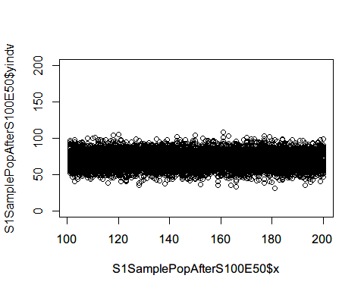

#Compute mean at each time point  
(S1SamplePopAfterS100E50AGG<-S1SamplePopAfterS100E50 %>%   
 group_by(x) %>%   
 summarise(y=mean(yindv)))

## # A tibble: 100 x 2  
## x y  
## <dbl> <dbl>  
## 1 101 71.4  
## 2 102 71.3  
## 3 103 69.6  
## 4 104 69.5  
## 5 105 70.4  
## 6 106 70.0  
## 7 107 69.2  
## 8 108 70.2  
## 9 109 68.3  
## 10 110 70.3  
## # ... with 90 more rows

plot(S1SamplePopAfterS100E50AGG$x,S1SamplePopAfterS100E50AGG$y,ylim=c(0,200))

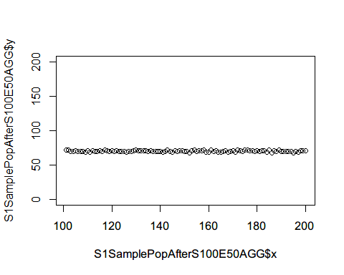 Simulate sample of 1000 from the observed population

S1SamplePopAfterS1000E50=c()  
i=1  
temp=data.frame()  
set.seed(8)  
for(i in 1:length(S1TrueOutcomeAfterE50$y)){  
 x=rep(i+100,1000)  
 Individual=1:1000  
 yindv=rnorm(1000,S1TrueOutcomeAfterE50$y[i],10)  
 temp=data.frame(cbind(x,Individual,yindv))  
 S1SamplePopAfterS1000E50=rbind(S1SamplePopAfterS1000E50,temp)  
 i=i+1  
}  
#Compute mean at each time point  
(S1SamplePopAfterS1000E50AGG<-S1SamplePopAfterS1000E50 %>%   
 group_by(x) %>%   
 summarise(y=mean(yindv)))

## # A tibble: 100 x 2  
## x y  
## <dbl> <dbl>  
## 1 101 69.6  
## 2 102 70.2  
## 3 103 70.3  
## 4 104 70.2  
## 5 105 69.9  
## 6 106 70.1  
## 7 107 69.8  
## 8 108 70.1  
## 9 109 70.1  
## 10 110 70.1  
## # ... with 90 more rows

plot(S1SamplePopAfterS1000E50AGG$x,S1SamplePopAfterS1000E50AGG$y,ylim=c(0,200))

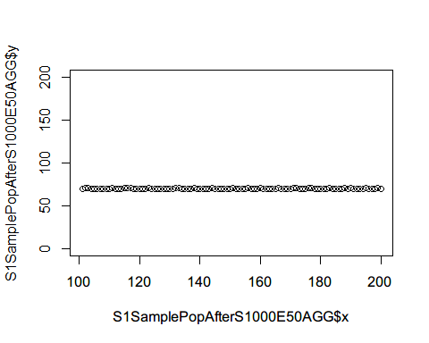

Combine before and after for size 20

S1SamplePopS20E50AGG<-rbind(S1SamplePopBefore20AGG,S1SamplePopAfterS20E50AGG)  
plot(x=1:200, y=rep(1,200), type="n", ylim=c(0,200),   
 xlab="time", ylab="mean of outcome")  
abline(v=100)  
points(S1SamplePopBefore20AGG$x, S1SamplePopBefore20AGG$y, pch=3, col=2,cex=0.7)  
points(S1SamplePopAfterS20E50AGG$x, S1SamplePopAfterS20E50AGG$y, pch=4, col=4,cex=0.7)

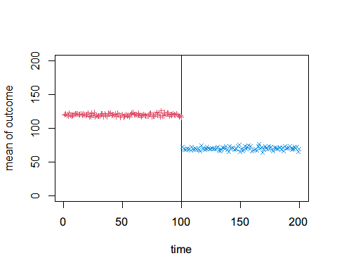 Combine before and after for size 100

S1SamplePopS100E50AGG<-rbind(S1SamplePopBefore100AGG,S1SamplePopAfterS100E50AGG)  
plot(x=1:200, y=rep(1,200), type="n", ylim=c(0,200),   
 xlab="time", ylab="mean of outcome")  
abline(v=100)  
points(S1SamplePopBefore100AGG$x, S1SamplePopBefore100AGG$y, pch=3, col=2,cex=0.7)  
points(S1SamplePopAfterS100E50AGG$x, S1SamplePopAfterS100E50AGG$y, pch=4, col=4,cex=0.7)

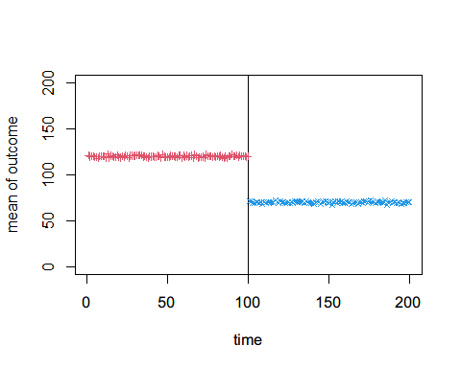 Combine before and after for size 1000

S1SamplePopS1000E50AGG<-rbind(S1SamplePopBefore100AGG,S1SamplePopAfterS1000E50AGG)  
plot(x=1:200, y=rep(1,200), type="n", ylim=c(0,200),   
 xlab="time", ylab="mean of outcome")  
abline(v=100)  
points(S1SamplePopBefore1000AGG$x, S1SamplePopBefore1000AGG$y, pch=3, col=2,cex=0.7)  
points(S1SamplePopAfterS1000E50AGG$x, S1SamplePopAfterS1000E50AGG$y, pch=4, col=4,cex=0.7)

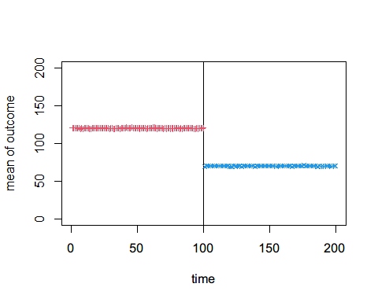 ## Effect Size: 100  
Simulate level changed time points after intervention.

x=101:200  
S1TrueOutcomeAfterE100 = data.frame(x, y=20)  
plot(S1TrueOutcomeAfterE100$x,S1TrueOutcomeAfterE100$y)

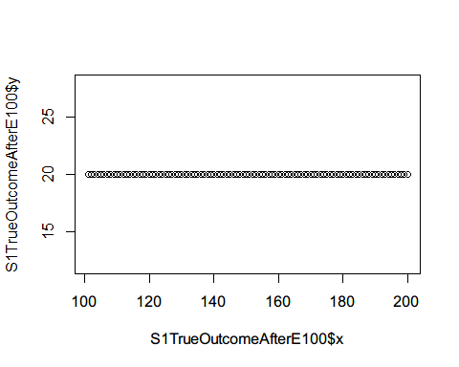

S1CounterfactualAfterE100=subset(S1TrueOutcomeAfterE100,x<120&x>100)

Simulate sample of 20 from the observed population

S1SamplePopAfterS20E100=c()  
i=1  
temp=data.frame()  
set.seed(9)  
for(i in 1:length(S1TrueOutcomeAfterE100$y)){  
 x=rep(i+100,20)  
 Individual=1:20  
 yindv=rnorm(20,S1TrueOutcomeAfterE100$y[i],10)  
 temp=data.frame(cbind(x,Individual,yindv))  
 S1SamplePopAfterS20E100=rbind(S1SamplePopAfterS20E100,temp)  
 i=i+1  
}  
#Individual level variation  
plot(S1SamplePopAfterS20E100$x,S1SamplePopAfterS20E100$yindv,ylim=c(0,200))

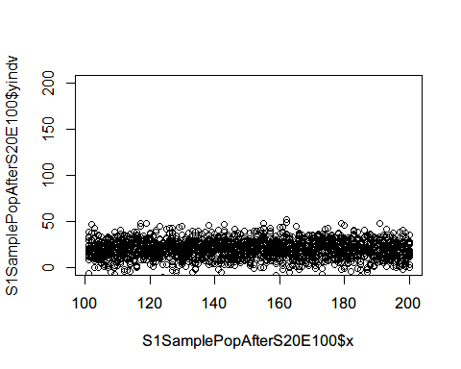

#Compute mean at each time point  
(S1SamplePopAfterS20E100AGG<-S1SamplePopAfterS20E100 %>%   
 group_by(x) %>%   
 summarise(y=mean(yindv)))

## # A tibble: 100 x 2  
## x y  
## <dbl> <dbl>  
## 1 101 18.5  
## 2 102 22.0  
## 3 103 18.8  
## 4 104 20.1  
## 5 105 18.0  
## 6 106 18.3  
## 7 107 20.6  
## 8 108 18.0  
## 9 109 16.0  
## 10 110 20.3  
## # ... with 90 more rows

plot(S1SamplePopAfterS20E100AGG$x,S1SamplePopAfterS20E100AGG$y,ylim=c(0,200))

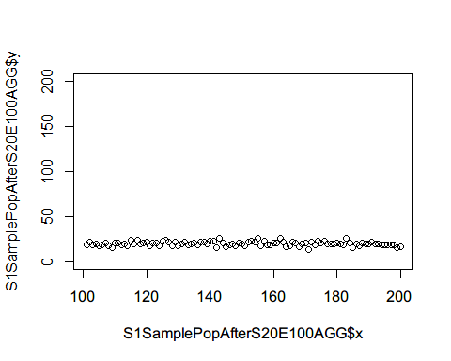

Simulate sample of 100 from the observed population

S1SamplePopAfterS100E100=c()  
i=1  
temp=data.frame()  
set.seed(10)  
for(i in 1:length(S1TrueOutcomeAfterE100$y)){  
 x=rep(i+100,100)  
 Individual=1:100  
 yindv=rnorm(100,S1TrueOutcomeAfterE100$y[i],10)  
 temp=data.frame(cbind(x,Individual,yindv))  
 S1SamplePopAfterS100E100=rbind(S1SamplePopAfterS100E100,temp)  
 i=i+1  
}  
#Individual level variation  
plot(S1SamplePopAfterS100E100$x,S1SamplePopAfterS100E100$yindv,ylim=c(0,200))

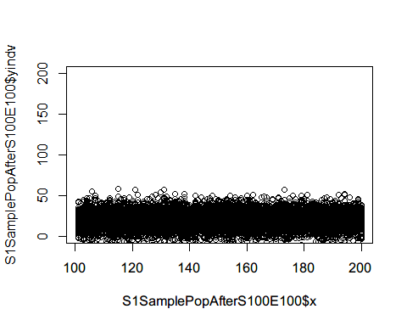

#Compute mean at each time point  
(S1SamplePopAfterS100E100AGG<-S1SamplePopAfterS100E100 %>%   
 group_by(x) %>%   
 summarise(y=mean(yindv)))

## # A tibble: 100 x 2  
## x y  
## <dbl> <dbl>  
## 1 101 18.6  
## 2 102 19.1  
## 3 103 20.3  
## 4 104 22.0  
## 5 105 19.5  
## 6 106 20.7  
## 7 107 19.7  
## 8 108 18.7  
## 9 109 20.4  
## 10 110 22.2  
## # ... with 90 more rows

plot(S1SamplePopAfterS100E100AGG$x,S1SamplePopAfterS100E100AGG$y,ylim=c(0,200))

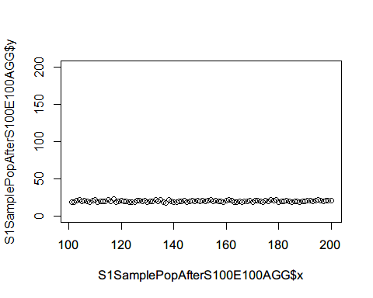 Simulate sample of 1000 from the observed population

S1SamplePopAfterS1000E100=c()  
i=1  
temp=data.frame()  
set.seed(11)  
for(i in 1:length(S1TrueOutcomeAfterE100$y)){  
 x=rep(i+100,1000)  
 Individual=1:1000  
 yindv=rnorm(1000,S1TrueOutcomeAfterE100$y[i],10)  
 temp=data.frame(cbind(x,Individual,yindv))  
 S1SamplePopAfterS1000E100=rbind(S1SamplePopAfterS1000E100,temp)  
 i=i+1  
}  
#Compute mean at each time point  
(S1SamplePopAfterS1000E100AGG<-S1SamplePopAfterS1000E100 %>%   
 group_by(x) %>%   
 summarise(y=mean(yindv)))

## # A tibble: 100 x 2  
## x y  
## <dbl> <dbl>  
## 1 101 20.1  
## 2 102 20.0  
## 3 103 20.4  
## 4 104 20.0  
## 5 105 20.5  
## 6 106 19.9  
## 7 107 20.0  
## 8 108 20.0  
## 9 109 20.2  
## 10 110 20.0  
## # ... with 90 more rows

plot(S1SamplePopAfterS1000E100AGG$x,S1SamplePopAfterS1000E100AGG$y,ylim=c(0,200))

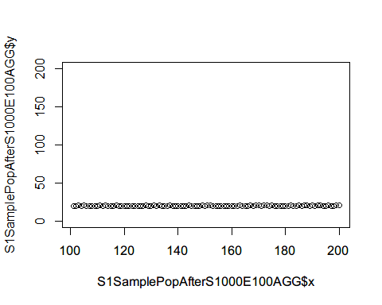

Combine before and after for size 20

S1SamplePopS20E100AGG<-rbind(S1SamplePopBefore20AGG,S1SamplePopAfterS20E100AGG)  
plot(x=1:200, y=rep(1,200), type="n", ylim=c(0,200),   
 xlab="time", ylab="mean of outcome")  
abline(v=100)  
points(S1SamplePopBefore20AGG$x, S1SamplePopBefore20AGG$y, pch=3, col=2,cex=0.7)  
points(S1SamplePopAfterS20E100AGG$x, S1SamplePopAfterS20E100AGG$y, pch=4, col=4,cex=0.7)

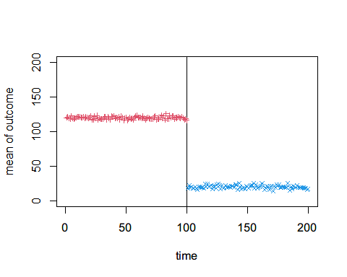 Combine before and after for size 100

S1SamplePopS100E100AGG<-rbind(S1SamplePopBefore100AGG,S1SamplePopAfterS100E100AGG)  
plot(x=1:200, y=rep(1,200), type="n", ylim=c(0,200),   
 xlab="time", ylab="mean of outcome")  
abline(v=100)  
points(S1SamplePopBefore100AGG$x, S1SamplePopBefore100AGG$y, pch=3, col=2,cex=0.7)  
points(S1SamplePopAfterS100E100AGG$x, S1SamplePopAfterS100E100AGG$y, pch=4, col=4,cex=0.7)

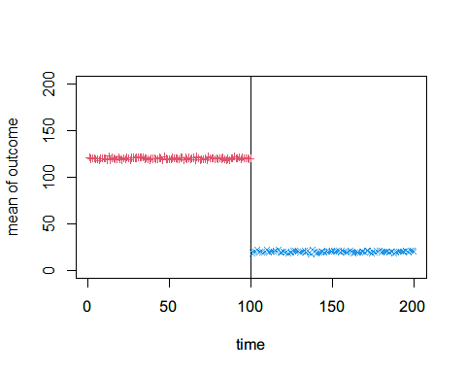 Combine before and after for size 1000

S1SamplePopS1000E100AGG<-rbind(S1SamplePopBefore100AGG,S1SamplePopAfterS1000E100AGG)  
plot(x=1:200, y=rep(1,200), type="n", ylim=c(0,200),   
 xlab="time", ylab="mean of outcome")  
abline(v=100)  
points(S1SamplePopBefore1000AGG$x, S1SamplePopBefore1000AGG$y, pch=3, col=2,cex=0.7)  
points(S1SamplePopAfterS1000E100AGG$x, S1SamplePopAfterS1000E100AGG$y, pch=4, col=4,cex=0.7)

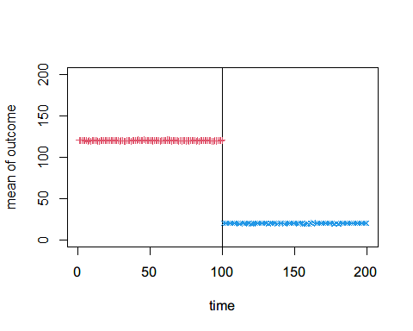 # Senario 2: with pre-exisiting trend, has level change but not slope change Simulate a constant observed outcome before intervention.

x=1:100  
S2TrueOutcomeBefore = data.frame(x, y=x+20)  
plot(S2TrueOutcomeBefore$x,S2TrueOutcomeBefore$y)

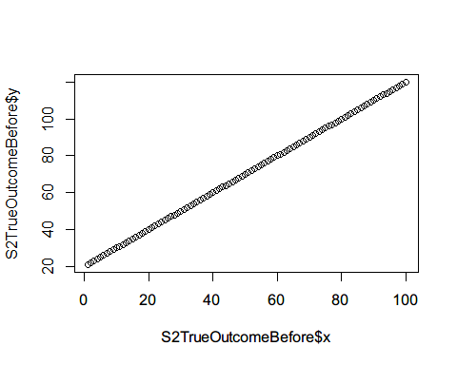

x=101:119  
S2CounterfactualBefore = data.frame(x, y=x+20)

Simulate sample of 20 from the observed population

S2SamplePopBefore20=c()  
i=1  
temp=data.frame()  
set.seed(12)  
for(i in 1:length(S2TrueOutcomeBefore$y)){  
 x=rep(i,20)  
 Individual=1:20  
 yindv=rnorm(20,S2TrueOutcomeBefore$y[i],10)  
 temp=data.frame(cbind(x,Individual,yindv))  
 S2SamplePopBefore20=rbind(S2SamplePopBefore20,temp)  
 i=i+1  
}  
#Individual level variation  
plot(S2SamplePopBefore20$x,S2SamplePopBefore20$yindv,ylim=c(0,200))

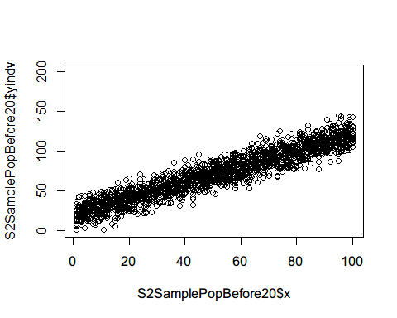

#Compute mean at each time point  
(S2SamplePopBefore20AGG<-S2SamplePopBefore20 %>%   
 group_by(x) %>%   
 summarise(y=mean(yindv)))

## # A tibble: 100 x 2  
## x y  
## <dbl> <dbl>  
## 1 1 17.7  
## 2 2 23.0  
## 3 3 22.4  
## 4 4 25.6  
## 5 5 24.8  
## 6 6 27.5  
## 7 7 28.2  
## 8 8 26.4  
## 9 9 27.9  
## 10 10 30.5  
## # ... with 90 more rows

plot(S2SamplePopBefore20AGG$x,S2SamplePopBefore20AGG$y,ylim=c(0,200))

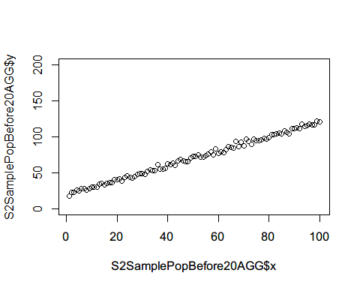 Simulate sample of 100 from the observed population

S2SamplePopBefore100=c()  
i=1  
temp=data.frame()  
set.seed(13)  
for(i in 1:length(S2TrueOutcomeBefore$y)){  
 x=rep(i,100)  
 Individual=1:100  
 yindv=rnorm(100,S2TrueOutcomeBefore$y[i],10)  
 temp=data.frame(cbind(x,Individual,yindv))  
 S2SamplePopBefore100=rbind(S2SamplePopBefore100,temp)  
 i=i+1  
}  
#Individual level variation  
plot(S2SamplePopBefore100$x,S2SamplePopBefore100$yindv,ylim=c(0,200))

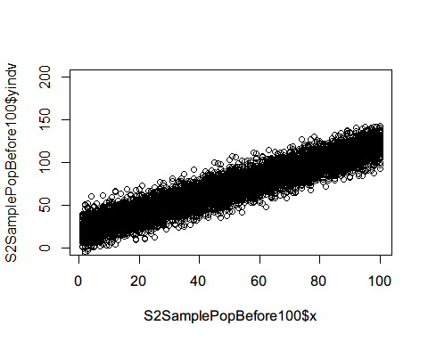

#Compute mean at each time point  
(S2SamplePopBefore100AGG<-S2SamplePopBefore100 %>%   
 group_by(x) %>%   
 summarise(y=mean(yindv)))

## # A tibble: 100 x 2  
## x y  
## <dbl> <dbl>  
## 1 1 20.4  
## 2 2 22.3  
## 3 3 21.2  
## 4 4 26.0  
## 5 5 25.3  
## 6 6 25.8  
## 7 7 26.7  
## 8 8 28.1  
## 9 9 30.0  
## 10 10 29.0  
## # ... with 90 more rows

plot(S2SamplePopBefore100AGG$x,S2SamplePopBefore100AGG$y,ylim=c(0,200))

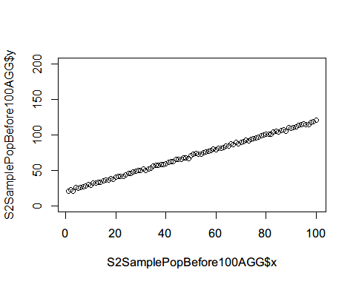

Simulate sample of 1000 from the observed population

S2SamplePopBefore1000=c()  
i=1  
temp=data.frame()  
set.seed(14)  
for(i in 1:length(S2TrueOutcomeBefore$y)){  
 x=rep(i,1000)  
 Individual=1:1000  
 yindv=rnorm(1000,S2TrueOutcomeBefore$y[i],10)  
 temp=data.frame(cbind(x,Individual,yindv))  
 S2SamplePopBefore1000=rbind(S2SamplePopBefore1000,temp)  
 i=i+1  
}  
#Compute mean at each time point  
(S2SamplePopBefore1000AGG<-S2SamplePopBefore1000 %>%   
 group_by(x) %>%   
 summarise(y=mean(yindv)))

## # A tibble: 100 x 2  
## x y  
## <dbl> <dbl>  
## 1 1 20.7  
## 2 2 21.7  
## 3 3 23.1  
## 4 4 23.7  
## 5 5 25.1  
## 6 6 25.9  
## 7 7 27.3  
## 8 8 27.8  
## 9 9 28.9  
## 10 10 29.9  
## # ... with 90 more rows

plot(S2SamplePopBefore1000AGG$x,S2SamplePopBefore1000AGG$y,ylim=c(0,200))

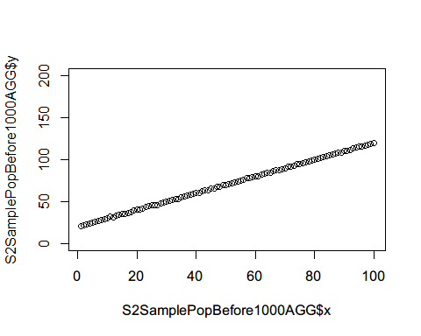 ## Effect Size: 20  
Simulate level changed time points after intervention.

x=101:200  
S2TrueOutcomeAfterE20 = data.frame(x, y=x)  
plot(S2TrueOutcomeAfterE20$x,S2TrueOutcomeAfterE20$y)

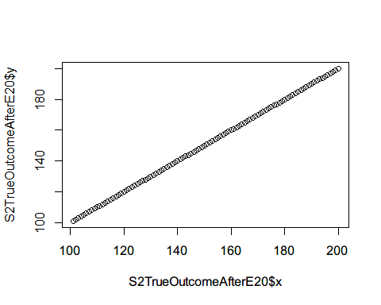

S2CounterfactualAfterE20=subset(S2TrueOutcomeAfterE20,x<120&x>100)

Simulate sample of 20 from the observed population

S2SamplePopAfterS20E20=c()  
i=1  
temp=data.frame()  
set.seed(15)  
for(i in 1:length(S2TrueOutcomeAfterE20$y)){  
 x=rep(i+100,20)  
 Individual=1:20  
 yindv=rnorm(20,S2TrueOutcomeAfterE20$y[i],10)  
 temp=data.frame(cbind(x,Individual,yindv))  
 S2SamplePopAfterS20E20=rbind(S2SamplePopAfterS20E20,temp)  
 i=i+1  
}  
#Individual level variation  
plot(S2SamplePopAfterS20E20$x,S2SamplePopAfterS20E20$yindv,ylim=c(0,200))

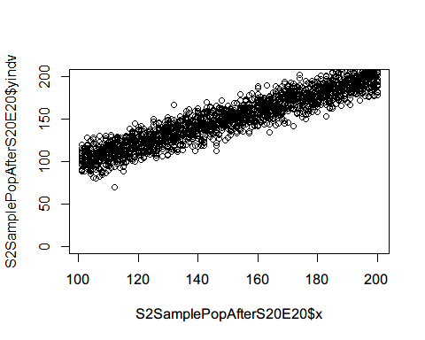

#Compute mean at each time point  
(S2SamplePopAfterS20E20AGG<-S2SamplePopAfterS20E20 %>%   
 group_by(x) %>%   
 summarise(y=mean(yindv)))

## # A tibble: 100 x 2  
## x y  
## <dbl> <dbl>  
## 1 101 101.  
## 2 102 105.  
## 3 103 108.  
## 4 104 100.  
## 5 105 105.  
## 6 106 106.  
## 7 107 105.  
## 8 108 103.  
## 9 109 110.  
## 10 110 110.  
## # ... with 90 more rows

plot(S2SamplePopAfterS20E20AGG$x,S2SamplePopAfterS20E20AGG$y,ylim=c(0,200))

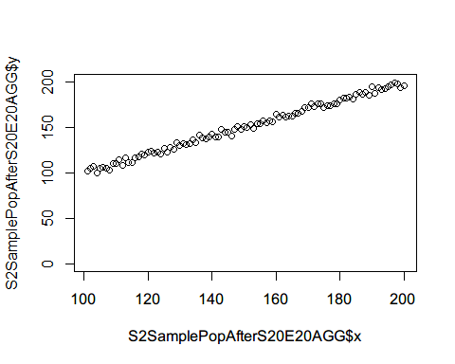

Simulate sample of 100 from the observed population

S2SamplePopAfterS100E20=c()  
i=1  
temp=data.frame()  
set.seed(16)  
for(i in 1:length(S2TrueOutcomeAfterE20$y)){  
 x=rep(i+100,100)  
 Individual=1:100  
 yindv=rnorm(100,S2TrueOutcomeAfterE20$y[i],10)  
 temp=data.frame(cbind(x,Individual,yindv))  
 S2SamplePopAfterS100E20=rbind(S2SamplePopAfterS100E20,temp)  
 i=i+1  
}  
#Individual level variation  
plot(S2SamplePopAfterS100E20$x,S2SamplePopAfterS100E20$yindv,ylim=c(0,200))

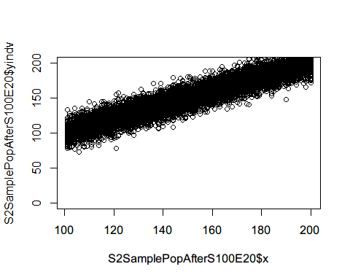

#Compute mean at each time point  
(S2SamplePopAfterS100E20AGG<-S2SamplePopAfterS100E20 %>%   
 group_by(x) %>%   
 summarise(y=mean(yindv)))

## # A tibble: 100 x 2  
## x y  
## <dbl> <dbl>  
## 1 101 102.  
## 2 102 102.  
## 3 103 104.  
## 4 104 106.  
## 5 105 105.  
## 6 106 107.  
## 7 107 109.  
## 8 108 108.  
## 9 109 108.  
## 10 110 110.  
## # ... with 90 more rows

plot(S2SamplePopAfterS100E20AGG$x,S2SamplePopAfterS100E20AGG$y,ylim=c(0,200))

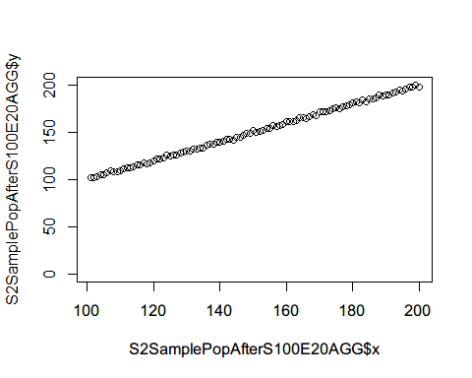 Simulate sample of 1000 from the observed population

S2SamplePopAfterS1000E20=c()  
i=1  
temp=data.frame()  
set.seed(17)  
for(i in 1:length(S2TrueOutcomeAfterE20$y)){  
 x=rep(i+100,1000)  
 Individual=1:1000  
 yindv=rnorm(1000,S2TrueOutcomeAfterE20$y[i],10)  
 temp=data.frame(cbind(x,Individual,yindv))  
 S2SamplePopAfterS1000E20=rbind(S2SamplePopAfterS1000E20,temp)  
 i=i+1  
}  
#Compute mean at each time point  
(S2SamplePopAfterS1000E20AGG<-S2SamplePopAfterS1000E20 %>%   
 group_by(x) %>%   
 summarise(y=mean(yindv)))

## # A tibble: 100 x 2  
## x y  
## <dbl> <dbl>  
## 1 101 101.  
## 2 102 102.  
## 3 103 103.  
## 4 104 103.  
## 5 105 105.  
## 6 106 107.  
## 7 107 108.  
## 8 108 108.  
## 9 109 109.  
## 10 110 110.  
## # ... with 90 more rows

plot(S2SamplePopAfterS1000E20AGG$x,S2SamplePopAfterS1000E20AGG$y,ylim=c(0,200))

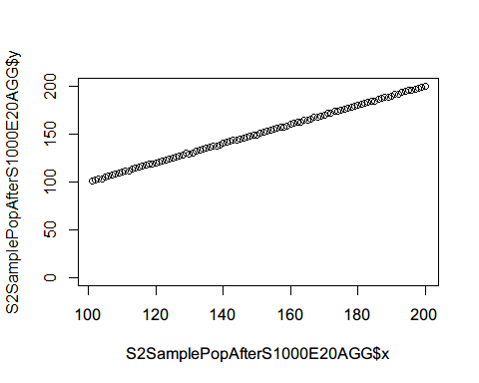

Combine before and after for size 20

S2SamplePopS20E20AGG<-rbind(S2SamplePopBefore20AGG,S2SamplePopAfterS20E20AGG)  
plot(x=1:200, y=rep(1,200), type="n", ylim=c(0,200),   
 xlab="time", ylab="mean of outcome")  
abline(v=100)  
points(S2SamplePopBefore20AGG$x, S2SamplePopBefore20AGG$y, pch=3, col=2,cex=0.7)  
points(S2SamplePopAfterS20E20AGG$x, S2SamplePopAfterS20E20AGG$y, pch=4, col=4,cex=0.7)

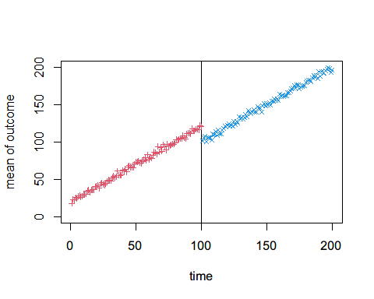 Combine before and after for size 100

S2SamplePopS100E20AGG<-rbind(S2SamplePopBefore100AGG,S2SamplePopAfterS100E20AGG)  
plot(x=1:200, y=rep(1,200), type="n", ylim=c(0,200),   
 xlab="time", ylab="mean of outcome")  
abline(v=100)  
points(S2SamplePopBefore100AGG$x, S2SamplePopBefore100AGG$y, pch=3, col=2,cex=0.7)  
points(S2SamplePopAfterS100E20AGG$x, S2SamplePopAfterS100E20AGG$y, pch=4, col=4,cex=0.7)

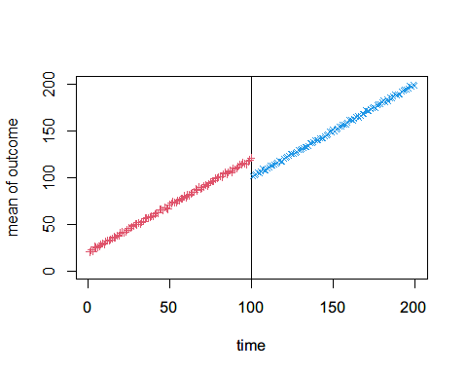

Combine before and after for size 1000

S2SamplePopS1000E20AGG<-rbind(S2SamplePopBefore100AGG,S2SamplePopAfterS1000E20AGG)  
plot(x=1:200, y=rep(1,200), type="n", ylim=c(0,200),   
 xlab="time", ylab="mean of outcome")  
abline(v=100)  
points(S2SamplePopBefore1000AGG$x, S2SamplePopBefore1000AGG$y, pch=3, col=2,cex=0.7)  
points(S2SamplePopAfterS1000E20AGG$x, S2SamplePopAfterS1000E20AGG$y, pch=4, col=4,cex=0.7)

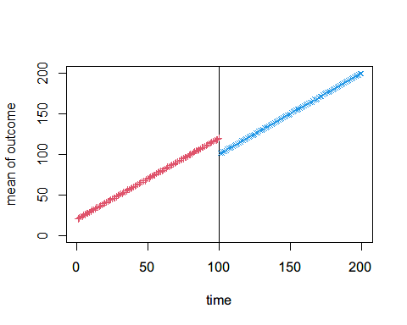

## Effect Size: 50

Simulate level changed time points after intervention.

x=101:200  
S2TrueOutcomeAfterE50 = data.frame(x, y=x-30)  
plot(S2TrueOutcomeAfterE50$x,S2TrueOutcomeAfterE50$y)

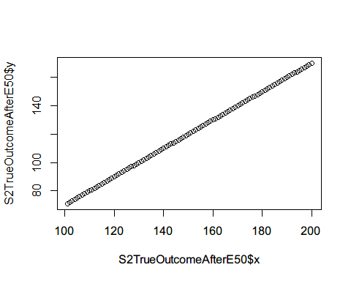

S2CounterfactualAfterE50=subset(S2TrueOutcomeAfterE50,x<120&x>100)

Simulate sample of 20 from the observed population

S2SamplePopAfterS20E50=c()  
i=1  
temp=data.frame()  
set.seed(18)  
for(i in 1:length(S2TrueOutcomeAfterE50$y)){  
 x=rep(i+100,20)  
 Individual=1:20  
 yindv=rnorm(20,S2TrueOutcomeAfterE50$y[i],10)  
 temp=data.frame(cbind(x,Individual,yindv))  
 S2SamplePopAfterS20E50=rbind(S2SamplePopAfterS20E50,temp)  
 i=i+1  
}  
#Individual level variation  
plot(S2SamplePopAfterS20E50$x,S2SamplePopAfterS20E50$yindv,ylim=c(0,200))

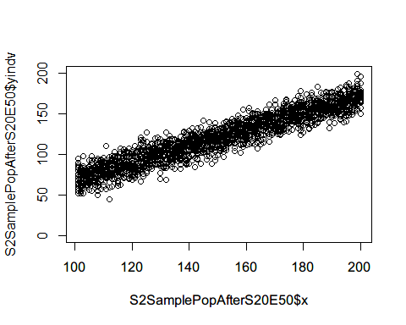

#Compute mean at each time point  
(S2SamplePopAfterS20E50AGG<-S2SamplePopAfterS20E50 %>%   
 group_by(x) %>%   
 summarise(y=mean(yindv)))

## # A tibble: 100 x 2  
## x y  
## <dbl> <dbl>  
## 1 101 72.0  
## 2 102 69.3  
## 3 103 73.1  
## 4 104 71.3  
## 5 105 73.1  
## 6 106 78.8  
## 7 107 75.4  
## 8 108 76.4  
## 9 109 78.8  
## 10 110 80.6  
## # ... with 90 more rows

plot(S2SamplePopAfterS20E50AGG$x,S2SamplePopAfterS20E50AGG$y,ylim=c(0,200))

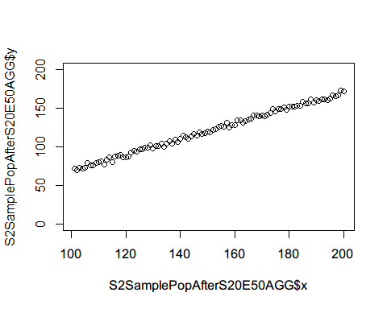

Simulate sample of 100 from the observed population

S2SamplePopAfterS100E50=c()  
i=1  
temp=data.frame()  
set.seed(19)  
for(i in 1:length(S2TrueOutcomeAfterE50$y)){  
 x=rep(i+100,100)  
 Individual=1:100  
 yindv=rnorm(100,S2TrueOutcomeAfterE50$y[i],10)  
 temp=data.frame(cbind(x,Individual,yindv))  
 S2SamplePopAfterS100E50=rbind(S2SamplePopAfterS100E50,temp)  
 i=i+1  
}  
#Individual level variation  
plot(S2SamplePopAfterS100E50$x,S2SamplePopAfterS100E50$yindv,ylim=c(0,200))

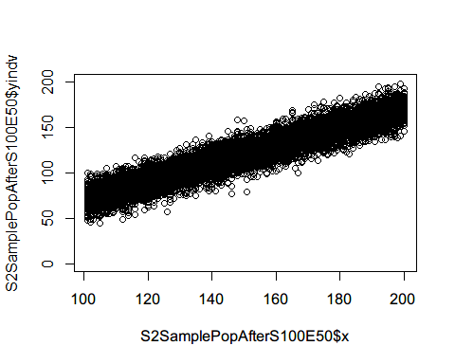

#Compute mean at each time point  
(S2SamplePopAfterS100E50AGG<-S2SamplePopAfterS100E50 %>%   
 group_by(x) %>%   
 summarise(y=mean(yindv)))

## # A tibble: 100 x 2  
## x y  
## <dbl> <dbl>  
## 1 101 71.1  
## 2 102 73.5  
## 3 103 71.2  
## 4 104 73.8  
## 5 105 74.7  
## 6 106 75.5  
## 7 107 76.8  
## 8 108 79.4  
## 9 109 78.5  
## 10 110 79.9  
## # ... with 90 more rows

plot(S2SamplePopAfterS100E50AGG$x,S2SamplePopAfterS100E50AGG$y,ylim=c(0,200))

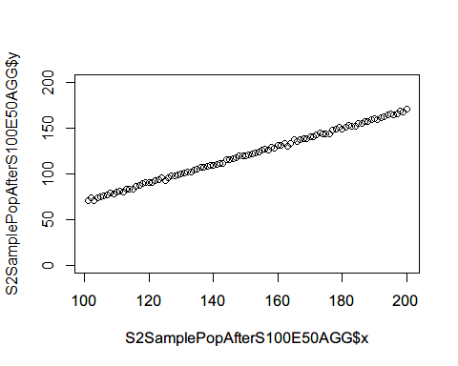 Simulate sample of 1000 from the observed population

S2SamplePopAfterS1000E50=c()  
i=1  
temp=data.frame()  
set.seed(20)  
for(i in 1:length(S2TrueOutcomeAfterE50$y)){  
 x=rep(i+100,1000)  
 Individual=1:1000  
 yindv=rnorm(1000,S2TrueOutcomeAfterE50$y[i],10)  
 temp=data.frame(cbind(x,Individual,yindv))  
 S2SamplePopAfterS1000E50=rbind(S2SamplePopAfterS1000E50,temp)  
 i=i+1  
}  
#Compute mean at each time point  
(S2SamplePopAfterS1000E50AGG<-S2SamplePopAfterS1000E50 %>%   
 group_by(x) %>%   
 summarise(y=mean(yindv)))

## # A tibble: 100 x 2  
## x y  
## <dbl> <dbl>  
## 1 101 70.8  
## 2 102 71.7  
## 3 103 73.2  
## 4 104 74.0  
## 5 105 74.9  
## 6 106 75.5  
## 7 107 76.9  
## 8 108 78.6  
## 9 109 78.7  
## 10 110 79.9  
## # ... with 90 more rows

plot(S2SamplePopAfterS1000E50AGG$x,S2SamplePopAfterS1000E50AGG$y,ylim=c(0,200))

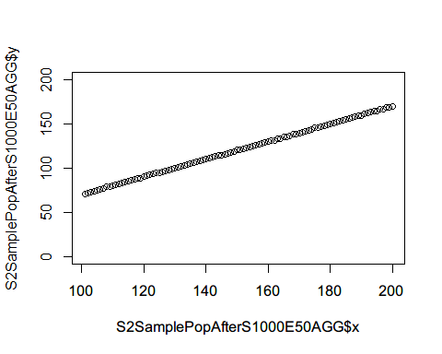

Combine before and after for size 20

S2SamplePopS20E50AGG<-rbind(S2SamplePopBefore20AGG,S2SamplePopAfterS20E50AGG)  
plot(x=1:200, y=rep(1,200), type="n", ylim=c(0,200),   
 xlab="time", ylab="mean of outcome")  
abline(v=100)  
points(S2SamplePopBefore20AGG$x, S2SamplePopBefore20AGG$y, pch=3, col=2,cex=0.7)  
points(S2SamplePopAfterS20E50AGG$x, S2SamplePopAfterS20E50AGG$y, pch=4, col=4,cex=0.7)

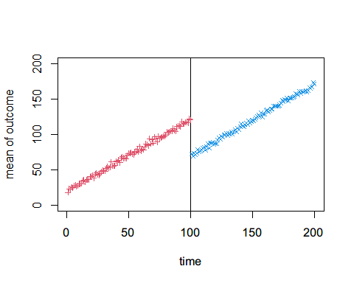 Combine before and after for size 100

S2SamplePopS100E50AGG<-rbind(S2SamplePopBefore100AGG,S2SamplePopAfterS100E50AGG)  
plot(x=1:200, y=rep(1,200), type="n", ylim=c(0,200),   
 xlab="time", ylab="mean of outcome")  
abline(v=100)  
points(S2SamplePopBefore100AGG$x, S2SamplePopBefore100AGG$y, pch=3, col=2,cex=0.7)  
points(S2SamplePopAfterS100E50AGG$x, S2SamplePopAfterS100E50AGG$y, pch=4, col=4,cex=0.7)

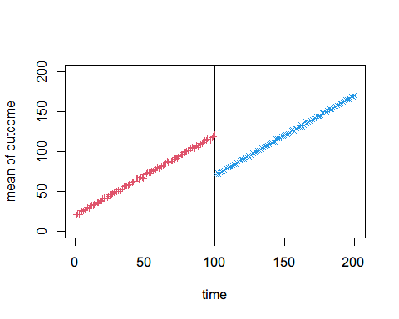 Combine before and after for size 1000

S2SamplePopS1000E50AGG<-rbind(S2SamplePopBefore100AGG,S2SamplePopAfterS1000E50AGG)  
plot(x=1:200, y=rep(1,200), type="n", ylim=c(0,200),   
 xlab="time", ylab="mean of outcome")  
abline(v=100)  
points(S2SamplePopBefore1000AGG$x, S2SamplePopBefore1000AGG$y, pch=3, col=2,cex=0.7)  
points(S2SamplePopAfterS1000E50AGG$x, S2SamplePopAfterS1000E50AGG$y, pch=4, col=4,cex=0.7)

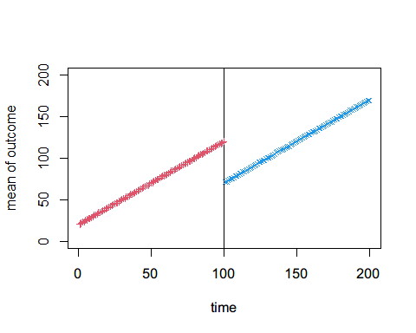 ## Effect Size: 100  
Simulate level changed time points after intervention.

x=101:200  
S2TrueOutcomeAfterE100 = data.frame(x, y=x-80)  
plot(S2TrueOutcomeAfterE100$x,S2TrueOutcomeAfterE100$y)

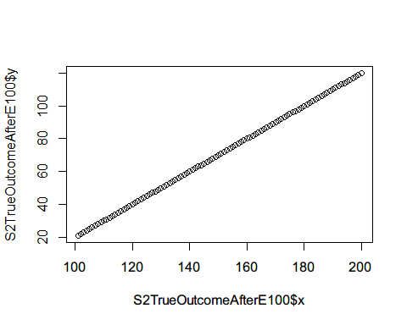

S2CounterfactualAfterE100=subset(S2TrueOutcomeAfterE100,x<120&x>100)

Simulate sample of 20 from the observed population

S2SamplePopAfterS20E100=c()  
i=1  
temp=data.frame()  
set.seed(21)  
for(i in 1:length(S2TrueOutcomeAfterE100$y)){  
 x=rep(i+100,20)  
 Individual=1:20  
 yindv=rnorm(20,S2TrueOutcomeAfterE100$y[i],10)  
 temp=data.frame(cbind(x,Individual,yindv))  
 S2SamplePopAfterS20E100=rbind(S2SamplePopAfterS20E100,temp)  
 i=i+1  
}  
#Individual level variation  
plot(S2SamplePopAfterS20E100$x,S2SamplePopAfterS20E100$yindv,ylim=c(0,200))

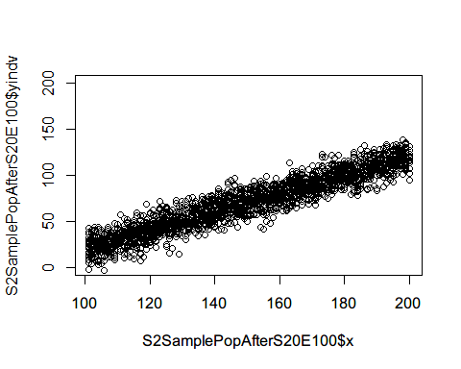

#Compute mean at each time point  
(S2SamplePopAfterS20E100AGG<-S2SamplePopAfterS20E100 %>%   
 group_by(x) %>%   
 summarise(y=mean(yindv)))

## # A tibble: 100 x 2  
## x y  
## <dbl> <dbl>  
## 1 101 22.4  
## 2 102 22.8  
## 3 103 25.6  
## 4 104 22.9  
## 5 105 24.9  
## 6 106 23.0  
## 7 107 27.4  
## 8 108 26.7  
## 9 109 26.2  
## 10 110 31.7  
## # ... with 90 more rows

plot(S2SamplePopAfterS20E100AGG$x,S2SamplePopAfterS20E100AGG$y,ylim=c(0,200))

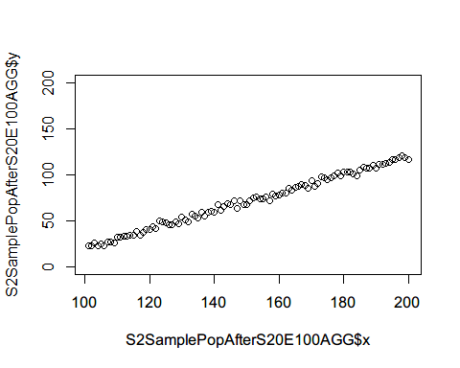

Simulate sample of 100 from the observed population

S2SamplePopAfterS100E100=c()  
i=1  
temp=data.frame()  
set.seed(22)  
for(i in 1:length(S2TrueOutcomeAfterE100$y)){  
 x=rep(i+100,100)  
 Individual=1:100  
 yindv=rnorm(100,S2TrueOutcomeAfterE100$y[i],10)  
 temp=data.frame(cbind(x,Individual,yindv))  
 S2SamplePopAfterS100E100=rbind(S2SamplePopAfterS100E100,temp)  
 i=i+1  
}  
#Individual level variation  
plot(S2SamplePopAfterS100E100$x,S2SamplePopAfterS100E100$yindv,ylim=c(0,200))

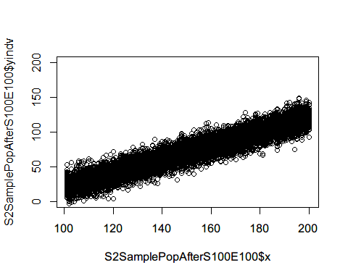

#Compute mean at each time point  
(S2SamplePopAfterS100E100AGG<-S2SamplePopAfterS100E100 %>%   
 group_by(x) %>%   
 summarise(y=mean(yindv)))

## # A tibble: 100 x 2  
## x y  
## <dbl> <dbl>  
## 1 101 21.8  
## 2 102 19.8  
## 3 103 21.4  
## 4 104 24.6  
## 5 105 25.7  
## 6 106 26.2  
## 7 107 26.8  
## 8 108 28.3  
## 9 109 28.6  
## 10 110 31.0  
## # ... with 90 more rows

plot(S2SamplePopAfterS100E100AGG$x,S2SamplePopAfterS100E100AGG$y,ylim=c(0,200))

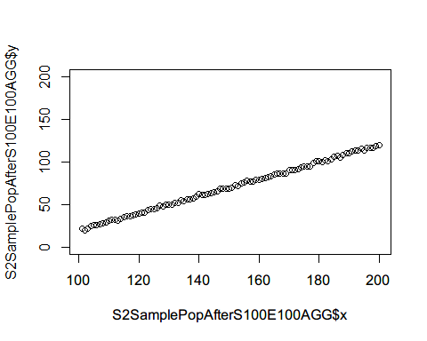 Simulate sample of 1000 from the observed population

S2SamplePopAfterS1000E100=c()  
i=1  
temp=data.frame()  
set.seed(23)  
for(i in 1:length(S2TrueOutcomeAfterE100$y)){  
 x=rep(i+100,1000)  
 Individual=1:1000  
 yindv=rnorm(1000,S2TrueOutcomeAfterE100$y[i],10)  
 temp=data.frame(cbind(x,Individual,yindv))  
 S2SamplePopAfterS1000E100=rbind(S2SamplePopAfterS1000E100,temp)  
 i=i+1  
}  
#Compute mean at each time point  
(S2SamplePopAfterS1000E100AGG<-S2SamplePopAfterS1000E100 %>%   
 group_by(x) %>%   
 summarise(y=mean(yindv)))

## # A tibble: 100 x 2  
## x y  
## <dbl> <dbl>  
## 1 101 21.4  
## 2 102 21.8  
## 3 103 23.3  
## 4 104 24.2  
## 5 105 25.1  
## 6 106 26.2  
## 7 107 26.5  
## 8 108 28.0  
## 9 109 28.8  
## 10 110 30.3  
## # ... with 90 more rows

plot(S2SamplePopAfterS1000E100AGG$x,S2SamplePopAfterS1000E100AGG$y,ylim=c(0,200))

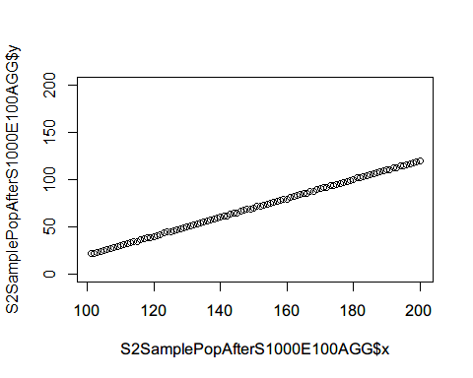

Combine before and after for size 20

S2SamplePopS20E100AGG<-rbind(S2SamplePopBefore20AGG,S2SamplePopAfterS20E100AGG)  
plot(x=1:200, y=rep(1,200), type="n", ylim=c(0,200),   
 xlab="time", ylab="mean of outcome")  
abline(v=100)  
points(S2SamplePopBefore20AGG$x, S2SamplePopBefore20AGG$y, pch=3, col=2,cex=0.7)  
points(S2SamplePopAfterS20E100AGG$x, S2SamplePopAfterS20E100AGG$y, pch=4, col=4,cex=0.7)

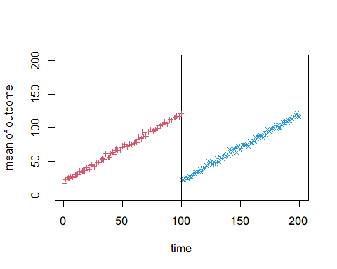 Combine before and after for size 100

S2SamplePopS100E100AGG<-rbind(S2SamplePopBefore100AGG,S2SamplePopAfterS100E100AGG)  
plot(x=1:200, y=rep(1,200), type="n", ylim=c(0,200),   
 xlab="time", ylab="mean of outcome")  
abline(v=100)  
points(S2SamplePopBefore100AGG$x, S2SamplePopBefore100AGG$y, pch=3, col=2,cex=0.7)  
points(S2SamplePopAfterS100E100AGG$x, S2SamplePopAfterS100E100AGG$y, pch=4, col=4,cex=0.7)

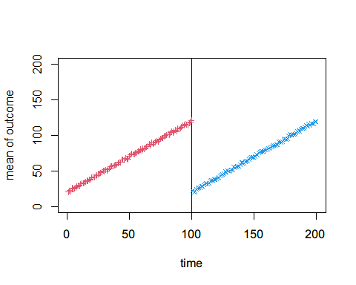 Combine before and after for size 1000

S2SamplePopS1000E100AGG<-rbind(S2SamplePopBefore100AGG,S2SamplePopAfterS1000E100AGG)  
plot(x=1:200, y=rep(1,200), type="n", ylim=c(0,200),   
 xlab="time", ylab="mean of outcome")  
abline(v=100)  
points(S2SamplePopBefore1000AGG$x, S2SamplePopBefore1000AGG$y, pch=3, col=2,cex=0.7)  
points(S2SamplePopAfterS1000E100AGG$x, S2SamplePopAfterS1000E100AGG$y, pch=4, col=4,cex=0.7)

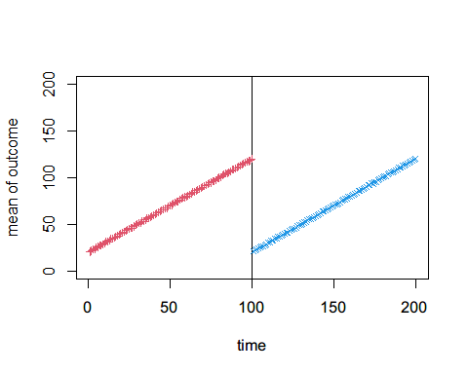

# Senario 3: with pre-exisiting trend, has level change and slope change.

Simulate a constant observed outcome before intervention.

x=1:100  
S3TrueOutcomeBefore = data.frame(x, y=x+20)  
plot(S3TrueOutcomeBefore$x,S3TrueOutcomeBefore$y)

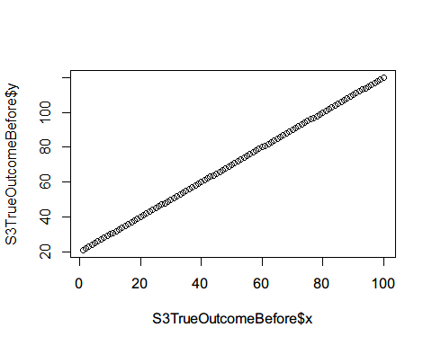

x=101:119  
S3CounterfactualBefore = data.frame(x, y=x+20)

Simulate sample of 20 from the observed population

S3SamplePopBefore20=c()  
i=1  
temp=data.frame()  
set.seed(24)  
for(i in 1:length(S3TrueOutcomeBefore$y)){  
 x=rep(i,20)  
 Individual=1:20  
 yindv=rnorm(20,S3TrueOutcomeBefore$y[i],10)  
 temp=data.frame(cbind(x,Individual,yindv))  
 S3SamplePopBefore20=rbind(S3SamplePopBefore20,temp)  
 i=i+1  
}  
#Individual level variation  
plot(S3SamplePopBefore20$x,S3SamplePopBefore20$yindv,ylim=c(0,200))

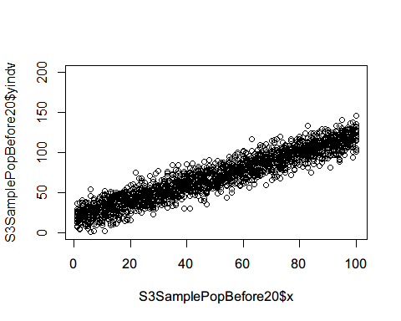

#Compute mean at each time point  
(S3SamplePopBefore20AGG<-S3SamplePopBefore20 %>%   
 group_by(x) %>%   
 summarise(y=mean(yindv)))

## # A tibble: 100 x 2  
## x y  
## <dbl> <dbl>  
## 1 1 20.7  
## 2 2 17.5  
## 3 3 25.0  
## 4 4 22.1  
## 5 5 23.5  
## 6 6 23.9  
## 7 7 25.8  
## 8 8 26.1  
## 9 9 29.7  
## 10 10 29.7  
## # ... with 90 more rows

plot(S3SamplePopBefore20AGG$x,S3SamplePopBefore20AGG$y,ylim=c(0,200))

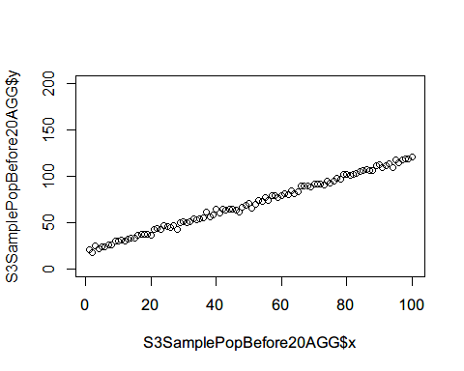 Simulate sample of 100 from the observed population

S3SamplePopBefore100=c()  
i=1  
temp=data.frame()  
set.seed(25)  
for(i in 1:length(S3TrueOutcomeBefore$y)){  
 x=rep(i,100)  
 Individual=1:100  
 yindv=rnorm(100,S3TrueOutcomeBefore$y[i],10)  
 temp=data.frame(cbind(x,Individual,yindv))  
 S3SamplePopBefore100=rbind(S3SamplePopBefore100,temp)  
 i=i+1  
}  
#Individual level variation  
plot(S3SamplePopBefore100$x,S3SamplePopBefore100$yindv,ylim=c(0,200))

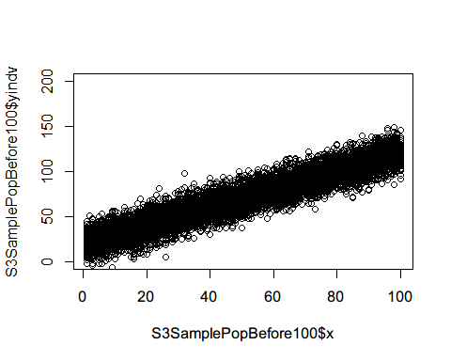

#Compute mean at each time point  
(S3SamplePopBefore100AGG<-S3SamplePopBefore100 %>%   
 group_by(x) %>%   
 summarise(y=mean(yindv)))

## # A tibble: 100 x 2  
## x y  
## <dbl> <dbl>  
## 1 1 19.2  
## 2 2 22.0  
## 3 3 23.2  
## 4 4 24.3  
## 5 5 25.4  
## 6 6 26.1  
## 7 7 27.4  
## 8 8 27.3  
## 9 9 30.4  
## 10 10 30.1  
## # ... with 90 more rows

plot(S3SamplePopBefore100AGG$x,S3SamplePopBefore100AGG$y,ylim=c(0,200))

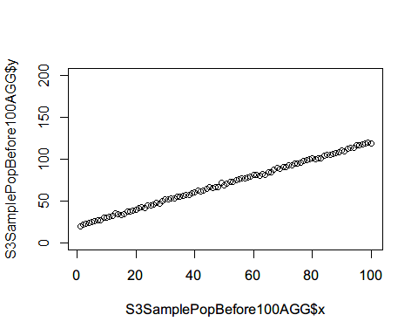

Simulate sample of 1000 from the observed population

S3SamplePopBefore1000=c()  
i=1  
temp=data.frame()  
set.seed(26)  
for(i in 1:length(S3TrueOutcomeBefore$y)){  
 x=rep(i,1000)  
 Individual=1:1000  
 yindv=rnorm(1000,S3TrueOutcomeBefore$y[i],10)  
 temp=data.frame(cbind(x,Individual,yindv))  
 S3SamplePopBefore1000=rbind(S3SamplePopBefore1000,temp)  
 i=i+1  
}  
#Compute mean at each time point  
(S3SamplePopBefore1000AGG<-S3SamplePopBefore1000 %>%   
 group_by(x) %>%   
 summarise(y=mean(yindv)))

## # A tibble: 100 x 2  
## x y  
## <dbl> <dbl>  
## 1 1 20.9  
## 2 2 21.5  
## 3 3 23.5  
## 4 4 24.2  
## 5 5 24.8  
## 6 6 25.6  
## 7 7 26.8  
## 8 8 28.7  
## 9 9 29.3  
## 10 10 30.5  
## # ... with 90 more rows

plot(S3SamplePopBefore1000AGG$x,S3SamplePopBefore1000AGG$y,ylim=c(0,200))

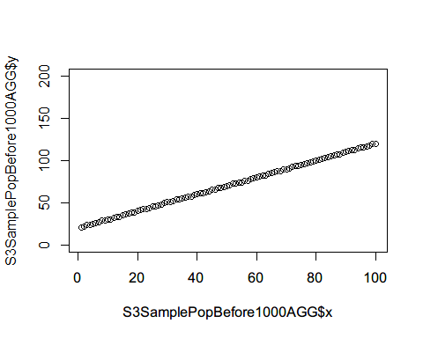 ## Effect Size: 20  
Simulate level changed time points after intervention.

x=101:200  
S3TrueOutcomeAfterE20 = data.frame(x, y=2*x-100)  
plot(S3TrueOutcomeAfterE20$x,S3TrueOutcomeAfterE20$y)

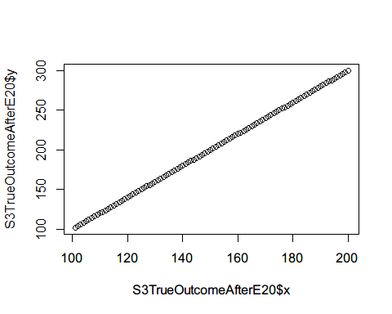

S3CounterfactualAfterE20=subset(S3TrueOutcomeAfterE20,x<120&x>100)

Simulate sample of 20 from the observed population

S3SamplePopAfterS20E20=c()  
i=1  
temp=data.frame()  
set.seed(27)  
for(i in 1:length(S3TrueOutcomeAfterE20$y)){  
 x=rep(i+100,20)  
 Individual=1:20  
 yindv=rnorm(20,S3TrueOutcomeAfterE20$y[i],10)  
 temp=data.frame(cbind(x,Individual,yindv))  
 S3SamplePopAfterS20E20=rbind(S3SamplePopAfterS20E20,temp)  
 i=i+1  
}  
#Individual level variation  
plot(S3SamplePopAfterS20E20$x,S3SamplePopAfterS20E20$yindv,ylim=c(0,200))

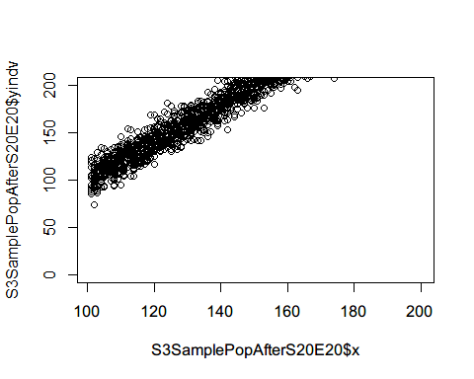

#Compute mean at each time point  
(S3SamplePopAfterS20E20AGG<-S3SamplePopAfterS20E20 %>%   
 group_by(x) %>%   
 summarise(y=mean(yindv)))

## # A tibble: 100 x 2  
## x y  
## <dbl> <dbl>  
## 1 101 102.  
## 2 102 102.  
## 3 103 107.  
## 4 104 109.  
## 5 105 111.  
## 6 106 116.  
## 7 107 116.  
## 8 108 112.  
## 9 109 120.  
## 10 110 123.  
## # ... with 90 more rows

plot(S3SamplePopAfterS20E20AGG$x,S3SamplePopAfterS20E20AGG$y,ylim=c(0,200))

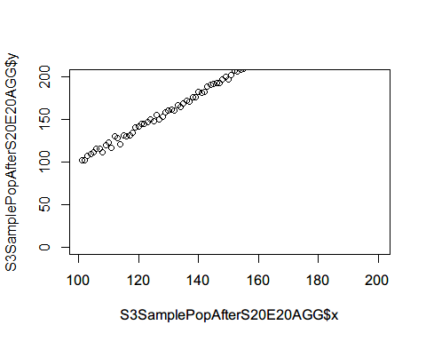

Simulate sample of 100 from the observed population

S3SamplePopAfterS100E20=c()  
i=1  
temp=data.frame()  
set.seed(28)  
for(i in 1:length(S3TrueOutcomeAfterE20$y)){  
 x=rep(i+100,100)  
 Individual=1:100  
 yindv=rnorm(100,S3TrueOutcomeAfterE20$y[i],10)  
 temp=data.frame(cbind(x,Individual,yindv))  
 S3SamplePopAfterS100E20=rbind(S3SamplePopAfterS100E20,temp)  
 i=i+1  
}  
#Individual level variation  
plot(S3SamplePopAfterS100E20$x,S3SamplePopAfterS100E20$yindv,ylim=c(0,200))

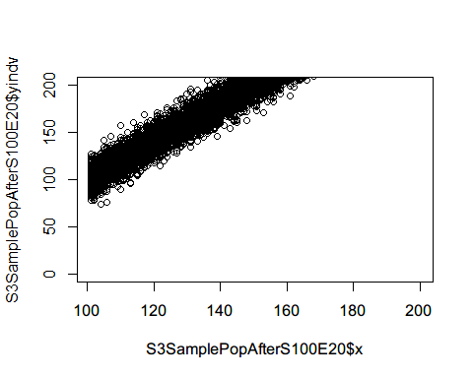

#Compute mean at each time point  
(S3SamplePopAfterS100E20AGG<-S3SamplePopAfterS100E20 %>%   
 group_by(x) %>%   
 summarise(y=mean(yindv)))

## # A tibble: 100 x 2  
## x y  
## <dbl> <dbl>  
## 1 101 102.  
## 2 102 102.  
## 3 103 106.  
## 4 104 106.  
## 5 105 109.  
## 6 106 112.  
## 7 107 114.  
## 8 108 116.  
## 9 109 117.  
## 10 110 121.  
## # ... with 90 more rows

plot(S3SamplePopAfterS100E20AGG$x,S3SamplePopAfterS100E20AGG$y,ylim=c(0,200))

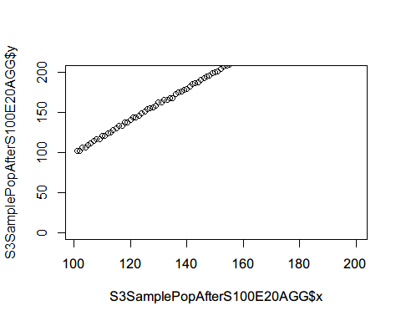 Simulate sample of 1000 from the observed population

S3SamplePopAfterS1000E20=c()  
i=1  
temp=data.frame()  
set.seed(29)  
for(i in 1:length(S3TrueOutcomeAfterE20$y)){  
 x=rep(i+100,1000)  
 Individual=1:1000  
 yindv=rnorm(1000,S3TrueOutcomeAfterE20$y[i],10)  
 temp=data.frame(cbind(x,Individual,yindv))  
 S3SamplePopAfterS1000E20=rbind(S3SamplePopAfterS1000E20,temp)  
 i=i+1  
}  
#Compute mean at each time point  
(S3SamplePopAfterS1000E20AGG<-S3SamplePopAfterS1000E20 %>%   
 group_by(x) %>%   
 summarise(y=mean(yindv)))

## # A tibble: 100 x 2  
## x y  
## <dbl> <dbl>  
## 1 101 102.  
## 2 102 104.  
## 3 103 106.  
## 4 104 108.  
## 5 105 110.  
## 6 106 112.  
## 7 107 114.  
## 8 108 116.  
## 9 109 118.  
## 10 110 120.  
## # ... with 90 more rows

plot(S3SamplePopAfterS1000E20AGG$x,S3SamplePopAfterS1000E20AGG$y,ylim=c(0,200))

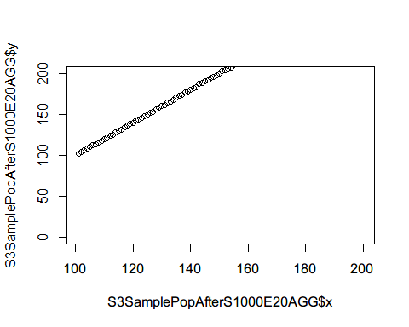

Combine before and after for size 20

S3SamplePopS20E20AGG<-rbind(S3SamplePopBefore20AGG,S3SamplePopAfterS20E20AGG)  
plot(x=1:200, y=rep(1,200), type="n", ylim=c(0,300),   
 xlab="time", ylab="mean of outcome")  
abline(v=100)  
points(S3SamplePopBefore20AGG$x, S3SamplePopBefore20AGG$y, pch=3, col=2,cex=0.7)  
points(S3SamplePopAfterS20E20AGG$x, S3SamplePopAfterS20E20AGG$y, pch=4, col=4,cex=0.7)

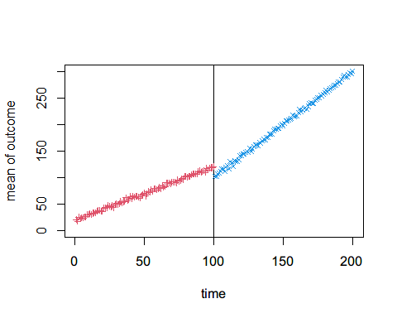 Combine before and after for size 100

S3SamplePopS100E20AGG<-rbind(S3SamplePopBefore100AGG,S3SamplePopAfterS100E20AGG)  
plot(x=1:200, y=rep(1,200), type="n", ylim=c(0,300),   
 xlab="time", ylab="mean of outcome")  
abline(v=100)  
points(S3SamplePopBefore100AGG$x, S3SamplePopBefore100AGG$y, pch=3, col=2,cex=0.7)  
points(S3SamplePopAfterS100E20AGG$x, S3SamplePopAfterS100E20AGG$y, pch=4, col=4,cex=0.7)

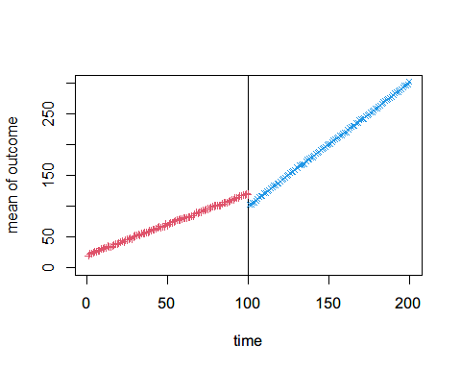

Combine before and after for size 1000

S3SamplePopS1000E20AGG<-rbind(S3SamplePopBefore100AGG,S3SamplePopAfterS1000E20AGG)  
plot(x=1:200, y=rep(1,200), type="n", ylim=c(0,300),   
 xlab="time", ylab="mean of outcome")  
abline(v=100)  
points(S3SamplePopBefore1000AGG$x, S3SamplePopBefore1000AGG$y, pch=3, col=2,cex=0.7)  
points(S3SamplePopAfterS1000E20AGG$x, S3SamplePopAfterS1000E20AGG$y, pch=4, col=4,cex=0.7)

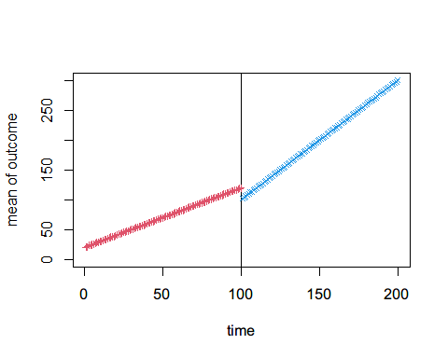

## Effect Size: 50

Simulate level changed time points after intervention.

x=101:200  
S3TrueOutcomeAfterE50 = data.frame(x, y=2*x-130)  
plot(S3TrueOutcomeAfterE50$x,S3TrueOutcomeAfterE50$y)

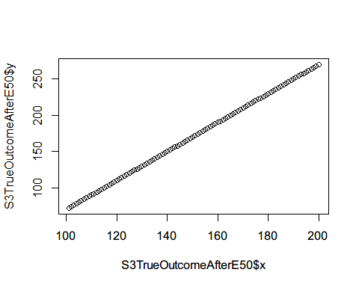

S3CounterfactualAfterE50=subset(S3TrueOutcomeAfterE50,x<120&x>100)

Simulate sample of 20 from the observed population

S3SamplePopAfterS20E50=c()  
i=1  
temp=data.frame()  
set.seed(30)  
for(i in 1:length(S3TrueOutcomeAfterE50$y)){  
 x=rep(i+100,20)  
 Individual=1:20  
 yindv=rnorm(20,S3TrueOutcomeAfterE50$y[i],10)  
 temp=data.frame(cbind(x,Individual,yindv))  
 S3SamplePopAfterS20E50=rbind(S3SamplePopAfterS20E50,temp)  
 i=i+1  
}  
#Individual level variation  
plot(S3SamplePopAfterS20E50$x,S3SamplePopAfterS20E50$yindv,ylim=c(0,200))

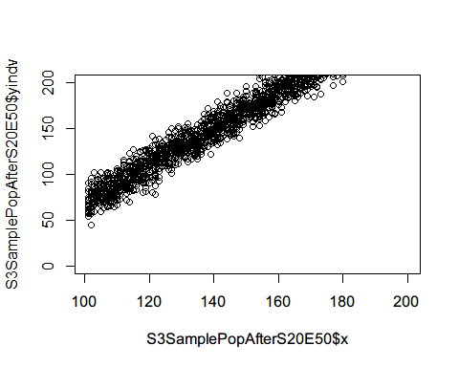

#Compute mean at each time point  
(S3SamplePopAfterS20E50AGG<-S3SamplePopAfterS20E50 %>%   
 group_by(x) %>%   
 summarise(y=mean(yindv)))

## # A tibble: 100 x 2  
## x y  
## <dbl> <dbl>  
## 1 101 68.1  
## 2 102 73.7  
## 3 103 73.2  
## 4 104 81.8  
## 5 105 79.4  
## 6 106 81.4  
## 7 107 82.6  
## 8 108 77.8  
## 9 109 83.7  
## 10 110 89.1  
## # ... with 90 more rows

plot(S3SamplePopAfterS20E50AGG$x,S3SamplePopAfterS20E50AGG$y,ylim=c(0,200))

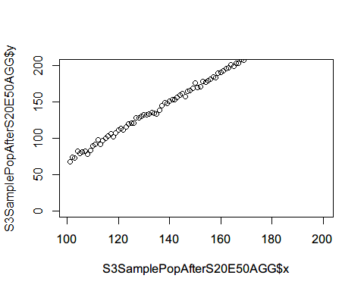

Simulate sample of 100 from the observed population

S3SamplePopAfterS100E50=c()  
i=1  
temp=data.frame()  
set.seed(31)  
for(i in 1:length(S3TrueOutcomeAfterE50$y)){  
 x=rep(i+100,100)  
 Individual=1:100  
 yindv=rnorm(100,S3TrueOutcomeAfterE50$y[i],10)  
 temp=data.frame(cbind(x,Individual,yindv))  
 S3SamplePopAfterS100E50=rbind(S3SamplePopAfterS100E50,temp)  
 i=i+1  
}  
#Individual level variation  
plot(S3SamplePopAfterS100E50$x,S3SamplePopAfterS100E50$yindv,ylim=c(0,200))

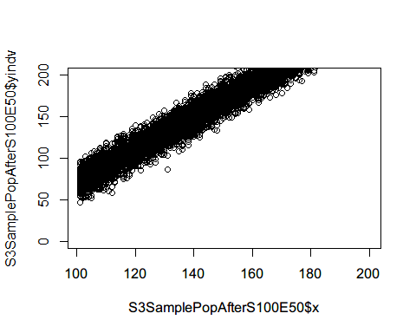

#Compute mean at each time point  
(S3SamplePopAfterS100E50AGG<-S3SamplePopAfterS100E50 %>%   
 group_by(x) %>%   
 summarise(y=mean(yindv)))

## # A tibble: 100 x 2  
## x y  
## <dbl> <dbl>  
## 1 101 71.8  
## 2 102 74.6  
## 3 103 75.7  
## 4 104 79.1  
## 5 105 79.7  
## 6 106 83.3  
## 7 107 83.7  
## 8 108 86.9  
## 9 109 87.0  
## 10 110 91.3  
## # ... with 90 more rows

plot(S3SamplePopAfterS100E50AGG$x,S3SamplePopAfterS100E50AGG$y,ylim=c(0,200))

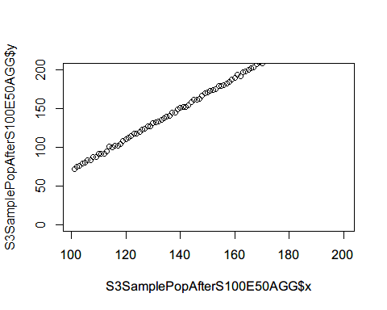 Simulate sample of 1000 from the observed population

S3SamplePopAfterS1000E50=c()  
i=1  
temp=data.frame()  
set.seed(32)  
for(i in 1:length(S3TrueOutcomeAfterE50$y)){  
 x=rep(i+100,1000)  
 Individual=1:1000  
 yindv=rnorm(1000,S3TrueOutcomeAfterE50$y[i],10)  
 temp=data.frame(cbind(x,Individual,yindv))  
 S3SamplePopAfterS1000E50=rbind(S3SamplePopAfterS1000E50,temp)  
 i=i+1  
}  
#Compute mean at each time point  
(S3SamplePopAfterS1000E50AGG<-S3SamplePopAfterS1000E50 %>%   
 group_by(x) %>%   
 summarise(y=mean(yindv)))

## # A tibble: 100 x 2  
## x y  
## <dbl> <dbl>  
## 1 101 72.0  
## 2 102 73.5  
## 3 103 75.9  
## 4 104 78.1  
## 5 105 80.7  
## 6 106 82.4  
## 7 107 84.6  
## 8 108 86.2  
## 9 109 88.1  
## 10 110 90.3  
## # ... with 90 more rows

plot(S3SamplePopAfterS1000E50AGG$x,S3SamplePopAfterS1000E50AGG$y,ylim=c(0,200))

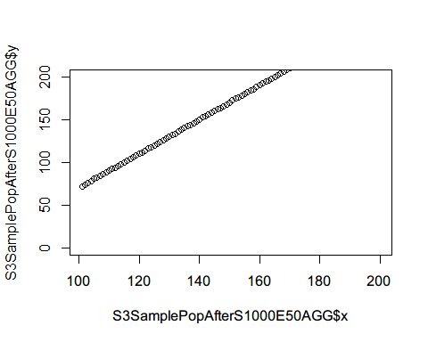

Combine before and after for size 20

S3SamplePopS20E50AGG<-rbind(S3SamplePopBefore20AGG,S3SamplePopAfterS20E50AGG)  
plot(x=1:200, y=rep(1,200), type="n", ylim=c(0,300),   
 xlab="time", ylab="mean of outcome")  
abline(v=100)  
points(S3SamplePopBefore20AGG$x, S3SamplePopBefore20AGG$y, pch=3, col=2,cex=0.7)  
points(S3SamplePopAfterS20E50AGG$x, S3SamplePopAfterS20E50AGG$y, pch=4, col=4,cex=0.7)

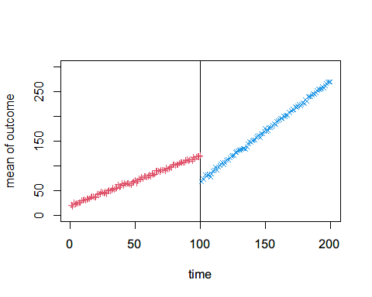 Combine before and after for size 100

S3SamplePopS100E50AGG<-rbind(S3SamplePopBefore100AGG,S3SamplePopAfterS100E50AGG)  
plot(x=1:200, y=rep(1,200), type="n", ylim=c(0,300),   
 xlab="time", ylab="mean of outcome")  
abline(v=100)  
points(S3SamplePopBefore100AGG$x, S3SamplePopBefore100AGG$y, pch=3, col=2,cex=0.7)  
points(S3SamplePopAfterS100E50AGG$x, S3SamplePopAfterS100E50AGG$y, pch=4, col=4,cex=0.7)

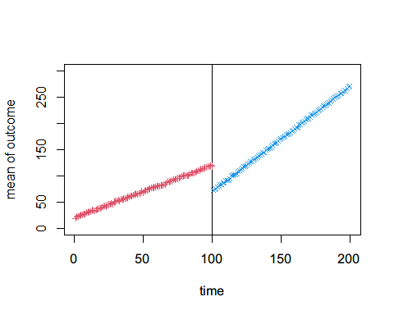 Combine before and after for size 1000

S3SamplePopS1000E50AGG<-rbind(S3SamplePopBefore100AGG,S3SamplePopAfterS1000E50AGG)  
plot(x=1:200, y=rep(1,200), type="n", ylim=c(0,300),   
 xlab="time", ylab="mean of outcome")  
abline(v=100)  
points(S3SamplePopBefore1000AGG$x, S3SamplePopBefore1000AGG$y, pch=3, col=2,cex=0.7)  
points(S3SamplePopAfterS1000E50AGG$x, S3SamplePopAfterS1000E50AGG$y, pch=4, col=4,cex=0.7)

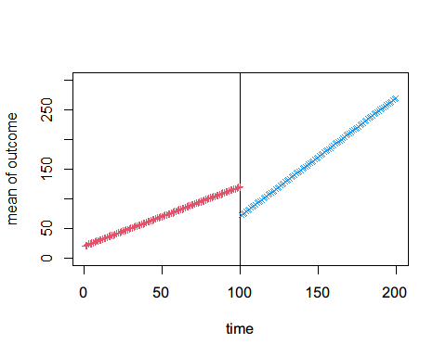 ## Effect Size: 100  
Simulate level changed time points after intervention.

x=101:200  
S3TrueOutcomeAfterE100 = data.frame(x, y=2*x-180)  
plot(S3TrueOutcomeAfterE100$x,S3TrueOutcomeAfterE100$y)

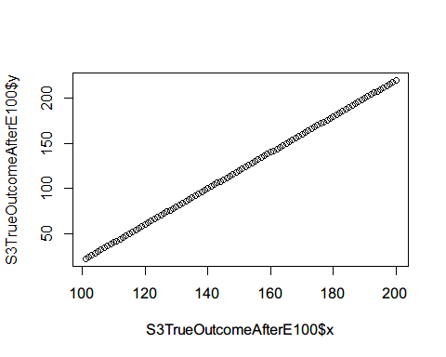

S3CounterfactualAfterE100=subset(S3TrueOutcomeAfterE100,x<120&x>100)

Simulate sample of 20 from the observed population

S3SamplePopAfterS20E100=c()  
i=1  
temp=data.frame()  
set.seed(33)  
for(i in 1:length(S3TrueOutcomeAfterE100$y)){  
 x=rep(i+100,20)  
 Individual=1:20  
 yindv=rnorm(20,S3TrueOutcomeAfterE100$y[i],10)  
 temp=data.frame(cbind(x,Individual,yindv))  
 S3SamplePopAfterS20E100=rbind(S3SamplePopAfterS20E100,temp)  
 i=i+1  
}  
#Individual level variation  
plot(S3SamplePopAfterS20E100$x,S3SamplePopAfterS20E100$yindv,ylim=c(0,200))

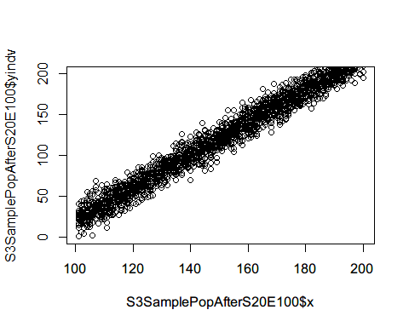

#Compute mean at each time point  
(S3SamplePopAfterS20E100AGG<-S3SamplePopAfterS20E100 %>%   
 group_by(x) %>%   
 summarise(y=mean(yindv)))

## # A tibble: 100 x 2  
## x y  
## <dbl> <dbl>  
## 1 101 22.7  
## 2 102 25.8  
## 3 103 23.9  
## 4 104 31.4  
## 5 105 29.1  
## 6 106 33.6  
## 7 107 38.9  
## 8 108 36.6  
## 9 109 36.9  
## 10 110 39.8  
## # ... with 90 more rows

plot(S3SamplePopAfterS20E100AGG$x,S3SamplePopAfterS20E100AGG$y,ylim=c(0,200))

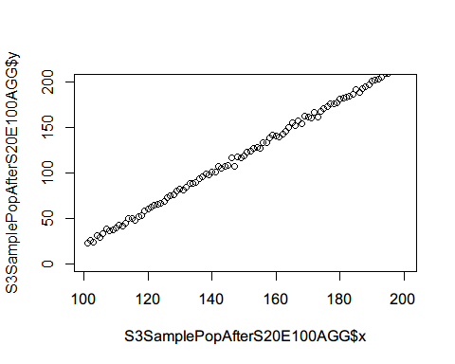

Simulate sample of 100 from the observed population

S3SamplePopAfterS100E100=c()  
i=1  
temp=data.frame()  
set.seed(34)  
for(i in 1:length(S3TrueOutcomeAfterE100$y)){  
 x=rep(i+100,100)  
 Individual=1:100  
 yindv=rnorm(100,S3TrueOutcomeAfterE100$y[i],10)  
 temp=data.frame(cbind(x,Individual,yindv))  
 S3SamplePopAfterS100E100=rbind(S3SamplePopAfterS100E100,temp)  
 i=i+1  
}  
#Individual level variation  
plot(S3SamplePopAfterS100E100$x,S3SamplePopAfterS100E100$yindv,ylim=c(0,200))

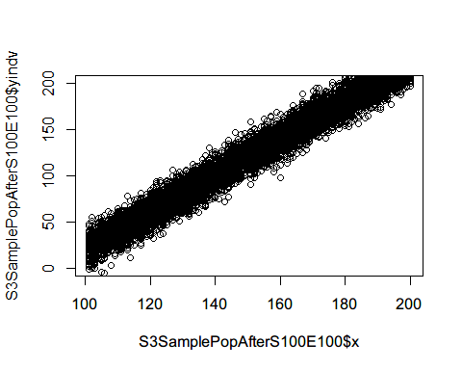

#Compute mean at each time point  
(S3SamplePopAfterS100E100AGG<-S3SamplePopAfterS100E100 %>%   
 group_by(x) %>%   
 summarise(y=mean(yindv)))

## # A tibble: 100 x 2  
## x y  
## <dbl> <dbl>  
## 1 101 21.9  
## 2 102 25.3  
## 3 103 25.0  
## 4 104 27.7  
## 5 105 30.3  
## 6 106 30.6  
## 7 107 33.4  
## 8 108 36.1  
## 9 109 38.2  
## 10 110 39.4  
## # ... with 90 more rows

plot(S3SamplePopAfterS100E100AGG$x,S3SamplePopAfterS100E100AGG$y,ylim=c(0,200))

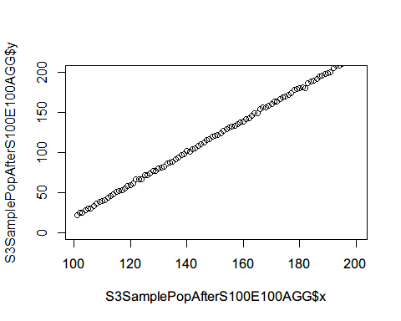 Simulate sample of 1000 from the observed population

S3SamplePopAfterS1000E100=c()  
i=1  
temp=data.frame()  
set.seed(35)  
for(i in 1:length(S3TrueOutcomeAfterE100$y)){  
 x=rep(i+100,1000)  
 Individual=1:1000  
 yindv=rnorm(1000,S3TrueOutcomeAfterE100$y[i],10)  
 temp=data.frame(cbind(x,Individual,yindv))  
 S3SamplePopAfterS1000E100=rbind(S3SamplePopAfterS1000E100,temp)  
 i=i+1  
}  
#Compute mean at each time point  
(S3SamplePopAfterS1000E100AGG<-S3SamplePopAfterS1000E100 %>%   
 group_by(x) %>%   
 summarise(y=mean(yindv)))

## # A tibble: 100 x 2  
## x y  
## <dbl> <dbl>  
## 1 101 22.9  
## 2 102 24.5  
## 3 103 25.9  
## 4 104 28.5  
## 5 105 29.9  
## 6 106 31.9  
## 7 107 34.2  
## 8 108 35.8  
## 9 109 38.3  
## 10 110 40.0  
## # ... with 90 more rows

plot(S3SamplePopAfterS1000E100AGG$x,S3SamplePopAfterS1000E100AGG$y,ylim=c(0,200))

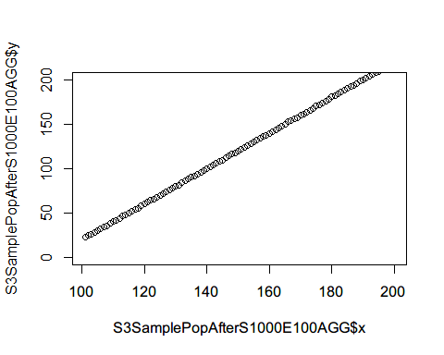

Combine before and after for size 20

S3SamplePopS20E100AGG<-rbind(S3SamplePopBefore20AGG,S3SamplePopAfterS20E100AGG)  
plot(x=1:200, y=rep(1,200), type="n", ylim=c(0,200),   
 xlab="time", ylab="mean of outcome")  
abline(v=100)  
points(S3SamplePopBefore20AGG$x, S3SamplePopBefore20AGG$y, pch=3, col=2,cex=0.7)  
points(S3SamplePopAfterS20E100AGG$x, S3SamplePopAfterS20E100AGG$y, pch=4, col=4,cex=0.7)

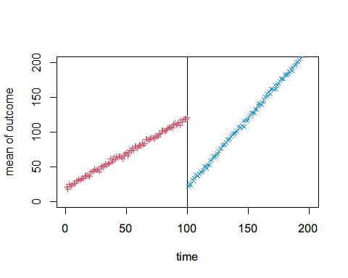 Combine before and after for size 100

S3SamplePopS100E100AGG<-rbind(S3SamplePopBefore100AGG,S3SamplePopAfterS100E100AGG)  
plot(x=1:200, y=rep(1,200), type="n", ylim=c(0,200),   
 xlab="time", ylab="mean of outcome")  
abline(v=100)  
points(S3SamplePopBefore100AGG$x, S3SamplePopBefore100AGG$y, pch=3, col=2,cex=0.7)  
points(S3SamplePopAfterS100E100AGG$x, S3SamplePopAfterS100E100AGG$y, pch=4, col=4,cex=0.7)

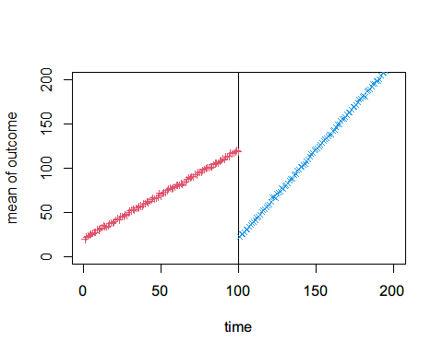 Combine before and after for size 1000

S3SamplePopS1000E100AGG<-rbind(S3SamplePopBefore100AGG,S3SamplePopAfterS1000E100AGG)  
plot(x=1:200, y=rep(1,200), type="n", ylim=c(0,200),   
 xlab="time", ylab="mean of outcome")  
abline(v=100)  
points(S3SamplePopBefore1000AGG$x, S3SamplePopBefore1000AGG$y, pch=3, col=2,cex=0.7)  
points(S3SamplePopAfterS1000E100AGG$x, S3SamplePopAfterS1000E100AGG$y, pch=4, col=4,cex=0.7)

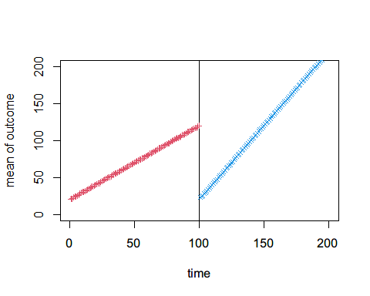 # Simulating Phase-in period

# Senario 1

## Effect Size: 20

### Sample size: 20

S1SamplePopBefore20$Int<-FALSE  
S1SamplePopAfterS20E20Delay<-subset(S1SamplePopAfterS20E20,x>=120)  
S1SamplePopAfterS20E20Delay$Int<-TRUE  
# Phase-in period  
i=1  
temp1=data.frame()  
temp2=data.frame()  
set.seed(36)  
p=1:19  
ss=20  
for(i in p){  
 x=rep(i+100,ss-i)  
 Individual=head(1:ss,ss-i)  
 yindv=rnorm(ss-i,S1CounterfactualBefore$y[i],10)  
 Int=FALSE  
 temp1=data.frame(cbind(x,Individual,yindv,Int))  
 S1SamplePopAfterS20E20Delay=rbind(S1SamplePopAfterS20E20Delay,temp1)  
   
 x=rep(i+100,i)  
 Individual=tail(1:ss,i)  
 yindv=rnorm(i,S1CounterfactualAfterE20$y[i],10)  
 Int=TRUE  
 temp2=data.frame(cbind(x,Individual,yindv,Int))  
 S1SamplePopAfterS20E20Delay=rbind(S1SamplePopAfterS20E20Delay,temp2)  
 i=i+1  
}  
  
S1PhaseInS20E20=rbind(S1SamplePopBefore20,S1SamplePopAfterS20E20Delay)  
#Individual level variation  
plot(S1PhaseInS20E20$x,S1PhaseInS20E20$yindv,ylim=c(0,200))

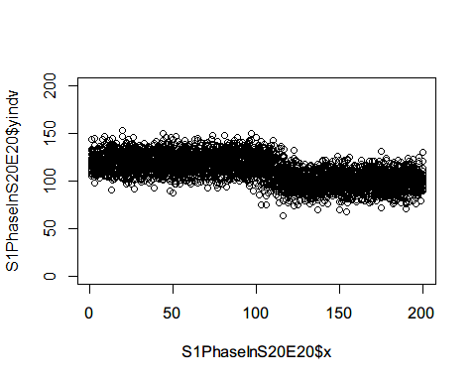

#Compute mean at each time point  
S1PhaseInS20E20AGG<-S1PhaseInS20E20 %>%   
 group_by(x) %>%   
 summarise(y=mean(yindv))  
plot(S1PhaseInS20E20AGG$x,S1PhaseInS20E20AGG$y,ylim=c(0,200),xaxp=c(0,200,10),  
 ylab = "Mean of Outcome",xlab="Time",main = "Level Change Only - Effect Size 20 and Sample Size 20")  
abline(v=100)  
abline(v=120)

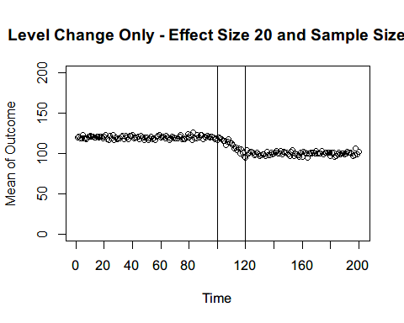

### Sample size: 100

S1SamplePopBefore100$Int<-FALSE  
S1SamplePopAfterS100E20Delay<-subset(S1SamplePopAfterS100E20,x>=120)  
S1SamplePopAfterS100E20Delay$Int<-TRUE  
  
# Phase-in period  
i=1  
temp1=data.frame()  
temp2=data.frame()  
set.seed(37)  
p=1:19  
ss=100  
step=ss/20  
for(i in p){  
 x=rep(i+100,ss-i*step)  
 Individual=head(1:ss,ss-i*step)  
 yindv=rnorm(ss-i*step,S1CounterfactualBefore$y[i],10)  
 Int=FALSE  
 temp1=data.frame(cbind(x,Individual,yindv,Int))  
 S1SamplePopAfterS100E20Delay=rbind(S1SamplePopAfterS100E20Delay,temp1)  
   
 x=rep(i+100,i*step)  
 Individual=tail(1:ss,i*step)  
 yindv=rnorm(i,S1CounterfactualAfterE20$y[i],10)  
 Int=TRUE  
 temp2=data.frame(cbind(x,Individual,yindv,Int))  
 S1SamplePopAfterS100E20Delay=rbind(S1SamplePopAfterS100E20Delay,temp2)  
 i=i+1  
}  
  
S1PhaseInS100E20=rbind(S1SamplePopBefore100,S1SamplePopAfterS100E20Delay)  
#Individual level variation  
plot(S1PhaseInS100E20$x,S1PhaseInS100E20$yindv,ylim=c(0,200))

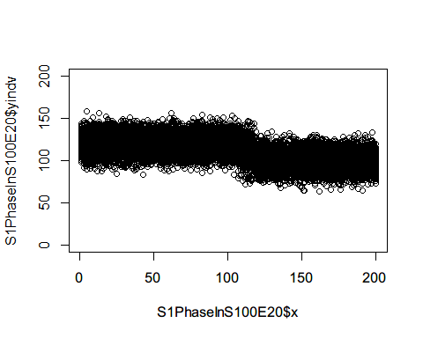

#Compute mean at each time point  
S1PhaseInS100E20AGG<-S1PhaseInS100E20 %>%   
 group_by(x) %>%   
 summarise(y=mean(yindv))  
plot(S1PhaseInS100E20AGG$x,S1PhaseInS100E20AGG$y,ylim=c(0,200),xaxp=c(0,200,10),  
 ylab = "Mean of Outcome",xlab="Time",main = "Level Change Only - Effect Size 20 and Sample Size 100")  
abline(v=100)  
abline(v=120)

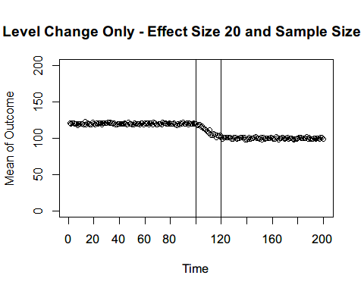

### Sample size: 1000

S1SamplePopBefore1000$Int<-FALSE  
S1SamplePopAfterS1000E20Delay<-subset(S1SamplePopAfterS1000E20,x>=120)  
S1SamplePopAfterS1000E20Delay$Int<-TRUE  
  
# Phase-in period  
i=1  
temp1=data.frame()  
temp2=data.frame()  
set.seed(38)  
p=1:19  
ss=1000  
step=ss/20  
for(i in p){  
 x=rep(i+100,ss-i*step)  
 Individual=head(1:ss,ss-i*step)  
 yindv=rnorm(ss-i*step,S1CounterfactualBefore$y[i],10)  
 Int=FALSE  
 temp1=data.frame(cbind(x,Individual,yindv,Int))  
 S1SamplePopAfterS1000E20Delay=rbind(S1SamplePopAfterS1000E20Delay,temp1)  
   
 x=rep(i+100,i*step)  
 Individual=tail(1:ss,i*step)  
 yindv=rnorm(i,S1CounterfactualAfterE20$y[i],10)  
 Int=TRUE  
 temp2=data.frame(cbind(x,Individual,yindv,Int))  
 S1SamplePopAfterS1000E20Delay=rbind(S1SamplePopAfterS1000E20Delay,temp2)  
 i=i+1  
}  
  
S1PhaseInS1000E20=rbind(S1SamplePopBefore1000,S1SamplePopAfterS1000E20Delay)  
#Individual level variation  
plot(S1PhaseInS1000E20$x,S1PhaseInS1000E20$yindv,ylim=c(0,200))

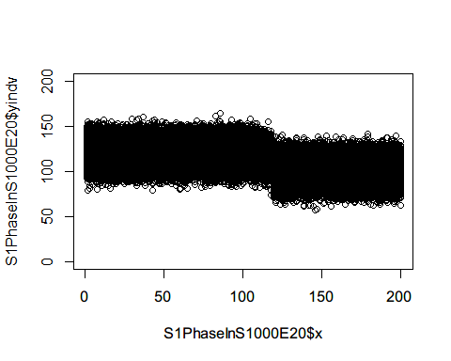

#Compute mean at each time point  
S1PhaseInS1000E20AGG<-S1PhaseInS1000E20 %>%   
 group_by(x) %>%   
 summarise(y=mean(yindv))  
plot(S1PhaseInS1000E20AGG$x,S1PhaseInS1000E20AGG$y,ylim=c(0,200),xaxp=c(0,200,10),  
 ylab = "Mean of Outcome",xlab="Time",main = "Level Change Only - Effect Size 20 and Sample Size 1000")  
abline(v=100)  
abline(v=120)

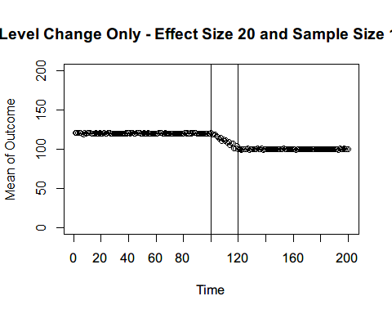

## Effect Size: 50

### Sample size: 20

S1SamplePopAfterS20E50Delay<-subset(S1SamplePopAfterS20E50,x>=120)  
S1SamplePopAfterS20E50Delay$Int<-TRUE  
  
# Phase-in period  
i=1  
temp1=data.frame()  
temp2=data.frame()  
set.seed(39)  
p=1:19  
ss=20  
for(i in p){  
 x=rep(i+100,ss-i)  
 Individual=head(1:ss,ss-i)  
 yindv=rnorm(ss-i,S1CounterfactualBefore$y[i],10)  
 Int=FALSE  
 temp1=data.frame(cbind(x,Individual,yindv,Int))  
 S1SamplePopAfterS20E50Delay=rbind(S1SamplePopAfterS20E50Delay,temp1)  
   
 x=rep(i+100,i)  
 Individual=tail(1:ss,i)  
 yindv=rnorm(i,S1CounterfactualAfterE50$y[i],10)  
 Int=TRUE  
 temp2=data.frame(cbind(x,Individual,yindv,Int))  
 S1SamplePopAfterS20E50Delay=rbind(S1SamplePopAfterS20E50Delay,temp2)  
 i=i+1  
}  
  
S1PhaseInS20E50=rbind(S1SamplePopBefore20,S1SamplePopAfterS20E50Delay)  
#Individual level variation  
plot(S1PhaseInS20E50$x,S1PhaseInS20E50$yindv,ylim=c(0,200))

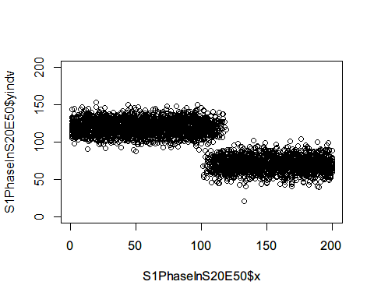

#Compute mean at each time point  
S1PhaseInS20E50AGG<-S1PhaseInS20E50 %>%   
 group_by(x) %>%   
 summarise(y=mean(yindv))  
plot(S1PhaseInS20E50AGG$x,S1PhaseInS20E50AGG$y,ylim=c(0,200),xaxp=c(0,200,10),  
 ylab = "Mean of Outcome",xlab="Time",main = "Level Change Only   
 without pre-existing trend - Effect Size 50 and Sample Size 20")  
abline(v=100)  
abline(v=120)

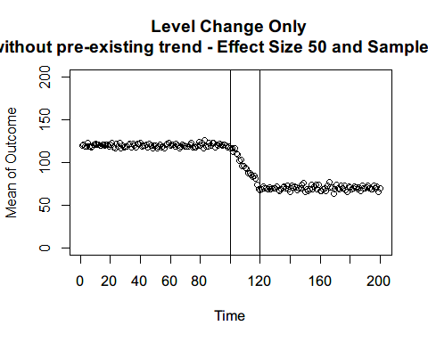 ### Sample size: 100

S1SamplePopAfterS100E50Delay<-subset(S1SamplePopAfterS100E50,x>=120)  
S1SamplePopAfterS100E50Delay$Int<-TRUE  
  
# Phase-in period  
i=1  
temp1=data.frame()  
temp2=data.frame()  
set.seed(40)  
p=1:19  
ss=100  
step=ss/20  
for(i in p){  
 x=rep(i+100,ss-i*step)  
 Individual=head(1:ss,ss-i*step)  
 yindv=rnorm(ss-i*step,S1CounterfactualBefore$y[i],10)  
 Int=FALSE  
 temp1=data.frame(cbind(x,Individual,yindv,Int))  
 S1SamplePopAfterS100E50Delay=rbind(S1SamplePopAfterS100E50Delay,temp1)  
   
 x=rep(i+100,i*step)  
 Individual=tail(1:ss,i*step)  
 yindv=rnorm(i,S1CounterfactualAfterE50$y[i],10)  
 Int=TRUE  
 temp2=data.frame(cbind(x,Individual,yindv,Int))  
 S1SamplePopAfterS100E50Delay=rbind(S1SamplePopAfterS100E50Delay,temp2)  
 i=i+1  
}  
  
S1PhaseInS100E50=rbind(S1SamplePopBefore100,S1SamplePopAfterS100E50Delay)  
#Individual level variation  
plot(S1PhaseInS100E50$x,S1PhaseInS100E50$yindv,ylim=c(0,200))

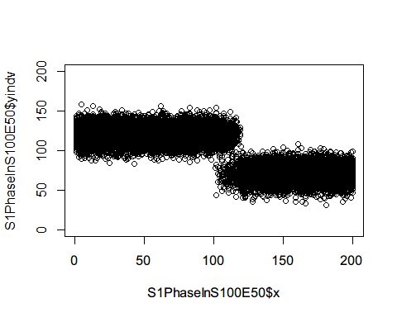

#Compute mean at each time point  
S1PhaseInS100E50AGG<-S1PhaseInS100E50 %>%   
 group_by(x) %>%   
 summarise(y=mean(yindv))  
plot(S1PhaseInS100E50AGG$x,S1PhaseInS100E50AGG$y,ylim=c(0,200),xaxp=c(0,200,10),  
 ylab = "Mean of Outcome",xlab="Time",main = "Level Change Only   
 without pre-existing trend - Effect Size 50 and Sample Size 100")  
abline(v=100)  
abline(v=120)

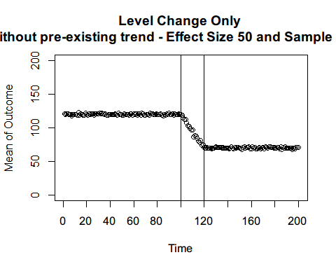

### Sample size: 1000

S1SamplePopAfterS1000E50Delay<-subset(S1SamplePopAfterS1000E50,x>=120)  
S1SamplePopAfterS1000E50Delay$Int<-TRUE  
  
# Phase-in period  
i=1  
temp1=data.frame()  
temp2=data.frame()  
set.seed(41)  
p=1:19  
ss=1000  
step=ss/20  
for(i in p){  
 x=rep(i+100,ss-i*step)  
 Individual=head(1:ss,ss-i*step)  
 yindv=rnorm(ss-i*step,S1CounterfactualBefore$y[i],10)  
 Int=FALSE  
 temp1=data.frame(cbind(x,Individual,yindv,Int))  
 S1SamplePopAfterS1000E50Delay=rbind(S1SamplePopAfterS1000E50Delay,temp1)  
   
 x=rep(i+100,i*step)  
 Individual=tail(1:ss,i*step)  
 yindv=rnorm(i,S1CounterfactualAfterE50$y[i],10)  
 Int=TRUE  
 temp2=data.frame(cbind(x,Individual,yindv,Int))  
 S1SamplePopAfterS1000E50Delay=rbind(S1SamplePopAfterS1000E50Delay,temp2)  
 i=i+1  
}  
  
S1PhaseInS1000E50=rbind(S1SamplePopBefore1000,S1SamplePopAfterS1000E50Delay)  
#Individual level variation  
plot(S1PhaseInS1000E50$x,S1PhaseInS1000E50$yindv,ylim=c(0,200))

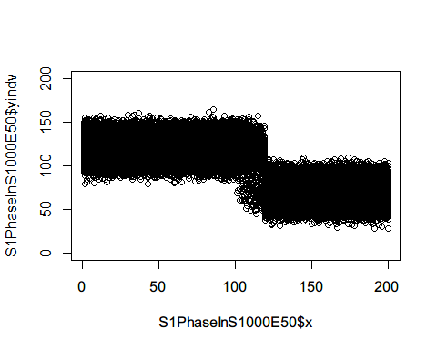

#Compute mean at each time point  
S1PhaseInS1000E50AGG<-S1PhaseInS1000E50 %>%   
 group_by(x) %>%   
 summarise(y=mean(yindv))  
plot(S1PhaseInS1000E50AGG$x,S1PhaseInS1000E50AGG$y,ylim=c(0,200),xaxp=c(0,200,10),  
 ylab = "Mean of Outcome",xlab="Time",main = "Level Change Only   
 without pre-existing trend - Effect Size 50 and Sample Size 1000")  
abline(v=100)  
abline(v=120)

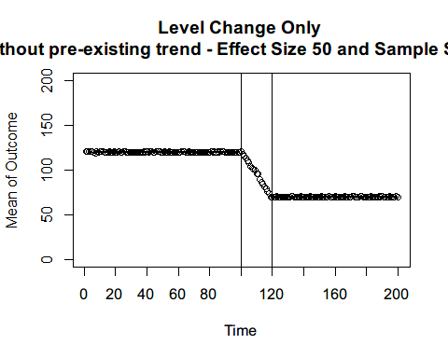

## Effect Size: 100

### Sample size: 20

S1SamplePopAfterS20E100Delay<-subset(S1SamplePopAfterS20E100,x>=120)  
S1SamplePopAfterS20E100Delay$Int<-TRUE  
  
# Phase-in period  
i=1  
temp1=data.frame()  
temp2=data.frame()  
set.seed(42)  
p=1:19  
ss=20  
for(i in p){  
 x=rep(i+100,ss-i)  
 Individual=head(1:ss,ss-i)  
 yindv=rnorm(ss-i,S1CounterfactualBefore$y[i],10)  
 Int=FALSE  
 temp1=data.frame(cbind(x,Individual,yindv,Int))  
 S1SamplePopAfterS20E100Delay=rbind(S1SamplePopAfterS20E100Delay,temp1)  
   
 x=rep(i+100,i)  
 Individual=tail(1:ss,i)  
 yindv=rnorm(i,S1CounterfactualAfterE100$y[i],10)  
 Int=TRUE  
 temp2=data.frame(cbind(x,Individual,yindv,Int))  
 S1SamplePopAfterS20E100Delay=rbind(S1SamplePopAfterS20E100Delay,temp2)  
 i=i+1  
}  
  
S1PhaseInS20E100=rbind(S1SamplePopBefore20,S1SamplePopAfterS20E100Delay)  
#Individual level variation  
plot(S1PhaseInS20E100$x,S1PhaseInS20E100$yindv,ylim=c(0,200))

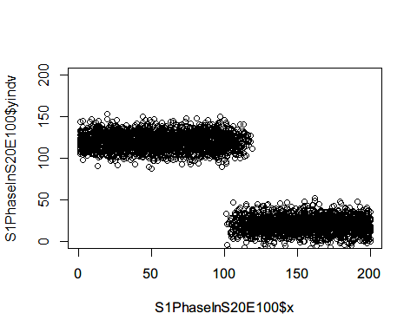

#Compute mean at each time point  
S1PhaseInS20E100AGG<-S1PhaseInS20E100 %>%   
 group_by(x) %>%   
 summarise(y=mean(yindv))  
plot(S1PhaseInS20E100AGG$x,S1PhaseInS20E100AGG$y,ylim=c(0,200),xaxp=c(0,200,10),  
 ylab = "Mean of Outcome",xlab="Time",main = "Level Change Only   
 without pre-existing trend - Effect Size 100 and Sample Size 20")  
abline(v=100)  
abline(v=120)

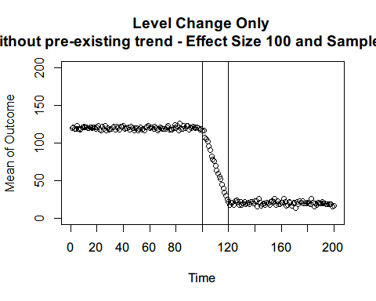 ### Sample size: 100

S1SamplePopAfterS100E100Delay<-subset(S1SamplePopAfterS100E100,x>=120)  
S1SamplePopAfterS100E100Delay$Int<-TRUE  
  
# Phase-in period  
i=1  
temp1=data.frame()  
temp2=data.frame()  
set.seed(43)  
p=1:19  
ss=100  
step=ss/20  
for(i in p){  
 x=rep(i+100,ss-i*step)  
 Individual=head(1:ss,ss-i*step)  
 yindv=rnorm(ss-i*step,S1CounterfactualBefore$y[i],10)  
 Int=FALSE  
 temp1=data.frame(cbind(x,Individual,yindv,Int))  
 S1SamplePopAfterS100E100Delay=rbind(S1SamplePopAfterS100E100Delay,temp1)  
   
 x=rep(i+100,i*step)  
 Individual=tail(1:ss,i*step)  
 yindv=rnorm(i,S1CounterfactualAfterE100$y[i],10)  
 Int=TRUE  
 temp2=data.frame(cbind(x,Individual,yindv,Int))  
 S1SamplePopAfterS100E100Delay=rbind(S1SamplePopAfterS100E100Delay,temp2)  
 i=i+1  
}  
  
S1PhaseInS100E100=rbind(S1SamplePopBefore100,S1SamplePopAfterS100E100Delay)  
#Individual level variation  
plot(S1PhaseInS100E100$x,S1PhaseInS100E100$yindv,ylim=c(0,200))

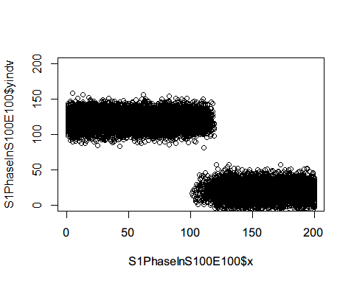

#Compute mean at each time point  
S1PhaseInS100E100AGG<-S1PhaseInS100E100 %>%   
 group_by(x) %>%   
 summarise(y=mean(yindv))  
plot(S1PhaseInS100E100AGG$x,S1PhaseInS100E100AGG$y,ylim=c(0,200),xaxp=c(0,200,10),  
 ylab = "Mean of Outcome",xlab="Time",main = "Level Change Only   
 without pre-existing trend - Effect Size 100 and Sample Size 100")  
abline(v=100)  
abline(v=120)

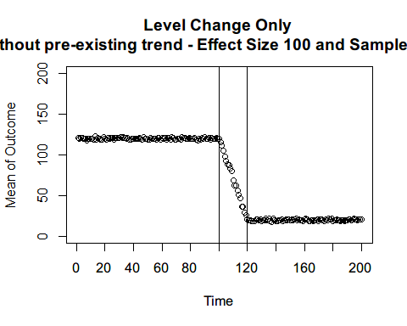

### Sample size: 1000

S1SamplePopAfterS1000E100Delay<-subset(S1SamplePopAfterS1000E100,x>=120)  
S1SamplePopAfterS1000E100Delay$Int<-TRUE  
  
# Phase-in period  
i=1  
temp1=data.frame()  
temp2=data.frame()  
set.seed(44)  
p=1:19  
ss=1000  
step=ss/20  
for(i in p){  
 x=rep(i+100,ss-i*step)  
 Individual=head(1:ss,ss-i*step)  
 yindv=rnorm(ss-i*step,S1CounterfactualBefore$y[i],10)  
 Int=FALSE  
 temp1=data.frame(cbind(x,Individual,yindv,Int))  
 S1SamplePopAfterS1000E100Delay=rbind(S1SamplePopAfterS1000E100Delay,temp1)  
   
 x=rep(i+100,i*step)  
 Individual=tail(1:ss,i*step)  
 yindv=rnorm(i,S1CounterfactualAfterE100$y[i],10)  
 Int=TRUE  
 temp2=data.frame(cbind(x,Individual,yindv,Int))  
 S1SamplePopAfterS1000E100Delay=rbind(S1SamplePopAfterS1000E100Delay,temp2)  
 i=i+1  
}  
  
S1PhaseInS1000E100=rbind(S1SamplePopBefore1000,S1SamplePopAfterS1000E100Delay)  
#Individual level variation  
plot(S1PhaseInS1000E100$x,S1PhaseInS1000E100$yindv,ylim=c(0,200))

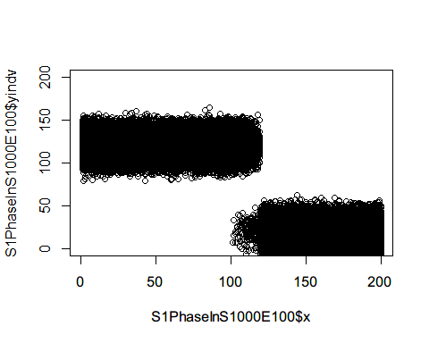

#Compute mean at each time point  
S1PhaseInS1000E100AGG<-S1PhaseInS1000E100 %>%   
 group_by(x) %>%   
 summarise(y=mean(yindv))  
plot(S1PhaseInS1000E100AGG$x,S1PhaseInS1000E100AGG$y,ylim=c(0,200),xaxp=c(0,200,10),  
 ylab = "Mean of Outcome",xlab="Time",main = "Level Change Only   
 without pre-existing trend - Effect Size 100 and Sample Size 1000")  
abline(v=100)  
abline(v=120)

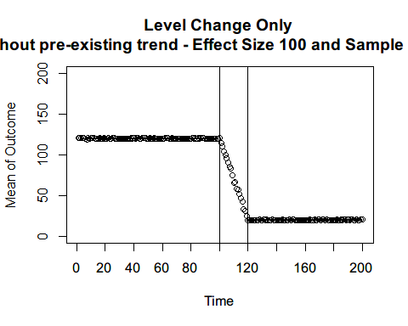

# Senario 2

## Effect Size: 20

### Sample size: 20

S2SamplePopBefore20$Int<-FALSE  
S2SamplePopAfterS20E20Delay<-subset(S2SamplePopAfterS20E20,x>=120)  
S2SamplePopAfterS20E20Delay$Int<-TRUE  
  
# Phase-in period  
i=1  
temp1=data.frame()  
temp2=data.frame()  
set.seed(45)  
p=1:19  
ss=20  
for(i in p){  
 x=rep(i+100,ss-i)  
 Individual=head(1:ss,ss-i)  
 yindv=rnorm(ss-i,S2CounterfactualBefore$y[i],10)  
 Int=FALSE  
 temp1=data.frame(cbind(x,Individual,yindv,Int))  
 S2SamplePopAfterS20E20Delay=rbind(S2SamplePopAfterS20E20Delay,temp1)  
   
 x=rep(i+100,i)  
 Individual=tail(1:ss,i)  
 yindv=rnorm(i,S2CounterfactualAfterE20$y[i],10)  
 Int=TRUE  
 temp2=data.frame(cbind(x,Individual,yindv,Int))  
 S2SamplePopAfterS20E20Delay=rbind(S2SamplePopAfterS20E20Delay,temp2)  
 i=i+1  
}  
  
S2PhaseInS20E20=rbind(S2SamplePopBefore20,S2SamplePopAfterS20E20Delay)  
#Individual level variation  
plot(S2PhaseInS20E20$x,S2PhaseInS20E20$yindv,ylim=c(0,200))

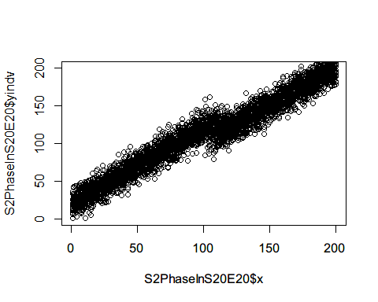

#Compute mean at each time point  
S2PhaseInS20E20AGG<-S2PhaseInS20E20 %>%   
 group_by(x) %>%   
 summarise(y=mean(yindv))  
plot(S2PhaseInS20E20AGG$x,S2PhaseInS20E20AGG$y,ylim=c(0,200),xaxp=c(0,200,10),  
 ylab = "Mean of Outcome",xlab="Time",main = "Level Change Only  
 with pre-existing trend - Effect Size 20 and Sample Size 20")  
abline(v=100)  
abline(v=120)

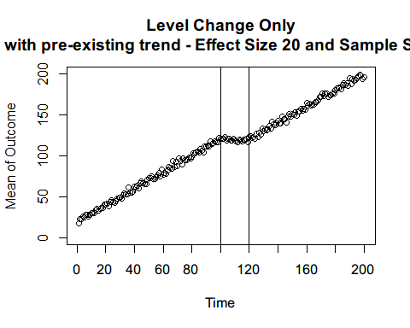

### Sample size: 100

S2SamplePopBefore100$Int<-FALSE  
S2SamplePopAfterS100E20Delay<-subset(S2SamplePopAfterS100E20,x>=120)  
S2SamplePopAfterS100E20Delay$Int<-TRUE  
  
# Phase-in period  
i=1  
temp1=data.frame()  
temp2=data.frame()  
set.seed(46)  
p=1:19  
ss=100  
step=ss/20  
for(i in p){  
 x=rep(i+100,ss-i*step)  
 Individual=head(1:ss,ss-i*step)  
 yindv=rnorm(ss-i*step,S2CounterfactualBefore$y[i],10)  
 Int=FALSE  
 temp1=data.frame(cbind(x,Individual,yindv,Int))  
 S2SamplePopAfterS100E20Delay=rbind(S2SamplePopAfterS100E20Delay,temp1)  
   
 x=rep(i+100,i*step)  
 Individual=tail(1:ss,i*step)  
 yindv=rnorm(i,S2CounterfactualAfterE20$y[i],10)  
 Int=TRUE  
 temp2=data.frame(cbind(x,Individual,yindv,Int))  
 S2SamplePopAfterS100E20Delay=rbind(S2SamplePopAfterS100E20Delay,temp2)  
 i=i+1  
}  
  
S2PhaseInS100E20=rbind(S2SamplePopBefore100,S2SamplePopAfterS100E20Delay)  
#Individual level variation  
plot(S2PhaseInS100E20$x,S2PhaseInS100E20$yindv,ylim=c(0,200))

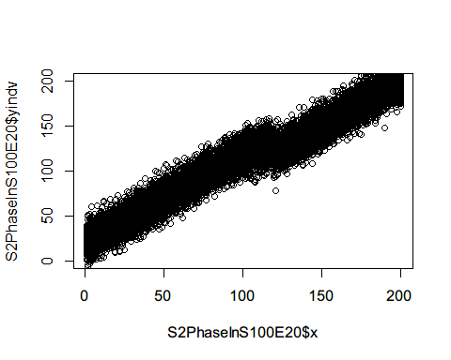

#Compute mean at each time point  
S2PhaseInS100E20AGG<-S2PhaseInS100E20 %>%   
 group_by(x) %>%   
 summarise(y=mean(yindv))  
plot(S2PhaseInS100E20AGG$x,S2PhaseInS100E20AGG$y,ylim=c(0,200),xaxp=c(0,200,10),  
 ylab = "Mean of Outcome",xlab="Time",main = "Level Change Only   
 with pre-existing trend - Effect Size 20 and Sample Size 100")  
abline(v=100)  
abline(v=120)

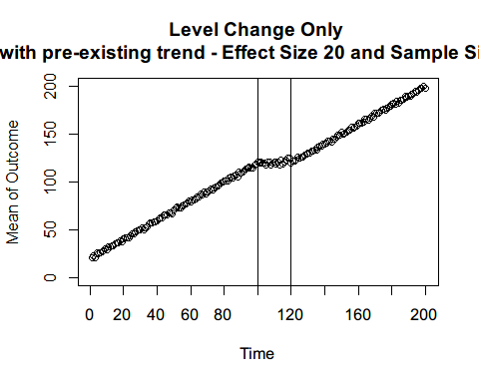

### Sample size: 1000

S2SamplePopBefore1000$Int<-FALSE  
S2SamplePopAfterS1000E20Delay<-subset(S2SamplePopAfterS1000E20,x>=120)  
S2SamplePopAfterS1000E20Delay$Int<-TRUE  
  
# Phase-in period  
i=1  
temp1=data.frame()  
temp2=data.frame()  
set.seed(47)  
p=1:19  
ss=1000  
step=ss/20  
for(i in p){  
 x=rep(i+100,ss-i*step)  
 Individual=head(1:ss,ss-i*step)  
 yindv=rnorm(ss-i*step,S2CounterfactualBefore$y[i],10)  
 Int=FALSE  
 temp1=data.frame(cbind(x,Individual,yindv,Int))  
 S2SamplePopAfterS1000E20Delay=rbind(S2SamplePopAfterS1000E20Delay,temp1)  
   
 x=rep(i+100,i*step)  
 Individual=tail(1:ss,i*step)  
 yindv=rnorm(i,S2CounterfactualAfterE20$y[i],10)  
 Int=TRUE  
 temp2=data.frame(cbind(x,Individual,yindv,Int))  
 S2SamplePopAfterS1000E20Delay=rbind(S2SamplePopAfterS1000E20Delay,temp2)  
 i=i+1  
}  
  
S2PhaseInS1000E20=rbind(S2SamplePopBefore1000,S2SamplePopAfterS1000E20Delay)  
#Individual level variation  
plot(S2PhaseInS1000E20$x,S2PhaseInS1000E20$yindv,ylim=c(0,200))

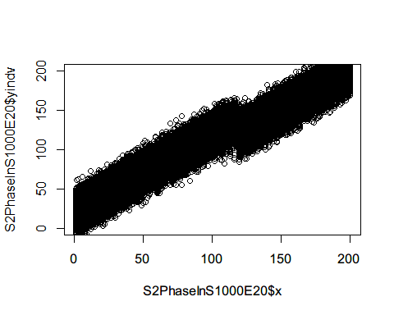

#Compute mean at each time point  
S2PhaseInS1000E20AGG<-S2PhaseInS1000E20 %>%   
 group_by(x) %>%   
 summarise(y=mean(yindv))  
plot(S2PhaseInS1000E20AGG$x,S2PhaseInS1000E20AGG$y,ylim=c(0,200),xaxp=c(0,200,10),  
 ylab = "Mean of Outcome",xlab="Time",main = "Level Change only   
 with pre-existing trend - Effect Size 20 and Sample Size 1000")  
abline(v=100)  
abline(v=120)

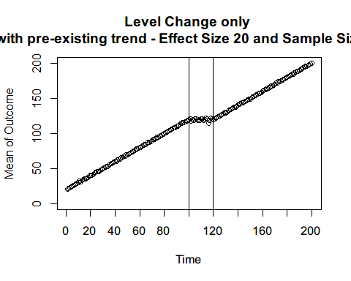

## Effect Size: 50

### Sample size: 20

S2SamplePopAfterS20E50Delay<-subset(S2SamplePopAfterS20E50,x>=120)  
S2SamplePopAfterS20E50Delay$Int<-TRUE  
  
# Phase-in period  
i=1  
temp1=data.frame()  
temp2=data.frame()  
set.seed(48)  
p=1:19  
ss=20  
for(i in p){  
 x=rep(i+100,ss-i)  
 Individual=head(1:ss,ss-i)  
 yindv=rnorm(ss-i,S2CounterfactualBefore$y[i],10)  
 Int=FALSE  
 temp1=data.frame(cbind(x,Individual,yindv,Int))  
 S2SamplePopAfterS20E50Delay=rbind(S2SamplePopAfterS20E50Delay,temp1)  
   
 x=rep(i+100,i)  
 Individual=tail(1:ss,i)  
 yindv=rnorm(i,S2CounterfactualAfterE50$y[i],10)  
 Int=TRUE  
 temp2=data.frame(cbind(x,Individual,yindv,Int))  
 S2SamplePopAfterS20E50Delay=rbind(S2SamplePopAfterS20E50Delay,temp2)  
 i=i+1  
}  
  
S2PhaseInS20E50=rbind(S2SamplePopBefore20,S2SamplePopAfterS20E50Delay)  
#Individual level variation  
plot(S2PhaseInS20E50$x,S2PhaseInS20E50$yindv,ylim=c(0,200))

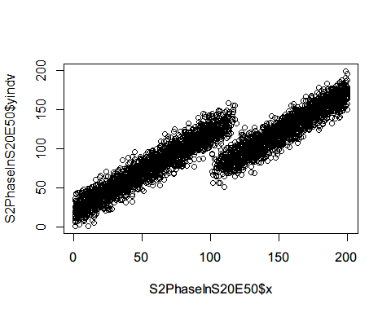

#Compute mean at each time point  
S2PhaseInS20E50AGG<-S2PhaseInS20E50 %>%   
 group_by(x) %>%   
 summarise(y=mean(yindv))  
plot(S2PhaseInS20E50AGG$x,S2PhaseInS20E50AGG$y,ylim=c(0,200),xaxp=c(0,200,10),  
 ylab = "Mean of Outcome",xlab="Time",main = "Level Change Only  
 with pre-existing trend - Effect Size 50 and Sample Size 20")  
abline(v=100)  
abline(v=120)

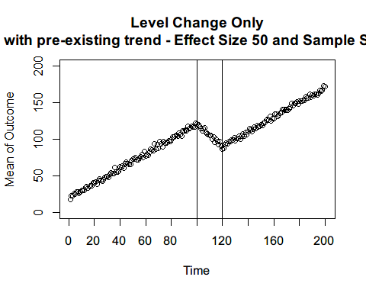 ### Sample size: 100

S2SamplePopAfterS100E50Delay<-subset(S2SamplePopAfterS100E50,x>=120)  
S2SamplePopAfterS100E50Delay$Int<-TRUE  
  
# Phase-in period  
i=1  
temp1=data.frame()  
temp2=data.frame()  
set.seed(49)  
p=1:19  
ss=100  
step=ss/20  
for(i in p){  
 x=rep(i+100,ss-i*step)  
 Individual=head(1:ss,ss-i*step)  
 yindv=rnorm(ss-i*step,S2CounterfactualBefore$y[i],10)  
 Int=FALSE  
 temp1=data.frame(cbind(x,Individual,yindv,Int))  
 S2SamplePopAfterS100E50Delay=rbind(S2SamplePopAfterS100E50Delay,temp1)  
   
 x=rep(i+100,i*step)  
 Individual=tail(1:ss,i*step)  
 yindv=rnorm(i,S2CounterfactualAfterE50$y[i],10)  
 Int=TRUE  
 temp2=data.frame(cbind(x,Individual,yindv,Int))  
 S2SamplePopAfterS100E50Delay=rbind(S2SamplePopAfterS100E50Delay,temp2)  
 i=i+1  
}  
  
S2PhaseInS100E50=rbind(S2SamplePopBefore100,S2SamplePopAfterS100E50Delay)  
#Individual level variation  
plot(S2PhaseInS100E50$x,S2PhaseInS100E50$yindv,ylim=c(0,200))

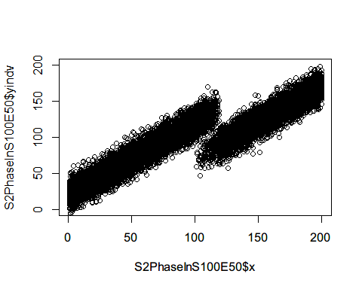

#Compute mean at each time point  
S2PhaseInS100E50AGG<-S2PhaseInS100E50 %>%   
 group_by(x) %>%   
 summarise(y=mean(yindv))  
plot(S2PhaseInS100E50AGG$x,S2PhaseInS100E50AGG$y,ylim=c(0,200),xaxp=c(0,200,10),  
 ylab = "Mean of Outcome",xlab="Time",main = "Level Change Only   
 with pre-existing trend - Effect Size 50 and Sample Size 100")  
abline(v=100)  
abline(v=120)

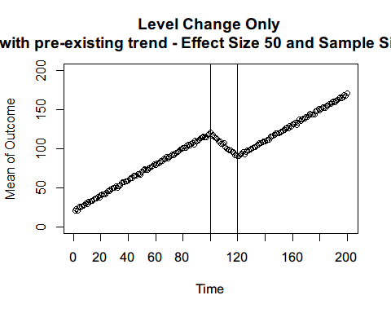

### Sample size: 1000

S2SamplePopAfterS1000E50Delay<-subset(S2SamplePopAfterS1000E50,x>=120)  
S2SamplePopAfterS1000E50Delay$Int<-TRUE  
  
# Phase-in period  
i=1  
temp1=data.frame()  
temp2=data.frame()  
set.seed(50)  
p=1:19  
ss=1000  
step=ss/20  
for(i in p){  
 x=rep(i+100,ss-i*step)  
 Individual=head(1:ss,ss-i*step)  
 yindv=rnorm(ss-i*step,S2CounterfactualBefore$y[i],10)  
 Int=FALSE  
 temp1=data.frame(cbind(x,Individual,yindv,Int))  
 S2SamplePopAfterS1000E50Delay=rbind(S2SamplePopAfterS1000E50Delay,temp1)  
   
 x=rep(i+100,i*step)  
 Individual=tail(1:ss,i*step)  
 yindv=rnorm(i,S2CounterfactualAfterE50$y[i],10)  
 Int=TRUE  
 temp2=data.frame(cbind(x,Individual,yindv,Int))  
 S2SamplePopAfterS1000E50Delay=rbind(S2SamplePopAfterS1000E50Delay,temp2)  
 i=i+1  
}  
  
S2PhaseInS1000E50=rbind(S2SamplePopBefore1000,S2SamplePopAfterS1000E50Delay)  
#Individual level variation  
plot(S2PhaseInS1000E50$x,S2PhaseInS1000E50$yindv,ylim=c(0,200))

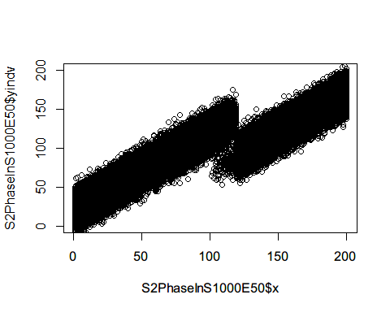

#Compute mean at each time point  
S2PhaseInS1000E50AGG<-S2PhaseInS1000E50 %>%   
 group_by(x) %>%   
 summarise(y=mean(yindv))  
plot(S2PhaseInS1000E50AGG$x,S2PhaseInS1000E50AGG$y,ylim=c(0,200),xaxp=c(0,200,10),  
 ylab = "Mean of Outcome",xlab="Time",main = "Level Change only   
 with pre-existing trend - Effect Size 50 and Sample Size 1000")  
abline(v=100)  
abline(v=120)

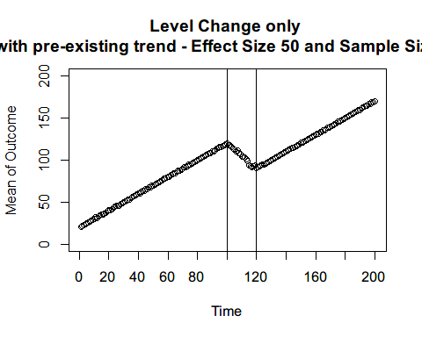

## Effect Size: 100

### Sample size: 20

S2SamplePopAfterS20E100Delay<-subset(S2SamplePopAfterS20E100,x>=120)  
S2SamplePopAfterS20E100Delay$Int<-TRUE  
  
# Phase-in period  
i=1  
temp1=data.frame()  
temp2=data.frame()  
set.seed(51)  
p=1:19  
ss=20  
for(i in p){  
 x=rep(i+100,ss-i)  
 Individual=head(1:ss,ss-i)  
 yindv=rnorm(ss-i,S2CounterfactualBefore$y[i],10)  
 Int=FALSE  
 temp1=data.frame(cbind(x,Individual,yindv,Int))  
 S2SamplePopAfterS20E100Delay=rbind(S2SamplePopAfterS20E100Delay,temp1)  
   
 x=rep(i+100,i)  
 Individual=tail(1:ss,i)  
 yindv=rnorm(i,S2CounterfactualAfterE100$y[i],10)  
 Int=TRUE  
 temp2=data.frame(cbind(x,Individual,yindv,Int))  
 S2SamplePopAfterS20E100Delay=rbind(S2SamplePopAfterS20E100Delay,temp2)  
 i=i+1  
}  
  
S2PhaseInS20E100=rbind(S2SamplePopBefore20,S2SamplePopAfterS20E100Delay)  
#Individual level variation  
plot(S2PhaseInS20E100$x,S2PhaseInS20E100$yindv,ylim=c(0,200))

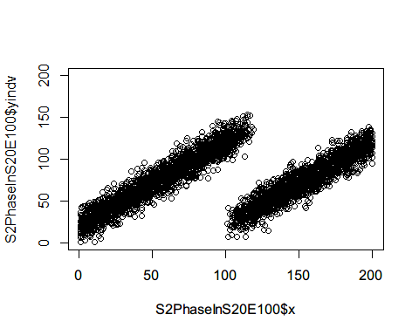

#Compute mean at each time point  
S2PhaseInS20E100AGG<-S2PhaseInS20E100 %>%   
 group_by(x) %>%   
 summarise(y=mean(yindv))  
plot(S2PhaseInS20E100AGG$x,S2PhaseInS20E100AGG$y,ylim=c(0,200),xaxp=c(0,200,10),  
 ylab = "Mean of Outcome",xlab="Time",main = "Level Change Only  
 with pre-existing trend - Effect Size 100 and Sample Size 20")  
abline(v=100)  
abline(v=120)

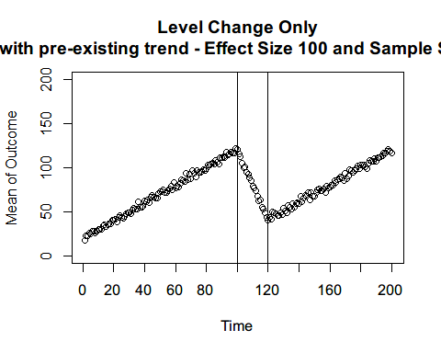 ### Sample size: 100

S2SamplePopAfterS100E100Delay<-subset(S2SamplePopAfterS100E100,x>=120)  
S2SamplePopAfterS100E100Delay$Int<-TRUE  
  
# Phase-in period  
i=1  
temp1=data.frame()  
temp2=data.frame()  
set.seed(52)  
p=1:19  
ss=100  
step=ss/20  
for(i in p){  
 x=rep(i+100,ss-i*step)  
 Individual=head(1:ss,ss-i*step)  
 yindv=rnorm(ss-i*step,S2CounterfactualBefore$y[i],10)  
 Int=FALSE  
 temp1=data.frame(cbind(x,Individual,yindv,Int))  
 S2SamplePopAfterS100E100Delay=rbind(S2SamplePopAfterS100E100Delay,temp1)  
   
 x=rep(i+100,i*step)  
 Individual=tail(1:ss,i*step)  
 yindv=rnorm(i,S2CounterfactualAfterE100$y[i],10)  
 Int=TRUE  
 temp2=data.frame(cbind(x,Individual,yindv,Int))  
 S2SamplePopAfterS100E100Delay=rbind(S2SamplePopAfterS100E100Delay,temp2)  
 i=i+1  
}  
  
S2PhaseInS100E100=rbind(S2SamplePopBefore100,S2SamplePopAfterS100E100Delay)  
#Individual level variation  
plot(S2PhaseInS100E100$x,S2PhaseInS100E100$yindv,ylim=c(0,200))

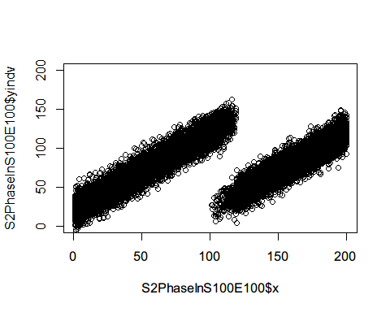

#Compute mean at each time point  
S2PhaseInS100E100AGG<-S2PhaseInS100E100 %>%   
 group_by(x) %>%   
 summarise(y=mean(yindv))  
plot(S2PhaseInS100E100AGG$x,S2PhaseInS100E100AGG$y,ylim=c(0,200),xaxp=c(0,200,10),  
 ylab = "Mean of Outcome",xlab="Time",main = "Level Change Only   
 with pre-existing trend - Effect Size 100 and Sample Size 100")  
abline(v=100)  
abline(v=120)

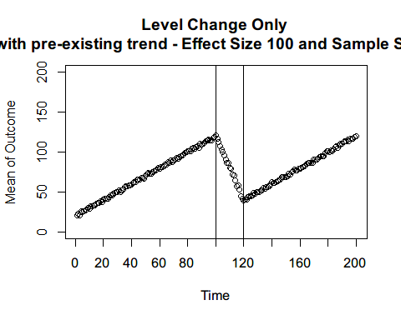

### Sample size: 1000

S2SamplePopAfterS1000E100Delay<-subset(S2SamplePopAfterS1000E100,x>=120)  
S2SamplePopAfterS1000E100Delay$Int<-TRUE  
  
# Phase-in period  
i=1  
temp1=data.frame()  
temp2=data.frame()  
set.seed(53)  
p=1:19  
ss=1000  
step=ss/20  
for(i in p){  
 x=rep(i+100,ss-i*step)  
 Individual=head(1:ss,ss-i*step)  
 yindv=rnorm(ss-i*step,S2CounterfactualBefore$y[i],10)  
 Int=FALSE  
 temp1=data.frame(cbind(x,Individual,yindv,Int))  
 S2SamplePopAfterS1000E100Delay=rbind(S2SamplePopAfterS1000E100Delay,temp1)  
   
 x=rep(i+100,i*step)  
 Individual=tail(1:ss,i*step)  
 yindv=rnorm(i,S2CounterfactualAfterE100$y[i],10)  
 Int=TRUE  
 temp2=data.frame(cbind(x,Individual,yindv,Int))  
 S2SamplePopAfterS1000E100Delay=rbind(S2SamplePopAfterS1000E100Delay,temp2)  
 i=i+1  
}  
  
S2PhaseInS1000E100=rbind(S2SamplePopBefore1000,S2SamplePopAfterS1000E100Delay)  
#Individual level variation  
plot(S2PhaseInS1000E100$x,S2PhaseInS1000E100$yindv,ylim=c(0,200))

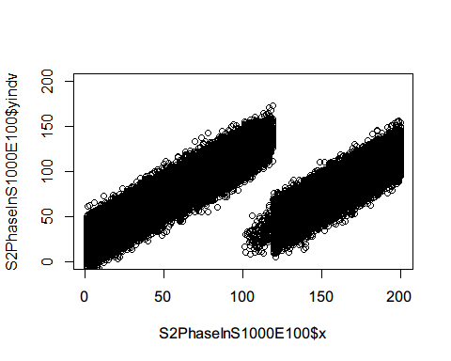

#Compute mean at each time point  
S2PhaseInS1000E100AGG<-S2PhaseInS1000E100 %>%   
 group_by(x) %>%   
 summarise(y=mean(yindv))  
plot(S2PhaseInS1000E100AGG$x,S2PhaseInS1000E100AGG$y,ylim=c(0,200),xaxp=c(0,200,10),  
 ylab = "Mean of Outcome",xlab="Time",main = "Level Change only   
 with pre-existing trend - Effect Size 100 and Sample Size 1000")  
abline(v=100)  
abline(v=120)

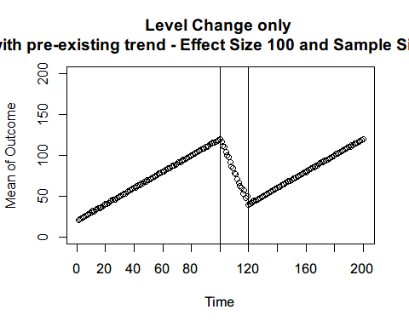

# Senario 3

## Effect Size: 20

### Sample size: 20

S3SamplePopBefore20$Int<-FALSE  
S3SamplePopAfterS20E20Delay<-subset(S3SamplePopAfterS20E20,x>=120)  
S3SamplePopAfterS20E20Delay$Int<-TRUE  
  
# Phase-in period  
i=1  
temp1=data.frame()  
temp2=data.frame()  
set.seed(54)  
p=1:19  
ss=20  
for(i in p){  
 x=rep(i+100,ss-i)  
 Individual=head(1:ss,ss-i)  
 yindv=rnorm(ss-i,S3CounterfactualBefore$y[i],10)  
 Int=FALSE  
 temp1=data.frame(cbind(x,Individual,yindv,Int))  
 S3SamplePopAfterS20E20Delay=rbind(S3SamplePopAfterS20E20Delay,temp1)  
   
 x=rep(i+100,i)  
 Individual=tail(1:ss,i)  
 yindv=rnorm(i,S3CounterfactualAfterE20$y[i],10)  
 Int=TRUE  
 temp2=data.frame(cbind(x,Individual,yindv,Int))  
 S3SamplePopAfterS20E20Delay=rbind(S3SamplePopAfterS20E20Delay,temp2)  
 i=i+1  
}  
  
S3PhaseInS20E20=rbind(S3SamplePopBefore20,S3SamplePopAfterS20E20Delay)  
#Individual level variation  
plot(S3PhaseInS20E20$x,S3PhaseInS20E20$yindv,ylim=c(0,300))

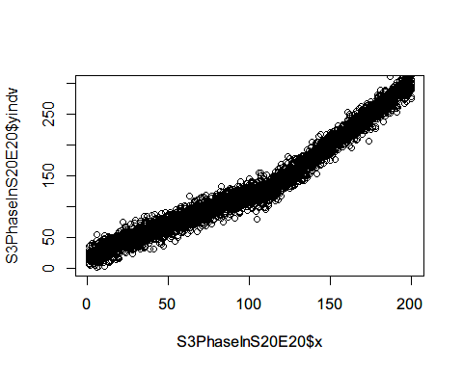

#Compute mean at each time point  
S3PhaseInS20E20AGG<-S3PhaseInS20E20 %>%   
 group_by(x) %>%   
 summarise(y=mean(yindv))  
plot(S3PhaseInS20E20AGG$x,S3PhaseInS20E20AGG$y,ylim=c(0,300),xaxp=c(0,200,10),  
 ylab = "Mean of Outcome",xlab="Time",main = "Level and Slope Change   
 with pre-existing trend - Effect Size 20 and Sample Size 20")  
abline(v=100)  
abline(v=120)

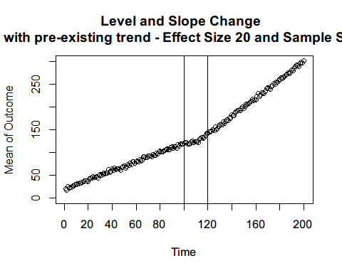 ### Sample size: 100

S3SamplePopBefore100$Int<-FALSE  
S3SamplePopAfterS100E20Delay<-subset(S3SamplePopAfterS100E20,x>=120)  
S3SamplePopAfterS100E20Delay$Int<-TRUE  
  
# Phase-in period  
i=1  
temp1=data.frame()  
temp2=data.frame()  
set.seed(55)  
p=1:19  
ss=100  
step=ss/20  
for(i in p){  
 x=rep(i+100,ss-i*step)  
 Individual=head(1:ss,ss-i*step)  
 yindv=rnorm(ss-i*step,S3CounterfactualBefore$y[i],10)  
 Int=FALSE  
 temp1=data.frame(cbind(x,Individual,yindv,Int))  
 S3SamplePopAfterS100E20Delay=rbind(S3SamplePopAfterS100E20Delay,temp1)  
   
 x=rep(i+100,i*step)  
 Individual=tail(1:ss,i*step)  
 yindv=rnorm(i,S3CounterfactualAfterE20$y[i],10)  
 Int=TRUE  
 temp2=data.frame(cbind(x,Individual,yindv,Int))  
 S3SamplePopAfterS100E20Delay=rbind(S3SamplePopAfterS100E20Delay,temp2)  
 i=i+1  
}  
  
S3PhaseInS100E20=rbind(S3SamplePopBefore100,S3SamplePopAfterS100E20Delay)  
#Individual level variation  
plot(S3PhaseInS100E20$x,S3PhaseInS100E20$yindv,ylim=c(0,200))

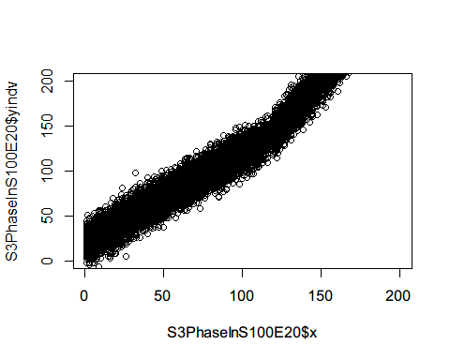

#Compute mean at each time point  
S3PhaseInS100E20AGG<-S3PhaseInS100E20 %>%   
 group_by(x) %>%   
 summarise(y=mean(yindv))  
plot(S3PhaseInS100E20AGG$x,S3PhaseInS100E20AGG$y,ylim=c(0,200),xaxp=c(0,200,10),  
 ylab = "Mean of Outcome",xlab="Time",main = "Level and Slope Change   
 with pre-existing trend - Effect Size 20 and Sample Size 100")  
abline(v=100)  
abline(v=120)

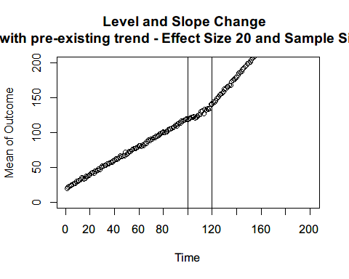

### Sample size: 1000

S3SamplePopBefore1000$Int<-FALSE  
S3SamplePopAfterS1000E20Delay<-subset(S3SamplePopAfterS1000E20,x>=120)  
S3SamplePopAfterS1000E20Delay$Int<-TRUE  
  
# Phase-in period  
i=1  
temp1=data.frame()  
temp2=data.frame()  
set.seed(56)  
p=1:19  
ss=1000  
step=ss/20  
for(i in p){  
 x=rep(i+100,ss-i*step)  
 Individual=head(1:ss,ss-i*step)  
 yindv=rnorm(ss-i*step,S3CounterfactualBefore$y[i],10)  
 Int=FALSE  
 temp1=data.frame(cbind(x,Individual,yindv,Int))  
 S3SamplePopAfterS1000E20Delay=rbind(S3SamplePopAfterS1000E20Delay,temp1)  
   
 x=rep(i+100,i*step)  
 Individual=tail(1:ss,i*step)  
 yindv=rnorm(i,S3CounterfactualAfterE20$y[i],10)  
 Int=TRUE  
 temp2=data.frame(cbind(x,Individual,yindv,Int))  
 S3SamplePopAfterS1000E20Delay=rbind(S3SamplePopAfterS1000E20Delay,temp2)  
 i=i+1  
}  
  
S3PhaseInS1000E20=rbind(S3SamplePopBefore1000,S3SamplePopAfterS1000E20Delay)  
#Individual level variation  
plot(S3PhaseInS1000E20$x,S3PhaseInS1000E20$yindv,ylim=c(0,300))

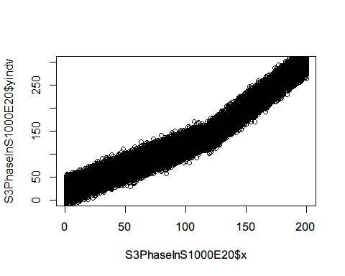

#Compute mean at each time point  
S3PhaseInS1000E20AGG<-S3PhaseInS1000E20 %>%   
 group_by(x) %>%   
 summarise(y=mean(yindv))  
plot(S3PhaseInS1000E20AGG$x,S3PhaseInS1000E20AGG$y,ylim=c(0,300),xaxp=c(0,200,10),  
 ylab = "Mean of Outcome",xlab="Time",main = "Level and Slope Change   
 with pre-existing trend - Effect Size 20 and Sample Size 1000")  
abline(v=100)  
abline(v=120)

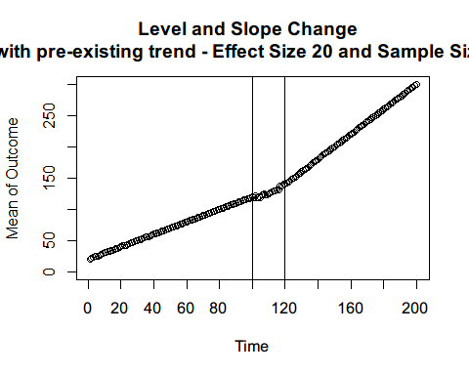

## Effect Size: 50

### Sample size: 20

S3SamplePopAfterS20E50Delay<-subset(S3SamplePopAfterS20E50,x>=120)  
S3SamplePopAfterS20E50Delay$Int<-TRUE  
  
# Phase-in period  
i=1  
temp1=data.frame()  
temp2=data.frame()  
set.seed(57)  
p=1:19  
ss=20  
for(i in p){  
 x=rep(i+100,ss-i)  
 Individual=head(1:ss,ss-i)  
 yindv=rnorm(ss-i,S3CounterfactualBefore$y[i],10)  
 Int=FALSE  
 temp1=data.frame(cbind(x,Individual,yindv,Int))  
 S3SamplePopAfterS20E50Delay=rbind(S3SamplePopAfterS20E50Delay,temp1)  
   
 x=rep(i+100,i)  
 Individual=tail(1:ss,i)  
 yindv=rnorm(i,S3CounterfactualAfterE50$y[i],10)  
 Int=TRUE  
 temp2=data.frame(cbind(x,Individual,yindv,Int))  
 S3SamplePopAfterS20E50Delay=rbind(S3SamplePopAfterS20E50Delay,temp2)  
 i=i+1  
}  
  
S3PhaseInS20E50=rbind(S3SamplePopBefore20,S3SamplePopAfterS20E50Delay)  
#Individual level variation  
plot(S3PhaseInS20E50$x,S3PhaseInS20E50$yindv,ylim=c(0,300))

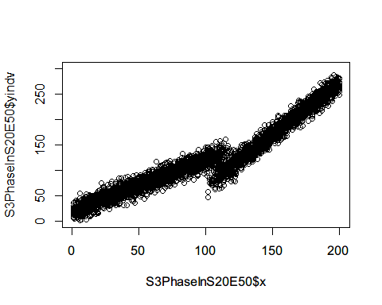

#Compute mean at each time point  
S3PhaseInS20E50AGG<-S3PhaseInS20E50 %>%   
 group_by(x) %>%   
 summarise(y=mean(yindv))  
plot(S3PhaseInS20E50AGG$x,S3PhaseInS20E50AGG$y,ylim=c(0,300),xaxp=c(0,200,10),  
 ylab = "Mean of Outcome",xlab="Time",main = "Level and Slope Change   
 with pre-existing trend - Effect Size 50 and Sample Size 20")  
abline(v=100)  
abline(v=120)

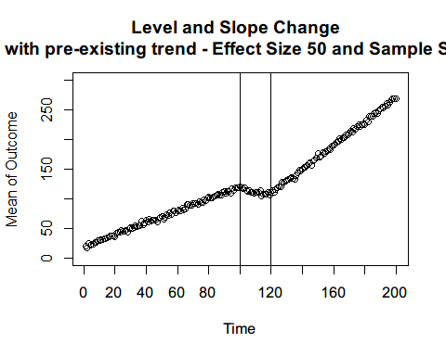 ### Sample size: 100

S3SamplePopAfterS100E50Delay<-subset(S3SamplePopAfterS100E50,x>=120)  
S3SamplePopAfterS100E50Delay$Int<-TRUE  
  
# Phase-in period  
i=1  
temp1=data.frame()  
temp2=data.frame()  
set.seed(58)  
p=1:19  
ss=100  
step=ss/20  
for(i in p){  
 x=rep(i+100,ss-i*step)  
 Individual=head(1:ss,ss-i*step)  
 yindv=rnorm(ss-i*step,S3CounterfactualBefore$y[i],10)  
 Int=FALSE  
 temp1=data.frame(cbind(x,Individual,yindv,Int))  
 S3SamplePopAfterS100E50Delay=rbind(S3SamplePopAfterS100E50Delay,temp1)  
   
 x=rep(i+100,i*step)  
 Individual=tail(1:ss,i*step)  
 yindv=rnorm(i,S3CounterfactualAfterE50$y[i],10)  
 Int=TRUE  
 temp2=data.frame(cbind(x,Individual,yindv,Int))  
 S3SamplePopAfterS100E50Delay=rbind(S3SamplePopAfterS100E50Delay,temp2)  
 i=i+1  
}  
  
S3PhaseInS100E50=rbind(S3SamplePopBefore100,S3SamplePopAfterS100E50Delay)  
#Individual level variation  
plot(S3PhaseInS100E50$x,S3PhaseInS100E50$yindv,ylim=c(0,200))

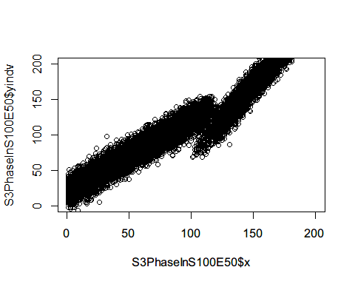

#Compute mean at each time point  
S3PhaseInS100E50AGG<-S3PhaseInS100E50 %>%   
 group_by(x) %>%   
 summarise(y=mean(yindv))  
plot(S3PhaseInS100E50AGG$x,S3PhaseInS100E50AGG$y,ylim=c(0,200),xaxp=c(0,200,10),  
 ylab = "Mean of Outcome",xlab="Time",main = "Level and Slope Change   
 with pre-existing trend - Effect Size 50 and Sample Size 100")  
abline(v=100)  
abline(v=120)

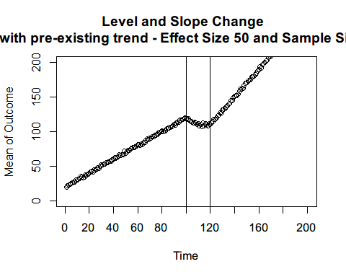

### Sample size: 1000

S3SamplePopAfterS1000E50Delay<-subset(S3SamplePopAfterS1000E50,x>=120)  
S3SamplePopAfterS1000E50Delay$Int<-TRUE  
  
# Phase-in period  
i=1  
temp1=data.frame()  
temp2=data.frame()  
set.seed(59)  
p=1:19  
ss=1000  
step=ss/20  
for(i in p){  
 x=rep(i+100,ss-i*step)  
 Individual=head(1:ss,ss-i*step)  
 yindv=rnorm(ss-i*step,S3CounterfactualBefore$y[i],10)  
 Int=FALSE  
 temp1=data.frame(cbind(x,Individual,yindv,Int))  
 S3SamplePopAfterS1000E50Delay=rbind(S3SamplePopAfterS1000E50Delay,temp1)  
   
 x=rep(i+100,i*step)  
 Individual=tail(1:ss,i*step)  
 yindv=rnorm(i,S3CounterfactualAfterE50$y[i],10)  
 Int=TRUE  
 temp2=data.frame(cbind(x,Individual,yindv,Int))  
 S3SamplePopAfterS1000E50Delay=rbind(S3SamplePopAfterS1000E50Delay,temp2)  
 i=i+1  
}  
  
S3PhaseInS1000E50=rbind(S3SamplePopBefore1000,S3SamplePopAfterS1000E50Delay)  
#Individual level variation  
plot(S3PhaseInS1000E50$x,S3PhaseInS1000E50$yindv,ylim=c(0,300))

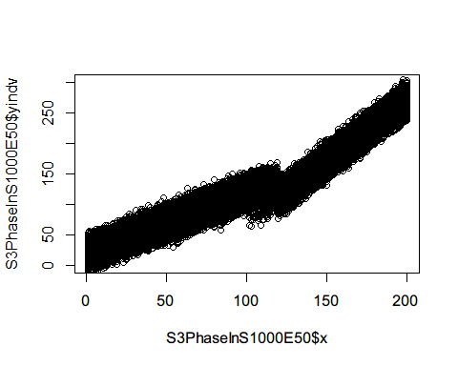

#Compute mean at each time point  
S3PhaseInS1000E50AGG<-S3PhaseInS1000E50 %>%   
 group_by(x) %>%   
 summarise(y=mean(yindv))  
plot(S3PhaseInS1000E50AGG$x,S3PhaseInS1000E50AGG$y,ylim=c(0,300),xaxp=c(0,200,10),  
 ylab = "Mean of Outcome",xlab="Time",main = "Level and Slope Change   
 with pre-existing trend - Effect Size 50 and Sample Size 1000")  
abline(v=100)  
abline(v=120)

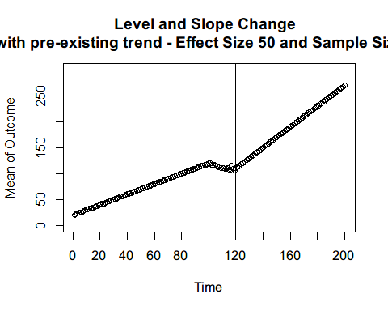

## Effect Size: 100

### Sample size: 20

S3SamplePopAfterS20E100Delay<-subset(S3SamplePopAfterS20E100,x>=120)  
S3SamplePopAfterS20E100Delay$Int<-TRUE  
  
# Phase-in period  
i=1  
temp1=data.frame()  
temp2=data.frame()  
set.seed(60)  
p=1:19  
ss=20  
for(i in p){  
 x=rep(i+100,ss-i)  
 Individual=head(1:ss,ss-i)  
 yindv=rnorm(ss-i,S3CounterfactualBefore$y[i],10)  
 Int=FALSE  
 temp1=data.frame(cbind(x,Individual,yindv,Int))  
 S3SamplePopAfterS20E100Delay=rbind(S3SamplePopAfterS20E100Delay,temp1)  
   
 x=rep(i+100,i)  
 Individual=tail(1:ss,i)  
 yindv=rnorm(i,S3CounterfactualAfterE100$y[i],10)  
 Int=TRUE  
 temp2=data.frame(cbind(x,Individual,yindv,Int))  
 S3SamplePopAfterS20E100Delay=rbind(S3SamplePopAfterS20E100Delay,temp2)  
 i=i+1  
}  
  
S3PhaseInS20E100=rbind(S3SamplePopBefore20,S3SamplePopAfterS20E100Delay)  
#Individual level variation  
plot(S3PhaseInS20E100$x,S3PhaseInS20E100$yindv,ylim=c(0,300))

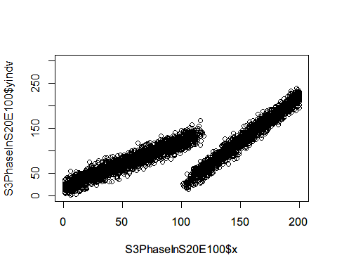

#Compute mean at each time point  
S3PhaseInS20E100AGG<-S3PhaseInS20E100 %>%   
 group_by(x) %>%   
 summarise(y=mean(yindv))  
plot(S3PhaseInS20E100AGG$x,S3PhaseInS20E100AGG$y,ylim=c(0,300),xaxp=c(0,200,10),  
 ylab = "Mean of Outcome",xlab="Time",main = "Level and Slope Change   
 with pre-existing trend - Effect Size 100 and Sample Size 20")  
abline(v=100)  
abline(v=120)

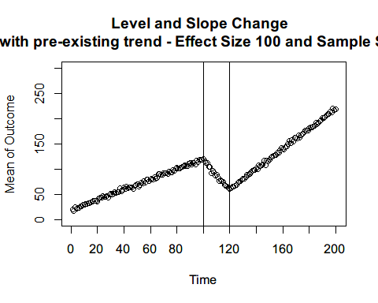 ### Sample size: 100

S3SamplePopAfterS100E100Delay<-subset(S3SamplePopAfterS100E100,x>=120)  
S3SamplePopAfterS100E100Delay$Int<-TRUE  
  
# Phase-in period  
i=1  
temp1=data.frame()  
temp2=data.frame()  
set.seed(61)  
p=1:19  
ss=100  
step=ss/20  
for(i in p){  
 x=rep(i+100,ss-i*step)  
 Individual=head(1:ss,ss-i*step)  
 yindv=rnorm(ss-i*step,S3CounterfactualBefore$y[i],10)  
 Int=FALSE  
 temp1=data.frame(cbind(x,Individual,yindv,Int))  
 S3SamplePopAfterS100E100Delay=rbind(S3SamplePopAfterS100E100Delay,temp1)  
   
 x=rep(i+100,i*step)  
 Individual=tail(1:ss,i*step)  
 yindv=rnorm(i,S3CounterfactualAfterE100$y[i],10)  
 Int=TRUE  
 temp2=data.frame(cbind(x,Individual,yindv,Int))  
 S3SamplePopAfterS100E100Delay=rbind(S3SamplePopAfterS100E100Delay,temp2)  
 i=i+1  
}  
  
S3PhaseInS100E100=rbind(S3SamplePopBefore100,S3SamplePopAfterS100E100Delay)  
#Individual level variation  
plot(S3PhaseInS100E100$x,S3PhaseInS100E100$yindv,ylim=c(0,200))

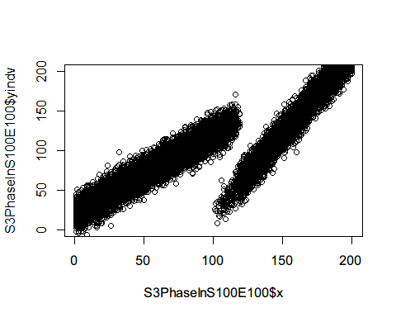

#Compute mean at each time point  
S3PhaseInS100E100AGG<-S3PhaseInS100E100 %>%   
 group_by(x) %>%   
 summarise(y=mean(yindv))  
plot(S3PhaseInS100E100AGG$x,S3PhaseInS100E100AGG$y,ylim=c(0,200),xaxp=c(0,200,10),  
 ylab = "Mean of Outcome",xlab="Time",main = "Level and Slope Change   
 with pre-existing trend - Effect Size 100 and Sample Size 100")  
abline(v=100)  
abline(v=120)

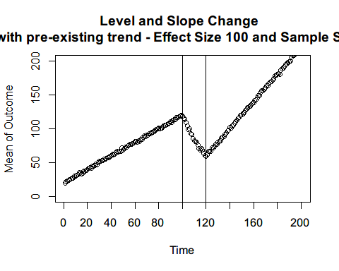

### Sample size: 1000

S3SamplePopAfterS1000E100Delay<-subset(S3SamplePopAfterS1000E100,x>=120)  
S3SamplePopAfterS1000E100Delay$Int<-TRUE  
  
# Phase-in period  
i=1  
temp1=data.frame()  
temp2=data.frame()  
set.seed(62)  
p=1:19  
ss=1000  
step=ss/20  
for(i in p){  
 x=rep(i+100,ss-i*step)  
 Individual=head(1:ss,ss-i*step)  
 yindv=rnorm(ss-i*step,S3CounterfactualBefore$y[i],10)  
 Int=FALSE  
 temp1=data.frame(cbind(x,Individual,yindv,Int))  
 S3SamplePopAfterS1000E100Delay=rbind(S3SamplePopAfterS1000E100Delay,temp1)  
   
 x=rep(i+100,i*step)  
 Individual=tail(1:ss,i*step)  
 yindv=rnorm(i,S3CounterfactualAfterE100$y[i],10)  
 Int=TRUE  
 temp2=data.frame(cbind(x,Individual,yindv,Int))  
 S3SamplePopAfterS1000E100Delay=rbind(S3SamplePopAfterS1000E100Delay,temp2)  
 i=i+1  
}  
  
S3PhaseInS1000E100=rbind(S3SamplePopBefore1000,S3SamplePopAfterS1000E100Delay)  
#Individual level variation  
plot(S3PhaseInS1000E100$x,S3PhaseInS1000E100$yindv,ylim=c(0,300))

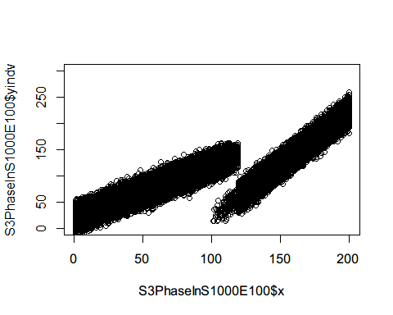

#Compute mean at each time point  
S3PhaseInS1000E100AGG<-S3PhaseInS1000E100 %>%   
 group_by(x) %>%   
 summarise(y=mean(yindv))  
plot(S3PhaseInS1000E100AGG$x,S3PhaseInS1000E100AGG$y,ylim=c(0,300),xaxp=c(0,200,10),  
 ylab = "Mean of Outcome",xlab="Time",main = "Level and Slope Change   
 with pre-existing trend - Effect Size 100 and Sample Size 1000")  
abline(v=100)  
abline(v=120)

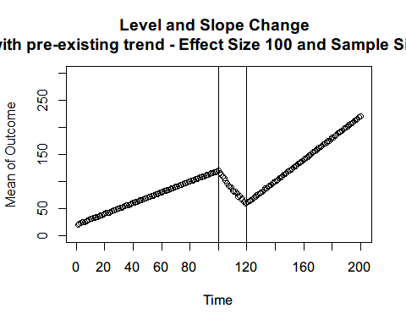

# Creating and Analyzing delayed ITS

# Senario 1

Sample size 20 Effect Size 20 Model 1: Abrupt at time 100

S1PhaseInS20E20AGGM1<-S1PhaseInS20E20AGG  
S1PhaseInS20E20AGGM1$intervention = S1PhaseInS20E20AGGM1$x > 100  
S1PhaseInS20E20AGGM1$time_after_intervention = ifelse(S1PhaseInS20E20AGGM1$x > 100, S1PhaseInS20E20AGGM1$x - 100, 0)  
S1S20E20M1<-lm(y ~ x + intervention + time_after_intervention, data=S1PhaseInS20E20AGGM1)  
summary(S1S20E20M1)

##   
## Call:  
## lm(formula = y ~ x + intervention + time_after_intervention,   
## data = S1PhaseInS20E20AGGM1)  
##   
## Residuals:  
## Min 1Q Median 3Q Max   
## -9.8693 -1.9588 -0.0217 1.6634 13.3122   
##   
## Coefficients:  
## Estimate Std. Error t value Pr(>|t|)   
## (Intercept) 119.853722 0.708537 169.157 < 0.0000000000000002 ***  
## x -0.001125 0.012181 -0.092 0.927   
## interventionTRUE -12.970783 0.994591 -13.041 < 0.0000000000000002 ***  
## time_after_intervention -0.098288 0.017226 -5.706 0.0000000423 ***  
## ---  
## Signif. codes: 0 '***' 0.001 '**' 0.01 '*' 0.05 '.' 0.1 ' ' 1  
##   
## Residual standard error: 3.516 on 196 degrees of freedom  
## Multiple R-squared: 0.8759, Adjusted R-squared: 0.874   
## F-statistic: 461.3 on 3 and 196 DF, p-value: < 0.00000000000000022

confint(S1S20E20M1)

## 2.5 % 97.5 %  
## (Intercept) 118.45638836 121.25105650  
## x -0.02514724 0.02289764  
## interventionTRUE -14.93225630 -11.00930984  
## time_after_intervention -0.13226111 -0.06431538

Model 2: Abrupt at time 120

S1PhaseInS20E20AGGM2<-S1PhaseInS20E20AGG  
S1PhaseInS20E20AGGM2$intervention = S1PhaseInS20E20AGGM2$x > 120  
S1PhaseInS20E20AGGM2$time_after_intervention = ifelse(S1PhaseInS20E20AGGM2$x > 120, S1PhaseInS20E20AGGM2$x - 120, 0)  
S1S20E20M2<-lm(y ~ x + intervention + time_after_intervention, data=S1PhaseInS20E20AGGM2)  
summary(S1S20E20M2)

##   
## Call:  
## lm(formula = y ~ x + intervention + time_after_intervention,   
## data = S1PhaseInS20E20AGGM2)  
##   
## Residuals:  
## Min 1Q Median 3Q Max   
## -18.4856 -1.6578 0.4358 1.9074 9.4243   
##   
## Coefficients:  
## Estimate Std. Error t value Pr(>|t|)   
## (Intercept) 122.808675 0.681622 180.17 < 0.0000000000000002 ***  
## x -0.078418 0.009777 -8.02 0.0000000000000939 ***  
## interventionTRUE -13.723526 1.074449 -12.77 < 0.0000000000000002 ***  
## time_after_intervention 0.082420 0.020451 4.03 0.0000797545001763 ***  
## ---  
## Signif. codes: 0 '***' 0.001 '**' 0.01 '*' 0.05 '.' 0.1 ' ' 1  
##   
## Residual standard error: 3.71 on 196 degrees of freedom  
## Multiple R-squared: 0.8619, Adjusted R-squared: 0.8598   
## F-statistic: 407.6 on 3 and 196 DF, p-value: < 0.00000000000000022

confint(S1S20E20M2)

## 2.5 % 97.5 %  
## (Intercept) 121.46442056 124.15292895  
## x -0.09769972 -0.05913539  
## interventionTRUE -15.84249203 -11.60456038  
## time_after_intervention 0.04208748 0.12275327

Model 3: Excluding Phase-in Period

S1PhaseInS20E20AGGM3<-subset(S1PhaseInS20E20AGG,x<100|x>=120)  
S1PhaseInS20E20AGGM3$x<-S1PhaseInS20E20AGGM3$x-((S1PhaseInS20E20AGGM3$x)>100)*20  
  
S1PhaseInS20E20AGGM3$intervention = S1PhaseInS20E20AGGM3$x > 100  
S1PhaseInS20E20AGGM3$time_after_intervention = ifelse(S1PhaseInS20E20AGGM3$x > 100, S1PhaseInS20E20AGGM3$x - 100, 0)  
S1S20E20M3<-lm(y ~ x + intervention + time_after_intervention, data=S1PhaseInS20E20AGGM3)  
summary(S1S20E20M3)

##   
## Call:  
## lm(formula = y ~ x + intervention + time_after_intervention,   
## data = S1PhaseInS20E20AGGM3)  
##   
## Residuals:  
## Min 1Q Median 3Q Max   
## -23.9844 -1.2444 0.2193 1.2934 6.5916   
##   
## Coefficients:  
## Estimate Std. Error t value Pr(>|t|)   
## (Intercept) 120.282034 0.546304 220.174 <0.0000000000000002 ***  
## x -0.013847 0.009392 -1.474 0.142   
## interventionTRUE -19.222300 0.814921 -23.588 <0.0000000000000002 ***  
## time_after_intervention 0.017850 0.016140 1.106 0.270   
## ---  
## Signif. codes: 0 '***' 0.001 '**' 0.01 '*' 0.05 '.' 0.1 ' ' 1  
##   
## Residual standard error: 2.711 on 176 degrees of freedom  
## Multiple R-squared: 0.9306, Adjusted R-squared: 0.9294   
## F-statistic: 786.6 on 3 and 176 DF, p-value: < 0.00000000000000022

confint(S1S20E20M3)

## 2.5 % 97.5 %  
## (Intercept) 119.20388438 121.360182645  
## x -0.03238205 0.004688221  
## interventionTRUE -20.83057493 -17.614025438  
## time_after_intervention -0.01400286 0.049702324

Model 4: Counterfactual from Before

S1PhaseInS20E20AGGM4<-subset(S1PhaseInS20E20AGG,x<=100|x>=120)  
S1PhaseInS20E20AGGM4<-rbind(S1PhaseInS20E20AGGM4,S1CounterfactualBefore)  
  
S1PhaseInS20E20AGGM4$intervention = S1PhaseInS20E20AGGM4$x > 120  
S1PhaseInS20E20AGGM4$time_after_intervention = ifelse(S1PhaseInS20E20AGGM4$x > 120, S1PhaseInS20E20AGGM4$x - 120, 0)  
S1S20E20M4<-lm(y ~ x + intervention + time_after_intervention, data=S1PhaseInS20E20AGGM4)  
summary(S1S20E20M4)

##   
## Call:  
## lm(formula = y ~ x + intervention + time_after_intervention,   
## data = S1PhaseInS20E20AGGM4)  
##   
## Residuals:  
## Min 1Q Median 3Q Max   
## -24.1372 -1.1793 0.3868 1.0941 6.3188   
##   
## Coefficients:  
## Estimate Std. Error t value Pr(>|t|)   
## (Intercept) 120.202936 0.474966 253.077 <0.0000000000000002 ***  
## x -0.009607 0.006813 -1.410 0.160   
## interventionTRUE -19.375044 0.748695 -25.878 <0.0000000000000002 ***  
## time_after_intervention 0.013610 0.014251 0.955 0.341   
## ---  
## Signif. codes: 0 '***' 0.001 '**' 0.01 '*' 0.05 '.' 0.1 ' ' 1  
##   
## Residual standard error: 2.585 on 196 degrees of freedom  
## Multiple R-squared: 0.9349, Adjusted R-squared: 0.9339   
## F-statistic: 937.8 on 3 and 196 DF, p-value: < 0.00000000000000022

confint(S1S20E20M4)

## 2.5 % 97.5 %  
## (Intercept) 119.26623633 121.139636631  
## x -0.02304324 0.003829068  
## interventionTRUE -20.85157704 -17.898511133  
## time_after_intervention -0.01449477 0.041714583

Model 5: Counterfactual from After

S1PhaseInS20E20AGGM5<-subset(S1PhaseInS20E20AGG,x<=100|x>=120)  
S1PhaseInS20E20AGGM5<-rbind(S1PhaseInS20E20AGGM5,S1CounterfactualAfterE20)  
  
S1PhaseInS20E20AGGM5$intervention = S1PhaseInS20E20AGGM5$x > 100  
S1PhaseInS20E20AGGM5$time_after_intervention = ifelse(S1PhaseInS20E20AGGM5$x > 100, S1PhaseInS20E20AGGM5$x - 100, 0)  
S1S20E20M5<-lm(y ~ x + intervention + time_after_intervention, data=S1PhaseInS20E20AGGM5)  
summary(S1S20E20M5)

##   
## Call:  
## lm(formula = y ~ x + intervention + time_after_intervention,   
## data = S1PhaseInS20E20AGGM5)  
##   
## Residuals:  
## Min 1Q Median 3Q Max   
## -5.2183 -1.2339 0.2586 1.1189 5.9640   
##   
## Coefficients:  
## Estimate Std. Error t value Pr(>|t|)   
## (Intercept) 119.853722 0.389368 307.816 <0.0000000000000002 ***  
## x -0.001125 0.006694 -0.168 0.867   
## interventionTRUE -20.040958 0.546565 -36.667 <0.0000000000000002 ***  
## time_after_intervention 0.003473 0.009467 0.367 0.714   
## ---  
## Signif. codes: 0 '***' 0.001 '**' 0.01 '*' 0.05 '.' 0.1 ' ' 1  
##   
## Residual standard error: 1.932 on 196 degrees of freedom  
## Multiple R-squared: 0.9646, Adjusted R-squared: 0.9641   
## F-statistic: 1782 on 3 and 196 DF, p-value: < 0.00000000000000022

confint(S1S20E20M5)

## 2.5 % 97.5 %  
## (Intercept) 119.08583437 120.62161049  
## x -0.01432605 0.01207644  
## interventionTRUE -21.11886199 -18.96305414  
## time_after_intervention -0.01519665 0.02214210

Sample size 20 Effect Size 50 Model 1: Abrupt at time 100

S1PhaseInS20E50AGGM1<-S1PhaseInS20E50AGG  
S1PhaseInS20E50AGGM1$intervention = S1PhaseInS20E50AGGM1$x > 100  
S1PhaseInS20E50AGGM1$time_after_intervention = ifelse(S1PhaseInS20E50AGGM1$x > 100, S1PhaseInS20E50AGGM1$x - 100, 0)  
S1S20E50M1<-lm(y ~ x + intervention + time_after_intervention, data=S1PhaseInS20E50AGGM1)  
summary(S1S20E50M1)

##   
## Call:  
## lm(formula = y ~ x + intervention + time_after_intervention,   
## data = S1PhaseInS20E50AGGM1)  
##   
## Residuals:  
## Min 1Q Median 3Q Max   
## -14.050 -2.591 -0.025 2.213 30.106   
##   
## Coefficients:  
## Estimate Std. Error t value Pr(>|t|)   
## (Intercept) 119.853722 1.363050 87.931 < 0.0000000000000002 ***  
## x -0.001125 0.023433 -0.048 0.962   
## interventionTRUE -32.749391 1.913347 -17.116 < 0.0000000000000002 ***  
## time_after_intervention -0.242689 0.033139 -7.323 0.00000000000613 ***  
## ---  
## Signif. codes: 0 '***' 0.001 '**' 0.01 '*' 0.05 '.' 0.1 ' ' 1  
##   
## Residual standard error: 6.764 on 196 degrees of freedom  
## Multiple R-squared: 0.9225, Adjusted R-squared: 0.9213   
## F-statistic: 777.6 on 3 and 196 DF, p-value: < 0.00000000000000022

confint(S1S20E50M1)

## 2.5 % 97.5 %  
## (Intercept) 117.16559587 122.54184899  
## x -0.04733806 0.04508846  
## interventionTRUE -36.52278261 -28.97599991  
## time_after_intervention -0.30804395 -0.17733311

Model 2: Abrupt at time 120

S1PhaseInS20E50AGGM2<-S1PhaseInS20E50AGG  
S1PhaseInS20E50AGGM2$intervention = S1PhaseInS20E50AGGM2$x > 120  
S1PhaseInS20E50AGGM2$time_after_intervention = ifelse(S1PhaseInS20E50AGGM2$x > 120, S1PhaseInS20E50AGGM2$x - 120, 0)  
S1S20E50M2<-lm(y ~ x + intervention + time_after_intervention, data=S1PhaseInS20E50AGGM2)  
summary(S1S20E50M2)

##   
## Call:  
## lm(formula = y ~ x + intervention + time_after_intervention,   
## data = S1PhaseInS20E50AGGM2)  
##   
## Residuals:  
## Min 1Q Median 3Q Max   
## -35.681 -3.141 0.341 3.774 14.715   
##   
## Coefficients:  
## Estimate Std. Error t value Pr(>|t|)   
## (Intercept) 127.21883 1.38993 91.529 < 0.0000000000000002 ***  
## x -0.19530 0.01994 -9.796 < 0.0000000000000002 ***  
## interventionTRUE -33.89133 2.19096 -15.469 < 0.0000000000000002 ***  
## time_after_intervention 0.19775 0.04170 4.742 0.00000407 ***  
## ---  
## Signif. codes: 0 '***' 0.001 '**' 0.01 '*' 0.05 '.' 0.1 ' ' 1  
##   
## Residual standard error: 7.565 on 196 degrees of freedom  
## Multiple R-squared: 0.903, Adjusted R-squared: 0.9016   
## F-statistic: 608.5 on 3 and 196 DF, p-value: < 0.00000000000000022

confint(S1S20E50M2)

## 2.5 % 97.5 %  
## (Intercept) 124.4777014 129.9599588  
## x -0.2346195 -0.1559812  
## interventionTRUE -38.2122069 -29.5704515  
## time_after_intervention 0.1155015 0.2799907

Model 3: Excluding Phase-in Period

S1PhaseInS20E50AGGM3<-subset(S1PhaseInS20E50AGG,x<100|x>=120)  
S1PhaseInS20E50AGGM3$x<-S1PhaseInS20E50AGGM3$x-((S1PhaseInS20E50AGGM3$x)>100)*20  
  
S1PhaseInS20E50AGGM3$intervention = S1PhaseInS20E50AGGM3$x > 100  
S1PhaseInS20E50AGGM3$time_after_intervention = ifelse(S1PhaseInS20E50AGGM3$x > 100, S1PhaseInS20E50AGGM3$x - 100, 0)  
S1S20E50M3<-lm(y ~ x + intervention + time_after_intervention, data=S1PhaseInS20E50AGGM3)  
summary(S1S20E50M3)

##   
## Call:  
## lm(formula = y ~ x + intervention + time_after_intervention,   
## data = S1PhaseInS20E50AGGM3)  
##   
## Residuals:  
## Min 1Q Median 3Q Max   
## -49.739 -1.078 0.030 1.646 7.377   
##   
## Coefficients:  
## Estimate Std. Error t value Pr(>|t|)   
## (Intercept) 120.81825 0.88649 136.288 <0.0000000000000002 ***  
## x -0.02977 0.01524 -1.954 0.0523 .   
## interventionTRUE -47.94938 1.32238 -36.260 <0.0000000000000002 ***  
## time_after_intervention 0.03222 0.02619 1.230 0.2203   
## ---  
## Signif. codes: 0 '***' 0.001 '**' 0.01 '*' 0.05 '.' 0.1 ' ' 1  
##   
## Residual standard error: 4.399 on 176 degrees of freedom  
## Multiple R-squared: 0.9695, Adjusted R-squared: 0.969   
## F-statistic: 1864 on 3 and 176 DF, p-value: < 0.00000000000000022

confint(S1S20E50M3)

## 2.5 % 97.5 %  
## (Intercept) 119.06872457 122.5677736964  
## x -0.05985128 0.0003030587  
## interventionTRUE -50.55914531 -45.3396147389  
## time_after_intervention -0.01946773 0.0839073698

Model 4: Counterfactual from Before

S1PhaseInS20E50AGGM4<-subset(S1PhaseInS20E50AGG,x<=100|x>=120)  
S1PhaseInS20E50AGGM4<-rbind(S1PhaseInS20E50AGGM4,S1CounterfactualBefore)  
  
S1PhaseInS20E50AGGM4$intervention = S1PhaseInS20E50AGGM4$x > 120  
S1PhaseInS20E50AGGM4$time_after_intervention = ifelse(S1PhaseInS20E50AGGM4$x > 120, S1PhaseInS20E50AGGM4$x - 120, 0)  
S1S20E50M4<-lm(y ~ x + intervention + time_after_intervention, data=S1PhaseInS20E50AGGM4)  
summary(S1S20E50M4)

##   
## Call:  
## lm(formula = y ~ x + intervention + time_after_intervention,   
## data = S1PhaseInS20E50AGGM4)  
##   
## Residuals:  
## Min 1Q Median 3Q Max   
## -50.065 -1.090 0.365 1.631 6.791   
##   
## Coefficients:  
## Estimate Std. Error t value Pr(>|t|)   
## (Intercept) 120.64978 0.76917 156.856 <0.0000000000000002 ***  
## x -0.02069 0.01103 -1.875 0.0623 .   
## interventionTRUE -48.27601 1.21246 -39.817 <0.0000000000000002 ***  
## time_after_intervention 0.02313 0.02308 1.002 0.3174   
## ---  
## Signif. codes: 0 '***' 0.001 '**' 0.01 '*' 0.05 '.' 0.1 ' ' 1  
##   
## Residual standard error: 4.187 on 196 degrees of freedom  
## Multiple R-squared: 0.9715, Adjusted R-squared: 0.9711   
## F-statistic: 2230 on 3 and 196 DF, p-value: < 0.00000000000000022

confint(S1S20E50M4)

## 2.5 % 97.5 %  
## (Intercept) 119.13286273 122.166702923  
## x -0.04244483 0.001072987  
## interventionTRUE -50.66715549 -45.884872709  
## time_after_intervention -0.02238192 0.068645180

Model 5: Counterfactual from After

S1PhaseInS20E50AGGM5<-subset(S1PhaseInS20E50AGG,x<=100|x>=120)  
S1PhaseInS20E50AGGM5<-rbind(S1PhaseInS20E50AGGM5,S1CounterfactualAfterE50)  
  
S1PhaseInS20E50AGGM5$intervention = S1PhaseInS20E50AGGM5$x > 100  
S1PhaseInS20E50AGGM5$time_after_intervention = ifelse(S1PhaseInS20E50AGGM5$x > 100, S1PhaseInS20E50AGGM5$x - 100, 0)  
S1S20E50M5<-lm(y ~ x + intervention + time_after_intervention, data=S1PhaseInS20E50AGGM5)  
summary(S1S20E50M5)

##   
## Call:  
## lm(formula = y ~ x + intervention + time_after_intervention,   
## data = S1PhaseInS20E50AGGM5)  
##   
## Residuals:  
## Min 1Q Median 3Q Max   
## -6.2319 -1.2762 0.0503 1.1984 6.4704   
##   
## Coefficients:  
## Estimate Std. Error t value Pr(>|t|)   
## (Intercept) 119.853722 0.418757 286.213 <0.0000000000000002 ***  
## x -0.001125 0.007199 -0.156 0.876   
## interventionTRUE -49.861526 0.587820 -84.825 <0.0000000000000002 ***  
## time_after_intervention 0.002980 0.010181 0.293 0.770   
## ---  
## Signif. codes: 0 '***' 0.001 '**' 0.01 '*' 0.05 '.' 0.1 ' ' 1  
##   
## Residual standard error: 2.078 on 196 degrees of freedom  
## Multiple R-squared: 0.9932, Adjusted R-squared: 0.9931   
## F-statistic: 9580 on 3 and 196 DF, p-value: < 0.00000000000000022

confint(S1S20E50M5)

## 2.5 % 97.5 %  
## (Intercept) 119.02787479 120.67957007  
## x -0.01532246 0.01307286  
## interventionTRUE -51.02078903 -48.70226252  
## time_after_intervention -0.01709803 0.02305902

Sample size 20 Effect Size 100 Model 1: Abrupt at time 100

S1PhaseInS20E100AGGM1<-S1PhaseInS20E100AGG  
S1PhaseInS20E100AGGM1$intervention = S1PhaseInS20E100AGGM1$x > 100  
S1PhaseInS20E100AGGM1$time_after_intervention = ifelse(S1PhaseInS20E100AGGM1$x > 100, S1PhaseInS20E100AGGM1$x - 100, 0)  
S1S20E100M1<-lm(y ~ x + intervention + time_after_intervention, data=S1PhaseInS20E100AGGM1)  
summary(S1S20E100M1)

##   
## Call:  
## lm(formula = y ~ x + intervention + time_after_intervention,   
## data = S1PhaseInS20E100AGGM1)  
##   
## Residuals:  
## Min 1Q Median 3Q Max   
## -26.775 -3.157 -0.236 2.887 62.504   
##   
## Coefficients:  
## Estimate Std. Error t value Pr(>|t|)   
## (Intercept) 119.853722 2.576576 46.517 < 0.0000000000000002 ***  
## x -0.001125 0.044296 -0.025 0.98   
## interventionTRUE -64.821825 3.616805 -17.922 < 0.0000000000000002 ***  
## time_after_intervention -0.502952 0.062643 -8.029 0.0000000000000892 ***  
## ---  
## Signif. codes: 0 '***' 0.001 '**' 0.01 '*' 0.05 '.' 0.1 ' ' 1  
##   
## Residual standard error: 12.79 on 196 degrees of freedom  
## Multiple R-squared: 0.9305, Adjusted R-squared: 0.9295   
## F-statistic: 875 on 3 and 196 DF, p-value: < 0.00000000000000022

confint(S1S20E100M1)

## 2.5 % 97.5 %  
## (Intercept) 114.77235126 124.93509361  
## x -0.08848183 0.08623222  
## interventionTRUE -71.95467484 -57.68897597  
## time_after_intervention -0.62649357 -0.37941059

Model 2: Abrupt at time 120

S1PhaseInS20E100AGGM2<-S1PhaseInS20E100AGG  
S1PhaseInS20E100AGGM2$intervention = S1PhaseInS20E100AGGM2$x > 120  
S1PhaseInS20E100AGGM2$time_after_intervention = ifelse(S1PhaseInS20E100AGGM2$x > 120, S1PhaseInS20E100AGGM2$x - 120, 0)  
S1S20E100M2<-lm(y ~ x + intervention + time_after_intervention, data=S1PhaseInS20E100AGGM2)  
summary(S1S20E100M2)

##   
## Call:  
## lm(formula = y ~ x + intervention + time_after_intervention,   
## data = S1PhaseInS20E100AGGM2)  
##   
## Residuals:  
## Min 1Q Median 3Q Max   
## -66.095 -3.285 0.370 5.945 23.666   
##   
## Coefficients:  
## Estimate Std. Error t value Pr(>|t|)   
## (Intercept) 134.52908 2.67511 50.289 < 0.0000000000000002 ***  
## x -0.38805 0.03837 -10.113 < 0.0000000000000002 ***  
## interventionTRUE -67.18496 4.21680 -15.933 < 0.0000000000000002 ***  
## time_after_intervention 0.36875 0.08026 4.594 0.00000776 ***  
## ---  
## Signif. codes: 0 '***' 0.001 '**' 0.01 '*' 0.05 '.' 0.1 ' ' 1  
##   
## Residual standard error: 14.56 on 196 degrees of freedom  
## Multiple R-squared: 0.9099, Adjusted R-squared: 0.9085   
## F-statistic: 659.8 on 3 and 196 DF, p-value: < 0.00000000000000022

confint(S1S20E100M2)

## 2.5 % 97.5 %  
## (Intercept) 129.2533959 139.8047685  
## x -0.4637211 -0.3123707  
## interventionTRUE -75.5010949 -58.8688253  
## time_after_intervention 0.2104582 0.5270407

Model 3: Excluding Phase-in Period

S1PhaseInS20E100AGGM3<-subset(S1PhaseInS20E100AGG,x<100|x>=120)  
S1PhaseInS20E100AGGM3$x<-S1PhaseInS20E100AGGM3$x-((S1PhaseInS20E100AGGM3$x)>100)*20  
  
S1PhaseInS20E100AGGM3$intervention = S1PhaseInS20E100AGGM3$x > 100  
S1PhaseInS20E100AGGM3$time_after_intervention = ifelse(S1PhaseInS20E100AGGM3$x > 100, S1PhaseInS20E100AGGM3$x - 100, 0)  
S1S20E100M3<-lm(y ~ x + intervention + time_after_intervention, data=S1PhaseInS20E100AGGM3)  
summary(S1S20E100M3)

##   
## Call:  
## lm(formula = y ~ x + intervention + time_after_intervention,   
## data = S1PhaseInS20E100AGGM3)  
##   
## Residuals:  
## Min 1Q Median 3Q Max   
## -94.151 -1.101 0.360 1.965 8.732   
##   
## Coefficients:  
## Estimate Std. Error t value Pr(>|t|)   
## (Intercept) 121.74293 1.52079 80.052 <0.0000000000000002 ***  
## x -0.05724 0.02614 -2.189 0.0299 *   
## interventionTRUE -95.24033 2.26857 -41.983 <0.0000000000000002 ***  
## time_after_intervention 0.03794 0.04493 0.845 0.3995   
## ---  
## Signif. codes: 0 '***' 0.001 '**' 0.01 '*' 0.05 '.' 0.1 ' ' 1  
##   
## Residual standard error: 7.547 on 176 degrees of freedom  
## Multiple R-squared: 0.9775, Adjusted R-squared: 0.9771   
## F-statistic: 2544 on 3 and 176 DF, p-value: < 0.00000000000000022

confint(S1S20E100M3)

## 2.5 % 97.5 %  
## (Intercept) 118.74159127 124.744265656  
## x -0.10883769 -0.005641972  
## interventionTRUE -99.71742386 -90.763236220  
## time_after_intervention -0.05072743 0.126614198

Model 4: Counterfactual from Before

S1PhaseInS20E100AGGM4<-subset(S1PhaseInS20E100AGG,x<=100|x>=120)  
S1PhaseInS20E100AGGM4<-rbind(S1PhaseInS20E100AGGM4,S1CounterfactualBefore)  
  
S1PhaseInS20E100AGGM4$intervention = S1PhaseInS20E100AGGM4$x > 120  
S1PhaseInS20E100AGGM4$time_after_intervention = ifelse(S1PhaseInS20E100AGGM4$x > 120, S1PhaseInS20E100AGGM4$x - 120, 0)  
S1S20E100M4<-lm(y ~ x + intervention + time_after_intervention, data=S1PhaseInS20E100AGGM4)  
summary(S1S20E100M4)

##   
## Call:  
## lm(formula = y ~ x + intervention + time_after_intervention,   
## data = S1PhaseInS20E100AGGM4)  
##   
## Residuals:  
## Min 1Q Median 3Q Max   
## -94.777 -1.076 0.265 2.144 7.607   
##   
## Coefficients:  
## Estimate Std. Error t value Pr(>|t|)   
## (Intercept) 121.42035 1.31870 92.076 <0.0000000000000002 ***  
## x -0.03979 0.01892 -2.104 0.0367 *   
## interventionTRUE -95.86683 2.07868 -46.119 <0.0000000000000002 ***  
## time_after_intervention 0.02049 0.03957 0.518 0.6051   
## ---  
## Signif. codes: 0 '***' 0.001 '**' 0.01 '*' 0.05 '.' 0.1 ' ' 1  
##   
## Residual standard error: 7.178 on 196 degrees of freedom  
## Multiple R-squared: 0.979, Adjusted R-squared: 0.9787   
## F-statistic: 3046 on 3 and 196 DF, p-value: < 0.00000000000000022

confint(S1S20E100M4)

## 2.5 % 97.5 %  
## (Intercept) 118.81969304 124.021004836  
## x -0.07709503 -0.002486703  
## interventionTRUE -99.96627838 -91.767381181  
## time_after_intervention -0.05753545 0.098524288

Model 5: Counterfactual from After

S1PhaseInS20E100AGGM5<-subset(S1PhaseInS20E100AGG,x<=100|x>=120)  
S1PhaseInS20E100AGGM5<-rbind(S1PhaseInS20E100AGGM5,S1CounterfactualAfterE100)  
  
S1PhaseInS20E100AGGM5$intervention = S1PhaseInS20E100AGGM5$x > 100  
S1PhaseInS20E100AGGM5$time_after_intervention = ifelse(S1PhaseInS20E100AGGM5$x > 100, S1PhaseInS20E100AGGM5$x - 100, 0)  
S1S20E100M5<-lm(y ~ x + intervention + time_after_intervention, data=S1PhaseInS20E100AGGM5)  
summary(S1S20E100M5)

##   
## Call:  
## lm(formula = y ~ x + intervention + time_after_intervention,   
## data = S1PhaseInS20E100AGGM5)  
##   
## Residuals:  
## Min 1Q Median 3Q Max   
## -6.0978 -1.2452 -0.3411 1.2961 5.9640   
##   
## Coefficients:  
## Estimate Std. Error t value Pr(>|t|)   
## (Intercept) 119.853722 0.411818 291.036 <0.0000000000000002 ***  
## x -0.001125 0.007080 -0.159 0.874   
## interventionTRUE -99.190037 0.578079 -171.586 <0.0000000000000002 ***  
## time_after_intervention -0.009466 0.010012 -0.945 0.346   
## ---  
## Signif. codes: 0 '***' 0.001 '**' 0.01 '*' 0.05 '.' 0.1 ' ' 1  
##   
## Residual standard error: 2.044 on 196 degrees of freedom  
## Multiple R-squared: 0.9984, Adjusted R-squared: 0.9983   
## F-statistic: 3.973e+04 on 3 and 196 DF, p-value: < 0.00000000000000022

confint(S1S20E100M5)

## 2.5 % 97.5 %  
## (Intercept) 119.04155959 120.66588527  
## x -0.01508720 0.01283760  
## interventionTRUE -100.33009093 -98.04998383  
## time_after_intervention -0.02921182 0.01027981

Sample size 100 Effect Size 20 Model 1: Abrupt at time 100

S1PhaseInS100E20AGGM1<-S1PhaseInS100E20AGG  
S1PhaseInS100E20AGGM1$intervention = S1PhaseInS100E20AGGM1$x > 100  
S1PhaseInS100E20AGGM1$time_after_intervention = ifelse(S1PhaseInS100E20AGGM1$x > 100, S1PhaseInS100E20AGGM1$x - 100, 0)  
S1S100E20M1<-lm(y ~ x + intervention + time_after_intervention, data=S1PhaseInS100E20AGGM1)  
summary(S1S100E20M1)

##   
## Call:  
## lm(formula = y ~ x + intervention + time_after_intervention,   
## data = S1PhaseInS100E20AGGM1)  
##   
## Residuals:  
## Min 1Q Median 3Q Max   
## -5.7324 -1.3827 -0.1439 0.8591 12.4534   
##   
## Coefficients:  
## Estimate Std. Error t value Pr(>|t|)  
## (Intercept) 119.9596674 0.5472075 219.222 < 0.0000000000000002  
## x -0.0004958 0.0094074 -0.053 0.958  
## interventionTRUE -13.0842973 0.7681290 -17.034 < 0.0000000000000002  
## time_after_intervention -0.1000879 0.0133041 -7.523 0.00000000000189  
##   
## (Intercept) ***  
## x   
## interventionTRUE ***  
## time_after_intervention ***  
## ---  
## Signif. codes: 0 '***' 0.001 '**' 0.01 '*' 0.05 '.' 0.1 ' ' 1  
##   
## Residual standard error: 2.716 on 196 degrees of freedom  
## Multiple R-squared: 0.9232, Adjusted R-squared: 0.9221   
## F-statistic: 785.8 on 3 and 196 DF, p-value: < 0.00000000000000022

confint(S1S100E20M1)

## 2.5 % 97.5 %  
## (Intercept) 118.88049693 121.03883784  
## x -0.01904849 0.01805690  
## interventionTRUE -14.59915619 -11.56943838  
## time_after_intervention -0.12632541 -0.07385047

Model 2: Abrupt at time 120

S1PhaseInS100E20AGGM2<-S1PhaseInS100E20AGG  
S1PhaseInS100E20AGGM2$intervention = S1PhaseInS100E20AGGM2$x > 120  
S1PhaseInS100E20AGGM2$time_after_intervention = ifelse(S1PhaseInS100E20AGGM2$x > 120, S1PhaseInS100E20AGGM2$x - 120, 0)  
S1S100E20M2<-lm(y ~ x + intervention + time_after_intervention, data=S1PhaseInS100E20AGGM2)  
summary(S1S100E20M2)

##   
## Call:  
## lm(formula = y ~ x + intervention + time_after_intervention,   
## data = S1PhaseInS100E20AGGM2)  
##   
## Residuals:  
## Min 1Q Median 3Q Max   
## -12.9257 -0.9856 0.1757 1.4166 6.3699   
##   
## Coefficients:  
## Estimate Std. Error t value Pr(>|t|)   
## (Intercept) 122.924628 0.566932 216.824 < 0.0000000000000002 ***  
## x -0.078770 0.008132 -9.686 < 0.0000000000000002 ***  
## interventionTRUE -13.420421 0.893662 -15.017 < 0.0000000000000002 ***  
## time_after_intervention 0.074100 0.017010 4.356 0.0000213 ***  
## ---  
## Signif. codes: 0 '***' 0.001 '**' 0.01 '*' 0.05 '.' 0.1 ' ' 1  
##   
## Residual standard error: 3.086 on 196 degrees of freedom  
## Multiple R-squared: 0.9009, Adjusted R-squared: 0.8994   
## F-statistic: 593.8 on 3 and 196 DF, p-value: < 0.00000000000000022

confint(S1S100E20M2)

## 2.5 % 97.5 %  
## (Intercept) 121.80655907 124.04269766  
## x -0.09480800 -0.06273252  
## interventionTRUE -15.18284901 -11.65799391  
## time_after_intervention 0.04055366 0.10764659

Model 3: Excluding Phase-in Period

S1PhaseInS100E20AGGM3<-subset(S1PhaseInS100E20AGG,x<100|x>=120)  
S1PhaseInS100E20AGGM3$x<-S1PhaseInS100E20AGGM3$x-((S1PhaseInS100E20AGGM3$x)>100)*20  
  
S1PhaseInS100E20AGGM3$intervention = S1PhaseInS100E20AGGM3$x > 100  
S1PhaseInS100E20AGGM3$time_after_intervention = ifelse(S1PhaseInS100E20AGGM3$x > 100, S1PhaseInS100E20AGGM3$x - 100, 0)  
S1S100E20M3<-lm(y ~ x + intervention + time_after_intervention, data=S1PhaseInS100E20AGGM3)  
summary(S1S100E20M3)

##   
## Call:  
## lm(formula = y ~ x + intervention + time_after_intervention,   
## data = S1PhaseInS100E20AGGM3)  
##   
## Residuals:  
## Min 1Q Median 3Q Max   
## -18.2646 -0.7013 0.1506 0.8716 2.9308   
##   
## Coefficients:  
## Estimate Std. Error t value Pr(>|t|)   
## (Intercept) 120.342501 0.346801 347.008 <0.0000000000000002 ***  
## x -0.011867 0.005962 -1.990 0.0481 *   
## interventionTRUE -19.104017 0.517322 -36.929 <0.0000000000000002 ***  
## time_after_intervention 0.007197 0.010246 0.702 0.4833   
## ---  
## Signif. codes: 0 '***' 0.001 '**' 0.01 '*' 0.05 '.' 0.1 ' ' 1  
##   
## Residual standard error: 1.721 on 176 degrees of freedom  
## Multiple R-squared: 0.9712, Adjusted R-squared: 0.9707   
## F-statistic: 1978 on 3 and 176 DF, p-value: < 0.00000000000000022

confint(S1S100E20M3)

## 2.5 % 97.5 %  
## (Intercept) 119.65807769 121.0269235797  
## x -0.02363342 -0.0001007402  
## interventionTRUE -20.12497020 -18.0830631884  
## time_after_intervention -0.01302349 0.0274173806

Model 4: Counterfactual from Before

S1PhaseInS100E20AGGM4<-subset(S1PhaseInS100E20AGG,x<=100|x>=120)  
S1PhaseInS100E20AGGM4<-rbind(S1PhaseInS100E20AGGM4,S1CounterfactualBefore)  
  
S1PhaseInS100E20AGGM4$intervention = S1PhaseInS100E20AGGM4$x > 120  
S1PhaseInS100E20AGGM4$time_after_intervention = ifelse(S1PhaseInS100E20AGGM4$x > 120, S1PhaseInS100E20AGGM4$x - 120, 0)  
S1S100E20M4<-lm(y ~ x + intervention + time_after_intervention, data=S1PhaseInS100E20AGGM4)  
summary(S1S100E20M4)

##   
## Call:  
## lm(formula = y ~ x + intervention + time_after_intervention,   
## data = S1PhaseInS100E20AGGM4)  
##   
## Residuals:  
## Min 1Q Median 3Q Max   
## -18.4352 -0.5749 0.2208 0.6993 2.6470   
##   
## Coefficients:  
## Estimate Std. Error t value Pr(>|t|)   
## (Intercept) 120.253897 0.300839 399.729 <0.0000000000000002 ***  
## x -0.007729 0.004315 -1.791 0.0748 .   
## interventionTRUE -19.274625 0.474216 -40.645 <0.0000000000000002 ***  
## time_after_intervention 0.003059 0.009026 0.339 0.7351   
## ---  
## Signif. codes: 0 '***' 0.001 '**' 0.01 '*' 0.05 '.' 0.1 ' ' 1  
##   
## Residual standard error: 1.637 on 196 degrees of freedom  
## Multiple R-squared: 0.9732, Adjusted R-squared: 0.9728   
## F-statistic: 2370 on 3 and 196 DF, p-value: < 0.00000000000000022

confint(S1S100E20M4)

## 2.5 % 97.5 %  
## (Intercept) 119.66060029 120.8471937764  
## x -0.01623947 0.0007811932  
## interventionTRUE -20.20984652 -18.3394033687  
## time_after_intervention -0.01474223 0.0208602289

Model 5: Counterfactual from After

S1PhaseInS100E20AGGM5<-subset(S1PhaseInS100E20AGG,x<=100|x>=120)  
S1PhaseInS100E20AGGM5<-rbind(S1PhaseInS100E20AGGM5,S1CounterfactualAfterE20)  
  
S1PhaseInS100E20AGGM5$intervention = S1PhaseInS100E20AGGM5$x > 100  
S1PhaseInS100E20AGGM5$time_after_intervention = ifelse(S1PhaseInS100E20AGGM5$x > 100, S1PhaseInS100E20AGGM5$x - 100, 0)  
S1S100E20M5<-lm(y ~ x + intervention + time_after_intervention, data=S1PhaseInS100E20AGGM5)  
summary(S1S100E20M5)

##   
## Call:  
## lm(formula = y ~ x + intervention + time_after_intervention,   
## data = S1PhaseInS100E20AGGM5)  
##   
## Residuals:  
## Min 1Q Median 3Q Max   
## -2.54159 -0.49998 -0.04835 0.66046 2.47240   
##   
## Coefficients:  
## Estimate Std. Error t value Pr(>|t|)   
## (Intercept) 119.9596674 0.1903450 630.222 <0.0000000000000002 ***  
## x -0.0004958 0.0032723 -0.152 0.880   
## interventionTRUE -19.8072498 0.2671922 -74.131 <0.0000000000000002 ***  
## time_after_intervention -0.0035402 0.0046278 -0.765 0.445   
## ---  
## Signif. codes: 0 '***' 0.001 '**' 0.01 '*' 0.05 '.' 0.1 ' ' 1  
##   
## Residual standard error: 0.9446 on 196 degrees of freedom  
## Multiple R-squared: 0.9914, Adjusted R-squared: 0.9912   
## F-statistic: 7499 on 3 and 196 DF, p-value: < 0.00000000000000022

confint(S1S100E20M5)

## 2.5 % 97.5 %  
## (Intercept) 119.584280087 120.335054688  
## x -0.006949315 0.005957720  
## interventionTRUE -20.334190422 -19.280309098  
## time_after_intervention -0.012666857 0.005586447

Sample size 100 Effect Size 50 Model 1: Abrupt at time 100

S1PhaseInS100E50AGGM1<-S1PhaseInS100E50AGG  
S1PhaseInS100E50AGGM1$intervention = S1PhaseInS100E50AGGM1$x > 100  
S1PhaseInS100E50AGGM1$time_after_intervention = ifelse(S1PhaseInS100E50AGGM1$x > 100, S1PhaseInS100E50AGGM1$x - 100, 0)  
S1S100E50M1<-lm(y ~ x + intervention + time_after_intervention, data=S1PhaseInS100E50AGGM1)  
summary(S1S100E50M1)

##   
## Call:  
## lm(formula = y ~ x + intervention + time_after_intervention,   
## data = S1PhaseInS100E50AGGM1)  
##   
## Residuals:  
## Min 1Q Median 3Q Max   
## -12.1992 -1.8713 -0.1476 1.2453 31.5888   
##   
## Coefficients:  
## Estimate Std. Error t value Pr(>|t|)  
## (Intercept) 119.9596674 1.2937049 92.726 < 0.0000000000000002  
## x -0.0004958 0.0222409 -0.022 0.982  
## interventionTRUE -32.8214661 1.8160064 -18.073 < 0.0000000000000002  
## time_after_intervention -0.2450706 0.0314534 -7.792 0.000000000000378  
##   
## (Intercept) ***  
## x   
## interventionTRUE ***  
## time_after_intervention ***  
## ---  
## Signif. codes: 0 '***' 0.001 '**' 0.01 '*' 0.05 '.' 0.1 ' ' 1  
##   
## Residual standard error: 6.42 on 196 degrees of freedom  
## Multiple R-squared: 0.93, Adjusted R-squared: 0.929   
## F-statistic: 868.5 on 3 and 196 DF, p-value: < 0.00000000000000022

confint(S1S100E50M1)

## 2.5 % 97.5 %  
## (Intercept) 117.40829859 122.51103619  
## x -0.04435797 0.04336638  
## interventionTRUE -36.40288714 -29.24004511  
## time_after_intervention -0.30710106 -0.18304010

Model 2: Abrupt at time 120

S1PhaseInS100E50AGGM2<-S1PhaseInS100E50AGG  
S1PhaseInS100E50AGGM2$intervention = S1PhaseInS100E50AGGM2$x > 120  
S1PhaseInS100E50AGGM2$time_after_intervention = ifelse(S1PhaseInS100E50AGGM2$x > 120, S1PhaseInS100E50AGGM2$x - 120, 0)  
S1S100E50M2<-lm(y ~ x + intervention + time_after_intervention, data=S1PhaseInS100E50AGGM2)  
summary(S1S100E50M2)

##   
## Call:  
## lm(formula = y ~ x + intervention + time_after_intervention,   
## data = S1PhaseInS100E50AGGM2)  
##   
## Residuals:  
## Min 1Q Median 3Q Max   
## -32.723 -1.209 0.209 3.145 12.456   
##   
## Coefficients:  
## Estimate Std. Error t value Pr(>|t|)   
## (Intercept) 127.35603 1.34363 94.785 < 0.0000000000000002 ***  
## x -0.19563 0.01927 -10.150 < 0.0000000000000002 ***  
## interventionTRUE -33.82902 2.11798 -15.972 < 0.0000000000000002 ***  
## time_after_intervention 0.19428 0.04031 4.819 0.00000288 ***  
## ---  
## Signif. codes: 0 '***' 0.001 '**' 0.01 '*' 0.05 '.' 0.1 ' ' 1  
##   
## Residual standard error: 7.313 on 196 degrees of freedom  
## Multiple R-squared: 0.9092, Adjusted R-squared: 0.9078   
## F-statistic: 654.3 on 3 and 196 DF, p-value: < 0.00000000000000022

confint(S1S100E50M2)

## 2.5 % 97.5 %  
## (Intercept) 124.7062115 130.0058507  
## x -0.2336387 -0.1576199  
## interventionTRUE -38.0059638 -29.6520718  
## time_after_intervention 0.1147786 0.2737886

Model 3: Excluding Phase-in Period

S1PhaseInS100E50AGGM3<-subset(S1PhaseInS100E50AGG,x<100|x>=120)  
S1PhaseInS100E50AGGM3$x<-S1PhaseInS100E50AGGM3$x-((S1PhaseInS100E50AGGM3$x)>100)*20  
  
S1PhaseInS100E50AGGM3$intervention = S1PhaseInS100E50AGGM3$x > 100  
S1PhaseInS100E50AGGM3$time_after_intervention = ifelse(S1PhaseInS100E50AGGM3$x > 100, S1PhaseInS100E50AGGM3$x - 100, 0)  
S1S100E50M3<-lm(y ~ x + intervention + time_after_intervention, data=S1PhaseInS100E50AGGM3)  
summary(S1S100E50M3)

##   
## Call:  
## lm(formula = y ~ x + intervention + time_after_intervention,   
## data = S1PhaseInS100E50AGGM3)  
##   
## Residuals:  
## Min 1Q Median 3Q Max   
## -46.827 -0.544 0.266 1.033 3.926   
##   
## Coefficients:  
## Estimate Std. Error t value Pr(>|t|)   
## (Intercept) 120.93718 0.75193 160.835 <0.0000000000000002 ***  
## x -0.02953 0.01293 -2.284 0.0235 *   
## interventionTRUE -47.93260 1.12166 -42.734 <0.0000000000000002 ***  
## time_after_intervention 0.02819 0.02221 1.269 0.2062   
## ---  
## Signif. codes: 0 '***' 0.001 '**' 0.01 '*' 0.05 '.' 0.1 ' ' 1  
##   
## Residual standard error: 3.732 on 176 degrees of freedom  
## Multiple R-squared: 0.978, Adjusted R-squared: 0.9776   
## F-statistic: 2603 on 3 and 176 DF, p-value: < 0.00000000000000022

confint(S1S100E50M3)

## 2.5 % 97.5 %  
## (Intercept) 119.45321176 122.421144405  
## x -0.05504256 -0.004018977  
## interventionTRUE -50.14623505 -45.718970788  
## time_after_intervention -0.01565688 0.072027041

Model 4: Counterfactual from Before

S1PhaseInS100E50AGGM4<-subset(S1PhaseInS100E50AGG,x<=100|x>=120)  
S1PhaseInS100E50AGGM4<-rbind(S1PhaseInS100E50AGGM4,S1CounterfactualBefore)  
  
S1PhaseInS100E50AGGM4$intervention = S1PhaseInS100E50AGGM4$x > 120  
S1PhaseInS100E50AGGM4$time_after_intervention = ifelse(S1PhaseInS100E50AGGM4$x > 120, S1PhaseInS100E50AGGM4$x - 120, 0)  
S1S100E50M4<-lm(y ~ x + intervention + time_after_intervention, data=S1PhaseInS100E50AGGM4)  
summary(S1S100E50M4)

##   
## Call:  
## lm(formula = y ~ x + intervention + time_after_intervention,   
## data = S1PhaseInS100E50AGGM4)  
##   
## Residuals:  
## Min 1Q Median 3Q Max   
## -47.190 -0.535 0.303 1.178 3.257   
##   
## Coefficients:  
## Estimate Std. Error t value Pr(>|t|)   
## (Intercept) 120.749462 0.652301 185.113 <0.0000000000000002 ***  
## x -0.020016 0.009357 -2.139 0.0337 *   
## interventionTRUE -48.296060 1.028230 -46.970 <0.0000000000000002 ***  
## time_after_intervention 0.018670 0.019572 0.954 0.3413   
## ---  
## Signif. codes: 0 '***' 0.001 '**' 0.01 '*' 0.05 '.' 0.1 ' ' 1  
##   
## Residual standard error: 3.55 on 196 degrees of freedom  
## Multiple R-squared: 0.9795, Adjusted R-squared: 0.9792   
## F-statistic: 3117 on 3 and 196 DF, p-value: < 0.00000000000000022

confint(S1S100E50M4)

## 2.5 % 97.5 %  
## (Intercept) 119.46303284 122.035890305  
## x -0.03846857 -0.001563151  
## interventionTRUE -50.32387480 -46.268245242  
## time_after_intervention -0.01992773 0.057268078

Model 5: Counterfactual from After

S1PhaseInS100E50AGGM5<-subset(S1PhaseInS100E50AGG,x<=100|x>=120)  
S1PhaseInS100E50AGGM5<-rbind(S1PhaseInS100E50AGGM5,S1CounterfactualAfterE50)  
  
S1PhaseInS100E50AGGM5$intervention = S1PhaseInS100E50AGGM5$x > 100  
S1PhaseInS100E50AGGM5$time_after_intervention = ifelse(S1PhaseInS100E50AGGM5$x > 100, S1PhaseInS100E50AGGM5$x - 100, 0)  
S1S100E50M5<-lm(y ~ x + intervention + time_after_intervention, data=S1PhaseInS100E50AGGM5)  
summary(S1S100E50M5)

##   
## Call:  
## lm(formula = y ~ x + intervention + time_after_intervention,   
## data = S1PhaseInS100E50AGGM5)  
##   
## Residuals:  
## Min 1Q Median 3Q Max   
## -2.61244 -0.46479 -0.05254 0.60904 2.47240   
##   
## Coefficients:  
## Estimate Std. Error t value Pr(>|t|)  
## (Intercept) 119.9596674 0.1872589 640.609 <0.0000000000000002  
## x -0.0004958 0.0032193 -0.154 0.878  
## interventionTRUE -49.8432766 0.2628600 -189.619 <0.0000000000000002  
## time_after_intervention -0.0006456 0.0045528 -0.142 0.887  
##   
## (Intercept) ***  
## x   
## interventionTRUE ***  
## time_after_intervention   
## ---  
## Signif. codes: 0 '***' 0.001 '**' 0.01 '*' 0.05 '.' 0.1 ' ' 1  
##   
## Residual standard error: 0.9293 on 196 degrees of freedom  
## Multiple R-squared: 0.9986, Adjusted R-squared: 0.9986   
## F-statistic: 4.811e+04 on 3 and 196 DF, p-value: < 0.00000000000000022

confint(S1S100E50M5)

## 2.5 % 97.5 %  
## (Intercept) 119.590366436 120.328968340  
## x -0.006844681 0.005853086  
## interventionTRUE -50.361673749 -49.324879547  
## time_after_intervention -0.009624261 0.008333093

Sample size 100 Effect Size 100 Model 1: Abrupt at time 100

S1PhaseInS100E100AGGM1<-S1PhaseInS100E100AGG  
S1PhaseInS100E100AGGM1$intervention = S1PhaseInS100E100AGGM1$x > 100  
S1PhaseInS100E100AGGM1$time_after_intervention = ifelse(S1PhaseInS100E100AGGM1$x > 100, S1PhaseInS100E100AGGM1$x - 100, 0)  
S1S100E100M1<-lm(y ~ x + intervention + time_after_intervention, data=S1PhaseInS100E100AGGM1)  
summary(S1S100E100M1)

##   
## Call:  
## lm(formula = y ~ x + intervention + time_after_intervention,   
## data = S1PhaseInS100E100AGGM1)  
##   
## Residuals:  
## Min 1Q Median 3Q Max   
## -24.857 -2.791 -0.144 1.284 60.975   
##   
## Coefficients:  
## Estimate Std. Error t value Pr(>|t|)  
## (Intercept) 119.9596674 2.6077427 46.001 < 0.0000000000000002  
## x -0.0004958 0.0448313 -0.011 0.991  
## interventionTRUE -65.3441964 3.6605545 -17.851 < 0.0000000000000002  
## time_after_intervention -0.4952819 0.0634011 -7.812 0.000000000000334  
##   
## (Intercept) ***  
## x   
## interventionTRUE ***  
## time_after_intervention ***  
## ---  
## Signif. codes: 0 '***' 0.001 '**' 0.01 '*' 0.05 '.' 0.1 ' ' 1  
##   
## Residual standard error: 12.94 on 196 degrees of freedom  
## Multiple R-squared: 0.9289, Adjusted R-squared: 0.9279   
## F-statistic: 854.2 on 3 and 196 DF, p-value: < 0.00000000000000022

confint(S1S100E100M1)

## 2.5 % 97.5 %  
## (Intercept) 114.81683045 125.10250432  
## x -0.08890952 0.08791792  
## interventionTRUE -72.56332688 -58.12506591  
## time_after_intervention -0.62031779 -0.37024603

Model 2: Abrupt at time 120

S1PhaseInS100E100AGGM2<-S1PhaseInS100E100AGG  
S1PhaseInS100E100AGGM2$intervention = S1PhaseInS100E100AGGM2$x > 120  
S1PhaseInS100E100AGGM2$time_after_intervention = ifelse(S1PhaseInS100E100AGGM2$x > 120, S1PhaseInS100E100AGGM2$x - 120, 0)  
S1S100E100M2<-lm(y ~ x + intervention + time_after_intervention, data=S1PhaseInS100E100AGGM2)  
summary(S1S100E100M2)

##   
## Call:  
## lm(formula = y ~ x + intervention + time_after_intervention,   
## data = S1PhaseInS100E100AGGM2)  
##   
## Residuals:  
## Min 1Q Median 3Q Max   
## -68.024 -1.503 0.214 6.009 24.050   
##   
## Coefficients:  
## Estimate Std. Error t value Pr(>|t|)   
## (Intercept) 134.58647 2.65216 50.746 < 0.0000000000000002 ***  
## x -0.38604 0.03804 -10.147 < 0.0000000000000002 ***  
## interventionTRUE -68.46626 4.18064 -16.377 < 0.0000000000000002 ***  
## time_after_intervention 0.39066 0.07958 4.909 0.00000192 ***  
## ---  
## Signif. codes: 0 '***' 0.001 '**' 0.01 '*' 0.05 '.' 0.1 ' ' 1  
##   
## Residual standard error: 14.44 on 196 degrees of freedom  
## Multiple R-squared: 0.9116, Adjusted R-squared: 0.9102   
## F-statistic: 673.6 on 3 and 196 DF, p-value: < 0.00000000000000022

confint(S1S100E100M2)

## 2.5 % 97.5 %  
## (Intercept) 129.3560285 139.8169073  
## x -0.4610646 -0.3110123  
## interventionTRUE -76.7110696 -60.2214467  
## time_after_intervention 0.2337311 0.5475985

Model 3: Excluding Phase-in Period

S1PhaseInS100E100AGGM3<-subset(S1PhaseInS100E100AGG,x<100|x>=120)  
S1PhaseInS100E100AGGM3$x<-S1PhaseInS100E100AGGM3$x-((S1PhaseInS100E100AGGM3$x)>100)*20  
  
S1PhaseInS100E100AGGM3$intervention = S1PhaseInS100E100AGGM3$x > 100  
S1PhaseInS100E100AGGM3$time_after_intervention = ifelse(S1PhaseInS100E100AGGM3$x > 100, S1PhaseInS100E100AGGM3$x - 100, 0)  
S1S100E100M3<-lm(y ~ x + intervention + time_after_intervention, data=S1PhaseInS100E100AGGM3)  
summary(S1S100E100M3)

##   
## Call:  
## lm(formula = y ~ x + intervention + time_after_intervention,   
## data = S1PhaseInS100E100AGGM3)  
##   
## Residuals:  
## Min 1Q Median 3Q Max   
## -95.740 -0.636 0.340 1.326 5.630   
##   
## Coefficients:  
## Estimate Std. Error t value Pr(>|t|)   
## (Intercept) 121.95557 1.49614 81.514 <0.0000000000000002 ***  
## x -0.05978 0.02572 -2.324 0.0213 *   
## interventionTRUE -96.18197 2.23179 -43.096 <0.0000000000000002 ***  
## time_after_intervention 0.06441 0.04420 1.457 0.1469   
## ---  
## Signif. codes: 0 '***' 0.001 '**' 0.01 '*' 0.05 '.' 0.1 ' ' 1  
##   
## Residual standard error: 7.425 on 176 degrees of freedom  
## Multiple R-squared: 0.9782, Adjusted R-squared: 0.9778   
## F-statistic: 2633 on 3 and 176 DF, p-value: < 0.00000000000000022

confint(S1S100E100M3)

## 2.5 % 97.5 %  
## (Intercept) 119.00289117 124.908249370  
## x -0.11054139 -0.009018692  
## interventionTRUE -100.58647726 -91.777456147  
## time_after_intervention -0.02282684 0.151639699

Model 4: Counterfactual from Before

S1PhaseInS100E100AGGM4<-subset(S1PhaseInS100E100AGG,x<=100|x>=120)  
S1PhaseInS100E100AGGM4<-rbind(S1PhaseInS100E100AGGM4,S1CounterfactualBefore)  
  
S1PhaseInS100E100AGGM4$intervention = S1PhaseInS100E100AGGM4$x > 120  
S1PhaseInS100E100AGGM4$time_after_intervention = ifelse(S1PhaseInS100E100AGGM4$x > 120, S1PhaseInS100E100AGGM4$x - 120, 0)  
S1S100E100M4<-lm(y ~ x + intervention + time_after_intervention, data=S1PhaseInS100E100AGGM4)  
summary(S1S100E100M4)

##   
## Call:  
## lm(formula = y ~ x + intervention + time_after_intervention,   
## data = S1PhaseInS100E100AGGM4)  
##   
## Residuals:  
## Min 1Q Median 3Q Max   
## -96.434 -0.519 0.318 1.496 4.302   
##   
## Coefficients:  
## Estimate Std. Error t value Pr(>|t|)   
## (Intercept) 121.59812 1.29752 93.716 <0.0000000000000002 ***  
## x -0.04106 0.01861 -2.206 0.0285 *   
## interventionTRUE -96.87568 2.04529 -47.365 <0.0000000000000002 ***  
## time_after_intervention 0.04568 0.03893 1.173 0.2420   
## ---  
## Signif. codes: 0 '***' 0.001 '**' 0.01 '*' 0.05 '.' 0.1 ' ' 1  
##   
## Residual standard error: 7.062 on 196 degrees of freedom  
## Multiple R-squared: 0.9797, Adjusted R-squared: 0.9794   
## F-statistic: 3154 on 3 and 196 DF, p-value: < 0.00000000000000022

confint(S1S100E100M4)

## 2.5 % 97.5 %  
## (Intercept) 119.03923629 124.157007172  
## x -0.07776202 -0.004352019  
## interventionTRUE -100.90928503 -92.842074479  
## time_after_intervention -0.03109318 0.122460001

Model 5: Counterfactual from After

S1PhaseInS100E100AGGM5<-subset(S1PhaseInS100E100AGG,x<=100|x>=120)  
S1PhaseInS100E100AGGM5<-rbind(S1PhaseInS100E100AGGM5,S1CounterfactualAfterE100)  
  
S1PhaseInS100E100AGGM5$intervention = S1PhaseInS100E100AGGM5$x > 100  
S1PhaseInS100E100AGGM5$time_after_intervention = ifelse(S1PhaseInS100E100AGGM5$x > 100, S1PhaseInS100E100AGGM5$x - 100, 0)  
S1S100E100M5<-lm(y ~ x + intervention + time_after_intervention, data=S1PhaseInS100E100AGGM5)  
summary(S1S100E100M5)

##   
## Call:  
## lm(formula = y ~ x + intervention + time_after_intervention,   
## data = S1PhaseInS100E100AGGM5)  
##   
## Residuals:  
## Min 1Q Median 3Q Max   
## -2.61755 -0.48187 0.08696 0.55726 2.47240   
##   
## Coefficients:  
## Estimate Std. Error t value Pr(>|t|)  
## (Intercept) 119.9596674 0.1823829 657.735 <0.0000000000000002  
## x -0.0004958 0.0031355 -0.158 0.875  
## interventionTRUE -100.0282984 0.2560156 -390.712 <0.0000000000000002  
## time_after_intervention 0.0026139 0.0044342 0.589 0.556  
##   
## (Intercept) ***  
## x   
## interventionTRUE ***  
## time_after_intervention   
## ---  
## Signif. codes: 0 '***' 0.001 '**' 0.01 '*' 0.05 '.' 0.1 ' ' 1  
##   
## Residual standard error: 0.9051 on 196 degrees of freedom  
## Multiple R-squared: 0.9997, Adjusted R-squared: 0.9997   
## F-statistic: 2.032e+05 on 3 and 196 DF, p-value: < 0.00000000000000022

confint(S1S100E100M5)

## 2.5 % 97.5 %  
## (Intercept) 119.599982457 120.319352319  
## x -0.006679366 0.005687771  
## interventionTRUE -100.533197226 -99.523399528  
## time_after_intervention -0.006131030 0.011358742

Sample size 1000 Effect Size 20 Model 1: Abrupt at time 100

S1PhaseInS1000E20AGGM1<-S1PhaseInS1000E20AGG  
S1PhaseInS1000E20AGGM1$intervention = S1PhaseInS1000E20AGGM1$x > 100  
S1PhaseInS1000E20AGGM1$time_after_intervention = ifelse(S1PhaseInS1000E20AGGM1$x > 100, S1PhaseInS1000E20AGGM1$x - 100, 0)  
S1S1000E20M1<-lm(y ~ x + intervention + time_after_intervention, data=S1PhaseInS1000E20AGGM1)  
summary(S1S1000E20M1)

##   
## Call:  
## lm(formula = y ~ x + intervention + time_after_intervention,   
## data = S1PhaseInS1000E20AGGM1)  
##   
## Residuals:  
## Min 1Q Median 3Q Max   
## -5.7388 -0.7458 -0.0355 0.4322 11.6605   
##   
## Coefficients:  
## Estimate Std. Error t value Pr(>|t|)   
## (Intercept) 120.085386 0.546432 219.763 < 0.0000000000000002 ***  
## x -0.001081 0.009394 -0.115 0.908   
## interventionTRUE -12.543143 0.767040 -16.353 < 0.0000000000000002 ***  
## time_after_intervention -0.106684 0.013285 -8.030 0.0000000000000884 ***  
## ---  
## Signif. codes: 0 '***' 0.001 '**' 0.01 '*' 0.05 '.' 0.1 ' ' 1  
##   
## Residual standard error: 2.712 on 196 degrees of freedom  
## Multiple R-squared: 0.9228, Adjusted R-squared: 0.9217   
## F-statistic: 781.4 on 3 and 196 DF, p-value: < 0.00000000000000022

confint(S1S1000E20M1)

## 2.5 % 97.5 %  
## (Intercept) 119.0077448 121.16302707  
## x -0.0196076 0.01744521  
## interventionTRUE -14.0558548 -11.03043051  
## time_after_intervention -0.1328841 -0.08048349

Model 2: Abrupt at time 120

S1PhaseInS1000E20AGGM2<-S1PhaseInS1000E20AGG  
S1PhaseInS1000E20AGGM2$intervention = S1PhaseInS1000E20AGGM2$x > 120  
S1PhaseInS1000E20AGGM2$time_after_intervention = ifelse(S1PhaseInS1000E20AGGM2$x > 120, S1PhaseInS1000E20AGGM2$x - 120, 0)  
S1S1000E20M2<-lm(y ~ x + intervention + time_after_intervention, data=S1PhaseInS1000E20AGGM2)  
summary(S1S1000E20M2)

##   
## Call:  
## lm(formula = y ~ x + intervention + time_after_intervention,   
## data = S1PhaseInS1000E20AGGM2)  
##   
## Residuals:  
## Min 1Q Median 3Q Max   
## -14.1508 -0.5822 0.0311 1.3238 5.0266   
##   
## Coefficients:  
## Estimate Std. Error t value Pr(>|t|)   
## (Intercept) 122.813464 0.510128 240.750 < 0.0000000000000002 ***  
## x -0.072853 0.007317 -9.956 < 0.0000000000000002 ***  
## interventionTRUE -14.113872 0.804121 -17.552 < 0.0000000000000002 ***  
## time_after_intervention 0.071924 0.015306 4.699 0.00000491 ***  
## ---  
## Signif. codes: 0 '***' 0.001 '**' 0.01 '*' 0.05 '.' 0.1 ' ' 1  
##   
## Residual standard error: 2.777 on 196 degrees of freedom  
## Multiple R-squared: 0.9191, Adjusted R-squared: 0.9179   
## F-statistic: 742.3 on 3 and 196 DF, p-value: < 0.00000000000000022

confint(S1S1000E20M2)

## 2.5 % 97.5 %  
## (Intercept) 121.80741947 123.81950809  
## x -0.08728346 -0.05842179  
## interventionTRUE -15.69971352 -12.52803136  
## time_after_intervention 0.04173837 0.10210891

Model 3: Excluding Phase-in Period

S1PhaseInS1000E20AGGM3<-subset(S1PhaseInS1000E20AGG,x<100|x>=120)  
S1PhaseInS1000E20AGGM3$x<-S1PhaseInS1000E20AGGM3$x-((S1PhaseInS1000E20AGGM3$x)>100)*20  
  
S1PhaseInS1000E20AGGM3$intervention = S1PhaseInS1000E20AGGM3$x > 100  
S1PhaseInS1000E20AGGM3$time_after_intervention = ifelse(S1PhaseInS1000E20AGGM3$x > 100, S1PhaseInS1000E20AGGM3$x - 100, 0)  
S1S1000E20M3<-lm(y ~ x + intervention + time_after_intervention, data=S1PhaseInS1000E20AGGM3)  
summary(S1S1000E20M3)

##   
## Call:  
## lm(formula = y ~ x + intervention + time_after_intervention,   
## data = S1PhaseInS1000E20AGGM3)  
##   
## Residuals:  
## Min 1Q Median 3Q Max   
## -19.2438 -0.1438 0.0413 0.3712 1.1097   
##   
## Coefficients:  
## Estimate Std. Error t value Pr(>|t|)   
## (Intercept) 120.498075 0.306059 393.709 <0.0000000000000002 ***  
## x -0.013339 0.005262 -2.535 0.0121 *   
## interventionTRUE -19.206870 0.456548 -42.070 <0.0000000000000002 ***  
## time_after_intervention 0.012410 0.009042 1.372 0.1717   
## ---  
## Signif. codes: 0 '***' 0.001 '**' 0.01 '*' 0.05 '.' 0.1 ' ' 1  
##   
## Residual standard error: 1.519 on 176 degrees of freedom  
## Multiple R-squared: 0.9775, Adjusted R-squared: 0.9771   
## F-statistic: 2547 on 3 and 176 DF, p-value: < 0.00000000000000022

confint(S1S1000E20M3)

## 2.5 % 97.5 %  
## (Intercept) 119.894057128 121.102092203  
## x -0.023723319 -0.002955234  
## interventionTRUE -20.107883223 -18.305857652  
## time_after_intervention -0.005434663 0.030255246

Model 4: Counterfactual from Before

S1PhaseInS1000E20AGGM4<-subset(S1PhaseInS1000E20AGG,x<=100|x>=120)  
S1PhaseInS1000E20AGGM4<-rbind(S1PhaseInS1000E20AGGM4,S1CounterfactualBefore)  
  
S1PhaseInS1000E20AGGM4$intervention = S1PhaseInS1000E20AGGM4$x > 120  
S1PhaseInS1000E20AGGM4$time_after_intervention = ifelse(S1PhaseInS1000E20AGGM4$x > 120, S1PhaseInS1000E20AGGM4$x - 120, 0)  
S1S1000E20M4<-lm(y ~ x + intervention + time_after_intervention, data=S1PhaseInS1000E20AGGM4)  
summary(S1S1000E20M4)

##   
## Call:  
## lm(formula = y ~ x + intervention + time_after_intervention,   
## data = S1PhaseInS1000E20AGGM4)  
##   
## Residuals:  
## Min 1Q Median 3Q Max   
## -19.3943 -0.1382 0.0460 0.4275 1.0574   
##   
## Coefficients:  
## Estimate Std. Error t value Pr(>|t|)   
## (Intercept) 120.411103 0.265652 453.266 <0.0000000000000002 ***  
## x -0.009137 0.003811 -2.398 0.0174 *   
## interventionTRUE -19.357406 0.418751 -46.227 <0.0000000000000002 ***  
## time_after_intervention 0.008208 0.007971 1.030 0.3044   
## ---  
## Signif. codes: 0 '***' 0.001 '**' 0.01 '*' 0.05 '.' 0.1 ' ' 1  
##   
## Residual standard error: 1.446 on 196 degrees of freedom  
## Multiple R-squared: 0.979, Adjusted R-squared: 0.9787   
## F-statistic: 3044 on 3 and 196 DF, p-value: < 0.00000000000000022

confint(S1S1000E20M4)

## 2.5 % 97.5 %  
## (Intercept) 119.887199571 120.935006682  
## x -0.016651780 -0.001621892  
## interventionTRUE -20.183242400 -18.531570066  
## time_after_intervention -0.007511309 0.023927011

Model 5: Counterfactual from After

S1PhaseInS1000E20AGGM5<-subset(S1PhaseInS1000E20AGG,x<=100|x>=120)  
S1PhaseInS1000E20AGGM5<-rbind(S1PhaseInS1000E20AGGM5,S1CounterfactualAfterE20)  
  
S1PhaseInS1000E20AGGM5$intervention = S1PhaseInS1000E20AGGM5$x > 100  
S1PhaseInS1000E20AGGM5$time_after_intervention = ifelse(S1PhaseInS1000E20AGGM5$x > 100, S1PhaseInS1000E20AGGM5$x - 100, 0)  
S1S1000E20M5<-lm(y ~ x + intervention + time_after_intervention, data=S1PhaseInS1000E20AGGM5)  
summary(S1S1000E20M5)

##   
## Call:  
## lm(formula = y ~ x + intervention + time_after_intervention,   
## data = S1PhaseInS1000E20AGGM5)  
##   
## Residuals:  
## Min 1Q Median 3Q Max   
## -0.92306 -0.15140 0.00662 0.16743 0.95679   
##   
## Coefficients:  
## Estimate Std. Error t value Pr(>|t|)  
## (Intercept) 120.0853859 0.0657253 1827.079 <0.0000000000000002  
## x -0.0010812 0.0011299 -0.957 0.340  
## interventionTRUE -19.9808372 0.0922603 -216.570 <0.0000000000000002  
## time_after_intervention -0.0001367 0.0015980 -0.086 0.932  
##   
## (Intercept) ***  
## x   
## interventionTRUE ***  
## time_after_intervention   
## ---  
## Signif. codes: 0 '***' 0.001 '**' 0.01 '*' 0.05 '.' 0.1 ' ' 1  
##   
## Residual standard error: 0.3262 on 196 degrees of freedom  
## Multiple R-squared: 0.999, Adjusted R-squared: 0.999   
## F-statistic: 6.327e+04 on 3 and 196 DF, p-value: < 0.00000000000000022

confint(S1S1000E20M5)

## 2.5 % 97.5 %  
## (Intercept) 119.955766287 120.215005577  
## x -0.003309568 0.001147177  
## interventionTRUE -20.162787577 -19.798886818  
## time_after_intervention -0.003288083 0.003014705

Sample size 1000 Effect Size 50 Model 1: Abrupt at time 100

S1PhaseInS1000E50AGGM1<-S1PhaseInS1000E50AGG  
S1PhaseInS1000E50AGGM1$intervention = S1PhaseInS1000E50AGGM1$x > 100  
S1PhaseInS1000E50AGGM1$time_after_intervention = ifelse(S1PhaseInS1000E50AGGM1$x > 100, S1PhaseInS1000E50AGGM1$x - 100, 0)  
S1S1000E50M1<-lm(y ~ x + intervention + time_after_intervention, data=S1PhaseInS1000E50AGGM1)  
summary(S1S1000E50M1)

##   
## Call:  
## lm(formula = y ~ x + intervention + time_after_intervention,   
## data = S1PhaseInS1000E50AGGM1)  
##   
## Residuals:  
## Min 1Q Median 3Q Max   
## -12.8508 -1.2766 -0.0505 0.5406 30.4962   
##   
## Coefficients:  
## Estimate Std. Error t value Pr(>|t|)   
## (Intercept) 120.085386 1.323825 90.711 < 0.0000000000000002 ***  
## x -0.001081 0.022759 -0.048 0.962   
## interventionTRUE -32.775461 1.858287 -17.637 < 0.0000000000000002 ***  
## time_after_intervention -0.245950 0.032186 -7.642 0.000000000000931 ***  
## ---  
## Signif. codes: 0 '***' 0.001 '**' 0.01 '*' 0.05 '.' 0.1 ' ' 1  
##   
## Residual standard error: 6.57 on 196 degrees of freedom  
## Multiple R-squared: 0.9272, Adjusted R-squared: 0.9261   
## F-statistic: 831.9 on 3 and 196 DF, p-value: < 0.00000000000000022

confint(S1S1000E50M1)

## 2.5 % 97.5 %  
## (Intercept) 117.47461586 122.69615600  
## x -0.04596457 0.04380218  
## interventionTRUE -36.44026485 -29.11065669  
## time_after_intervention -0.30942480 -0.18247543

Model 2: Abrupt at time 120

S1PhaseInS1000E50AGGM2<-S1PhaseInS1000E50AGG  
S1PhaseInS1000E50AGGM2$intervention = S1PhaseInS1000E50AGGM2$x > 120  
S1PhaseInS1000E50AGGM2$time_after_intervention = ifelse(S1PhaseInS1000E50AGGM2$x > 120, S1PhaseInS1000E50AGGM2$x - 120, 0)  
S1S1000E50M2<-lm(y ~ x + intervention + time_after_intervention, data=S1PhaseInS1000E50AGGM2)  
summary(S1S1000E50M2)

##   
## Call:  
## lm(formula = y ~ x + intervention + time_after_intervention,   
## data = S1PhaseInS1000E50AGGM2)  
##   
## Residuals:  
## Min 1Q Median 3Q Max   
## -34.477 -0.684 0.061 3.190 12.689   
##   
## Coefficients:  
## Estimate Std. Error t value Pr(>|t|)   
## (Intercept) 127.50656 1.36041 93.726 < 0.0000000000000002 ***  
## x -0.19641 0.01951 -10.065 < 0.0000000000000002 ***  
## interventionTRUE -33.95346 2.14444 -15.833 < 0.0000000000000002 ***  
## time_after_intervention 0.19707 0.04082 4.828 0.00000277 ***  
## ---  
## Signif. codes: 0 '***' 0.001 '**' 0.01 '*' 0.05 '.' 0.1 ' ' 1  
##   
## Residual standard error: 7.405 on 196 degrees of freedom  
## Multiple R-squared: 0.9075, Adjusted R-squared: 0.9061   
## F-statistic: 640.9 on 3 and 196 DF, p-value: < 0.00000000000000022

confint(S1S1000E50M2)

## 2.5 % 97.5 %  
## (Intercept) 124.8236373 130.1894857  
## x -0.2348918 -0.1579233  
## interventionTRUE -38.1825878 -29.7243294  
## time_after_intervention 0.1165717 0.2775682

Model 3: Excluding Phase-in Period

S1PhaseInS1000E50AGGM3<-subset(S1PhaseInS1000E50AGG,x<100|x>=120)  
S1PhaseInS1000E50AGGM3$x<-S1PhaseInS1000E50AGGM3$x-((S1PhaseInS1000E50AGGM3$x)>100)*20  
  
S1PhaseInS1000E50AGGM3$intervention = S1PhaseInS1000E50AGGM3$x > 100  
S1PhaseInS1000E50AGGM3$time_after_intervention = ifelse(S1PhaseInS1000E50AGGM3$x > 100, S1PhaseInS1000E50AGGM3$x - 100, 0)  
S1S1000E50M3<-lm(y ~ x + intervention + time_after_intervention, data=S1PhaseInS1000E50AGGM3)  
summary(S1S1000E50M3)

##   
## Call:  
## lm(formula = y ~ x + intervention + time_after_intervention,   
## data = S1PhaseInS1000E50AGGM3)  
##   
## Residuals:  
## Min 1Q Median 3Q Max   
## -48.383 -0.249 0.113 0.749 2.107   
##   
## Coefficients:  
## Estimate Std. Error t value Pr(>|t|)   
## (Intercept) 121.10476 0.75264 160.907 <0.0000000000000002 ***  
## x -0.03136 0.01294 -2.424 0.0164 *   
## interventionTRUE -47.98459 1.12271 -42.740 <0.0000000000000002 ***  
## time_after_intervention 0.03202 0.02224 1.440 0.1516   
## ---  
## Signif. codes: 0 '***' 0.001 '**' 0.01 '*' 0.05 '.' 0.1 ' ' 1  
##   
## Residual standard error: 3.735 on 176 degrees of freedom  
## Multiple R-squared: 0.978, Adjusted R-squared: 0.9776   
## F-statistic: 2605 on 3 and 176 DF, p-value: < 0.00000000000000022

confint(S1S1000E50M3)

## 2.5 % 97.5 %  
## (Intercept) 119.61940286 122.59012020  
## x -0.05689541 -0.00582395  
## interventionTRUE -50.20030217 -45.76888398  
## time_after_intervention -0.01186102 0.07590517

Model 4: Counterfactual from Before

S1PhaseInS1000E50AGGM4<-subset(S1PhaseInS1000E50AGG,x<=100|x>=120)  
S1PhaseInS1000E50AGGM4<-rbind(S1PhaseInS1000E50AGGM4,S1CounterfactualBefore)  
  
S1PhaseInS1000E50AGGM4$intervention = S1PhaseInS1000E50AGGM4$x > 120  
S1PhaseInS1000E50AGGM4$time_after_intervention = ifelse(S1PhaseInS1000E50AGGM4$x > 120, S1PhaseInS1000E50AGGM4$x - 120, 0)  
S1S1000E50M4<-lm(y ~ x + intervention + time_after_intervention, data=S1PhaseInS1000E50AGGM4)  
summary(S1S1000E50M4)

##   
## Call:  
## lm(formula = y ~ x + intervention + time_after_intervention,   
## data = S1PhaseInS1000E50AGGM4)  
##   
## Residuals:  
## Min 1Q Median 3Q Max   
## -48.730 -0.194 0.123 0.593 1.805   
##   
## Coefficients:  
## Estimate Std. Error t value Pr(>|t|)   
## (Intercept) 120.916676 0.652744 185.244 <0.0000000000000002 ***  
## x -0.021672 0.009363 -2.315 0.0217 *   
## interventionTRUE -48.331872 1.028929 -46.973 <0.0000000000000002 ***  
## time_after_intervention 0.022334 0.019585 1.140 0.2555   
## ---  
## Signif. codes: 0 '***' 0.001 '**' 0.01 '*' 0.05 '.' 0.1 ' ' 1  
##   
## Residual standard error: 3.553 on 196 degrees of freedom  
## Multiple R-squared: 0.9795, Adjusted R-squared: 0.9792   
## F-statistic: 3119 on 3 and 196 DF, p-value: < 0.00000000000000022

confint(S1S1000E50M4)

## 2.5 % 97.5 %  
## (Intercept) 119.62937172 122.203979310  
## x -0.04013695 -0.003206427  
## interventionTRUE -50.36106643 -46.302678117  
## time_after_intervention -0.01629007 0.060958246

Model 5: Counterfactual from After

S1PhaseInS1000E50AGGM5<-subset(S1PhaseInS1000E50AGG,x<=100|x>=120)  
S1PhaseInS1000E50AGGM5<-rbind(S1PhaseInS1000E50AGGM5,S1CounterfactualAfterE50)  
  
S1PhaseInS1000E50AGGM5$intervention = S1PhaseInS1000E50AGGM5$x > 100  
S1PhaseInS1000E50AGGM5$time_after_intervention = ifelse(S1PhaseInS1000E50AGGM5$x > 100, S1PhaseInS1000E50AGGM5$x - 100, 0)  
S1S1000E50M5<-lm(y ~ x + intervention + time_after_intervention, data=S1PhaseInS1000E50AGGM5)  
summary(S1S1000E50M5)

##   
## Call:  
## lm(formula = y ~ x + intervention + time_after_intervention,   
## data = S1PhaseInS1000E50AGGM5)  
##   
## Residuals:  
## Min 1Q Median 3Q Max   
## -0.92306 -0.16579 0.01679 0.16941 0.95679   
##   
## Coefficients:  
## Estimate Std. Error t value Pr(>|t|)   
## (Intercept) 120.085386 0.062479 1922.013 <0.0000000000000002 ***  
## x -0.001081 0.001074 -1.007 0.315   
## interventionTRUE -50.002708 0.087703 -570.135 <0.0000000000000002 ***  
## time_after_intervention 0.001678 0.001519 1.104 0.271   
## ---  
## Signif. codes: 0 '***' 0.001 '**' 0.01 '*' 0.05 '.' 0.1 ' ' 1  
##   
## Residual standard error: 0.3101 on 196 degrees of freedom  
## Multiple R-squared: 0.9998, Adjusted R-squared: 0.9998   
## F-statistic: 4.339e+05 on 3 and 196 DF, p-value: < 0.00000000000000022

confint(S1S1000E50M5)

## 2.5 % 97.5 %  
## (Intercept) 119.962168610 120.208603254  
## x -0.003199501 0.001037111  
## interventionTRUE -50.175671681 -49.829745130  
## time_after_intervention -0.001318014 0.004673460

Sample size 1000 Effect Size 100 Model 1: Abrupt at time 100

S1PhaseInS1000E100AGGM1<-S1PhaseInS1000E100AGG  
S1PhaseInS1000E100AGGM1$intervention = S1PhaseInS1000E100AGGM1$x > 100  
S1PhaseInS1000E100AGGM1$time_after_intervention = ifelse(S1PhaseInS1000E100AGGM1$x > 100, S1PhaseInS1000E100AGGM1$x - 100, 0)  
S1S1000E100M1<-lm(y ~ x + intervention + time_after_intervention, data=S1PhaseInS1000E100AGGM1)  
summary(S1S1000E100M1)

##   
## Call:  
## lm(formula = y ~ x + intervention + time_after_intervention,   
## data = S1PhaseInS1000E100AGGM1)  
##   
## Residuals:  
## Min 1Q Median 3Q Max   
## -25.322 -1.934 -0.051 0.541 60.050   
##   
## Coefficients:  
## Estimate Std. Error t value Pr(>|t|)   
## (Intercept) 120.085386 2.591071 46.346 < 0.0000000000000002 ***  
## x -0.001081 0.044545 -0.024 0.981   
## interventionTRUE -65.287388 3.637152 -17.950 < 0.0000000000000002 ***  
## time_after_intervention -0.495783 0.062996 -7.870 0.000000000000235 ***  
## ---  
## Signif. codes: 0 '***' 0.001 '**' 0.01 '*' 0.05 '.' 0.1 ' ' 1  
##   
## Residual standard error: 12.86 on 196 degrees of freedom  
## Multiple R-squared: 0.9298, Adjusted R-squared: 0.9288   
## F-statistic: 865.9 on 3 and 196 DF, p-value: < 0.00000000000000022

confint(S1S1000E100M1)

## 2.5 % 97.5 %  
## (Intercept) 114.97542784 125.19534402  
## x -0.08892967 0.08676728  
## interventionTRUE -72.46036555 -58.11441033  
## time_after_intervention -0.62001956 -0.37154653

Model 2: Abrupt at time 120

S1PhaseInS1000E100AGGM2<-S1PhaseInS1000E100AGG  
S1PhaseInS1000E100AGGM2$intervention = S1PhaseInS1000E100AGGM2$x > 120  
S1PhaseInS1000E100AGGM2$time_after_intervention = ifelse(S1PhaseInS1000E100AGGM2$x > 120, S1PhaseInS1000E100AGGM2$x - 100, 0)  
S1S1000E100M2<-lm(y ~ x + intervention + time_after_intervention, data=S1PhaseInS1000E100AGGM2)  
summary(S1S1000E100M2)

##   
## Call:  
## lm(formula = y ~ x + intervention + time_after_intervention,   
## data = S1PhaseInS1000E100AGGM2)  
##   
## Residuals:  
## Min 1Q Median 3Q Max   
## -68.892 -0.963 0.111 6.106 24.502   
##   
## Coefficients:  
## Estimate Std. Error t value Pr(>|t|)   
## (Intercept) 134.70643 2.64235 50.98 < 0.0000000000000002 ***  
## x -0.38653 0.03790 -10.20 < 0.0000000000000002 ***  
## interventionTRUE -76.11744 4.92939 -15.44 < 0.0000000000000002 ***  
## time_after_intervention 0.38849 0.07928 4.90 0.000002 ***  
## ---  
## Signif. codes: 0 '***' 0.001 '**' 0.01 '*' 0.05 '.' 0.1 ' ' 1  
##   
## Residual standard error: 14.38 on 196 degrees of freedom  
## Multiple R-squared: 0.9122, Adjusted R-squared: 0.9109   
## F-statistic: 679 on 3 and 196 DF, p-value: < 0.00000000000000022

confint(S1S1000E100M2)

## 2.5 % 97.5 %  
## (Intercept) 129.4953526 139.9175108  
## x -0.4612803 -0.3117834  
## interventionTRUE -85.8388927 -66.3959892  
## time_after_intervention 0.2321391 0.5448447

Model 3: Excluding Phase-in Period

S1PhaseInS1000E100AGGM3<-subset(S1PhaseInS1000E100AGG,x<100|x>=120)  
S1PhaseInS1000E100AGGM3$x<-S1PhaseInS1000E100AGGM3$x-((S1PhaseInS1000E100AGGM3$x)>100)*20  
  
S1PhaseInS1000E100AGGM3$intervention = S1PhaseInS1000E100AGGM3$x > 100  
S1PhaseInS1000E100AGGM3$time_after_intervention = ifelse(S1PhaseInS1000E100AGGM3$x > 100, S1PhaseInS1000E100AGGM3$x - 100, 0)  
S1S1000E100M3<-lm(y ~ x + intervention + time_after_intervention, data=S1PhaseInS1000E100AGGM3)  
summary(S1S1000E100M3)

##   
## Call:  
## lm(formula = y ~ x + intervention + time_after_intervention,   
## data = S1PhaseInS1000E100AGGM3)  
##   
## Residuals:  
## Min 1Q Median 3Q Max   
## -96.562 -0.348 0.132 1.458 4.018   
##   
## Coefficients:  
## Estimate Std. Error t value Pr(>|t|)   
## (Intercept) 122.10786 1.49803 81.512 <0.0000000000000002 ***  
## x -0.06115 0.02575 -2.375 0.0186 *   
## interventionTRUE -96.01737 2.23462 -42.968 <0.0000000000000002 ***  
## time_after_intervention 0.06311 0.04426 1.426 0.1556   
## ---  
## Signif. codes: 0 '***' 0.001 '**' 0.01 '*' 0.05 '.' 0.1 ' ' 1  
##   
## Residual standard error: 7.434 on 176 degrees of freedom  
## Multiple R-squared: 0.9782, Adjusted R-squared: 0.9778   
## F-statistic: 2627 on 3 and 176 DF, p-value: < 0.00000000000000022

confint(S1S1000E100M3)

## 2.5 % 97.5 %  
## (Intercept) 119.15144345 125.06428643  
## x -0.11198052 -0.01032914  
## interventionTRUE -100.42746605 -91.60727988  
## time_after_intervention -0.02422897 0.15045870

Model 4: Counterfactual from Before

S1PhaseInS1000E100AGGM4<-subset(S1PhaseInS1000E100AGG,x<=100|x>=120)  
S1PhaseInS1000E100AGGM4<-rbind(S1PhaseInS1000E100AGGM4,S1CounterfactualBefore)  
  
S1PhaseInS1000E100AGGM4$intervention = S1PhaseInS1000E100AGGM4$x > 120  
S1PhaseInS1000E100AGGM4$time_after_intervention = ifelse(S1PhaseInS1000E100AGGM4$x > 120, S1PhaseInS1000E100AGGM4$x - 120, 0)  
S1S1000E100M4<-lm(y ~ x + intervention + time_after_intervention, data=S1PhaseInS1000E100AGGM4)  
summary(S1S1000E100M4)

##   
## Call:  
## lm(formula = y ~ x + intervention + time_after_intervention,   
## data = S1PhaseInS1000E100AGGM4)  
##   
## Residuals:  
## Min 1Q Median 3Q Max   
## -97.234 -0.306 0.181 1.103 3.293   
##   
## Coefficients:  
## Estimate Std. Error t value Pr(>|t|)   
## (Intercept) 121.75260 1.29889 93.736 <0.0000000000000002 ***  
## x -0.04240 0.01863 -2.276 0.024 *   
## interventionTRUE -96.68995 2.04746 -47.224 <0.0000000000000002 ***  
## time_after_intervention 0.04436 0.03897 1.138 0.256   
## ---  
## Signif. codes: 0 '***' 0.001 '**' 0.01 '*' 0.05 '.' 0.1 ' ' 1  
##   
## Residual standard error: 7.07 on 196 degrees of freedom  
## Multiple R-squared: 0.9797, Adjusted R-squared: 0.9794   
## F-statistic: 3148 on 3 and 196 DF, p-value: < 0.00000000000000022

confint(S1S1000E100M4)

## 2.5 % 97.5 %  
## (Intercept) 119.19100299 124.314187053  
## x -0.07914079 -0.005653139  
## interventionTRUE -100.72782180 -92.652078386  
## time_after_intervention -0.03250080 0.121214798

Model 5: Counterfactual from After

S1PhaseInS1000E100AGGM5<-subset(S1PhaseInS1000E100AGG,x<=100|x>=120)  
S1PhaseInS1000E100AGGM5<-rbind(S1PhaseInS1000E100AGGM5,S1CounterfactualAfterE100)  
  
S1PhaseInS1000E100AGGM5$intervention = S1PhaseInS1000E100AGGM5$x > 100  
S1PhaseInS1000E100AGGM5$time_after_intervention = ifelse(S1PhaseInS1000E100AGGM5$x > 100, S1PhaseInS1000E100AGGM5$x - 100, 0)  
S1S1000E100M5<-lm(y ~ x + intervention + time_after_intervention, data=S1PhaseInS1000E100AGGM5)  
summary(S1S1000E100M5)

##   
## Call:  
## lm(formula = y ~ x + intervention + time_after_intervention,   
## data = S1PhaseInS1000E100AGGM5)  
##   
## Residuals:  
## Min 1Q Median 3Q Max   
## -0.92306 -0.18156 0.03149 0.17911 0.95679   
##   
## Coefficients:  
## Estimate Std. Error t value Pr(>|t|)  
## (Intercept) 120.085386 0.065559 1831.710 <0.0000000000000002  
## x -0.001081 0.001127 -0.959 0.3386  
## interventionTRUE -100.027012 0.092027 -1086.930 <0.0000000000000002  
## time_after_intervention 0.002815 0.001594 1.766 0.0789  
##   
## (Intercept) ***  
## x   
## interventionTRUE ***  
## time_after_intervention .   
## ---  
## Signif. codes: 0 '***' 0.001 '**' 0.01 '*' 0.05 '.' 0.1 ' ' 1  
##   
## Residual standard error: 0.3253 on 196 degrees of freedom  
## Multiple R-squared: 1, Adjusted R-squared: 1   
## F-statistic: 1.574e+06 on 3 and 196 DF, p-value: < 0.00000000000000022

confint(S1S1000E100M5)

## 2.5 % 97.5 %  
## (Intercept) 119.9560939985 120.214677865  
## x -0.0033039336 0.001141543  
## interventionTRUE -100.2085027128 -99.845521989  
## time_after_intervention -0.0003282322 0.005958621

# Senario 2

Sample size 20 Effect Size 20 Model 1: Abrupt at time 100

S2PhaseInS20E20AGGM1<-S2PhaseInS20E20AGG  
S2PhaseInS20E20AGGM1$intervention = S2PhaseInS20E20AGGM1$x > 100  
S2PhaseInS20E20AGGM1$time_after_intervention = ifelse(S2PhaseInS20E20AGGM1$x > 100, S2PhaseInS20E20AGGM1$x - 100, 0)  
S2S20E20M1<-lm(y ~ x + intervention + time_after_intervention, data=S2PhaseInS20E20AGGM1)  
summary(S2S20E20M1)

##   
## Call:  
## lm(formula = y ~ x + intervention + time_after_intervention,   
## data = S2PhaseInS20E20AGGM1)  
##   
## Residuals:  
## Min 1Q Median 3Q Max   
## -8.1935 -2.1636 -0.5698 1.7661 13.1780   
##   
## Coefficients:  
## Estimate Std. Error t value Pr(>|t|)   
## (Intercept) 19.39915 0.67526 28.728 < 0.0000000000000002 ***  
## x 1.01274 0.01161 87.238 < 0.0000000000000002 ***  
## interventionTRUE -13.66352 0.94788 -14.415 < 0.0000000000000002 ***  
## time_after_intervention -0.11608 0.01642 -7.071 0.0000000000265 ***  
## ---  
## Signif. codes: 0 '***' 0.001 '**' 0.01 '*' 0.05 '.' 0.1 ' ' 1  
##   
## Residual standard error: 3.351 on 196 degrees of freedom  
## Multiple R-squared: 0.9955, Adjusted R-squared: 0.9954   
## F-statistic: 1.444e+04 on 3 and 196 DF, p-value: < 0.00000000000000022

confint(S2S20E20M1)

## 2.5 % 97.5 %  
## (Intercept) 18.0674406 20.73085625  
## x 0.9898410 1.03562943  
## interventionTRUE -15.5328756 -11.79417159  
## time_after_intervention -0.1484615 -0.08370686

Model 2: Abrupt at time 120

S2PhaseInS20E20AGGM2<-S2PhaseInS20E20AGG  
S2PhaseInS20E20AGGM2$intervention = S2PhaseInS20E20AGGM2$x > 120  
S2PhaseInS20E20AGGM2$time_after_intervention = ifelse(S2PhaseInS20E20AGGM2$x > 120, S2PhaseInS20E20AGGM2$x - 120, 0)  
S2S20E20M2<-lm(y ~ x + intervention + time_after_intervention, data=S2PhaseInS20E20AGGM2)  
summary(S2S20E20M2)

##   
## Call:  
## lm(formula = y ~ x + intervention + time_after_intervention,   
## data = S2PhaseInS20E20AGGM2)  
##   
## Residuals:  
## Min 1Q Median 3Q Max   
## -16.0841 -2.0504 0.1391 2.4442 9.4507   
##   
## Coefficients:  
## Estimate Std. Error t value Pr(>|t|)   
## (Intercept) 22.71041 0.72442 31.350 < 0.0000000000000002 ***  
## x 0.92539 0.01039 89.055 < 0.0000000000000002 ***  
## interventionTRUE -13.09333 1.14191 -11.466 < 0.0000000000000002 ***  
## time_after_intervention 0.05811 0.02174 2.673 0.00814 **   
## ---  
## Signif. codes: 0 '***' 0.001 '**' 0.01 '*' 0.05 '.' 0.1 ' ' 1  
##   
## Residual standard error: 3.943 on 196 degrees of freedom  
## Multiple R-squared: 0.9938, Adjusted R-squared: 0.9937   
## F-statistic: 1.041e+04 on 3 and 196 DF, p-value: < 0.00000000000000022

confint(S2S20E20M2)

## 2.5 % 97.5 %  
## (Intercept) 21.2817528 24.1390748  
## x 0.9048975 0.9458833  
## interventionTRUE -15.3453426 -10.8413078  
## time_after_intervention 0.0152413 0.1009722

Model 3: Excluding Phase-in Period

S2PhaseInS20E20AGGM3<-subset(S2PhaseInS20E20AGG,x<100|x>=120)  
S2PhaseInS20E20AGGM3$x<-S2PhaseInS20E20AGGM3$x-((S2PhaseInS20E20AGGM3$x)>100)*20  
  
S2PhaseInS20E20AGGM3$intervention = S2PhaseInS20E20AGGM3$x > 100  
S2PhaseInS20E20AGGM3$time_after_intervention = ifelse(S2PhaseInS20E20AGGM3$x > 100, S2PhaseInS20E20AGGM3$x - 100, 0)  
S2S20E20M3<-lm(y ~ x + intervention + time_after_intervention, data=S2PhaseInS20E20AGGM3)  
summary(S2S20E20M3)

##   
## Call:  
## lm(formula = y ~ x + intervention + time_after_intervention,   
## data = S2PhaseInS20E20AGGM3)  
##   
## Residuals:  
## Min 1Q Median 3Q Max   
## -6.1733 -1.6028 0.0418 1.5901 6.8750   
##   
## Coefficients:  
## Estimate Std. Error t value Pr(>|t|)   
## (Intercept) 19.363962 0.467461 41.424 <0.0000000000000002 ***  
## x 1.013780 0.008036 126.148 <0.0000000000000002 ***  
## interventionTRUE -0.078058 0.697311 -0.112 0.9110   
## time_after_intervention -0.030283 0.013811 -2.193 0.0296 *   
## ---  
## Signif. codes: 0 '***' 0.001 '**' 0.01 '*' 0.05 '.' 0.1 ' ' 1  
##   
## Residual standard error: 2.32 on 176 degrees of freedom  
## Multiple R-squared: 0.9981, Adjusted R-squared: 0.998   
## F-statistic: 3.013e+04 on 3 and 176 DF, p-value: < 0.00000000000000022

confint(S2S20E20M3)

## 2.5 % 97.5 %  
## (Intercept) 18.4414125 20.286511445  
## x 0.9979202 1.029640472  
## interventionTRUE -1.4542250 1.298108525  
## time_after_intervention -0.0575388 -0.003027619

Model 4: Counterfactual from Before

S2PhaseInS20E20AGGM4<-subset(S2PhaseInS20E20AGG,x<=100|x>=120)  
S2PhaseInS20E20AGGM4<-rbind(S2PhaseInS20E20AGGM4,S2CounterfactualBefore)  
  
S2PhaseInS20E20AGGM4$intervention = S2PhaseInS20E20AGGM4$x > 120  
S2PhaseInS20E20AGGM4$time_after_intervention = ifelse(S2PhaseInS20E20AGGM4$x > 120, S2PhaseInS20E20AGGM4$x - 120, 0)  
S2S20E20M4<-lm(y ~ x + intervention + time_after_intervention, data=S2PhaseInS20E20AGGM4)  
summary(S2S20E20M4)

##   
## Call:  
## lm(formula = y ~ x + intervention + time_after_intervention,   
## data = S2PhaseInS20E20AGGM4)  
##   
## Residuals:  
## Min 1Q Median 3Q Max   
## -17.5284 -1.3866 0.1226 1.3802 7.2756   
##   
## Coefficients:  
## Estimate Std. Error t value Pr(>|t|)   
## (Intercept) 19.901348 0.467347 42.584 <0.0000000000000002 ***  
## x 0.999781 0.006704 149.139 <0.0000000000000002 ***  
## interventionTRUE -19.211171 0.736685 -26.078 <0.0000000000000002 ***  
## time_after_intervention -0.016284 0.014022 -1.161 0.247   
## ---  
## Signif. codes: 0 '***' 0.001 '**' 0.01 '*' 0.05 '.' 0.1 ' ' 1  
##   
## Residual standard error: 2.544 on 196 degrees of freedom  
## Multiple R-squared: 0.9974, Adjusted R-squared: 0.9974   
## F-statistic: 2.541e+04 on 3 and 196 DF, p-value: < 0.00000000000000022

confint(S2S20E20M4)

## 2.5 % 97.5 %  
## (Intercept) 18.97967421 20.82302251  
## x 0.98656073 1.01300197  
## interventionTRUE -20.66401867 -17.75832415  
## time_after_intervention -0.04393804 0.01136963

Model 5: Counterfactual from After

S2PhaseInS20E20AGGM5<-subset(S2PhaseInS20E20AGG,x<=100|x>=120)  
S2PhaseInS20E20AGGM5<-rbind(S2PhaseInS20E20AGGM5,S2CounterfactualAfterE20)  
  
S2PhaseInS20E20AGGM5$intervention = S2PhaseInS20E20AGGM5$x > 100  
S2PhaseInS20E20AGGM5$time_after_intervention = ifelse(S2PhaseInS20E20AGGM5$x > 100, S2PhaseInS20E20AGGM5$x - 100, 0)  
S2S20E20M5<-lm(y ~ x + intervention + time_after_intervention, data=S2PhaseInS20E20AGGM5)  
summary(S2S20E20M5)

##   
## Call:  
## lm(formula = y ~ x + intervention + time_after_intervention,   
## data = S2PhaseInS20E20AGGM5)  
##   
## Residuals:  
## Min 1Q Median 3Q Max   
## -6.0004 -1.4267 -0.2832 1.4249 6.9099   
##   
## Coefficients:  
## Estimate Std. Error t value Pr(>|t|)   
## (Intercept) 19.399148 0.444633 43.630 <0.0000000000000002 ***  
## x 1.012735 0.007644 132.488 <0.0000000000000002 ***  
## interventionTRUE -20.180544 0.624142 -32.333 <0.0000000000000002 ***  
## time_after_intervention -0.022086 0.010810 -2.043 0.0424 *   
## ---  
## Signif. codes: 0 '***' 0.001 '**' 0.01 '*' 0.05 '.' 0.1 ' ' 1  
##   
## Residual standard error: 2.207 on 196 degrees of freedom  
## Multiple R-squared: 0.998, Adjusted R-squared: 0.998   
## F-statistic: 3.335e+04 on 3 and 196 DF, p-value: < 0.00000000000000022

confint(S2S20E20M5)

## 2.5 % 97.5 %  
## (Intercept) 18.52226970 20.2760271811  
## x 0.99766024 1.0278101758  
## interventionTRUE -21.41144053 -18.9496467328  
## time_after_intervention -0.04340492 -0.0007664688

Sample size 20 Effect Size 50 Model 1: Abrupt at time 100

S2PhaseInS20E50AGGM1<-S2PhaseInS20E50AGG  
S2PhaseInS20E50AGGM1$intervention = S2PhaseInS20E50AGGM1$x > 100  
S2PhaseInS20E50AGGM1$time_after_intervention = ifelse(S2PhaseInS20E50AGGM1$x > 100, S2PhaseInS20E50AGGM1$x - 100, 0)  
S2S20E50M1<-lm(y ~ x + intervention + time_after_intervention, data=S2PhaseInS20E50AGGM1)  
summary(S2S20E50M1)

##   
## Call:  
## lm(formula = y ~ x + intervention + time_after_intervention,   
## data = S2PhaseInS20E50AGGM1)  
##   
## Residuals:  
## Min 1Q Median 3Q Max   
## -15.989 -2.801 -0.087 2.286 31.975   
##   
## Coefficients:  
## Estimate Std. Error t value Pr(>|t|)   
## (Intercept) 19.39915 1.37972 14.060 < 0.0000000000000002 ***  
## x 1.01274 0.02372 42.696 < 0.0000000000000002 ***  
## interventionTRUE -33.35006 1.93675 -17.220 < 0.0000000000000002 ***  
## time_after_intervention -0.25838 0.03354 -7.703 0.000000000000646 ***  
## ---  
## Signif. codes: 0 '***' 0.001 '**' 0.01 '*' 0.05 '.' 0.1 ' ' 1  
##   
## Residual standard error: 6.847 on 196 degrees of freedom  
## Multiple R-squared: 0.9686, Adjusted R-squared: 0.9681   
## F-statistic: 2015 on 3 and 196 DF, p-value: < 0.00000000000000022

confint(S2S20E50M1)

## 2.5 % 97.5 %  
## (Intercept) 16.6781428 22.1201541  
## x 0.9659567 1.0595137  
## interventionTRUE -37.1695998 -29.5305107  
## time_after_intervention -0.3245360 -0.1922264

Model 2: Abrupt at time 120

S2PhaseInS20E50AGGM2<-S2PhaseInS20E50AGG  
S2PhaseInS20E50AGGM2$intervention = S2PhaseInS20E50AGGM2$x > 120  
S2PhaseInS20E50AGGM2$time_after_intervention = ifelse(S2PhaseInS20E50AGGM2$x > 120, S2PhaseInS20E50AGGM2$x - 120, 0)  
S2S20E50M2<-lm(y ~ x + intervention + time_after_intervention, data=S2PhaseInS20E50AGGM2)  
summary(S2S20E50M2)

##   
## Call:  
## lm(formula = y ~ x + intervention + time_after_intervention,   
## data = S2PhaseInS20E50AGGM2)  
##   
## Residuals:  
## Min 1Q Median 3Q Max   
## -37.865 -2.372 0.404 3.556 15.250   
##   
## Coefficients:  
## Estimate Std. Error t value Pr(>|t|)   
## (Intercept) 26.92953 1.41364 19.050 < 0.0000000000000002 ***  
## x 0.81420 0.02028 40.153 < 0.0000000000000002 ***  
## interventionTRUE -34.68064 2.22835 -15.563 < 0.0000000000000002 ***  
## time_after_intervention 0.19109 0.04241 4.505 0.0000114 ***  
## ---  
## Signif. codes: 0 '***' 0.001 '**' 0.01 '*' 0.05 '.' 0.1 ' ' 1  
##   
## Residual standard error: 7.695 on 196 degrees of freedom  
## Multiple R-squared: 0.9603, Adjusted R-squared: 0.9597   
## F-statistic: 1582 on 3 and 196 DF, p-value: < 0.00000000000000022

confint(S2S20E50M2)

## 2.5 % 97.5 %  
## (Intercept) 24.1416274 29.7174389  
## x 0.7742076 0.8541878  
## interventionTRUE -39.0752482 -30.2860220  
## time_after_intervention 0.1074467 0.2747429

Model 3: Excluding Phase-in Period

S2PhaseInS20E50AGGM3<-subset(S2PhaseInS20E50AGG,x<100|x>=120)  
S2PhaseInS20E50AGGM3$x<-S2PhaseInS20E50AGGM3$x-((S2PhaseInS20E50AGGM3$x)>100)*20  
  
S2PhaseInS20E50AGGM3$intervention = S2PhaseInS20E50AGGM3$x > 100  
S2PhaseInS20E50AGGM3$time_after_intervention = ifelse(S2PhaseInS20E50AGGM3$x > 100, S2PhaseInS20E50AGGM3$x - 100, 0)  
S2S20E50M3<-lm(y ~ x + intervention + time_after_intervention, data=S2PhaseInS20E50AGGM3)  
summary(S2S20E50M3)

##   
## Call:  
## lm(formula = y ~ x + intervention + time_after_intervention,   
## data = S2PhaseInS20E50AGGM3)  
##   
## Residuals:  
## Min 1Q Median 3Q Max   
## -32.572 -1.501 -0.025 1.513 7.580   
##   
## Coefficients:  
## Estimate Std. Error t value Pr(>|t|)   
## (Intercept) 20.07553 0.66143 30.352 <0.0000000000000002 ***  
## x 0.99264 0.01137 87.296 <0.0000000000000002 ***  
## interventionTRUE -29.38738 0.98666 -29.785 <0.0000000000000002 ***  
## time_after_intervention 0.01265 0.01954 0.647 0.518   
## ---  
## Signif. codes: 0 '***' 0.001 '**' 0.01 '*' 0.05 '.' 0.1 ' ' 1  
##   
## Residual standard error: 3.282 on 176 degrees of freedom  
## Multiple R-squared: 0.9935, Adjusted R-squared: 0.9933   
## F-statistic: 8901 on 3 and 176 DF, p-value: < 0.00000000000000022

confint(S2S20E50M3)

## 2.5 % 97.5 %  
## (Intercept) 18.77017338 21.38088565  
## x 0.97020349 1.01508587  
## interventionTRUE -31.33457500 -27.44017627  
## time_after_intervention -0.02591736 0.05121292

Model 4: Counterfactual from Before

S2PhaseInS20E50AGGM4<-subset(S2PhaseInS20E50AGG,x<=100|x>=120)  
S2PhaseInS20E50AGGM4<-rbind(S2PhaseInS20E50AGGM4,S2CounterfactualBefore)  
  
S2PhaseInS20E50AGGM4$intervention = S2PhaseInS20E50AGGM4$x > 120  
S2PhaseInS20E50AGGM4$time_after_intervention = ifelse(S2PhaseInS20E50AGGM4$x > 120, S2PhaseInS20E50AGGM4$x - 120, 0)  
S2S20E50M4<-lm(y ~ x + intervention + time_after_intervention, data=S2PhaseInS20E50AGGM4)  
summary(S2S20E50M4)

##   
## Call:  
## lm(formula = y ~ x + intervention + time_after_intervention,   
## data = S2PhaseInS20E50AGGM4)  
##   
## Residuals:  
## Min 1Q Median 3Q Max   
## -51.935 -1.414 0.503 1.371 7.668   
##   
## Coefficients:  
## Estimate Std. Error t value Pr(>|t|)   
## (Intercept) 20.49432 0.78596 26.076 <0.0000000000000002 ***  
## x 0.98508 0.01127 87.377 <0.0000000000000002 ***  
## interventionTRUE -48.75124 1.23892 -39.350 <0.0000000000000002 ***  
## time_after_intervention 0.02021 0.02358 0.857 0.392   
## ---  
## Signif. codes: 0 '***' 0.001 '**' 0.01 '*' 0.05 '.' 0.1 ' ' 1  
##   
## Residual standard error: 4.278 on 196 degrees of freedom  
## Multiple R-squared: 0.9884, Adjusted R-squared: 0.9882   
## F-statistic: 5566 on 3 and 196 DF, p-value: < 0.00000000000000022

confint(S2S20E50M4)

## 2.5 % 97.5 %  
## (Intercept) 18.94430155 22.04434105  
## x 0.96284584 1.00731323  
## interventionTRUE -51.19456094 -46.30792731  
## time_after_intervention -0.02629375 0.06671958

Model 5: Counterfactual from After

S2PhaseInS20E50AGGM5<-subset(S2PhaseInS20E50AGG,x<=100|x>=120)  
S2PhaseInS20E50AGGM5<-rbind(S2PhaseInS20E50AGGM5,S2CounterfactualAfterE50)  
  
S2PhaseInS20E50AGGM5$intervention = S2PhaseInS20E50AGGM5$x > 100  
S2PhaseInS20E50AGGM5$time_after_intervention = ifelse(S2PhaseInS20E50AGGM5$x > 100, S2PhaseInS20E50AGGM5$x - 100, 0)  
S2S20E50M5<-lm(y ~ x + intervention + time_after_intervention, data=S2PhaseInS20E50AGGM5)  
summary(S2S20E50M5)

##   
## Call:  
## lm(formula = y ~ x + intervention + time_after_intervention,   
## data = S2PhaseInS20E50AGGM5)  
##   
## Residuals:  
## Min 1Q Median 3Q Max   
## -4.3002 -1.4329 0.0966 1.3457 6.9099   
##   
## Coefficients:  
## Estimate Std. Error t value Pr(>|t|)   
## (Intercept) 19.399148 0.407652 47.59 <0.0000000000000002 ***  
## x 1.012735 0.007008 144.51 <0.0000000000000002 ***  
## interventionTRUE -50.848936 0.572232 -88.86 <0.0000000000000002 ***  
## time_after_intervention -0.007240 0.009911 -0.73 0.466   
## ---  
## Signif. codes: 0 '***' 0.001 '**' 0.01 '*' 0.05 '.' 0.1 ' ' 1  
##   
## Residual standard error: 2.023 on 196 degrees of freedom  
## Multiple R-squared: 0.9973, Adjusted R-squared: 0.9972   
## F-statistic: 2.403e+04 on 3 and 196 DF, p-value: < 0.00000000000000022

confint(S2S20E50M5)

## 2.5 % 97.5 %  
## (Intercept) 18.59520087 20.20309601  
## x 0.99891404 1.02655637  
## interventionTRUE -51.97745746 -49.72041433  
## time_after_intervention -0.02678577 0.01230639

Sample size 20 Effect Size 100 Model 1: Abrupt at time 100

S2PhaseInS20E100AGGM1<-S2PhaseInS20E100AGG  
S2PhaseInS20E100AGGM1$intervention = S2PhaseInS20E100AGGM1$x > 100  
S2PhaseInS20E100AGGM1$time_after_intervention = ifelse(S2PhaseInS20E100AGGM1$x > 100, S2PhaseInS20E100AGGM1$x - 100, 0)  
S2S20E100M1<-lm(y ~ x + intervention + time_after_intervention, data=S2PhaseInS20E100AGGM1)  
summary(S2S20E100M1)

##   
## Call:  
## lm(formula = y ~ x + intervention + time_after_intervention,   
## data = S2PhaseInS20E100AGGM1)  
##   
## Residuals:  
## Min 1Q Median 3Q Max   
## -24.712 -4.022 -0.501 2.501 59.818   
##   
## Coefficients:  
## Estimate Std. Error t value Pr(>|t|)   
## (Intercept) 19.39915 2.54581 7.62 0.0000000000010597 ***  
## x 1.01274 0.04377 23.14 < 0.0000000000000002 ***  
## interventionTRUE -65.47141 3.57362 -18.32 < 0.0000000000000002 ***  
## time_after_intervention -0.51250 0.06190 -8.28 0.0000000000000189 ***  
## ---  
## Signif. codes: 0 '***' 0.001 '**' 0.01 '*' 0.05 '.' 0.1 ' ' 1  
##   
## Residual standard error: 12.63 on 196 degrees of freedom  
## Multiple R-squared: 0.7805, Adjusted R-squared: 0.7771   
## F-statistic: 232.3 on 3 and 196 DF, p-value: < 0.00000000000000022

confint(S2S20E100M1)

## 2.5 % 97.5 %  
## (Intercept) 14.3784503 24.4198466  
## x 0.9264213 1.0990492  
## interventionTRUE -72.5190885 -58.4237262  
## time_after_intervention -0.6345661 -0.3904334

Model 2: Abrupt at time 120

S2PhaseInS20E100AGGM2<-S2PhaseInS20E100AGG  
S2PhaseInS20E100AGGM2$intervention = S2PhaseInS20E100AGGM2$x > 120  
S2PhaseInS20E100AGGM2$time_after_intervention = ifelse(S2PhaseInS20E100AGGM2$x > 120, S2PhaseInS20E100AGGM2$x - 120, 0)  
S2S20E100M2<-lm(y ~ x + intervention + time_after_intervention, data=S2PhaseInS20E100AGGM2)  
summary(S2S20E100M2)

##   
## Call:  
## lm(formula = y ~ x + intervention + time_after_intervention,   
## data = S2PhaseInS20E100AGGM2)  
##   
## Residuals:  
## Min 1Q Median 3Q Max   
## -68.132 -3.806 0.755 5.746 26.506   
##   
## Coefficients:  
## Estimate Std. Error t value Pr(>|t|)   
## (Intercept) 34.30174 2.69796 12.714 < 0.0000000000000002 ***  
## x 0.61937 0.03870 16.004 < 0.0000000000000002 ***  
## interventionTRUE -67.15612 4.25283 -15.791 < 0.0000000000000002 ***  
## time_after_intervention 0.35906 0.08095 4.436 0.0000153 ***  
## ---  
## Signif. codes: 0 '***' 0.001 '**' 0.01 '*' 0.05 '.' 0.1 ' ' 1  
##   
## Residual standard error: 14.69 on 196 degrees of freedom  
## Multiple R-squared: 0.7034, Adjusted R-squared: 0.6989   
## F-statistic: 155 on 3 and 196 DF, p-value: < 0.00000000000000022

confint(S2S20E100M2)

## 2.5 % 97.5 %  
## (Intercept) 28.9809837 39.6225049  
## x 0.5430472 0.6956907  
## interventionTRUE -75.5433022 -58.7689303  
## time_after_intervention 0.1994203 0.5187076

Model 3: Excluding Phase-in Period

S2PhaseInS20E100AGGM3<-subset(S2PhaseInS20E100AGG,x<100|x>=120)  
S2PhaseInS20E100AGGM3$x<-S2PhaseInS20E100AGGM3$x-((S2PhaseInS20E100AGGM3$x)>100)*20  
  
S2PhaseInS20E100AGGM3$intervention = S2PhaseInS20E100AGGM3$x > 100  
S2PhaseInS20E100AGGM3$time_after_intervention = ifelse(S2PhaseInS20E100AGGM3$x > 100, S2PhaseInS20E100AGGM3$x - 100, 0)  
S2S20E100M3<-lm(y ~ x + intervention + time_after_intervention, data=S2PhaseInS20E100AGGM3)  
summary(S2S20E100M3)

##   
## Call:  
## lm(formula = y ~ x + intervention + time_after_intervention,   
## data = S2PhaseInS20E100AGGM3)  
##   
## Residuals:  
## Min 1Q Median 3Q Max   
## -77.022 -1.558 0.421 2.134 8.496   
##   
## Coefficients:  
## Estimate Std. Error t value Pr(>|t|)   
## (Intercept) 21.00101 1.28604 16.330 <0.0000000000000002 ***  
## x 0.96516 0.02211 43.654 <0.0000000000000002 ***  
## interventionTRUE -76.04662 1.91838 -39.641 <0.0000000000000002 ***  
## time_after_intervention 0.01328 0.03799 0.349 0.727   
## ---  
## Signif. codes: 0 '***' 0.001 '**' 0.01 '*' 0.05 '.' 0.1 ' ' 1  
##   
## Residual standard error: 6.382 on 176 degrees of freedom  
## Multiple R-squared: 0.9454, Adjusted R-squared: 0.9445   
## F-statistic: 1016 on 3 and 176 DF, p-value: < 0.00000000000000022

confint(S2S20E100M3)

## 2.5 % 97.5 %  
## (Intercept) 18.46297600 23.53904647  
## x 0.92152217 1.00878807  
## interventionTRUE -79.83260686 -72.26063402  
## time_after_intervention -0.06170534 0.08826091

Model 4: Counterfactual from Before

S2PhaseInS20E100AGGM4<-subset(S2PhaseInS20E100AGG,x<=100|x>=120)  
S2PhaseInS20E100AGGM4<-rbind(S2PhaseInS20E100AGGM4,S2CounterfactualBefore)  
  
S2PhaseInS20E100AGGM4$intervention = S2PhaseInS20E100AGGM4$x > 120  
S2PhaseInS20E100AGGM4$time_after_intervention = ifelse(S2PhaseInS20E100AGGM4$x > 120, S2PhaseInS20E100AGGM4$x - 120, 0)  
S2S20E100M4<-lm(y ~ x + intervention + time_after_intervention, data=S2PhaseInS20E100AGGM4)  
summary(S2S20E100M4)

##   
## Call:  
## lm(formula = y ~ x + intervention + time_after_intervention,   
## data = S2PhaseInS20E100AGGM4)  
##   
## Residuals:  
## Min 1Q Median 3Q Max   
## -96.686 -1.534 0.510 2.373 8.178   
##   
## Coefficients:  
## Estimate Std. Error t value Pr(>|t|)   
## (Intercept) 21.26556 1.35524 15.691 <0.0000000000000002 ***  
## x 0.96596 0.01944 49.690 <0.0000000000000002 ***  
## interventionTRUE -95.71061 2.13629 -44.802 <0.0000000000000002 ***  
## time_after_intervention 0.01247 0.04066 0.307 0.759   
## ---  
## Signif. codes: 0 '***' 0.001 '**' 0.01 '*' 0.05 '.' 0.1 ' ' 1  
##   
## Residual standard error: 7.377 on 196 degrees of freedom  
## Multiple R-squared: 0.9426, Adjusted R-squared: 0.9418   
## F-statistic: 1074 on 3 and 196 DF, p-value: < 0.00000000000000022

confint(S2S20E100M4)

## 2.5 % 97.5 %  
## (Intercept) 18.59282376 23.93828837  
## x 0.92761998 1.00429605  
## interventionTRUE -99.92367840 -91.49755121  
## time_after_intervention -0.06771755 0.09266734

Model 5: Counterfactual from After

S2PhaseInS20E100AGGM5<-subset(S2PhaseInS20E100AGG,x<=100|x>=120)  
S2PhaseInS20E100AGGM5<-rbind(S2PhaseInS20E100AGGM5,S2CounterfactualAfterE100)  
  
S2PhaseInS20E100AGGM5$intervention = S2PhaseInS20E100AGGM5$x > 100  
S2PhaseInS20E100AGGM5$time_after_intervention = ifelse(S2PhaseInS20E100AGGM5$x > 100, S2PhaseInS20E100AGGM5$x - 100, 0)  
S2S20E100M5<-lm(y ~ x + intervention + time_after_intervention, data=S2PhaseInS20E100AGGM5)  
summary(S2S20E100M5)

##   
## Call:  
## lm(formula = y ~ x + intervention + time_after_intervention,   
## data = S2PhaseInS20E100AGGM5)  
##   
## Residuals:  
## Min 1Q Median 3Q Max   
## -5.4370 -1.3310 -0.4989 1.5520 6.9099   
##   
## Coefficients:  
## Estimate Std. Error t value Pr(>|t|)   
## (Intercept) 19.399148 0.458677 42.294 <0.0000000000000002 ***  
## x 1.012735 0.007885 128.432 <0.0000000000000002 ***  
## interventionTRUE -99.913014 0.643856 -155.179 <0.0000000000000002 ***  
## time_after_intervention -0.018232 0.011152 -1.635 0.104   
## ---  
## Signif. codes: 0 '***' 0.001 '**' 0.01 '*' 0.05 '.' 0.1 ' ' 1  
##   
## Residual standard error: 2.276 on 196 degrees of freedom  
## Multiple R-squared: 0.994, Adjusted R-squared: 0.9939   
## F-statistic: 1.08e+04 on 3 and 196 DF, p-value: < 0.00000000000000022

confint(S2S20E100M5)

## 2.5 % 97.5 %  
## (Intercept) 18.49457292 20.303723963  
## x 0.99718408 1.028286328  
## interventionTRUE -101.18278994 -98.643238793  
## time_after_intervention -0.04022412 0.003761101

Sample size 100 Effect Size 20 Model 1: Abrupt at time 100

S2PhaseInS100E20AGGM1<-S2PhaseInS100E20AGG  
S2PhaseInS100E20AGGM1$intervention = S2PhaseInS100E20AGGM1$x > 100  
S2PhaseInS100E20AGGM1$time_after_intervention = ifelse(S2PhaseInS100E20AGGM1$x > 100, S2PhaseInS100E20AGGM1$x - 100, 0)  
S2S100E20M1<-lm(y ~ x + intervention + time_after_intervention, data=S2PhaseInS100E20AGGM1)  
summary(S2S100E20M1)

##   
## Call:  
## lm(formula = y ~ x + intervention + time_after_intervention,   
## data = S2PhaseInS100E20AGGM1)  
##   
## Residuals:  
## Min 1Q Median 3Q Max   
## -5.2299 -1.1981 0.0014 1.0551 12.0780   
##   
## Coefficients:  
## Estimate Std. Error t value Pr(>|t|)   
## (Intercept) 20.106621 0.541338 37.142 < 0.0000000000000002 ***  
## x 0.996466 0.009306 107.072 < 0.0000000000000002 ***  
## interventionTRUE -12.610945 0.759890 -16.596 < 0.0000000000000002 ***  
## time_after_intervention -0.101108 0.013161 -7.682 0.00000000000073 ***  
## ---  
## Signif. codes: 0 '***' 0.001 '**' 0.01 '*' 0.05 '.' 0.1 ' ' 1  
##   
## Residual standard error: 2.686 on 196 degrees of freedom  
## Multiple R-squared: 0.9971, Adjusted R-squared: 0.997   
## F-statistic: 2.241e+04 on 3 and 196 DF, p-value: < 0.00000000000000022

confint(S2S100E20M1)

## 2.5 % 97.5 %  
## (Intercept) 19.0390255 21.17421700  
## x 0.9781128 1.01482016  
## interventionTRUE -14.1095561 -11.11233359  
## time_after_intervention -0.1270644 -0.07515227

Model 2: Abrupt at time 120

S2PhaseInS100E20AGGM2<-S2PhaseInS100E20AGG  
S2PhaseInS100E20AGGM2$intervention = S2PhaseInS100E20AGGM2$x > 120  
S2PhaseInS100E20AGGM2$time_after_intervention = ifelse(S2PhaseInS100E20AGGM2$x > 120, S2PhaseInS100E20AGGM2$x - 120, 0)  
S2S100E20M2<-lm(y ~ x + intervention + time_after_intervention, data=S2PhaseInS100E20AGGM2)  
summary(S2S100E20M2)

##   
## Call:  
## lm(formula = y ~ x + intervention + time_after_intervention,   
## data = S2PhaseInS100E20AGGM2)  
##   
## Residuals:  
## Min 1Q Median 3Q Max   
## -13.9675 -0.9848 0.1756 1.5228 5.7428   
##   
## Coefficients:  
## Estimate Std. Error t value Pr(>|t|)   
## (Intercept) 22.816853 0.514722 44.328 < 0.0000000000000002 ***  
## x 0.924752 0.007383 125.250 < 0.0000000000000002 ***  
## interventionTRUE -13.880156 0.811364 -17.107 < 0.0000000000000002 ***  
## time_after_intervention 0.073500 0.015444 4.759 0.00000377 ***  
## ---  
## Signif. codes: 0 '***' 0.001 '**' 0.01 '*' 0.05 '.' 0.1 ' ' 1  
##   
## Residual standard error: 2.802 on 196 degrees of freedom  
## Multiple R-squared: 0.9968, Adjusted R-squared: 0.9968   
## F-statistic: 2.06e+04 on 3 and 196 DF, p-value: < 0.00000000000000022

confint(S2S100E20M2)

## 2.5 % 97.5 %  
## (Intercept) 21.80174779 23.8319586  
## x 0.91019093 0.9393126  
## interventionTRUE -15.48028029 -12.2800320  
## time_after_intervention 0.04304298 0.1039573

Model 3: Excluding Phase-in Period

S2PhaseInS100E20AGGM3<-subset(S2PhaseInS100E20AGG,x<100|x>=120)  
S2PhaseInS100E20AGGM3$x<-S2PhaseInS100E20AGGM3$x-((S2PhaseInS100E20AGGM3$x)>100)*20  
  
S2PhaseInS100E20AGGM3$intervention = S2PhaseInS100E20AGGM3$x > 100  
S2PhaseInS100E20AGGM3$time_after_intervention = ifelse(S2PhaseInS100E20AGGM3$x > 100, S2PhaseInS100E20AGGM3$x - 100, 0)  
S2S100E20M3<-lm(y ~ x + intervention + time_after_intervention, data=S2PhaseInS100E20AGGM3)  
summary(S2S100E20M3)

##   
## Call:  
## lm(formula = y ~ x + intervention + time_after_intervention,   
## data = S2PhaseInS100E20AGGM3)  
##   
## Residuals:  
## Min 1Q Median 3Q Max   
## -2.79638 -0.64756 -0.01321 0.69057 2.31276   
##   
## Coefficients:  
## Estimate Std. Error t value Pr(>|t|)   
## (Intercept) 20.130926 0.190457 105.698 <0.0000000000000002 ***  
## x 0.995745 0.003274 304.112 <0.0000000000000002 ***  
## interventionTRUE 0.201526 0.284105 0.709 0.479   
## time_after_intervention 0.002507 0.005627 0.446 0.656   
## ---  
## Signif. codes: 0 '***' 0.001 '**' 0.01 '*' 0.05 '.' 0.1 ' ' 1  
##   
## Residual standard error: 0.9452 on 176 degrees of freedom  
## Multiple R-squared: 0.9997, Adjusted R-squared: 0.9997   
## F-statistic: 1.808e+05 on 3 and 176 DF, p-value: < 0.00000000000000022

confint(S2S100E20M3)

## 2.5 % 97.5 %  
## (Intercept) 19.755051709 20.50680012  
## x 0.989282649 1.00220642  
## interventionTRUE -0.359164992 0.76221790  
## time_after_intervention -0.008597418 0.01361206

Model 4: Counterfactual from Before

S2PhaseInS100E20AGGM4<-subset(S2PhaseInS100E20AGG,x<=100|x>=120)  
S2PhaseInS100E20AGGM4<-rbind(S2PhaseInS100E20AGGM4,S2CounterfactualBefore)  
  
S2PhaseInS100E20AGGM4$intervention = S2PhaseInS100E20AGGM4$x > 120  
S2PhaseInS100E20AGGM4$time_after_intervention = ifelse(S2PhaseInS100E20AGGM4$x > 120, S2PhaseInS100E20AGGM4$x - 120, 0)  
S2S100E20M4<-lm(y ~ x + intervention + time_after_intervention, data=S2PhaseInS100E20AGGM4)  
summary(S2S100E20M4)

##   
## Call:  
## lm(formula = y ~ x + intervention + time_after_intervention,   
## data = S2PhaseInS100E20AGGM4)  
##   
## Residuals:  
## Min 1Q Median 3Q Max   
## -19.3643 -0.5554 0.1692 0.7374 2.3664   
##   
## Coefficients:  
## Estimate Std. Error t value Pr(>|t|)   
## (Intercept) 20.370022 0.307037 66.344 <0.0000000000000002 ***  
## x 0.990115 0.004404 224.813 <0.0000000000000002 ***  
## interventionTRUE -19.276912 0.483986 -39.829 <0.0000000000000002 ***  
## time_after_intervention 0.008137 0.009212 0.883 0.378   
## ---  
## Signif. codes: 0 '***' 0.001 '**' 0.01 '*' 0.05 '.' 0.1 ' ' 1  
##   
## Residual standard error: 1.671 on 196 degrees of freedom  
## Multiple R-squared: 0.9989, Adjusted R-squared: 0.9989   
## F-statistic: 5.864e+04 on 3 and 196 DF, p-value: < 0.00000000000000022

confint(S2S100E20M4)

## 2.5 % 97.5 %  
## (Intercept) 19.76450197 20.97554218  
## x 0.98142930 0.99880063  
## interventionTRUE -20.23140118 -18.32242234  
## time_after_intervention -0.01003108 0.02630487

Model 5: Counterfactual from After

S2PhaseInS100E20AGGM5<-subset(S2PhaseInS100E20AGG,x<=100|x>=120)  
S2PhaseInS100E20AGGM5<-rbind(S2PhaseInS100E20AGGM5,S2CounterfactualAfterE20)  
  
S2PhaseInS100E20AGGM5$intervention = S2PhaseInS100E20AGGM5$x > 100  
S2PhaseInS100E20AGGM5$time_after_intervention = ifelse(S2PhaseInS100E20AGGM5$x > 100, S2PhaseInS100E20AGGM5$x - 100, 0)  
S2S100E20M5<-lm(y ~ x + intervention + time_after_intervention, data=S2PhaseInS100E20AGGM5)  
summary(S2S100E20M5)

##   
## Call:  
## lm(formula = y ~ x + intervention + time_after_intervention,   
## data = S2PhaseInS100E20AGGM5)  
##   
## Residuals:  
## Min 1Q Median 3Q Max   
## -2.80745 -0.54889 0.02663 0.54258 2.29952   
##   
## Coefficients:  
## Estimate Std. Error t value Pr(>|t|)   
## (Intercept) 20.106621 0.181486 110.789 <0.0000000000000002 ***  
## x 0.996466 0.003120 319.376 <0.0000000000000002 ***  
## interventionTRUE -19.764861 0.254757 -77.583 <0.0000000000000002 ***  
## time_after_intervention 0.001131 0.004412 0.256 0.798   
## ---  
## Signif. codes: 0 '***' 0.001 '**' 0.01 '*' 0.05 '.' 0.1 ' ' 1  
##   
## Residual standard error: 0.9006 on 196 degrees of freedom  
## Multiple R-squared: 0.9997, Adjusted R-squared: 0.9997   
## F-statistic: 1.994e+05 on 3 and 196 DF, p-value: < 0.00000000000000022

confint(S2S100E20M5)

## 2.5 % 97.5 %  
## (Intercept) 19.748704723 20.464537732  
## x 0.990313292 1.002619624  
## interventionTRUE -20.267277442 -19.262444514  
## time_after_intervention -0.007570833 0.009832948

Sample size 100 Effect Size 50 Model 1: Abrupt at time 100

S2PhaseInS100E50AGGM1<-S2PhaseInS100E50AGG  
S2PhaseInS100E50AGGM1$intervention = S2PhaseInS100E50AGGM1$x > 100  
S2PhaseInS100E50AGGM1$time_after_intervention = ifelse(S2PhaseInS100E50AGGM1$x > 100, S2PhaseInS100E50AGGM1$x - 100, 0)  
S2S100E50M1<-lm(y ~ x + intervention + time_after_intervention, data=S2PhaseInS100E50AGGM1)  
summary(S2S100E50M1)

##   
## Call:  
## lm(formula = y ~ x + intervention + time_after_intervention,   
## data = S2PhaseInS100E50AGGM1)  
##   
## Residuals:  
## Min 1Q Median 3Q Max   
## -13.0354 -1.9392 -0.1071 1.1736 29.3583   
##   
## Coefficients:  
## Estimate Std. Error t value Pr(>|t|)   
## (Intercept) 20.10662 1.28033 15.704 < 0.0000000000000002 ***  
## x 0.99647 0.02201 45.271 < 0.0000000000000002 ***  
## interventionTRUE -32.79186 1.79723 -18.246 < 0.0000000000000002 ***  
## time_after_intervention -0.24116 0.03113 -7.747 0.000000000000494 ***  
## ---  
## Signif. codes: 0 '***' 0.001 '**' 0.01 '*' 0.05 '.' 0.1 ' ' 1  
##   
## Residual standard error: 6.354 on 196 degrees of freedom  
## Multiple R-squared: 0.9725, Adjusted R-squared: 0.9721   
## F-statistic: 2310 on 3 and 196 DF, p-value: < 0.00000000000000022

confint(S2S100E50M1)

## 2.5 % 97.5 %  
## (Intercept) 17.5816276 22.6316149  
## x 0.9530577 1.0398752  
## interventionTRUE -36.3362571 -29.2474620  
## time_after_intervention -0.3025448 -0.1797664

Model 2: Abrupt at time 120

S2PhaseInS100E50AGGM2<-S2PhaseInS100E50AGG  
S2PhaseInS100E50AGGM2$intervention = S2PhaseInS100E50AGGM2$x > 120  
S2PhaseInS100E50AGGM2$time_after_intervention = ifelse(S2PhaseInS100E50AGGM2$x > 120, S2PhaseInS100E50AGGM2$x - 120, 0)  
S2S100E50M2<-lm(y ~ x + intervention + time_after_intervention, data=S2PhaseInS100E50AGGM2)  
summary(S2S100E50M2)

##   
## Call:  
## lm(formula = y ~ x + intervention + time_after_intervention,   
## data = S2PhaseInS100E50AGGM2)  
##   
## Residuals:  
## Min 1Q Median 3Q Max   
## -33.589 -1.400 0.166 3.309 13.419   
##   
## Coefficients:  
## Estimate Std. Error t value Pr(>|t|)   
## (Intercept) 27.51398 1.34075 20.521 < 0.0000000000000002 ***  
## x 0.80102 0.01923 41.650 < 0.0000000000000002 ***  
## interventionTRUE -33.55292 2.11345 -15.876 < 0.0000000000000002 ***  
## time_after_intervention 0.19574 0.04023 4.866 0.00000234 ***  
## ---  
## Signif. codes: 0 '***' 0.001 '**' 0.01 '*' 0.05 '.' 0.1 ' ' 1  
##   
## Residual standard error: 7.298 on 196 degrees of freedom  
## Multiple R-squared: 0.9637, Adjusted R-squared: 0.9632   
## F-statistic: 1735 on 3 and 196 DF, p-value: < 0.00000000000000022

confint(S2S100E50M2)

## 2.5 % 97.5 %  
## (Intercept) 24.8698198 30.1581319  
## x 0.7630923 0.8389486  
## interventionTRUE -37.7209407 -29.3849036  
## time_after_intervention 0.1164075 0.2750776

Model 3: Excluding Phase-in Period

S2PhaseInS100E50AGGM3<-subset(S2PhaseInS100E50AGG,x<100|x>=120)  
S2PhaseInS100E50AGGM3$x<-S2PhaseInS100E50AGGM3$x-((S2PhaseInS100E50AGGM3$x)>100)*20  
  
S2PhaseInS100E50AGGM3$intervention = S2PhaseInS100E50AGGM3$x > 100  
S2PhaseInS100E50AGGM3$time_after_intervention = ifelse(S2PhaseInS100E50AGGM3$x > 100, S2PhaseInS100E50AGGM3$x - 100, 0)  
S2S100E50M3<-lm(y ~ x + intervention + time_after_intervention, data=S2PhaseInS100E50AGGM3)  
summary(S2S100E50M3)

##   
## Call:  
## lm(formula = y ~ x + intervention + time_after_intervention,   
## data = S2PhaseInS100E50AGGM3)  
##   
## Residuals:  
## Min 1Q Median 3Q Max   
## -28.4846 -0.5219 0.0998 0.8135 2.9090   
##   
## Coefficients:  
## Estimate Std. Error t value Pr(>|t|)   
## (Intercept) 20.726366 0.483109 42.902 <0.0000000000000002 ***  
## x 0.978058 0.008305 117.761 <0.0000000000000002 ***  
## interventionTRUE -28.448678 0.720654 -39.476 <0.0000000000000002 ***  
## time_after_intervention 0.018705 0.014273 1.311 0.192   
## ---  
## Signif. codes: 0 '***' 0.001 '**' 0.01 '*' 0.05 '.' 0.1 ' ' 1  
##   
## Residual standard error: 2.397 on 176 degrees of freedom  
## Multiple R-squared: 0.9964, Adjusted R-squared: 0.9964   
## F-statistic: 1.646e+04 on 3 and 176 DF, p-value: < 0.00000000000000022

confint(S2S100E50M3)

## 2.5 % 97.5 %  
## (Intercept) 19.772933478 21.67979857  
## x 0.961667143 0.99444925  
## interventionTRUE -29.870913125 -27.02644301  
## time_after_intervention -0.009463174 0.04687281

Model 4: Counterfactual from Before

S2PhaseInS100E50AGGM4<-subset(S2PhaseInS100E50AGG,x<=100|x>=120)  
S2PhaseInS100E50AGGM4<-rbind(S2PhaseInS100E50AGGM4,S2CounterfactualBefore)  
  
S2PhaseInS100E50AGGM4$intervention = S2PhaseInS100E50AGGM4$x > 120  
S2PhaseInS100E50AGGM4$time_after_intervention = ifelse(S2PhaseInS100E50AGGM4$x > 120, S2PhaseInS100E50AGGM4$x - 120, 0)  
S2S100E50M4<-lm(y ~ x + intervention + time_after_intervention, data=S2PhaseInS100E50AGGM4)  
summary(S2S100E50M4)

##   
## Call:  
## lm(formula = y ~ x + intervention + time_after_intervention,   
## data = S2PhaseInS100E50AGGM4)  
##   
## Residuals:  
## Min 1Q Median 3Q Max   
## -48.156 -0.509 0.192 1.079 2.909   
##   
## Coefficients:  
## Estimate Std. Error t value Pr(>|t|)   
## (Intercept) 20.866222 0.664930 31.38 <0.0000000000000002 ***  
## x 0.977812 0.009538 102.52 <0.0000000000000002 ***  
## interventionTRUE -48.120212 1.048138 -45.91 <0.0000000000000002 ***  
## time_after_intervention 0.018951 0.019951 0.95 0.343   
## ---  
## Signif. codes: 0 '***' 0.001 '**' 0.01 '*' 0.05 '.' 0.1 ' ' 1  
##   
## Residual standard error: 3.619 on 196 degrees of freedom  
## Multiple R-squared: 0.9916, Adjusted R-squared: 0.9914   
## F-statistic: 7688 on 3 and 196 DF, p-value: < 0.00000000000000022

confint(S2S100E50M4)

## 2.5 % 97.5 %  
## (Intercept) 19.55488598 22.17755836  
## x 0.95900250 0.99662247  
## interventionTRUE -50.18728920 -46.05313572  
## time_after_intervention -0.02039469 0.05829576

Model 5: Counterfactual from After

S2PhaseInS100E50AGGM5<-subset(S2PhaseInS100E50AGG,x<=100|x>=120)  
S2PhaseInS100E50AGGM5<-rbind(S2PhaseInS100E50AGGM5,S2CounterfactualAfterE50)  
  
S2PhaseInS100E50AGGM5$intervention = S2PhaseInS100E50AGGM5$x > 100  
S2PhaseInS100E50AGGM5$time_after_intervention = ifelse(S2PhaseInS100E50AGGM5$x > 100, S2PhaseInS100E50AGGM5$x - 100, 0)  
S2S100E50M5<-lm(y ~ x + intervention + time_after_intervention, data=S2PhaseInS100E50AGGM5)  
summary(S2S100E50M5)

##   
## Call:  
## lm(formula = y ~ x + intervention + time_after_intervention,   
## data = S2PhaseInS100E50AGGM5)  
##   
## Residuals:  
## Min 1Q Median 3Q Max   
## -2.80745 -0.54054 -0.03701 0.57974 2.91534   
##   
## Coefficients:  
## Estimate Std. Error t value Pr(>|t|)   
## (Intercept) 20.106621 0.186988 107.529 <0.0000000000000002 ***  
## x 0.996466 0.003215 309.979 <0.0000000000000002 ***  
## interventionTRUE -49.683220 0.262480 -189.284 <0.0000000000000002 ***  
## time_after_intervention 0.001402 0.004546 0.308 0.758   
## ---  
## Signif. codes: 0 '***' 0.001 '**' 0.01 '*' 0.05 '.' 0.1 ' ' 1  
##   
## Residual standard error: 0.9279 on 196 degrees of freedom  
## Multiple R-squared: 0.9994, Adjusted R-squared: 0.9994   
## F-statistic: 1.126e+05 on 3 and 196 DF, p-value: < 0.00000000000000022

confint(S2S100E50M5)

## 2.5 % 97.5 %  
## (Intercept) 19.737854196 20.47538826  
## x 0.990126754 1.00280616  
## interventionTRUE -50.200867620 -49.16557237  
## time_after_intervention -0.007563714 0.01036768

Sample size 100 Effect Size 100 Model 1: Abrupt at time 100

S2PhaseInS100E100AGGM1<-S2PhaseInS100E100AGG  
S2PhaseInS100E100AGGM1$intervention = S2PhaseInS100E100AGGM1$x > 100  
S2PhaseInS100E100AGGM1$time_after_intervention = ifelse(S2PhaseInS100E100AGGM1$x > 100, S2PhaseInS100E100AGGM1$x - 100, 0)  
S2S100E100M1<-lm(y ~ x + intervention + time_after_intervention, data=S2PhaseInS100E100AGGM1)  
summary(S2S100E100M1)

##   
## Call:  
## lm(formula = y ~ x + intervention + time_after_intervention,   
## data = S2PhaseInS100E100AGGM1)  
##   
## Residuals:  
## Min 1Q Median 3Q Max   
## -25.120 -2.950 -0.169 1.233 61.365   
##   
## Coefficients:  
## Estimate Std. Error t value Pr(>|t|)   
## (Intercept) 20.10662 2.59934 7.735 0.000000000000531 ***  
## x 0.99647 0.04469 22.299 < 0.0000000000000002 ***  
## interventionTRUE -65.37792 3.64876 -17.918 < 0.0000000000000002 ***  
## time_after_intervention -0.49192 0.06320 -7.784 0.000000000000396 ***  
## ---  
## Signif. codes: 0 '***' 0.001 '**' 0.01 '*' 0.05 '.' 0.1 ' ' 1  
##   
## Residual standard error: 12.9 on 196 degrees of freedom  
## Multiple R-squared: 0.7687, Adjusted R-squared: 0.7652   
## F-statistic: 217.1 on 3 and 196 DF, p-value: < 0.00000000000000022

confint(S2S100E100M1)

## 2.5 % 97.5 %  
## (Intercept) 14.9803495 25.2328930  
## x 0.9083375 1.0845954  
## interventionTRUE -72.5738024 -58.1820474  
## time_after_intervention -0.6165519 -0.3672856

Model 2: Abrupt at time 120

S2PhaseInS100E100AGGM2<-S2PhaseInS100E100AGG  
S2PhaseInS100E100AGGM2$intervention = S2PhaseInS100E100AGGM2$x > 120  
S2PhaseInS100E100AGGM2$time_after_intervention = ifelse(S2PhaseInS100E100AGGM2$x > 120, S2PhaseInS100E100AGGM2$x - 120, 0)  
S2S100E100M2<-lm(y ~ x + intervention + time_after_intervention, data=S2PhaseInS100E100AGGM2)  
summary(S2S100E100M2)

##   
## Call:  
## lm(formula = y ~ x + intervention + time_after_intervention,   
## data = S2PhaseInS100E100AGGM2)  
##   
## Residuals:  
## Min 1Q Median 3Q Max   
## -68.548 -1.971 0.145 6.763 25.322   
##   
## Coefficients:  
## Estimate Std. Error t value Pr(>|t|)   
## (Intercept) 34.80410 2.66666 13.052 < 0.0000000000000002 ***  
## x 0.60909 0.03825 15.924 < 0.0000000000000002 ***  
## interventionTRUE -68.01485 4.20349 -16.181 < 0.0000000000000002 ***  
## time_after_intervention 0.39074 0.08001 4.884 0.00000216 ***  
## ---  
## Signif. codes: 0 '***' 0.001 '**' 0.01 '*' 0.05 '.' 0.1 ' ' 1  
##   
## Residual standard error: 14.51 on 196 degrees of freedom  
## Multiple R-squared: 0.7072, Adjusted R-squared: 0.7027   
## F-statistic: 157.8 on 3 and 196 DF, p-value: < 0.00000000000000022

confint(S2S100E100M2)

## 2.5 % 97.5 %  
## (Intercept) 29.5450789 40.0631308  
## x 0.5336534 0.6845258  
## interventionTRUE -76.3047209 -59.7249753  
## time_after_intervention 0.2329444 0.5485271

Model 3: Excluding Phase-in Period

S2PhaseInS100E100AGGM3<-subset(S2PhaseInS100E100AGG,x<100|x>=120)  
S2PhaseInS100E100AGGM3$x<-S2PhaseInS100E100AGGM3$x-((S2PhaseInS100E100AGGM3$x)>100)*20  
  
S2PhaseInS100E100AGGM3$intervention = S2PhaseInS100E100AGGM3$x > 100  
S2PhaseInS100E100AGGM3$time_after_intervention = ifelse(S2PhaseInS100E100AGGM3$x > 100, S2PhaseInS100E100AGGM3$x - 100, 0)  
S2S100E100M3<-lm(y ~ x + intervention + time_after_intervention, data=S2PhaseInS100E100AGGM3)  
summary(S2S100E100M3)

##   
## Call:  
## lm(formula = y ~ x + intervention + time_after_intervention,   
## data = S2PhaseInS100E100AGGM3)  
##   
## Residuals:  
## Min 1Q Median 3Q Max   
## -77.188 -0.696 0.260 1.413 4.199   
##   
## Coefficients:  
## Estimate Std. Error t value Pr(>|t|)   
## (Intercept) 21.74039 1.21388 17.910 <0.0000000000000002 ***  
## x 0.94794 0.02087 45.424 <0.0000000000000002 ***  
## interventionTRUE -76.65425 1.81075 -42.333 <0.0000000000000002 ***  
## time_after_intervention 0.05189 0.03586 1.447 0.15   
## ---  
## Signif. codes: 0 '***' 0.001 '**' 0.01 '*' 0.05 '.' 0.1 ' ' 1  
##   
## Residual standard error: 6.024 on 176 degrees of freedom  
## Multiple R-squared: 0.9505, Adjusted R-squared: 0.9497   
## F-statistic: 1127 on 3 and 176 DF, p-value: < 0.00000000000000022

confint(S2S100E100M3)

## 2.5 % 97.5 %  
## (Intercept) 19.34475272 24.1360228  
## x 0.90675388 0.9891236  
## interventionTRUE -80.22782101 -73.0806848  
## time_after_intervention -0.01888947 0.1226627

Model 4: Counterfactual from Before

S2PhaseInS100E100AGGM4<-subset(S2PhaseInS100E100AGG,x<=100|x>=120)  
S2PhaseInS100E100AGGM4<-rbind(S2PhaseInS100E100AGGM4,S2CounterfactualBefore)  
  
S2PhaseInS100E100AGGM4$intervention = S2PhaseInS100E100AGGM4$x > 120  
S2PhaseInS100E100AGGM4$time_after_intervention = ifelse(S2PhaseInS100E100AGGM4$x > 120, S2PhaseInS100E100AGGM4$x - 120, 0)  
S2S100E100M4<-lm(y ~ x + intervention + time_after_intervention, data=S2PhaseInS100E100AGGM4)  
summary(S2S100E100M4)

##   
## Call:  
## lm(formula = y ~ x + intervention + time_after_intervention,   
## data = S2PhaseInS100E100AGGM4)  
##   
## Residuals:  
## Min 1Q Median 3Q Max   
## -97.188 -0.701 0.260 1.550 3.637   
##   
## Coefficients:  
## Estimate Std. Error t value Pr(>|t|)   
## (Intercept) 21.71124 1.30926 16.583 <0.0000000000000002 ***  
## x 0.95686 0.01878 50.950 <0.0000000000000002 ***  
## interventionTRUE -96.65463 2.06381 -46.833 <0.0000000000000002 ***  
## time_after_intervention 0.04296 0.03928 1.094 0.275   
## ---  
## Signif. codes: 0 '***' 0.001 '**' 0.01 '*' 0.05 '.' 0.1 ' ' 1  
##   
## Residual standard error: 7.126 on 196 degrees of freedom  
## Multiple R-squared: 0.946, Adjusted R-squared: 0.9452   
## F-statistic: 1145 on 3 and 196 DF, p-value: < 0.00000000000000022

confint(S2S100E100M4)

## 2.5 % 97.5 %  
## (Intercept) 19.12919057 24.2932900  
## x 0.91982435 0.9938989  
## interventionTRUE -100.72474539 -92.5845065  
## time_after_intervention -0.03450787 0.1204353

Model 5: Counterfactual from After

S2PhaseInS100E100AGGM5<-subset(S2PhaseInS100E100AGG,x<=100|x>=120)  
S2PhaseInS100E100AGGM5<-rbind(S2PhaseInS100E100AGGM5,S2CounterfactualAfterE100)  
  
S2PhaseInS100E100AGGM5$intervention = S2PhaseInS100E100AGGM5$x > 100  
S2PhaseInS100E100AGGM5$time_after_intervention = ifelse(S2PhaseInS100E100AGGM5$x > 100, S2PhaseInS100E100AGGM5$x - 100, 0)  
S2S100E100M5<-lm(y ~ x + intervention + time_after_intervention, data=S2PhaseInS100E100AGGM5)  
summary(S2S100E100M5)

##   
## Call:  
## lm(formula = y ~ x + intervention + time_after_intervention,   
## data = S2PhaseInS100E100AGGM5)  
##   
## Residuals:  
## Min 1Q Median 3Q Max   
## -2.80745 -0.66792 0.05896 0.59169 2.29952   
##   
## Coefficients:  
## Estimate Std. Error t value Pr(>|t|)   
## (Intercept) 20.106621 0.196542 102.302 <0.0000000000000002 ***  
## x 0.996466 0.003379 294.910 <0.0000000000000002 ***  
## interventionTRUE -99.807412 0.275891 -361.764 <0.0000000000000002 ***  
## time_after_intervention 0.002463 0.004778 0.516 0.607   
## ---  
## Signif. codes: 0 '***' 0.001 '**' 0.01 '*' 0.05 '.' 0.1 ' ' 1  
##   
## Residual standard error: 0.9753 on 196 degrees of freedom  
## Multiple R-squared: 0.9989, Adjusted R-squared: 0.9989   
## F-statistic: 5.812e+04 on 3 and 196 DF, p-value: < 0.00000000000000022

confint(S2S100E100M5)

## 2.5 % 97.5 %  
## (Intercept) 19.719012234 20.4942302  
## x 0.989802830 1.0031301  
## interventionTRUE -100.351508753 -99.2633156  
## time_after_intervention -0.006960383 0.0118872

Sample size 1000 Effect Size 20 Model 1: Abrupt at time 100

S2PhaseInS1000E20AGGM1<-S2PhaseInS1000E20AGG  
S2PhaseInS1000E20AGGM1$intervention = S2PhaseInS1000E20AGGM1$x > 100  
S2PhaseInS1000E20AGGM1$time_after_intervention = ifelse(S2PhaseInS1000E20AGGM1$x > 100, S2PhaseInS1000E20AGGM1$x - 100, 0)  
S2S1000E20M1<-lm(y ~ x + intervention + time_after_intervention, data=S2PhaseInS1000E20AGGM1)  
summary(S2S1000E20M1)

##   
## Call:  
## lm(formula = y ~ x + intervention + time_after_intervention,   
## data = S2PhaseInS1000E20AGGM1)  
##   
## Residuals:  
## Min 1Q Median 3Q Max   
## -7.1398 -0.6276 -0.0676 0.4522 13.1974   
##   
## Coefficients:  
## Estimate Std. Error t value Pr(>|t|)   
## (Intercept) 20.015174 0.522138 38.333 < 0.0000000000000002 ***  
## x 0.998801 0.008976 111.270 < 0.0000000000000002 ***  
## interventionTRUE -13.182516 0.732939 -17.986 < 0.0000000000000002 ***  
## time_after_intervention -0.095476 0.012695 -7.521 0.00000000000191 ***  
## ---  
## Signif. codes: 0 '***' 0.001 '**' 0.01 '*' 0.05 '.' 0.1 ' ' 1  
##   
## Residual standard error: 2.591 on 196 degrees of freedom  
## Multiple R-squared: 0.9973, Adjusted R-squared: 0.9973   
## F-statistic: 2.414e+04 on 3 and 196 DF, p-value: < 0.00000000000000022

confint(S2S1000E20M1)

## 2.5 % 97.5 %  
## (Intercept) 18.9854440 21.04490430  
## x 0.9810983 1.01650375  
## interventionTRUE -14.6279740 -11.73705740  
## time_after_intervention -0.1205113 -0.07044045

Model 2: Abrupt at time 120

S2PhaseInS1000E20AGGM2<-S2PhaseInS1000E20AGG  
S2PhaseInS1000E20AGGM2$intervention = S2PhaseInS1000E20AGGM2$x > 120  
S2PhaseInS1000E20AGGM2$time_after_intervention = ifelse(S2PhaseInS1000E20AGGM2$x > 120, S2PhaseInS1000E20AGGM2$x - 120, 0)  
S2S1000E20M2<-lm(y ~ x + intervention + time_after_intervention, data=S2PhaseInS1000E20AGGM2)  
summary(S2S1000E20M2)

##   
## Call:  
## lm(formula = y ~ x + intervention + time_after_intervention,   
## data = S2PhaseInS1000E20AGGM2)  
##   
## Residuals:  
## Min 1Q Median 3Q Max   
## -15.7115 -0.4841 0.0974 1.3072 4.8856   
##   
## Coefficients:  
## Estimate Std. Error t value Pr(>|t|)   
## (Intercept) 22.994283 0.545727 42.135 < 0.0000000000000002 ***  
## x 0.920201 0.007828 117.553 < 0.0000000000000002 ***  
## interventionTRUE -13.437071 0.860237 -15.620 < 0.0000000000000002 ***  
## time_after_intervention 0.079815 0.016374 4.874 0.00000225 ***  
## ---  
## Signif. codes: 0 '***' 0.001 '**' 0.01 '*' 0.05 '.' 0.1 ' ' 1  
##   
## Residual standard error: 2.97 on 196 degrees of freedom  
## Multiple R-squared: 0.9965, Adjusted R-squared: 0.9964   
## F-statistic: 1.836e+04 on 3 and 196 DF, p-value: < 0.00000000000000022

confint(S2S1000E20M2)

## 2.5 % 97.5 %  
## (Intercept) 21.91803197 24.0705336  
## x 0.90476310 0.9356389  
## interventionTRUE -15.13357911 -11.7405621  
## time_after_intervention 0.04752299 0.1121065

Model 3: Excluding Phase-in Period

S2PhaseInS1000E20AGGM3<-subset(S2PhaseInS1000E20AGG,x<100|x>=120)  
S2PhaseInS1000E20AGGM3$x<-S2PhaseInS1000E20AGGM3$x-((S2PhaseInS1000E20AGGM3$x)>100)*20  
  
S2PhaseInS1000E20AGGM3$intervention = S2PhaseInS1000E20AGGM3$x > 100  
S2PhaseInS1000E20AGGM3$time_after_intervention = ifelse(S2PhaseInS1000E20AGGM3$x > 100, S2PhaseInS1000E20AGGM3$x - 100, 0)  
S2S1000E20M3<-lm(y ~ x + intervention + time_after_intervention, data=S2PhaseInS1000E20AGGM3)  
summary(S2S1000E20M3)

##   
## Call:  
## lm(formula = y ~ x + intervention + time_after_intervention,   
## data = S2PhaseInS1000E20AGGM3)  
##   
## Residuals:  
## Min 1Q Median 3Q Max   
## -0.88598 -0.19521 0.00036 0.20872 0.75070   
##   
## Coefficients:  
## Estimate Std. Error t value Pr(>|t|)   
## (Intercept) 20.014685 0.060501 330.816 <0.0000000000000002 ***  
## x 0.998816 0.001040 960.299 <0.0000000000000002 ***  
## interventionTRUE 0.085091 0.090249 0.943 0.347   
## time_after_intervention 0.001200 0.001787 0.671 0.503   
## ---  
## Signif. codes: 0 '***' 0.001 '**' 0.01 '*' 0.05 '.' 0.1 ' ' 1  
##   
## Residual standard error: 0.3002 on 176 degrees of freedom  
## Multiple R-squared: 1, Adjusted R-squared: 1   
## F-statistic: 1.797e+06 on 3 and 176 DF, p-value: < 0.00000000000000022

confint(S2S1000E20M3)

## 2.5 % 97.5 %  
## (Intercept) 19.895284695 20.134085868  
## x 0.996762849 1.000868229  
## interventionTRUE -0.093018352 0.263201288  
## time_after_intervention -0.002327365 0.004727722

Model 4: Counterfactual from Before

S2PhaseInS1000E20AGGM4<-subset(S2PhaseInS1000E20AGG,x<=100|x>=120)  
S2PhaseInS1000E20AGGM4<-rbind(S2PhaseInS1000E20AGGM4,S2CounterfactualBefore)  
  
S2PhaseInS1000E20AGGM4$intervention = S2PhaseInS1000E20AGGM4$x > 120  
S2PhaseInS1000E20AGGM4$time_after_intervention = ifelse(S2PhaseInS1000E20AGGM4$x > 120, S2PhaseInS1000E20AGGM4$x - 120, 0)  
S2S1000E20M4<-lm(y ~ x + intervention + time_after_intervention, data=S2PhaseInS1000E20AGGM4)  
summary(S2S1000E20M4)

##   
## Call:  
## lm(formula = y ~ x + intervention + time_after_intervention,   
## data = S2PhaseInS1000E20AGGM4)  
##   
## Residuals:  
## Min 1Q Median 3Q Max   
## -19.3543 -0.1510 0.0951 0.3256 1.0589   
##   
## Coefficients:  
## Estimate Std. Error t value Pr(>|t|)   
## (Intercept) 20.319693 0.263551 77.100 <0.0000000000000002 ***  
## x 0.991326 0.003780 262.227 <0.0000000000000002 ***  
## interventionTRUE -19.297434 0.415439 -46.451 <0.0000000000000002 ***  
## time_after_intervention 0.008690 0.007908 1.099 0.273   
## ---  
## Signif. codes: 0 '***' 0.001 '**' 0.01 '*' 0.05 '.' 0.1 ' ' 1  
##   
## Residual standard error: 1.435 on 196 degrees of freedom  
## Multiple R-squared: 0.9992, Adjusted R-squared: 0.9992   
## F-statistic: 7.983e+04 on 3 and 196 DF, p-value: < 0.00000000000000022

confint(S2S1000E20M4)

## 2.5 % 97.5 %  
## (Intercept) 19.799933004 20.83945296  
## x 0.983870087 0.99878110  
## interventionTRUE -20.116738377 -18.47812920  
## time_after_intervention -0.006904715 0.02428496

Model 5: Counterfactual from After

S2PhaseInS1000E20AGGM5<-subset(S2PhaseInS1000E20AGG,x<=100|x>=120)  
S2PhaseInS1000E20AGGM5<-rbind(S2PhaseInS1000E20AGGM5,S2CounterfactualAfterE20)  
  
S2PhaseInS1000E20AGGM5$intervention = S2PhaseInS1000E20AGGM5$x > 100  
S2PhaseInS1000E20AGGM5$time_after_intervention = ifelse(S2PhaseInS1000E20AGGM5$x > 100, S2PhaseInS1000E20AGGM5$x - 100, 0)  
S2S1000E20M5<-lm(y ~ x + intervention + time_after_intervention, data=S2PhaseInS1000E20AGGM5)  
summary(S2S1000E20M5)

##   
## Call:  
## lm(formula = y ~ x + intervention + time_after_intervention,   
## data = S2PhaseInS1000E20AGGM5)  
##   
## Residuals:  
## Min 1Q Median 3Q Max   
## -0.88631 -0.17674 0.00927 0.18576 0.75104   
##   
## Coefficients:  
## Estimate Std. Error t value Pr(>|t|)  
## (Intercept) 20.0151741 0.0573425 349.046 <0.0000000000000002  
## x 0.9988010 0.0009858 1013.178 <0.0000000000000002  
## interventionTRUE -19.9035182 0.0804931 -247.270 <0.0000000000000002  
## time_after_intervention 0.0010616 0.0013941 0.761 0.447  
##   
## (Intercept) ***  
## x ***  
## interventionTRUE ***  
## time_after_intervention   
## ---  
## Signif. codes: 0 '***' 0.001 '**' 0.01 '*' 0.05 '.' 0.1 ' ' 1  
##   
## Residual standard error: 0.2846 on 196 degrees of freedom  
## Multiple R-squared: 1, Adjusted R-squared: 1   
## F-statistic: 2.003e+06 on 3 and 196 DF, p-value: < 0.00000000000000022

confint(S2S1000E20M5)

## 2.5 % 97.5 %  
## (Intercept) 19.902086689 20.128261593  
## x 0.996856862 1.000745176  
## interventionTRUE -20.062261920 -19.744774478  
## time_after_intervention -0.001687893 0.003811013

Sample size 1000 Effect Size 50 Model 1: Abrupt at time 100

S2PhaseInS1000E50AGGM1<-S2PhaseInS1000E50AGG  
S2PhaseInS1000E50AGGM1$intervention = S2PhaseInS1000E50AGGM1$x > 100  
S2PhaseInS1000E50AGGM1$time_after_intervention = ifelse(S2PhaseInS1000E50AGGM1$x > 100, S2PhaseInS1000E50AGGM1$x - 100, 0)  
S2S1000E50M1<-lm(y ~ x + intervention + time_after_intervention, data=S2PhaseInS1000E50AGGM1)  
summary(S2S1000E50M1)

##   
## Call:  
## lm(formula = y ~ x + intervention + time_after_intervention,   
## data = S2PhaseInS1000E50AGGM1)  
##   
## Residuals:  
## Min 1Q Median 3Q Max   
## -11.8899 -1.5028 -0.0649 0.4399 30.0990   
##   
## Coefficients:  
## Estimate Std. Error t value Pr(>|t|)   
## (Intercept) 20.01517 1.29583 15.446 < 0.0000000000000002 ***  
## x 0.99880 0.02228 44.835 < 0.0000000000000002 ***  
## interventionTRUE -32.71695 1.81899 -17.986 < 0.0000000000000002 ***  
## time_after_intervention -0.24567 0.03150 -7.798 0.000000000000364 ***  
## ---  
## Signif. codes: 0 '***' 0.001 '**' 0.01 '*' 0.05 '.' 0.1 ' ' 1  
##   
## Residual standard error: 6.431 on 196 degrees of freedom  
## Multiple R-squared: 0.9719, Adjusted R-squared: 0.9715   
## F-statistic: 2259 on 3 and 196 DF, p-value: < 0.00000000000000022

confint(S2S1000E50M1)

## 2.5 % 97.5 %  
## (Intercept) 17.4596183 22.5707299  
## x 0.9548669 1.0427352  
## interventionTRUE -36.3042437 -29.1296469  
## time_after_intervention -0.3078059 -0.1835413

Model 2: Abrupt at time 120

S2PhaseInS1000E50AGGM2<-S2PhaseInS1000E50AGG  
S2PhaseInS1000E50AGGM2$intervention = S2PhaseInS1000E50AGGM2$x > 120  
S2PhaseInS1000E50AGGM2$time_after_intervention = ifelse(S2PhaseInS1000E50AGGM2$x > 120, S2PhaseInS1000E50AGGM2$x - 120, 0)  
S2S1000E50M2<-lm(y ~ x + intervention + time_after_intervention, data=S2PhaseInS1000E50AGGM2)  
summary(S2S1000E50M2)

##   
## Call:  
## lm(formula = y ~ x + intervention + time_after_intervention,   
## data = S2PhaseInS1000E50AGGM2)  
##   
## Residuals:  
## Min 1Q Median 3Q Max   
## -33.444 -0.561 0.045 3.017 12.112   
##   
## Coefficients:  
## Estimate Std. Error t value Pr(>|t|)   
## (Intercept) 27.41945 1.34508 20.385 < 0.0000000000000002 ***  
## x 0.80369 0.01929 41.655 < 0.0000000000000002 ***  
## interventionTRUE -33.74288 2.12027 -15.914 < 0.0000000000000002 ***  
## time_after_intervention 0.19384 0.04036 4.803 0.0000031 ***  
## ---  
## Signif. codes: 0 '***' 0.001 '**' 0.01 '*' 0.05 '.' 0.1 ' ' 1  
##   
## Residual standard error: 7.321 on 196 degrees of freedom  
## Multiple R-squared: 0.9636, Adjusted R-squared: 0.963   
## F-statistic: 1728 on 3 and 196 DF, p-value: < 0.00000000000000022

confint(S2S1000E50M2)

## 2.5 % 97.5 %  
## (Intercept) 24.7667612 30.0721446  
## x 0.7656360 0.8417371  
## interventionTRUE -37.9243569 -29.5614102  
## time_after_intervention 0.1142452 0.2734275

Model 3: Excluding Phase-in Period

S2PhaseInS1000E50AGGM3<-subset(S2PhaseInS1000E50AGG,x<100|x>=120)  
S2PhaseInS1000E50AGGM3$x<-S2PhaseInS1000E50AGGM3$x-((S2PhaseInS1000E50AGGM3$x)>100)*20  
  
S2PhaseInS1000E50AGGM3$intervention = S2PhaseInS1000E50AGGM3$x > 100  
S2PhaseInS1000E50AGGM3$time_after_intervention = ifelse(S2PhaseInS1000E50AGGM3$x > 100, S2PhaseInS1000E50AGGM3$x - 100, 0)  
S2S1000E50M3<-lm(y ~ x + intervention + time_after_intervention, data=S2PhaseInS1000E50AGGM3)  
summary(S2S1000E50M3)

##   
## Call:  
## lm(formula = y ~ x + intervention + time_after_intervention,   
## data = S2PhaseInS1000E50AGGM3)  
##   
## Residuals:  
## Min 1Q Median 3Q Max   
## -28.3160 -0.1964 0.1089 0.4384 1.6572   
##   
## Coefficients:  
## Estimate Std. Error t value Pr(>|t|)   
## (Intercept) 20.604824 0.443036 46.51 <0.0000000000000002 ***  
## x 0.981287 0.007617 128.84 <0.0000000000000002 ***  
## interventionTRUE -28.614537 0.660876 -43.30 <0.0000000000000002 ***  
## time_after_intervention 0.016236 0.013089 1.24 0.216   
## ---  
## Signif. codes: 0 '***' 0.001 '**' 0.01 '*' 0.05 '.' 0.1 ' ' 1  
##   
## Residual standard error: 2.199 on 176 degrees of freedom  
## Multiple R-squared: 0.997, Adjusted R-squared: 0.997   
## F-statistic: 1.963e+04 on 3 and 176 DF, p-value: < 0.00000000000000022

confint(S2S1000E50M3)

## 2.5 % 97.5 %  
## (Intercept) 19.730477300 21.47917011  
## x 0.966255240 0.99631811  
## interventionTRUE -29.918799498 -27.31027493  
## time_after_intervention -0.009595236 0.04206774

Model 4: Counterfactual from Before

S2PhaseInS1000E50AGGM4<-subset(S2PhaseInS1000E50AGG,x<=100|x>=120)  
S2PhaseInS1000E50AGGM4<-rbind(S2PhaseInS1000E50AGGM4,S2CounterfactualBefore)  
  
S2PhaseInS1000E50AGGM4$intervention = S2PhaseInS1000E50AGGM4$x > 120  
S2PhaseInS1000E50AGGM4$time_after_intervention = ifelse(S2PhaseInS1000E50AGGM4$x > 120, S2PhaseInS1000E50AGGM4$x - 120, 0)  
S2S1000E50M4<-lm(y ~ x + intervention + time_after_intervention, data=S2PhaseInS1000E50AGGM4)  
summary(S2S1000E50M4)

##   
## Call:  
## lm(formula = y ~ x + intervention + time_after_intervention,   
## data = S2PhaseInS1000E50AGGM4)  
##   
## Residuals:  
## Min 1Q Median 3Q Max   
## -47.890 -0.193 0.121 0.581 1.672   
##   
## Coefficients:  
## Estimate Std. Error t value Pr(>|t|)   
## (Intercept) 20.811475 0.641241 32.455 <0.0000000000000002 ***  
## x 0.979133 0.009198 106.450 <0.0000000000000002 ***  
## interventionTRUE -48.188439 1.010797 -47.674 <0.0000000000000002 ***  
## time_after_intervention 0.018390 0.019240 0.956 0.34   
## ---  
## Signif. codes: 0 '***' 0.001 '**' 0.01 '*' 0.05 '.' 0.1 ' ' 1  
##   
## Residual standard error: 3.49 on 196 degrees of freedom  
## Multiple R-squared: 0.9922, Adjusted R-squared: 0.9921   
## F-statistic: 8284 on 3 and 196 DF, p-value: < 0.00000000000000022

confint(S2S1000E50M4)

## 2.5 % 97.5 %  
## (Intercept) 19.54685724 22.07609276  
## x 0.96099280 0.99727250  
## interventionTRUE -50.18187322 -46.19500550  
## time_after_intervention -0.01955321 0.05633376

Model 5: Counterfactual from After

S2PhaseInS1000E50AGGM5<-subset(S2PhaseInS1000E50AGG,x<=100|x>=120)  
S2PhaseInS1000E50AGGM5<-rbind(S2PhaseInS1000E50AGGM5,S2CounterfactualAfterE50)  
  
S2PhaseInS1000E50AGGM5$intervention = S2PhaseInS1000E50AGGM5$x > 100  
S2PhaseInS1000E50AGGM5$time_after_intervention = ifelse(S2PhaseInS1000E50AGGM5$x > 100, S2PhaseInS1000E50AGGM5$x - 100, 0)  
S2S1000E50M5<-lm(y ~ x + intervention + time_after_intervention, data=S2PhaseInS1000E50AGGM5)  
summary(S2S1000E50M5)

##   
## Call:  
## lm(formula = y ~ x + intervention + time_after_intervention,   
## data = S2PhaseInS1000E50AGGM5)  
##   
## Residuals:  
## Min 1Q Median 3Q Max   
## -0.80387 -0.18304 -0.06214 0.19000 0.92607   
##   
## Coefficients:  
## Estimate Std. Error t value Pr(>|t|)  
## (Intercept) 20.01517414 0.05821324 343.82 <0.0000000000000002  
## x 0.99880102 0.00100078 998.02 <0.0000000000000002  
## interventionTRUE -49.81346784 0.08171540 -609.60 <0.0000000000000002  
## time_after_intervention -0.00004314 0.00141532 -0.03 0.976  
##   
## (Intercept) ***  
## x ***  
## interventionTRUE ***  
## time_after_intervention   
## ---  
## Signif. codes: 0 '***' 0.001 '**' 0.01 '*' 0.05 '.' 0.1 ' ' 1  
##   
## Residual standard error: 0.2889 on 196 degrees of freedom  
## Multiple R-squared: 0.9999, Adjusted R-squared: 0.9999   
## F-statistic: 1.165e+06 on 3 and 196 DF, p-value: < 0.00000000000000022

confint(S2S1000E50M5)

## 2.5 % 97.5 %  
## (Intercept) 19.900369407 20.129978875  
## x 0.996827339 1.000774698  
## interventionTRUE -49.974622157 -49.652313530  
## time_after_intervention -0.002834344 0.002748066

Sample size 1000 Effect Size 100 Model 1: Abrupt at time 100

S2PhaseInS1000E100AGGM1<-S2PhaseInS1000E100AGG  
S2PhaseInS1000E100AGGM1$intervention = S2PhaseInS1000E100AGGM1$x > 100  
S2PhaseInS1000E100AGGM1$time_after_intervention = ifelse(S2PhaseInS1000E100AGGM1$x > 100, S2PhaseInS1000E100AGGM1$x - 100, 0)  
S2S1000E100M1<-lm(y ~ x + intervention + time_after_intervention, data=S2PhaseInS1000E100AGGM1)  
summary(S2S1000E100M1)

##   
## Call:  
## lm(formula = y ~ x + intervention + time_after_intervention,   
## data = S2PhaseInS1000E100AGGM1)  
##   
## Residuals:  
## Min 1Q Median 3Q Max   
## -24.925 -2.077 -0.065 0.486 61.083   
##   
## Coefficients:  
## Estimate Std. Error t value Pr(>|t|)   
## (Intercept) 20.01517 2.58099 7.755 0.000000000000472 ***  
## x 0.99880 0.04437 22.510 < 0.0000000000000002 ***  
## interventionTRUE -65.35878 3.62301 -18.040 < 0.0000000000000002 ***  
## time_after_intervention -0.49370 0.06275 -7.868 0.000000000000238 ***  
## ---  
## Signif. codes: 0 '***' 0.001 '**' 0.01 '*' 0.05 '.' 0.1 ' ' 1  
##   
## Residual standard error: 12.81 on 196 degrees of freedom  
## Multiple R-squared: 0.7722, Adjusted R-squared: 0.7687   
## F-statistic: 221.4 on 3 and 196 DF, p-value: < 0.00000000000000022

confint(S2S1000E100M1)

## 2.5 % 97.5 %  
## (Intercept) 14.9250897 25.105259  
## x 0.9112942 1.086308  
## interventionTRUE -72.5038647 -58.213704  
## time_after_intervention -0.6174516 -0.369945

Model 2: Abrupt at time 120

S2PhaseInS1000E100AGGM2<-S2PhaseInS1000E100AGG  
S2PhaseInS1000E100AGGM2$intervention = S2PhaseInS1000E100AGGM2$x > 120  
S2PhaseInS1000E100AGGM2$time_after_intervention = ifelse(S2PhaseInS1000E100AGGM2$x > 120, S2PhaseInS1000E100AGGM2$x - 100, 0)  
S2S1000E100M2<-lm(y ~ x + intervention + time_after_intervention, data=S2PhaseInS1000E100AGGM2)  
summary(S2S1000E100M2)

##   
## Call:  
## lm(formula = y ~ x + intervention + time_after_intervention,   
## data = S2PhaseInS1000E100AGGM2)  
##   
## Residuals:  
## Min 1Q Median 3Q Max   
## -68.484 -0.765 0.077 5.889 23.960   
##   
## Coefficients:  
## Estimate Std. Error t value Pr(>|t|)   
## (Intercept) 34.64850 2.63928 13.128 < 0.0000000000000002 ***  
## x 0.61291 0.03786 16.190 < 0.0000000000000002 ***  
## interventionTRUE -76.06574 4.92366 -15.449 < 0.0000000000000002 ***  
## time_after_intervention 0.38966 0.07919 4.921 0.00000182 ***  
## ---  
## Signif. codes: 0 '***' 0.001 '**' 0.01 '*' 0.05 '.' 0.1 ' ' 1  
##   
## Residual standard error: 14.37 on 196 degrees of freedom  
## Multiple R-squared: 0.7134, Adjusted R-squared: 0.709   
## F-statistic: 162.6 on 3 and 196 DF, p-value: < 0.00000000000000022

confint(S2S1000E100M2)

## 2.5 % 97.5 %  
## (Intercept) 29.4434731 39.8535196  
## x 0.5382487 0.6875718  
## interventionTRUE -85.7758960 -66.3555874  
## time_after_intervention 0.2334869 0.5458291

Model 3: Excluding Phase-in Period

S2PhaseInS1000E100AGGM3<-subset(S2PhaseInS1000E100AGG,x<100|x>=120)  
S2PhaseInS1000E100AGGM3$x<-S2PhaseInS1000E100AGGM3$x-((S2PhaseInS1000E100AGGM3$x)>100)*20  
  
S2PhaseInS1000E100AGGM3$intervention = S2PhaseInS1000E100AGGM3$x > 100  
S2PhaseInS1000E100AGGM3$time_after_intervention = ifelse(S2PhaseInS1000E100AGGM3$x > 100, S2PhaseInS1000E100AGGM3$x - 100, 0)  
S2S1000E100M3<-lm(y ~ x + intervention + time_after_intervention, data=S2PhaseInS1000E100AGGM3)  
summary(S2S1000E100M3)

##   
## Call:  
## lm(formula = y ~ x + intervention + time_after_intervention,   
## data = S2PhaseInS1000E100AGGM3)  
##   
## Residuals:  
## Min 1Q Median 3Q Max   
## -77.022 -0.300 0.121 1.068 3.294   
##   
## Coefficients:  
## Estimate Std. Error t value Pr(>|t|)   
## (Intercept) 21.61891 1.19529 18.087 <0.0000000000000002 ***  
## x 0.95117 0.02055 46.288 <0.0000000000000002 ***  
## interventionTRUE -76.81031 1.78302 -43.079 <0.0000000000000002 ***  
## time_after_intervention 0.05140 0.03531 1.456 0.147   
## ---  
## Signif. codes: 0 '***' 0.001 '**' 0.01 '*' 0.05 '.' 0.1 ' ' 1  
##   
## Residual standard error: 5.932 on 176 degrees of freedom  
## Multiple R-squared: 0.9523, Adjusted R-squared: 0.9514   
## F-statistic: 1170 on 3 and 176 DF, p-value: < 0.00000000000000022

confint(S2S1000E100M3)

## 2.5 % 97.5 %  
## (Intercept) 19.2599572 23.9778536  
## x 0.9106113 0.9917196  
## interventionTRUE -80.3291479 -73.2914632  
## time_after_intervention -0.0182894 0.1210950

Model 4: Counterfactual from Before

S2PhaseInS1000E100AGGM4<-subset(S2PhaseInS1000E100AGG,x<=100|x>=120)  
S2PhaseInS1000E100AGGM4<-rbind(S2PhaseInS1000E100AGGM4,S2CounterfactualBefore)  
  
S2PhaseInS1000E100AGGM4$intervention = S2PhaseInS1000E100AGGM4$x > 120  
S2PhaseInS1000E100AGGM4$time_after_intervention = ifelse(S2PhaseInS1000E100AGGM4$x > 120, S2PhaseInS1000E100AGGM4$x - 120, 0)  
S2S1000E100M4<-lm(y ~ x + intervention + time_after_intervention, data=S2PhaseInS1000E100AGGM4)  
summary(S2S1000E100M4)

##   
## Call:  
## lm(formula = y ~ x + intervention + time_after_intervention,   
## data = S2PhaseInS1000E100AGGM4)  
##   
## Residuals:  
## Min 1Q Median 3Q Max   
## -96.925 -0.250 0.136 1.195 3.320   
##   
## Coefficients:  
## Estimate Std. Error t value Pr(>|t|)   
## (Intercept) 21.65654 1.29453 16.729 <0.0000000000000002 ***  
## x 0.95818 0.01857 51.601 <0.0000000000000002 ***  
## interventionTRUE -96.71307 2.04059 -47.395 <0.0000000000000002 ***  
## time_after_intervention 0.04439 0.03884 1.143 0.255   
## ---  
## Signif. codes: 0 '***' 0.001 '**' 0.01 '*' 0.05 '.' 0.1 ' ' 1  
##   
## Residual standard error: 7.046 on 196 degrees of freedom  
## Multiple R-squared: 0.9474, Adjusted R-squared: 0.9466   
## F-statistic: 1176 on 3 and 196 DF, p-value: < 0.00000000000000022

confint(S2S1000E100M4)

## 2.5 % 97.5 %  
## (Intercept) 19.10354200 24.2095442  
## x 0.92155995 0.9948011  
## interventionTRUE -100.73739550 -92.6887361  
## time_after_intervention -0.03221233 0.1209877

Model 5: Counterfactual from After

S2PhaseInS1000E100AGGM5<-subset(S2PhaseInS1000E100AGG,x<=100|x>=120)  
S2PhaseInS1000E100AGGM5<-rbind(S2PhaseInS1000E100AGGM5,S2CounterfactualAfterE100)  
  
S2PhaseInS1000E100AGGM5$intervention = S2PhaseInS1000E100AGGM5$x > 100  
S2PhaseInS1000E100AGGM5$time_after_intervention = ifelse(S2PhaseInS1000E100AGGM5$x > 100, S2PhaseInS1000E100AGGM5$x - 100, 0)  
S2S1000E100M5<-lm(y ~ x + intervention + time_after_intervention, data=S2PhaseInS1000E100AGGM5)  
summary(S2S1000E100M5)

##   
## Call:  
## lm(formula = y ~ x + intervention + time_after_intervention,   
## data = S2PhaseInS1000E100AGGM5)  
##   
## Residuals:  
## Min 1Q Median 3Q Max   
## -0.8039 -0.1930 0.0278 0.1804 0.7646   
##   
## Coefficients:  
## Estimate Std. Error t value Pr(>|t|)   
## (Intercept) 20.015174 0.059241 337.860 <0.0000000000000002 ***  
## x 0.998801 0.001018 980.708 <0.0000000000000002 ***  
## interventionTRUE -99.960651 0.083158 -1202.056 <0.0000000000000002 ***  
## time_after_intervention 0.002899 0.001440 2.013 0.0455 *   
## ---  
## Signif. codes: 0 '***' 0.001 '**' 0.01 '*' 0.05 '.' 0.1 ' ' 1  
##   
## Residual standard error: 0.294 on 196 degrees of freedom  
## Multiple R-squared: 0.9999, Adjusted R-squared: 0.9999   
## F-statistic: 6.431e+05 on 3 and 196 DF, p-value: < 0.00000000000000022

confint(S2S1000E100M5)

## 2.5 % 97.5 %  
## (Intercept) 19.89834258769 20.13200569  
## x 0.99679249440 1.00080954  
## interventionTRUE -100.12465064916 -99.79665183  
## time_after_intervention 0.00005821533 0.00573918

# Senario 3

Sample size 20 Effect Size 20 Model 1: Abrupt at time 100

S3PhaseInS20E20AGGM1<-S3PhaseInS20E20AGG  
S3PhaseInS20E20AGGM1$intervention = S3PhaseInS20E20AGGM1$x > 100  
S3PhaseInS20E20AGGM1$time_after_intervention = ifelse(S3PhaseInS20E20AGGM1$x > 100, S3PhaseInS20E20AGGM1$x - 100, 0)  
S3S20E20M1<-lm(y ~ x + intervention + time_after_intervention, data=S3PhaseInS20E20AGGM1)  
summary(S3S20E20M1)

##   
## Call:  
## lm(formula = y ~ x + intervention + time_after_intervention,   
## data = S3PhaseInS20E20AGGM1)  
##   
## Residuals:  
## Min 1Q Median 3Q Max   
## -6.9401 -1.5039 -0.1159 1.2519 15.8803   
##   
## Coefficients:  
## Estimate Std. Error t value Pr(>|t|)   
## (Intercept) 19.19209 0.59659 32.17 <0.0000000000000002 ***  
## x 1.01063 0.01026 98.54 <0.0000000000000002 ***  
## interventionTRUE -15.87718 0.83745 -18.96 <0.0000000000000002 ***  
## time_after_intervention 0.92256 0.01450 63.60 <0.0000000000000002 ***  
## ---  
## Signif. codes: 0 '***' 0.001 '**' 0.01 '*' 0.05 '.' 0.1 ' ' 1  
##   
## Residual standard error: 2.961 on 196 degrees of freedom  
## Multiple R-squared: 0.9986, Adjusted R-squared: 0.9986   
## F-statistic: 4.81e+04 on 3 and 196 DF, p-value: < 0.00000000000000022

confint(S3S20E20M1)

## 2.5 % 97.5 %  
## (Intercept) 18.0155393 20.3686499  
## x 0.9904070 1.0308608  
## interventionTRUE -17.5287436 -14.2256226  
## time_after_intervention 0.8939534 0.9511637

Model 2: Abrupt at time 120

S3PhaseInS20E20AGGM2<-S3PhaseInS20E20AGG  
S3PhaseInS20E20AGGM2$intervention = S3PhaseInS20E20AGGM2$x > 120  
S3PhaseInS20E20AGGM2$time_after_intervention = ifelse(S3PhaseInS20E20AGGM2$x > 120, S3PhaseInS20E20AGGM2$x - 120, 0)  
S3S20E20M2<-lm(y ~ x + intervention + time_after_intervention, data=S3PhaseInS20E20AGGM2)  
summary(S3S20E20M2)

##   
## Call:  
## lm(formula = y ~ x + intervention + time_after_intervention,   
## data = S3PhaseInS20E20AGGM2)  
##   
## Residuals:  
## Min 1Q Median 3Q Max   
## -7.9870 -1.4607 0.0152 1.4825 5.3195   
##   
## Coefficients:  
## Estimate Std. Error t value Pr(>|t|)   
## (Intercept) 20.133535 0.434654 46.321 <0.0000000000000002 ***  
## x 0.984511 0.006235 157.907 <0.0000000000000002 ***  
## interventionTRUE 1.427722 0.685151 2.084 0.0385 *   
## time_after_intervention 1.016596 0.013041 77.952 <0.0000000000000002 ***  
## ---  
## Signif. codes: 0 '***' 0.001 '**' 0.01 '*' 0.05 '.' 0.1 ' ' 1  
##   
## Residual standard error: 2.366 on 196 degrees of freedom  
## Multiple R-squared: 0.9991, Adjusted R-squared: 0.9991   
## F-statistic: 7.536e+04 on 3 and 196 DF, p-value: < 0.00000000000000022

confint(S3S20E20M2)

## 2.5 % 97.5 %  
## (Intercept) 19.27633667 20.9907341  
## x 0.97221503 0.9968066  
## interventionTRUE 0.07650822 2.7789357  
## time_after_intervention 0.99087646 1.0423151

Model 3: Excluding Phase-in Period

S3PhaseInS20E20AGGM3<-subset(S3PhaseInS20E20AGG,x<100|x>=120)  
S3PhaseInS20E20AGGM3$x<-S3PhaseInS20E20AGGM3$x-((S3PhaseInS20E20AGGM3$x)>100)*20  
  
S3PhaseInS20E20AGGM3$intervention = S3PhaseInS20E20AGGM3$x > 100  
S3PhaseInS20E20AGGM3$time_after_intervention = ifelse(S3PhaseInS20E20AGGM3$x > 100, S3PhaseInS20E20AGGM3$x - 100, 0)  
S3S20E20M3<-lm(y ~ x + intervention + time_after_intervention, data=S3PhaseInS20E20AGGM3)  
summary(S3S20E20M3)

##   
## Call:  
## lm(formula = y ~ x + intervention + time_after_intervention,   
## data = S3PhaseInS20E20AGGM3)  
##   
## Residuals:  
## Min 1Q Median 3Q Max   
## -5.5170 -1.4516 -0.0426 1.1641 20.9110   
##   
## Coefficients:  
## Estimate Std. Error t value Pr(>|t|)   
## (Intercept) 18.763133 0.523866 35.82 <0.0000000000000002 ***  
## x 1.023375 0.009006 113.63 <0.0000000000000002 ***  
## interventionTRUE 18.601890 0.781450 23.80 <0.0000000000000002 ***  
## time_after_intervention 0.977731 0.015477 63.17 <0.0000000000000002 ***  
## ---  
## Signif. codes: 0 '***' 0.001 '**' 0.01 '*' 0.05 '.' 0.1 ' ' 1  
##   
## Residual standard error: 2.6 on 176 degrees of freedom  
## Multiple R-squared: 0.9991, Adjusted R-squared: 0.999   
## F-statistic: 6.225e+04 on 3 and 176 DF, p-value: < 0.00000000000000022

confint(S3S20E20M3)

## 2.5 % 97.5 %  
## (Intercept) 17.729267 19.797000  
## x 1.005601 1.041149  
## interventionTRUE 17.059672 20.144109  
## time_after_intervention 0.947187 1.008276

Model 4: Counterfactual from Before

S3PhaseInS20E20AGGM4<-subset(S3PhaseInS20E20AGG,x<=100|x>=120)  
S3PhaseInS20E20AGGM4<-rbind(S3PhaseInS20E20AGGM4,S3CounterfactualBefore)  
  
S3PhaseInS20E20AGGM4$intervention = S3PhaseInS20E20AGGM4$x > 120  
S3PhaseInS20E20AGGM4$time_after_intervention = ifelse(S3PhaseInS20E20AGGM4$x > 120, S3PhaseInS20E20AGGM4$x - 120, 0)  
S3S20E20M4<-lm(y ~ x + intervention + time_after_intervention, data=S3PhaseInS20E20AGGM4)  
summary(S3S20E20M4)

##   
## Call:  
## lm(formula = y ~ x + intervention + time_after_intervention,   
## data = S3PhaseInS20E20AGGM4)  
##   
## Residuals:  
## Min 1Q Median 3Q Max   
## -5.3265 -1.1704 -0.1574 1.1120 5.3195   
##   
## Coefficients:  
## Estimate Std. Error t value Pr(>|t|)   
## (Intercept) 19.254608 0.356652 53.987 <0.0000000000000002 ***  
## x 1.008866 0.005116 197.203 <0.0000000000000002 ***  
## interventionTRUE -0.616008 0.562196 -1.096 0.275   
## time_after_intervention 0.992240 0.010701 92.724 <0.0000000000000002 ***  
## ---  
## Signif. codes: 0 '***' 0.001 '**' 0.01 '*' 0.05 '.' 0.1 ' ' 1  
##   
## Residual standard error: 1.941 on 196 degrees of freedom  
## Multiple R-squared: 0.9994, Adjusted R-squared: 0.9994   
## F-statistic: 1.118e+05 on 3 and 196 DF, p-value: < 0.00000000000000022

confint(S3S20E20M4)

## 2.5 % 97.5 %  
## (Intercept) 18.5512395 19.9579772  
## x 0.9987771 1.0189555  
## interventionTRUE -1.7247380 0.4927214  
## time_after_intervention 0.9711365 1.0133441

Model 5: Counterfactual from After

S3PhaseInS20E20AGGM5<-subset(S3PhaseInS20E20AGG,x<=100|x>=120)  
S3PhaseInS20E20AGGM5<-rbind(S3PhaseInS20E20AGGM5,S3CounterfactualAfterE20)  
  
S3PhaseInS20E20AGGM5$intervention = S3PhaseInS20E20AGGM5$x > 100  
S3PhaseInS20E20AGGM5$time_after_intervention = ifelse(S3PhaseInS20E20AGGM5$x > 100, S3PhaseInS20E20AGGM5$x - 100, 0)  
S3S20E20M5<-lm(y ~ x + intervention + time_after_intervention, data=S3PhaseInS20E20AGGM5)  
summary(S3S20E20M5)

##   
## Call:  
## lm(formula = y ~ x + intervention + time_after_intervention,   
## data = S3PhaseInS20E20AGGM5)  
##   
## Residuals:  
## Min 1Q Median 3Q Max   
## -5.3471 -1.1671 0.0732 1.1013 5.2804   
##   
## Coefficients:  
## Estimate Std. Error t value Pr(>|t|)   
## (Intercept) 19.192095 0.391471 49.03 <0.0000000000000002 ***  
## x 1.010634 0.006730 150.17 <0.0000000000000002 ***  
## interventionTRUE -20.306408 0.549518 -36.95 <0.0000000000000002 ***  
## time_after_intervention 0.986771 0.009518 103.68 <0.0000000000000002 ***  
## ---  
## Signif. codes: 0 '***' 0.001 '**' 0.01 '*' 0.05 '.' 0.1 ' ' 1  
##   
## Residual standard error: 1.943 on 196 degrees of freedom  
## Multiple R-squared: 0.9994, Adjusted R-squared: 0.9994   
## F-statistic: 1.122e+05 on 3 and 196 DF, p-value: < 0.00000000000000022

confint(S3S20E20M5)

## 2.5 % 97.5 %  
## (Intercept) 18.4200585 19.964131  
## x 0.9973613 1.023906  
## interventionTRUE -21.3901345 -19.222681  
## time_after_intervention 0.9680006 1.005541

Sample size 20 Effect Size 50 Model 1: Abrupt at time 100

S3PhaseInS20E50AGGM1<-S3PhaseInS20E50AGG  
S3PhaseInS20E50AGGM1$intervention = S3PhaseInS20E50AGGM1$x > 100  
S3PhaseInS20E50AGGM1$time_after_intervention = ifelse(S3PhaseInS20E50AGGM1$x > 100, S3PhaseInS20E50AGGM1$x - 100, 0)  
S3S20E50M1<-lm(y ~ x + intervention + time_after_intervention, data=S3PhaseInS20E50AGGM1)  
summary(S3S20E50M1)

##   
## Call:  
## lm(formula = y ~ x + intervention + time_after_intervention,   
## data = S3PhaseInS20E50AGGM1)  
##   
## Residuals:  
## Min 1Q Median 3Q Max   
## -14.268 -2.471 -0.213 1.952 32.193   
##   
## Coefficients:  
## Estimate Std. Error t value Pr(>|t|)   
## (Intercept) 19.19209 1.28217 14.97 <0.0000000000000002 ***  
## x 1.01063 0.02204 45.85 <0.0000000000000002 ***  
## interventionTRUE -35.41896 1.79982 -19.68 <0.0000000000000002 ***  
## time_after_intervention 0.77780 0.03117 24.95 <0.0000000000000002 ***  
## ---  
## Signif. codes: 0 '***' 0.001 '**' 0.01 '*' 0.05 '.' 0.1 ' ' 1  
##   
## Residual standard error: 6.363 on 196 degrees of freedom  
## Multiple R-squared: 0.9913, Adjusted R-squared: 0.9911   
## F-statistic: 7427 on 3 and 196 DF, p-value: < 0.00000000000000022

confint(S3S20E50M1)

## 2.5 % 97.5 %  
## (Intercept) 16.6634678 21.720721  
## x 0.9671627 1.054105  
## interventionTRUE -38.9684547 -31.869460  
## time_after_intervention 0.7163179 0.839273

Model 2: Abrupt at time 120

S3PhaseInS20E50AGGM2<-S3PhaseInS20E50AGG  
S3PhaseInS20E50AGGM2$intervention = S3PhaseInS20E50AGGM2$x > 120  
S3PhaseInS20E50AGGM2$time_after_intervention = ifelse(S3PhaseInS20E50AGGM2$x > 120, S3PhaseInS20E50AGGM2$x - 120, 0)  
S3S20E50M2<-lm(y ~ x + intervention + time_after_intervention, data=S3PhaseInS20E50AGGM2)  
summary(S3S20E50M2)

##   
## Call:  
## lm(formula = y ~ x + intervention + time_after_intervention,   
## data = S3PhaseInS20E50AGGM2)  
##   
## Residuals:  
## Min 1Q Median 3Q Max   
## -21.1146 -2.1330 0.3594 2.8380 10.0838   
##   
## Coefficients:  
## Estimate Std. Error t value Pr(>|t|)   
## (Intercept) 24.54152 0.99876 24.57 <0.0000000000000002 ***  
## x 0.86867 0.01433 60.63 <0.0000000000000002 ***  
## interventionTRUE -18.99612 1.57435 -12.07 <0.0000000000000002 ***  
## time_after_intervention 1.13866 0.02997 38.00 <0.0000000000000002 ***  
## ---  
## Signif. codes: 0 '***' 0.001 '**' 0.01 '*' 0.05 '.' 0.1 ' ' 1  
##   
## Residual standard error: 5.436 on 196 degrees of freedom  
## Multiple R-squared: 0.9936, Adjusted R-squared: 0.9935   
## F-statistic: 1.02e+04 on 3 and 196 DF, p-value: < 0.00000000000000022

confint(S3S20E50M2)

## 2.5 % 97.5 %  
## (Intercept) 22.5718270 26.5112036  
## x 0.8404168 0.8969237  
## interventionTRUE -22.1009682 -15.8912762  
## time_after_intervention 1.0795577 1.1977544

Model 3: Excluding Phase-in Period

S3PhaseInS20E50AGGM3<-subset(S3PhaseInS20E50AGG,x<100|x>=120)  
S3PhaseInS20E50AGGM3$x<-S3PhaseInS20E50AGGM3$x-((S3PhaseInS20E50AGGM3$x)>100)*20  
  
S3PhaseInS20E50AGGM3$intervention = S3PhaseInS20E50AGGM3$x > 100  
S3PhaseInS20E50AGGM3$time_after_intervention = ifelse(S3PhaseInS20E50AGGM3$x > 100, S3PhaseInS20E50AGGM3$x - 100, 0)  
S3S20E50M3<-lm(y ~ x + intervention + time_after_intervention, data=S3PhaseInS20E50AGGM3)  
summary(S3S20E50M3)

##   
## Call:  
## lm(formula = y ~ x + intervention + time_after_intervention,   
## data = S3PhaseInS20E50AGGM3)  
##   
## Residuals:  
## Min 1Q Median 3Q Max   
## -8.8522 -1.1547 0.2249 1.4365 6.2750   
##   
## Coefficients:  
## Estimate Std. Error t value Pr(>|t|)   
## (Intercept) 19.382816 0.439200 44.13 <0.0000000000000002 ***  
## x 1.004969 0.007551 133.10 <0.0000000000000002 ***  
## interventionTRUE -10.093879 0.655154 -15.41 <0.0000000000000002 ***  
## time_after_intervention 1.002357 0.012976 77.25 <0.0000000000000002 ***  
## ---  
## Signif. codes: 0 '***' 0.001 '**' 0.01 '*' 0.05 '.' 0.1 ' ' 1  
##   
## Residual standard error: 2.18 on 176 degrees of freedom  
## Multiple R-squared: 0.9991, Adjusted R-squared: 0.9991   
## F-statistic: 6.359e+04 on 3 and 176 DF, p-value: < 0.00000000000000022

confint(S3S20E50M3)

## 2.5 % 97.5 %  
## (Intercept) 18.5160407 20.249592  
## x 0.9900676 1.019870  
## interventionTRUE -11.3868480 -8.800911  
## time_after_intervention 0.9767496 1.027965

Model 4: Counterfactual from Before

S3PhaseInS20E50AGGM4<-subset(S3PhaseInS20E50AGG,x<=100|x>=120)  
S3PhaseInS20E50AGGM4<-rbind(S3PhaseInS20E50AGGM4,S3CounterfactualBefore)  
  
S3PhaseInS20E50AGGM4$intervention = S3PhaseInS20E50AGGM4$x > 120  
S3PhaseInS20E50AGGM4$time_after_intervention = ifelse(S3PhaseInS20E50AGGM4$x > 120, S3PhaseInS20E50AGGM4$x - 120, 0)  
S3S20E50M4<-lm(y ~ x + intervention + time_after_intervention, data=S3PhaseInS20E50AGGM4)  
summary(S3S20E50M4)

##   
## Call:  
## lm(formula = y ~ x + intervention + time_after_intervention,   
## data = S3PhaseInS20E50AGGM4)  
##   
## Residuals:  
## Min 1Q Median 3Q Max   
## -28.2711 -1.0784 0.4192 1.4145 6.2750   
##   
## Coefficients:  
## Estimate Std. Error t value Pr(>|t|)   
## (Intercept) 19.771011 0.522013 37.88 <0.0000000000000002 ***  
## x 0.996063 0.007488 133.02 <0.0000000000000002 ***  
## interventionTRUE -29.512736 0.822856 -35.87 <0.0000000000000002 ***  
## time_after_intervention 1.011263 0.015662 64.57 <0.0000000000000002 ***  
## ---  
## Signif. codes: 0 '***' 0.001 '**' 0.01 '*' 0.05 '.' 0.1 ' ' 1  
##   
## Residual standard error: 2.841 on 196 degrees of freedom  
## Multiple R-squared: 0.9983, Adjusted R-squared: 0.9982   
## F-statistic: 3.744e+04 on 3 and 196 DF, p-value: < 0.00000000000000022

confint(S3S20E50M4)

## 2.5 % 97.5 %  
## (Intercept) 18.7415269 20.800494  
## x 0.9812959 1.010830  
## interventionTRUE -31.1355247 -27.889947  
## time_after_intervention 0.9803748 1.042152

Model 5: Counterfactual from After

S3PhaseInS20E50AGGM5<-subset(S3PhaseInS20E50AGG,x<=100|x>=120)  
S3PhaseInS20E50AGGM5<-rbind(S3PhaseInS20E50AGGM5,S3CounterfactualAfterE50)  
  
S3PhaseInS20E50AGGM5$intervention = S3PhaseInS20E50AGGM5$x > 100  
S3PhaseInS20E50AGGM5$time_after_intervention = ifelse(S3PhaseInS20E50AGGM5$x > 100, S3PhaseInS20E50AGGM5$x - 100, 0)  
S3S20E50M5<-lm(y ~ x + intervention + time_after_intervention, data=S3PhaseInS20E50AGGM5)  
summary(S3S20E50M5)

##   
## Call:  
## lm(formula = y ~ x + intervention + time_after_intervention,   
## data = S3PhaseInS20E50AGGM5)  
##   
## Residuals:  
## Min 1Q Median 3Q Max   
## -6.8484 -1.0508 0.1071 1.2296 6.2064   
##   
## Coefficients:  
## Estimate Std. Error t value Pr(>|t|)   
## (Intercept) 19.192095 0.395877 48.48 <0.0000000000000002 ***  
## x 1.010634 0.006806 148.50 <0.0000000000000002 ***  
## interventionTRUE -50.389620 0.555703 -90.68 <0.0000000000000002 ***  
## time_after_intervention 0.993533 0.009625 103.23 <0.0000000000000002 ***  
## ---  
## Signif. codes: 0 '***' 0.001 '**' 0.01 '*' 0.05 '.' 0.1 ' ' 1  
##   
## Residual standard error: 1.965 on 196 degrees of freedom  
## Multiple R-squared: 0.9992, Adjusted R-squared: 0.9992   
## F-statistic: 8.018e+04 on 3 and 196 DF, p-value: < 0.00000000000000022

confint(S3S20E50M5)

## 2.5 % 97.5 %  
## (Intercept) 18.4113691 19.972820  
## x 0.9972119 1.024056  
## interventionTRUE -51.4855437 -49.293695  
## time_after_intervention 0.9745519 1.012515

Sample size 20 Effect Size 50

Sample size 20 Effect Size 100 Model 1: Abrupt at time 100

S3PhaseInS20E100AGGM1<-S3PhaseInS20E100AGG  
S3PhaseInS20E100AGGM1$intervention = S3PhaseInS20E100AGGM1$x > 100  
S3PhaseInS20E100AGGM1$time_after_intervention = ifelse(S3PhaseInS20E100AGGM1$x > 100, S3PhaseInS20E100AGGM1$x - 100, 0)  
S3S20E100M1<-lm(y ~ x + intervention + time_after_intervention, data=S3PhaseInS20E100AGGM1)  
summary(S3S20E100M1)

##   
## Call:  
## lm(formula = y ~ x + intervention + time_after_intervention,   
## data = S3PhaseInS20E100AGGM1)  
##   
## Residuals:  
## Min 1Q Median 3Q Max   
## -23.669 -3.695 -0.121 2.550 61.410   
##   
## Coefficients:  
## Estimate Std. Error t value Pr(>|t|)   
## (Intercept) 19.19209 2.51382 7.635 0.00000000000097107 ***  
## x 1.01063 0.04322 23.385 < 0.0000000000000002 ***  
## interventionTRUE -67.04806 3.52871 -19.001 < 0.0000000000000002 ***  
## time_after_intervention 0.51362 0.06112 8.404 0.00000000000000873 ***  
## ---  
## Signif. codes: 0 '***' 0.001 '**' 0.01 '*' 0.05 '.' 0.1 ' ' 1  
##   
## Residual standard error: 12.47 on 196 degrees of freedom  
## Multiple R-squared: 0.9376, Adjusted R-squared: 0.9367   
## F-statistic: 981.9 on 3 and 196 DF, p-value: < 0.00000000000000022

confint(S3S20E100M1)

## 2.5 % 97.5 %  
## (Intercept) 14.2344904 24.1496987  
## x 0.9254046 1.0958631  
## interventionTRUE -74.0071762 -60.0889472  
## time_after_intervention 0.3930836 0.6341483

Model 2: Abrupt at time 120

S3PhaseInS20E100AGGM2<-S3PhaseInS20E100AGG  
S3PhaseInS20E100AGGM2$intervention = S3PhaseInS20E100AGGM2$x > 120  
S3PhaseInS20E100AGGM2$time_after_intervention = ifelse(S3PhaseInS20E100AGGM2$x > 120, S3PhaseInS20E100AGGM2$x - 120, 0)  
S3S20E100M2<-lm(y ~ x + intervention + time_after_intervention, data=S3PhaseInS20E100AGGM2)  
summary(S3S20E100M2)

##   
## Call:  
## lm(formula = y ~ x + intervention + time_after_intervention,   
## data = S3PhaseInS20E100AGGM2)  
##   
## Residuals:  
## Min 1Q Median 3Q Max   
## -53.393 -2.294 0.199 5.161 20.775   
##   
## Coefficients:  
## Estimate Std. Error t value Pr(>|t|)   
## (Intercept) 31.64883 2.23689 14.15 <0.0000000000000002 ***  
## x 0.68140 0.03209 21.24 <0.0000000000000002 ***  
## interventionTRUE -52.79630 3.52604 -14.97 <0.0000000000000002 ***  
## time_after_intervention 1.30833 0.06712 19.49 <0.0000000000000002 ***  
## ---  
## Signif. codes: 0 '***' 0.001 '**' 0.01 '*' 0.05 '.' 0.1 ' ' 1  
##   
## Residual standard error: 12.18 on 196 degrees of freedom  
## Multiple R-squared: 0.9406, Adjusted R-squared: 0.9397   
## F-statistic: 1034 on 3 and 196 DF, p-value: < 0.00000000000000022

confint(S3S20E100M2)

## 2.5 % 97.5 %  
## (Intercept) 27.2373670 36.060297  
## x 0.6181167 0.744674  
## interventionTRUE -59.7501528 -45.842451  
## time_after_intervention 1.1759736 1.440696

Model 3: Excluding Phase-in Period

S3PhaseInS20E100AGGM3<-subset(S3PhaseInS20E100AGG,x<100|x>=120)  
S3PhaseInS20E100AGGM3$x<-S3PhaseInS20E100AGGM3$x-((S3PhaseInS20E100AGGM3$x)>100)*20  
  
S3PhaseInS20E100AGGM3$intervention = S3PhaseInS20E100AGGM3$x > 100  
S3PhaseInS20E100AGGM3$time_after_intervention = ifelse(S3PhaseInS20E100AGGM3$x > 100, S3PhaseInS20E100AGGM3$x - 100, 0)  
S3S20E100M3<-lm(y ~ x + intervention + time_after_intervention, data=S3PhaseInS20E100AGGM3)  
summary(S3S20E100M3)

##   
## Call:  
## lm(formula = y ~ x + intervention + time_after_intervention,   
## data = S3PhaseInS20E100AGGM3)  
##   
## Residuals:  
## Min 1Q Median 3Q Max   
## -57.847 -1.151 0.163 1.695 5.214   
##   
## Coefficients:  
## Estimate Std. Error t value Pr(>|t|)   
## (Intercept) 20.40290 0.98153 20.79 <0.0000000000000002 ***  
## x 0.97467 0.01687 57.76 <0.0000000000000002 ***  
## interventionTRUE -57.24986 1.46415 -39.10 <0.0000000000000002 ***  
## time_after_intervention 1.01506 0.02900 35.00 <0.0000000000000002 ***  
## ---  
## Signif. codes: 0 '***' 0.001 '**' 0.01 '*' 0.05 '.' 0.1 ' ' 1  
##   
## Residual standard error: 4.871 on 176 degrees of freedom  
## Multiple R-squared: 0.9913, Adjusted R-squared: 0.9912   
## F-statistic: 6684 on 3 and 176 DF, p-value: < 0.00000000000000022

confint(S3S20E100M3)

## 2.5 % 97.5 %  
## (Intercept) 18.4658155 22.339985  
## x 0.9413677 1.007971  
## interventionTRUE -60.1394094 -54.360313  
## time_after_intervention 0.9578321 1.072290

Model 4: Counterfactual from Before

S3PhaseInS20E100AGGM4<-subset(S3PhaseInS20E100AGG,x<=100|x>=120)  
S3PhaseInS20E100AGGM4<-rbind(S3PhaseInS20E100AGGM4,S3CounterfactualBefore)  
  
S3PhaseInS20E100AGGM4$intervention = S3PhaseInS20E100AGGM4$x > 120  
S3PhaseInS20E100AGGM4$time_after_intervention = ifelse(S3PhaseInS20E100AGGM4$x > 120, S3PhaseInS20E100AGGM4$x - 120, 0)  
S3S20E100M4<-lm(y ~ x + intervention + time_after_intervention, data=S3PhaseInS20E100AGGM4)  
summary(S3S20E100M4)

##   
## Call:  
## lm(formula = y ~ x + intervention + time_after_intervention,   
## data = S3PhaseInS20E100AGGM4)  
##   
## Residuals:  
## Min 1Q Median 3Q Max   
## -77.596 -1.119 0.252 1.984 5.214   
##   
## Coefficients:  
## Estimate Std. Error t value Pr(>|t|)   
## (Intercept) 20.62108 1.09163 18.89 <0.0000000000000002 ***  
## x 0.97499 0.01566 62.27 <0.0000000000000002 ***  
## interventionTRUE -76.99952 1.72075 -44.75 <0.0000000000000002 ***  
## time_after_intervention 1.01474 0.03275 30.98 <0.0000000000000002 ***  
## ---  
## Signif. codes: 0 '***' 0.001 '**' 0.01 '*' 0.05 '.' 0.1 ' ' 1  
##   
## Residual standard error: 5.942 on 196 degrees of freedom  
## Multiple R-squared: 0.986, Adjusted R-squared: 0.9858   
## F-statistic: 4606 on 3 and 196 DF, p-value: < 0.00000000000000022

confint(S3S20E100M4)

## 2.5 % 97.5 %  
## (Intercept) 18.4682301 22.773931  
## x 0.9441060 1.005868  
## interventionTRUE -80.3930888 -73.605955  
## time_after_intervention 0.9501495 1.079337

Model 5: Counterfactual from After

S3PhaseInS20E100AGGM5<-subset(S3PhaseInS20E100AGG,x<=100|x>=120)  
S3PhaseInS20E100AGGM5<-rbind(S3PhaseInS20E100AGGM5,S3CounterfactualAfterE100)  
  
S3PhaseInS20E100AGGM5$intervention = S3PhaseInS20E100AGGM5$x > 100  
S3PhaseInS20E100AGGM5$time_after_intervention = ifelse(S3PhaseInS20E100AGGM5$x > 100, S3PhaseInS20E100AGGM5$x - 100, 0)  
S3S20E100M5<-lm(y ~ x + intervention + time_after_intervention, data=S3PhaseInS20E100AGGM5)  
summary(S3S20E100M5)

##   
## Call:  
## lm(formula = y ~ x + intervention + time_after_intervention,   
## data = S3PhaseInS20E100AGGM5)  
##   
## Residuals:  
## Min 1Q Median 3Q Max   
## -6.7359 -1.1083 -0.2453 1.0364 5.2562   
##   
## Coefficients:  
## Estimate Std. Error t value Pr(>|t|)   
## (Intercept) 19.192095 0.379880 50.52 <0.0000000000000002 ***  
## x 1.010634 0.006531 154.75 <0.0000000000000002 ***  
## interventionTRUE -99.924992 0.533247 -187.39 <0.0000000000000002 ***  
## time_after_intervention 0.986059 0.009236 106.76 <0.0000000000000002 ***  
## ---  
## Signif. codes: 0 '***' 0.001 '**' 0.01 '*' 0.05 '.' 0.1 ' ' 1  
##   
## Residual standard error: 1.885 on 196 degrees of freedom  
## Multiple R-squared: 0.9987, Adjusted R-squared: 0.9987   
## F-statistic: 5.131e+04 on 3 and 196 DF, p-value: < 0.00000000000000022

confint(S3S20E100M5)

## 2.5 % 97.5 %  
## (Intercept) 18.4429182 19.941271  
## x 0.9977543 1.023513  
## interventionTRUE -100.9766296 -98.873354  
## time_after_intervention 0.9678444 1.004273

Sample size 100 Effect Size 20 Model 1: Abrupt at time 100

S3PhaseInS100E20AGGM1<-S3PhaseInS100E20AGG  
S3PhaseInS100E20AGGM1$intervention = S3PhaseInS100E20AGGM1$x > 100  
S3PhaseInS100E20AGGM1$time_after_intervention = ifelse(S3PhaseInS100E20AGGM1$x > 100, S3PhaseInS100E20AGGM1$x - 100, 0)  
S3S100E20M1<-lm(y ~ x + intervention + time_after_intervention, data=S3PhaseInS100E20AGGM1)  
summary(S3S100E20M1)

##   
## Call:  
## lm(formula = y ~ x + intervention + time_after_intervention,   
## data = S3PhaseInS100E20AGGM1)  
##   
## Residuals:  
## Min 1Q Median 3Q Max   
## -5.8997 -1.2826 -0.0735 0.9114 12.1581   
##   
## Coefficients:  
## Estimate Std. Error t value Pr(>|t|)   
## (Intercept) 20.036564 0.472823 42.38 <0.0000000000000002 ***  
## x 0.998701 0.008129 122.86 <0.0000000000000002 ***  
## interventionTRUE -14.556715 0.663713 -21.93 <0.0000000000000002 ***  
## time_after_intervention 0.925490 0.011496 80.51 <0.0000000000000002 ***  
## ---  
## Signif. codes: 0 '***' 0.001 '**' 0.01 '*' 0.05 '.' 0.1 ' ' 1  
##   
## Residual standard error: 2.346 on 196 degrees of freedom  
## Multiple R-squared: 0.9991, Adjusted R-squared: 0.9991   
## F-statistic: 7.65e+04 on 3 and 196 DF, p-value: < 0.00000000000000022

confint(S3S100E20M1)

## 2.5 % 97.5 %  
## (Intercept) 19.1040909 20.9690369  
## x 0.9826703 1.0147318  
## interventionTRUE -15.8656512 -13.2477793  
## time_after_intervention 0.9028193 0.9481611

Model 2: Abrupt at time 120

S3PhaseInS100E20AGGM2<-S3PhaseInS100E20AGG  
S3PhaseInS100E20AGGM2$intervention = S3PhaseInS100E20AGGM2$x > 120  
S3PhaseInS100E20AGGM2$time_after_intervention = ifelse(S3PhaseInS100E20AGGM2$x > 120, S3PhaseInS100E20AGGM2$x - 120, 0)  
S3S100E20M2<-lm(y ~ x + intervention + time_after_intervention, data=S3PhaseInS100E20AGGM2)  
summary(S3S100E20M2)

##   
## Call:  
## lm(formula = y ~ x + intervention + time_after_intervention,   
## data = S3PhaseInS100E20AGGM2)  
##   
## Residuals:  
## Min 1Q Median 3Q Max   
## -4.5590 -0.6130 0.0565 0.7879 2.8637   
##   
## Coefficients:  
## Estimate Std. Error t value Pr(>|t|)   
## (Intercept) 20.640406 0.220886 93.444 < 0.0000000000000002 ***  
## x 0.981995 0.003168 309.932 < 0.0000000000000002 ***  
## interventionTRUE 1.927852 0.348186 5.537 0.0000000981 ***  
## time_after_intervention 1.011991 0.006627 152.697 < 0.0000000000000002 ***  
## ---  
## Signif. codes: 0 '***' 0.001 '**' 0.01 '*' 0.05 '.' 0.1 ' ' 1  
##   
## Residual standard error: 1.202 on 196 degrees of freedom  
## Multiple R-squared: 0.9998, Adjusted R-squared: 0.9998   
## F-statistic: 2.915e+05 on 3 and 196 DF, p-value: < 0.00000000000000022

confint(S3S100E20M2)

## 2.5 % 97.5 %  
## (Intercept) 20.2047875 21.0760249  
## x 0.9757463 0.9882434  
## interventionTRUE 1.2411806 2.6145237  
## time_after_intervention 0.9989211 1.0250616

Model 3: Excluding Phase-in Period

S3PhaseInS100E20AGGM3<-subset(S3PhaseInS100E20AGG,x<100|x>=120)  
S3PhaseInS100E20AGGM3$x<-S3PhaseInS100E20AGGM3$x-((S3PhaseInS100E20AGGM3$x)>100)*20  
  
S3PhaseInS100E20AGGM3$intervention = S3PhaseInS100E20AGGM3$x > 100  
S3PhaseInS100E20AGGM3$time_after_intervention = ifelse(S3PhaseInS100E20AGGM3$x > 100, S3PhaseInS100E20AGGM3$x - 100, 0)  
S3S100E20M3<-lm(y ~ x + intervention + time_after_intervention, data=S3PhaseInS100E20AGGM3)  
summary(S3S100E20M3)

##   
## Call:  
## lm(formula = y ~ x + intervention + time_after_intervention,   
## data = S3PhaseInS100E20AGGM3)  
##   
## Residuals:  
## Min 1Q Median 3Q Max   
## -3.0117 -0.6832 -0.0510 0.5407 19.2768   
##   
## Coefficients:  
## Estimate Std. Error t value Pr(>|t|)   
## (Intercept) 19.606832 0.353273 55.50 <0.0000000000000002 ***  
## x 1.011465 0.006073 166.54 <0.0000000000000002 ***  
## interventionTRUE 19.654272 0.526977 37.30 <0.0000000000000002 ***  
## time_after_intervention 0.982521 0.010437 94.14 <0.0000000000000002 ***  
## ---  
## Signif. codes: 0 '***' 0.001 '**' 0.01 '*' 0.05 '.' 0.1 ' ' 1  
##   
## Residual standard error: 1.753 on 176 degrees of freedom  
## Multiple R-squared: 0.9996, Adjusted R-squared: 0.9996   
## F-statistic: 1.368e+05 on 3 and 176 DF, p-value: < 0.00000000000000022

confint(S3S100E20M3)

## 2.5 % 97.5 %  
## (Intercept) 18.9096357 20.304028  
## x 0.9994794 1.023451  
## interventionTRUE 18.6142649 20.694280  
## time_after_intervention 0.9619230 1.003119

Model 4: Counterfactual from Before

S3PhaseInS100E20AGGM4<-subset(S3PhaseInS100E20AGG,x<=100|x>=120)  
S3PhaseInS100E20AGGM4<-rbind(S3PhaseInS100E20AGGM4,S3CounterfactualBefore)  
  
S3PhaseInS100E20AGGM4$intervention = S3PhaseInS100E20AGGM4$x > 120  
S3PhaseInS100E20AGGM4$time_after_intervention = ifelse(S3PhaseInS100E20AGGM4$x > 120, S3PhaseInS100E20AGGM4$x - 120, 0)  
S3S100E20M4<-lm(y ~ x + intervention + time_after_intervention, data=S3PhaseInS100E20AGGM4)  
summary(S3S100E20M4)

##   
## Call:  
## lm(formula = y ~ x + intervention + time_after_intervention,   
## data = S3PhaseInS100E20AGGM4)  
##   
## Residuals:  
## Min 1Q Median 3Q Max   
## -2.64528 -0.49508 0.05029 0.54833 2.41330   
##   
## Coefficients:  
## Estimate Std. Error t value Pr(>|t|)   
## (Intercept) 20.008582 0.163981 122.017 <0.0000000000000002 ***  
## x 0.999462 0.002352 424.910 <0.0000000000000002 ***  
## interventionTRUE 0.463572 0.258486 1.793 0.0744 .   
## time_after_intervention 0.994524 0.004920 202.135 <0.0000000000000002 ***  
## ---  
## Signif. codes: 0 '***' 0.001 '**' 0.01 '*' 0.05 '.' 0.1 ' ' 1  
##   
## Residual standard error: 0.8926 on 196 degrees of freedom  
## Multiple R-squared: 0.9999, Adjusted R-squared: 0.9999   
## F-statistic: 5.287e+05 on 3 and 196 DF, p-value: < 0.00000000000000022

confint(S3S100E20M4)

## 2.5 % 97.5 %  
## (Intercept) 19.68518756 20.3319767  
## x 0.99482358 1.0041012  
## interventionTRUE -0.04619925 0.9733431  
## time_after_intervention 0.98482072 1.0042269

Model 5: Counterfactual from After

S3PhaseInS100E20AGGM5<-subset(S3PhaseInS100E20AGG,x<=100|x>=120)  
S3PhaseInS100E20AGGM5<-rbind(S3PhaseInS100E20AGGM5,S3CounterfactualAfterE20)  
  
S3PhaseInS100E20AGGM5$intervention = S3PhaseInS100E20AGGM5$x > 100  
S3PhaseInS100E20AGGM5$time_after_intervention = ifelse(S3PhaseInS100E20AGGM5$x > 100, S3PhaseInS100E20AGGM5$x - 100, 0)  
S3S100E20M5<-lm(y ~ x + intervention + time_after_intervention, data=S3PhaseInS100E20AGGM5)  
summary(S3S100E20M5)

##   
## Call:  
## lm(formula = y ~ x + intervention + time_after_intervention,   
## data = S3PhaseInS100E20AGGM5)  
##   
## Residuals:  
## Min 1Q Median 3Q Max   
## -2.62454 -0.45833 -0.06365 0.55970 2.42263   
##   
## Coefficients:  
## Estimate Std. Error t value Pr(>|t|)   
## (Intercept) 20.036564 0.180812 110.81 <0.0000000000000002 ***  
## x 0.998701 0.003108 321.29 <0.0000000000000002 ***  
## interventionTRUE -19.698617 0.253810 -77.61 <0.0000000000000002 ***  
## time_after_intervention 0.999784 0.004396 227.43 <0.0000000000000002 ***  
## ---  
## Signif. codes: 0 '***' 0.001 '**' 0.01 '*' 0.05 '.' 0.1 ' ' 1  
##   
## Residual standard error: 0.8973 on 196 degrees of freedom  
## Multiple R-squared: 0.9999, Adjusted R-squared: 0.9999   
## F-statistic: 5.256e+05 on 3 and 196 DF, p-value: < 0.00000000000000022

confint(S3S100E20M5)

## 2.5 % 97.5 %  
## (Intercept) 19.6799772 20.393151  
## x 0.9925708 1.004831  
## interventionTRUE -20.1991668 -19.198067  
## time_after_intervention 0.9911148 1.008454

Sample size 100 Effect Size 50 Model 1: Abrupt at time 100

S3PhaseInS100E50AGGM1<-S3PhaseInS100E50AGG  
S3PhaseInS100E50AGGM1$intervention = S3PhaseInS100E50AGGM1$x > 100  
S3PhaseInS100E50AGGM1$time_after_intervention = ifelse(S3PhaseInS100E50AGGM1$x > 100, S3PhaseInS100E50AGGM1$x - 100, 0)  
S3S100E50M1<-lm(y ~ x + intervention + time_after_intervention, data=S3PhaseInS100E50AGGM1)  
summary(S3S100E50M1)

##   
## Call:  
## lm(formula = y ~ x + intervention + time_after_intervention,   
## data = S3PhaseInS100E50AGGM1)  
##   
## Residuals:  
## Min 1Q Median 3Q Max   
## -10.5926 -1.8667 -0.0456 1.1253 30.9294   
##   
## Coefficients:  
## Estimate Std. Error t value Pr(>|t|)   
## (Intercept) 20.03656 1.21464 16.50 <0.0000000000000002 ***  
## x 0.99870 0.02088 47.83 <0.0000000000000002 ***  
## interventionTRUE -34.68407 1.70502 -20.34 <0.0000000000000002 ***  
## time_after_intervention 0.78202 0.02953 26.48 <0.0000000000000002 ***  
## ---  
## Signif. codes: 0 '***' 0.001 '**' 0.01 '*' 0.05 '.' 0.1 ' ' 1  
##   
## Residual standard error: 6.028 on 196 degrees of freedom  
## Multiple R-squared: 0.9921, Adjusted R-squared: 0.992   
## F-statistic: 8213 on 3 and 196 DF, p-value: < 0.00000000000000022

confint(S3S100E50M1)

## 2.5 % 97.5 %  
## (Intercept) 17.6411171 22.4320107  
## x 0.9575194 1.0398827  
## interventionTRUE -38.0466211 -31.3215225  
## time_after_intervention 0.7237845 0.8402637

Model 2: Abrupt at time 120

S3PhaseInS100E50AGGM2<-S3PhaseInS100E50AGG  
S3PhaseInS100E50AGGM2$intervention = S3PhaseInS100E50AGGM2$x > 120  
S3PhaseInS100E50AGGM2$time_after_intervention = ifelse(S3PhaseInS100E50AGGM2$x > 120, S3PhaseInS100E50AGGM2$x - 120, 0)  
S3S100E50M2<-lm(y ~ x + intervention + time_after_intervention, data=S3PhaseInS100E50AGGM2)  
summary(S3S100E50M2)

##   
## Call:  
## lm(formula = y ~ x + intervention + time_after_intervention,   
## data = S3PhaseInS100E50AGGM2)  
##   
## Residuals:  
## Min 1Q Median 3Q Max   
## -18.6642 -1.3019 0.2307 1.9500 9.6277   
##   
## Coefficients:  
## Estimate Std. Error t value Pr(>|t|)   
## (Intercept) 25.12590 0.89565 28.05 <0.0000000000000002 ***  
## x 0.86358 0.01285 67.22 <0.0000000000000002 ***  
## interventionTRUE -18.85363 1.41183 -13.35 <0.0000000000000002 ***  
## time_after_intervention 1.13802 0.02687 42.35 <0.0000000000000002 ***  
## ---  
## Signif. codes: 0 '***' 0.001 '**' 0.01 '*' 0.05 '.' 0.1 ' ' 1  
##   
## Residual standard error: 4.875 on 196 degrees of freedom  
## Multiple R-squared: 0.9948, Adjusted R-squared: 0.9948   
## F-statistic: 1.259e+04 on 3 and 196 DF, p-value: < 0.00000000000000022

confint(S3S100E50M2)

## 2.5 % 97.5 %  
## (Intercept) 23.3595435 26.8922475  
## x 0.8382424 0.8889159  
## interventionTRUE -21.6379567 -16.0693083  
## time_after_intervention 1.0850239 1.1910189

Model 3: Excluding Phase-in Period

S3PhaseInS100E50AGGM3<-subset(S3PhaseInS100E50AGG,x<100|x>=120)  
S3PhaseInS100E50AGGM3$x<-S3PhaseInS100E50AGGM3$x-((S3PhaseInS100E50AGGM3$x)>100)*20  
  
S3PhaseInS100E50AGGM3$intervention = S3PhaseInS100E50AGGM3$x > 100  
S3PhaseInS100E50AGGM3$time_after_intervention = ifelse(S3PhaseInS100E50AGGM3$x > 100, S3PhaseInS100E50AGGM3$x - 100, 0)  
S3S100E50M3<-lm(y ~ x + intervention + time_after_intervention, data=S3PhaseInS100E50AGGM3)  
summary(S3S100E50M3)

##   
## Call:  
## lm(formula = y ~ x + intervention + time_after_intervention,   
## data = S3PhaseInS100E50AGGM3)  
##   
## Residuals:  
## Min 1Q Median 3Q Max   
## -9.3351 -0.5456 0.0381 0.7621 2.4982   
##   
## Coefficients:  
## Estimate Std. Error t value Pr(>|t|)   
## (Intercept) 20.202544 0.240814 83.89 <0.0000000000000002 ***  
## x 0.993771 0.004140 240.04 <0.0000000000000002 ***  
## interventionTRUE -9.677879 0.359223 -26.94 <0.0000000000000002 ***  
## time_after_intervention 1.007830 0.007115 141.66 <0.0000000000000002 ***  
## ---  
## Signif. codes: 0 '***' 0.001 '**' 0.01 '*' 0.05 '.' 0.1 ' ' 1  
##   
## Residual standard error: 1.195 on 176 degrees of freedom  
## Multiple R-squared: 0.9997, Adjusted R-squared: 0.9997   
## F-statistic: 2.099e+05 on 3 and 176 DF, p-value: < 0.00000000000000022

confint(S3S100E50M3)

## 2.5 % 97.5 %  
## (Intercept) 19.7272885 20.677799  
## x 0.9856005 1.001941  
## interventionTRUE -10.3868172 -8.968940  
## time_after_intervention 0.9937887 1.021870

Model 4: Counterfactual from Before

S3PhaseInS100E50AGGM4<-subset(S3PhaseInS100E50AGG,x<=100|x>=120)  
S3PhaseInS100E50AGGM4<-rbind(S3PhaseInS100E50AGGM4,S3CounterfactualBefore)  
  
S3PhaseInS100E50AGGM4$intervention = S3PhaseInS100E50AGGM4$x > 120  
S3PhaseInS100E50AGGM4$time_after_intervention = ifelse(S3PhaseInS100E50AGGM4$x > 120, S3PhaseInS100E50AGGM4$x - 120, 0)  
S3S100E50M4<-lm(y ~ x + intervention + time_after_intervention, data=S3PhaseInS100E50AGGM4)  
summary(S3S100E50M4)

##   
## Call:  
## lm(formula = y ~ x + intervention + time_after_intervention,   
## data = S3PhaseInS100E50AGGM4)  
##   
## Residuals:  
## Min 1Q Median 3Q Max   
## -28.7190 -0.4939 0.1355 0.9086 2.5200   
##   
## Coefficients:  
## Estimate Std. Error t value Pr(>|t|)   
## (Intercept) 20.505009 0.418195 49.03 <0.0000000000000002 ***  
## x 0.987154 0.005999 164.56 <0.0000000000000002 ***  
## interventionTRUE -29.061764 0.659206 -44.09 <0.0000000000000002 ***  
## time_after_intervention 1.014446 0.012547 80.85 <0.0000000000000002 ***  
## ---  
## Signif. codes: 0 '***' 0.001 '**' 0.01 '*' 0.05 '.' 0.1 ' ' 1  
##   
## Residual standard error: 2.276 on 196 degrees of freedom  
## Multiple R-squared: 0.9989, Adjusted R-squared: 0.9989   
## F-statistic: 5.789e+04 on 3 and 196 DF, p-value: < 0.00000000000000022

confint(S3S100E50M4)

## 2.5 % 97.5 %  
## (Intercept) 19.6802694 21.3297481  
## x 0.9753241 0.9989845  
## interventionTRUE -30.3618112 -27.7617159  
## time_after_intervention 0.9897008 1.0391916

Model 5: Counterfactual from After

S3PhaseInS100E50AGGM5<-subset(S3PhaseInS100E50AGG,x<=100|x>=120)  
S3PhaseInS100E50AGGM5<-rbind(S3PhaseInS100E50AGGM5,S3CounterfactualAfterE50)  
  
S3PhaseInS100E50AGGM5$intervention = S3PhaseInS100E50AGGM5$x > 100  
S3PhaseInS100E50AGGM5$time_after_intervention = ifelse(S3PhaseInS100E50AGGM5$x > 100, S3PhaseInS100E50AGGM5$x - 100, 0)  
S3S100E50M5<-lm(y ~ x + intervention + time_after_intervention, data=S3PhaseInS100E50AGGM5)  
summary(S3S100E50M5)

##   
## Call:  
## lm(formula = y ~ x + intervention + time_after_intervention,   
## data = S3PhaseInS100E50AGGM5)  
##   
## Residuals:  
## Min 1Q Median 3Q Max   
## -2.78940 -0.51833 0.04147 0.60120 2.42263   
##   
## Coefficients:  
## Estimate Std. Error t value Pr(>|t|)   
## (Intercept) 20.036564 0.183626 109.1 <0.0000000000000002 ***  
## x 0.998701 0.003157 316.4 <0.0000000000000002 ***  
## interventionTRUE -49.951617 0.257761 -193.8 <0.0000000000000002 ***  
## time_after_intervention 1.001708 0.004464 224.4 <0.0000000000000002 ***  
## ---  
## Signif. codes: 0 '***' 0.001 '**' 0.01 '*' 0.05 '.' 0.1 ' ' 1  
##   
## Residual standard error: 0.9113 on 196 degrees of freedom  
## Multiple R-squared: 0.9998, Adjusted R-squared: 0.9998   
## F-statistic: 3.7e+05 on 3 and 196 DF, p-value: < 0.00000000000000022

confint(S3S100E50M5)

## 2.5 % 97.5 %  
## (Intercept) 19.6744272 20.398701  
## x 0.9924753 1.004927  
## interventionTRUE -50.4599576 -49.443277  
## time_after_intervention 0.9929035 1.010513

Sample size 100 Effect Size 100 Model 1: Abrupt at time 100

S3PhaseInS100E100AGGM1<-S3PhaseInS100E100AGG  
S3PhaseInS100E100AGGM1$intervention = S3PhaseInS100E100AGGM1$x > 100  
S3PhaseInS100E100AGGM1$time_after_intervention = ifelse(S3PhaseInS100E100AGGM1$x > 100, S3PhaseInS100E100AGGM1$x - 100, 0)  
S3S100E100M1<-lm(y ~ x + intervention + time_after_intervention, data=S3PhaseInS100E100AGGM1)  
summary(S3S100E100M1)

##   
## Call:  
## lm(formula = y ~ x + intervention + time_after_intervention,   
## data = S3PhaseInS100E100AGGM1)  
##   
## Residuals:  
## Min 1Q Median 3Q Max   
## -23.749 -2.682 -0.042 1.343 61.795   
##   
## Coefficients:  
## Estimate Std. Error t value Pr(>|t|)   
## (Intercept) 20.03656 2.47117 8.108 0.0000000000000548 ***  
## x 0.99870 0.04248 23.508 < 0.0000000000000002 ***  
## interventionTRUE -67.87034 3.46885 -19.566 < 0.0000000000000002 ***  
## time_after_intervention 0.54089 0.06008 9.003 < 0.0000000000000002 ***  
## ---  
## Signif. codes: 0 '***' 0.001 '**' 0.01 '*' 0.05 '.' 0.1 ' ' 1  
##   
## Residual standard error: 12.26 on 196 degrees of freedom  
## Multiple R-squared: 0.9394, Adjusted R-squared: 0.9384   
## F-statistic: 1012 on 3 and 196 DF, p-value: < 0.00000000000000022

confint(S3S100E100M1)

## 2.5 % 97.5 %  
## (Intercept) 15.1630622 24.9100657  
## x 0.9149176 1.0824845  
## interventionTRUE -74.7113980 -61.0292823  
## time_after_intervention 0.4224068 0.6593821

Model 2: Abrupt at time 120

S3PhaseInS100E100AGGM2<-S3PhaseInS100E100AGG  
S3PhaseInS100E100AGGM2$intervention = S3PhaseInS100E100AGGM2$x > 120  
S3PhaseInS100E100AGGM2$time_after_intervention = ifelse(S3PhaseInS100E100AGGM2$x > 120, S3PhaseInS100E100AGGM2$x - 120, 0)  
S3S100E100M2<-lm(y ~ x + intervention + time_after_intervention, data=S3PhaseInS100E100AGGM2)  
summary(S3S100E100M2)

##   
## Call:  
## lm(formula = y ~ x + intervention + time_after_intervention,   
## data = S3PhaseInS100E100AGGM2)  
##   
## Residuals:  
## Min 1Q Median 3Q Max   
## -53.210 -1.809 0.069 6.070 21.614   
##   
## Coefficients:  
## Estimate Std. Error t value Pr(>|t|)   
## (Intercept) 32.72971 2.24725 14.56 <0.0000000000000002 ***  
## x 0.66299 0.03223 20.57 <0.0000000000000002 ***  
## interventionTRUE -52.07744 3.54236 -14.70 <0.0000000000000002 ***  
## time_after_intervention 1.33328 0.06743 19.77 <0.0000000000000002 ***  
## ---  
## Signif. codes: 0 '***' 0.001 '**' 0.01 '*' 0.05 '.' 0.1 ' ' 1  
##   
## Residual standard error: 12.23 on 196 degrees of freedom  
## Multiple R-squared: 0.9397, Adjusted R-squared: 0.9387   
## F-statistic: 1017 on 3 and 196 DF, p-value: < 0.00000000000000022

confint(S3S100E100M2)

## 2.5 % 97.5 %  
## (Intercept) 28.2978281 37.1616012  
## x 0.5994192 0.7265624  
## interventionTRUE -59.0634798 -45.0913961  
## time_after_intervention 1.2003051 1.4662530

Model 3: Excluding Phase-in Period

S3PhaseInS100E100AGGM3<-subset(S3PhaseInS100E100AGG,x<100|x>=120)  
S3PhaseInS100E100AGGM3$x<-S3PhaseInS100E100AGGM3$x-((S3PhaseInS100E100AGGM3$x)>100)*20  
  
S3PhaseInS100E100AGGM3$intervention = S3PhaseInS100E100AGGM3$x > 100  
S3PhaseInS100E100AGGM3$time_after_intervention = ifelse(S3PhaseInS100E100AGGM3$x > 100, S3PhaseInS100E100AGGM3$x - 100, 0)  
S3S100E100M3<-lm(y ~ x + intervention + time_after_intervention, data=S3PhaseInS100E100AGGM3)  
summary(S3S100E100M3)

##   
## Call:  
## lm(formula = y ~ x + intervention + time_after_intervention,   
## data = S3PhaseInS100E100AGGM3)  
##   
## Residuals:  
## Min 1Q Median 3Q Max   
## -58.485 -0.579 0.242 1.087 4.047   
##   
## Coefficients:  
## Estimate Std. Error t value Pr(>|t|)   
## (Intercept) 21.22586 0.92916 22.84 <0.0000000000000002 ***  
## x 0.96338 0.01597 60.31 <0.0000000000000002 ***  
## interventionTRUE -57.35224 1.38602 -41.38 <0.0000000000000002 ***  
## time_after_intervention 1.03289 0.02745 37.63 <0.0000000000000002 ***  
## ---  
## Signif. codes: 0 '***' 0.001 '**' 0.01 '*' 0.05 '.' 0.1 ' ' 1  
##   
## Residual standard error: 4.611 on 176 degrees of freedom  
## Multiple R-squared: 0.9921, Adjusted R-squared: 0.992   
## F-statistic: 7409 on 3 and 176 DF, p-value: < 0.00000000000000022

confint(S3S100E100M3)

## 2.5 % 97.5 %  
## (Intercept) 19.3921369 23.0595771  
## x 0.9318509 0.9949001  
## interventionTRUE -60.0875958 -54.6168763  
## time_after_intervention 0.9787193 1.0870693

Model 4: Counterfactual from Before

S3PhaseInS100E100AGGM4<-subset(S3PhaseInS100E100AGG,x<=100|x>=120)  
S3PhaseInS100E100AGGM4<-rbind(S3PhaseInS100E100AGGM4,S3CounterfactualBefore)  
  
S3PhaseInS100E100AGGM4$intervention = S3PhaseInS100E100AGGM4$x > 120  
S3PhaseInS100E100AGGM4$time_after_intervention = ifelse(S3PhaseInS100E100AGGM4$x > 120, S3PhaseInS100E100AGGM4$x - 120, 0)  
S3S100E100M4<-lm(y ~ x + intervention + time_after_intervention, data=S3PhaseInS100E100AGGM4)  
summary(S3S100E100M4)

##   
## Call:  
## lm(formula = y ~ x + intervention + time_after_intervention,   
## data = S3PhaseInS100E100AGGM4)  
##   
## Residuals:  
## Min 1Q Median 3Q Max   
## -78.200 -0.582 0.337 1.351 3.665   
##   
## Coefficients:  
## Estimate Std. Error t value Pr(>|t|)   
## (Intercept) 21.35777 1.05855 20.18 <0.0000000000000002 ***  
## x 0.96601 0.01518 63.62 <0.0000000000000002 ***  
## interventionTRUE -77.06797 1.66861 -46.19 <0.0000000000000002 ***  
## time_after_intervention 1.03026 0.03176 32.44 <0.0000000000000002 ***  
## ---  
## Signif. codes: 0 '***' 0.001 '**' 0.01 '*' 0.05 '.' 0.1 ' ' 1  
##   
## Residual standard error: 5.762 on 196 degrees of freedom  
## Multiple R-squared: 0.9867, Adjusted R-squared: 0.9865   
## F-statistic: 4865 on 3 and 196 DF, p-value: < 0.00000000000000022

confint(S3S100E100M4)

## 2.5 % 97.5 %  
## (Intercept) 19.2701589 23.4453805  
## x 0.9360665 0.9959564  
## interventionTRUE -80.3587012 -73.7772438  
## time_after_intervention 0.9676219 1.0928949

Model 5: Counterfactual from After

S3PhaseInS100E100AGGM5<-subset(S3PhaseInS100E100AGG,x<=100|x>=120)  
S3PhaseInS100E100AGGM5<-rbind(S3PhaseInS100E100AGGM5,S3CounterfactualAfterE100)  
  
S3PhaseInS100E100AGGM5$intervention = S3PhaseInS100E100AGGM5$x > 100  
S3PhaseInS100E100AGGM5$time_after_intervention = ifelse(S3PhaseInS100E100AGGM5$x > 100, S3PhaseInS100E100AGGM5$x - 100, 0)  
S3S100E100M5<-lm(y ~ x + intervention + time_after_intervention, data=S3PhaseInS100E100AGGM5)  
summary(S3S100E100M5)

##   
## Call:  
## lm(formula = y ~ x + intervention + time_after_intervention,   
## data = S3PhaseInS100E100AGGM5)  
##   
## Residuals:  
## Min 1Q Median 3Q Max   
## -3.4113 -0.5162 -0.0545 0.6174 2.8794   
##   
## Coefficients:  
## Estimate Std. Error t value Pr(>|t|)   
## (Intercept) 20.036564 0.195577 102.4 <0.0000000000000002 ***  
## x 0.998701 0.003362 297.0 <0.0000000000000002 ***  
## interventionTRUE -99.817525 0.274537 -363.6 <0.0000000000000002 ***  
## time_after_intervention 1.000303 0.004755 210.4 <0.0000000000000002 ***  
## ---  
## Signif. codes: 0 '***' 0.001 '**' 0.01 '*' 0.05 '.' 0.1 ' ' 1  
##   
## Residual standard error: 0.9706 on 196 degrees of freedom  
## Multiple R-squared: 0.9997, Adjusted R-squared: 0.9997   
## F-statistic: 1.925e+05 on 3 and 196 DF, p-value: < 0.00000000000000022

confint(S3S100E100M5)

## 2.5 % 97.5 %  
## (Intercept) 19.6508579 20.422270  
## x 0.9920701 1.005332  
## interventionTRUE -100.3589508 -99.276100  
## time_after_intervention 0.9909259 1.009681

Sample size 1000 Effect Size 20 Model 1: Abrupt at time 100

S3PhaseInS1000E20AGGM1<-S3PhaseInS1000E20AGG  
S3PhaseInS1000E20AGGM1$intervention = S3PhaseInS1000E20AGGM1$x > 100  
S3PhaseInS1000E20AGGM1$time_after_intervention = ifelse(S3PhaseInS1000E20AGGM1$x > 100, S3PhaseInS1000E20AGGM1$x - 100, 0)  
S3S1000E20M1<-lm(y ~ x + intervention + time_after_intervention, data=S3PhaseInS1000E20AGGM1)  
summary(S3S1000E20M1)

##   
## Call:  
## lm(formula = y ~ x + intervention + time_after_intervention,   
## data = S3PhaseInS1000E20AGGM1)  
##   
## Residuals:  
## Min 1Q Median 3Q Max   
## -5.2237 -0.5663 -0.0397 0.3493 12.8180   
##   
## Coefficients:  
## Estimate Std. Error t value Pr(>|t|)   
## (Intercept) 20.037403 0.431691 46.42 <0.0000000000000002 ***  
## x 0.999463 0.007421 134.67 <0.0000000000000002 ***  
## interventionTRUE -15.173971 0.605976 -25.04 <0.0000000000000002 ***  
## time_after_intervention 0.932126 0.010496 88.81 <0.0000000000000002 ***  
## ---  
## Signif. codes: 0 '***' 0.001 '**' 0.01 '*' 0.05 '.' 0.1 ' ' 1  
##   
## Residual standard error: 2.142 on 196 degrees of freedom  
## Multiple R-squared: 0.9993, Adjusted R-squared: 0.9993   
## F-statistic: 9.175e+04 on 3 and 196 DF, p-value: < 0.00000000000000022

confint(S3S1000E20M1)

## 2.5 % 97.5 %  
## (Intercept) 19.1860469 20.8887584  
## x 0.9848268 1.0140992  
## interventionTRUE -16.3690409 -13.9789016  
## time_after_intervention 0.9114278 0.9528251

Model 2: Abrupt at time 120

S3PhaseInS1000E20AGGM2<-S3PhaseInS1000E20AGG  
S3PhaseInS1000E20AGGM2$intervention = S3PhaseInS1000E20AGGM2$x > 120  
S3PhaseInS1000E20AGGM2$time_after_intervention = ifelse(S3PhaseInS1000E20AGGM2$x > 120, S3PhaseInS1000E20AGGM2$x - 120, 0)  
S3S1000E20M2<-lm(y ~ x + intervention + time_after_intervention, data=S3PhaseInS1000E20AGGM2)  
summary(S3S1000E20M2)

##   
## Call:  
## lm(formula = y ~ x + intervention + time_after_intervention,   
## data = S3PhaseInS1000E20AGGM2)  
##   
## Residuals:  
## Min 1Q Median 3Q Max   
## -4.4098 -0.2615 0.0633 0.4303 2.8988   
##   
## Coefficients:  
## Estimate Std. Error t value Pr(>|t|)   
## (Intercept) 20.756266 0.185229 112.06 < 0.0000000000000002 ***  
## x 0.979420 0.002657 368.63 < 0.0000000000000002 ***  
## interventionTRUE 1.731345 0.291978 5.93 0.0000000135 ***  
## time_after_intervention 1.021736 0.005558 183.84 < 0.0000000000000002 ***  
## ---  
## Signif. codes: 0 '***' 0.001 '**' 0.01 '*' 0.05 '.' 0.1 ' ' 1  
##   
## Residual standard error: 1.008 on 196 degrees of freedom  
## Multiple R-squared: 0.9998, Adjusted R-squared: 0.9998   
## F-statistic: 4.145e+05 on 3 and 196 DF, p-value: < 0.00000000000000022

confint(S3S1000E20M2)

## 2.5 % 97.5 %  
## (Intercept) 20.3909695 21.1215634  
## x 0.9741802 0.9846599  
## interventionTRUE 1.1555227 2.3071676  
## time_after_intervention 1.0107753 1.0326960

Model 3: Excluding Phase-in Period

S3PhaseInS1000E20AGGM3<-subset(S3PhaseInS1000E20AGG,x<100|x>=120)  
S3PhaseInS1000E20AGGM3$x<-S3PhaseInS1000E20AGGM3$x-((S3PhaseInS1000E20AGGM3$x)>100)*20  
  
S3PhaseInS1000E20AGGM3$intervention = S3PhaseInS1000E20AGGM3$x > 100  
S3PhaseInS1000E20AGGM3$time_after_intervention = ifelse(S3PhaseInS1000E20AGGM3$x > 100, S3PhaseInS1000E20AGGM3$x - 100, 0)  
S3S1000E20M3<-lm(y ~ x + intervention + time_after_intervention, data=S3PhaseInS1000E20AGGM3)  
summary(S3S1000E20M3)

##   
## Call:  
## lm(formula = y ~ x + intervention + time_after_intervention,   
## data = S3PhaseInS1000E20AGGM3)  
##   
## Residuals:  
## Min 1Q Median 3Q Max   
## -1.6054 -0.3402 -0.1077 0.1641 19.1885   
##   
## Coefficients:  
## Estimate Std. Error t value Pr(>|t|)   
## (Intercept) 19.634739 0.304082 64.57 <0.0000000000000002 ***  
## x 1.011423 0.005228 193.47 <0.0000000000000002 ***  
## interventionTRUE 19.240952 0.453599 42.42 <0.0000000000000002 ***  
## time_after_intervention 0.989732 0.008984 110.17 <0.0000000000000002 ***  
## ---  
## Signif. codes: 0 '***' 0.001 '**' 0.01 '*' 0.05 '.' 0.1 ' ' 1  
##   
## Residual standard error: 1.509 on 176 degrees of freedom  
## Multiple R-squared: 0.9997, Adjusted R-squared: 0.9997   
## F-statistic: 1.846e+05 on 3 and 176 DF, p-value: < 0.00000000000000022

confint(S3S1000E20M3)

## 2.5 % 97.5 %  
## (Intercept) 19.0346222 20.234856  
## x 1.0011063 1.021740  
## interventionTRUE 18.3457582 20.136146  
## time_after_intervention 0.9720027 1.007462

Model 4: Counterfactual from Before

S3PhaseInS1000E20AGGM4<-subset(S3PhaseInS1000E20AGG,x<=100|x>=120)  
S3PhaseInS1000E20AGGM4<-rbind(S3PhaseInS1000E20AGGM4,S3CounterfactualBefore)  
  
S3PhaseInS1000E20AGGM4$intervention = S3PhaseInS1000E20AGGM4$x > 120  
S3PhaseInS1000E20AGGM4$time_after_intervention = ifelse(S3PhaseInS1000E20AGGM4$x > 120, S3PhaseInS1000E20AGGM4$x - 120, 0)  
S3S1000E20M4<-lm(y ~ x + intervention + time_after_intervention, data=S3PhaseInS1000E20AGGM4)  
summary(S3S1000E20M4)

##   
## Call:  
## lm(formula = y ~ x + intervention + time_after_intervention,   
## data = S3PhaseInS1000E20AGGM4)  
##   
## Residuals:  
## Min 1Q Median 3Q Max   
## -0.84460 -0.17249 0.00957 0.20507 0.84717   
##   
## Coefficients:  
## Estimate Std. Error t value Pr(>|t|)   
## (Intercept) 20.0322656 0.0549050 364.854 <0.0000000000000002 ***  
## x 0.9996036 0.0007876 1269.234 <0.0000000000000002 ***  
## interventionTRUE 0.0333247 0.0865474 0.385 0.701   
## time_after_intervention 1.0015522 0.0016474 607.973 <0.0000000000000002 ***  
## ---  
## Signif. codes: 0 '***' 0.001 '**' 0.01 '*' 0.05 '.' 0.1 ' ' 1  
##   
## Residual standard error: 0.2988 on 196 degrees of freedom  
## Multiple R-squared: 1, Adjusted R-squared: 1   
## F-statistic: 4.714e+06 on 3 and 196 DF, p-value: < 0.00000000000000022

confint(S3S1000E20M4)

## 2.5 % 97.5 %  
## (Intercept) 19.9239852 20.1405459  
## x 0.9980504 1.0011568  
## interventionTRUE -0.1373590 0.2040085  
## time_after_intervention 0.9983033 1.0048010

Model 5: Counterfactual from After

S3PhaseInS1000E20AGGM5<-subset(S3PhaseInS1000E20AGG,x<=100|x>=120)  
S3PhaseInS1000E20AGGM5<-rbind(S3PhaseInS1000E20AGGM5,S3CounterfactualAfterE20)  
  
S3PhaseInS1000E20AGGM5$intervention = S3PhaseInS1000E20AGGM5$x > 100  
S3PhaseInS1000E20AGGM5$time_after_intervention = ifelse(S3PhaseInS1000E20AGGM5$x > 100, S3PhaseInS1000E20AGGM5$x - 100, 0)  
S3S1000E20M5<-lm(y ~ x + intervention + time_after_intervention, data=S3PhaseInS1000E20AGGM5)  
summary(S3S1000E20M5)

##   
## Call:  
## lm(formula = y ~ x + intervention + time_after_intervention,   
## data = S3PhaseInS1000E20AGGM5)  
##   
## Residuals:  
## Min 1Q Median 3Q Max   
## -0.83596 -0.17381 -0.00245 0.20852 0.84946   
##   
## Coefficients:  
## Estimate Std. Error t value Pr(>|t|)   
## (Intercept) 20.037403 0.060219 332.7 <0.0000000000000002 ***  
## x 0.999463 0.001035 965.4 <0.0000000000000002 ***  
## interventionTRUE -19.994133 0.084530 -236.5 <0.0000000000000002 ***  
## time_after_intervention 1.001764 0.001464 684.2 <0.0000000000000002 ***  
## ---  
## Signif. codes: 0 '***' 0.001 '**' 0.01 '*' 0.05 '.' 0.1 ' ' 1  
##   
## Residual standard error: 0.2988 on 196 degrees of freedom  
## Multiple R-squared: 1, Adjusted R-squared: 1   
## F-statistic: 4.737e+06 on 3 and 196 DF, p-value: < 0.00000000000000022

confint(S3S1000E20M5)

## 2.5 % 97.5 %  
## (Intercept) 19.9186431 20.156162  
## x 0.9974213 1.001505  
## interventionTRUE -20.1608386 -19.827427  
## time_after_intervention 0.9988764 1.004651

Sample size 1000 Effect Size 50 Model 1: Abrupt at time 100

S3PhaseInS1000E50AGGM1<-S3PhaseInS1000E50AGG  
S3PhaseInS1000E50AGGM1$intervention = S3PhaseInS1000E50AGGM1$x > 100  
S3PhaseInS1000E50AGGM1$time_after_intervention = ifelse(S3PhaseInS1000E50AGGM1$x > 100, S3PhaseInS1000E50AGGM1$x - 100, 0)  
S3S1000E50M1<-lm(y ~ x + intervention + time_after_intervention, data=S3PhaseInS1000E50AGGM1)  
summary(S3S1000E50M1)

##   
## Call:  
## lm(formula = y ~ x + intervention + time_after_intervention,   
## data = S3PhaseInS1000E50AGGM1)  
##   
## Residuals:  
## Min 1Q Median 3Q Max   
## -12.777 -1.003 -0.040 0.418 32.916   
##   
## Coefficients:  
## Estimate Std. Error t value Pr(>|t|)   
## (Intercept) 20.03740 1.22103 16.41 <0.0000000000000002 ***  
## x 0.99946 0.02099 47.61 <0.0000000000000002 ***  
## interventionTRUE -34.47579 1.71399 -20.11 <0.0000000000000002 ***  
## time_after_intervention 0.77710 0.02969 26.18 <0.0000000000000002 ***  
## ---  
## Signif. codes: 0 '***' 0.001 '**' 0.01 '*' 0.05 '.' 0.1 ' ' 1  
##   
## Residual standard error: 6.059 on 196 degrees of freedom  
## Multiple R-squared: 0.992, Adjusted R-squared: 0.9919   
## F-statistic: 8121 on 3 and 196 DF, p-value: < 0.00000000000000022

confint(S3S1000E50M1)

## 2.5 % 97.5 %  
## (Intercept) 17.6293643 22.4454410  
## x 0.9580649 1.0408611  
## interventionTRUE -37.8560150 -31.0955662  
## time_after_intervention 0.7185550 0.8356465

Model 2: Abrupt at time 120

S3PhaseInS1000E50AGGM2<-S3PhaseInS1000E50AGG  
S3PhaseInS1000E50AGGM2$intervention = S3PhaseInS1000E50AGGM2$x > 120  
S3PhaseInS1000E50AGGM2$time_after_intervention = ifelse(S3PhaseInS1000E50AGGM2$x > 120, S3PhaseInS1000E50AGGM2$x - 120, 0)  
S3S1000E50M2<-lm(y ~ x + intervention + time_after_intervention, data=S3PhaseInS1000E50AGGM2)  
summary(S3S1000E50M2)

##   
## Call:  
## lm(formula = y ~ x + intervention + time_after_intervention,   
## data = S3PhaseInS1000E50AGGM2)  
##   
## Residuals:  
## Min 1Q Median 3Q Max   
## -21.5484 -0.5224 0.0552 1.8811 8.5170   
##   
## Coefficients:  
## Estimate Std. Error t value Pr(>|t|)   
## (Intercept) 25.11623 0.89210 28.15 <0.0000000000000002 ***  
## x 0.86486 0.01280 67.59 <0.0000000000000002 ***  
## interventionTRUE -18.79979 1.40622 -13.37 <0.0000000000000002 ***  
## time_after_intervention 1.13290 0.02677 42.33 <0.0000000000000002 ***  
## ---  
## Signif. codes: 0 '***' 0.001 '**' 0.01 '*' 0.05 '.' 0.1 ' ' 1  
##   
## Residual standard error: 4.856 on 196 degrees of freedom  
## Multiple R-squared: 0.9949, Adjusted R-squared: 0.9948   
## F-statistic: 1.268e+04 on 3 and 196 DF, p-value: < 0.00000000000000022

confint(S3S1000E50M2)

## 2.5 % 97.5 %  
## (Intercept) 23.3568893 26.8755721  
## x 0.8396195 0.8900919  
## interventionTRUE -21.5730622 -16.0265155  
## time_after_intervention 1.0801153 1.1856895

Model 3: Excluding Phase-in Period

S3PhaseInS1000E50AGGM3<-subset(S3PhaseInS1000E50AGG,x<100|x>=120)  
S3PhaseInS1000E50AGGM3$x<-S3PhaseInS1000E50AGGM3$x-((S3PhaseInS1000E50AGGM3$x)>100)*20  
  
S3PhaseInS1000E50AGGM3$intervention = S3PhaseInS1000E50AGGM3$x > 100  
S3PhaseInS1000E50AGGM3$time_after_intervention = ifelse(S3PhaseInS1000E50AGGM3$x > 100, S3PhaseInS1000E50AGGM3$x - 100, 0)  
S3S1000E50M3<-lm(y ~ x + intervention + time_after_intervention, data=S3PhaseInS1000E50AGGM3)  
summary(S3S1000E50M3)

##   
## Call:  
## lm(formula = y ~ x + intervention + time_after_intervention,   
## data = S3PhaseInS1000E50AGGM3)  
##   
## Residuals:  
## Min 1Q Median 3Q Max   
## -9.2609 -0.1822 0.0505 0.2787 0.8199   
##   
## Coefficients:  
## Estimate Std. Error t value Pr(>|t|)   
## (Intercept) 20.227067 0.156830 128.97 <0.0000000000000002 ***  
## x 0.993829 0.002696 368.61 <0.0000000000000002 ***  
## interventionTRUE -9.510880 0.233944 -40.66 <0.0000000000000002 ***  
## time_after_intervention 1.003929 0.004633 216.67 <0.0000000000000002 ***  
## ---  
## Signif. codes: 0 '***' 0.001 '**' 0.01 '*' 0.05 '.' 0.1 ' ' 1  
##   
## Residual standard error: 0.7783 on 176 degrees of freedom  
## Multiple R-squared: 0.9999, Adjusted R-squared: 0.9999   
## F-statistic: 4.947e+05 on 3 and 176 DF, p-value: < 0.00000000000000022

confint(S3S1000E50M3)

## 2.5 % 97.5 %  
## (Intercept) 19.9175575 20.5365771  
## x 0.9885084 0.9991504  
## interventionTRUE -9.9725762 -9.0491848  
## time_after_intervention 0.9947846 1.0130728

Model 4: Counterfactual from Before

S3PhaseInS1000E50AGGM4<-subset(S3PhaseInS1000E50AGG,x<=100|x>=120)  
S3PhaseInS1000E50AGGM4<-rbind(S3PhaseInS1000E50AGGM4,S3CounterfactualBefore)  
  
S3PhaseInS1000E50AGGM4$intervention = S3PhaseInS1000E50AGGM4$x > 120  
S3PhaseInS1000E50AGGM4$time_after_intervention = ifelse(S3PhaseInS1000E50AGGM4$x > 120, S3PhaseInS1000E50AGGM4$x - 120, 0)  
S3S1000E50M4<-lm(y ~ x + intervention + time_after_intervention, data=S3PhaseInS1000E50AGGM4)  
summary(S3S1000E50M4)

##   
## Call:  
## lm(formula = y ~ x + intervention + time_after_intervention,   
## data = S3PhaseInS1000E50AGGM4)  
##   
## Residuals:  
## Min 1Q Median 3Q Max   
## -28.6606 -0.1822 0.1191 0.4770 1.0577   
##   
## Coefficients:  
## Estimate Std. Error t value Pr(>|t|)   
## (Intercept) 20.525873 0.386346 53.13 <0.0000000000000002 ***  
## x 0.987365 0.005542 178.17 <0.0000000000000002 ***  
## interventionTRUE -28.910595 0.609003 -47.47 <0.0000000000000002 ***  
## time_after_intervention 1.010393 0.011592 87.16 <0.0000000000000002 ***  
## ---  
## Signif. codes: 0 '***' 0.001 '**' 0.01 '*' 0.05 '.' 0.1 ' ' 1  
##   
## Residual standard error: 2.103 on 196 degrees of freedom  
## Multiple R-squared: 0.999, Adjusted R-squared: 0.999   
## F-statistic: 6.779e+04 on 3 and 196 DF, p-value: < 0.00000000000000022

confint(S3S1000E50M4)

## 2.5 % 97.5 %  
## (Intercept) 19.7639430 21.2878020  
## x 0.9764362 0.9982946  
## interventionTRUE -30.1116346 -27.7095554  
## time_after_intervention 0.9875318 1.0332536

Model 5: Counterfactual from After

S3PhaseInS1000E50AGGM5<-subset(S3PhaseInS1000E50AGG,x<=100|x>=120)  
S3PhaseInS1000E50AGGM5<-rbind(S3PhaseInS1000E50AGGM5,S3CounterfactualAfterE50)  
  
S3PhaseInS1000E50AGGM5$intervention = S3PhaseInS1000E50AGGM5$x > 100  
S3PhaseInS1000E50AGGM5$time_after_intervention = ifelse(S3PhaseInS1000E50AGGM5$x > 100, S3PhaseInS1000E50AGGM5$x - 100, 0)  
S3S1000E50M5<-lm(y ~ x + intervention + time_after_intervention, data=S3PhaseInS1000E50AGGM5)  
summary(S3S1000E50M5)

##   
## Call:  
## lm(formula = y ~ x + intervention + time_after_intervention,   
## data = S3PhaseInS1000E50AGGM5)  
##   
## Residuals:  
## Min 1Q Median 3Q Max   
## -0.83596 -0.19754 -0.03975 0.22440 0.85048   
##   
## Coefficients:  
## Estimate Std. Error t value Pr(>|t|)   
## (Intercept) 20.037403 0.060316 332.2 <0.0000000000000002 ***  
## x 0.999463 0.001037 963.9 <0.0000000000000002 ***  
## interventionTRUE -49.913168 0.084667 -589.5 <0.0000000000000002 ***  
## time_after_intervention 0.999341 0.001466 681.5 <0.0000000000000002 ***  
## ---  
## Signif. codes: 0 '***' 0.001 '**' 0.01 '*' 0.05 '.' 0.1 ' ' 1  
##   
## Residual standard error: 0.2993 on 196 degrees of freedom  
## Multiple R-squared: 1, Adjusted R-squared: 1   
## F-statistic: 3.427e+06 on 3 and 196 DF, p-value: < 0.00000000000000022

confint(S3S1000E50M5)

## 2.5 % 97.5 %  
## (Intercept) 19.9184517 20.156354  
## x 0.9974180 1.001508  
## interventionTRUE -50.0801425 -49.746193  
## time_after_intervention 0.9964494 1.002233

Sample size 1000 Effect Size 100 Model 1: Abrupt at time 100

S3PhaseInS1000E100AGGM1<-S3PhaseInS1000E100AGG  
S3PhaseInS1000E100AGGM1$intervention = S3PhaseInS1000E100AGGM1$x > 100  
S3PhaseInS1000E100AGGM1$time_after_intervention = ifelse(S3PhaseInS1000E100AGGM1$x > 100, S3PhaseInS1000E100AGGM1$x - 100, 0)  
S3S1000E100M1<-lm(y ~ x + intervention + time_after_intervention, data=S3PhaseInS1000E100AGGM1)  
summary(S3S1000E100M1)

##   
## Call:  
## lm(formula = y ~ x + intervention + time_after_intervention,   
## data = S3PhaseInS1000E100AGGM1)  
##   
## Residuals:  
## Min 1Q Median 3Q Max   
## -22.795 -2.346 -0.071 0.418 62.580   
##   
## Coefficients:  
## Estimate Std. Error t value Pr(>|t|)   
## (Intercept) 20.03740 2.47902 8.083 0.000000000000064015 ***  
## x 0.99946 0.04262 23.451 < 0.0000000000000002 ***  
## interventionTRUE -67.87393 3.47987 -19.505 < 0.0000000000000002 ***  
## time_after_intervention 0.53899 0.06027 8.943 0.000000000000000285 ***  
## ---  
## Signif. codes: 0 '***' 0.001 '**' 0.01 '*' 0.05 '.' 0.1 ' ' 1  
##   
## Residual standard error: 12.3 on 196 degrees of freedom  
## Multiple R-squared: 0.9389, Adjusted R-squared: 0.938   
## F-statistic: 1005 on 3 and 196 DF, p-value: < 0.00000000000000022

confint(S3S1000E100M1)

## 2.5 % 97.5 %  
## (Intercept) 15.1484154 24.9263900  
## x 0.9154133 1.0835126  
## interventionTRUE -74.7367269 -61.0111362  
## time_after_intervention 0.4201307 0.6578589

Model 2: Abrupt at time 120

S3PhaseInS1000E100AGGM2<-S3PhaseInS1000E100AGG  
S3PhaseInS1000E100AGGM2$intervention = S3PhaseInS1000E100AGGM2$x > 120  
S3PhaseInS1000E100AGGM2$time_after_intervention = ifelse(S3PhaseInS1000E100AGGM2$x > 120, S3PhaseInS1000E100AGGM2$x - 100, 0)  
S3S1000E100M2<-lm(y ~ x + intervention + time_after_intervention, data=S3PhaseInS1000E100AGGM2)  
summary(S3S1000E100M2)

##   
## Call:  
## lm(formula = y ~ x + intervention + time_after_intervention,   
## data = S3PhaseInS1000E100AGGM2)  
##   
## Residuals:  
## Min 1Q Median 3Q Max   
## -52.846 -0.947 0.055 5.012 20.778   
##   
## Coefficients:  
## Estimate Std. Error t value Pr(>|t|)   
## (Intercept) 32.71628 2.24230 14.59 <0.0000000000000002 ***  
## x 0.66424 0.03216 20.65 <0.0000000000000002 ***  
## interventionTRUE -78.99746 4.18308 -18.89 <0.0000000000000002 ***  
## time_after_intervention 1.33401 0.06728 19.83 <0.0000000000000002 ***  
## ---  
## Signif. codes: 0 '***' 0.001 '**' 0.01 '*' 0.05 '.' 0.1 ' ' 1  
##   
## Residual standard error: 12.2 on 196 degrees of freedom  
## Multiple R-squared: 0.9399, Adjusted R-squared: 0.939   
## F-statistic: 1022 on 3 and 196 DF, p-value: < 0.00000000000000022

confint(S3S1000E100M2)

## 2.5 % 97.5 %  
## (Intercept) 28.2941523 37.1384029  
## x 0.6008053 0.7276685  
## interventionTRUE -87.2470905 -70.7478291  
## time_after_intervention 1.2013264 1.4666886

Model 3: Excluding Phase-in Period

S3PhaseInS1000E100AGGM3<-subset(S3PhaseInS1000E100AGG,x<100|x>=120)  
S3PhaseInS1000E100AGGM3$x<-S3PhaseInS1000E100AGGM3$x-((S3PhaseInS1000E100AGGM3$x)>100)*20  
  
S3PhaseInS1000E100AGGM3$intervention = S3PhaseInS1000E100AGGM3$x > 100  
S3PhaseInS1000E100AGGM3$time_after_intervention = ifelse(S3PhaseInS1000E100AGGM3$x > 100, S3PhaseInS1000E100AGGM3$x - 100, 0)  
S3S1000E100M3<-lm(y ~ x + intervention + time_after_intervention, data=S3PhaseInS1000E100AGGM3)  
summary(S3S1000E100M3)

##   
## Call:  
## lm(formula = y ~ x + intervention + time_after_intervention,   
## data = S3PhaseInS1000E100AGGM3)  
##   
## Residuals:  
## Min 1Q Median 3Q Max   
## -57.545 -0.220 0.093 0.726 2.589   
##   
## Coefficients:  
## Estimate Std. Error t value Pr(>|t|)   
## (Intercept) 21.23237 0.89405 23.75 <0.0000000000000002 ***  
## x 0.96397 0.01537 62.72 <0.0000000000000002 ***  
## interventionTRUE -57.52186 1.33365 -43.13 <0.0000000000000002 ***  
## time_after_intervention 1.03428 0.02641 39.16 <0.0000000000000002 ***  
## ---  
## Signif. codes: 0 '***' 0.001 '**' 0.01 '*' 0.05 '.' 0.1 ' ' 1  
##   
## Residual standard error: 4.437 on 176 degrees of freedom  
## Multiple R-squared: 0.9927, Adjusted R-squared: 0.9926   
## F-statistic: 8003 on 3 and 176 DF, p-value: < 0.00000000000000022

confint(S3S1000E100M3)

## 2.5 % 97.5 %  
## (Intercept) 19.4679365 22.9968090  
## x 0.9336353 0.9943023  
## interventionTRUE -60.1538662 -54.8898481  
## time_after_intervention 0.9821475 1.0864037

Model 4: Counterfactual from Before

S3PhaseInS1000E100AGGM4<-subset(S3PhaseInS1000E100AGG,x<=100|x>=120)  
S3PhaseInS1000E100AGGM4<-rbind(S3PhaseInS1000E100AGGM4,S3CounterfactualBefore)  
  
S3PhaseInS1000E100AGGM4$intervention = S3PhaseInS1000E100AGGM4$x > 120  
S3PhaseInS1000E100AGGM4$time_after_intervention = ifelse(S3PhaseInS1000E100AGGM4$x > 120, S3PhaseInS1000E100AGGM4$x - 120, 0)  
S3S1000E100M4<-lm(y ~ x + intervention + time_after_intervention, data=S3PhaseInS1000E100AGGM4)  
summary(S3S1000E100M4)

##   
## Call:  
## lm(formula = y ~ x + intervention + time_after_intervention,   
## data = S3PhaseInS1000E100AGGM4)  
##   
## Residuals:  
## Min 1Q Median 3Q Max   
## -77.271 -0.231 0.143 1.000 2.612   
##   
## Coefficients:  
## Estimate Std. Error t value Pr(>|t|)   
## (Intercept) 21.36363 1.03258 20.69 <0.0000000000000002 ***  
## x 0.96659 0.01481 65.26 <0.0000000000000002 ***  
## interventionTRUE -77.24758 1.62767 -47.46 <0.0000000000000002 ***  
## time_after_intervention 1.03165 0.03098 33.30 <0.0000000000000002 ***  
## ---  
## Signif. codes: 0 '***' 0.001 '**' 0.01 '*' 0.05 '.' 0.1 ' ' 1  
##   
## Residual standard error: 5.62 on 196 degrees of freedom  
## Multiple R-squared: 0.9874, Adjusted R-squared: 0.9872   
## F-statistic: 5114 on 3 and 196 DF, p-value: < 0.00000000000000022

confint(S3S1000E100M4)

## 2.5 % 97.5 %  
## (Intercept) 19.3272369 23.4000171  
## x 0.9373844 0.9958049  
## interventionTRUE -80.4575726 -74.0375947  
## time_after_intervention 0.9705501 1.0927495

Model 5: Counterfactual from After

S3PhaseInS1000E100AGGM5<-subset(S3PhaseInS1000E100AGG,x<=100|x>=120)  
S3PhaseInS1000E100AGGM5<-rbind(S3PhaseInS1000E100AGGM5,S3CounterfactualAfterE100)  
  
S3PhaseInS1000E100AGGM5$intervention = S3PhaseInS1000E100AGGM5$x > 100  
S3PhaseInS1000E100AGGM5$time_after_intervention = ifelse(S3PhaseInS1000E100AGGM5$x > 100, S3PhaseInS1000E100AGGM5$x - 100, 0)  
S3S1000E100M5<-lm(y ~ x + intervention + time_after_intervention, data=S3PhaseInS1000E100AGGM5)  
summary(S3S1000E100M5)

##   
## Call:  
## lm(formula = y ~ x + intervention + time_after_intervention,   
## data = S3PhaseInS1000E100AGGM5)  
##   
## Residuals:  
## Min 1Q Median 3Q Max   
## -0.94459 -0.18272 -0.03966 0.22590 0.75462   
##   
## Coefficients:  
## Estimate Std. Error t value Pr(>|t|)   
## (Intercept) 20.037403 0.059976 334.1 <0.0000000000000002 ***  
## x 0.999463 0.001031 969.3 <0.0000000000000002 ***  
## interventionTRUE -99.924483 0.084190 -1186.9 <0.0000000000000002 ***  
## time_after_intervention 0.999956 0.001458 685.8 <0.0000000000000002 ***  
## ---  
## Signif. codes: 0 '***' 0.001 '**' 0.01 '*' 0.05 '.' 0.1 ' ' 1  
##   
## Residual standard error: 0.2976 on 196 degrees of freedom  
## Multiple R-squared: 1, Adjusted R-squared: 1   
## F-statistic: 2.047e+06 on 3 and 196 DF, p-value: < 0.00000000000000022

confint(S3S1000E100M5)

## 2.5 % 97.5 %  
## (Intercept) 19.9191215 20.155684  
## x 0.9974295 1.001496  
## interventionTRUE -100.0905172 -99.758449  
## time_after_intervention 0.9970803 1.002832