

信息科学与工程学院
《Java程序设计及应用》实验报告

系 别 信息科学与工程学院
专 业 信息工程
年 级 本科大二
姓 名 张鸿尧
指导教师 翟 洁

2023-2024学年 第2学期
《Java程序设计及应用》综合实 验 报 告
学号： 22012995 姓名： 张鸿尧 班级： 信工223 成绩：
实验名称：Java程序综合实验 | 实验地点：215
所使用的工具软件及环境： Eclipse
一、实验目的：
熟悉Eclipse基本运行环境；熟悉Java类和对象的建立、GUI图形界面

二、实验步骤：
1、设置Eclipse的工作空间为D:\javaExecise
（1）在D盘下建立javaExecise文件夹。
（2）双击桌面的Eclipse。
（3）在出现的当前工作空间设置对话框中输入“D:\javaExecise”，并单击OK按钮进入
Eclipse工作界面。
2、创建项目MyProject并在该项目下创建类
（1）单击File |New |Java Project命令，打开New Java Project对话框。在Project name文本框中输入MyProject2，单击Finish按钮关闭对话框。
（2）单击File |New |package命令，打开New Java package对话框。在name文本框中输入包名，如zonghe。
（3）单击File |New |Class命令，打开New Java Class对话框。在name文本框中输入类名，例如Product，然后选中public static void main(String[ ] args)和Generate comments复选框以自动生成main主方法及程序的相关注释，最后单击Finish按钮。
二、实验内容：
1、设计一个标题为“银行电子柜台”的GUI界面，实现存钱和取钱功能。（详情见综合实验.ppt）
加分题
在“银行电子柜台”GUI界面上增加密码判别、转账等功能。

三、程序设计代码

代码文件结构:

│ index.java
│
├─Bank
│ bank.java
│
├─bg
│ bg.jpg
│
├─Cust
│ Cust.java
│ CustInit.java
│ VIPcust.java
│
├─KB
│ KB.java
│
└─Pages
page.java
page_DepositOperation.java
page_home.java
page_InformationQuery.java
page_PasswordChange.java
page_TransactionRecord.java
page_TransferOperation.java
page_UserLogin.java
page_UserRegister.java
page_WithdrawalOperation.java

// @filename : index.java
// @brief : 程序主入口

import Bank.bank;

public class index {

public static bank b;

public static void main(String[] args) {
b = new bank();

}
}

// @filename : bank.java
// @brief : 银行管理系统主类, 负责初始化界面, 设置菜单栏

package Bank;

import javax.swing.*;

import Cust.CustInit;

import java.awt.event.*;

import java.awt.*;

public class bank extends JFrame implements ActionListener {
// 设计前端GUI界面, 有左侧的菜单栏, 右侧是主界面
// 菜单栏有: 用户登录, 用户注册, 密码修改, 信息查询, 存款操作, 取款操作, 转账操作, 交易记录, 退出系统
public Pages.page mainPage;
public static JLabel logText;
static JMenu menu0, menu1, menu2, menu3;
static JMenuItem Home, UserLogin, UserRegister, PasswordChange, InformationQuery, DepositOperation,
WithdrawalOperation,
TransferOperation, TransactionRecord, ExitSystem;

public void init() {
// 设置窗口的标题, 大小, 位置, 关闭方式
setTitle("银行电子柜台 - Powered By zhyDaDa");
setSize(800, 600);
setLocationRelativeTo(null);
setDefaultCloseOperation(JFrame.EXIT_ON_CLOSE);
// 设置窗口可见
setVisible(true);

// 添加背景图片
ImageIcon icon = new ImageIcon("src/bg/bg.jpg");
// 调整大小

// 获取屏幕尺寸
Dimension screenSize = Toolkit.getDefaultToolkit().getScreenSize();
int screenWidth = (int) screenSize.getWidth();
int screenHeight = (int) screenSize.getHeight();

int picW = icon.getIconWidth() * screenHeight / 4500;
int picH = icon.getIconHeight() * screenHeight / 4500;

icon.setImage(icon.getImage().getScaledInstance(picW, picH, Image.SCALE_DEFAULT));
JLabel label = new JLabel(icon);
label.setBounds(0, 30, picW, picH);
JPanel imagePanel = (JPanel) getContentPane();
// 透明度
imagePanel.setOpaque(true);
getLayeredPane().add(label, -99);

// 设置菜单栏
JMenuBar menuBar = new JMenuBar();
setJMenuBar(menuBar);
JMenu menu0 = new JMenu("主页");
JMenu menu1 = new JMenu("用户操作");
JMenu menu2 = new JMenu("钱款操作");
JMenu menu3 = new JMenu("系统操作");

// 在菜单栏中添加菜单
menuBar.add(menu0);
menuBar.add(menu1);
menuBar.add(menu2);
menuBar.add(menu3);

// 在菜单中添加按钮
Home = new JMenuItem("主页");
UserLogin = new JMenuItem("用户登录");
UserRegister = new JMenuItem("用户注册");
PasswordChange = new JMenuItem("密码修改");
InformationQuery = new JMenuItem("信息查询");
DepositOperation = new JMenuItem("存款操作");
WithdrawalOperation = new JMenuItem("取款操作");
TransferOperation = new JMenuItem("转账操作");
TransactionRecord = new JMenuItem("交易记录");
ExitSystem = new JMenuItem("退出系统");

// 添加到菜单中
menu0.add(Home);
menu1.add(UserLogin);
menu1.add(UserRegister);
menu1.add(PasswordChange);
menu1.add(InformationQuery);
menu2.add(DepositOperation);
menu2.add(WithdrawalOperation);
menu2.add(TransferOperation);
menu2.add(TransactionRecord);
menu3.add(ExitSystem);

// 设置底部log显示
logText = new JLabel("Tip: 这里是提示信息");
logText.setFont(new java.awt.Font("微软雅黑", 0, 18));
add(logText, "South");

// 设置导航栏的监听事件
Home.addActionListener(this);
UserLogin.addActionListener(this);
UserRegister.addActionListener(this);
PasswordChange.addActionListener(this);
InformationQuery.addActionListener(this);
DepositOperation.addActionListener(this);
WithdrawalOperation.addActionListener(this);
TransferOperation.addActionListener(this);
TransactionRecord.addActionListener(this);
ExitSystem.addActionListener(this);

// 初始化

Pages.page_home homePage = new Pages.page_home(this);
showPage(homePage);

}

private void showPage(Pages.page page) {
// 关闭当前页面
if (mainPage != null) {
remove(mainPage.main);
}
// 显示页面
mainPage = page;
page.display();
add(page.main);
log("页面加载成功!");
}

public CustInit custs;

// public static void main(String[] args) {
// SwingUtilities.invokeLater(new Runnable() {
// public void run() {
// new bank();
// }
// });
// // 用户信息初始化
// custs = new CustInit();
// }
public bank() {
SwingUtilities.invokeLater(new Runnable() {
public void run() {
init();
}
});
// 用户信息初始化
custs = new CustInit();
}

public void actionPerformed(ActionEvent e) {
log("加载中...");
if (e.getSource() == Home) {
// 主页
showPage(new Pages.page_home(this));
} else if (e.getSource() == UserLogin) {
// 用户登录
showPage(new Pages.page_UserLogin(this));
} else if (e.getSource() == UserRegister) {
// 用户注册
showPage(new Pages.page_UserRegister(this));
} else if (e.getSource() == PasswordChange) {
// 密码修改
showPage(new Pages.page_PasswordChange(this));
} else if (e.getSource() == InformationQuery) {
// 信息查询
if (this.custs.currentCustIndex == -1) {
log("请先登录");
return;
}
showPage(new Pages.page_InformationQuery(this));
} else if (e.getSource() == DepositOperation) {
// 存款操作
if (this.custs.currentCustIndex == -1) {
log("请先登录");
return;
}
showPage(new Pages.page_DepositOperation(this));
} else if (e.getSource() == WithdrawalOperation) {
// 取款操作
if (this.custs.currentCustIndex == -1) {
log("请先登录");
return;
}
showPage(new Pages.page_WithdrawalOperation(this));
} else if (e.getSource() == TransferOperation) {
// 转账操作
if (this.custs.currentCustIndex == -1) {
log("请先登录");
return;
}
showPage(new Pages.page_TransferOperation(this));
} else if (e.getSource() == TransactionRecord) {
// 交易记录
if (this.custs.currentCustIndex == -1) {
log("请先登录");
return;
}
showPage(new Pages.page_TransactionRecord(this));
} else if (e.getSource() == ExitSystem) {
// 退出系统
// 弹窗确认
int result = JOptionPane.showConfirmDialog(null, "是否退出系统?", "退出系统", JOptionPane.YES_NO_OPTION);
if (result == JOptionPane.YES_OPTION) {
System.exit(0);
} else {
log("取消退出");
}
}
}

public static void log(String text) {
logText.setText(text);
}
}

// @filename : Cust.java
// @brief : 账户类, 包含账户信息的读写

package Cust;

public class Cust {
String name;
int ID;
String PWD;
int money;
public String[] record = new String[20];
public Integer recordIndex = 0;

public Cust(String name, int ID, int money, String PWD) {
this.name = name;
this.ID = ID;
this.money = money;
this.PWD = PWD;
}

public int getID() {
return ID;
}

public String getName() {
return name;
}

public int getMoney() {
return money;
}

public String getPWD() {
return PWD;
}

public void setPWD(String PWD) {
this.PWD = PWD;
}

public void withdrawMoney(Integer m) {
money -= m;
}

boolean getMoney(int m) {
if (m > money) {
System.out.println("不能透支");
return false;
} else {
money -= m;
return true;
}
}

public void saveMoney(int m) {
this.money += m;
}

public void addRecord(String s) {
record[recordIndex] = s;
recordIndex++;
}
}

// @filename : Cust.VIPcust.java
// @brief : Cust子类, VIP客户

package Cust;

public class VIPcust extends Cust {
public VIPcust(String name, int ID, int money, String PWD) {
super(name, ID, money, PWD);
}

public boolean isVIP() {
return true;
}

}

// @filename : CustInit.java
// @brief : 用户信息初始化, 提供用户操作方法

package Cust;

import Bank.bank;

public class CustInit {
public int currentCustIndex = -1;
public int custNum = 8;
public Cust st[] = new Cust[20];

public CustInit() {
init();
}

public void init() {
st[0] = new Cust("Tom", 111, 1000, "111");
st[1] = new Cust("Jerry", 222, 2000, "222");
st[2] = new Cust("Mary", 333, 3000, "333");
st[3] = new Cust("Linda", 444, 4000, "444");
st[4] = new VIPcust("Tom", 1111, 1000, "1111");
st[5] = new VIPcust("Jerry", 2222, 2000, "2222");
st[6] = new VIPcust("Mary", 3333, 3000, "3333");
st[7] = new VIPcust("Linda", 4444, 4000, "4444");
}

// 通过用户名和密码登录, 判断能否登录
public boolean login(int id, String pwd) {
for (int i = 0; i < this.custNum; i++) {
if (id == st[i].getID()) {
if (st[i].getPWD().equals(pwd)) {
currentCustIndex = i;
return true;
} else {
bank.logText.setText("密码错误，请重新输入");
}
}
}
bank.logText.setText("用户ID不存在");
return false;
}

public Cust getCustById(int id) {
for (int i = 0; i < custNum; i++) {
if (id == st[i].getID()) {
return st[i];
}
}
return null;
}

public void addCust(Cust st[], Cust newCust) {
st[custNum] = newCust;
custNum++;
}
}

// @filename : page.java
// @brief : 页面抽象类, 设计每个页面的基本属性和方法

package Pages;

import javax.swing.*;
import java.awt.*;

public abstract class page {
// 抽象类, 设计每个页面的基本属性和方法
public Bank.bank b;
public String title;
public JPanel main;

public page(Bank.bank b, String title) {
this.b = b;
this.title = title;
this.main = new JPanel();

// 获取屏幕尺寸
Dimension screenSize = Toolkit.getDefaultToolkit().getScreenSize();
int screenWidth = (int) screenSize.getWidth();
int screenHeight = (int) screenSize.getHeight();

// 计算border大小
int borderWidth = (int) (screenWidth * 0.04);
int borderHeight = (int) (screenHeight * 0.04);

// 设置主界面的大小
// main.setBounds(borderWidth, borderHeight, screenWidth - 2 * borderWidth,
// screenHeight - 2 * borderHeight);
main.setBorder(
BorderFactory.createEmptyBorder(borderHeight, borderWidth, borderHeight, borderWidth));
}

public abstract void display();

public Font font_s = new Font("微软雅黑", Font.PLAIN, 16);
public Font font_b = new Font("微软雅黑", Font.BOLD, 18);
public Font font_l = new Font("微软雅黑", Font.PLAIN, 22);

public class Gbc extends GridBagConstraints {
// GridBagConstraints的简化
{
this.weightx = 1.0;
this.weighty = 1.0;
// this.weightx = .8;
// this.weighty = .8;
this.fill = GridBagConstraints.HORIZONTAL;
}

public Gbc(int x, int y) {
this.gridx = x;
this.gridy = y;
}

public Gbc(int x, int y, int w, int h) {
this.gridx = x;
this.gridy = y;
this.gridwidth = w;
this.gridheight = h;
}
}

}

// @filename : page_home.java
// @brief : 主页页面, 显示欢迎信息

package Pages;

import javax.swing.*;

import java.awt.*;

public class page_home extends page {
// 主页
public page_home(Bank.bank b) {
super(b, "系统主页面");
}

public void display() {
// 设置主界面
main.setLayout(new GridBagLayout());

JLabel label = new JLabel("欢迎来到银行管理系统! \n Powered by zhyDaDa");
label.setHorizontalAlignment(SwingConstants.CENTER);
label.setVerticalAlignment(SwingConstants.CENTER);
Gbc gbc = new Gbc(0, 0, 8, 1);
label.setFont(new Font("宋体", Font.BOLD, 22));
main.add(label, gbc);

// 换行
JLabel label1 = new JLabel(" ");
label1.setPreferredSize(new Dimension(600, 200));
main.add(label1);

if (b.custs.currentCustIndex != -1) {
JLabel label2 = new JLabel("当前登陆用户: " + b.custs.st[b.custs.currentCustIndex].getName());
Gbc gbc2 = new Gbc(0, 1, 8, 1);
label2.setHorizontalAlignment(SwingConstants.CENTER);
label2.setVerticalAlignment(SwingConstants.CENTER);
label2.setFont(new Font("宋体", Font.BOLD, 22));
main.add(label2, gbc2);
} else {
JLabel label2 = new JLabel("尚未登录, 请先登录!");
Gbc gbc2 = new Gbc(0, 1, 8, 1);
label2.setHorizontalAlignment(SwingConstants.CENTER);
label2.setVerticalAlignment(SwingConstants.CENTER);
label2.setFont(new Font("宋体", Font.BOLD, 22));
main.add(label2, gbc2);
}
}
}

// @filename : page_UserLogin.java
// @brief : 用户登录界面

package Pages;

import Bank.bank;

import javax.swing.*;

import java.awt.event.*;

import java.awt.*;

public class page_UserLogin extends page implements ActionListener {
public page_UserLogin(bank b) {
super(b, "用户登录");
}

private JLabel label1, label2;
private JTextField text1, text2;
private JButton button1, button2;

public void display() {
main.setLayout(new GridBagLayout());
main.setBounds(0, 0, 600, 400);

JLabel label = new JLabel("用户登录");
label.setBounds(300, 200, 200, 50);
label.setHorizontalAlignment(SwingConstants.CENTER);
Gbc gbc1 = new Gbc(0, 0, 8, 1);
main.add(label, gbc1);

// 账号和密码的输入
label1 = new JLabel("账号ID:");
label1.setBounds(200, 250, 50, 50);
Gbc gbc2 = new Gbc(0, 1, 2, 1);
main.add(label1, gbc2);
text1 = new JTextField();
text1.setBounds(250, 250, 200, 50);
Gbc gbc3 = new Gbc(2, 1, 6, 1);
main.add(text1, gbc3);

label2 = new JLabel("密码:");
label2.setBounds(200, 300, 50, 50);
Gbc gbc4 = new Gbc(0, 2, 2, 1);
main.add(label2, gbc4);
text2 = new JTextField();
text2.setBounds(250, 300, 200, 50);
Gbc gbc5 = new Gbc(2, 2, 6, 1);
main.add(text2, gbc5);

// 登录按钮 和 重置按钮
button1 = new JButton("登录");
button1.setBounds(200, 350, 100, 50);
Gbc gbc6 = new Gbc(2, 3, 2, 1);
main.add(button1, gbc6);
button2 = new JButton("重置");
button2.setBounds(350, 350, 100, 50);
Gbc gbc7 = new Gbc(4, 3, 2, 1);
main.add(button2, gbc7);

button1.addActionListener(this);
button2.addActionListener(this);
label.setFont(font_l);
label1.setFont(font_b);
label2.setFont(font_b);
text1.setFont(font_s);
text2.setFont(font_s);
button1.setFont(font_b);
button2.setFont(font_b);
}

public void actionPerformed(ActionEvent e) {
if (e.getSource() == button1) {
// 用户登录
// 判断账号和密码是否正确
boolean res = b.custs.login(Integer.parseInt(text1.getText()), text2.getText());
if (res) {
bank.log("登录成功, 用户名: " + b.custs.getCustById(Integer.parseInt(text1.getText())).getName());
} else {
bank.log("登录失败");
}
} else if (e.getSource() == button2) {
// 重置
text1.setText("");
text2.setText("");
bank.log("已重置");
}
}
}

// @filename : page_UserRegister.java
// @brief : 用户注册页面

package Pages;

import Bank.bank;

import javax.swing.*;

import java.awt.event.*;

import java.awt.*;

import Cust.Cust;

public class page_UserRegister extends page implements ActionListener {
public page_UserRegister(Bank.bank b) {
super(b, "用户注册");
}

static JLabel l1, l2, l3, l4, l5;
static JTextField t1, t2, t3, t4, t5;
static JButton b1, b2;

public void display() {
main.setLayout(new GridBagLayout());

l1 = new JLabel("用户名:");
l2 = new JLabel("ID:");
l3 = new JLabel("密码:");
l4 = new JLabel("确认密码:");
l5 = new JLabel("存款金额:");

t1 = new JTextField(10);
t2 = new JTextField(10);
t3 = new JTextField(10);
t4 = new JTextField(10);
t5 = new JTextField(10);

b1 = new JButton("注册");
b2 = new JButton("清空");

JLabel label = new JLabel("用户注册");
label.setHorizontalAlignment(SwingConstants.CENTER);
Gbc gbc0 = new Gbc(0, 0, 8, 1);
label.setFont(font_l);
main.add(label, gbc0);

Gbc gbc1 = new Gbc(0, 1, 2, 1);
l1.setFont(font_b);
main.add(l1, gbc1);
Gbc gbc2 = new Gbc(2, 1, 6, 1);
t1.setFont(font_s);
main.add(t1, gbc2);

Gbc gbc3 = new Gbc(0, 2, 2, 1);
l2.setFont(font_b);
main.add(l2, gbc3);
Gbc gbc4 = new Gbc(2, 2, 6, 1);
t2.setFont(font_s);
main.add(t2, gbc4);

Gbc gbc5 = new Gbc(0, 3, 2, 1);
l3.setFont(font_b);
main.add(l3, gbc5);
Gbc gbc6 = new Gbc(2, 3, 6, 1);
t3.setFont(font_s);
main.add(t3, gbc6);

Gbc gbc7 = new Gbc(0, 4, 2, 1);
l4.setFont(font_b);
main.add(l4, gbc7);
Gbc gbc8 = new Gbc(2, 4, 6, 1);
t4.setFont(font_s);
main.add(t4, gbc8);

Gbc gbc9 = new Gbc(0, 5, 2, 1);
l5.setFont(font_b);
main.add(l5, gbc9);
Gbc gbc10 = new Gbc(2, 5, 6, 1);
t5.setFont(font_s);
main.add(t5, gbc10);

Gbc gbc11 = new Gbc(2, 6, 2, 1);
b1.addActionListener(this);
b1.setFont(font_b);
main.add(b1, gbc11);
Gbc gbc12 = new Gbc(4, 6, 2, 1);
b2.addActionListener(this);
b2.setFont(font_b);
main.add(b2, gbc12);

}

public void actionPerformed(ActionEvent e) {
if (e.getSource() == b1) {
// 用户注册
String name = t1.getText();
String id = t2.getText();
String password = t3.getText();
String password2 = t4.getText();
String money = t5.getText();
if (name.equals("") || id.equals("") || password.equals("") || password2.equals("") || money.equals("")) {
bank.log("请填写完整信息!");
return;
}
if (!password.equals(password2)) {
bank.log("两次密码不一致!");
return;
}
if (b.custs.getCustById(Integer.parseInt(id)) != null) {
bank.log("用户已存在!");
return;
}
try {
Integer m = Integer.parseInt(money);
if (m < 0) {
bank.log("存款金额不能为负数!");
return;
}
Cust cust = new Cust(name, Integer.parseInt(id), m, password);
b.custs.addCust(b.custs.st, cust);
bank.log("注册成功!");
} catch (Exception e1) {
bank.log("存款金额格式错误!");
}
} else if (e.getSource() == b2) {
t1.setText("");
t2.setText("");
t3.setText("");
t4.setText("");
t5.setText("");
}
}
}

// @filename : page_PasswordChange.java
// @brief : 密码修改页面

package Pages;

import Bank.bank;

import javax.swing.*;

import java.awt.event.*;

import java.awt.*;

public class page_PasswordChange extends page implements ActionListener {
public page_PasswordChange(Bank.bank b) {
super(b, "密码修改");
}

public void display() {
main.setLayout(new GridBagLayout());

JLabel label = new JLabel("密码修改");
label.setHorizontalAlignment(SwingConstants.CENTER);
Gbc gbc0 = new Gbc(0, 0, 8, 1);
label.setFont(font_l);
main.add(label, gbc0);

JLabel l1 = new JLabel("当前账号ID:");
l1.setFont(font_b);
Gbc gbc1 = new Gbc(0, 1, 2, 1);
main.add(l1, gbc1);

JTextField t1 = new JTextField(10);
t1.setFont(font_s);
Gbc gbc2 = new Gbc(2, 1, 6, 1);
main.add(t1, gbc2);

JLabel l2 = new JLabel("原密码:");
l2.setFont(font_b);
Gbc gbc3 = new Gbc(0, 2, 2, 1);
main.add(l2, gbc3);

JTextField t2 = new JTextField(10);
t2.setFont(font_s);
Gbc gbc4 = new Gbc(2, 2, 6, 1);
main.add(t2, gbc4);

JLabel l3 = new JLabel("新密码:");
l3.setFont(font_b);
Gbc gbc5 = new Gbc(0, 3, 2, 1);
main.add(l3, gbc5);

JTextField t3 = new JTextField(10);
t3.setFont(font_s);
Gbc gbc6 = new Gbc(2, 3, 6, 1);
main.add(t3, gbc6);

JLabel l4 = new JLabel("确认密码:");
l4.setFont(font_b);
Gbc gbc7 = new Gbc(0, 4, 2, 1);
main.add(l4, gbc7);

JTextField t4 = new JTextField(10);
t4.setFont(font_s);
Gbc gbc8 = new Gbc(2, 4, 6, 1);
main.add(t4, gbc8);

JButton b1 = new JButton("确认");
b1.setFont(font_b);
Gbc gbc9 = new Gbc(0, 5, 4, 1);
main.add(b1, gbc9);

JButton b2 = new JButton("清空");
b2.setFont(font_b);
Gbc gbc10 = new Gbc(4, 5, 4, 1);
main.add(b2, gbc10);

b1.addActionListener(this);
b2.addActionListener(this);

// 显示当前的ID号
if (b.custs.currentCustIndex != -1) {
t1.setText(Integer.toString(b.custs.st[b.custs.currentCustIndex].getID()));
} else {
t1.setText("当前无用户登录, 请先登录");
}
// t1状态设置为不可编辑
t1.setEditable(false);
}

public void actionPerformed(ActionEvent e) {
String cmd = e.getActionCommand();
if (cmd.equals("确认")) {
if (b.custs.currentCustIndex == -1) {
bank.log("当前无用户登录, 请先登录");
return;
}
int id = Integer.parseInt(((JTextField) main.getComponent(2)).getText());
String oldPwd = ((JTextField) main.getComponent(4)).getText();
String newPwd = ((JTextField) main.getComponent(6)).getText();
String confirmPwd = ((JTextField) main.getComponent(8)).getText();

if (newPwd.equals(confirmPwd)) {
if (b.custs.login(id, oldPwd)) {
b.custs.st[b.custs.currentCustIndex].setPWD(newPwd);
bank.log("密码修改成功");
}
} else {
bank.log("两次密码不一致");
}
} else if (cmd.equals("清空")) {
((JTextField) main.getComponent(2)).setText("");
((JTextField) main.getComponent(4)).setText("");
((JTextField) main.getComponent(6)).setText("");
((JTextField) main.getComponent(8)).setText("");
}
}
}

// @filename : page_InformationQuery.java
// @brief : 信息查询界面

package Pages;

import Cust.Cust;

import javax.swing.*;

import java.awt.*;

public class page_InformationQuery extends page {
public page_InformationQuery(Bank.bank b) {
super(b, "信息查询");
}

public void display() {
main.setLayout(new GridBagLayout());

JLabel label = new JLabel("信息查询");
label.setHorizontalAlignment(SwingConstants.CENTER);
Gbc gbc0 = new Gbc(0, 0, 8, 1);
label.setFont(font_l);
main.add(label, gbc0);

JLabel l1 = new JLabel("账号ID:");
l1.setFont(font_b);
Gbc gbc1 = new Gbc(0, 1, 2, 1);
main.add(l1, gbc1);

JTextField t1 = new JTextField(10);
t1.setFont(font_s);
Gbc gbc2 = new Gbc(2, 1, 6, 1);
main.add(t1, gbc2);

JLabel l2 = new JLabel("密码:");
l2.setFont(font_b);
Gbc gbc3 = new Gbc(0, 2, 2, 1);
main.add(l2, gbc3);

JTextField t2 = new JTextField(10);
t2.setFont(font_s);
Gbc gbc4 = new Gbc(2, 2, 6, 1);
main.add(t2, gbc4);

JLabel l3 = new JLabel("账号名:");
l3.setFont(font_b);
Gbc gbc5 = new Gbc(0, 3, 2, 1);
main.add(l3, gbc5);

JTextField t3 = new JTextField(10);
t3.setFont(font_s);
Gbc gbc6 = new Gbc(2, 3, 6, 1);
main.add(t3, gbc6);

JLabel l4 = new JLabel("存款余额:");
l4.setFont(font_b);
Gbc gbc7 = new Gbc(0, 4, 2, 1);
main.add(l4, gbc7);

JTextField t4 = new JTextField(10);
t4.setFont(font_s);
Gbc gbc8 = new Gbc(2, 4, 6, 1);
main.add(t4, gbc8);

// 导入数据
Cust c = b.custs.st[b.custs.currentCustIndex];
t1.setText(Integer.toString(c.getID()));
t2.setText(c.getPWD());
t3.setText(c.getName());
t4.setText(Integer.toString(c.getMoney()));

// 设定为不可编辑
t1.setEditable(false);
t2.setEditable(false);
t3.setEditable(false);
t4.setEditable(false);
}

}

// @filename : page_DepositOperation.java
// @brief : 存款操作页面

package Pages;

import javax.swing.*;

import java.awt.event.*;

import java.awt.*;

import Cust.Cust;

import Bank.bank;

public class page_DepositOperation extends page implements ActionListener {
public page_DepositOperation(Bank.bank b) {
super(b, "存款操作");
}

static JLabel l1, l2, l3;
static JTextField t1, t2, t3;
static JButton b1, b2;

public void display() {
main.setLayout(new GridBagLayout());

l1 = new JLabel("账号ID:");
l2 = new JLabel("当前存款余额:");
l3 = new JLabel("存款金额:");

t1 = new JTextField(10);
t2 = new JTextField(10);
t3 = new JTextField(10);

b1 = new JButton("存款");
b2 = new JButton("清空");

JLabel label = new JLabel("存款操作");
label.setHorizontalAlignment(SwingConstants.CENTER);
Gbc gbc0 = new Gbc(0, 0, 8, 1);
label.setFont(font_l);
main.add(label, gbc0);

Gbc gbc1 = new Gbc(0, 1, 2, 1);
l1.setFont(font_b);
main.add(l1, gbc1);
Gbc gbc2 = new Gbc(2, 1, 6, 1);
t1.setFont(font_s);
main.add(t1, gbc2);

Gbc gbc3 = new Gbc(0, 2, 2, 1);
l2.setFont(font_b);
main.add(l2, gbc3);
Gbc gbc4 = new Gbc(2, 2, 6, 1);
t2.setFont(font_s);
main.add(t2, gbc4);

Gbc gbc7 = new Gbc(0, 4, 2, 1);
l3.setFont(font_b);
main.add(l3, gbc7);
Gbc gbc8 = new Gbc(2, 4, 6, 1);
t3.setFont(font_s);
main.add(t3, gbc8);

Gbc gbc5 = new Gbc(0, 3, 4, 1);
b1.setFont(font_b);
b1.addActionListener(this);
main.add(b1, gbc5);

Gbc gbc6 = new Gbc(4, 3, 4, 1);
b2.setFont(font_b);
b2.addActionListener(this);
main.add(b2, gbc6);

// 载入数据
if (b.custs.currentCustIndex != -1) {
Cust c = b.custs.st[b.custs.currentCustIndex];
t1.setText(Integer.toString(c.getID()));
t2.setText(Integer.toString(c.getMoney()));
} else {
t1.setText("请先登录");
t2.setText("请先登录");
}

// 设定为不可编辑
t1.setEditable(false);
t2.setEditable(false);
}

public void actionPerformed(ActionEvent e) {
if (e.getSource() == b1) {
if (b.custs.currentCustIndex != -1) {
Cust c = b.custs.st[b.custs.currentCustIndex];
int deposit = Integer.parseInt(t3.getText());
c.saveMoney(deposit);
t2.setText(Integer.toString(c.getMoney()));
t3.setText("");
bank.log("成功存入" + deposit + "元");
c.addRecord("存款" + deposit + "元");
} else {
bank.log("请先登录");
}
} else if (e.getSource() == b2) {
t3.setText("");
}
}
}

// @filename : page_WithdrawalOperation.java
// @brief : 取款操作界面

package Pages;

import javax.swing.*;

import java.awt.event.*;

import java.awt.*;

import Cust.Cust;

import Bank.bank;

public class page_WithdrawalOperation extends page implements ActionListener {
public page_WithdrawalOperation(Bank.bank b) {
super(b, "取款操作");
}

static JLabel l1, l2;
static JTextField t1, t2;
static JButton b1, b2, b3, b4, b5, b6;

public void display() {
main.setLayout(new GridBagLayout());

l1 = new JLabel("账号ID:");
l2 = new JLabel("当前存款余额:");

t1 = new JTextField(10);
t2 = new JTextField(10);

b1 = new JButton("取3000");
b2 = new JButton("取2500");
b3 = new JButton("取2000");
b4 = new JButton("取1500");
b5 = new JButton("取1000");
b6 = new JButton("取500");

JLabel label = new JLabel("取款操作");
label.setHorizontalAlignment(SwingConstants.CENTER);
Gbc gbc0 = new Gbc(0, 0, 8, 1);
label.setFont(font_l);
main.add(label, gbc0);

Gbc gbc1 = new Gbc(0, 1, 2, 1);
l1.setFont(font_b);
main.add(l1, gbc1);
Gbc gbc2 = new Gbc(2, 1, 6, 1);
t1.setFont(font_s);
main.add(t1, gbc2);

Gbc gbc3 = new Gbc(0, 2, 2, 1);
l2.setFont(font_b);
main.add(l2, gbc3);
Gbc gbc4 = new Gbc(2, 2, 6, 1);
t2.setFont(font_s);
main.add(t2, gbc4);

// 六个取款按钮 三行 两列 排列
Gbc gbc5 = new Gbc(0, 3, 4, 2);
b1.setFont(font_b);
main.add(b1, gbc5);

Gbc gbc6 = new Gbc(4, 3, 4, 2);
b2.setFont(font_b);
main.add(b2, gbc6);

Gbc gbc7 = new Gbc(0, 5, 4, 2);
b3.setFont(font_b);
main.add(b3, gbc7);

Gbc gbc8 = new Gbc(4, 5, 4, 2);
b4.setFont(font_b);
main.add(b4, gbc8);

Gbc gbc9 = new Gbc(0, 7, 4, 2);
b5.setFont(font_b);
main.add(b5, gbc9);

Gbc gbc10 = new Gbc(4, 7, 4, 2);
b6.setFont(font_b);
main.add(b6, gbc10);

b1.addActionListener(this);
b2.addActionListener(this);
b3.addActionListener(this);
b4.addActionListener(this);
b5.addActionListener(this);
b6.addActionListener(this);

// 载入数据
if (b.custs.currentCustIndex != -1) {
Cust c = b.custs.st[b.custs.currentCustIndex];
t1.setText(Integer.toString(c.getID()));
t2.setText(Integer.toString(c.getMoney()));
} else {
t1.setText("请先登录");
t2.setText("请先登录");
}

// 设定为不可编辑
t1.setEditable(false);
t2.setEditable(false);
}

public void actionPerformed(ActionEvent e) {
if (b.custs.currentCustIndex != -1) {
Cust c = b.custs.st[b.custs.currentCustIndex];
int money = c.getMoney();
int withdraw = 0;
if (e.getSource() == b1) {
withdraw = 3000;
} else if (e.getSource() == b2) {
withdraw = 2500;
} else if (e.getSource() == b3) {
withdraw = 2000;
} else if (e.getSource() == b4) {
withdraw = 1500;
} else if (e.getSource() == b5) {
withdraw = 1000;
} else if (e.getSource() == b6) {
withdraw = 500;
}
if (money >= withdraw) {
c.withdrawMoney(withdraw);
t2.setText(Integer.toString(c.getMoney()));
bank.log("成功取款" + withdraw + "元");
c.addRecord("取款" + withdraw + "元");
} else {
bank.log("余额不足");
}
} else {
bank.log("请先登录");
}
}
}

// @filename : page_TransferOperation.java
// @brief : 转账操作界面

package Pages;

import javax.swing.*;

import java.awt.event.*;

import java.awt.*;

import Cust.Cust;

import Bank.bank;

public class page_TransferOperation extends page implements ActionListener {
public page_TransferOperation(Bank.bank b) {
super(b, "转账操作");
}

static JLabel l1, l2, l3, l4;
static JTextField t1, t2, t3, t4;
static JButton b1, b2;

public void display() {
main.setLayout(new GridBagLayout());

l1 = new JLabel("转出账号ID:");
l2 = new JLabel("转入账号ID:");
l3 = new JLabel("当前存款余额:");
l4 = new JLabel("转出金额:");

t1 = new JTextField(10);
t2 = new JTextField(10);
t3 = new JTextField(10);
t4 = new JTextField(10);

b1 = new JButton("转账");
b2 = new JButton("清空");

JLabel label = new JLabel("转账操作");
label.setHorizontalAlignment(SwingConstants.CENTER);
Gbc gbc0 = new Gbc(0, 0, 8, 1);
label.setFont(font_l);
main.add(label, gbc0);

Gbc gbc1 = new Gbc(0, 1, 2, 1);
l1.setFont(font_b);
main.add(l1, gbc1);
Gbc gbc2 = new Gbc(2, 1, 6, 1);
t1.setFont(font_s);
main.add(t1, gbc2);

Gbc gbc3 = new Gbc(0, 2, 2, 1);
l2.setFont(font_b);
main.add(l2, gbc3);
Gbc gbc4 = new Gbc(2, 2, 6, 1);
t2.setFont(font_s);
main.add(t2, gbc4);

Gbc gbc7 = new Gbc(0, 4, 2, 1);
l3.setFont(font_b);
main.add(l3, gbc7);
Gbc gbc8 = new Gbc(2, 4, 6, 1);
t3.setFont(font_s);
main.add(t3, gbc8);

Gbc gbc9 = new Gbc(0, 5, 2, 1);
l4.setFont(font_b);
main.add(l4, gbc9);
Gbc gbc10 = new Gbc(2, 5, 6, 1);
t4.setFont(font_s);
main.add(t4, gbc10);

Gbc gbc5 = new Gbc(0, 3, 4, 1);
b1.setFont(font_b);
b1.addActionListener(this);
main.add(b1, gbc5);

Gbc gbc6 = new Gbc(4, 3, 4, 1);
b2.setFont(font_b);
b2.addActionListener(this);
main.add(b2, gbc6);

// 载入数据
if (b.custs.currentCustIndex != -1) {
t1.setText(Integer.toString(b.custs.st[b.custs.currentCustIndex].getID()));
t3.setText(Integer.toString(b.custs.st[b.custs.currentCustIndex].getMoney()));
} else {
t1.setText("请先登录");
}

// 设定为不可编辑
t1.setEditable(false);
t3.setEditable(false);
}

public void actionPerformed(ActionEvent e) {
if (e.getSource() == b1) {
if (b.custs.currentCustIndex == -1) {
bank.log("请先登录");
return;
}
Cust c = b.custs.getCustById(Integer.parseInt(t2.getText()));
if (c == null) {
bank.log("转入账号不存在!");
return;
}
int money = Integer.parseInt(t4.getText());
if (money <= 0) {
bank.log("转账金额必须大于0!");
return;
}
if (b.custs.st[b.custs.currentCustIndex].getMoney() < money) {
bank.log("余额不足!");
return;
}
b.custs.st[b.custs.currentCustIndex].withdrawMoney(money);
c.saveMoney(money);
t3.setText(Integer.toString(b.custs.st[b.custs.currentCustIndex].getMoney()));
t4.setText("");
bank.log("转账成功! 转出" + money + "元");
b.custs.st[b.custs.currentCustIndex]
.addRecord("转出" + money + "元给ID为" + b.custs.st[b.custs.currentCustIndex].getID() + "的用户");
c.addRecord("从ID为" + b.custs.st[b.custs.currentCustIndex].getID() + "的用户转入" + money + "元");
} else if (e.getSource() == b2) {
t2.setText("");
t4.setText("");
}
}
}

// @filename : page_TransactionRecord.java
// @brief : 展示当前登录用户的所有交易记录

package Pages;

import javax.swing.*;

import java.awt.*;

import Cust.Cust;

public class page_TransactionRecord extends page {
public page_TransactionRecord(Bank.bank b) {
super(b, "交易记录");
}

public void display() {
main.setLayout(new GridBagLayout());

JLabel label = new JLabel("交易记录");
label.setHorizontalAlignment(SwingConstants.CENTER);
Gbc gbc0 = new Gbc(0, 0, 8, 1);
label.setFont(font_l);
main.add(label, gbc0);

JLabel l1 = new JLabel("账号ID:");
l1.setFont(font_b);
Gbc gbc1 = new Gbc(0, 1, 2, 1);
main.add(l1, gbc1);

JTextField t1 = new JTextField(10);
t1.setFont(font_s);
Gbc gbc2 = new Gbc(2, 1, 6, 1);
main.add(t1, gbc2);

JLabel l2 = new JLabel("用户名:");
l2.setFont(font_b);
Gbc gbc3 = new Gbc(0, 2, 2, 1);
main.add(l2, gbc3);

JTextField t2 = new JTextField(10);
t2.setFont(font_s);
Gbc gbc4 = new Gbc(2, 2, 6, 1);
main.add(t2, gbc4);

// 载入数据
Cust c = b.custs.st[b.custs.currentCustIndex];
t1.setText(Integer.toString(c.getID()));
t2.setText(c.getName());

// 设置不可编辑
t1.setEditable(false);
t2.setEditable(false);

for (int i = 0; i < c.recordIndex; i++) {
JLabel lt = new JLabel("交易记录" + (i + 1) + ":");
lt.setFont(font_b);
Gbc gbct = new Gbc(0, 3 + i, 2, 1);
main.add(lt, gbct);

JTextField tt = new JTextField(10);
t2.setFont(font_s);
tt.setText(c.record[i]);
tt.setEditable(false);
Gbc gbctt = new Gbc(2, 3 + i, 6, 1);
main.add(tt, gbctt);
}

JLabel lt = new JLabel("共有交易记录" + (c.recordIndex) + "条");
lt.setFont(font_b);
Gbc gbct = new Gbc(0, 3 + c.recordIndex, 8, 1);
main.add(lt, gbct);
}
}

四、程序结果（请用界面截图说明每个程序的执行结果）
主页面
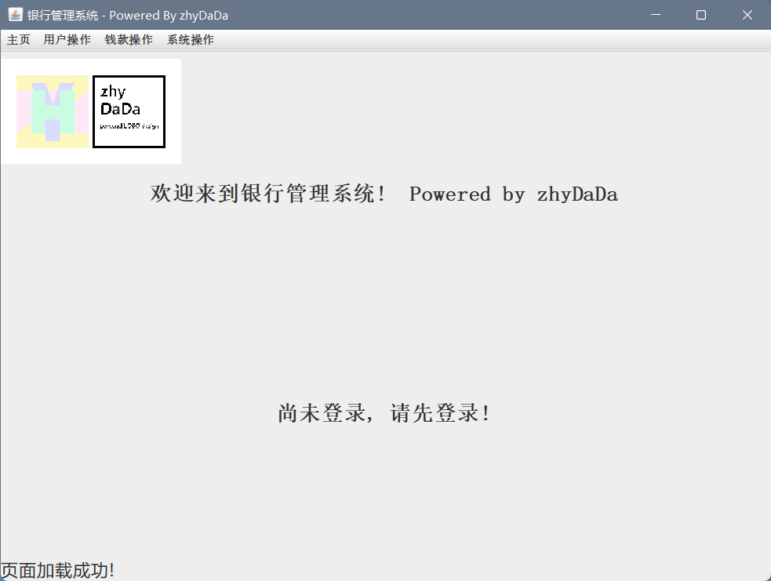
用户注册
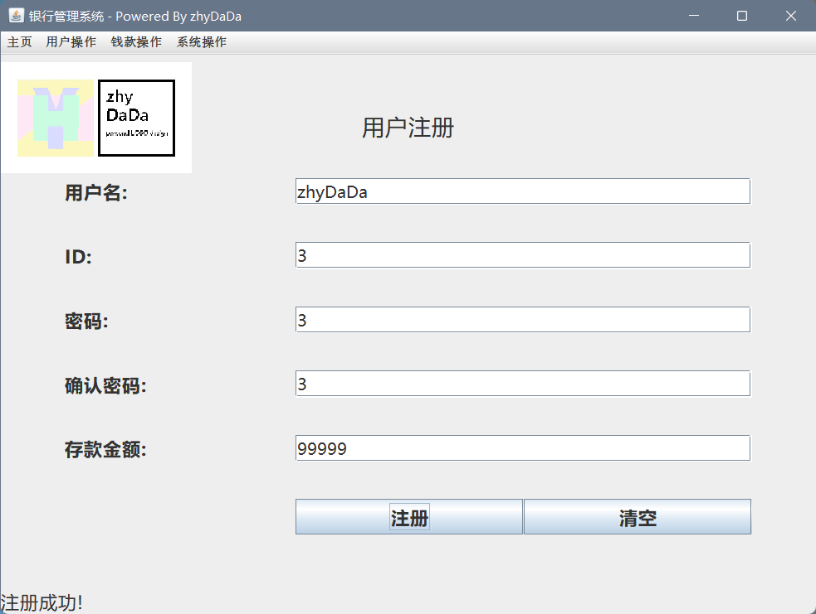
用户登录
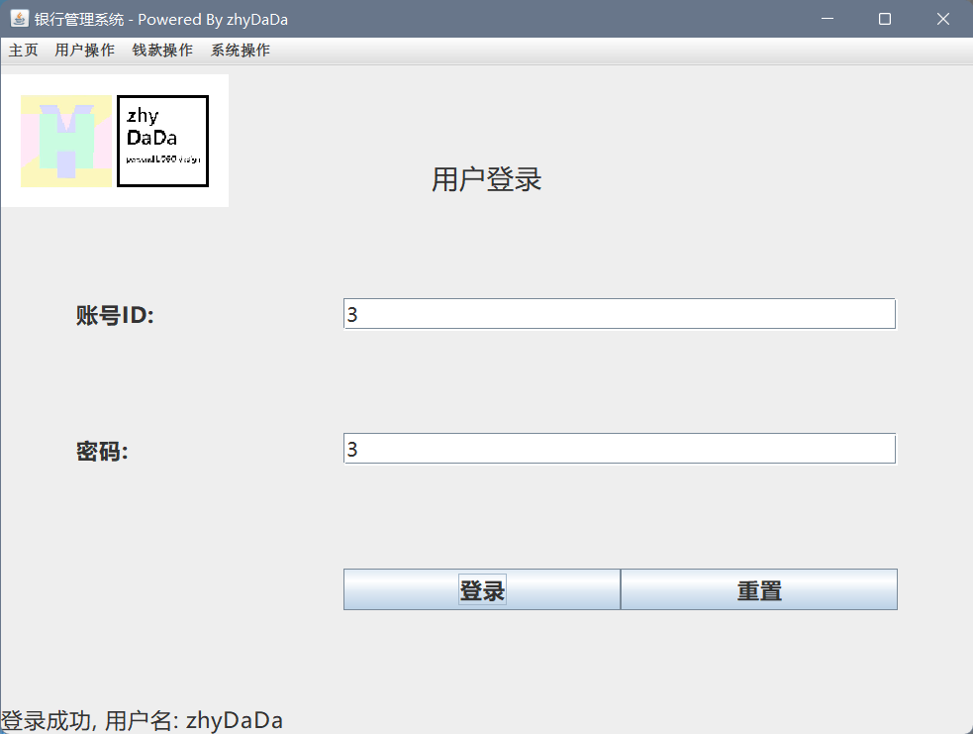
密码修改
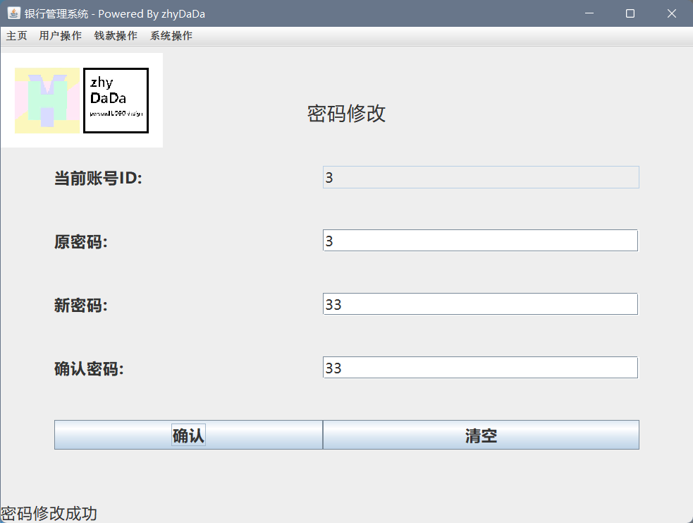
信息查询
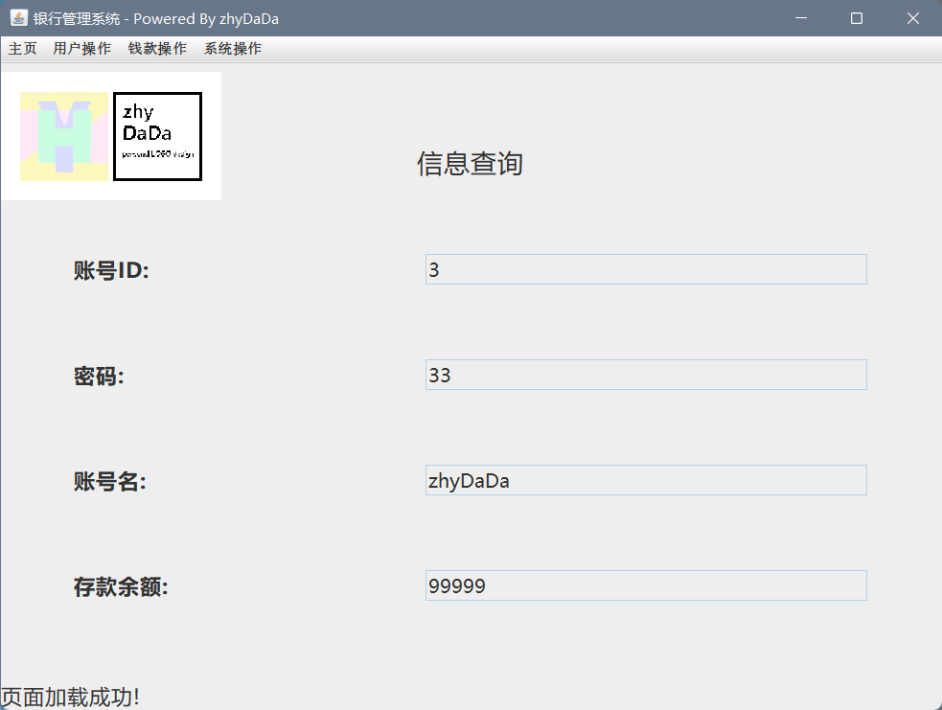
存款操作
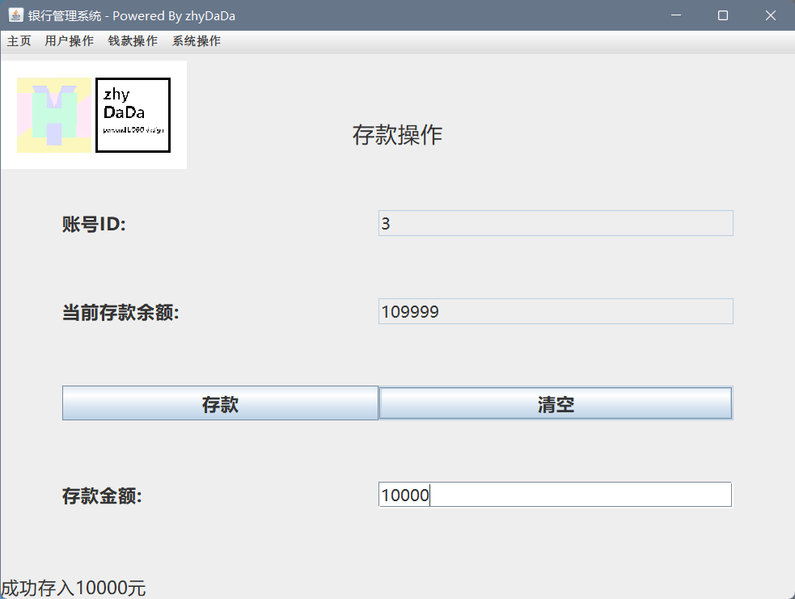
取款操作
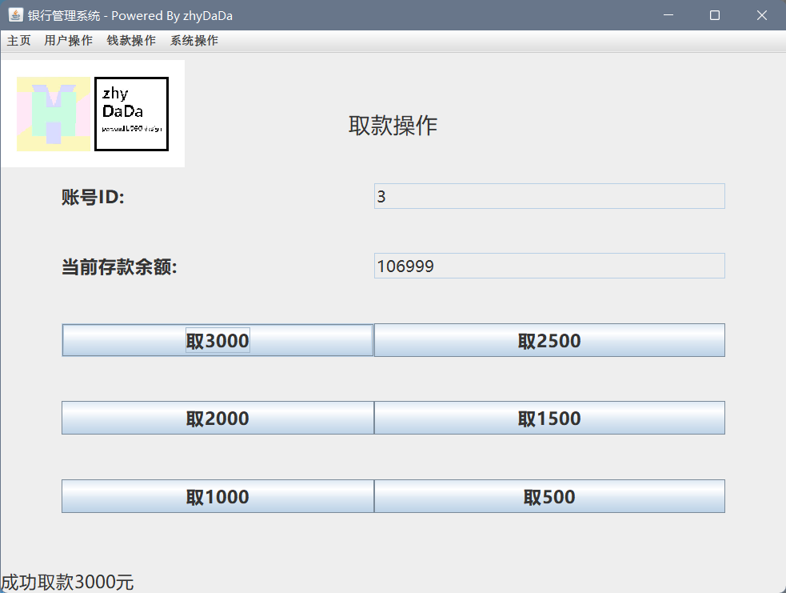
转账操作
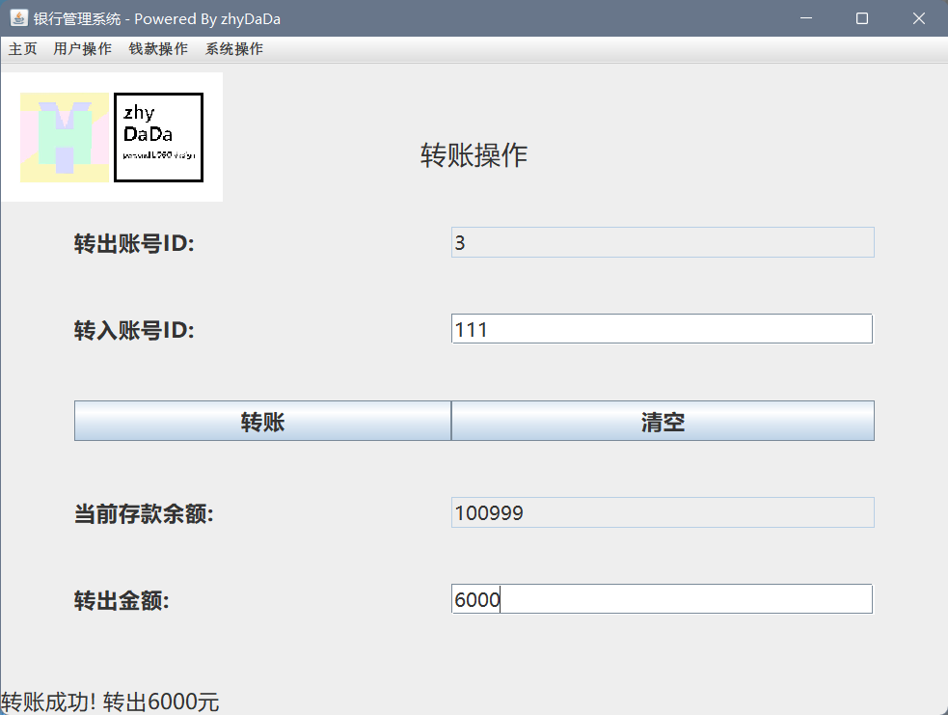
交易记录
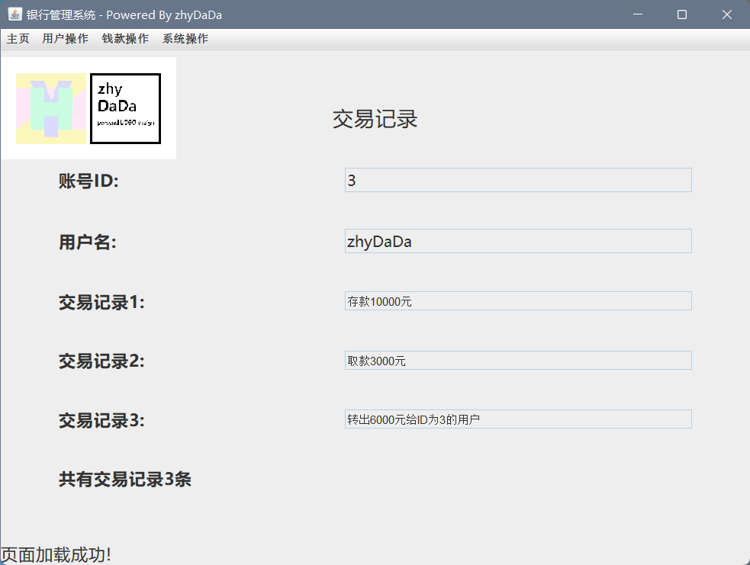
退出系统
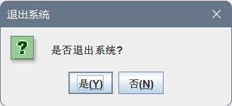

五、实验心得（100字左右）

通过这个实验，我深入理解了Java GUI编程的基本方法和技巧，提高了自己的实践能力。同时，这个实验也让我对Java有了更深的了解，为以后的学习和工作打下了基础。在实现过程中，我遇到了一些问题，如布局管理器的使用、事件处理等，通过查阅资料和尝试解决，我成功地解决了这些问题，这也让我感到非常有成就感。总的来说，这个实验让我受益匪浅，收获了满满的成就感。
六、教师评语
该学生完成了GUI界面设计及事件处理的实验，(很好/较好/基本)完成了实验任务，算法设计(很好/较好/基本)，实验结果(很好/较好/基本)，实验体会(很好/较好/基本)。
因此总体评价为 。

教师签字：

2024年 6 月 2日

