华东理工大学2019～2020学年第一学期
18级《Physical Chemistry》(I)期中测试试题 2019.10.31
开课学院：化学与分子工程学院 专业：18级大面积考试形式：开卷 所需时间：120 分钟
考生姓名： 学号： 班级： 任课教师：
题序 | 一 | 二 | 三 | 四 | 五 | 六 | 七 | 总 分
得分
评卷人

- Choices (10 points, each blank 1 point).
( )1. In which of the following groups, the properties are all intensive properties?
A. U, S, H B. p,, T C. U, S, V_{m}
( )2. At a specific p and T, the volume of a gas calculated by the ideal gas law is 10 dm³, whereas the real volume is 8 dm³, then, the compressibility factor is
A. 1 B. 0.8 C. 1.25
( )3. The Boyle temperature of N₂ is T_{B} = 322 K, When T >T_{B,} (∂Z/∂p)_{T} 0.
- > B. = C. <
( )4. The generalized equation of state can be expressed as pV_{m} = A+Bp+Cp²+……, where A, B, and C are parameters depending on the temperature. Then the value of (A/RT) 1.
- < B. = C. >
( )5. The concentrated H₂SO₄ and H₂O are stored separately by a diaphragm in an adiabatic container. Take the H₂SO₄ and H₂O as the system, when the diaphragm is damaged, which of the following statements are correct .
A. W>0, Q < 0, 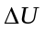=0 B. W< 0, Q >0, =0 C. W=0, Q =0, =0
( )6. At 298.15 K, the standard molar enthalpy of reaction 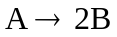 is 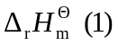, and that of reaction 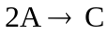is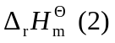, then the standard molar enthalpy of reaction 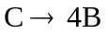 is
A. 2+
B. -
C. 2-
( )7. Suppose there is a reversible engine working between two temperature resources, in which T_{L} = 0.6T_{H}. Then the efficiency 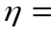 ?
A. 0.4 B. 0.5 C. 0.6
( )8. A chemical reaction is taken place in an isochoric and adiabatic container, which results in the increase of both temperature and pressure. Which of the following statements is correct?
A. 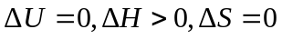
B. 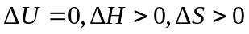
C. 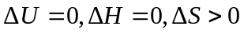
( )9. For a pure substance without non-volumetric work (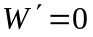), 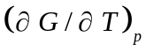 0.
- > B. = C. <
( )10. For 1 mol ideal gas, 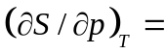 。
A. 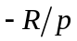 B. 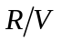 C. R

- Fill in the blanks according to the statement (20 points, each blank 2 point)
- For 1 mol ideal gas, the difference between 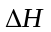 and 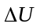 is when T₁ changes into T₂.
- At 298.15 K, 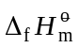 of H₂O(l) and H₂O(g) are -285.830 and -241.818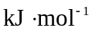, respectively, then the standard molar enthalpy of vaporization 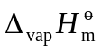 of H₂O is .
- When the combustion of 1 mol C₆H₆ (l) takes place in a closed container, in which the chemical reaction equation is 0 = 6CO₂(g) + 3H₂O(l) – C₆H₆(l) – 7.5O₂(g), at 298.15 K, the heat release is determined as 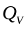= –3.268 × 10⁶ J, and then Q_{p}= J
- For a homogeneous pure substance system 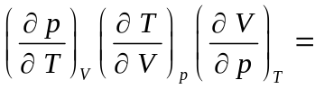
- For 1 mol monoatomic ideal gas, when the temperature increases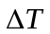, 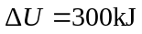. For the same temperature change, if the gas is a diatomic ideal gas, then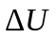=___________________.
- For 1 mol diatomic ideal gas at 0.1 MPa and 300 K, after an adiabatic compression, the temperature increases to 320 K. Then the work W = J.
- For 1 mol real gas at 0.4 MPa and 350 K, after a throttling expansion, the pressure decreases to 0.2 MPa. Given that the Joule-Thomson coefficient 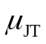=125K·MPa⁻¹, then the temperature of gas after the throttling, T= K.
- When gas A is at specified T₁, p₁, and B at T₂, p₂, they possess the same reduced temperature T_{r} and reduced pressure p_{r}. Given that V_{c,A}/V_{c,B}=1.25, then the molar volume ratio of B to A V_{m,B}/V_{m,A}= .
- When 1 mol Ar and 1 mol He with the same volume of V are mixed together isothermally to form a 2V mixture, 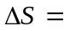 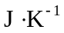. (The gases can be considered as the idea gas).
- When 1 mol ideal gas with the initial state of 300 K and 1000 kPa isothermally expends to the final stat with 100 kPa, then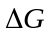= J.

III (12 points) 1 mol monatomic ideal gas undergoes a throttling expansion at 300K, the pressure decreases from 0.8 MPa to 0.1MPa, calculate 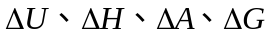and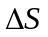.

IV (15 points) 1 mol monatomic ideal gas at T₁=300 K and p₁=0.1 MPa undergoes a reversible adiabatic compression to T₂=400 K. Calculate the pressure of the final state p₂, and Q, W, 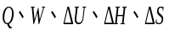of the process.

V (15 points) At 25℃, Given that
Substance | 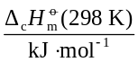 | 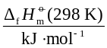
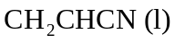 | −1759.5
C (graphite) | −393.5
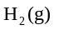 | −285.8
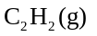 | −1299.6
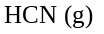 |  | 135.1
The standard molar enthalpy of vaporization of 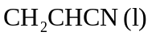 is 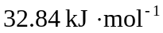.
(1) Calculate the standard molar enthalpy of formation 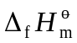 of 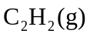, and 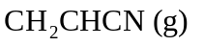, respectively. (8 points)
(2) Calculate the standard molar enthalpy of reaction 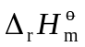 of 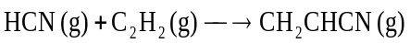 (7 points)

VI (14 points) 1 mol H₂O (l) at 373 K and 101325 Pa is vaporized into H₂O (g) with the same temperature and pressure under the following different processes. Given that of H₂O is 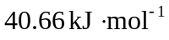. Calculate 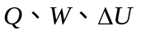、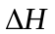for the processes of
(1). Vaporized under the external temperature and pressure of 373 K and 101325 Pa. (8 points)
(2). Vaporized at a vacuumed container with the temperature of 373 K. the volume of vapour is controlled to its corresponding final state. (6 points)
Notice: the volume of H₂O (l) can be neglected, and H₂O (g) can be regarded as an ideal gas.

VII (14 points） The equation of state of gas A is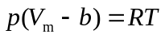, where 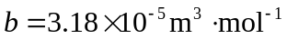. (1) Prove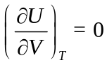 (4 points)
(2) What is the expression of 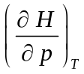（4 points）
(3). When 1mol gas A expands from 10 MPa to 0.1M Pa isothermally at 300K, calculate △U and △H.（6 points）
Notice: for the isothermal process, 