Physical Chemistry (I) Examination Paper
3. Thermodynamics of Multi-Component Systems, Fugacity and Activity

I Choice (1 point for each, totally 30 points)
- The statement that all state functions have their corresponding partial molar quantities is .
A：correct； B：wrong； C：undetermined
- According to the definition of the partial molar property, is correct?
A：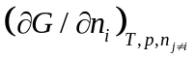； B： 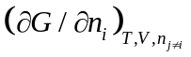； C： 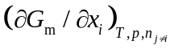
3. Of the following expressions, is a partial molar quantity.
A：； B：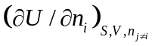； C：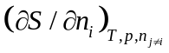
4. Of the following expressions, is not the chemical potential.
A：； B：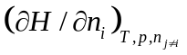； C：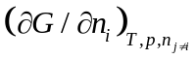
5. Of the following relations among various partial molar quantities of the same component,
is not correct.
A：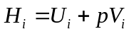； B：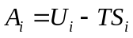、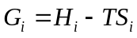；C：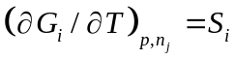
6. Of the following relations of the chemical potential and the temperature, is not correct.
A： 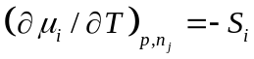；B： 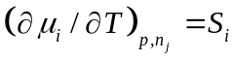；C： 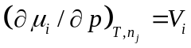
7. Of the following expressions, expresses correctly for both chemical potential and partial molar quantity.
A：； B：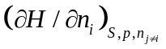； C：
8. For a binary mixture, when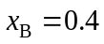, the partial molar volume of 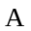 and are 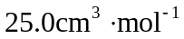 and 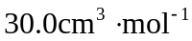, then the total volume of the mixture is 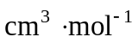.
A：27.0； B： 28.0； C： 29.0
9. For a binary mixture, when, the total volume of the mixture is 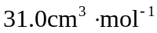and the partial molar volume of is , then the partial molar volume of B is
.
A：31.0； B： 40.0； C： 50.0
10. At specific temperature and pressure, when adding B into 5 mol A，the change of the total volume of the mixture V (cm³) with the adding amount of B n_{B} (mol) can be expressed as 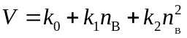, in which parameters k are constants. Then, the partial molar volumes of A and B are .
A：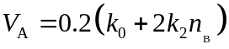、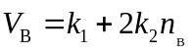；
B：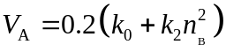、；
C： 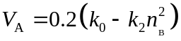、
11. If the extensive property X changes little with T and p, or when the T and p are fixed, of the following expressions, is not the correct one for Gibbs- Duhem equation.
A：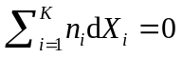； B：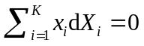； C：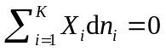
12. At a specific temperature, when the reaction of 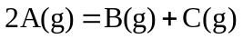is at equilibrium, of the following expressions, is correct.
A：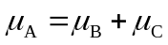； B： 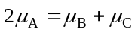； C： 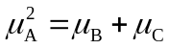
13. For a binary system , the criterion of the phase equilibrium of vapour and liquid is .
A：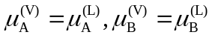； B：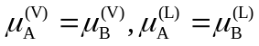； C：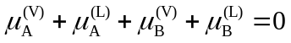
14. At 1000K, when H₂ and O₂ with the volume ratio of 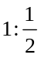 are added into a container, the reaction of 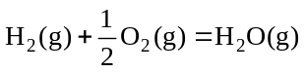 takes place. When it is at chemical equilibrium, the degree of the freedom of the system 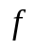= 。
A：0； B： 1； C： 2
15. At a specific temperature, CaCO₃(s), CaO(s) and CO₂(g) are mixed together with random compositions in a closed container. When the reaction is at the chemical equilibrium, the number of the component, K, the phase, π, and the degree of freedom f of the system are .
A：3，3，0； B：3，3，1； C：3，2，0
16. For a ternary system, when vapour –liquid –liquid three phases are at equilibrium, the degree of freedom f = .
A：0； B：1； C：2
17. 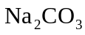and 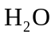can form three types of hydrates of 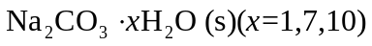. At 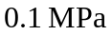, when aqueous solution equilibriums with the ice, type(s) of hydrate can coexist.
A：0； B：1； C：2
18. The statement of four phases of sulfur, including orthogonal, monoclinic, liquid, and vapour sulfurs can coexist is .
A：true； B：wrong； C：undetermined

19. At specific temperature and pressure, A and B can form an ideal mixture. When they mixed together with the same amount, at V-L equilibrium, 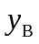=0.65 and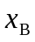 =0.40. Now, when 0.45mol A and 0.55mol B mixed together, when they are at equilibrium under the same temperature and pressure, 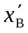 0.40.
A：>； B：=； C：<

20. At 400K, when the pressure of an ideal gas are 0.2MPa and 0.1MPa, their chemical potential are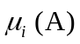 and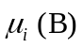, respectively, then 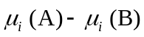= 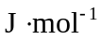.
A：2305.27； B：2405.27； C：2505.27

21. When the fugacity is used to calculate the chemical potential of solid substance, the reference state is
A：pure solid with the pressure of 0.1MPa at the system temperature;
B：pure gas with the pressure of 0.1MPa at the system temperature;
C：pure ideal gas with the pressure of 0.1MPa at the system temperature.

22. Of the following statements about the fugacity, is not correct.
A：The fugacity has the same unit with the pressure;
B：The fugacity is a corrected pressure relative to the ideal gas in the expression of the chemical potential;
C：With introducing the fugacity, the state function can be expressed as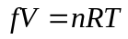

23. Of the following statements about the fugacity factor, is not correct.
A：The fugacity factor always equals 1 for the ideal gas；
B：The fugacity factor of real gases will be 1when the pressure approaches 0;
C：The fugacity factor of real gases can not be 1.

24. For a binary system of A and B, when two phases of 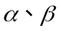are at equilibrium, of the following relations is correct.
A： 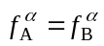； B：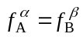； C： 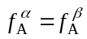

25. The solubility of CH₄(g) in H₂O(l) and C₆H₆(l) can be both described by the Henry’s law, and the Henry’s constant of CH₄(g) in H₂O(l) is much larger than that in C₆H₆(l). When the partial pressures of CH₄ in vapour of H₂O(l) solution and in C₆H₆(l) solution are the same，then the solubility of CH₄(g) in H₂O(l) is that in C₆H₆(l).
A：>; B：=； C：<

26. At 300K, the chemical potential 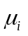of substance i in an ideal mixture is 100when x_{i} =0.5. Then, = when x_{i} =0.8.
A:1272.35; B:1372.35; C:1472.35

27．At a specific temperature, the saturated vapour pressure and the chemical potential of pure substance is 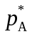 and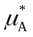. When adding some unvolatil solute to form a solution, the vapour pressure of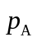and the chemical potential of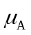will be .
A: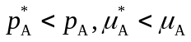; B: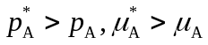; C：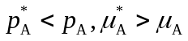

28. When the Selection I is adopted as the reference state, of the following statements about the activity factor, is not correct.
A: For the ideal mixture, the activity factor always equals 1；
B: For real mixtures, when 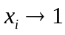，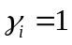;
C: For the ideal dilute solution, 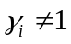

29. When the Selection II is adopted as the reference state, of the following statements about the activity factor of the solute, is not correct.
A: For the ideal dilute solution, 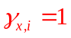；
B: For real mixtures, when 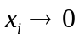, ;
C: For real mixtures, when , .

30. The chemical potential of i component in an ideal mixture is 。
A: 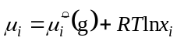； B: 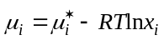； C: 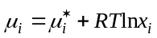

II (10 points, 5 for each)
- At a specific temperature, the partial pressure of B, p_{B}, of a binary mixture changes with its molar fraction in the solution, x_{B}, can be expressed as when the system is at V-L equilibrium. Calculate the saturated vapour pressure and the Henry’s constant of B; and deduce the analytical equations of 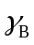 and 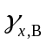. The vapour can be regarded as an ideal gas mixture.
- At 25℃, for a binary mixture, it is determined that 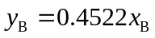and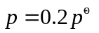. Calculate and . Given that 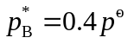and 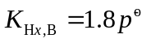, and suppose the vapour phases is an ideal gas mixture.

III (10 points)
At 100℃, the mixture of CCl₄ and SnCl₄ can be regarded as an ideal mixture. Given that the saturated vapour pressure are 193.317kPa and 66.661kPa for CCl₄ and SnCl₄, respectively.
- At 100℃, when the pressure of the liquid mixture decreases to 101325 Pa，the first bubble appears, what are the compositions of the liquid phase?
- For the same conditions as above, what are the compositions of the first bubble?
- When this mixture is completely vaporized, what are the compositions of the last liquid drop? And what is the system pressure?

IV (10 points)
At 57.20℃, the saturated vapour pressure of acetone (1) and methanol (2) are 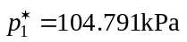 and 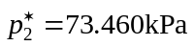.
- If the mixture can be regarded as an ideal mixture at 57.20 ℃, when 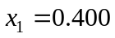, What are the compositions of the vapour phase and the total pressure of the system；
- At 57.20 ℃, the compositions of the vapour and liquid phases are determined as 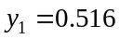and , and the total pressure is 101.325kPa. When the Selection I is adopted as the reference state, calculate the activities and activity factors of the two components.

V (10 points)
At 25℃，the saturated vapour pressure of substances A and B are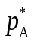=100 kPa and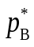=200 kPa.
1. If the mixture can be regarded as an ideal mixture, when x_{A}=0.355, what is y_{A} in the vapour phase and the pressure of the system；
2. If the substances A and B have the same molar fractions in the vapour phase, what is the corresponding x_{A} in the liquid phase, and the total pressure p?
3. When x_{A}=0.900, the total pressure is determined as 123 kPa, in which the partial pressure of B is 24 kPa. When the Selection I is adopted as the reference state, calculate the activity factors of the two components.

VI (10 points)
At 25℃, when adding the solute B into the solvent A, they can form an ideal dilute solution. When 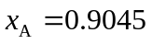, the total pressure of the system p=82.93kPa. Given that the saturated pressure of the solvent A.
- At 25℃, what is the Henry’s constant 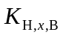of solute B?
- When 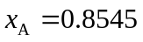, Calculate the corresponding 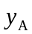and total pressure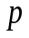.

VII (10 points)
For a binary mixture, when vapour and liquid phases are at equilibrium at 300K, 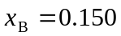. Suppose the vapour mixture can be regarded as the ideal gas. Given that the saturated vapour pressure of A and B are 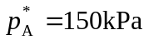 and 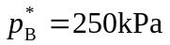.
- Suppose the mixture is an ideal mixture, calculate the corresponding and total pressure;
- When the total pressure is determined as 195kPa, and 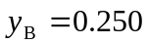, when the Selection I is adopted as the reference state, calculate the activity factors of the two components.
- Judge the real mixture is a positive deviation or a negative deviation？

VIII (10 points)
Given that the saturated vapour pressure of benzene at 20℃ is 10010Pa. When gaseous HCl dissolves into benzene, they can form an ideal dilute solution.
- When vapour and liquid phases are at equilibrium, the molar fraction of HCl in solution x_{HCl} = 0.0385, the molar fraction of C₆H₆ in vapour y_{C6H6} =0.095, calculate the total pressure of the vapour.
- When two phases are at equilibrium, if x_{HCl} = 0.0278, calculate partial pressure of HCl p_{HCl} in vapour.

