Physical Chemistry (I) Examination Paper
5. Chemical Equilibrium

I Choice (1 point for each, totally 30 points)
- For the standard equilibrium constant, 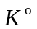, the statement of is wrong.
A：is a physical quantity with the dimension of 1；
B：depends on the nature of the reaction and the temperature；
C：depends on the total pressure of the system.
- For an ideal gaseous reaction 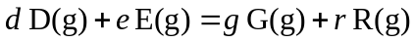, when the pressure of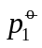and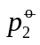are taken as the standard reference pressure, the corresponding 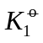/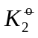is .
A. 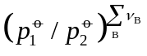； B. 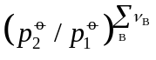； C. 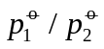
- In the equation of 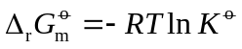, 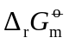 .
A. is the molar Gibbs function of reaction when the reaction is at equilibrium；
B. is the molar Gibbs function of reaction when all the substances participated in the reaction are at their standard state；
C. is the molar Gibbs function of reaction when the gaseous substances participated in the reaction are at their standard state.
- At a specific temperature, when =1, 0.
A. >； B. <； C. =
- At a specific temperature, the reaction A has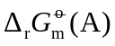and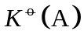 and the reaction B has 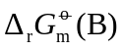and. Given that =2, then the relation between and 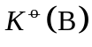 is .
A. =； B. =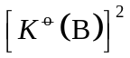； C. /
- For gaseous reactions of 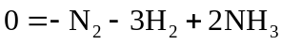 and 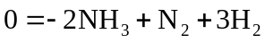, the values of the standard equilibrium constant are a and b，then .
A. b= - a； B. b=a； C. b=1/a
- The standard equilibrium constants of 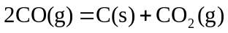,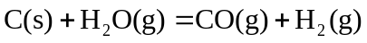 and 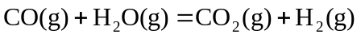, are ， and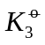, then .
A. =×； B. =+； C. =-
- For gaseous reactions, the relation between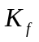and is .
A. 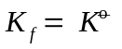； B. 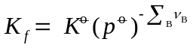； C. 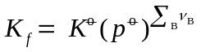
- At a specific temperature, when the pressure of a real gaseous reaction approached to zero, 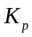=0.025 (kPa)². When the pressure increases, the statement of is correct.
A. ==0.025 (kPa)²；
B. =0.025(kPa)²，will change；
C. will change，will not change
- The relation between andin a gaseous reaction CO₂+H₂=CO+H₂O is .
A. =； B. >； C. <
- The relation between andin a gaseous reaction 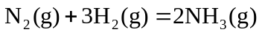 is .
A. =； B. =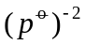； C. =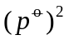
- The relation between andin a gaseous reaction 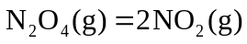 is .
A. =； B. =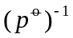； C. =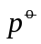
- Among the following reactions, shows the relation of =.
A. ；B. CO₂(g)+H₂(g)=CO(g)+H₂O(g)；C.
- At 25℃, for an ideal gaseous reaction 2CO₂(g)＝2CO(g)+O₂(g), its standard molar Gibbs function of reaction 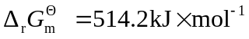, then 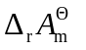__________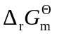。
A：=； B：>； C：<
- At a specific temperature, for an ideal gaseous reaction A(g)+ B(g)＝3C(g), 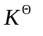= 2.55, then K_{p}= .
A：2.55 kPa； B：2.55×10⁻² kPa； C：2.55×10² kPa
- At a certain temperature, when the reaction 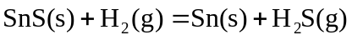 is at equilibrium, the gaseous substance can be regarded as an ideal gas, and their partial pressure are 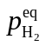 and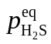. Of the following statements, is not correct.
A. 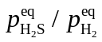 is a constant；
B. K_{p}=, and the value is the same as that of ；
C. the value ofdepends on the total pressure of the system.
- For the reaction 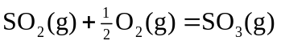, =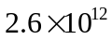at 25℃, the standard reaction enthalpy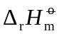=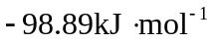and is independent with the temperature. Then at 35℃, = .
A：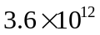； B：; C：7.13×10¹¹
- After adding NH₄Cl into a vacuumed container, the reaction 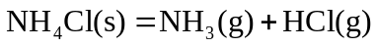 takes place with heating. At a certain temperature, the reaction is at equilibrium, the total pressure is 100kPa, then K_{p} is .
A: 10000(kPa)²； B: 2500(kPa)²； C: 50(kPa)²
- At a certain temperature and pressure, when adding some inert gas into an ideal gaseous reaction A(g)+B(g)=C(g) which is at equilibrium, the reaction will .
A：shift to the right; B：shift to the left; C：not change
- The reaction of can be regarded as an ideal gaseous reaction. When adding some water vapour into the reactants, the yield of styrene will .
A. increase; B. decrease； C. not change
- At a certain temperature and pressure, when adding some product into a reaction which is at equilibrium, 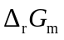 0.
A：>； B：=； C：<
- At 1000K, for an ideal gaseous reaction , =1.43. When the partial pressure of substance are 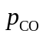=0.500MPa，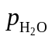=0.200MPa, 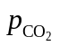=0.200MPa, to make the reaction taken place reversely, the partial pressure of H₂ should be MPa at least.
A：0.215； B：0.315； C：0.715
- At 473K, when the decomposition of 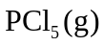 is at equilibrium, the decomposition degree is 48.5%, and at 573K, it is 97%. Then 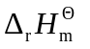 .
A. > 0； B. < 0； C. = 0
- For a decomposition reaction 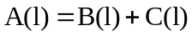, . If A is kept undecomposed, then the temperature should be no more than K.
A. 300； B. 400； C. 500
- At 298K, for an ideal gaseous reaction N₂O₄(g)=2NO₂(g), =0.1132. When the partial pressure of N₂O₄(g) and NO₂(g) are both 101.325kPa, the reaction will .
A：shift to the formation of NO₂; B：be at equilibrium; C：shift to the formation of N₂O₄
- The exothermic reaction 2NO(g) + O₂(g) = 2NO₂(g) is at equilibrium at a certain temperature. To obtain more NO₂, the appropriate ways are .
A：to decrease the temperature and the pressure;
B：to decrease the temperature and to increase the pressure;
C：to increase the temperature and to decrease the pressure
- At a certain temperature, after adding (NH₄)₂CO₃ into a vacuumed container, the decomposition reaction (NH₄)₂CO₃(s) = 2NH₃(g)+ CO₂(g) + H₂O(g) occurs with . Suppose all the gaseous substances are the ideal gas, and the decomposition pressure is p. If p>, then .
A：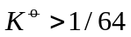； B：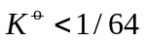； C：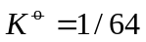
- At a specific temperature, for the ideal gaseous reaction A(g)+ 2B(g)＝2C(g), /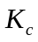= .
A：1； B：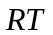； C：1/(RT)
- For the reaction 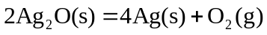, 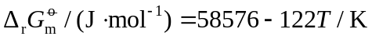. At a certain temperature, the reaction is at equilibrium with the pressure of pure O₂ of 100kPa. Then T and are .
A：298.15K、1； B：480.13K、1.2； C：480.13K、1
- For the reaction NH₄COONH₂(s)=2NH₃(g)+CO₂(g), K_{p}=66.37 Pa³ at 303.15K. Then the decomposition pressure of solid NH₄COONH₂ is .
A：4.65Pa； B：7.65Pa； C：9.65 Pa

II (10 points)
In the temperature range of 400K~500 K，for an ideal gaseous reaction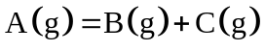, it is determined that .
- Deduce the relations of 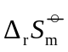, 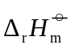 and 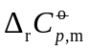with the temperature, respectively；
- Calculate 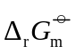, 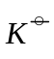 and 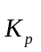at 450 K；
- At 450 K, substance A is added into a vacuumed container. When the reaction is at equilibrium, the total pressure is 101325Pa, calculate the conversion of substance A.

III (10 points)
At 25℃, the thermal properties of the substances are
Substance | SO₂ | O₂ | SO₃
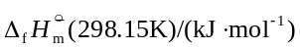 | −296.830 | 0 | −395.72
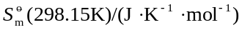 | 248.22 | 205.138 | 256.76
- Calculate 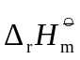, 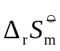, 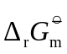 and 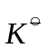of the reaction 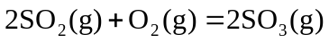 at 25℃.
- Suppose all the gases can be considered as the ideal gas, calculate 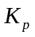andat 25℃.
- When the reaction temperature increases, the value of will increase or decrease? And Why?

IV (10 points)
At 298 K，the thermal properties of the substances are
Substance | H₂O (g) | CO (g) | CO₂ (g) | H₂ (g)
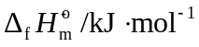 | -241.82 | -110.52 | -398.51 | 0
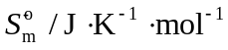 | 188.83 | 197.67 | 213.7 | 130.68
- For the reaction at 298K, calculate , , , and K_{p}.
- If = 0，calculate the reaction temperature when=1.

V (10 points)
The decomposition reaction of Ag₂CO₃(s) is Ag₂CO₃(s) → Ag₂O(s) + CO₂(g)，All the gases can be regarded as the ideal gas. At 298.15K, the thermal properties of the substances are
 |  |  | 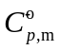 /J⋅mol⁻¹⋅K⁻¹
Ag₂CO₃(s)  Ag₂O(s)  CO₂(g) | -506.14  -30.57  -393.15 | 167.36  121.71  213.64 | 106.23  66.86  39.37
Suppose the heat capacity of all the substance are independent with the temperature.
  - Calculate , 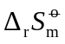, , and K_{p} of the reaction at 298.15 K
  - Put Ag₂CO₃(s) into a vacuumed container, the decomposition occurs with increasing the temperature, which is called as the decomposition temperature when the total pressure of the system is 101.3kPa. Calculate the decomposition temperature of Ag₂CO₃(s).

VI (10 points)
For the ideal gaseous reaction 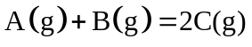, 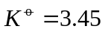, 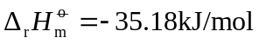 at 400K.
  - Calculate 、 and of the reaction at 400 K;
  - When the reaction is at equilibrium, 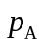=2kPa, 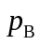=6kPa, then what is the value of 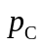?
  - Initially, there are only 1 mol A and 1 mol B in the reaction container, calculate the conversion of B.

VII (10 points)
The thermal properties of the substances are
substance | 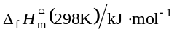 | 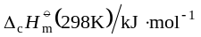 | 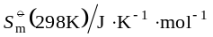 | 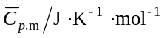
C(s) |  |  | 5.69 | 19.9
H₂(g) |  |  | 130.70 | 29.4
CH₄(g) |  | -890.31 | 186.38 | 54.0
H₂O(l) | -285.85
CO₂(g) | -393.51
Calculate 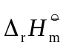、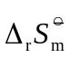 and 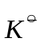of the reaction 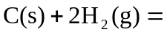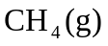 at 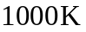.

VIII (10 points)
At 298.15K，for the reaction 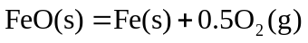,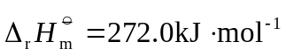, 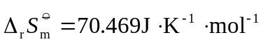, 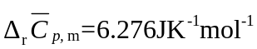. Calculate the equilibrium pressure of O₂(g) at

