Physical Chemistry (I) Examination Paper
4. Phase equilibrium

I Choice (1 point for each, totally 30 points)
- When the relation between the saturated vapour pressure of the pure substance and the temperature, the binary vapour-liquid phase diagram can be obtained for .
A：real solution； B：ideal mixture； C：ideal dilute solution
- For a binary ideal mixture, the description of in the isothermal vapour-liquid phase diagram is not correct?
A: the liquid line shows the change of vapour pressure with the liquid composition.
B: the straight liquid line is the characteristic of an ideal mixture.
C: the liquid line is also called as the bubble-point line.
- For a binary ideal mixture, the description of in the isothermal vapour-liquid phase diagram is not correct?
A: the vapour line shows the change of vapour pressure with the vapour composition.
B: the vapour line is a curved line.
C: the vapour line is also called as the dew-point line.
- For a binary ideal mixture, the description of in the isobaric vapour-liquid phase diagram is not correct?
A: the liquid line and vapour line are called as the bubble-point line and dew-point line, respectively.
B: the liquid line shows the change of the boiling point with the liquid composition.
C: the liquid line is a straight line.
- For a binary vapour-liquid phase diagram with the positive deviation, is correct.
A：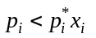；
B：under a strong positive deviation, the maximum azeotrope will occur；
C：under a strong positive deviation, the minimum azeotrope will occur.
- For a binary vapour-liquid phase diagram with the negative deviation, is correct.
A：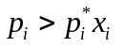；
B：under a strong negative deviation, the minimum azeotrope will occur；
C：under a strong negative deviation, the maximum azeotrope will occur.
- For a binary vapour-liquid phase diagram, is not the correct reason for its positive deviation.
A：There are strong molecular interaction among various components；
B：The molecular association degree decreases with adding another substance；
C：The molecular interaction among various components is weaker than that of pure substance.
- For a binary vapour-liquid phase diagram, is not the correct reason for its negative deviation.
A：There are strong molecular interaction among various components；
B：The molecules of various components associate together through the hydrogen bonding；
C：The attraction force among various components is weaker than that of pure substance.
- For the azeotrope, is not correct.
A：Azeotrope mixture is a compound with the fixed composition；
B：Azeotrope mixture is not a compound with the fixed composition；
C：At the azeotrope point, the bubble-point line and the dew-point line converge together.
- In a binary isobaric vapour-liquid phase diagram, the freedom at the azeotrope is .
A：0； B：1； C：2
- Benzene and ethanol can form the azeotrope at 341.2 K with the composition of x_{ethanol} =47.5%. For this binary solution with x_{ethanol} =77.5%, when it is at vapour-liquid equilibrium, the composition of ethanol in vapour phase is y₂, and that in liquid phase is x₂, is correct. Given that the boiling point of benzene and ethanol are 353.3 K and 351.6 K.
A：y₂>x₂； B：y₂=x₂ ； C：y₂<x₂
- For the same solution as above that x_{ethanol} =77.5%, after the fractional distillation, can be obtained.
A：pure benzene and azeotrope; B：pure ethanol and azeotrope; C：pure ethanol
- For an ideal mixture, at, the saturated vapour pressure of A and B are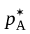 and 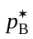, and 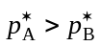, when the total pressure is, is correct.
A：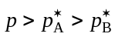； B：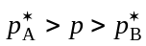； C. 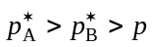
- The mixture of A and B is with the maximum azeotrope, after the fractional distillation, can be collected on the top of the tower.
A：pure substance with lower boiling point；
B：Pure A or pure B, depending on the initial composition of the solution；
C. azeotrope
- A and B can form a partially miscible solution with two conjugated liquid phases of α and β, At a specific temperature, the total pressure is p₁. If two liquids of α and β are separated, and their corresponding equilibrium pressure are p₂ and p₃. The relation among p₁，p₂ and p₃ is .
A： 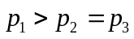； B：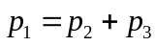； C. 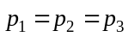
- For an ideal mixture, at, the saturated vapour pressure of A and B are and. At equilibrium, the relation between the compositions of the vapour phase y_{B} and liquid phase x_{B} is .
A：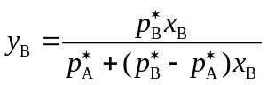； B：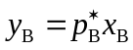； C：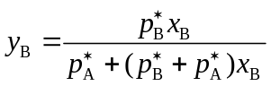
- At a fixed pressure, heating the liquid mixture of A and B with the initial composition of 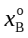 to 300 K, it approaches to the vapour-liquid phase equilibrium with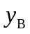=0.850 in vapour phase and 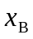 =0.350 in liquid phase. The initial composition is in the range of .
A：>0.850； B：0.850 ≥≥0.350； C：<0.350
- The way to make a mixture solution with upper consolution temperature to be a homogeneous single phase is .
A：to increase temperature； B：to decrease temperature； C：to increase pressure.
- The way to make a mixture solution with lower consolution temperature to be a homogeneous single phase is .
A：to increase temperature； B：to decrease temperature； C：to increase pressure.
- In a saturated NaCl aqueous solution, the chemical potential of solid NaCl is the chemical potential of dissolved NaCl in solution.
A：larger than； B：the same as； C：smaller than.
- In a binary liquid-solid phase diagram, A and B can form 3 types of stable compounds, and all the compounds are completely not miscible with each other. Then there are eutectics in the phase diagram
A：2； B：3 ； C：4
- In a binary liquid-solid phase diagram, A and B can form a stable compound, and all the compounds are completely not miscible with each other. Then there are eutectics in the phase diagram
A：2； B：3 ； C：4
- Bi and Cd are completely miscible in their liquid phase but not miscible in their solid phase at all. In the cooling curve of the mixture with 30%Cd, the horizontal segment occurs at T₁, and it changes into T₂ when the composition is 70%Cd, then T₁ T₂。
A：>； B：=； C：<
- In a partially miscible solution of water and isobutanol, at 101.325kPa there are single phases in their vapour-liquid-liquid phase diagram.
A：1； B：2； C：3
- At 273.15K, two cups of solution, in which the first has the composition of x_{A}=0.1 and the second of x_{A}=0.2 are put into the same closed container. After a long enough period, the contents of A and B in the first cup are
A：A increases, B decreases； B：A decreases, B increases； C：A increases, B does not change
- Increasing the pressure, the melting point of a pure compound will
A：decreases； B：increases； C：be determined by the characteristic of substance.
- The steam distillation is usually used for the system of the organic compound and water.
A：completely miscible; B：partially miscible; C：completely immiscible.
- Au (with the melting point of 1063 ℃) and Ag (with the melting point of 961 ℃) can form a completely miscible solid phase. When cooling the mixture solution with the mass fraction of Au of 50%, the mass fraction of Au in the first deposited solid 50%.
A：is larger than； B：equals to； C：is smaller than
- When adding liquid CS₂ into I₂ aqueous solution at a fixed temperature, after a long period for the equilibrium, the chemical potential of I₂ in water phase that in CS₂ phase.
A：is larger than； B：equals to； C：is smaller than
- Au (with the melting point of 1063 ℃) and Ag (with the melting point of 961 ℃) can form a completely miscible solid phase. When cooling the mixture solution with certain amount of Ag, the condensed solid is .
A：pure Au； B：pure Ag； C：a mixture

II (10 points, 5 for each)
- Nitrobenzene and water can be regarded as a completely immiscible liquid-liquid system. At 101.325 kPa, the boiling point of the mixture is 372.15 K. Given that at 372.15 K, the saturated vapour pressure of water is 97.730 kPa. When the steam distillation is applied for the purification of nitrobenzene. Calculate the weight percentage of nitrobenzene in the distillate.
- After the synthesis, the steam distillation is applied for the purification of the products. The boiling point of the mixture is 368.15 K when the pressure is 99.190 kPa. After the distillation, the mass fraction of water in the distillate is 0.45. What is the molecular mass of the product? Given that at 368.15 K, the saturated vapour pressure of water is 84.526 kPa.

III (10 points) The following is a binary vapour-liquid phase diagram under the isobaric condition.
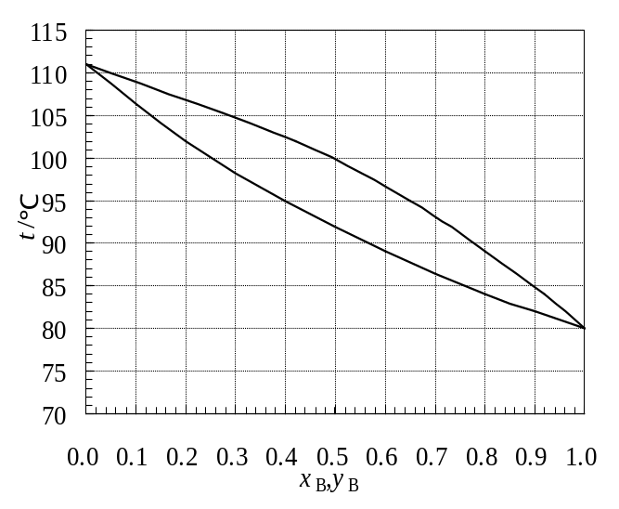
- When the solution with x_{B} = 0.30 is distilled by heating to 100℃, the compositions of vapour and liquid phases at equilibrium are
A：y_{B} = 0.49，x_{B} = 0.25； B：y_{B} = 0.60，x_{B} = 0.20； C：y_{B} = 0.49，x_{B} = 0.15
- When the liquid obtained after the process (1) is heated again at 105℃, the composition of the liquid phase at equilibrium is x_{B} ; meanwhile, when the vapour obtained after the process (1) is condensed to 95℃, the composition of the vapour phase at equilibrium is y_{B}, then .
A：x_{B} = 0.25，y_{B} = 0.65； B：x_{B} = 0.14，y_{B} = 0.65； C：x_{B} = 0.10，y_{B} = 0.49
- When the solution with x_{B} =0.40is heated to 95℃, the composition of the first bubble y_{B} is .
A：0.65； B：0.55； C：0.75
- When the vapour mixture with y_{B} =0.60 is cooled to 97 ℃, the composition of the first dew x_{B} is .
A：0.55； B：0.45； C：0.35
- 1mol liquid mixture with x_{B}=0.50 is heated to 95 ℃, at equilibrium, n^{V}/n^{L}= .
A：1/1； B：1/2； C：2/3
- The bubble point and the dew point of the mixture with x_{B}=0.90 are .
A：t_{Bubble}=82℃，t_{dew}=85℃； B：t_{Bubble}=85℃，t_{dew}=82℃； C：t_{Bubble}=80℃，t_{dew}=110℃
- The boiling point of pure A and pure B are .
A：t_{A}=111℃，t_{B}=80℃； B：t_{A}=80℃，t_{B}=111℃； C：undetermined
- When the distillation is used to separate A from B, the substance obtained at the top of the tower is 。
A：pure A； B：pure B； C：undetermined
- When the pressure of the system is increased, then .
A：both the vapour line and the liquid line move up；
B：both the vapour line and the liquid line move down；
C：the vapour line moves up and the liquid line moves down.
- In the region enclosed by the vapour line and the liquid line, the freedom degree is .
A：0； B：1； C：2

IV (10 points) The following is a sketch of a binary liquid-solid phase diagram.

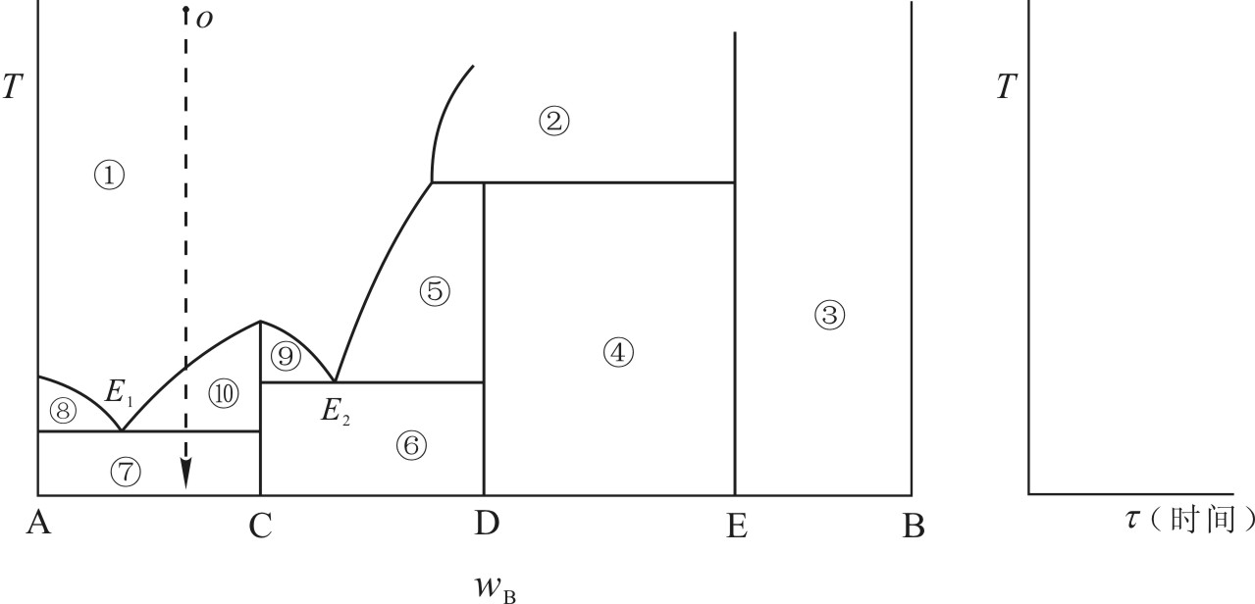
- Point out the phases occurring in various phase regions.
① ；② ； ③ ； ④ ； ⑤ ；
⑥ ；⑦ ； ⑧ ； ⑨ ； ⑩
- For the compounds of C and D, which is a stable compound？
- What are the degree of the freedom in the phase regions of ①、⑦、⑧?
- Passing through the point E₁, what are the equilibrium phases at the ends of the horizontal line?
- The composition of compound C is 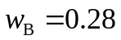, that of the eutectic 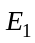 is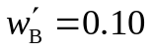. When cooling down 1kg mixture with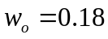 to separate out compound C, what is the maximum amount of pure compound C can be obtained？
- Draw the cooling curve of the mixture with an initial composition of O on the temperature-time coordinate system
V (10 points) The following is a sketch of the liquid-solid phase diagram of a binary of M and N. At 120℃, the unstable compound MN₃(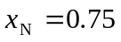) decomposes into pure solid N and liquid solution with 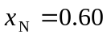.

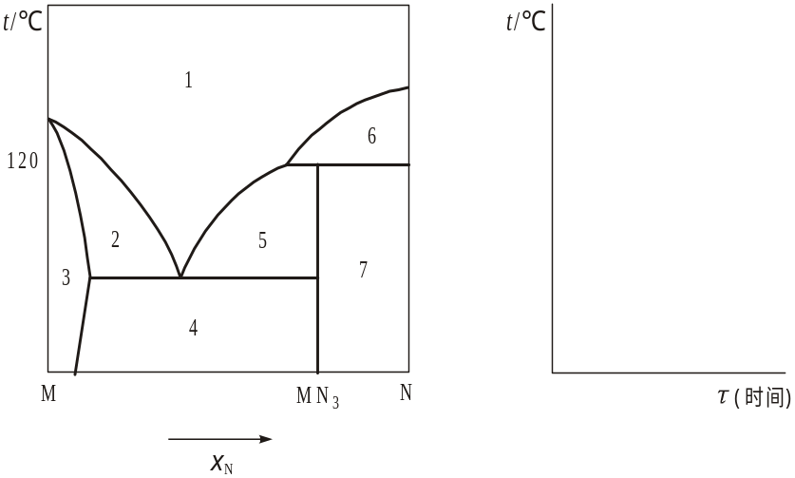
- Point out the phases occurring in various phase regions.
1 ；2 ；3 ；4 ；5 ；6 ；7 .
- If we want to obtain pure compound MN₃ by the crystallization, which region is suitable?
- Cooling 1 mol liquid mixture with 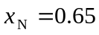, what substance is separated out first? What is the maximum amount?
- Draw the cooling curve of the mixture with an initial composition of on the above coordinate system.

VI (10 points)
The melting point of A and B are 80℃ and 160℃, respectively. They can form a stable compound C with the composition of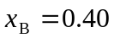, and the melting point of 120℃. In their liquid-solid equilibrium phase diagram, there are two eutectic points E₁ and E₂ located at 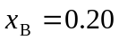, t = 40℃ and 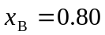, t = 80℃, respectively. The solid phases, S_{A}, S_{C} and S_{B} are completely immiscible.
          - Draw the sketch of the liquid-solid phase diagram of this system. Point out the phases occurring in various phase regions.
          - When 1mol liquid mixture with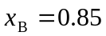is cooled down, what is separated put first, and what is the maximum amount?
          - When 1mol liquid mixture with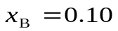is cooled down to the solid phase region, how many types of the substance existed? What is the molar ratio of those substance?
          - When 1mol liquid mixture with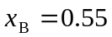is cooled down just to 80℃, how many phases coexisted? What are they, and what is their molar ratio?

VII (10 points)
A and B are partially miscible with two conjugated liquid phases of L1 and L2. As listed in the following table, the mass fractions of B in two liquid phase changed with the temperature：
t/°C | 0 | 10 | 20 | 30 | 40
w₁(B) | 0.30 | 0.37 | 0.45 | 0.53 | 0.64
w ₂(B) | 0.94 | 0.90 | 0.87 | 0.84 | 0.80
- Draw the sketch of the liquid-liquid phase diagram of this system；
- Determine the highest temperature of the consolution point;
- At 10 °C, B was added slowly into 100 g A. How many B was added when a cloud-like turbid phenomenon appears?
- At 10 °C, when 100 g B was added into 100 g A, what are the compositions and amounts of the two conjugated liquid phases?
- At 10 °C, how many B should be added in to 100 g A when a cloud-like turbid changes clear again?
- When the mixture of 100 g A and 150 g B was heated to 30 °C, what are the compositions and amounts of the two conjugated liquid phases?
- When the above mixture of was further heated, at what temperature the system can be changed into clear？

VIII (10 points)
The melting point of Mg and Zn are 924 K and 692 K, respectively. They can form a stable compound with the composition of x_{Mg}= 0.157 and the melting point of 863 K. In their liquid-solid equilibrium phase diagram, there are two eutectic points E₁ and E₂ located at x_{Mg}= 0.032, t = 641 K and x_{Mg}= 0.49, t = 620 K, respectively.
          - Draw the sketch of the liquid-solid phase diagram of this system. Point out the phases occurring in various phase regions.
          - Describe the phase changes during the cooling processes of two mixtures with x_{Mg}= 0.80 and x_{Mg}= 0.30 from 973 K to 573 K, respectively, using the phase rule to provide the demonstration.
          - Draw the sketch of the cooling curve of the mixture with x_{Mg}= 0.49.

