Physical Chemistry (I) Examination Paper
2. Laws and Fundamental Equations in Thermodynamics

I Choice (1 point for each, totally 30 points)
- Which of the following statements is not correct?
A：For any irreversible process, it is essentially the process with the degradation of energy;
B：For any process observing the conservation of energy, it can take place spontaneously；
C：If an impossible process takes place, the energy grade will be elevated.
- When an engine working between two heat resources of 800 K and 300 K, it absorbs 800 kJ heat from the hot resource and does work, then it must release kJ heat to the cold sink?
A：300； B：400； C：500
- From the statistical meaning of the entropy, the entropy change (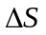) of the process will be larger than zero?
A：Monomer molecules are polymerized into polymer;
B：Gas molecules are adsorbed on the surface of catalysts;
C：Liquid substance is vaporized into gas
- Which of the following statements is not correct?
A：For any reversible adiabatic process, 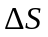= 0；
B：For any irreversible adiabatic process, > 0；
C：For any irreversible adiabatic process, < 0
- For the entropy exchange between the system and its surrounding during an irreversible adiabatic process, which of the following statements is correct?
A：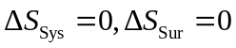； B：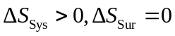； C：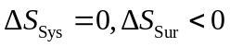
- When an explosion reaction takes place in an isochoric and adiabatic container, both the temperature and pressure increase. Which of the following statements is correct?
A：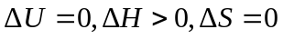； B：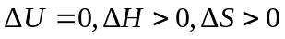； C：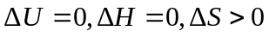
- When an explosion reaction takes place in an isobaric and adiabatic container (W/=0), both the temperature and volume increase. Which of the following statements is correct?
A：； B：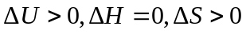； C：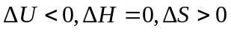
- When a reaction takes place under the isothermal and isochoric conditions, 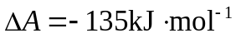. Which of the following statements is not correct?
A：Theoretically, the maximum non-volumetric work it can do is 135kJ;
B：The surrounding must provide 135kJ non-volumetric work at least to ensure the reversible reaction;
C：Theoretically, it can do 135kJ non-volumetric work at least.
- For the Gibbs function, G, which of the following statements is correct?
A：When 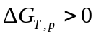, the process is impossible;
B：For all the irreversible processes, G always decreases;
C：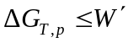 is a judgment of the irreversibility.
- For a homogeneous pure substance, 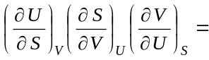
A： 1； B：0； C：-1
- For 1 mol ideal gas, 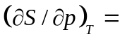
A： 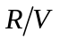； B：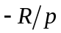； C：R
- For 1 mol ideal gas, 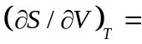
A： ； B：； C：R
- For n mol ideal gas, 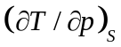
A：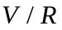； B：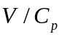； C: 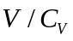
- For a closed system without changing the composition and W’=0,
A：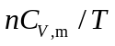； B：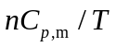； C: 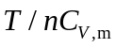
- For a closed system without changing the composition and W’=0, 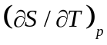＝
A：； B：； C： 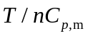
- When 1mol ideal gas expands to the double volume isothermally at 300K , 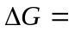 J.
A：-1728.95； B：1728.95； C：1528.95
- When an ideal gas expands adiabatically to the vacuum, then .
A：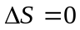，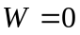； B：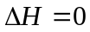，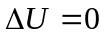； C：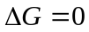，
- There are one reversible adiabatic line and one reversible isothermal line in the p－V diagram. Which of the following statements is correct? .
A：The cross of two lines is impossible;
B：The reversible adiabatic line is steeper than the reversible isothermal line;
C：The reversible isothermal line is steeper than the reversible adiabatic line
- When an ideal gas expands reversibly and adiabatically, which of the following statements is correct? .
A：It only obeys the reversible and adiabatic process equations, but not the ideal gas law;
B：It only obeys the ideal gas law, but not the reversible and adiabatic process equations;
C：It obeys both the ideal gas law and the reversible and adiabatic process equations.
- When 1 mol ideal gas experiences an adiabatic process, which of the following calculations for the work is not correct? .
A：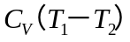； B：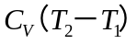； C：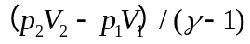
- When 1 mol ideal gas at 298.15K and 0.1MPa expands to the double initial volume under three different conditions of reversible isothermal, reversible adiabatic, and isobaric processes, the work done are W₁、W₂ and W₃, respectively. Which of the following is correct? .
A：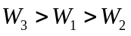； B：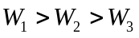； C：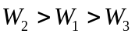
- When mixing two ideal gases under isothermal and isobaric conditions, which of the following calculations for the entropy is correct? .
A：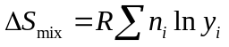； B：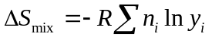； C：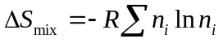
- When mixing 1 mol N₂(g) and 1 mol O₂(g) under isothermal and isobaric conditions, which of the following statements is correct? . Suppose N₂(g) and O₂(g) are ideal gases.
A：U，Ｈ，Ｖ； B：U，Ｈ，S； C：H，S，A
- For an ideal gas, after the throttling, which of the following statements is correct? .
A：；
B：；
C：
- For real gases, after the throttling, which of the following statements is correct? .
A：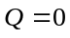，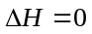，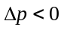；
B：，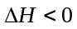，；
C：Q > 0，∆H = 0，∆p < 0
- When 1 mol pure liquid A is vaporized into gas at its normal boiling point, among the properties of ①volume, ②vapour pressure, ③enthalpy of vaporization, ④Gibbs function and ⑤internal energy, will be held as the constant.
A：②③⑤； B：①④⑤； C：②③④
- For a chemical reaction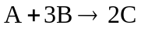,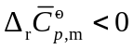，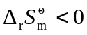, which of the following statements is correct? .
A：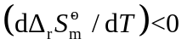，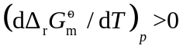；
B：，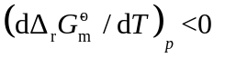；
C：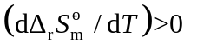，
- For a reversible reaction, 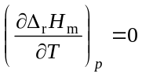, when the reaction temperature decreases, 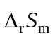 . A：decrease; B：increases; C：does not change.
- For a pure substance, when 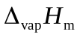is independent with the temperature, which of the following is correct? .
A：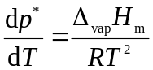； B：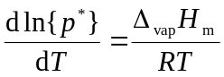； C：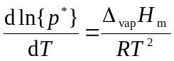
- For the Clausius-Clapeyron equation 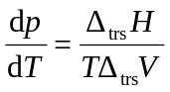, which of the following statements is correct? .
A：It can be used for the calculation of each phase boundary;
B：It can be used only for the calculation of liquid-gas phase boundary;
C：It can be used only for the calculation of liquid-solid phase boundary;

II (10 points, 5 points for each)
1. 1mol ideal gas at 300K and 1.5MPa expends isothermally to the final volume of 10dm³. Calculate △U, △H, △S, △A and △G of this expansion.
2. For 1mol monatomic ideal gas at 300K and 0.1MPa, after a reversible adiabatic compression to the final state at 400K, Calculate Q, W, △U, △H and △S of this compression, and what is the final pressure?

III (10 points)
1. Prove 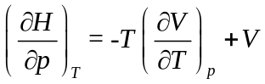
2. 1mol O₂ gas at 300K expends isothermally, the pressure drops from 1013250 Pa to 101325 Pa, Calculate △H,△U, and △S. Suppose O₂ gas obeys the equation of the state of 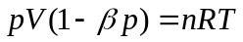, in which 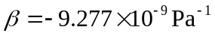.

IV (10 points)
- Based on 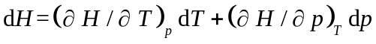, prove the temperature effect of a gas during the throttling process obeys 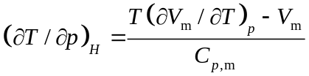.
2. If the gas is an ideal gas, based on the above temperature effect 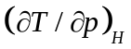, what is the temperature after the throttling? If the real gas obeys 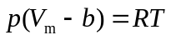, in which b has a positive value. How does the temperature change?

V (10 points)
1 mol of monatomic ideal gas expands from 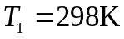 and 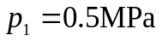to 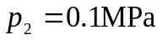by (1) a reversible adiabatic process, (2) an irreversible adiabatic process with the external pressure maintaining at 0.1MPa. What is the final temperature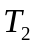, calculate Q, W, ΔU, ΔH, and ΔS for each process.
VI (10 points)
1 g water at 373K and 101325Pa is vaporized into the vapour with the same temperature and pressure when the surrounding is (1) at the normal boiling point; (2) a isothermal vacuum container at 373 K. calculate Q, W, ΔU, ΔH, ΔS,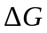and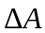for each process. Given that the enthalpy of water vaporization is 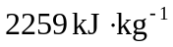. The volume of liquid water can be neglected, and the vapour can be considered as the ideal gas.

VII (10 points)
At 25℃, the thermodynamic data of substances taken place in the gaseous reaction of 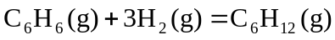 are listed in the following table
substance | 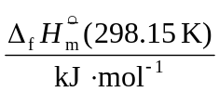 | 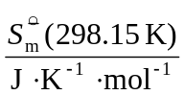
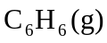 | 82.93 | 269.31
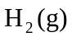 | 0 | 130.684
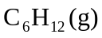 | -123.14 | 298.35
Given that in the temperature range of 25~200℃, 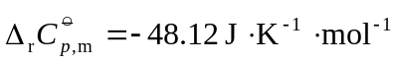, the gases can be considered as the ideal gas, calculate 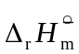, 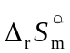, 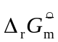 at 200℃.

VIII (10 points)
The vapour pressure of tungstate (W) at 2600 K and 3200 K are 7.213×10⁻⁵Pa and 6.570×10⁻²Pa , Suppose the enthalpy of sublimation of tungstate 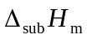is independent with the temperature. Calculate its enthalpy of sublimation, and what is the vapour pressure of tungstate at 3000K?

