Physical Chemistry (II) Examination Paper
1. Chemical Kinetics

I Choice (1 point for each, totally 30 points)
- For an elementary reaction 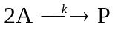, what are the correct rate expressions of and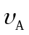
A：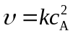、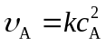； B：、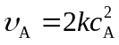； C：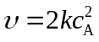、
- The reaction rate equation of 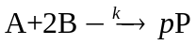is that 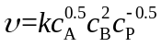, what is the reaction order ?
A：Zeroth； B：First； C：Second
- A unimolecular reaction the elementary reaction.
A：can’t be； B：must be； C：might be
- The experimental results showed that the rate equation of 2A+B ─→2C + D is = k[A][B]. If the initial concentrations of the reactants were [A]₀= 2[B]₀, the rate equation changed into = k_{a}[A]². What's the relationship between k_{a} and k 。
A：k_{a}=0.5k； B：0.5 k_{a}=k； C：k_{a} = k
- The rate equation of the chemical reaction is 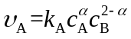. If the reaction rate 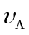 is in direct proportional to c_{A}, then 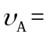 。
A: 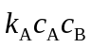； B：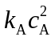； C：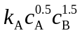
- The rate constant of the chemical reaction 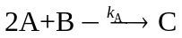 is k_{A}=0.095×10⁻³mol⋅dm⁻³⋅min⁻¹. Which of the following is a linear plotting? .
A: 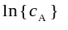~t ； B：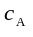~t； C：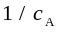~t
- For a zeroth reaction, 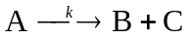, the half life of 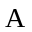is 25 min，the time for complete consumption of A is .
A：50； B：75； C：∞
- For a 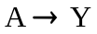, if 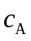shows a linear relationship with reaction time t, what is the reaction order ?
A：Zeroth； B：First； C：Second
- During the reaction of 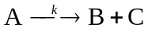，it is found that shows a linear relationship with reaction time t, then the half life of is to its initial concentration [A]₀.
A：irrelvent ； B：propotional; C：inversely proportional
- The time needed for completing the reaction is c₀/k，then this is a order reaction.
A：First； B：Second C：Zeroth；
- For a zeroth reaction 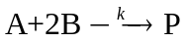, the initial consumption rate of A is 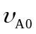 at c_{A0}，when the initial concentration changes into 2c_{A0}, the initial consumption rate of A is 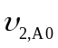, then
A：>； B：=； C：<
- For an ideal gaseous reaction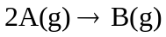, given that 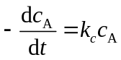or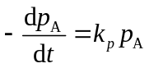, then 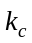=
A：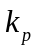； B：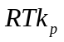； C：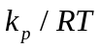
- For a first order reaction , the half life of A is 300 min. When the consumption rate of A is 1/4 of the initial one, the reaction time is .
A：300 min； B：600 min； C：900 min
- If the rate constant k_{A} = 7.7×10⁻⁴ s⁻¹, c_{A0}= 0.1 mol·dm⁻³, then the half life of A is .
A：600 s； B：900 s； C：1 800 s
- The rate constant of 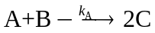is k_{A}=5.18×10⁻²h⁻¹, which one of the following is correct?
A： ~t is straight line；B： ~t is straight line；C：~t is straight line
- In the reaction of , if only A existed at the beginning of the reaction, the time for the consumption 75% of A is 2 times of that for the consumption 50% of A, the time for the consumption x% of A is 3 times of that for the consumption 50% of A, then x=
A： 75.0； B： 87.5； C：50
- For a simple order reaction, k_{A} = 0.1 dm³·mol⁻¹·s⁻¹，c_{A0}= 0.1 mol·dm⁻³, How much time does it take when the reaction rate decreases to the 1/4 of the initial rate？
A：10 s； B：100 s； C：300 s
- For a second order reaction A→B，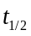 and 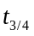are the reaction time for the consumption 50% and 75% of A, respectively. Then /=____________。
A：1/3； B：1/2； C：1/4
- For an ideal gaseous reaction, given that or, then
=
A：； B：； C：
- The apparent rate constant k of a complex reaction is 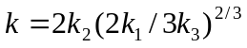, in which k_{i} is the rate constant of each elementary reaction. Then the apparent 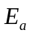=
A：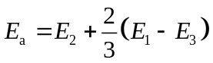； B：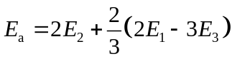；C：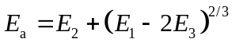
- At 300 K, for the first order opposite reaction 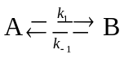 K_{c}=2. When 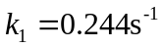, then
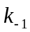 = s⁻¹.
A：0.122； B：0.244； C：0.488
- For a first order parallel reaction 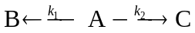, given that 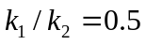. If only A exists at the beginning of the reaction, after a certain time, c_{B}=0.0204 mol⋅dm⁻³, then
c_{C}= mol⋅dm⁻³.
A：0.0204； B：0.0408； C：0.0816
- The conversion of a reaction at equilibrium is 25%. With adding catalyst, the reaction rate is 20 times of the original one. Then the equilibrium conversion is ___________________.
A: > 25%； B: < 25%； C: = 25%
- For the reaction 2A→2B(g)+C(g), plotting the logarithms of rate constant against the reciprocal of temperature 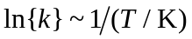, a straight line is obtained, the slope is -12.4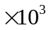 and the intercept is 31.36. The activation energy is ____________________KJ.mol⁻¹, assuming it is independent of temperature.
A: 83.1； B: 93.1； C:103.1
- Increasing the reaction temperature, the reaction rate constant________________________.
A: must increase；B: must keep unchanged；C: not necessarily increase
- At a certain temperature, when adding a specific catalyst into an opposite reaction 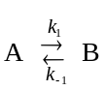, the rate constant k₁ increase 50%, then k_{－1} is_____________.
A: unchanged; B: increase 50%; C: decrease 50%
- Arrhenius equation__________________.
A: can be applied to all types of chemical reactions;
B: can be applied to the reactions, of which the reaction rate increases exponentially with the temperature;
C: can be applied to explosion reactions
- The effects of catalysts are to change __________________.
A: the reaction path; B: the equilibrium state; C: reaction enthalpy
- The mechanism of reaction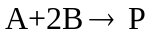 is as the following
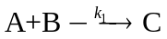;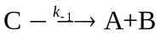;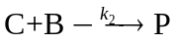 where C is an active intermediate , then 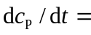 .
A：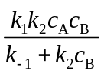； B：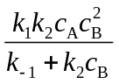； C：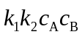
- When the forward reaction of an opposite reaction is exothermic, for a specific conversion x, the most optimized temperature is T. then, the relation between the reaction rate and the temperature 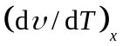=________________
A：> 0 ; B： = 0; C： < 0

II (5 points for each, totally 10 points)
(1) The hydrolysis of Aspirin is a first-order reaction, with the rate constant of 7.92 d⁻¹ and the activation energy of 56.43 kJ·mol⁻¹ at 100 °C. How long would it take for 30% of Aspirin to hydrolyze at 17°C?
(2) The dimerization of Butadiene (A), i.e. 2A(g) → A₂(g), is a second-order reaction. Its reaction rate reduces by half when the temperature decreases from 326 °C to 306 °C. Estimate the activation energy.
III (10 points)
N₂O₅(g) decomposes in a container with the volume V as 2N₂O₅(g) → 4NO₂(g) + O₂(g). At a certain temperature, the half life is 1.40×10³ s, and is irrelevant to the initial pressure of the reactant.
(1) Calculate the rate constant of the reaction.
(2) If the initial pressure of N₂O₅(g) is 60.0×10³ Pa, calculate the total pressure of the reaction system at 10 s and 600 s, respectively.
IV (10 points)
For a first-order gaseous reaction 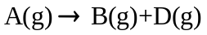, if only A(g) exists initially in the container with a pressure of 213 kP at 450 K, after 100 s, the total pressure changes into 233 kPa. Calculate the rate constant of this reaction, the half life of A, and the conversion of A at 120 s. Given that the volume of the container is a constant.
V (10 points)
The decomposition of N₂O₅ in solvent CCI₄ is a first order reaction. At 313 K, the initial reaction rate is  = 1.00×10⁻⁵ mol·dm⁻³·s⁻¹, after 1 h it changes = 3.26×10⁻⁶ mol·dm⁻³·s⁻¹. Calculate
- The rate constant. (2) The half life at 313 K, (3)The initial concentration c₀

VI (10 points)
For an opposite reaction 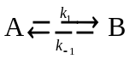, the rate constant k₋₁ and the equilibrium constant K (dimension is 1) change with the temperature as:
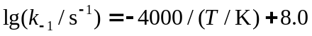；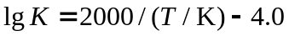
(1) Calculate the order of the forward and reverse reactions respectively;
(2) At 400 K, if 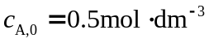,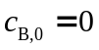, calculate the concentrations of A and B after 10s
VII (10 points)
At a certain temperature, the first order gaseous parallel reaction undergoes in a closed container:
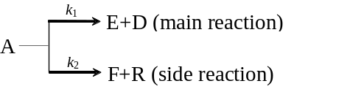
During the reaction process, the partial pressure of product F is always half of that of E. When we set the beginning of the reaction as t=0, then, the total pressure of the system change with the time as
t/min | 0 | 5 | 10 | 15 | ∞
p/kPa | 1.67 | 2.11 | 2.40 | 2.60 | 3.00
Assume the gases are the ideal gas, calculate:
- the rate constants of both main reaction and side reaction;
- the reaction time when the consumption of reactant A is 75%.
VIII (10 points)
The reaction mechanism of the complex reaction 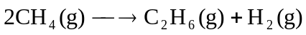is composed of following elementary chain reactions, and their corresponding activation energy are as listed
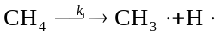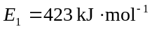
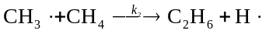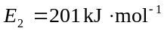
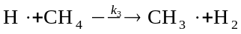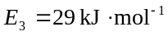
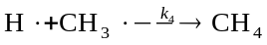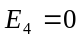
(1) Derive the rate equation of the formation of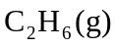by the steady state approximation.
(2) Calculate the activation energy 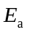of the complex reaction by those of elementary reactions.

