Physical Chemistry (II) Examination Paper
2. Statistical Mechanics of Independent Particle Systems

I Choice (1 point for each, totally 30 points)
- For the ideal liquid mixture, it is
A：independent non-localized-particle system；
B：dependent localized-particle system；
C：independent localized-particle system.
- The particles such as atoms, molecules, and ions in a crystal is .
A：independent non-localized-particle system；
B：dependent localized-particle system；
C：localized-particle system.
- Which of the following is an independent non-localized-particle system ?
A：a crystal at 0 K； B：ideal liquid mixture； C：ideal gas mixture
- The lowest energy level of the translational kinetic energy is
A：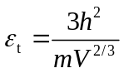； B：0； C：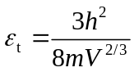
- For a translational level, its energy is 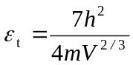, the degeneracy of the level 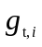is
A：6； B：5； C：4
- The ratio of the degree of the degeneracy of NO molecules at the first excited vibration level to its ground state is
A：1； B：2； C：3
- The vibrational energy of CO molecule in the k^{th} energy level is higher than that in k-1th energy level by
A：0.2 hv； B：0.5 hv； C： hv
- Among different energy levels, which one is related to system volume ?
A.vibrational energy level；B. rotational energy level；C.translational energy level
- Among different energy levels, which one has the equal energy level space ?
A.vibrational energy level；B. rotational energy level；C.translational energy level
- For N₂ at room temperature, which of the following has the largest energy level space ?
A.vibrational energy level；B. rotational energy level；C.translational energy level
- At the same volume, the large the mass of particles, the translational energy level space.
A：unchanged； B：the larger； C：the smaller
- The larger the volume, the translational energy level space.
A：unchanged； B：the larger； C：the smaller
- The larger the rotational moment of inertia, the rotational energy level space.
A：unchanged； B：the larger； C：the smaller
- The larger the vibrational frequency, the vibrational energy level space.
A：unchanged； B：the larger； C：the smaller
- 7 distinguishable particles are distributed in 3 energy levels with the degeneracy of 1, 3, 2; the energy of ε₀, ε₁, ε₂, and the particle distribution of 3, 3, 1, the number of the microscopic states is .
A：6560； B：7560； C：8560
- For a system composed of a large number of particles，when ω_{max}/Ω is small，lnω_{max}/lnΩ is closed to .
A: 0； B: 1； C: 2
- At normal temperature, the ratio of the number of particles distributed on any excited states Nv and that on the ground state N₀, Nv/ N₀ is ______.
A: <1; B: =1; C: >1
- At normal temperature, the ratio of the number of particles distributed on any excited states Nv and that on the neighboring state Nv₋₁, Nv/ Nv₋₁ is ________.
A: <1; B: =1; C: >1
- For diatomic molecules at room temperature, with the increase of the energy level J, the number of particles distributed in the J level, N_{J} .
A：decreases； B：increases；
C：increases first , then decreases, with a maximum value.
- For a system composed of N particles distributed in two energy levels, the energy are ε₁=0, ε₂=ε, and the degeneracy are g₁ and g₂, then, the molecular partition function q is .
A：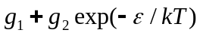；B：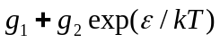；C：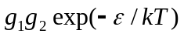
- When T, the ratio of N₂ molecules distributed in the rotational energy levels of J=1 and J=0, N₁/N₀ =
A：2； B：3； C：4
- It is known that the ground level are non-degenerate. At 400 K, for a diatomic molecular AB, 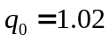, the ratio of the number of particles distributed on the ground level N₀ and the total number of particles N is .
A：0.98； B：1； C：1.02
- Among the following conclusions, the correct one is .
A：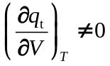； B：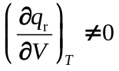； C：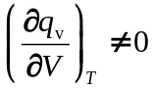
- At the same temperature and volume, which of the following gas has approximately the same translational partition function as N₂ .
A：CO； B：H₂； C：NO
- The mass ratio of A and B is M_{A}/M_{B} = 4, at the sanme temperature and volume, the ratio of the translational partition function q_{tA}/q_{tB} is .
A：4； B：8； C：12
- At 298.15k and 101.325Pa, _________ has the largest molar translational entropy.
A：H₂; B：CH₄ C：CO₂
- The rotational temperature Θ_{r} of N₂ and CO are 2.89K and 2.78K, respectively. The ratio of the rotational partition function 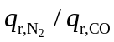=_______________. A：0.381； B：0.481； C：0.581
- At 298.15k and 101.325Pa, the molar translational entropy of _________ is approximately equal to N₂
A：CO; B：CH₄ C：CO₂
- For a non-localized-particle system, the total number of microscopic states is 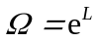, the entropy S of the system is__________.
A：0.5R B：R C：1.5R
- The mass and the moment of inertia of the diatomic molecule CO are approximately equal to those of diatomic molecule N₂, At 25℃,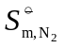 ____ 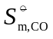. Suppose the vibration has little contributions to the entropy,
A：> B：= C：<
II (5 points for each, totally 10 points)
1. A system is composed of large amount of particles freely in three-dimensional translational movement. The relation among volumes V, particle mass m and temperature T is h²/(8mV^{2/3}) = 0.100 kT. Calculate the ratio of the particle number distributed in the energy level of 14h²/(8mV^{2/3}) and 3h²/(8mV^{2/3}).
2. X molecules are distributed in two energy levels with ε₁= 6.1×10⁻²¹ J，ε₂= 8.4×10⁻²¹J, the corresponding degeneracy are g₁= 3, g₂= 5. Suppose it is an independent-particle system, calculate the ratio of the particle number between these two levels when the temperature is 300K and 3000K, respectively.
III (10 points)
Given that, the molar mass of H₂ is M=2.0g.mol⁻¹, the rotational temperature 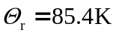, the vibrational temperature 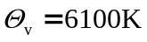, when the temperature is 298.15K, calculate:
- The molecule translational partition function of H₂ in a cube of 1 m³.
- The molecule rotational partition function of H₂.
- The molecule vibrational partition function of H₂, 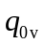.
- The ratio of the particle number between the first excited vibrational level and vibrational ground level.
IV (10 points)
- Suppose a molecular vibrational energy level spacing is 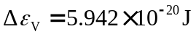. At 298 K, what is the ratio of number of molecule between two neighboring energy levels?
- Suppose vibrational energy level spacing is 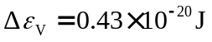. At 298 K, what is the ratio of number of molecule between two neighboring energy levels?.
- What can you conclude from the comparison of the above two calculation results?
V (10 points)
For a independent non-localized-particle system, the relation between entropy and molecular function is 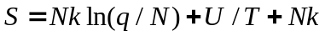. Prove that
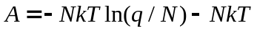，.
VI (10 points)
Given that the relation between the entropy and the molecular partition function of a independent non-localized-particle system is ..
1. Prove that the entropy of ideal monoatomic gas molecules is given by
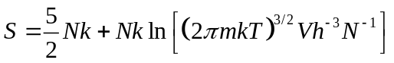.
2. Calculate the molar entropy of Ar at its normal boiling point. Given that the normal boiling point of Ar is 87.3 K and its molar mass is 39.95 g·mol⁻¹.
VII (10 points)
For a localized-particle system with N particles, it is given that 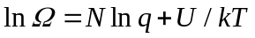. Prove that , 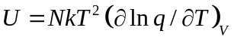 and 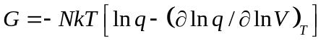.
VIII (10 points)
For 1 mol ideal monoatomic molecular gas, try to prove by statistical mechanics that when the temperature changes from T₁ to T₂, the entropy change at constant pressure is as 5/3 times large as that at constant temperature.

