《计算机图形学》
实验报告3

班 级 数172

学 号 10172911

姓 名 梁天一

批阅教师 赵宏庆

实验3 实现简单的直线作图

实验目的及要求
目的：掌握VC++基本的作图方法。
要求：1 用直线的斜率截距方程实现直线的基本绘制：y=kx+b
2 实现数值微分（DDA）法
3 书p75页，3.2，3.4，3.5 题
参考资料：书P30.

实验步骤

1.用直线的斜率截距方程实现直线的基本绘制：y=kx+b.
代码：
void CMFC_OPEGNGLView::OnDraw(CDC* pDC)
{
int x, y;
for (x = 0; x<1000; x++) {
y = 3 * x + 6;
pDC->SetPixel(x, int(y + 0.5), RGB(0,0,0));
}
CMFC_OPEGNGLDoc* pDoc = GetDocument();
ASSERT_VALID(pDoc);
// TODO: add draw code for native data here
}
绘图界面：
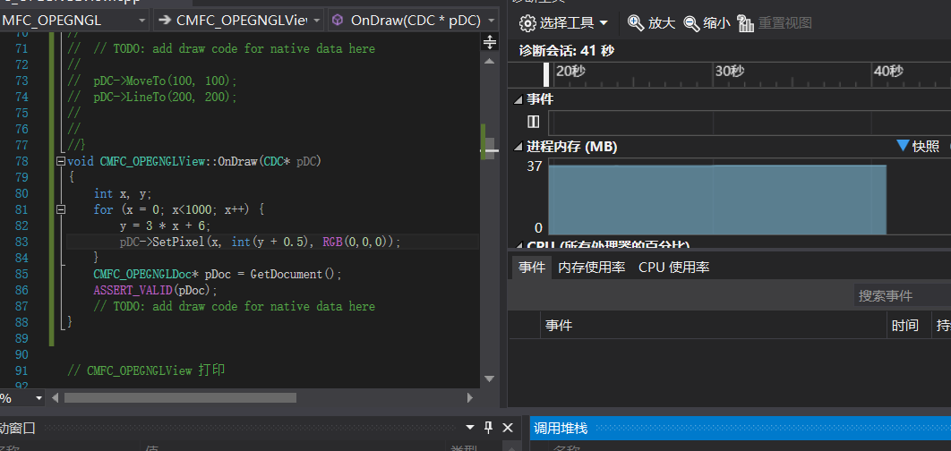
运行结果：
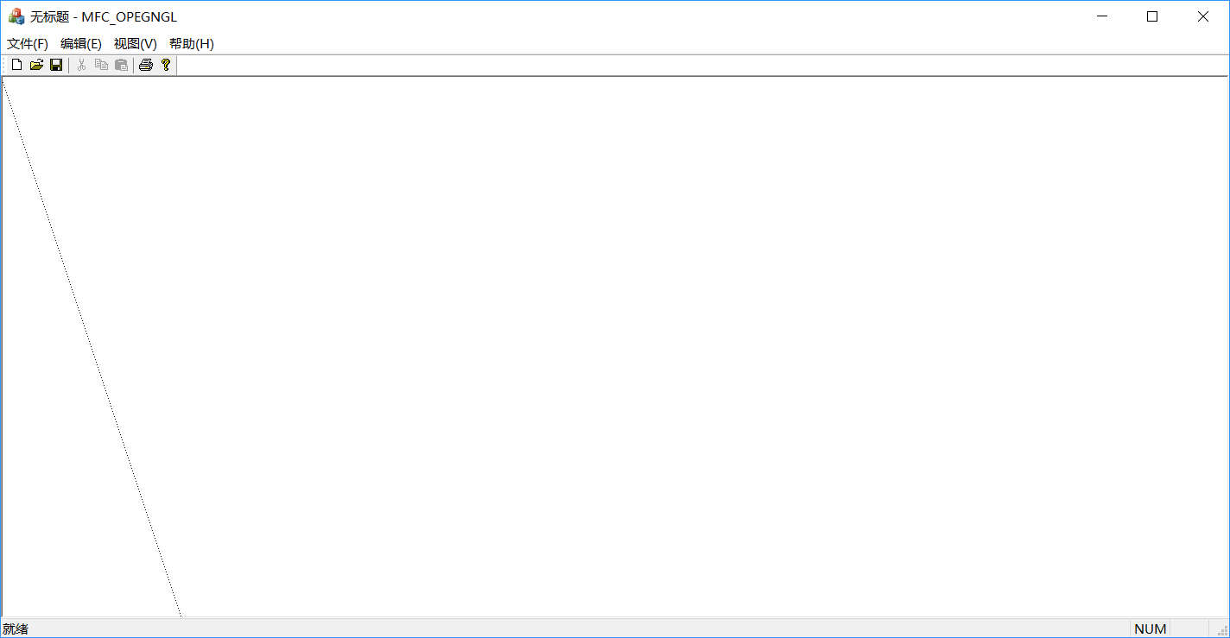

2 实现数值微分（DDA）法。
代码：
void CMFC_OPEGNGLView::OnDraw(CDC* pDC)
{
int i;
float dx, dy, length, x, y;
if (fabs(100 - 0) >= fabs(100 - 0))
length = fabs(100 - 0);
else
length = fabs(100 - 0);
dx = (100 - 0) / length;
dy = (100 - 0) / length;
i = 1;
x = 0;
y = 0;
while (i <= length)
{
pDC->SetPixel(int(x + 0.5), int(y + 0.5), RGB(255, 0, 0));
x = x + dx;
y = y + dy;
i++;
}
CMFC_OPEGNGLDoc* pDoc = GetDocument();
ASSERT_VALID(pDoc);
// TODO: add draw code for native data here
}
绘图界面：
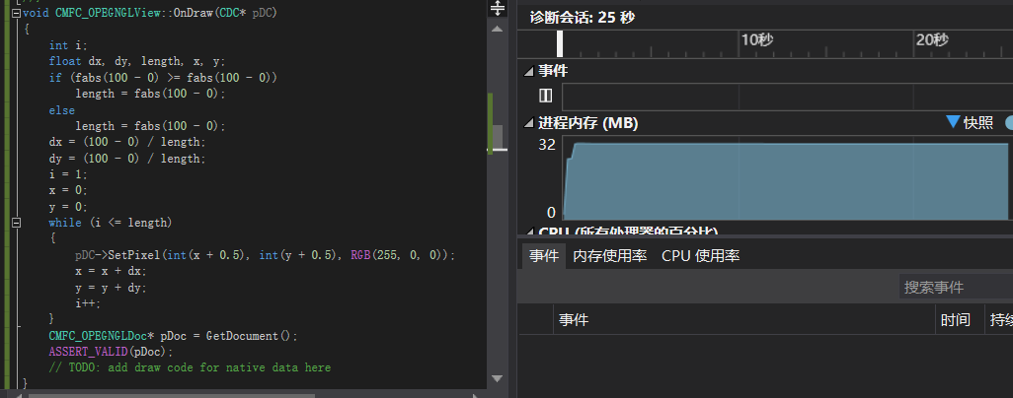
运行结果：
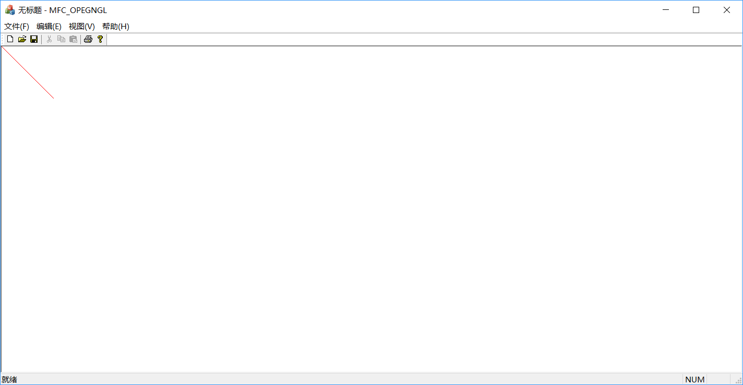
3

(1)3.2
代码：
void CMFC_OPEGNGLView::OnDraw(CDC* pDC)
{
int dx, dy, e, i, x, y;
dx = 300 - 100, dy = 500 - 200, e = 2 * dx - dy;
x = 100, y = 200;
for (i = 0; i <= dy; i++)
{
pDC->SetPixel(x, y, RGB(0, 255, 0));
y++;
if (e >= 0)
{
x++;
e = e + 2 * dx - 2 * dy;
}
else
e = e + 2 * dx;
}
CMFC_OPEGNGLDoc* pDoc = GetDocument();
ASSERT_VALID(pDoc);
// TODO: add draw code for native data here
}
绘图界面：
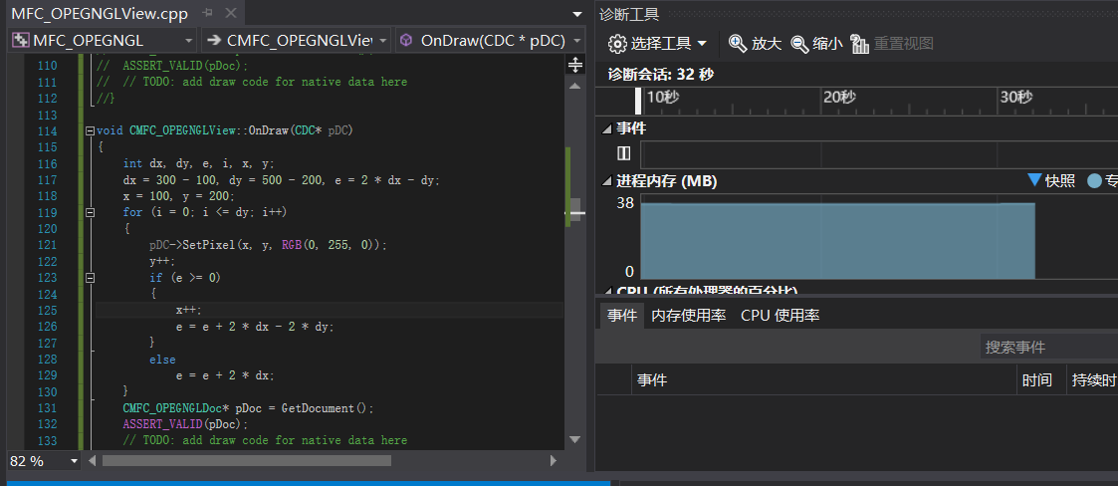
运行结果：
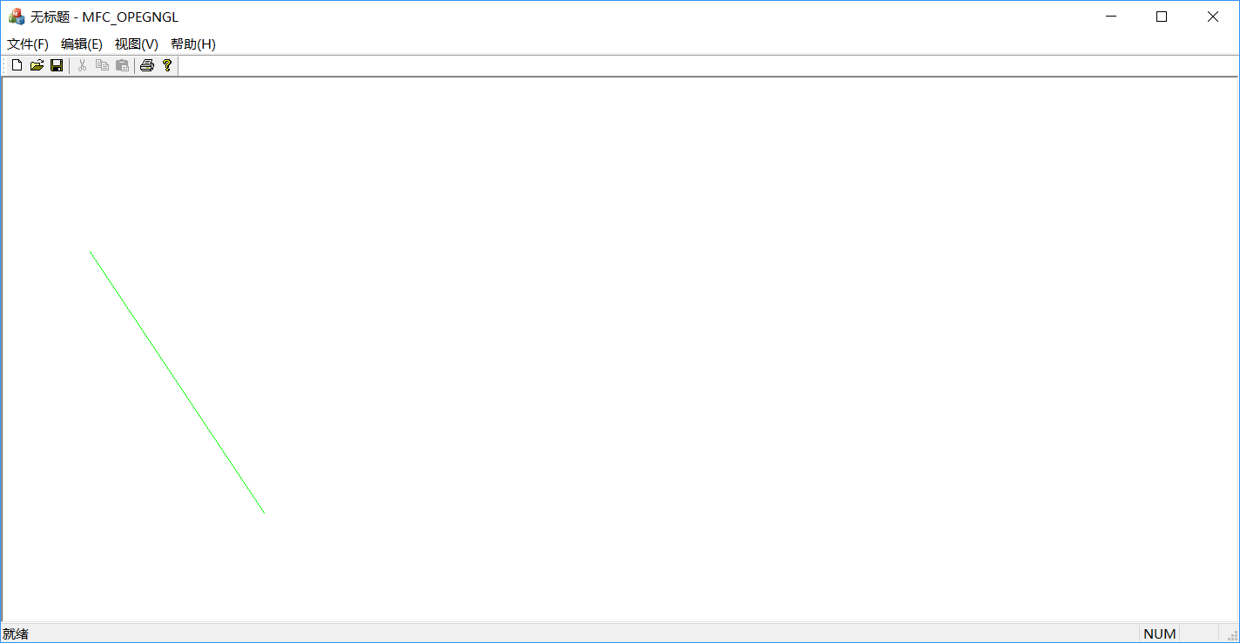
Ps：因为程序是将右方向和下方向分别作为两轴的正方向的，所以虽与平时的数学习惯不同，但实际上程序是完成了k>1的直线的绘制。

(2)3.4

代码：

void CMFC_OPEGNGLView::CirclePoints(CDC *pDC, int x, int y, int color)
{
pDC->SetPixel(500 + x, 500 + y, color); pDC->SetPixel(500 + y, 500 + x, color);
pDC->SetPixel(500 - x, 500 + y, color); pDC->SetPixel(500 + y, 500 + -x, color);
pDC->SetPixel(500 + x, 500 - y, color); pDC->SetPixel(500 - y, 500 + x, color);
pDC->SetPixel(500 - x, 500 - y, color); pDC->SetPixel(500 - y, 500 - x, color);
}

void CMFC_OPEGNGLView::MidPoints(CDC *pDC, int r, int color)
{
int x, y;
int e;
x = 0; y = r; e = 1 - r;
CirclePoints(pDC, x, y, color);
while (x <= y)
{
if (e<0)
e += 2 * x + 3;
else
{
e += 2 * (x - y) + 5;
y--;
}
x++;
CirclePoints(pDC, x, y, color);

}
}

void CMFC_OPEGNGLView::OnDraw(CDC* pDC)
{
/*CString str;
int i;
CPen redpen(PS_SOLID, 1, RGB(0, 100, 0));
pDC->SelectObject(redpen);
long t7 = GetTickCount();
for (i = 1; i <= 100000; i++)
{
pDC->MoveTo(50+ i , 60);
pDC->LineTo(150+i, 260);
}
long t8 = GetTickCount();
str.Format(L"Windows:%dms",t8 - t7);
AfxMessageBox(str);*/

MidPoints(pDC, 100, RGB(255, 100, 0));

//pDC->Ellipse(233, 233, 455, 455);
CMFC_OPEGNGLDoc* pDoc = GetDocument();
ASSERT_VALID(pDoc);
if (!pDoc)
return;

// TODO: 在此处为本机数据添加绘制代码
//wglMakeCurrent(pDC->m_hDC, m_hRC);
//DrawScene();
//wglMakeCurrent(pDC->m_hDC, NULL);

// TODO: add draw code for native data here

//pDC->MoveTo(100, 100);
//pDC->LineTo(200, 200);

}
绘图界面：
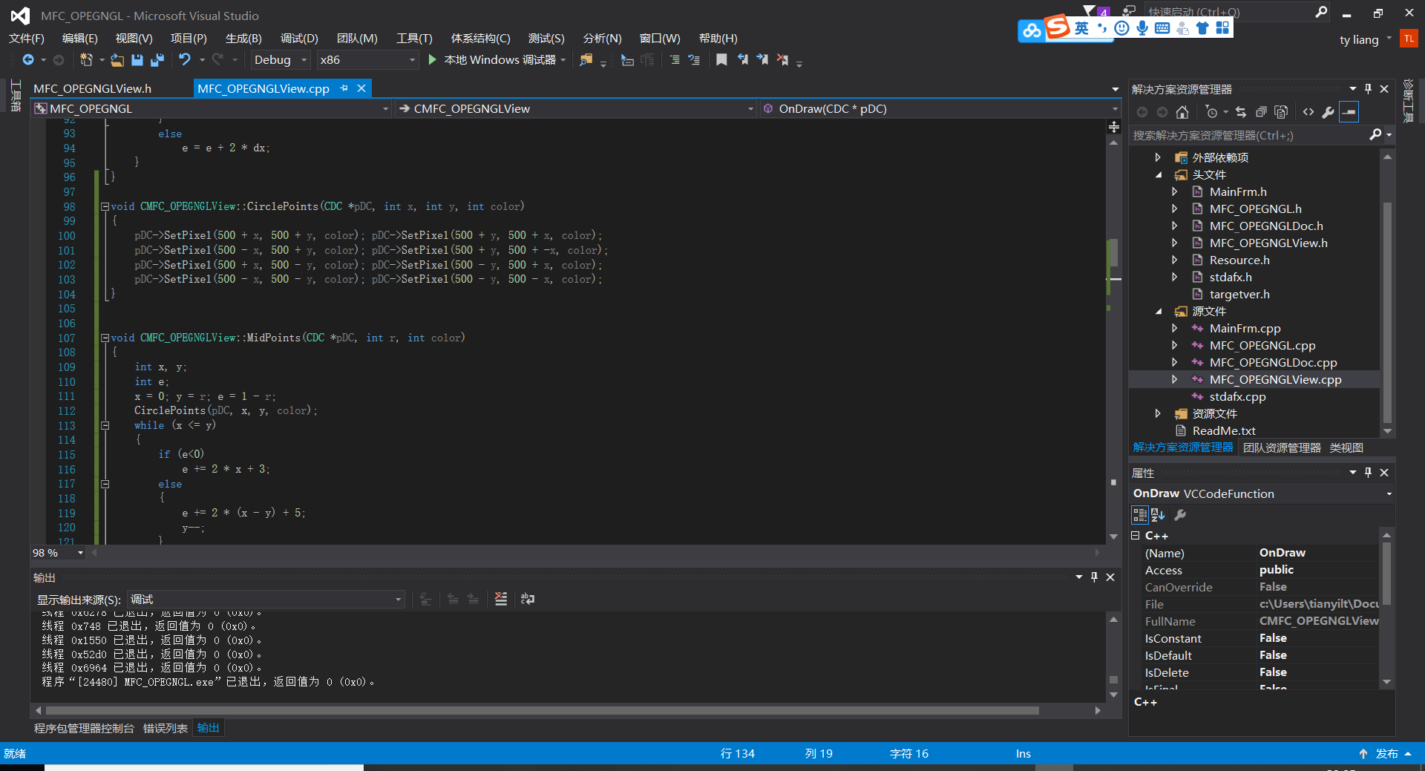
运行结果：
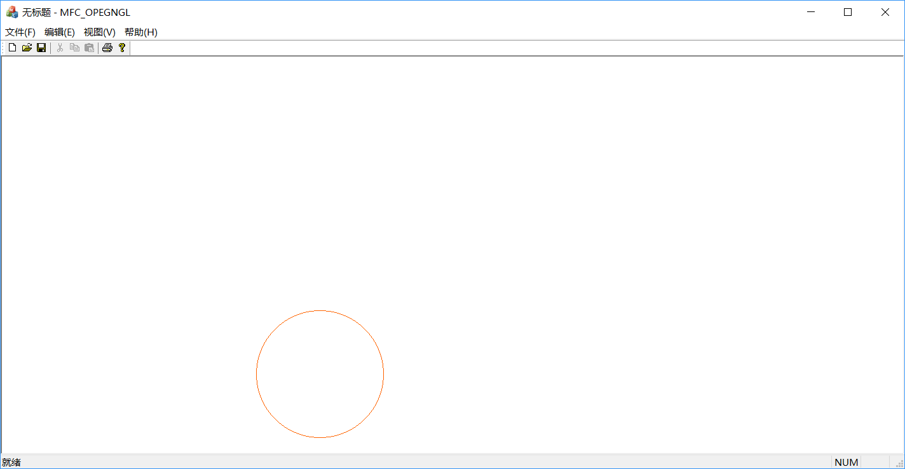

(3)3.5
代码：
四种算法的函数和ondraw函数；
void CMFC_OPEGNGLView::OnDraw(CDC* pDC)
{
int i;
CString str;
long t1 = GetTickCount();
for (i = 0; i <= 10000; i++)
{
DDALine(pDC, i, 0, 100 + i, 100, RGB(0, 255, 255));
}
long t2 = GetTickCount();
str.Format(L"time:%dms", t2 - t1);
AfxMessageBox(str);
CMFC_OPEGNGLDoc* pDoc = GetDocument();
ASSERT_VALID(pDoc);
// TODO: add draw code for native data here
}
函数
在
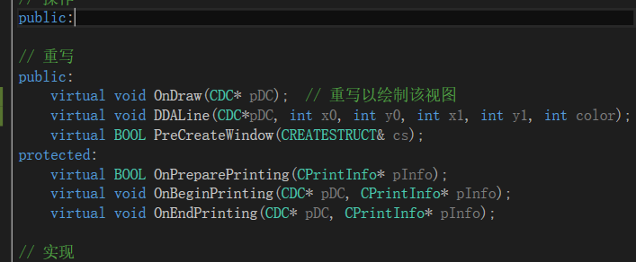
void CMFC_OPEGNGLView::DDALine(CDC*pDC,int x0, int y0, int x1, int y1, int color)
{ int i;
float dx,dy,length,x,y;
if(fabs(x1-x0)>=fabs(y1-y0))
length=fabs(x1-x0);
else
length=fabs(y1-y0);
dx=(x1-x0)/length;
dy=(y1-y0)/length;
i=1;
x=x0;
y=y0;
while(i<=length)
{
pDC->SetPixel(int(x+0.5),int(y+0.5),RGB(255,0,0));
x=x+dx;
y=y+dy;
i++;
}

}

void CMFC_OPEGNGLView::linedraw()
{
float i, j;
for (i = 0; i <= 1; i += 0.01)
{
for (j = 0; j <= 1; j += 0.01)
{
//glClear(GL_COLOR_BUFFER_BIT | GL_DEPTH_BUFFER_BIT);
glBegin(GL_LINES);
glColor3f(1.0, 0.8, 0.2);
glVertex2f(-1.0 + i, 1.0 - j);
glVertex2f(-0.99 + i, 0.99 - j);
glEnd();
glFlush();
SwapBuffers(wglGetCurrentDC());
}
}
}

WINDOWS:
void CMFC_OPEGNGLView::OnDraw(CDC* pDC)
{
CString str;
int i;
CPen redpen(PS_SOLID, 1, RGB(0, 100, 0));
pDC->SelectObject(redpen);
long t7 = GetTickCount();
for (i = 1; i <= 100000; i++)
{
pDC->MoveTo(50+ i , 60);
pDC->LineTo(150+i, 260);
}
long t8 = GetTickCount();
str.Format(L"Windows:%dms",t8 - t7);
AfxMessageBox(str);

//pDC->Ellipse(233, 233, 455, 455);
CMFC_OPEGNGLDoc* pDoc = GetDocument();
ASSERT_VALID(pDoc);
if (!pDoc)
return;

// TODO: 在此处为本机数据添加绘制代码
//wglMakeCurrent(pDC->m_hDC, m_hRC);
//DrawScene();
//wglMakeCurrent(pDC->m_hDC, NULL);

// TODO: add draw code for native data here

//pDC->MoveTo(100, 100);
//pDC->LineTo(200, 200);

}

void CMFC_OPEGNGLView::Bresenhamline(CDC*pDC, int x0, int y0, int x1, int y1, int color)
{
int dx, dy, e, i, x, y;
dx = x1 - x0, dy = y1 - y0, e = 2 * dx - dy;
x = x0, y = y0;
for (i = 0; i <= dy; i++)
{
pDC->SetPixel(x, y, RGB(0, 255, 0));
y++;
if (e >= 0)
{
x++;
e = e + 2 * dx - 2 * dy;
}
else
e = e + 2 * dx;
}

}

DDA：
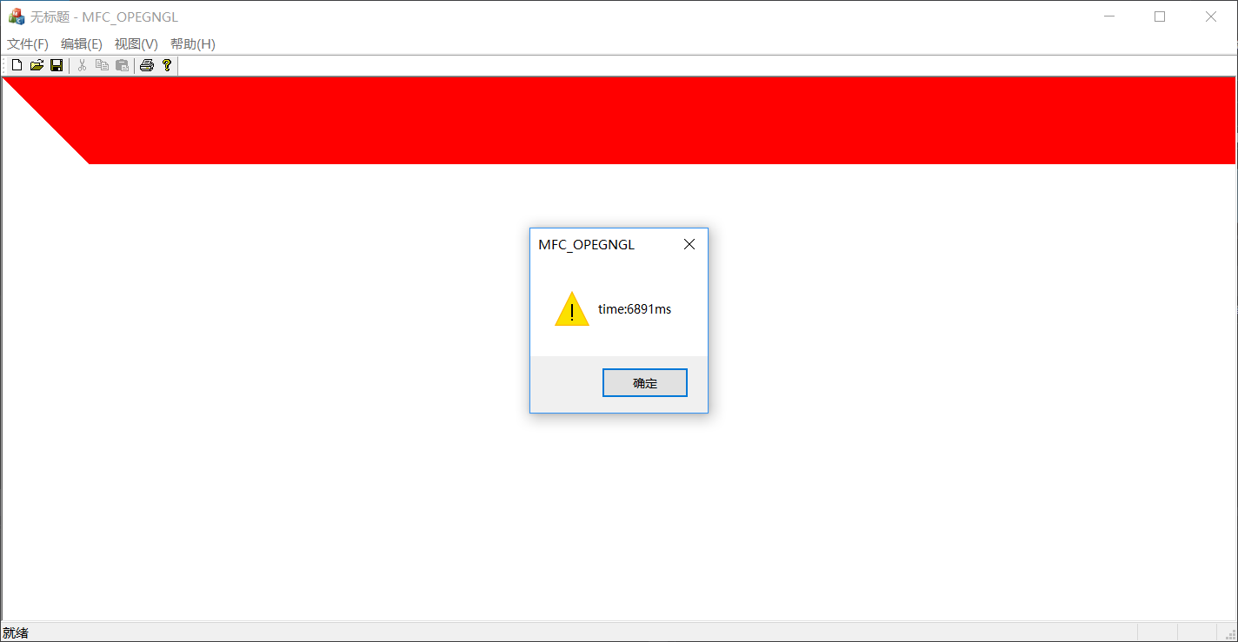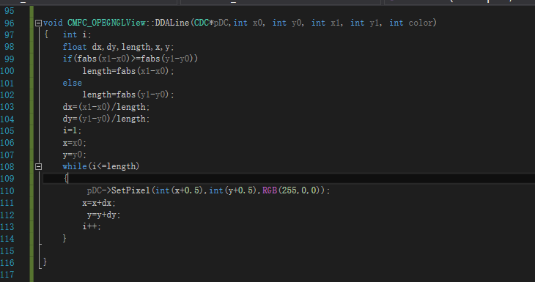

Windows：
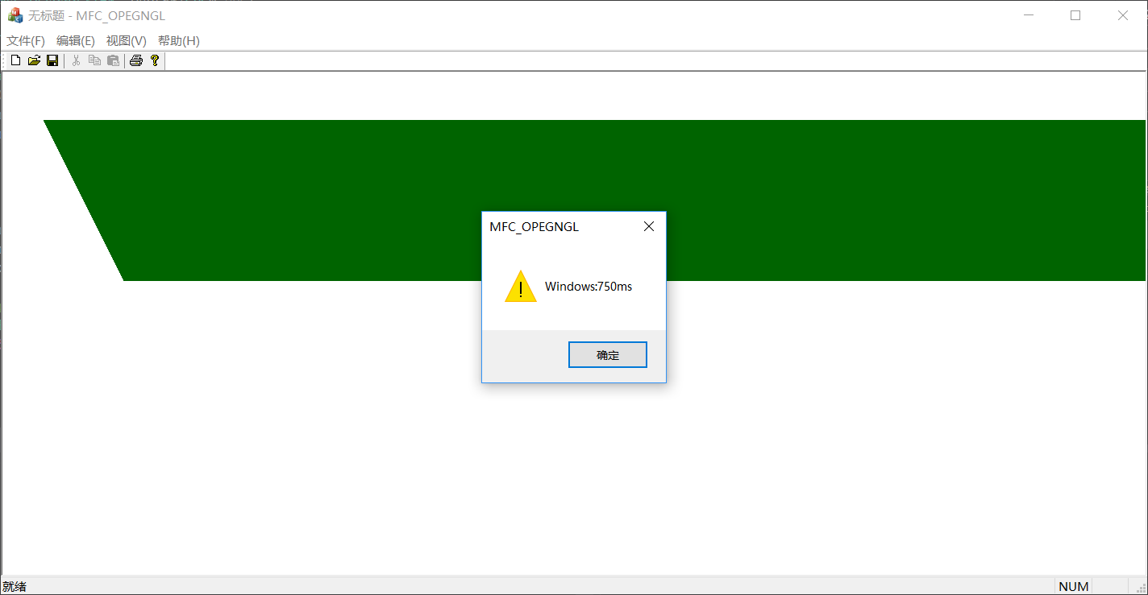
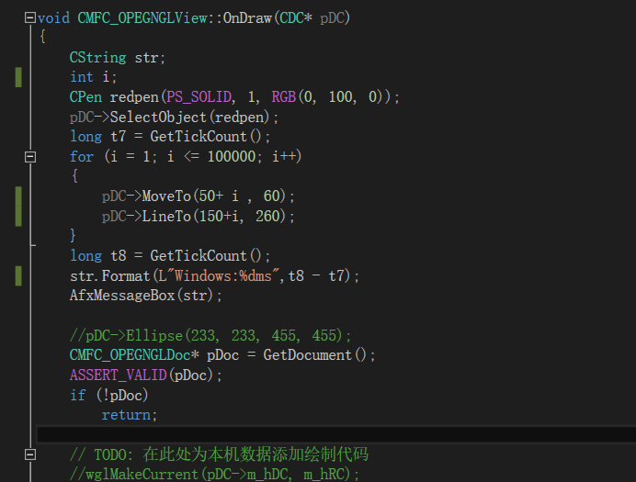

Bresenham：
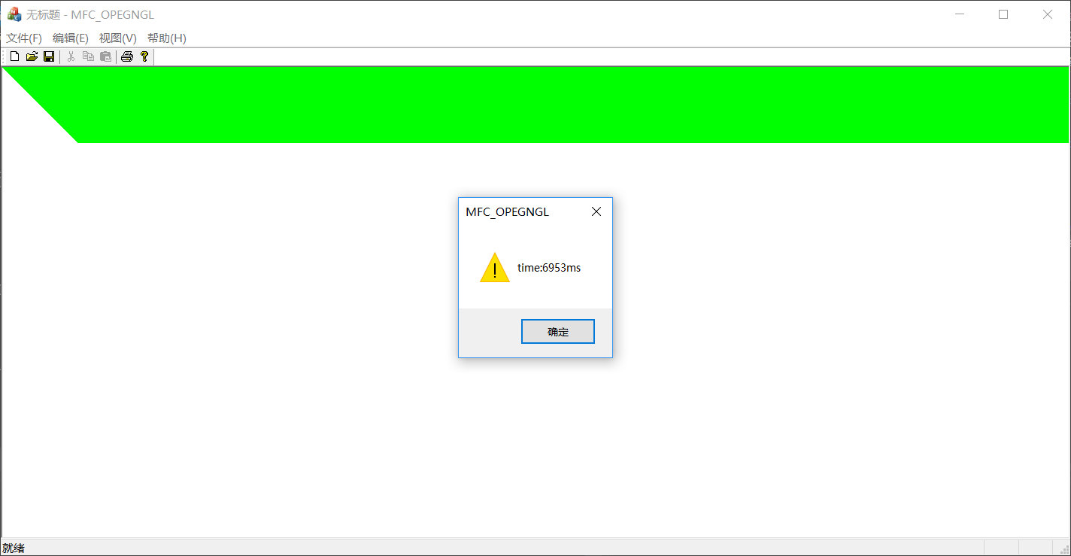

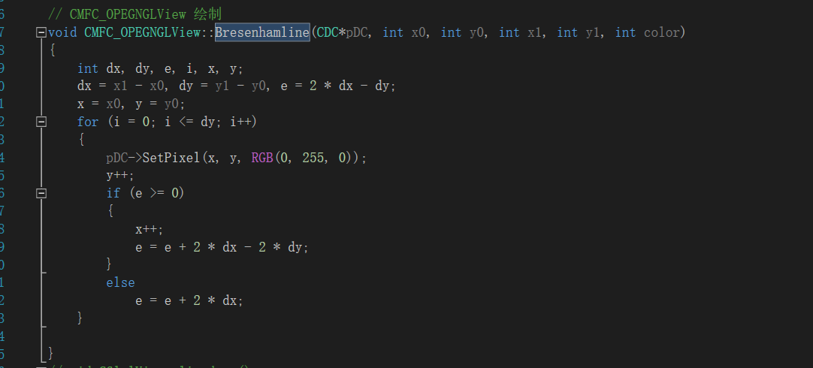

GL：
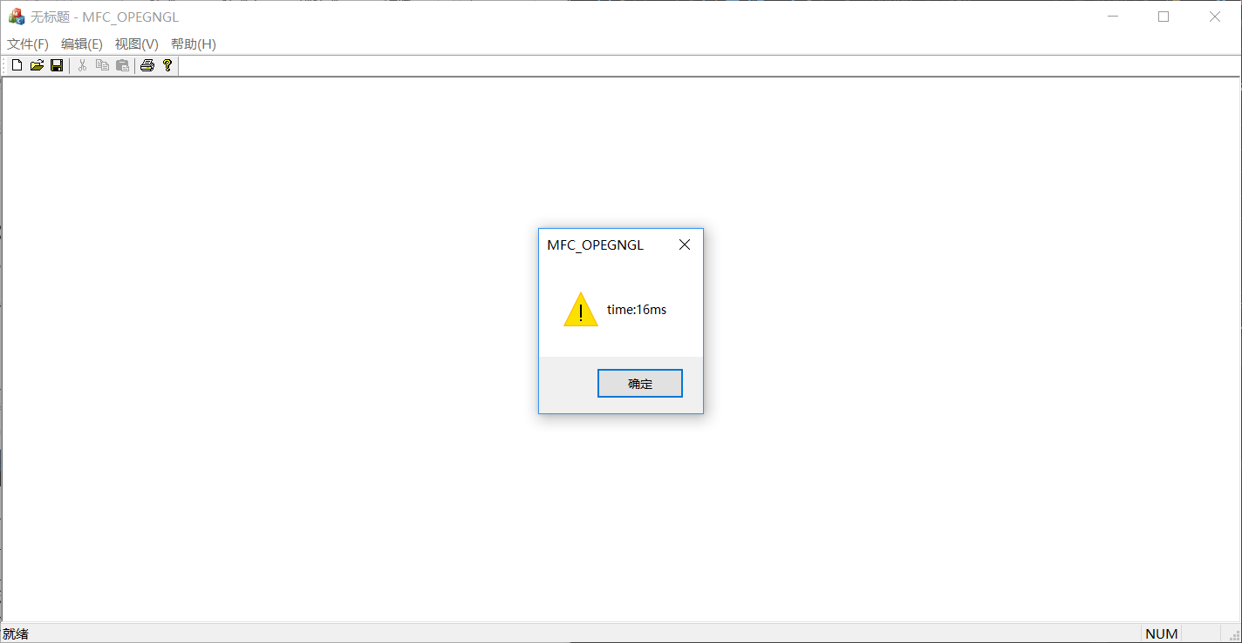
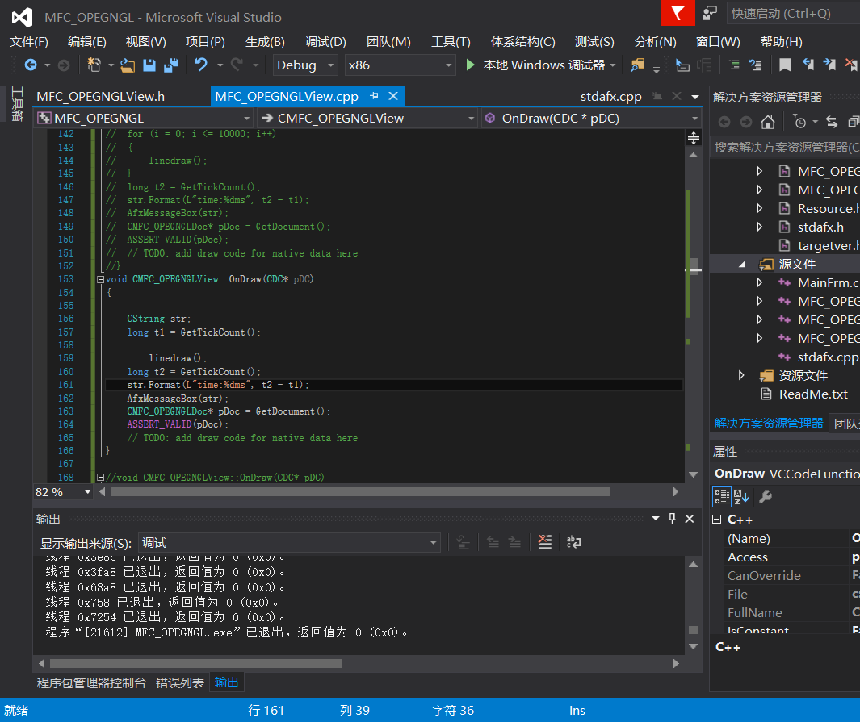
由上图可以知道
算法 | DDA | Windows | Brehenham | openGL
时间（ms） | 6891 | 750 | 6953 | 16
可以看出openGL的速度是最快的。

核心算法

1.用直线的斜率截距方程实现直线的基本绘制：y=kx+b.
代码：
void CMFC_OPEGNGLView::OnDraw(CDC* pDC)
{
int x, y;
for (x = 0; x<1000; x++) {
y = 3 * x + 6;
pDC->SetPixel(x, int(y + 0.5), RGB(0,0,0));
}
CMFC_OPEGNGLDoc* pDoc = GetDocument();
ASSERT_VALID(pDoc);
// TODO: add draw code for native data here
}

2 实现数值微分（DDA）法。
代码：
void CMFC_OPEGNGLView::OnDraw(CDC* pDC)
{
int i;
float dx, dy, length, x, y;
if (fabs(100 - 0) >= fabs(100 - 0))
length = fabs(100 - 0);
else
length = fabs(100 - 0);
dx = (100 - 0) / length;
dy = (100 - 0) / length;
i = 1;
x = 0;
y = 0;
while (i <= length)
{
pDC->SetPixel(int(x + 0.5), int(y + 0.5), RGB(255, 0, 0));
x = x + dx;
y = y + dy;
i++;
}
CMFC_OPEGNGLDoc* pDoc = GetDocument();
ASSERT_VALID(pDoc);
// TODO: add draw code for native data here
}

3

(1)3.2
代码：
void CMFC_OPEGNGLView::OnDraw(CDC* pDC)
{
int dx, dy, e, i, x, y;
dx = 300 - 100, dy = 500 - 200, e = 2 * dx - dy;
x = 100, y = 200;
for (i = 0; i <= dy; i++)
{
pDC->SetPixel(x, y, RGB(0, 255, 0));
y++;
if (e >= 0)
{
x++;
e = e + 2 * dx - 2 * dy;
}
else
e = e + 2 * dx;
}
CMFC_OPEGNGLDoc* pDoc = GetDocument();
ASSERT_VALID(pDoc);
// TODO: add draw code for native data here
}

(2)3.4
原来的算法：
代码：void CMFC_OPEGNGLView::CirclePoints(CDC *pDC, int x, int y, int color)
{ pDC->SetPixel(500+x,500+y,color); pDC->SetPixel(500+y,500+x,color);
pDC->SetPixel(500-x,500+y,color); pDC->SetPixel(500+y,500+-x,color);
pDC->SetPixel(500+x,500-y,color); pDC->SetPixel(500-y,500+x,color);
pDC->SetPixel(500-x,500-y,color); pDC->SetPixel(500-y,500-x,color);
}

CMFC_OPEGNGLView::MidPoints(CDC *pDC, int r, int color)
{ int x,y;
int e;
x=0; y=r; e=1-r;
CirclePoints(pDC,x,y,color);
while(x<=y)
{
if(e<0)
e+=2*x+3;
else
{
e+=2*(x-y)+5;
y--;
}
x++;
CirclePoints(pDC,x,y,color);

改变之后的算法：
代码：
void CMFC_OPEGNGLView::CirclePoints(CDC *pDC, int x, int y, int color)
{
pDC->SetPixel(500 + x, 500 + y, color); pDC->SetPixel(500 + y, 500 + x, color);
pDC->SetPixel(500 - x, 500 + y, color); pDC->SetPixel(500 + y, 500 + -x, color);
pDC->SetPixel(500 + x, 500 - y, color); pDC->SetPixel(500 - y, 500 + x, color);
pDC->SetPixel(500 - x, 500 - y, color); pDC->SetPixel(500 - y, 500 - x, color);
}

void CMFC_OPEGNGLView::MidPoints(CDC *pDC, int r, int color)
{
int x, y;
int e;
x = 0; y = r; e = 1 - r;
CirclePoints(pDC, x, y, color);
while (x <= y)
{
if (e<0)
e += 2 * x + 3;
else
{
e += 2 * (x - y) + 5;
y--;
}
x++;
CirclePoints(pDC, x, y, color);

}
}

void CMFC_OPEGNGLView::OnDraw(CDC* pDC)
{
/*CString str;
int i;
CPen redpen(PS_SOLID, 1, RGB(0, 100, 0));
pDC->SelectObject(redpen);
long t7 = GetTickCount();
for (i = 1; i <= 100000; i++)
{
pDC->MoveTo(50+ i , 60);
pDC->LineTo(150+i, 260);
}
long t8 = GetTickCount();
str.Format(L"Windows:%dms",t8 - t7);
AfxMessageBox(str);*/

MidPoints(pDC, 100, RGB(255, 100, 0));

//pDC->Ellipse(233, 233, 455, 455);
CMFC_OPEGNGLDoc* pDoc = GetDocument();
ASSERT_VALID(pDoc);
if (!pDoc)
return;

// TODO: 在此处为本机数据添加绘制代码
//wglMakeCurrent(pDC->m_hDC, m_hRC);
//DrawScene();
//wglMakeCurrent(pDC->m_hDC, NULL);

// TODO: add draw code for native data here

//pDC->MoveTo(100, 100);
//pDC->LineTo(200, 200);

}

(3)3.5
代码：
四种算法的函数和ondraw函数；
void CMFC_OPEGNGLView::OnDraw(CDC* pDC)
{
int i;
CString str;
long t1 = GetTickCount();
for (i = 0; i <= 10000; i++)
{
DDALine(pDC, i, 0, 100 + i, 100, RGB(0, 255, 255));
}
long t2 = GetTickCount();
str.Format(L"time:%dms", t2 - t1);
AfxMessageBox(str);
CMFC_OPEGNGLDoc* pDoc = GetDocument();
ASSERT_VALID(pDoc);
// TODO: add draw code for native data here
}
函数
在
void CMFC_OPEGNGLView::DDALine(CDC*pDC,int x0, int y0, int x1, int y1, int color)
{ int i;
float dx,dy,length,x,y;
if(fabs(x1-x0)>=fabs(y1-y0))
length=fabs(x1-x0);
else
length=fabs(y1-y0);
dx=(x1-x0)/length;
dy=(y1-y0)/length;
i=1;
x=x0;
y=y0;
while(i<=length)
{
pDC->SetPixel(int(x+0.5),int(y+0.5),RGB(255,0,0));
x=x+dx;
y=y+dy;
i++;
}

}

void CMFC_OPEGNGLView::linedraw()
{
float i, j;
for (i = 0; i <= 1; i += 0.01)
{
for (j = 0; j <= 1; j += 0.01)
{
//glClear(GL_COLOR_BUFFER_BIT | GL_DEPTH_BUFFER_BIT);
glBegin(GL_LINES);
glColor3f(1.0, 0.8, 0.2);
glVertex2f(-1.0 + i, 1.0 - j);
glVertex2f(-0.99 + i, 0.99 - j);
glEnd();
glFlush();
SwapBuffers(wglGetCurrentDC());
}
}
}

WINDOWS:
void CMFC_OPEGNGLView::OnDraw(CDC* pDC)
{
CString str;
int i;
CPen redpen(PS_SOLID, 1, RGB(0, 100, 0));
pDC->SelectObject(redpen);
long t7 = GetTickCount();
for (i = 1; i <= 100000; i++)
{
pDC->MoveTo(50+ i , 60);
pDC->LineTo(150+i, 260);
}
long t8 = GetTickCount();
str.Format(L"Windows:%dms",t8 - t7);
AfxMessageBox(str);

//pDC->Ellipse(233, 233, 455, 455);
CMFC_OPEGNGLDoc* pDoc = GetDocument();
ASSERT_VALID(pDoc);
if (!pDoc)
return;

// TODO: 在此处为本机数据添加绘制代码
//wglMakeCurrent(pDC->m_hDC, m_hRC);
//DrawScene();
//wglMakeCurrent(pDC->m_hDC, NULL);

// TODO: add draw code for native data here

//pDC->MoveTo(100, 100);
//pDC->LineTo(200, 200);

}

void CMFC_OPEGNGLView::Bresenhamline(CDC*pDC, int x0, int y0, int x1, int y1, int color)
{
int dx, dy, e, i, x, y;
dx = x1 - x0, dy = y1 - y0, e = 2 * dx - dy;
x = x0, y = y0;
for (i = 0; i <= dy; i++)
{
pDC->SetPixel(x, y, RGB(0, 255, 0));
y++;
if (e >= 0)
{
x++;
e = e + 2 * dx - 2 * dy;
}
else
e = e + 2 * dx;
}

}

由上图可以知道
算法 | DDA | Windows | Brehenham | openGL
时间（ms） | 6891 | 750 | 6953 | 16
可以看出openGL的速度是最快的。

程序调试及运行结果的自我分析与自我评价
使用函数之前必须要定义和申明,vs2015中可以自动修复相关声明问题,实际上只要去.h中修改

