Physical Chemistry (II) Examination Paper
4. Electrolyte Solutions

I Choice (1 point for each, totally 30 points)
- HCl dissociates and reaches equilibrium as HClH⁺+Cl⁻ in the aqueous solution. The relation between chemical potential of undissociated electrolyte HCl,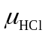, cation H⁺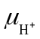, and anion Cl⁻ 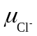is .
A: >+； B：=+； C：<+
- 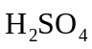 dissociates and reaches equilibrium as 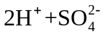 in the aqueous solution. The relation between chemical potential of undissociated electrolyte,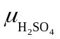, cation H⁺, and anion SO₄²⁻ 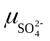is .
A: =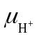+； B：=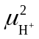+； C：=2+
- Among the first-kind electrolyte solutions of types of 1-1, 1-2, 2-2 and 3-1, the electrolyte solutions of types of show that 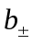=b.
A: 1-1 and 2-2 B: 1-2 and 3-1 C: 1-1 and 1-2
- Among the first-kind electrolyte solutions of types of 1-1, 1-2, 2-2 and 3-1, the electrolyte solutions of types of show that >b.
A: 1-1 and 2-2 B: 1-2 and 3-1 C: 1-1 and 1-2
- There are three kinds of ions of 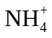, 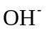 and 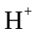in an electrolyte solution, and their molarities are a、b and c (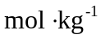), repetitively. Then their neutral condition is .
A. 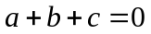； B. 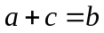； C. 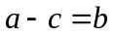
- For the first-kind electrolyte solution, the relation between the activity of electrolyte as whole 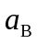 and the mean activity 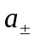 is .
A. 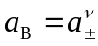； B . 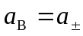； C. 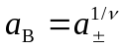
- The aqueous K₂SO₄ solution with b= will have the same ionic strength I as the aqueous KCl solution with 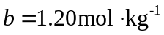
A. 1.20； B . 0.80； C. 0.40
- When the aqueous CuSO₄ solution and LaCl₃ solution have the same molarity, their ionic strength ratio 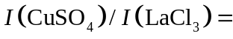
A. 1.667； B . 0.667； C. 0.267
- The aqueous KCl solution with , then 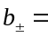
A. 0.80； B . 1.00； C. 1.20
- There are two kinds of electrolytes of MgCl₂ and KCl in a solution, both molarities are 1.2 . Then the ionic strength I = .
A. 2.40； B . 3.60； C. 4.80
- The osmotic factor of solvent of an idea dilute solution, φ_{x} 1.
A. >； B . =； C. <
- There are two kinds of electrolytes of MgCl₂ and KCl in a solution, when the mean ionic activity factor of MgCl₂ is calculated by 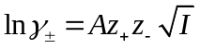, the correct way is .
A：z₊=2 and z₋=-1, I only dependents on MgCl₂；
B：z₊=1 and z₋=-1, I dependents on all ions；
C：z₊=2 and z₋=-1, I dependents on all ions.
- There are three types of 1-1, 2-1, and 2-2 electrolytes in a solution, the relation of their mean ionic activity factors is 1.
A. 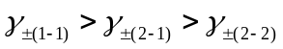； B. 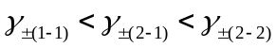； C. 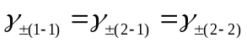
- At 298.15K, the mean ionic activity factors of three aqueous solutions of KCl、CaCl₂、CaSO₄ are 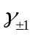、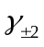、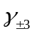, when they have the same molarities of 0.002, the relation of their mean ionic activity factors is
A. ==； B. <<； C. >>
- At 298.15K, based on the electrode reaction of 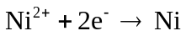, to obtain 2 mol Ni, the amount of electricity needed is
A. 2F； B. 3F； C. 4F
- The conductance of the electrolyte solution depends on the migration of ions and the electrode reaction. It is known that the mobility of 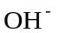is about 3 times that of K⁺ at 298.15K, then
A. 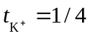，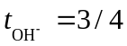； B. 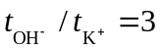, and 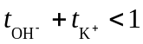；C. 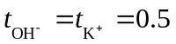
- In the electrolysis of water, KOH is usually added to improve the conductance. The conductance depends on the migration of K⁺ and ions, in which the transfer numbers are , and 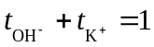. When KOH and NaOH are added together in water, then 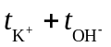
A. >； B. =； C.<
- The conductance depends on the migration of M⁺ and X⁻ ions and the electrode reactions. If the mobility of M⁺ and X⁻ ions are the same, then
A. 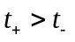； B. 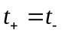, and 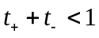； C. 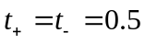
- There are three kinds of electrolytes of HCl, KOH and NaCl in a solution with the same concentration of 0.01 moldm⁻³. Then their molar electric conductivities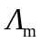are in the sequence of .
A. HCl＞KOH＞NaCl； B. KOH＞HCl＞NaCl； C. HCl＞NaCL＞KOH
- The molar electric conductivities of HCl, NaAc and NaCl in the very dilute solution are a，b and c, respectively. Then of HAc is
A. a+b+c； B. a+b-c； C. a-b-c
- At 291K, when the concentration of H₂SO₄ increases from 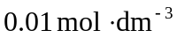to 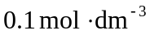, its electric conductivity and the molar electric conductivity
A. both 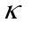and 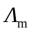 increase；B. decreases, increases； C. increases, decreases
- Only for strong electrolytes, the electric conductivity will have the maximum value when it changes with the concentration. This statement is .
A. correct B. wrong C. not sure
- Kohlrausch relation of 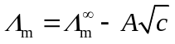 can be applied to________
A. strong electrolyte dilute solution
B. weak electrolyte dilute solution
C. both strong and weak electrolyte dilute solution
- There are three kinds of electrolytes of HCl, KOH and NaCl in a solution with the same molarity. Then their electric conductivitiesare in the sequence of .
A. HCl＞KOH＞NaCl； B. KOH＞HCl＞NaCl； C. HCl＞NaCL＞KOH
- When the electrolyte A with the electric conductivity 0.141 S·m⁻¹ is put into a cell, the resistance is determined as 500 Ω. When the electrolyte changes into B, the resistance is 1000 Ω, then the electric conductivity of electrolyte solution B is___________ S·m⁻¹
A. 0.141 B. 0.282 C. 0.0705
- Independent migration law of ions can be applied to
A. the dilute solution of strong electrolyte
B. the concentrated solution of strong electrolyte
C. the dilute solution of electrolyte
- At 25℃, the difference of molar electric conductivity at infinite dilution between LiCl₃ and LiNO₃ solutions 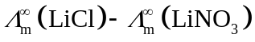 is 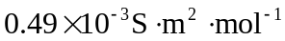. Which pair solutions have the same difference of the molar electric conductivity at infinite dilution ?
A: 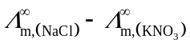； B：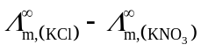； C：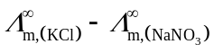
- The molar electric conductivity of a weak electrolyte at infinite dilution is a, the molar electric conductivity of the weak electrolyte at a certain concentration is b, then the degree of dissociation at this concentration is
A. a+b; B. a/b; C. b/a
- At a certain temperature, the electric conductivity of a sparingly soluble salt is determined as a， and that of water is b. then the solubility of this salt is
A. 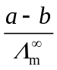； B. 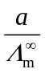； C. 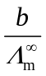
- The calculation of the degree of dissociation by 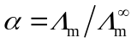can be applied to
A. all electrolytes B. weak electrolytes C. strong electrolytes

II (10 points, 5 points for each)
- For an aqueous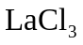solution with the molarity of b and the mean activity factor of 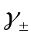, what are the mean ionic concentration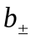, the mean ionic activity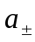, and the relation between 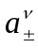 and ?
- Calculate the mean ionic concentration, the mean ionic activity, the electrolyte activity as a whole of an aqueous 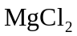solution of b=2.0 mol⋅kg⁻¹ at 25°C. Given that 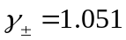
III (10 points)
At 25℃, the solubility product of silver chloride saturated solution is 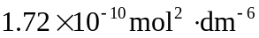. The electric conductivity of pure water is 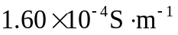. The infinite dilution molar conductivity of silver ions and chloride ions are 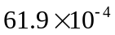and 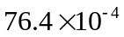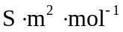. Calculate the electric conductivity of silver chloride saturated solution.
IV (10 points)
The electric conductivity of 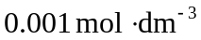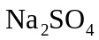 solution is 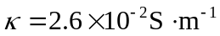. When 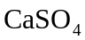 is dissolved and saturated in the above solution, the electric conductivity is measured as 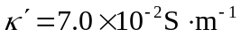. If both solutions can be regarded as infinite dilute solutions. Calculate the molar electric conductivity of 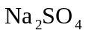solution 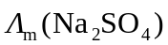 and the solubility of in solution. Given that 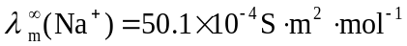 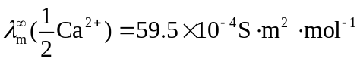
V (10 points)
The determination for the electric conductivity of electrolyte solution is actually by measuring its resistance. The relationship between electric conductivity κ and resistance R is κ=K_{cell}/R. For a fixed conductivity cell, the conductivity cell constant K_{cell} is a constant called, with the unit of m⁻¹. At 298.15K, when the conductivity cell is filled by KCI solution, with the electric conductivity of 0.141 S·m⁻¹, the resistance is 525. And the resistance of the cell is 2030when filled by 0.1 mol·dm⁻³ NH₄OH solution. Calculate the degree of dissociation and the dissociation constant. Given that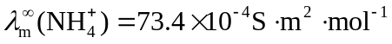, 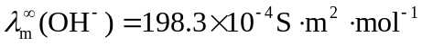.
VI (10 points)
At 25℃, the electric conductivity of the saturated SrSO₄ aqueous solution is determined as 1.482×10⁻² S·m⁻¹, and that of the water is 1.50×10⁻⁴ S·m⁻¹. Calculate the solubility (mol·m⁻³) of SrSO₄. Given that 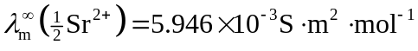，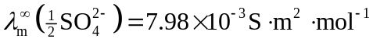；
VII (10 points)
At 298 K, both molarities of CaCl₂ and ZnSO₄ in one aqueous solution are 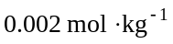, Calculate the mean ionic activity factor of ZnSO₄ based on Debye-Hückel limiting law. Given that 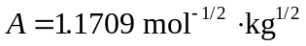.
VIII (10 points)
At 25℃, the saturated concentration of TlCl aqueous solution is 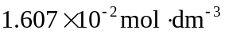, and changes into 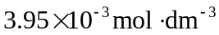 in 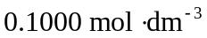NaCl solution. Calculate the mean ionic activity factors of TlCl in pure water and in NaCl solution, respectively. Given that the solubility product of TlCl is

