Air pollution at RDU from 2018 to 2020
Tianyi Lu
November 11, 2026
GitHub: tianyilu666-netizen/biostat721-project2

Data and cleaning
I used the three course-provided files from the EPA monitor at RDU airport to explore daily CO, PM2.5, and ozone concentrations. CO was generally higher in colder months, while ozone was higher in spring and summer. These data describe pollution levels only; they do not include the health outcomes needed to study an association with sickle cell disease.
The cleaning function removes exact duplicate rows, changes negative measurements to zero, and then averages the remaining measurements for each date. The order matters because duplicates would give some measurements extra weight, and a negative value would lower the daily mean if it were corrected afterward. Missing values are omitted from averages, but a day with no valid measurement stays missing; the function also allows ozone to be returned in ppb instead of the default ppm.
There are 361 observed dates in 2018, 365 in 2019, and 121 in January-April 2020. Four dates are absent from the 2018 file and are not filled in. The tables use non-missing daily concentrations.

Daily concentration ranges
Table 1. Minimum and maximum daily concentrations in 2018.
Pollutant | Minimum | Maximum
CO (ppm) | 0.100 | 1.000
PM2.5 (ug/m3 LC) | 0.000 | 20.400
O3 (ppm) | 0.012 | 0.067

Table 2. Minimum and maximum daily concentrations in 2019.
Pollutant | Minimum | Maximum
CO (ppm) | 0.100 | 1.300
PM2.5 (ug/m3 LC) | 1.400 | 21.300
O3 (ppm) | 0.015 | 0.068

Table 3. Minimum and maximum daily concentrations in January-April 2020.
Pollutant | Minimum | Maximum
CO (ppm) | 0.100 | 1.000
PM2.5 (ug/m3 LC) | 0.300 | 31.200
O3 (ppm) | 0.010 | 0.052

Monthly CO and ozone
For each calendar month, I pooled the daily values across available years. The points show the mean and the error bars show the requested 95% confidence interval, calculated as $\overset{‾}{x}±1.96s/\sqrt{n}$, where $n$ counts non-missing daily values for that pollutant. January-April include 2018-2020, while May-December include 2018-2019.
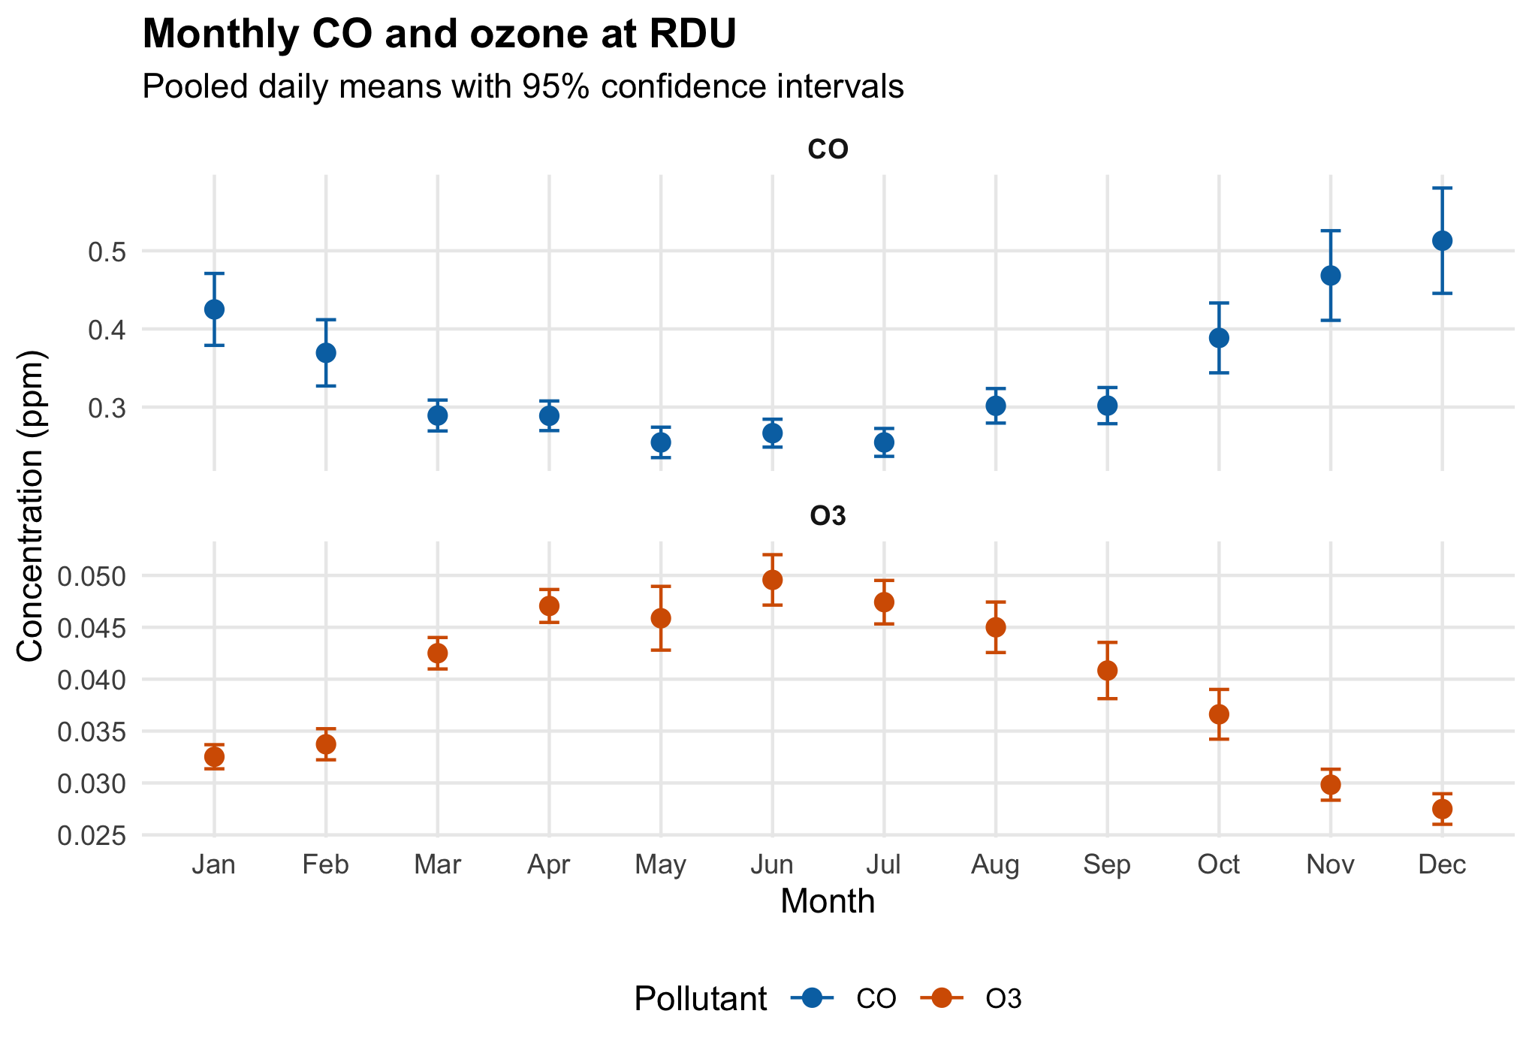
I used separate panels with different y-axis scales because ozone concentrations in ppm are much smaller than CO concentrations. This makes each seasonal pattern easier to see, although the heights of points should not be compared across panels.
These intervals follow the assignment’s formula; they do not account for possible correlation between measurements on nearby days.

Monthly PM2.5 by year
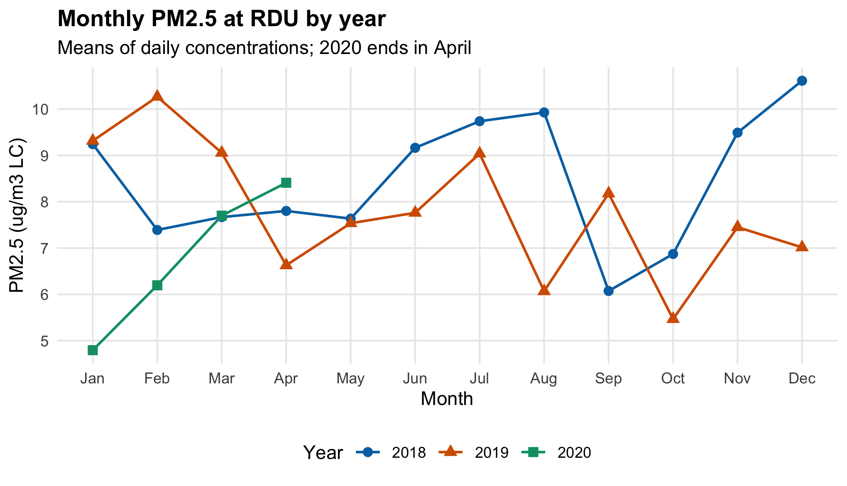
I used lines with points for monthly means because they make the month-to-month changes and differences between years easy to follow without crowding the plot with daily observations.

Interpretation
CO was highest in the colder months, especially November and December, while ozone was higher in spring and summer and peaked in June. PM2.5 varied more between years: 2018 had higher monthly means than 2019 in much of the second half of the year, and 2020 started lower in January and February but still had the largest daily maximum, 31.200 ug/m3 LC. The 2020 results cover only January-April, so they do not describe a full year, and the pooled May-December CO and ozone estimates use two years rather than three.

AI use statement
I used ChatGPT/Codex to help write the cleaning function, analysis code, and report draft. The generated code was run on all three files and checked with a small example for duplicate removal, negative values, and missing values, as well as checks of ozone unit conversion and monthly summaries; the rendered report was also checked for layout.

