Titanic Survival Prediction
Full Machine Learning Project — Documentation

Course: AI5225
Student: Tianyi Shi
Dataset: Kaggle Titanic Competition
Date: April 2026

1. Project Overview
This project builds a binary classification model to predict whether a passenger on the RMS Titanic survived the 1912 disaster. The workflow goes from start to finish, including loading the data, doing some exploratory analysis, cleaning it, creating features, training models, and evaluating them.
Two models are used for comparison: Logistic Regression as a simple and interpretable baseline, and Random Forest as a more advanced ensemble method. The performance of both models is evaluated using accuracy, confusion matrices, and feature importance.

2. Dataset Description
The training dataset (train.csv) contains 891 passengers and 12 columns. The table below summarises each column, its data type, and its role in the project.
Column | Type | Description
PassengerId | int | Unique row identifier — not predictive, excluded from modelling
Survived | int | Target variable: 0 = Died, 1 = Survived
Pclass | int | Ticket class: 1 = First, 2 = Second, 3 = Third
Name | object | Full passenger name (used only for title extraction, then dropped)
Sex | object | Gender
Age | float | Age in years (177 missing values, ~19.9%)
SibSp | int | Number of siblings / spouses aboard
Parch | int | Number of parents / children aboard
Ticket | object | Ticket number — alphanumeric ID, no direct predictive signal, dropped
Fare | float | Ticket fare paid
Cabin | object | Cabin number (~77% missing, dropped)
Embarked | object | Port of embarkation: C = Cherbourg, Q = Queenstown, S = Southampton

Missing Values (before cleaning)
Column | Missing Count | Missing %
Age | 177 | 19.9%
Cabin | 687 | 77.1%
Embarked | 2 | 0.2%

Overall survival rate: 38.4% survived (342 passengers), 61.6% died (549 passengers).

3. Exploratory Data Analysis (EDA)
EDA was conducted across six visualizations. The charts reveal the key demographic and socioeconomic patterns that drove survival outcomes.

3.1 Overall Survival Count
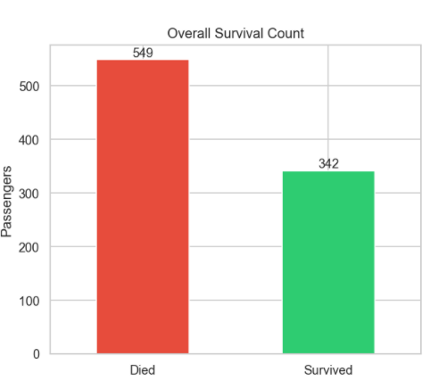
Figure 1: Titanic EDA — Overall survival count
Out of 891 passengers, 549 died and 342 survived, confirming a class imbalance of approximately 62/38. This imbalance was accounted for during the train/test split using stratified sampling to ensure both subsets preserved the same proportion.

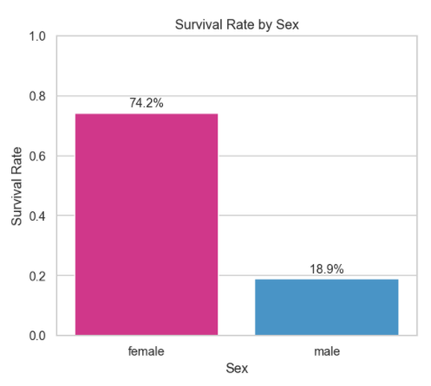
3.2 Survival Rate by Sex
Figure 2: Titanic EDA — Survival Rate by Sex
Sex was the single most decisive survival factor, reflecting the 'women and children first' evacuation policy enforced during the sinking.
Female passengers were nearly four times, which is 74.2% probability to get survival, while male passengers only have 18.9%.

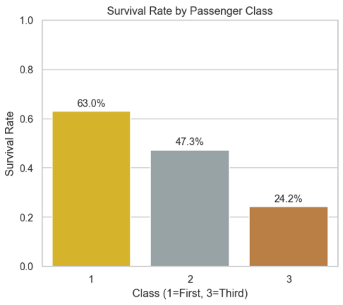
3.3 Survival Rate by Passenger Class
Figure 3: Titanic EDA — Survival Rate by Passenger Class
Survival declined sharply with lower ticket class, reflecting both physical proximity to lifeboats and social prioritization during evacuation.
Third-class passengers had less than a 1-in-4 chance of survival, compared to nearly 2-in-3 for first-class passengers — a more than twofold difference.

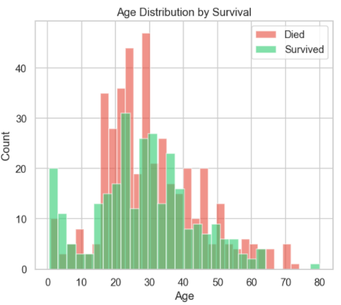
3.4 Age Distribution by Survival
Figure 4: Titanic EDA — Age Distribution by Survival

Overlapping histograms of age for survivors and casualties show that:
- Children aged 0–10 had a noticeably higher survival rate relative to the overall distribution, consistent with evacuation priority for young children.
- The 20–30 age range had the highest absolute death count, largely because it contained the greatest number of passengers overall.
- Survival and death distributions were broadly similar from age 30 onward, suggesting age alone was a weaker predictor for adults than sex or class.

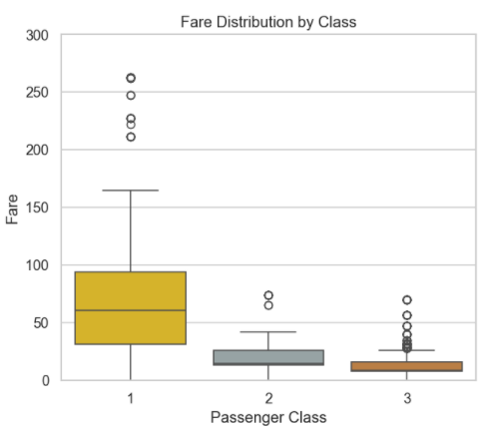
3.5 Fare Distribution by Class
Figure 5: Titanic EDA — Fare Distribution by Class

The boxplot reveals a strong fare gradient across classes:
- 1st class: Median fare ~$60, wide interquartile spread, several extreme outliers above $200 indicating a diverse range of cabin grades.
- 2nd class: Median fare ~$15–20, much narrower spread.
- 3rd class: Median fare under $10, tightly clustered near zero with a few outliers.
The y-axis is capped at $300 to keep the chart readable; a handful of first-class fares exceeded this value.

3.6 Survival Rate by Embarkation Port
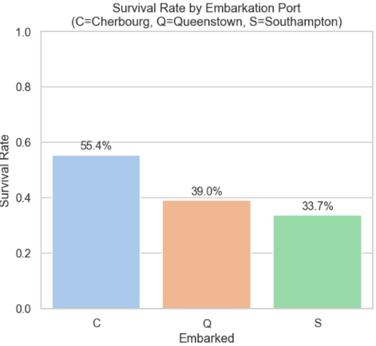
Figure 6: Titanic EDA — Survival Rate by Embarkation Port
Cherbourg passengers had a notably higher survival rate. This is likely a confounding effect of class composition: passengers boarding at Cherbourg were disproportionately first-class travellers, who had higher survival rates regardless of port.

3.7 Correlation Heatmap
The lower-triangle correlation heatmap of numeric features highlighted the following relationships (Pearson r values):
Feature Pair | Correlation (r) | Interpretation
Pclass vs Fare | -0.55 | Strong negative — higher class (lower number) paid higher fares
Age vs Pclass | -0.37 | Older passengers tended to hold higher-class tickets
SibSp vs Age | -0.31 | Younger passengers more likely to travel with siblings
SibSp vs Parch | +0.41 | Passengers with siblings also tended to travel with parents/children
Fare vs Survived | +0.26 | Modest positive link — higher fare correlated with higher survival
Pclass vs Survived | -0.34 | Higher class number (lower class) linked to lower survival
PassengerId vs all | ~0 | No predictive signal — confirms exclusion from the model
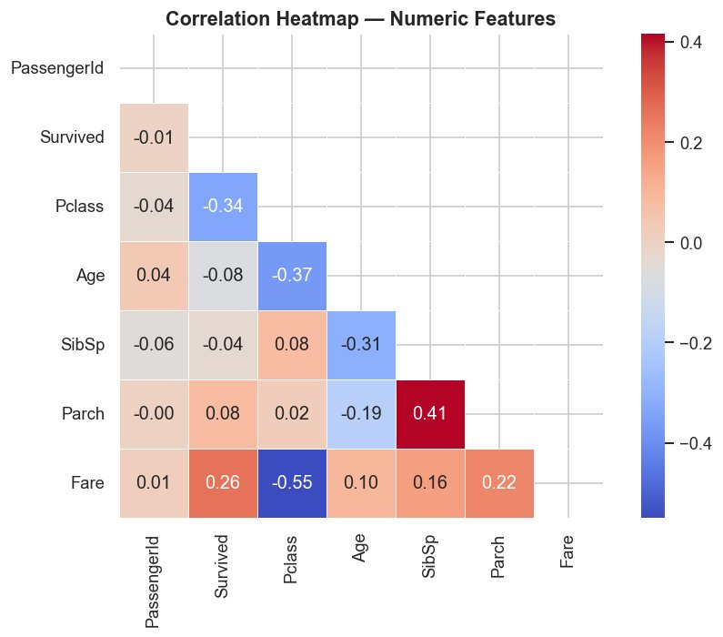
Figure 7: Correlation Heatmap — Numeric Features (lower triangle, Pearson r)

4. Data Cleaning & Preprocessing
All cleaning was performed on a copy of the raw Data Frame to preserve the original data for reference. The steps below were applied in order.

4.1 Impute Missing Age

Missing Age values were filled in by using the median age within each group defined by Sex and Class, resulting in six different median values overall.

The idea behind this is simple: age varies a lot depending on both gender and passenger class, so using one overall median wouldn’t give very good estimates for specific groups. By using a median that matches each subgroup, the imputed values are more representative of the actual passengers and help keep the dataset’s structure more realistic. After this step, there were no missing values left in the Age column.

4.2 Impute Missing Embarked
The two missing Embarked values were filled using the mode of the column, which corresponded to Southampton, denoted as 'S'.
Given that only 2 out of 891 records were affected, the choice of imputation strategy carries virtually no practical consequence for downstream modeling. In such cases, mode imputation is both the simplest and the most statistically defensible option, avoiding unnecessary complexity where none is warranted.

4.3 Drop Cabin and Ticket
Cabin was removed from the feature set due to the sheer volume of missing data — 77.1% of records lacked a cabin value, making any imputation attempt likely to introduce more noise than signal.

Ticket numbers, while alphanumeric and superficially varied, carry no direct predictive information in their raw form. Furthermore, whatever group-travel signal they might implicitly encode is already captured more cleanly and explicitly by the engineered Family Size feature, making their retention redundant.
Three new features were created to enrich the feature set beyond the raw columns.

5.1 Title (extracted from Name)
A regular expression extracted the honorific title from each passenger's full name. Titles encode both gender and social status in a single variable, making them more information-dense than Sex alone.
Action | Titles Affected
Collapsed to 'Rare' | Lady, Countess, Capt, Col, Don, Dr, Major, Rev, Sir, Jonkheer, Dona
Normalised (French to English) | Mlle -> Miss, Ms -> Miss, Mme -> Mrs

Final title categories: Mr, Mrs, Miss, Master, Rare. The Name column was then dropped.

5.2 FamilySize and IsAlone
Research on the Titanic shows that survival outcomes are non-linear with family size. Solo travellers and very large families (5+) had lower survival rates, while small family groups (2–4) tended to fare better.

5.3 AgeGroup
Continuous Age was binned into five life-stage categories to capture non-linear age effects (e.g., children were prioritised during evacuation).
Age Range | Label
0 – 12 | Child
12 – 18 | Teen
18 – 35 | Adult
35 – 60 | Middle-aged
60 – 100 | Senior

5.4 Label Encoding
LabelEncoder converted categorical string features (Sex, Embarked, Title, AgeGroup) into integer codes so scikit-learn models can process them. This is directly appropriate for tree-based models. For Logistic Regression, ordinal encoding may introduce unintended ordering; however, the small cardinality of each feature limits the practical impact.

Final Feature Set (11 features)
Pclass, Sex, Age, SibSp, Parch, Fare, Embarked, Title, FamilySize, IsAlone, AgeGroup
PassengerId was excluded as it is a row index with no predictive value.

6. Predictive Modeling

Train / Test Split
The cleaned dataset was split 80% training / 20% test using stratify=y to preserve the original 38.4% survival rate in both subsets. random_state=42 ensures reproducibility.
Split | Samples
Training | 712
Test | 179

Model 1 — Logistic Regression
Logistic Regression serves as the interpretable baseline. It models the log-odds of survival as a linear combination of the input features.
Hyperparameter | Value | Reason
max_iter | 500 | Default 100 iterations can be too few; 500 ensures convergence
random_state | 42 | Reproducibility

Model 2 — Random Forest Classifier
Random Forest is an ensemble of 200 decision trees, each trained on a random bootstrap sample and a random subset of features at each split. Final predictions are by majority vote.
Hyperparameter | Value | Reason
n_estimators | 200 | 200 trees provides a stable ensemble without excessive computation
max_depth | 6 | Limits tree depth to reduce overfitting while capturing non-linear interactions
random_state | 42 | Reproducibility
n_jobs | -1 | Use all available CPU cores for parallel training

7. Model Evaluation

7.1 Accuracy
Model | Accuracy
Logistic Regression | 81.0%
Random Forest | 83.2%

Random Forest outperformed Logistic Regression by 2.2 percentage points.

7.2 Confusion Matrices
Results on the 179-sample held-out test set:
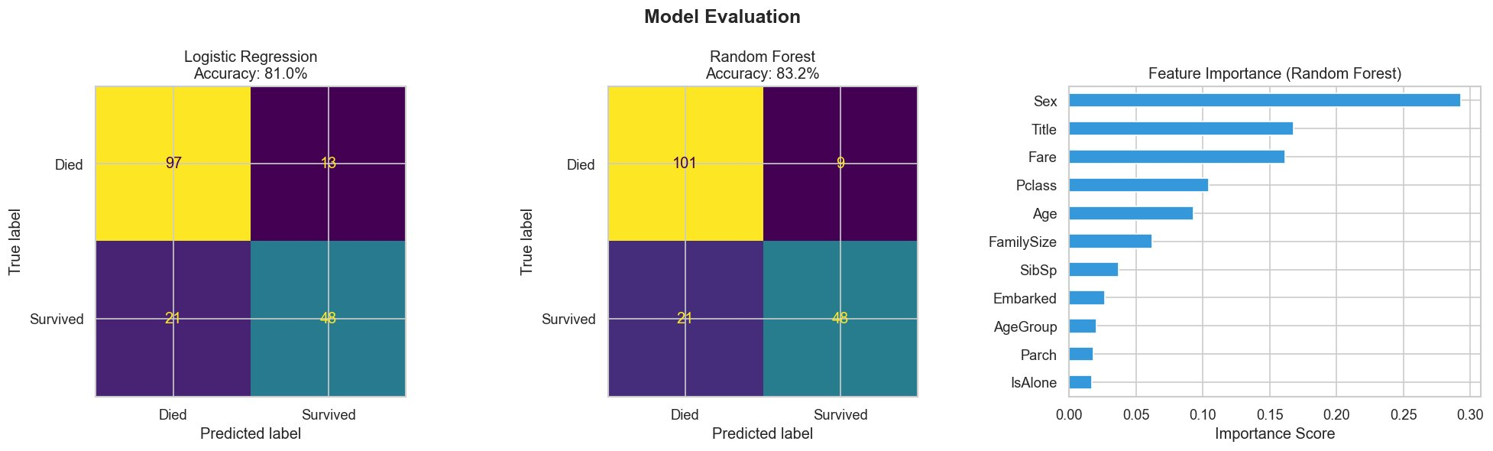
Figure 8: Model Evaluation — Confusion Matrices and Feature Importance (Random Forest)

Logistic Regression
 | Predicted: Died | Predicted: Survived
Actual: Died | 97 (True Negative) | 13 (False Positive)
Actual: Survived | 21 (False Negative) | 48 (True Positive)

Random Forest
 | Predicted: Died | Predicted: Survived
Actual: Died | 101 (True Negative) | 9 (False Positive)
Actual: Survived | 21 (False Negative) | 48 (True Positive)

Key observations:
- Random Forest reduced false positives from 13 to 9, reflecting better precision on the Survived class.
- Both models produced identical false negative counts (21), meaning they missed the same number of actual survivors.
- Both models correctly identified 48 true survivors, so neither has an advantage in recall for the positive class.

7.3 Feature Importance (Random Forest)
Importance is measured by the mean decrease in Gini impurity across all 200 trees. Higher scores indicate features used more consistently at high-gain splits.
Rank | Feature | Approx. Importance Score
1 | Sex | ~0.29
2 | Title | ~0.17
3 | Fare | ~0.16
4 | Pclass | ~0.14
5 | Age | ~0.12
6 | FamilySize | ~0.07
7 | SibSp | ~0.03
8 | Embarked | ~0.02
9 | AgeGroup | ~0.02
10 | Parch | ~0.01
11 | IsAlone | ~0.01

Among all predictors, Sex dominates with an importance score of approximately 29%, a finding entirely consistent with the EDA observation that female passengers survived at nearly four times the rate of males.
Title emerges as the second most influential feature at around 17%. Its strength lies in the fact that it simultaneously encodes both gender and social standing, offering a level of granularity that the binary Sex variable alone cannot capture.
Taken together, Fare and Pclass contribute roughly 30% of the model's predictive power, reinforcing the strong socioeconomic survival gradient that was already evident during exploratory analysis.
Age adds meaningful signal at approximately 12%, which in turn validates the group-median imputation strategy applied during preprocessing, as well as the decision to bin continuous age into life-stage categories via AgeGroup.
Finally, features such as IsAlone, Parch, and AgeGroup each carry relatively little individual weight, yet they should not be dismissed outright — their collective contribution provides supporting context that helps the model refine predictions at the margin.

8. Summary & Conclusions

Project Summary Table
Item | Detail
Dataset | Titanic training set — 891 passengers, 12 raw columns
Missing data — Age | Group-median imputation (by Sex x Pclass subgroups)
Missing data — Embarked | Mode imputation (2 rows)
Dropped columns | Cabin (77% missing), Ticket (no signal), Name (after title extraction)
Engineered features | Title, FamilySize, IsAlone, AgeGroup
Final features used | 11
Train / Test split | 80% / 20%, stratified by survival label
Baseline model | Logistic Regression — 81.0% accuracy
Best model | Random Forest — 83.2% accuracy
Top 3 predictors | Sex, Title, Fare

The analysis shows that gender was the strongest factor influencing survival. Female passengers had a survival rate of 74.2%, compared to only 18.9% for male passengers, reflecting the “women and children first” policy during the evacuation.
Socioeconomic status also played a major role. First-class passengers had a survival rate of 63.0%, which is more than double that of third-class passengers at 24.2%. This likely reflects both better access to lifeboats and the fact that lower-class cabins were located farther from the deck.
From a modeling point of view, feature engineering clearly helped improve performance. New variables like Title and Family Size were among the top features in the Random Forest model, showing that well-designed features can capture useful information beyond the original dataset.
When comparing models, Random Forest performed better in terms of precision, reducing false positives from 13 (Logistic Regression) to 9. This suggests it is better at capturing more complex, non-linear relationships between features.
However, both models had similar recall performance, each producing 21 false negatives, meaning they missed the same number of actual survivors. This indicates that correctly identifying survivors is still challenging. Future improvements could include adjusting classification thresholds, adding better family-related features, or trying more advanced ensemble methods.

