

Application to Establish or Alter a Memorial or Place of Interment
Revised November 2019
Instructions for completing this form:

- Section A must be completed by the Monumental Mason/Person Conducting Works.
- Section B must be completed in all cases by the Applicant.
- Section C must be completed by the Applicant.
- Section D must be completed in all cases.
- The completed Application Form must be accompanied with payment of the relevant Cemetery Trust fee.
- Any supporting documentation to the application should be attached to this Application Form.

NAME OF CEMETERY:

Section A – to be completed by Monumental Mason/Person Conducting Works

Monumental Mason/Person Conducting Works

Business Name: Representative:
Address:
Phone Number: email:
Acting as agent on behalf of and with authority of the Holder of the Right of Interment hereby apply for approval for:
(Tick appropriate box)
Additional Inscription;
Plaque – is base to be included Yes No
Renovation of Monument;
Headstone and Base;
Headstone, Kerb and Ledger/or Concrete Top and Chips; Cemetery Fee: $
Chapel, Kerb and Ledger or Concrete Top and Chips;
Chapel, Canopy, Kerb and Ledger;
Other (Specify)
On the site of the late
Site Location
I agree that I have read, understood and acknowledge at all times to comply with: (i) the terms and conditions under which the Trust approves this application (if the application is approved); and (ii) Australian Standard AS 4204 – 2019 (Headstones and Cemetery Monuments) and AS 4425 – 1996 (Above-ground Burial Structures), in relation to the proposed works.
I agree that such works are to be carried out in accordance with the provisions of the Cemeteries and Crematoria Act 2003, Cemeteries and Crematoria Regulations 2015, the Occupational Health and Safety Act 2004, the plans and specifications attached to this application and in compliance with any directions of the Trust at no cost to the Trust, as detailed on the Trust’s approval of this application (if any) or as may be advised by the Trust from time to time. I agree to strictly adhere to the requirements of any Cemetery Trust approval including any terms and conditions of approval, or any requirements to provide evidence of construction compliance as and when required. I accept that the Cemetery Trust may cancel the approval at any time if the terms and conditions of the approval have not been complied with. I understand I may be asked for proof of current licenses, third party and indemnity insurance.
Signature of Monumental Mason or person conducting works: _____________________________________________________
Date / /

Section B - to be completed by Applicant

(B-1) Applicant Details

Name of person making this application:
Address:
Are you the Holder of the Right of Interment?
Yes (if Yes, complete Section C - Declaration)
No (If No, complete Section C - Declaration and Section C - Supporting Evidence)

(B-2) If no, provide the details of the Holder(s) of the Right of Interment, and answer the following questions.
Name:
Address:
Telephone:
Has the Holder of the Right of Interment been informed of this application? Yes No
If no, please provide reasons why.

If yes, does the Holder of the Right of Interment consent to this application (written permission required)? Yes No

A Statutory Declaration from the Right of Interment Holder, or other supporting documentation as directed by the Trust from time to time will be required where the Applicant is not the Holder of the Right of Interment.
Important - Maintenance of Memorial and Costs
Under the Cemeteries and Crematoria Act 2003, the Holder of the Right of Interment is responsible for maintaining any memorial that has been established on their place of interment in a safe and proper condition. The Trust is empowered to issue directions in relation to the maintenance of memorials and if the Holder of the Right of Interment fails to take appropriate action requested, the Trust may take its own action and any costs and expenses incurred by the Trust may be recoverable from the Holder of the Right or Interment.
Below to be completed by Applicant & Monumental Mason/Person Conducting Works

The parties to this application listed in Sections A and B submit this application for approval in accordance with section 98 of the Cemeteries and Crematoria Act 2003 and hereby agree to adhere to and be bound by both the terms and conditions contained in this application and the terms and conditions of any Trust approval:
Signature of Monumental Mason/Person Conducting Works |  | Signature of Applicant
Name (PLEASE PRINT) |  | Name (PLEASE PRINT)

Section C - to be completed by Applicant

Declaration

Declaration by the Applicant (the person(s) named in Section B of this application):

I consent to the work described in this application being carried out and declare that I have read and understood this application and that the information in this application is true and correct. I understand the Trust may need to contact me directly to confirm details such as grave location or application details, and I acknowledge as the Holder of the Right of Interment, or on behalf of the Holder of the Right of Interment, the responsibility under the Cemeteries and Crematoria Act 2003 to maintain the memorial/place of interment in a safe and proper condition once completed and to keep the Trust advised of any change in the Holder of the Right of Interment's contact details. I acknowledge and agree that submitting this application does not: (i) constitute the Trust's approval of the application, which may be refused for any reason the Trust thinks fit under the Cemeteries and Crematoria Act 2003; (ii) create a binding contract or agreement between me and the Trust; or (iii) impose any liability on the Trust in relation to the proposed works I have requested be undertaken by the party listed in Section A of this application. The Trust's responsibility is to ensure the works conform with the Trust's terms and conditions of approval and/or Australian Standard AS 4204: 2019 Headstone and Cemetery Monuments. I release the Trust from any claim I may have or may have had against the Trust in relation to or connected with the works to the maximum extent permitted by law.

I acknowledge, warrant and declare that in submitting this application, I: (i) am the Holder of the Right of Interment in relation to the site location; or (ii) (if applicable) have the written consent of the Holder of the Right of Interment in accordance with section 98(2)(c) of the Cemeteries and Crematoria Act 2003. I release the Trust, including its members, employees, officers, agents and contractors, from any and all liability in connection with the information I have submitted in this application and agree to indemnify, and will keep indemnified, the Trust, including its members, employees, officers, agents and contractors, in respect of any claim, action, suit, proceeding, demand, damage, penalty, cost or expense however arising, by any person arising as a direct or indirect result of, or in connection with the information I have submitted in this application.

Supporting evidence - ROI

Please arrange for Holder of the Right of Interment to provide a Statutory Declaration.

STATUTORY DECLARATION IS ATTACHED Yes No

Signature of Applicant: ____________________________________________________ Date: / /

PRIVACY STATEMENT
If you wish to receive information about memorialisation goods and services please check this box
Any personal information you provide in your application will be treated in accordance with the principles set out in the Privacy and Data Protection Act 2014. You may request access to the information we hold about you and you may request its correction if necessary. The information you provide is required to enable us to process your application and inform you of matters concerning it. We also need the information to perform our functions, comply with our obligations and exercise our rights under the Cemeteries and Crematoria Act 2003. Except for the information you are required to submit under that legislation, you are not obliged to provide any personal information. However, should you choose not to provide this information, we may not be able to process your application or provide the services for which the information is required. Under the Cemeteries and Crematoria Act 2003, we are also required to keep records containing certain information regarding interments, cremations and rights of interment. Members of the public are entitled to access those records.

Section D

This Application Must Include:
- Plans and specifications drawn to scale and fully dimensioned as agreed between the Applicant and the Monumental
Mason/Person conducting the works. The scale is to be specified and descriptions are to be provided in block letters in English.
- Details of all materials to be used and surface finishes.
- Details and dimensions of ornaments and attachments to the memorial.
- Details and dimensions of dowel holes and dowels, including materials to be used and fixatives.
- A copy of the inscription.
- A translation in English in block letters must also be included if the inscription is to be in another language.

In addition to the above requirements, a Trust may request an application include photographs indicative of the same or substantially similar memorial to demonstrate evidence of the proposed works.

Under section 99 of the Cemeteries and Crematoria Act 2003, the Trust may also withhold its permission if the intended work is considered by the Trust to be inappropriate, unsafe or dangerous.

The Following Dimensions Must Be Supplied – (if applicable)
OVERALL DIMENSIONS -
Height: mm
Length: mm (Ashlar measurements are to be included)
Width: mm (Ashlar measurements are to be included)

The Trust reserves the right to cancel the approval and/or direct that the memorial/place of interment be modified or dismantled and removed where:
- The Applicant in Section B or Person Conducting the Works in Section A breach or fail to comply with the terms and conditions of the Trust's approval under the Cemeteries and Crematoria Act 2003, and/or Australian AS 4204: 2019 Headstone and Cemetery Monuments;
- The stated dimensions on the application or the memorial/place of interment as constructed are not in accordance with rules, regulations or directions of the Trust or adopted from time to time;
- The memorial/place of interment is not constructed in the exact position as directed by the Trust;
- Monumental construction works are not completed within 12 months of the date of the approval; or
- As directed by the Trust

The Work: AS 4204:2019 Headstones and Cemetery Monuments

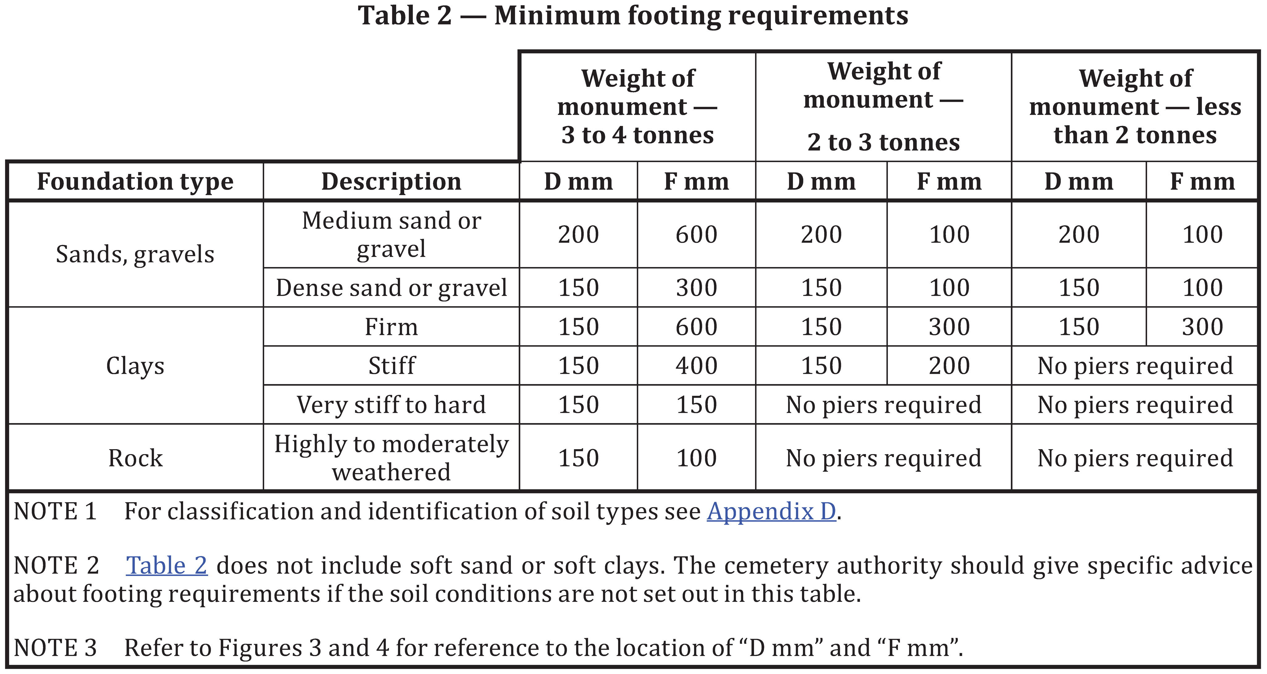

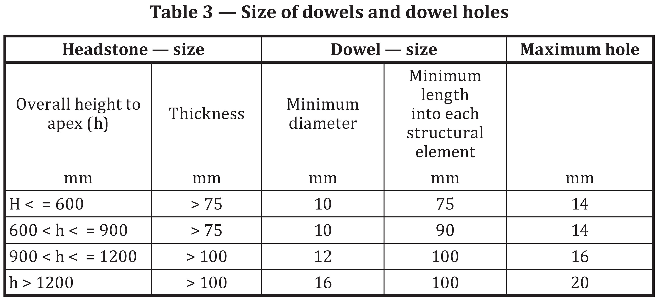

N.B. Dowels: Must be marine grade stainless steel and meet Australian Standard 4204 - 2019. Foundations to be left a minimum of three days before monumental work is erected thereon. Notwithstanding the provision that the footings of any memorial must be in accordance with the Australian Standard 4204 – 2019 (Headstones and Cemetery Monuments), naturally over time a memorial may demonstrate movement subject, but not limited to, the memorial, the size and varying soil conditions of the site location or other unforeseeable circumstances (for example extreme weather conditions).

Appendix D

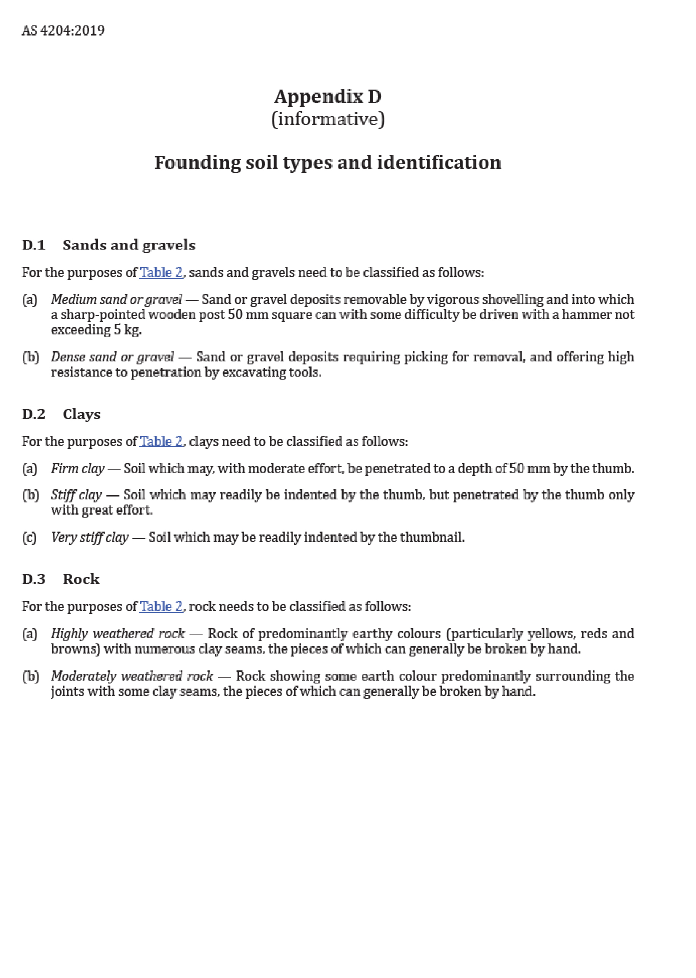
Figure 3
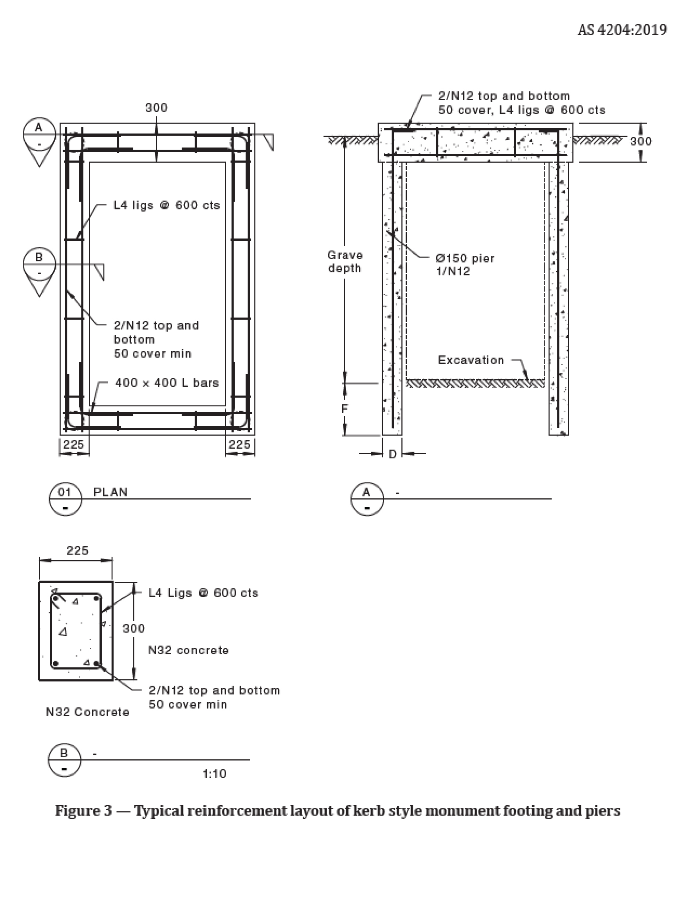

Figure 4
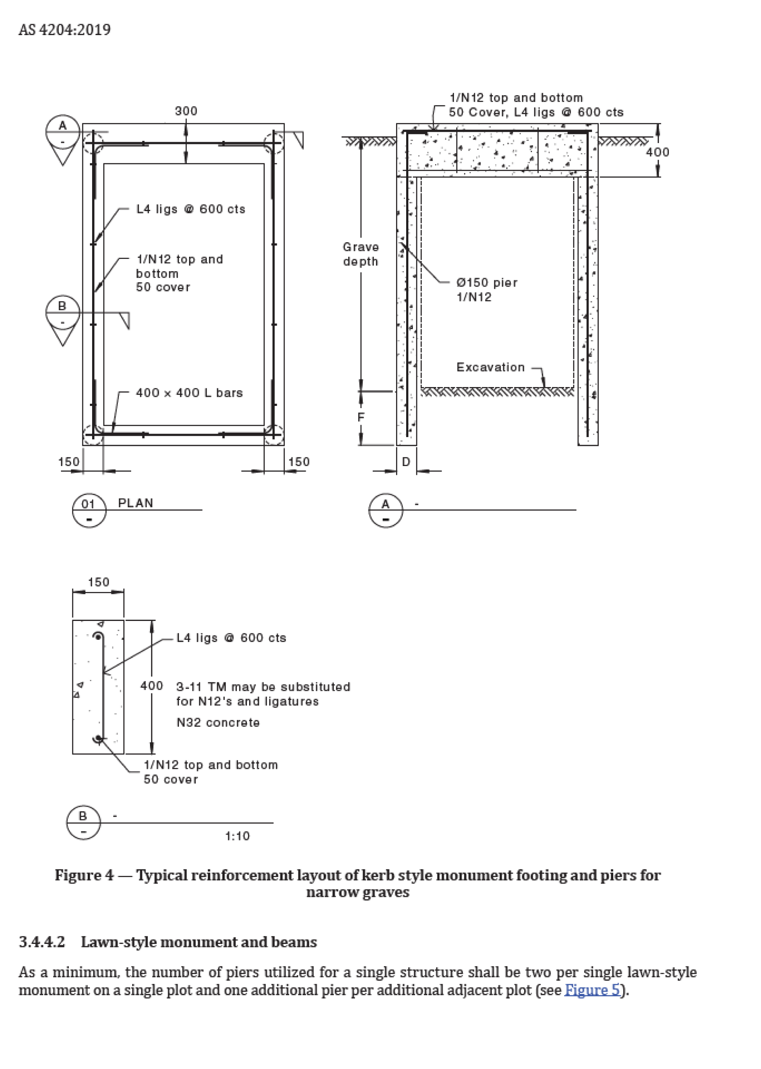

PLANS
(To include front elevation, side elevation & rear elevation)

Inscription | Translation
Name of translator and contact details:
Cemetery Trust Fee
The relevant fee accompanying this application relates, but is not limited to, administrative costs incurred by the Trust for review, process and acceptance/rejection of this application and in undertaking audits (if any) or supervision of the person(s) conducting the works in accordance with the Trust's requirements.
Construction Compliance
The Trust or Applicant may require the person conducting the works to provide the Trust date stamped images (to the satisfaction of the Trust) if and when required by Trust. This is recommended at the time of the following construction phases:
- Excavation completion to demonstrate appropriate depth of to appropriate requirements and/or AS 4204: 2019, Scale measures (e.g. tape measure) should be used to indicate depth;
- Dowel stage to demonstrate evidence of dowels meeting appropriate requirements, and/or Australian Standard 4204 – 2019; and
- Final completion to demonstrate the site location has been left in an appropriate manner required by the Trust.
The above requirements are considered advisable particularly in circumstances where the person conducting the works is providing footings for a monument however, such evidence of construction compliance is at the discretion of the Trust. The Trust reserves the right to require additional evidence of construction compliance in accordance with any approval of this application or if and when required by the Trust.
Audit
The Trust may, in its absolute discretion, conduct random audits or inspections at the site location from time to time.

THIS DOCUMENT AND THE INFORMATION PROVIDED IN IT IS INTENDED AS A GUIDE ONLY. WHILE CARE HAS BEEN TAKEN IN THE PREPARATION OF THIS DOCUMENT, THE CEMETERIES AND CREMATORIA ASSOCIATION OF VICTORIA MAKES NO REPRESENTATION OR WARRANTY AS TO, OR ACCEPTS ANY RESPONSIBILITY FOR, THE ACCURACY, RELIABILITY, COMPLETENESS OR CURRENCY OF THE INFORMATION, ITS USEFULNESS IN ACHIEVING ANY PURPOSE OR YOUR RELIANCE UPON IT. CEMETERY TRUSTS SHOULD SEEK APPROPRIATE PROFESSIONAL ADVICE IF RELYING ON OR INTENDING TO USE THIS DOCUMENT.
CEMETERY OFFICE USE:
Application approved/not approved on the by the Trust’s representative
Subject to the following special conditions:
• Foundations to be as per above requirements or as directed
• Other (specify)

cont…

Date of application submitted/approved / / Signature

Date of commencement / / Signature

Date memorial delivered / / Signature

Date memorial installed / / Signature

Date of foundation inspection / / Signature

Date(s) of construction inspection / / Signature

Date of completion of memorial/place
of interment / / Signature
THIS DOCUMENT AND THE INFORMATION PROVIDED IN IT IS INTENDED AS A GUIDE ONLY. WHILE CARE HAS BEEN TAKEN IN THE PREPARATION OF THIS DOCUMENT, THE CEMETERIES AND CREMATORIA ASSOCIATION OF VICTORIA MAKES NO REPRESENTATION OR WARRANTY AS TO, OR ACCEPTS ANY RESPONSIBILITY FOR, THE ACCURACY, RELIABILITY, COMPLETENESS OR CURRENCY OF THE INFORMATION, ITS USEFULNESS IN ACHIEVING ANY PURPOSE OR YOUR RELIANCE UPON IT. CEMETERY TRUSTS SHOULD SEEK APPROPRIATE PROFESSIONAL ADVICE IF RELYING ON OR INTENDING TO USE THIS DOCUMENT.

