**Monument**

1. Standard doors sizes as below,

|  |  |
| --- | --- |
| Kerb Door ( FAWKNER )： | 460*300 mm |
| Kerb Door ( SPRINGVALE & BUNURONG )： | 500*400 mm |
| Headstone Cabinet Door: | 950*300 mm |
| Candle Box Door： | 330*280 mm |
| Arch Door: | 115*330 mm |

1. Attention for the chapel door orders, (A) is correct design for door.

If you have design (B), we must order the door from Castagna then Andrew requires to measure the detail size on site with extra cost, AUD1,350+GST is minimum cost.

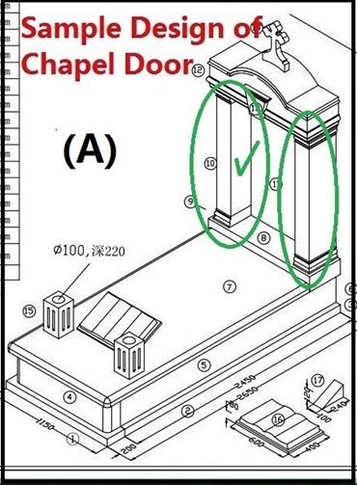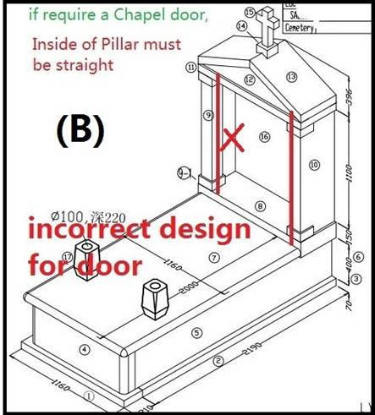

1. Standard desktop for both Springvale cemetery and Bunurong cemetery:

1100 x 500 x 150mm, 0.0825CBM,

The material is only limited in 3 colours, which are Black, Blue Pearl and TS Red. Although, Quotation = Material usage  x (0.15-0.3 cbm Price), please note that we have a minimum price for this desktop which is AUD 1,800.

1. ‘Shanxi Black’, ‘Black SB’ , ‘DS654’, ‘CH JUPURANA’ run out, no more quotes.
2. ‘ Euro Grey’, ‘ Regel green’ , quote Lawn or Plaque only.
3. ‘ Paradiso’ and ‘Black G20’ is back.

** We have a few different BLACK materials in use, you must state which ‘black’ in your drawing, such as Shanxi Black, Black one, Black TZ…etc. **

1. Please do not use Black & Emerald Pearl as Ashlars / Bases in Springvale _SONGHE.
2. Please avoid to use Black & Emerald Pearl as Ledgers.
3. For the standard monument quotes, please make the stone thickness 70mm to minimize the stone cost,  the stone parts are as below,

* Ledger
* Headstone   (including free standing and ≤ 900mm high)
* Front Kerb
* Back Kerb

1. Roof and Headstone, please note some max sizes as below,

* Asian Chapel Roof, the maximum width is ≤ 300mm, maximum thickness is ≤ 250mm
* The maximum height of All our Headstone is ≤ 1200mm

1. Double lawn foundation,

Do not fully paved with concrete, border only as the below sample shown,

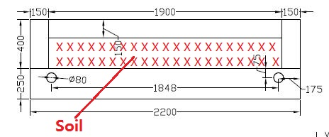

1. Lotus Garden Foundation,

Please note that we’re required to do inner foundation for Double or Triple monuments in Springvale _Lotus Garden.

Do not forget to charge the FOUNDATION FEES.

This is double grave layout as below shown,

