Note:

## Dynamic cross-cultural competencies and global leadership effectiveness

Both selection and development are critical for building a pipeline of effectiveglobal leaders.

### The purpose of the article

The primary question to be examined in this study is how these dynamic cross-cultural competencies are created or shaped –whether through individuals’ immutable personality traits orcross-cultural experiences (or both). Specifically, this study will examine the roles of experiential opportunities, organizationinitiated cross-cultural experiences (i.e., those found in leadership development programs) and non-work cross-cultural experiences.

1. Global leadership competencies and global leadership task performance

Predicting performance on global leadership tasks (e.g., interacting with external clients from other countries, developing a strategic business plan on a worldwide basis, managing a budget on a worldwide basis, managing foreign suppliers or vendors) is the ultimate goal for this study of global leadership development

Dynamic cross-cultural competencies

Dynamic cross-cultural competencies are those that can be acquired or enhanced through training and development

(1) reduced ethnocentrism or valuing cultural differences,

(2) cultural flexibility or adaptation

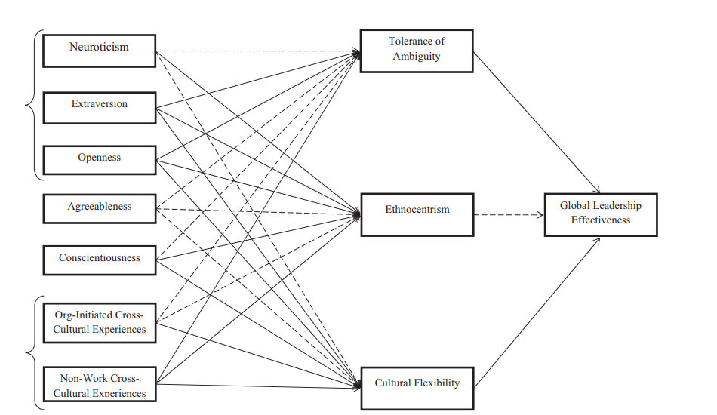(3) tolerance of ambiguity. These dynamic competencies have been identified as some of the competencies related to cross-cultural knowledge absorption (Kayes, Kayes, & Yamazaki, 2005), predictors of performance among expatriates (Shaffer et al., 2006) and the skills of global leaders (Maznevski & DiStefano, 2000).

Ethnocentrism is an individual’s nationalistic self-centeredness, harmful to company

work cross-cultural experiences

Reduced ethnocentrism, increased cultural flexibility, and greater tolerance of ambiguity) and, in turn, these competencies will improve their success in global leadership activities.

Non-work cross-cultural experiences

Family parttern

Personality characteristics

In addition to the dysfunctional experiences, another possible reason for the mediocre results in global leadership development programs is that cross-cultural developmental experiences, on their own, might not be sufficient to increase global leadership competencies.

1.3.1. Openness to experience Openness is the personality characteristics relating to the extent to which individuals are original, innovative, curious, and willing to take risks (Costa & McCrae, 1992).

1.3.2. Extraversion

Extraversion is the degree to which individuals are sociable, talkative, and seek social activities (Costa & McCrae, 1992). Following again from the social learning theory and contact hypothesis extroversion should predispose individuals to engage in cross-cultural interactions when involved in cross-cultural experiences. Extroverts have a greater natural ease with social demands and may be more willing to put forth the effort necessary to interact effectively with peers from different countries. In the training and development literature extroversion tends to be associated with a learning goal orientation (Zweig & Webster,2004).

1.3.3. Neuroticism

In contrast, those lower on this trait can be characterized as calm, self-confident, and cool-minded (Barrick & Mount, 1991). In an international context, those with lower neuroticism are more likely to have the ability to manage stress and anxiety often associated with living and working in new cultural environments such as the stress related to making new friends, and to succeed professionally.

Result：

Similarly, we found the positive influence of organization-initiated

experiences on cultural flexibility (B = .04, p < .05)

and tolerance of ambiguity (B = .06, p < .01).

Neuroticism is positively related to ethnocentrism, negatively related to cultural flexibility, and negatively related to tolerance of ambiguity As presented in Table 2, extraversion and openness to experience were significantly related to ethnocentrism

**Data Re-Identification** is the practice of matching [anonymous data](https://en.wikipedia.org/wiki/Data_anonymization) (also known as de-identified data) with publicly available information, or auxiliary data, in order to discover the individual to which the data belongs to. This is a concern because companies with [privacy](https://en.wikipedia.org/wiki/Privacy_(internet)) [policies](https://en.wikipedia.org/wiki/Policy), [health care](https://en.wikipedia.org/wiki/Health_care) providers, and [financial institutions](https://en.wikipedia.org/wiki/Financial_institution) may release the data they collect after the data has gone through the de-identification process.[[1]](https://en.wikipedia.org/wiki/Data_Re-Identification#cite_note-auto-1) The de-identification process involves masking, generalizing or deleting both direct and indirect identifiers; the definition of this process is not universal,

NORA

A new data analysis technology called nonobvious relationship awareness (NORA) has given both the government and the private sector even more powerful profiling capabilities. NORA can take information about people from many disparate sources, such as employment applications, telephone records, customer listings, and “wanted” lists, and correlate relationships to find obscure hidden connections that might help identify criminals or terrorists