Progress Report I

Unilever - Explore the National Health and Nutrition Examination Survey

Siyu Shen (ss6669), Shiyuan Xu (sx2311), Tianyu Han (th2987), Xinran Chen (xc2660), Ying Hong (yh3538)

Oct. 28, 2023

**1 Project Overview**

Skin diseases, such as psoriasis, not only impact the physical health of millions worldwide, but they also bear significant psychological and social implications for those affected. By researching skin diseases, we seek to understand their underlying causes, progression, and impact on quality of life. Delving into this realm offers opportunities to develop better diagnostic tools, more effective treatments, and comprehensive care strategies. Furthermore, the insights gained can shed light on the complex interplay between genetics, environmental triggers, and immune system responses, which can be pivotal for medical advancements beyond dermatology.

With the goal of understanding skin diseases, we explored datasets from the National Health and Nutrition Examination Survey (NHANES), a comprehensive initiative that provides detailed health and nutritional data from a diverse cross-section of the U.S. population. The NHANES datasets offer a wealth of information, including but not limited to, demographic details, medical histories, and specific dermatological assessments. Recognizing the profound impact of psoriasis on a significant portion of the population, we've chosen to begin our research by investigating this condition with the help of classification models. By starting with psoriasis, we hope to uncover patterns, trends, and potential risk factors, paving the way for a deeper understanding of skin diseases as a whole.

**2 Re-implementation of past NHANES study**

To gain more experience working with NHANES data before delving into our psoriasis study, we took the advice of our mentor and decided to reimplement a past study focusing on the relationship between bone mineral density and Vitamin E. Since Vitamin D level is an important feature that is commonly associated with psoriasis, the re-implementation of a past study on it will help us gain insights into our own study as well.

**2.1 Exploratory Data Analysis**

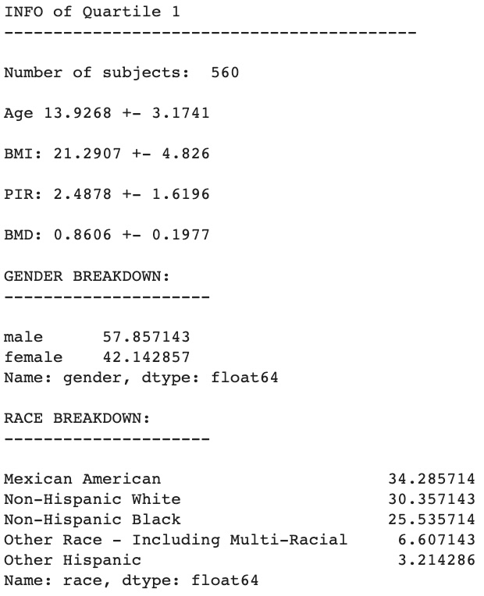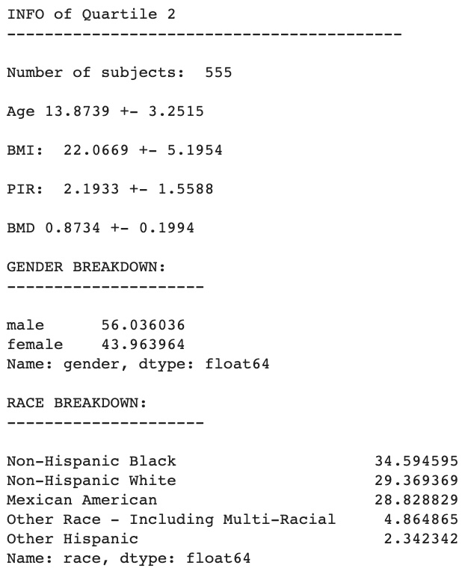

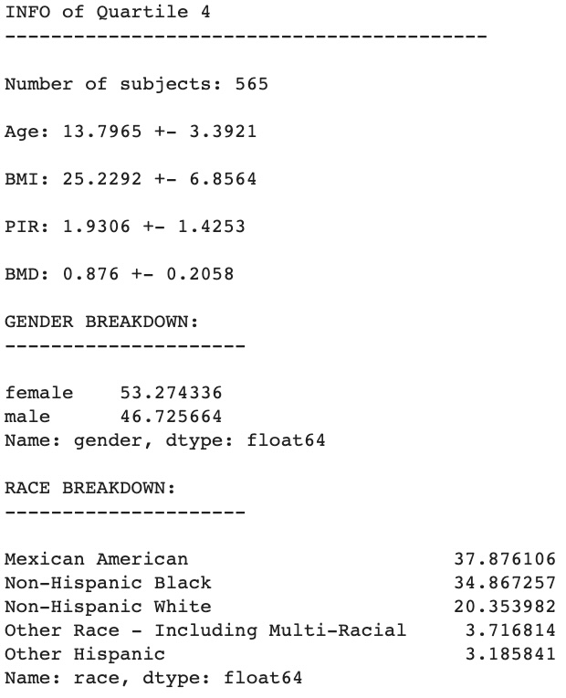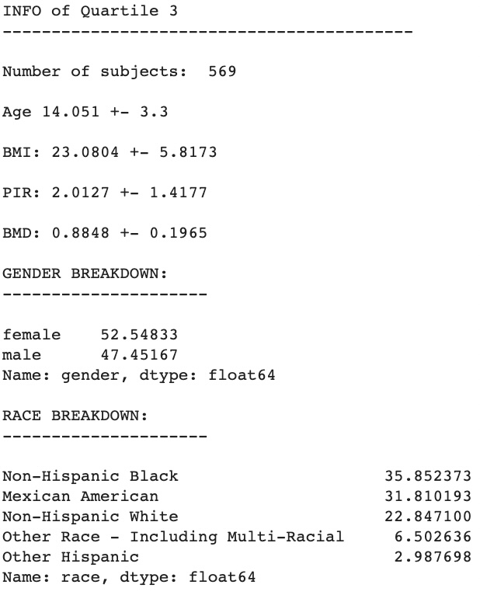

A series of preprocessing steps were conducted after we imported the NHANES data in XPT format. We joined the Vitamin E table and the BMD (bone mineral density) table with the demographic table using the unique survey participant ID. Then, we performed baseline characteristics analysis based on the quartile of alpha-tocopherol (a type of Vitamin E) to gain more understanding regarding the distribution of the features across the four quartiles. The four quartiles are created as follows:

***Categories 1: 7.5–15.4 umol/L***

***Categories 2: 15.4–17.6 umol/L***

***Categories 3: 17.6–20.4 umol/L***

***Categories 4: >20.4 umol/L***

We can see that there are more female participants in all four categories. Meanwhile, in the racial breakdown, Mexican Americans have the highest percentage in Category 1 and Category 4 while non-Hispanic blacks are the most prevalent race constituting Category 2 and Category 3. From the characteristic analysis, an increasing trend of BMI from Category 1 to Category 4 can also be witnessed, indicating that each individual’s alpha-tocopherol level might have a positive correlation with his/her body mass index.

**2.2 Regression Analysis**

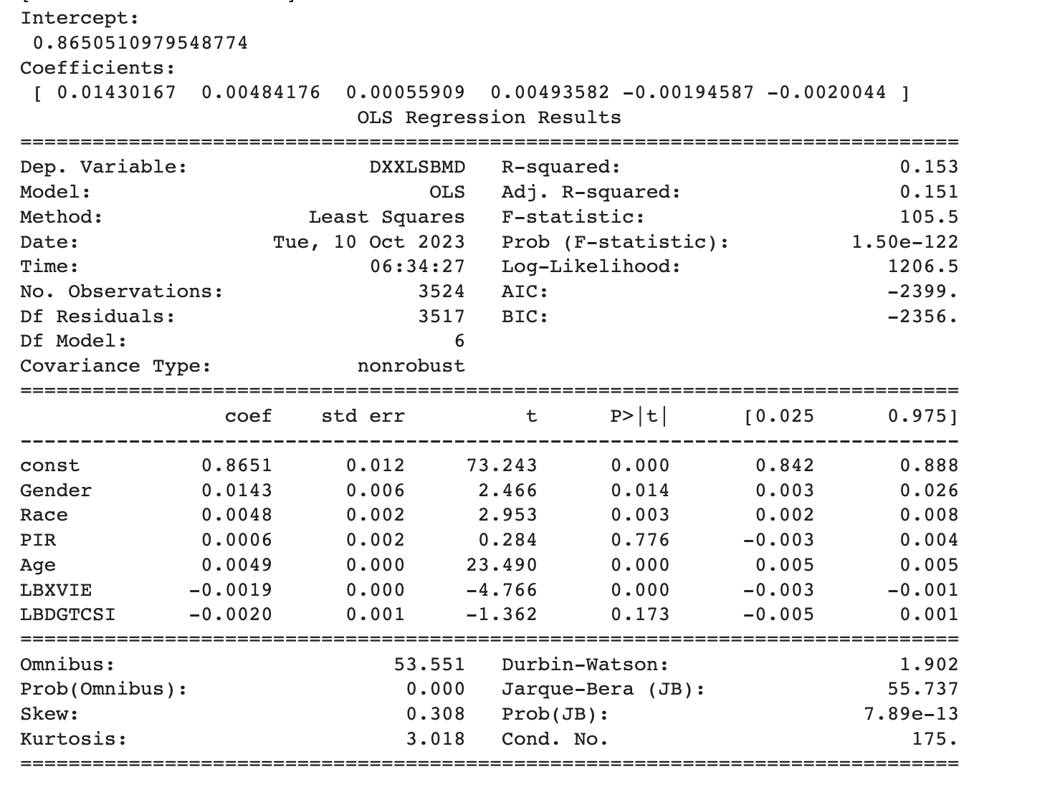

After exploratory analysis, a regression model is used to predict the influence of alpha-tocopherol and gamma-tocopherol (LBXVIE & LBDGTCSI) on the bone mineral density. We have also included demographic variables (gender, race, PIR, age) to adjust the linear regression. The resulting table indicates a negative correlation between alpha-tocopherol and BMD and also a negative correlation between gamma-tocopherol and BMD. This result aligns with the domain knowledge that bone mineral density should be inversely correlated with the Vitamin E level of the patient. In this reimplementation, we are able to find the inverse correlation present in the past study; however, due to a smaller sample size, we are unable to further adjust our regression model. Nevertheless, this recreation still serves as a solid foundation from where we can begin our study on psoriasis.

**3 Psoriasis Data Overview, EDA, and Data Cleaning**

Followed by the reimplementation of existing study, we want to focus on finding new lights on possible correlations with skin disease. Psoriasis is a chronic autoimmune skin disorder and it presents a complex interplay of genetic and environmental factors. While the precise cause of this disease is unclear, several potential influencing factors such as vitamin intake and dietary intake have been identified in past research. Thus, our next stage of exploring the NHANES comes with the goal of discovering any insights associated with psoriasis.

After exploring the NHANES dataset, we identified data containing information on psoriasis from the 2003-2004 Examination and Dermatology questionnaire. The examination dataset contains three readers’ results on respondents’ psoriasis presence and the questionnaire asks about whether the respondent has ever been told by a doctor that they had psoriasis. The criteria we set for the response variable “Psoriasis” is if any one of three readers gives positive results or the respondent used to have psoriasis according to the questionnaire, the label for psoriasis on the subject would be positive. Then, in order to gather as many skin disease related features as possible, we researched psoriasis and its common co-occurrence. Based on these inferences, we explored the NHANES dataset and prepared features spanning 10+ datasets. The main categories of these variables include demographics (e.g. ages, gender, race, bmi), smoking, drinking, dietary, Vitamin intake, other disease conditions etc.

With the initial data cleaning, we had gathered 2198 entries with around 20 features. Since several columns contain missing values, the first feature engineering step is imputation. For numerical values, mean imputation is used for simplicity. For categorical values, bootstrap imputation is employed to fill in missing values based on the observed distribution of non-missing values. On the other hand, collinearity may hinder the model interpretability, so we had also conducted the correlation analysis on the features and removed highly correlated features with correlation greater than 0.8. Here, body measures such as waist and thigh circumference and age measures with high correlation are dropped.

Below is the correlation heatmap of the data. At the initial analysis, there is no straightforward correlation between psoriasis and any other factors we have already identified, and more advanced modeling would be used to shed light on the study.

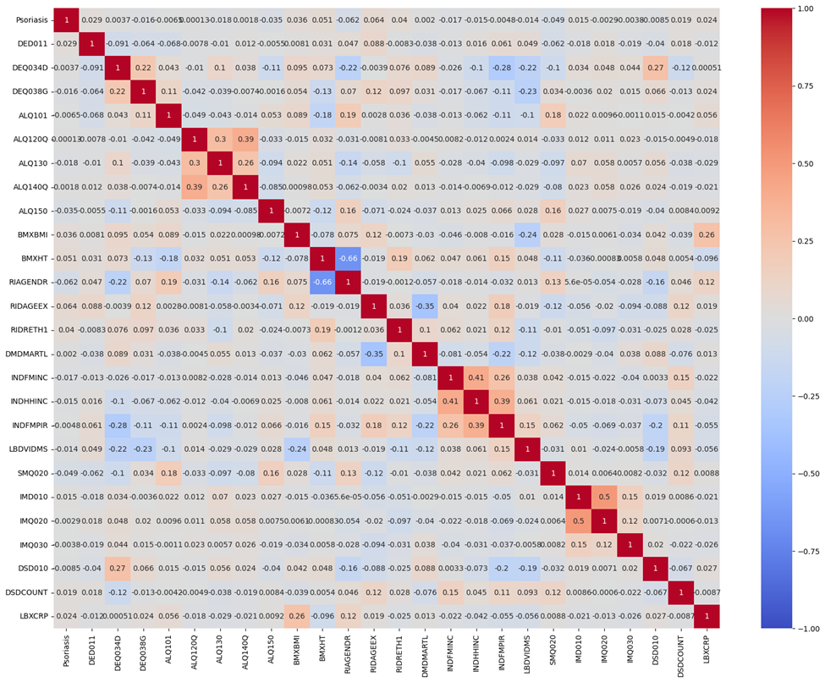

**4 Classification Model Selection**

**4.1 Classification models**

This section aims to discuss the critical progress of selecting suitable machine learning models to complete the task, which is predicting whether a given individual has psoriasis. The successful deployment of such models has the potential to revolutionize the conventional way of diagnosing psoriasis at early stages, allowing for timely treatments and proactive patient care.

The goal of our project was to develop a classification model that can predict the likelihood of psoriasis occurrence in individuals based on the provided data. However, as previously introduced in the data overview section, the amount of data at hand is limited and extremely imbalanced, causing our major concern. Hence, the models of choice must accurately address these issues to meet the desired outcome.

Due to the imbalances of the dataset, accuracy alone does not serve as a sufficient metric. To mitigate the influence of class imbalance on our model selection process, we will also examine the precision and recall of each model candidate to provide a more comprehensive understanding of model performance.

Furthermore, we will mainly focus on the classic machine learning models rather than deep learning models with more sophisticated architectures as the amount of available data cannot support the intensive training process of deep learning.

**4.2 Model Candidates**

For this project, we proposed four classification models:

4.2.1 Logistics Regression

Logistic regression models the probability of a binary outcome, making it suitable for binary classification tasks like psoriasis prediction. Its simplicity is essential for the model’s interpretability, and its low computational complexity expedites the training process. However, the logistic regression model has obvious weaknesses such as its assumption of the linear relationship between the logit and features.

4.2.2 Random Forest

Random Forest is an ensemble learning method that combines multiple decision trees to make predictions. It's known for its versatility and robustness. The model overcomes non-linearity as it can capture complex non-linear relationships in the data while providing a comprehensive and interpretable feature importance measurement. Nonetheless, random forest requires much more computational power than logistic regression, making the training process much more complex.

4.2.3 XGBoost

Similar to the random forest, XGBoost is an ensemble learning method. However, it introduces a gradient-boosting algorithm into the training process, which further improves the model performance. Due to its advanced structure, XGBoost requires even more time in the training process than random forest and has even more hyperparameters to tune.

4.2.4 Support Vector Machine (SVM)

SVM is a strong choice for psoriasis prediction due to its effectiveness with high-dimensional and non-linear data. However, computational intensity and class imbalance require attention, and interpretability may need post hoc analysis.

**4.3 Hyperparameter Tuning**

Logistics Regression: N/A

Random Forest: grid search on

i) Number of estimators

ii) Max depth of each decision tree

iii) Minimum samples required to split

iv) Minimum samples required in each leaf node.

XGboost: grid search on

i) Number of estimators

ii) Max depth of each decision tree

iii) Minimum sum of instance weight needed in a child node

iv) Learning rate

SVM: grid search on

i) Kernel (linear, sigmoid, polynomial)

**4.4 Data Splitting**

The imbalanced nature of the dataset requires more than simply splitting the dataset into training and test subsets. For this project, we decided to oversample the under-represented class and use 20% of the data as a testing set. For the sake of being able to reproduce our result, random_state is set to 42.

**5 Model Performance**

**5.1 Hyperparameters**

We employed a 5-fold cross-validation strategy, which divided the dataset into five subsets, to find the optimal hyperparameters. We evaluated the best hyperparameters for each model.

| Machine Learning Model | Best Hyperparameters Used |
| --- | --- |
| Logistic Regression | {‘C’: 0.1, ‘penalty’: ‘L2’, ‘solver’: ‘liblinear’} |
| Random Forest | {'max_depth': 10, 'min_samples_leaf': 1, 'min_samples_split': 10, 'n_estimators': 100} |
| XGboost | {'learning_rate': 0.1, 'max_depth': 6, 'min_child_weight': 1, 'n_estimators': 300} |
| Support Vector Machine | {'kernel': 'linear'} |

Table: Best hyperparameters

**5.2 Evaluation Metrics**

Since the dataset was imbalanced, we decided to use the following metrics to evaluate model performance. Precision measures the proportion of true positive predictions among all predicted positive instances. It assesses the model's ability to avoid false positives, which is crucial in a medical context. Recall measures the proportion of true positive predictions among all actual positive instances. In a medical context, it is important to obtain a high recall to avoid false negatives, minimizing the cases of psoriasis that are missed. F1-score is the harmonic mean of precision and recall, serving as an important metric when both false positives and false negatives are taken into consideration. The above three metrics are commonly used in imbalanced data classification model evaluation. Receiver Operating Characteristic Curve (ROC) can visualize the trade-off between true positive rate (TPR) and false positive rate (FPR) at different classification thresholds. Confusion Matrix provides insights into the actual counts of true positives, true negatives, false positives, and false negatives, which can be valuable for understanding the distribution of prediction errors such as Type I and Type II errors.

**5.3 Model Results and Evaluations**

| Model | Precision | Recall | F1-score | Accuracy | AUC |
| --- | --- | --- | --- | --- | --- |
| Logistic Regression | 0.92 | 0.63 | 0.73 | 0.63 | 0.62 |
| Random Forest | 0.98 | 0.98 | 0.98 | 0.98 | 1.00 |
| XGboost | 0.91 | 0.95 | 0.93 | 0.95 | 0.52 |
| SVM | 0.66 | 0.64 | 0.63 | 0.64 | 0.70 |

Table 5.3.1 Model Evaluation Metrics

| Logistic Regression | Predicted Negative | Predicted Positive |
| --- | --- | --- |
| Actual Negative | 568 | 331 |
| Actual Positive | 20 | 23 |

Table 5.3.2 Logistic Regression Confusion Matrix

| Random forest | Predicted Negative | Predicted Positive |
| --- | --- | --- |
| Actual Negative | 603 | 0 |
| Actual Positive | 22 | 574 |

Table 5.3.3 Random Forest Confusion Matrix

| XGboost | Predicted Negative | Predicted Positive |
| --- | --- | --- |
| Actual Negative | 891 | 8 |
| Actual Positive | 43 | 0 |

Table 5.3.4 XGboost Confusion Matrix

| SVM | Predicted Negative | Predicted Positive |
| --- | --- | --- |
| Actual Negative | 458 | 174 |
| Actual Positive | 477 | 689 |

Table 5.3.5 SVM Confusion Matrix

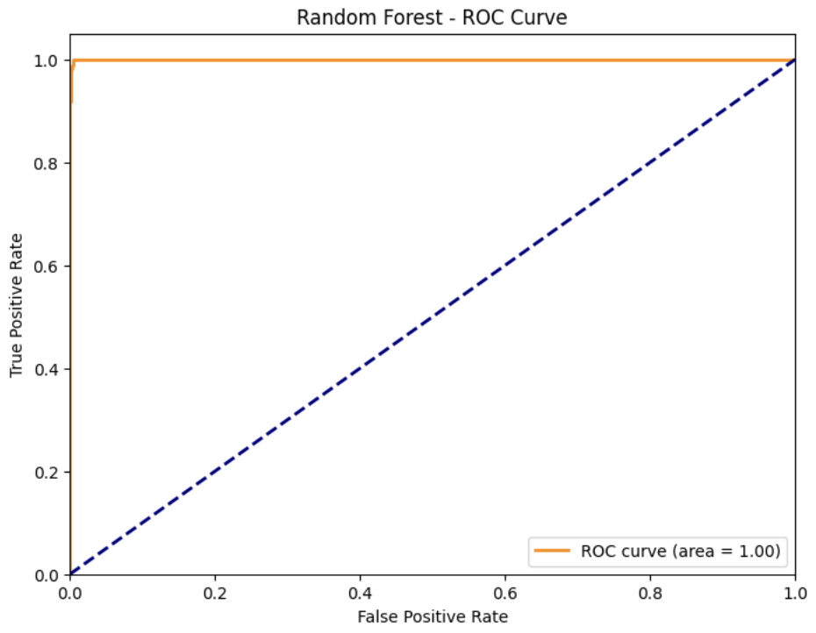

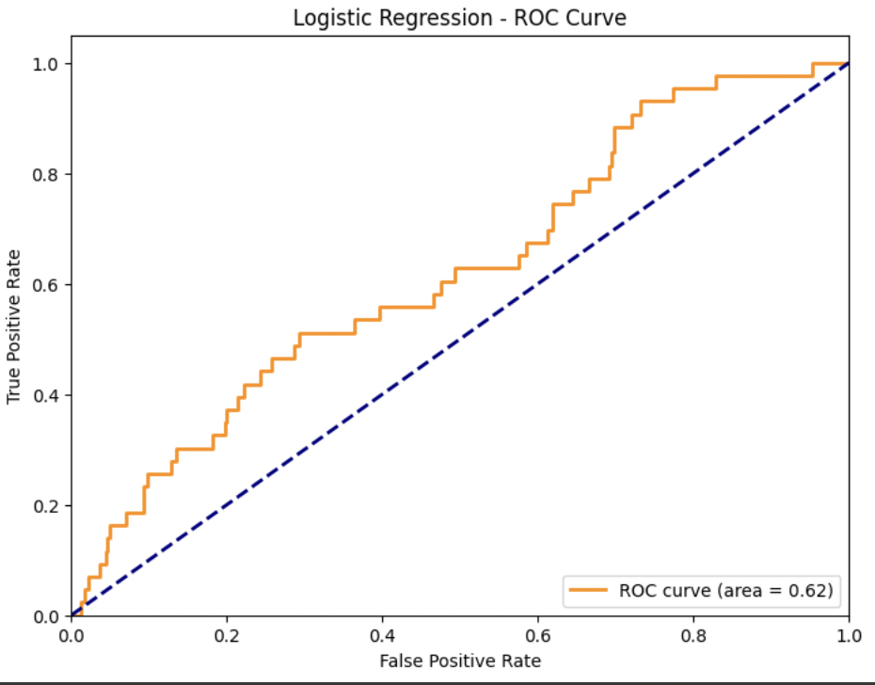

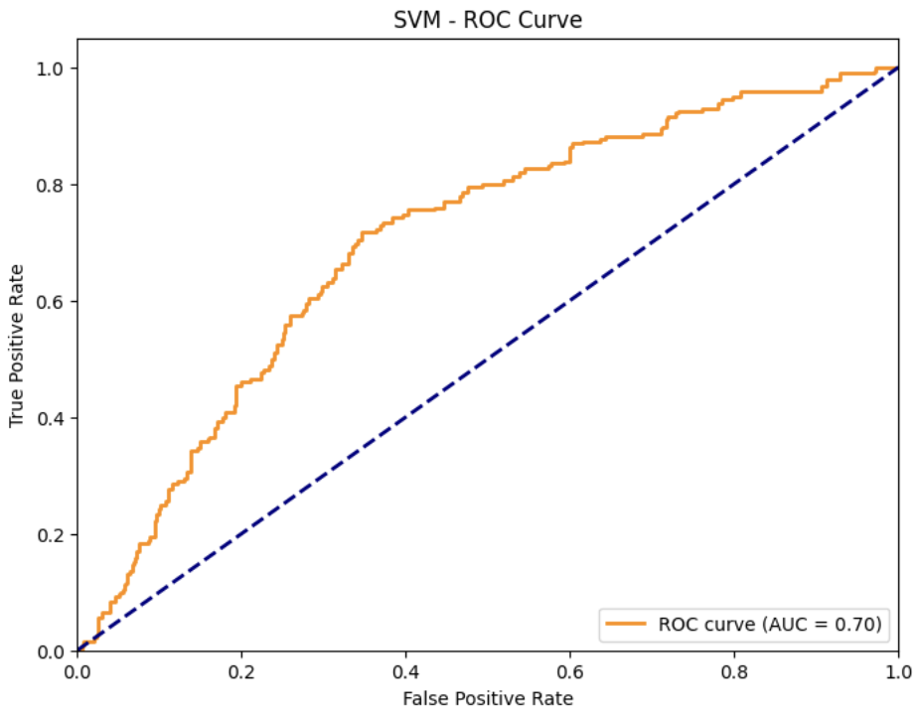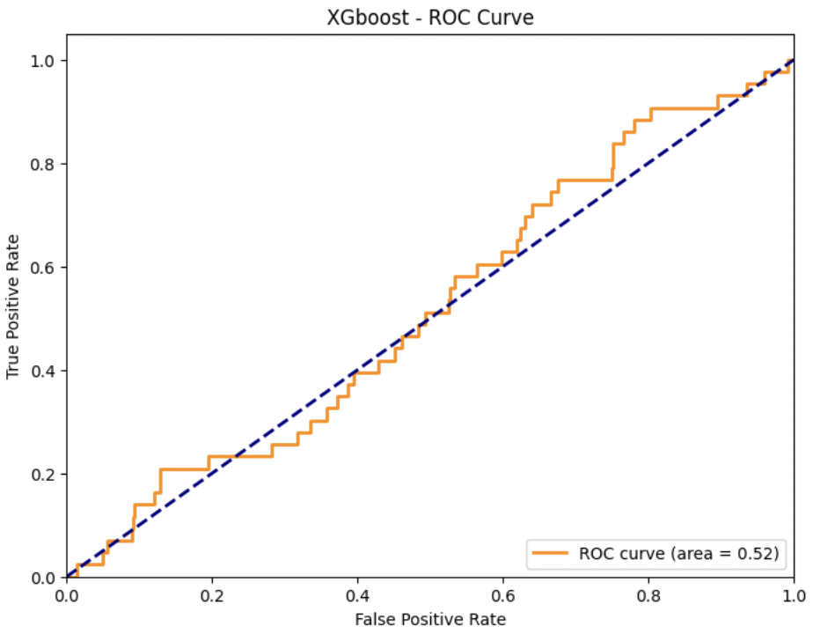

Figure 5.3.1 ROC Curves

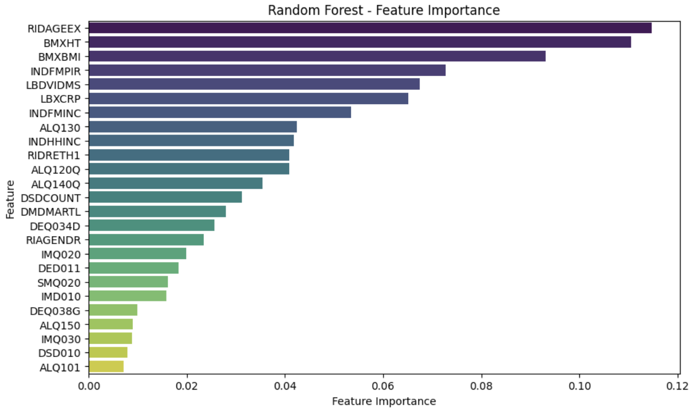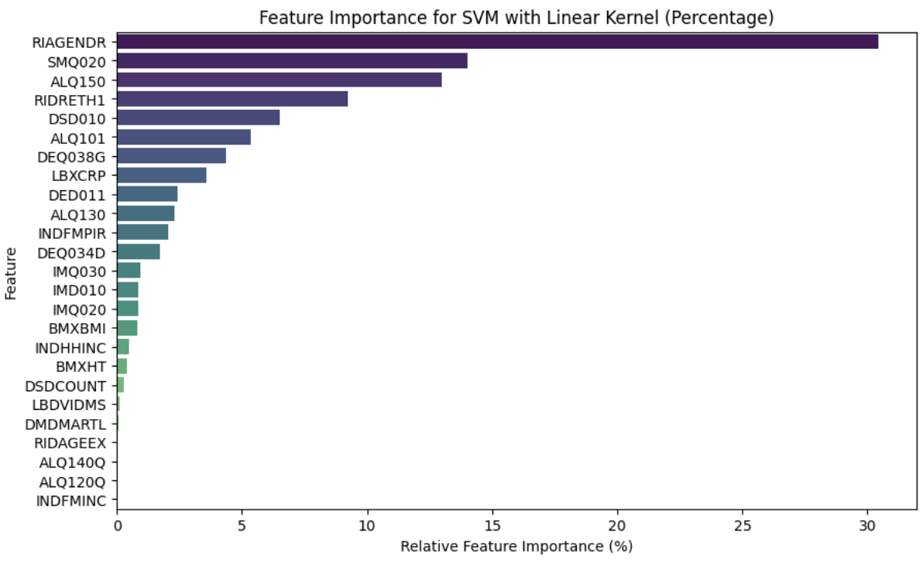

Figure 5.3.2 Feature Importance from Random Forest and SVM

Logistic Regression achieves moderate precision, recall, and F1-score, indicating a relatively balanced but not strong performance. AUC of 0.62 suggests that the Logistic Regression model performs slightly better than random guessing, but the ability to distinguish between classes is still weak. Random Forest demonstrates excellent precision, recall, and F1-score, indicating outstanding overall performance. The ROC curve, along with an AUC of 1.00, indicates that the Random Forest model achieves nearly flawless classification performance. The Random Forest model can correctly differentiate between the two classes, making it a highly accurate and reliable classifier for this dataset specifically. XGBoost achieves very high precision, recall, and F1-score, but a relatively low AUC of 0.52, suggesting strong overall performance with some room for improvement in differentiating between classes. SVM demonstrates moderate precision, recall, and F1-score, with a reasonable AUC of 0.70, indicating moderate but not exceptional performance.

We also examined feature importance from Random Forest and SVM models to check if the important features align with domain knowledge. We did not examine the importance of the other two models because of their weak ability to distinguish between the two classes. The top 5 most important features of the Random Forest model are as follows. RIDAGEEX, Exam age in months; BMXHT, Standing height (cm); BMXBMI, Body mass index (kg/m^2); INDFMPIR, Family PIR; LBDVIDMS, Vitamin D (nmol/L). The top 5 most important features of the SVM model are as follows. RIAGENDR, Gender; SMQ020, Smoked at least 100 cigarettes in life; ALQ150, Ever have 5 or more drinks every day; RIDRETH1, Race/Ethnicity; DSD010, Any dietary supplements taken.

**6 Next Steps**

**6.1 Data Integration**

1. Source Additional Datasets: Identify and gather more datasets related to psoriasis or other skin diseases, including environmental factors, genetic markers, and treatment outcomes. Also, we would incorporate self-reporting data which can drastically increase our sample size
2. Data Cleaning and Preprocessing: Ensure that the newly acquired data is cleaned, consistent, and devoid of anomalies. This includes handling missing values and outliers and removing duplicates.
3. Feature Engineering: Extract relevant features from the combined dataset to improve model accuracy and efficacy. This may include creating new features or transforming existing ones.
4. Data Fusion: Merge the existing dataset with the new datasets ensuring consistency in formats and units.

**6.2 Model Exploration**

1. Deep Dive into Used Models: Examine recent research and case studies where Logistic Regression, Random Forest, XGBoost, and SVM were applied to dermatological conditions or similar medical domains. Identify any novel techniques or variations that can enhance performance.
2. Identify New Models: Apart from Logistic Regression, Random Forest, XGBoost, and SVM, explore other machine learning models that might be suitable for the problem. Look into deep learning algorithms, and K-Nearest Neighbors, among others.

**7 Contributions**

Shiyuan Xu: Model selection, model implementation, literature review, and progress report

Tianyu Han: Model selection, model implementation, literature review, and progress report

Siyu Shen: Literature review, data preparation, cleaning, exploratory data analysis, and progress report

Xinran Chen: Literature review, data preparation, cleaning, and exploratory data analysis, and progress report

Ying Hong: Literature review, model metrics, model evaluation, and progress report

**8 References**

Lim RK, Woo S, El Raheb S, Qureshi A, Cho E. Association of serum vitamin D levels and psoriasis severity: An Analysis of the US National Health and Nutrition Examination Survey. Presented at: Nutrition 2023; July 22-25, 2023; Boston, MA. Accessed Thursday, July 27, 2023.

Large study shows link between Vitamin D and psoriasis severity. News release. Newswise. July 17, 2023. Accessed July 27, 2023. <https://www.newswise.com/faseb/large-study-shows-link-between-vitamin-d-and-psoriasis-severity/>

Zhang R, Huang Q, Su G, Wei M, Cui Y, Zhou H, Song W, Di D, Liu J, Wang Q. [Association between multiple vitamins and bone mineral density: a cross-sectional and population-based study in the NHANES from 2005 to 2006.](https://eur01.safelinks.protection.outlook.com/?url=https%3A%2F%2Fpubmed.ncbi.nlm.nih.gov%2F36765290%2F&data=05%7C01%7CPrem.Sreenivasan%40Unilever.com%7C270474d0649c44d4ade908dba81b9174%7Cf66fae025d36495bbfe078a6ff9f8e6e%7C1%7C0%7C638288608587164022%7CUnknown%7CTWFpbGZsb3d8eyJWIjoiMC4wLjAwMDAiLCJQIjoiV2luMzIiLCJBTiI6Ik1haWwiLCJXVCI6Mn0%3D%7C3000%7C%7C%7C&sdata=%2Fe9J72lkoD0n8YdEFYaV5FdJ5ZqyacNIKjQEGsmXSHw%3D&reserved=0) BMC Musculoskelet Disord. 2023 Feb 10;24(1):113. doi: 10.1186/s12891-023-06202-6. PMID: 36765290

Cui A, Xiao P, Fan Z, Zeng Y, Wang H, Zhuang Y. [Associations between vitamin E status and bone mineral density in children and adolescents aged 8-19 years: Evidence based on NHANES 2005-2006, 2017-2018.](https://eur01.safelinks.protection.outlook.com/?url=https%3A%2F%2Fpubmed.ncbi.nlm.nih.gov%2F36928218%2F&data=05%7C01%7CPrem.Sreenivasan%40Unilever.com%7C270474d0649c44d4ade908dba81b9174%7Cf66fae025d36495bbfe078a6ff9f8e6e%7C1%7C0%7C638288608587320260%7CUnknown%7CTWFpbGZsb3d8eyJWIjoiMC4wLjAwMDAiLCJQIjoiV2luMzIiLCJBTiI6Ik1haWwiLCJXVCI6Mn0%3D%7C3000%7C%7C%7C&sdata=29ms0CVczeAgoTAx7dir8wcHdZJ394IaZy9oHzBYqSw%3D&reserved=0) PLoS One. 2023 Mar 16;18(3):e0283127. doi: 10.1371/journal.pone.0283127. eCollection 2023. PMID: 36928218