Tianyi Wang

Nov. 06,2019

To Do list

Aggisnment05

**To Do List**

**Introduction**

In this paper, I will discuss how to add dictionary objects into a template script and allows the user to edit data in the To Do List. Observations and results will be shown. Also, GitHub will also be introduced in this paper.

**Writing the script**

Since most of the variables and constants are already declared, I was able to use them in the script directly. Under processing section, I applied similar codes as Professor Root’s example, listing 3 in Mod05 Notes, this allows me to load data from a file as shown in Figure 1. 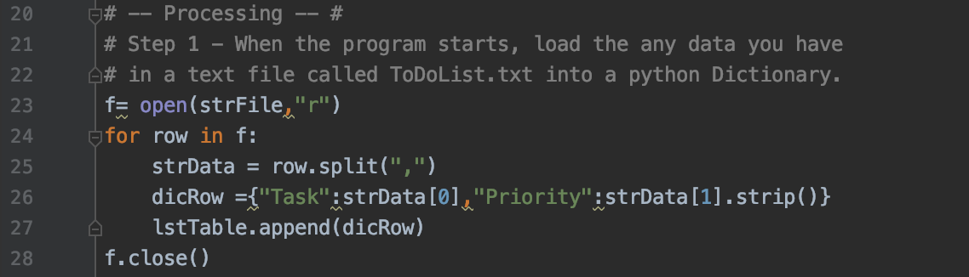

Figure Script under Processing section

Menu choices was not changed in the template. From now, I started adding scripts into each menu option. Step 3 and 4 are fairly easy by following Professor Root’s notes. I found some difficulties in step 5, which allows the user to remove the new item to the Table. I found some useful example online. Len() Function can return the number of character in the string. I used what I have learnt in Mod03 and Mod04 to finish the script. Figure 2 shows the script from step 3 to step 7.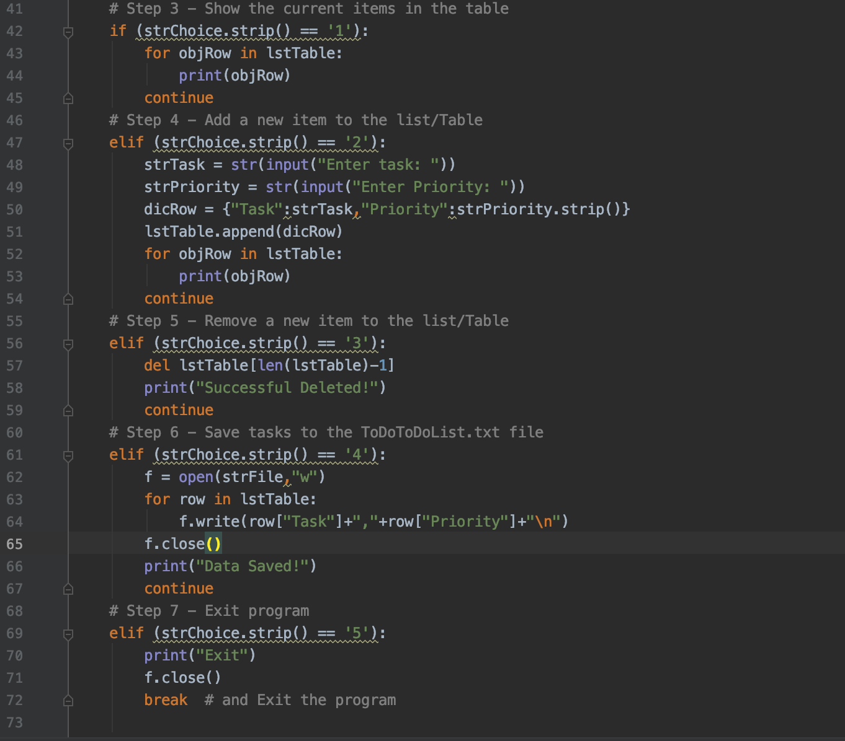

Figure Main body of the script

After the script was made, I ran the script and it have the results as I expected shown in Figure 3,4,5.

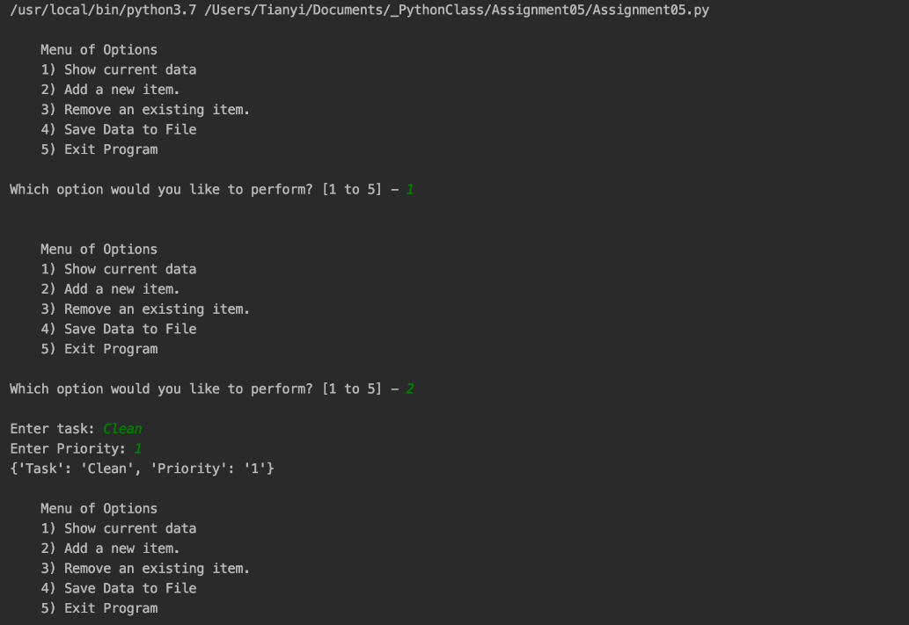

Figure Result for option 1 and 2

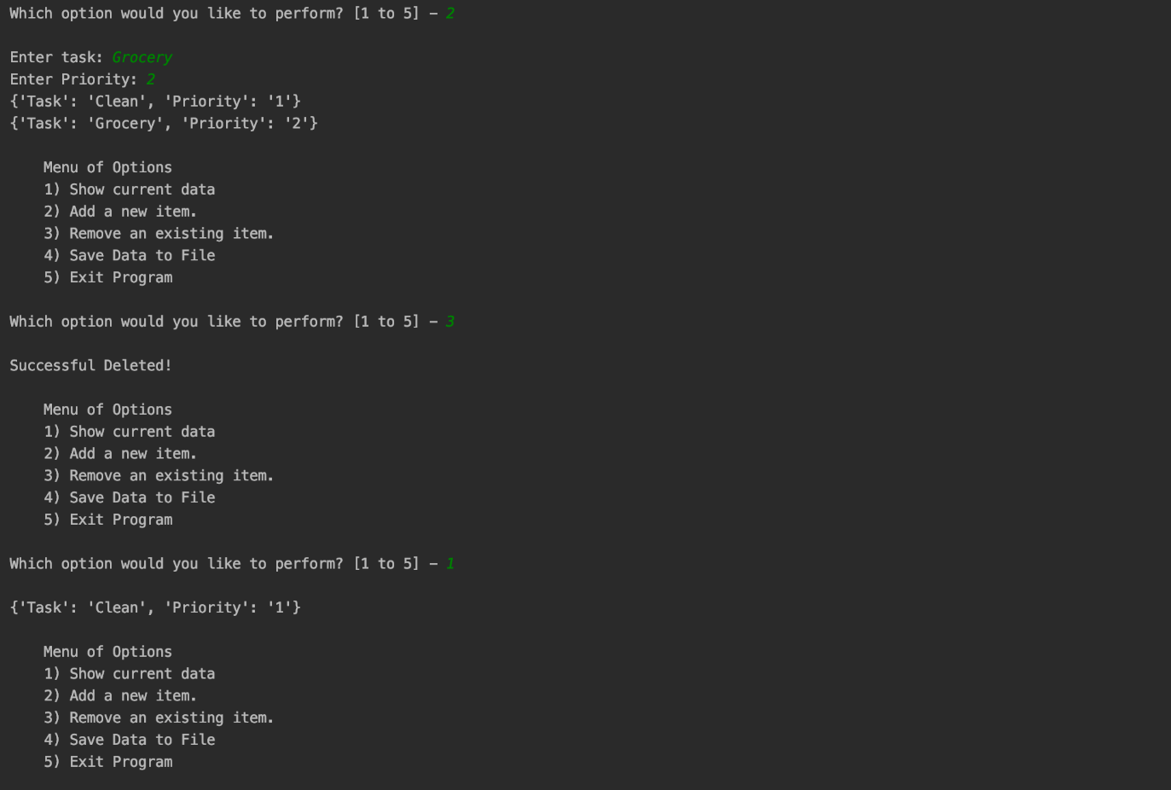

Figure Result for option 2 and 3

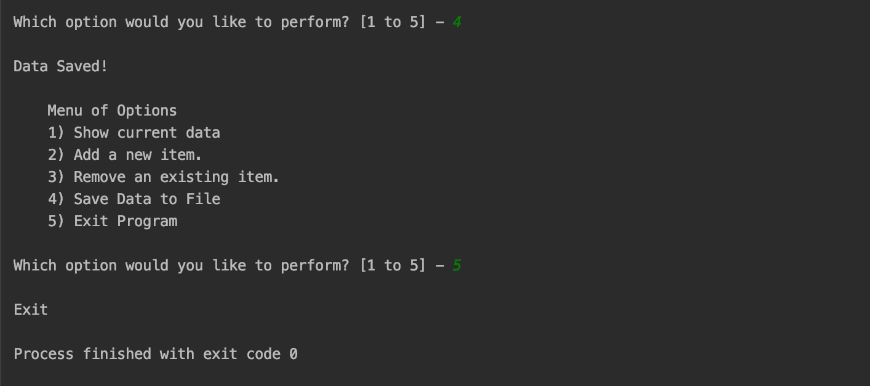

Figure Result for option 4 and 5

From the result, it shows that option 2 allows me to add data into the file and option 3 successfully delete an existing item and I verified that by choosing option 1 to show the current data in the file.

**Summary**

This lab creates an interactive program that allows the user to enter and make it into a file, as the same time, the user can retrieve and modify the data. This assignment combined most of the knowledge from the pervious modules and helps me to practice using may of the functions as well.