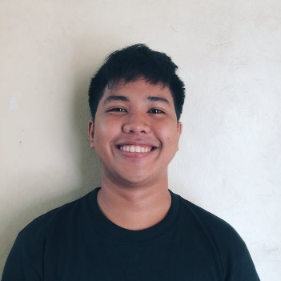Christian Ralf H. Ramos

Address: 117 Leon Merced St. Old Manggahan Brgy. San Isidro Angono Rizal

Contact #: 09368867538

Email: christianralfhaliliramos@gmail.com

**Objective:**

To work in a well-known institution where I can contribute my skills and knowledge to obtain professional and personal improvement**.**

**Skills:**

Determined to work

Good Communicator

Fast Learner

Time Management

Good Attitude

Computer Basics

**Educational Attainment:**

**Primary:**

Elementary Graduate (2011-2012)

Angono Elementary School

Angono, Rizal

**Secondary:**

G10 Completer (2015-2016)

Senior High School Completer (2016-2018)

Angono National High School

Angono, Rizal

**Tertiary:**

Fourth Year College

University of Rizal System

Binangonan, Rizal

**Personal Information:**

*Marital Status: Single*

*Date of Birth: May 19, 2000*

*Nationality:* Filipino

*Languages:* Tagalog/English

*Height:* 5’3

*Religion:* Roman Catholic

**Achievements:**

Certificate of Grade 10 Completer

Certificate of On the Job Trainining (Strivertech)

I hereby certify that the above information is true and correct to the best of knowledge and beliefs.

_________________

**Signature**