Christian Ralf Ramos BSIT 4-2

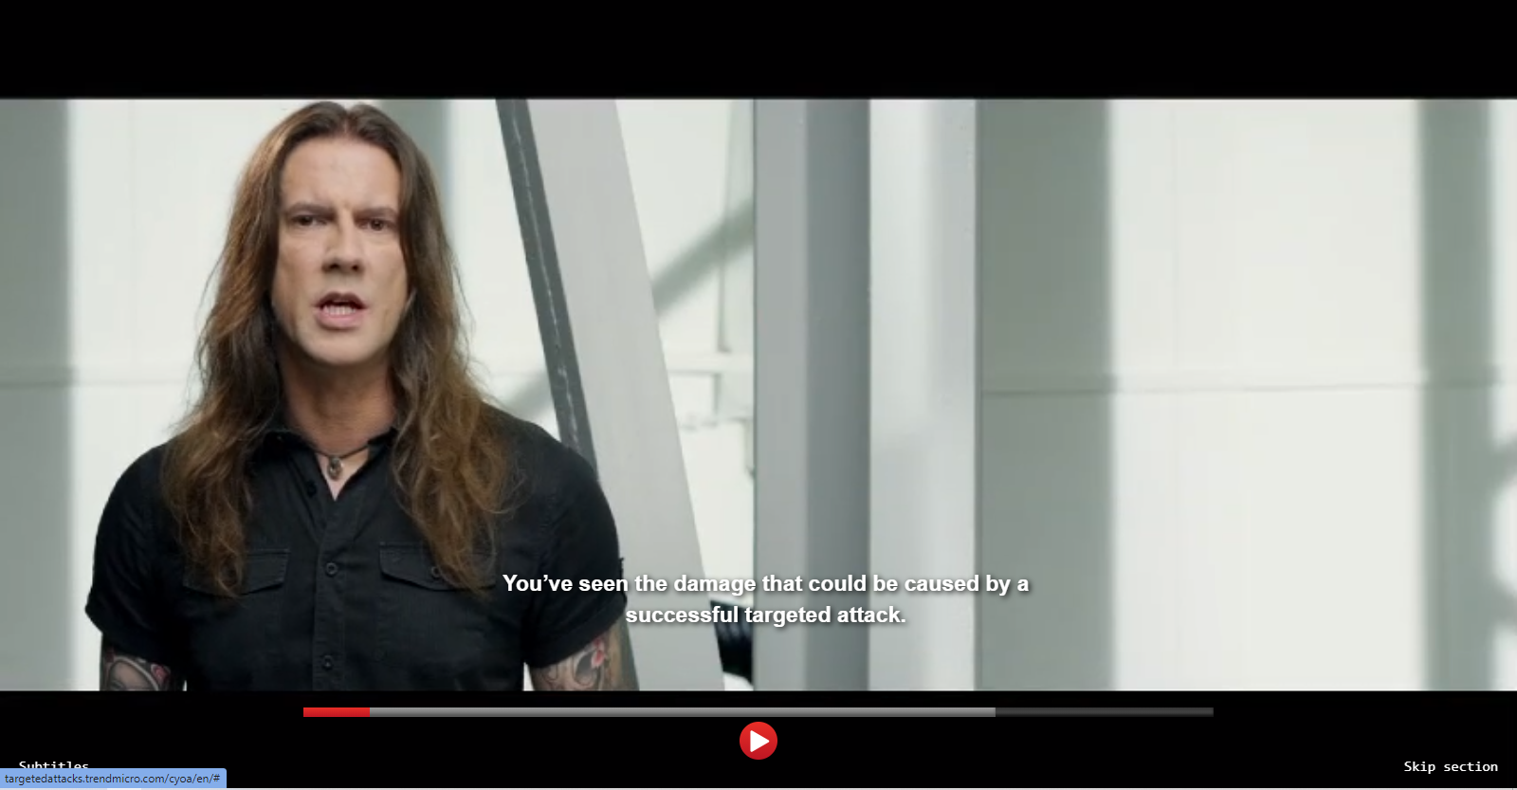

1. The problems in the simulation is data breach and launching the app.
2. The CIO role is important because he/she is the brain on how do you protect a systems data.
3. Information Security is important to an organization because data to an organization is very important that cannot be leaked.
4. Protect everything not only the users but also the security of your system, keep them balance to protect your organization.