**The University of Texas at Dallas**

**Shireen Khalani**

**Tian Zhang**

**Country Risk**

Introduction

Globalization has opened the doors for many corporations to expand their from their local base to many foreign bases. This has put a great need for estimation of the additional risks these companies face when they enter the foreign markets. The term, country risk, is usually used for default made by countries on lending and its sovereign debt. However, for some it means how much potential loses the investor can make investing in that country. Measuring county risk is a challenging process, since there can be a vast array of variables that can be taken into consideration. For a broader and more comprehensive look into country risk, we chose the broad categories of economic risk, political risk and legal risk for 31 diverse countries (Table 1: Appendix).

Methodology

Our model is to run linear regression model on these variables with country risk premium(Damodaran) as a dependent variable. We came up with an optimal model that predicts the country risk premium. We have also done forward, backward and stepwise regression to validate our findings.

Variables

The political risk has the following variables:

1. Physical Violence Score (pr1)
2. Physical Violence Ranking (pr2)
3. Corruption Score (pr3)
4. Corruption Ranking (pr4)

The economic risk has the following variables:

1. GDP (er1)
2. GDP per capita (er2)
3. Gross National Saving (er3)
4. Unemployment Rate (er4)
5. Taxes and other Revenue (er5)
6. %Public debt/GDP (er6)
7. Inflation Rate (er7)
8. Reserve of Foreign Exchange and Gold (er8)
9. Central Bank Discount Rate (er9)
10. Commercial Bank Prime Lending Rate (er10)
11. Current Balance (er11)

The legal risk had only one variable, called the legal risk score (lr1).

The first step was to find collinearity between the variables. We used the correlation matrix and vif calculations to check. We found out, that economic variables were correlated with each other to a very small extent. However, the political and legal variables were highly correlated with each other (as shown below).

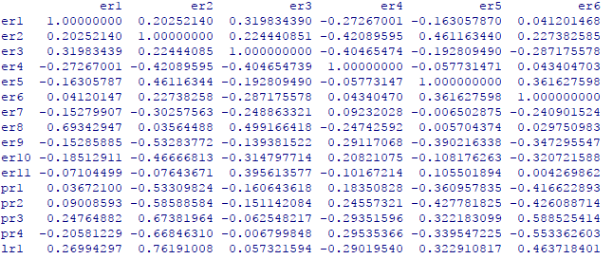

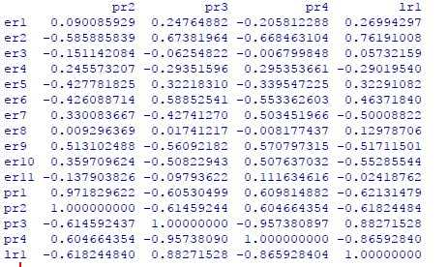

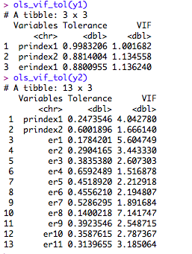

*Our vif results were also supporting the results of the correlation matrix*. The PCA of political risk and legal risk does not have any collinearity with the PCA of economic risk or variables of economic risk. We decided to do a principle component analysis on variables of political and legal risk to cater to that problem. We conducted the PCA on political and legal risk and decided to choose PC1 and PC2 since it explains 99.53% variance, as shown below.

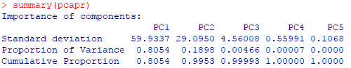

Since, we were running a regression model, we also attempted to do a PCA model on economic risk and do a linear regression model with both the indexes as an independent variable. The results are shown below:

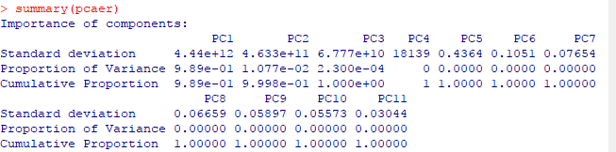

The indexes had to correlation with each other.

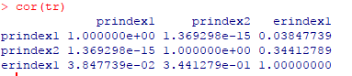

Regression models

We ran two models, one of the PCA of both economic risk and political and legal risk and one on PCA of political and legal risk and individual economic variables.



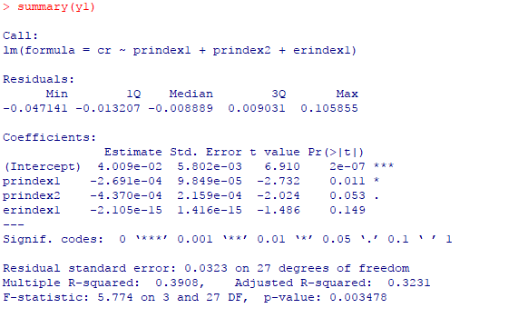

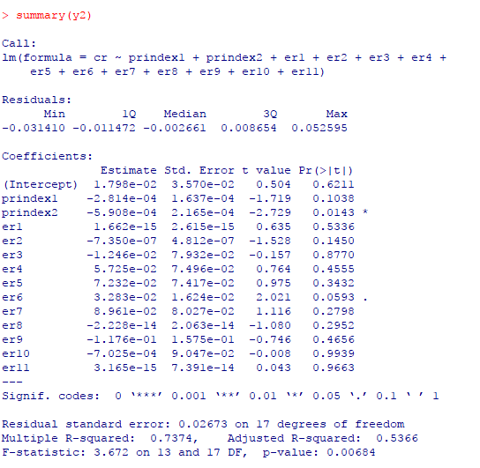

As evident, model y2 captures more variation through explaining some economic variable and also having a higher r-square value. Model y1 only captures how political and legal risk are entirely the major components of country risk, though the r-square is very low. Both the models are significant overall.

Forward/Backward/Stepwise Regression

Backward Regression

The results from the backward regression are summarized below:

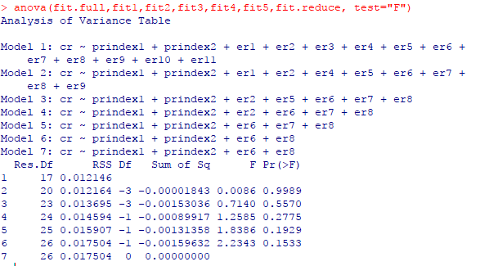

The final model from backward regression is:

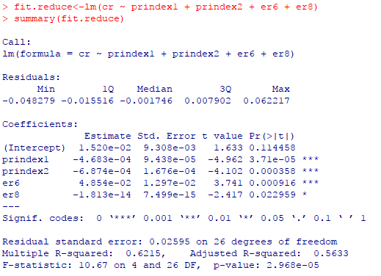

The significant variables are prindex1, prindex2, er6 and er8 and the adjusted r-square is 56.33% and the overall model is significant.

Forward Regression

We used the following code



The final result for forward regression is

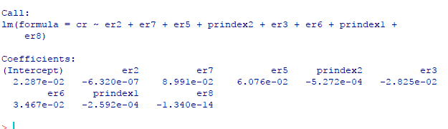

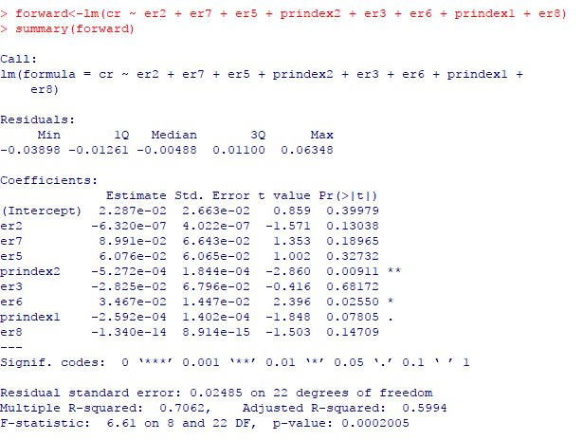

The results from forward regression are not very promising since only three variables are significant. However, the results are aligned with our original regression model. The r-square is 59.94% which is higher than backward regression.

Stepwise Regression

Our regression equation for stepwise regression and the final regression result from stepwise regression is shown below.

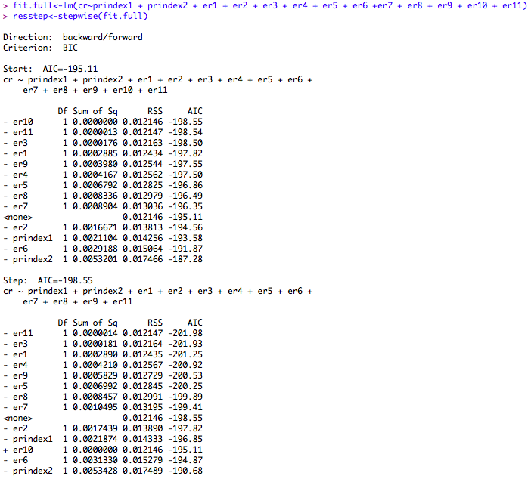

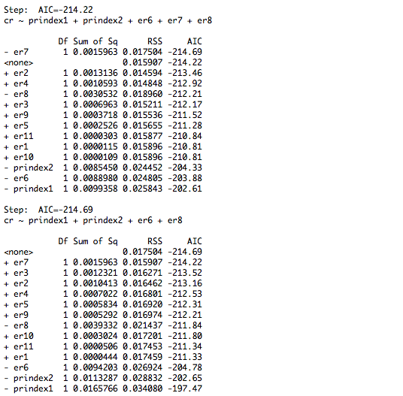

As seen, the regression results from stepwise regression matched the results from backward regression.

Conclusion

Our paper attempted to get the significant independent variables to explain the country risk premium. We tried multiple model and believe that the regression model with PCA of political and legal risk and economic risk variables is the best suited model.

Appendix

Table 1

|  |  |  |
| --- | --- | --- |
| Turkey | Kenya | Israel |
| Russia | Ethiopia | Jordan |
| Ukraine | Uganda | Kuwait |
| Poland | Zambia | Morocco |
| Argentina | South Africa | Canada |
| Brazil | China | U.S. |
| Mexico | Japan | Germany |
| Colombia | India | France |
| Peru | Vietnam | Switzerland |
| Egypt | Thailand | Greece |
| U.K. |  |  |

References

Country Risk: Determinants, Measures and Implications – The 2016 Edition Aswath Damodaran - https://papers.ssrn.com/sol3/papers.cfm?abstract_id=2812261

Damodaran, A. (n.d.). EQUITY RISK PREMIUMS: LOOKING BACKWARDS AND FORWARDS… . Retrieved December 8, 2017, from http://people.stern.nyu.edu/adamodar/pdfiles/country/ERP2014.pdf