Title page
Title: Temporal Dynamics and Phenotypic Heterogeneity in Oral Capsaicin-Induced Human Visceral Pain
Authors: Zilei Tian, PhD, Jianzhen Jiang, PhD, MD, Chongkai Luo, MS, Jingya Cao, PhD, MD, Xueping Yu, PhD, MD, Sijing Chen, MS, Jing Li, MS, Tao Yin, PhD, MD, and Fang Zeng, PhD, MD.
Affiliations: 1. Acupuncture and Tuina School, The 3rd Teaching Hospital, Chengdu University of Traditional Chinese Medicine, Chengdu, Sichuan, China; 2. Acupuncture and Brain Science Research Center, Chengdu University of Traditional Chinese Medicine, Chengdu, Sichuan, China; 3. Key Laboratory of Acupuncture for Senile Disease (Chengdu University of TCM), Ministry of Education, Chengdu, Sichuan, China; 4. Sichuan College of Traditional Chinese Medicine, Mianyang, Sichuan, China. Author-affiliation mapping: Zilei Tian (1,2); Jianzhen Jiang (1,2); Chongkai Luo (1,2); Jingya Cao (1,2); Xueping Yu (4); Sijing Chen (1); Jing Li (1); Tao Yin (1,2,3); Fang Zeng (1,2,3).
Corresponding author: Fang Zeng, Acupuncture and Tuina School, The 3rd Teaching Hospital, Chengdu University of Traditional Chinese Medicine, Chengdu, Sichuan, China. Email: zengfang@cdutcm.edu.cn.
Text Word Count: approximately 3,100 words, excluding title page, abstract, references, tables, and figure legends
Guarantor of the article: Fang Zeng.
Specific author contributions: Zilei Tian: Conceptualization, methodology, formal analysis, data curation, visualization, writing-original draft, and writing-review and editing. Jianzhen Jiang: Methodology, investigation, data curation, and writing-review and editing. Chongkai Luo: Investigation, data curation, validation, and writing-review and editing. Jingya Cao: Investigation, data curation, and writing-review and editing. Xueping Yu: Formal analysis, visualization, and writing-review and editing. Sijing Chen: Data curation, investigation, project administration, and writing-review and editing. Jing Li: Resources, validation, and writing-review and editing. Tao Yin: Methodology, supervision, validation, and writing-review and editing. Fang Zeng: Funding acquisition, resources, supervision, project administration, and writing-review and editing. All authors approved the final manuscript.
Financial support: The authors declare that financial support was received for this work and/or its publication. This study was supported by the National Outstanding Youth Science Fund Project of National Natural Science Foundation of China (grant number 82225050), the National Natural Science Foundation of China (grant number 82205285), Sichuan Provincial Natural Science Foundation Youth Fund Project (grant number 2024NSFSC11860), China Scholarship Council (grant number 202408730003), and Sichuan Province Tianfu Qingcheng Program (grant number 600008241023). The funding bodies provided financial support for the study and/or its publication. No funder had a direct role in data collection, data analysis, data interpretation, or drafting of the manuscript beyond the contributions of the funded authors described in the author-contributions statement. Fang Zeng, the corresponding author, contributed to funding acquisition, supervision, project administration, resources, and writing-review and editing as an author-investigator.
Potential competing interests: None declared.

Abstract
Objectives: Oral capsaicin studies often rely on static endpoints, leaving temporal response patterns and symptom heterogeneity underexamined. We combined trajectory analysis, symptom-region mapping, and Rome IV-informed categorization to characterize heterogeneity in oral capsaicin-induced visceral pain.
Methods: In this experimental observational study, 216 participants rated pain for 20 minutes after oral capsaicin administration on a visual analog scale (VAS). Analyses included onset and change-point detection, Kaplan-Meier estimation, dynamic time warping clustering, shapelet extraction, symptom-region and Rome IV-informed network analyses, grouped Sankey visualization, early-window phenotype classification, next-step VAS direction prediction, and phenotype prediction from baseline demographic, questionnaire-derived, electrocardiographic, electrogastrographic, and coupling features.
Results: The cohort mean trajectory peaked at minute 4 (mean VAS 4.22) and then declined. Median threshold-defined onset was 1.0 minute; median relief was not reached within 20 minutes. Dynamic time warping clustering identified delayed-peak (n=58), early-sustained (n=84), and late-rising (n=74) phenotypes (silhouette score 0.299). Abdominal distension was the most frequent symptom (154/216, 71.3%), and the right hypochondrium carried the largest regional burden (140/216, 64.8%; weighted degree 368). Rome IV-informed mapping clustered around biliary pain-like, bloating/distension-like, and irritable bowel syndrome-like patterns. Early-window phenotype classification reached accuracy 0.828 by 8 minutes and 0.902 with the full 20-minute trajectory. Logistic regression achieved balanced accuracy of 0.654 and macro F1 of 0.626 for next-step VAS direction prediction; baseline-feature phenotype prediction remained modest (best primary accuracy 0.601).
Conclusions: Oral capsaicin elicited heterogeneous visceral pain trajectories with reproducible temporal patterns. Trajectory, symptom-region, and Rome IV-informed analyses identified symptom constellations relevant to disorders of gut-brain interaction. Static summaries captured only part of this structure. Early-window classification and short-horizon prediction may help future studies track dynamic phenotypes and intervention-related trajectory change.
Keywords: capsaicin, visceral pain, time-series clustering, network analysis, Rome IV

Study highlights
WHAT IS KNOWN
- Oral capsaicin provides a controlled experimental model of upper gastrointestinal discomfort.
- Static pain summaries can miss temporal structure and inter-individual heterogeneity.
WHAT IS NEW HERE
- VAS trajectories separated into three temporal phenotypes.
- Symptom-region networks concentrated in the right hypochondrium and hypogastrium.
- The standardized provocation produced consistent early temporal landmarks and a recoverable phenotype structure.
- Early-window and next-step prediction analyses captured short-horizon response information; baseline-only phenotype prediction remained modest.

Introduction
Visceral pain is common in gastroenterology, but many studies reduce it to peak scores, mean scores, or area under the curve. These endpoints compress onset, persistence, and recovery [1-6]. In disorders of gut-brain interaction (DGBIs), timing, symptom quality, and perceived anatomical distribution shape clinical interpretation [1,2,7-11].
The oral capsaicin model provokes upper gastrointestinal discomfort under controlled conditions. Capsaicin activates transient receptor potential vanilloid 1 (TRPV1) channels on gastrointestinal sensory afferents and can evoke burning, cramping, nausea, and distension-like sensations that overlap with DGBI complaints [12-19]. TRPV1 activation may be followed by calcium-dependent desensitization, which allows investigators to track pain dynamics after provocation [20-23].
Few capsaicin studies jointly analyze time course, symptom quality, and anatomical distribution. Many still emphasize static pain summaries [14,24-27]. Researchers often analyze symptom qualities and anatomical locations separately, and few reports link symptom patterns to Rome IV constructs [7,8,28-31]. Trajectory shape, symptom-region co-occurrence, and symptom-pattern alignment remain incompletely characterized after oral capsaicin.
We used the oral capsaicin model to examine heterogeneity across time, symptom pattern, and anatomical distribution. The aims were to identify temporal response phenotypes using dynamic time warping (DTW)-based clustering, quantify symptom-region structure, map symptom patterns to Rome IV-informed categories, assess short-term predictability of VAS changes, and test whether early trajectories or baseline demographic, questionnaire-derived, electrocardiographic (ECG), electrogastrographic (EGG), and ECG-EGG coupling features predicted phenotype membership. The prespecified hypothesis was that oral capsaicin responses would show structured temporal heterogeneity and that early VAS trajectory features would improve classification beyond baseline features alone.

Methods

Ethics, registration, and reporting
The Medical Ethics Committee of the Affiliated Hospital of Chengdu University of Traditional Chinese Medicine approved the study under amendment approval No. 2024KL-044-02. All participants provided written informed consent, and the study followed the Declaration of Helsinki. The capsaicin substudy was nested within a parent registered project covered by the same amendment approval. Reporting followed STROBE where applicable, and TIDieR elements describe the capsaicin administration procedure.

Study design and participants
This experimental observational study used an oral capsaicin-induced visceral pain model under controlled laboratory conditions at Chengdu University of Traditional Chinese Medicine, Chengdu, Sichuan, China. Recruitment and data collection occurred from May 1, 2024, to June 1, 2025. The parent registered project recruited university volunteers. Eligible participants provided written informed consent, completed the oral capsaicin session, and contributed at least one valid post-administration VAS measurement. Participants were excluded if they did not complete capsaicin administration or lacked valid post-administration VAS data.
The analysis included 216 participants. All completed capsaicin ingestion and provided VAS ratings during the 20-minute observation period. The cohort comprised university students recruited on campus. Time-to-event analyses retained participants with no reported pain, defined as VAS equal to 0 at all recorded time points, as right-censored observations.

Capsaicin administration
Research staff dissolved food-grade capsaicin (purity 98%; CAS No. 404-86-4; Ruimao Biotechnology Co., Ltd., Xi’an, China) in ethanol (96%, v/v; Spirytus Rektyfikowany, Polmos, Poland) to prepare a 1% (w/v) stock solution. For each administration, staff encapsulated 10 microliters of solution, equivalent to 1 mg capsaicin, in a gastro-soluble gelatin capsule (Xuanyu Plastic Products Factory, Taizhou, China). Trained staff administered the capsule orally with water under direct observation. The protocol used no personalization, titration, or modification. Staff monitored participants for 20 minutes and recorded pain intensity at 1-minute intervals with a visual analog scale (VAS).

VAS numeric analysis
Primary VAS variables included minute-level pain intensity, pain onset time, pain relief time, total pain exposure quantified as area under the curve (AUC), first-order differences, local summary statistics, time-to-peak, and peak intensity. The analysis treated values marked “E” (early completion, defined as no sensation for 2 consecutive minutes) or “T” (trial termination for any reason, including excessive pain intensity or other intolerable symptoms) as censoring indicators. Once either marker appeared, all later measurements for that participant were set to missing and excluded from downstream analyses. Each operation excluded missing values, and no analysis interpolated post-termination observations.
Three approaches defined pain onset: first VAS >=3, first VAS difference >=0.5 between consecutive minutes, and change-point detection using the PELT algorithm with a rank-based model and penalty of 0.5 [32]. Kaplan-Meier methods estimated time to pain onset and time to pain relief. The Greenwood estimator produced median survival times and 95% confidence intervals. Because onset and relief used different event definitions in the same participants, the analysis interpreted the curves descriptively and did not compare them with a direct log-rank test. The trapezoidal rule computed AUC; each time series also provided peak VAS and time-to-peak.

Temporal clustering and shapelet analysis
Time-series clustering used DTW-based K-means clustering with DTW barycentric averaging centroids and DTW-based fuzzy c-medoids clustering (m=2), following established DTW and fuzzy objective-function approaches [33-35]. Silhouette analysis quantified separation for the three-cluster solution. Shapelet analysis identified discriminative local subsequences [36]. Shapelet extraction used DTW-based distance computation, a subsequence length of 5, and the top 3 shapelets per cluster; the workflow removed shapelets with correlation above 0.90 as redundant.

Symptom, Rome IV, and network analyses
Symptom variables included symptom categories coded A-L, anatomical regions coded 1-9, symptom-region co-occurrence pairs, and Rome IV-aligned DGBI categories. The parsing workflow read coded symptom and region entries at the character level, stripped delimiters, mapped codes to predefined labels, and deduplicated entries within participant. A rule-based algorithm assigned participant-level symptom profiles to Rome IV-informed categories using required and supportive symptoms and anatomical regions. The mapping represented symptom-based alignment with Rome IV constructs rather than formal clinical diagnosis.
The network analysis constructed a bipartite symptom-region network from all pairwise combinations between each participant’s reported symptoms and anatomical regions. Repeated symptom-region pairs within a participant contributed one occurrence. Across the cohort, pairwise associations formed a weighted matrix in which each cell represented co-occurrence frequency. A tripartite network linked symptoms, anatomical regions, and Rome IV-informed categories through symptom-region, symptom-disease, and region-disease edges [37-39]. A grouped supplementary Sankey visualization summarized participant-level flows across temporal phenotype, symptom, region, and each participant’s top Rome IV-informed category; lower-frequency nodes were combined for readability. Network analyses used frequency counts rather than probabilities.

Prediction and classification
To test whether early post-capsaicin trajectories predicted final temporal phenotype membership, a subject-level classification task compared the baseline feature matrix alone with datasets augmented by the first 3, 5, 8, or 20 minutes of VAS data. Added early-window features included raw prefix VAS values and derived summaries: mean, minimum, maximum, last value, prefix area under the curve, range, slope, early delta, and within-prefix peak time. Candidate classifiers included regularized linear models, support vector machines, distance-based methods, tree ensembles, histogram-based gradient boosting, and Gaussian naive Bayes. Stratified ten-fold cross-validation yielded strict out-of-fold accuracy, balanced accuracy, and F1 summaries.
Separately, a sliding-window framework predicted whether the next VAS score would decrease. The procedure segmented each participant’s VAS series into overlapping windows of length 3. Predictors included recent VAS values, current VAS, local summary statistics, local slope, monotonicity indicators, normalized time index, distances from recent running maxima and minima, and causal subject-level summaries computed from observations available up to the current minute. Models included a majority classifier, a persistence-direction model, and class-balanced logistic regression. Group-wise cross-validation assessed accuracy, balanced accuracy, macro F1, and weighted F1 while preventing leakage from repeated measures.
To assess whether pre-experiment characteristics predicted temporal phenotypes, classifiers used baseline demographic and questionnaire-derived exposure-history and symptom features together with ECG, EGG, and ECG-EGG coupling features. Column medians imputed missing values. Six model architectures were evaluated: class-balanced logistic regression, class-balanced random forest, gradient boosting, histogram-based gradient boosting, multilayer perceptron with early stopping, and a stacking ensemble. Stratified ten-fold cross-validation used balanced accuracy and macro F1 as primary metrics. A complementary classifier family used the same encoded feature matrix for supplementary feature-importance and confusion-matrix summaries.

Safety monitoring
Staff monitored adverse events throughout the post-administration observation period. The protocol defined an adverse event as any unfavorable or unintended medical occurrence that exceeded the expected transient gastrointestinal sensations induced by capsaicin, required medical intervention, led to trial termination, or caused clinically significant discomfort or risk. The safety analysis classified each T-coded trial termination as an adverse event. Staff recorded expected transient sensations, including heartburn, abdominal pain, abdominal distension, nausea, or related gastrointestinal discomfort, as study outcomes unless they exceeded the anticipated response profile.

Results

Participant characteristics
The analytic cohort included 216 participants. All completed capsaicin administration and contributed at least one valid post-administration VAS measurement. Core baseline variables were complete. Nine participants had T-coded adverse events that ended the trial early. No serious adverse events occurred. All symptoms resolved within 30 minutes, and no participant developed a more severe condition.
Table 1. Baseline Characteristics of Study Participants (N=216)
Characteristic | Value
Age, years, mean +/- SD | 20.4 +/- 1.9
Female, n (%) | 125 (57.9%)
Male, n (%) | 91 (42.1%)
Height, cm, mean +/- SD | 167.2 +/- 8.9
Weight, kg, mean +/- SD | 60.3 +/- 12.0
BMI, kg/m^2, mean +/- SD | 21.4 +/- 3.3
Time since last meal, hours, mean +/- SD | 4.1 +/- 2.0
Non-drinker, n (%) | 116 (53.7%)
Occasional drinker, n (%) | 83 (38.4%)
Regular drinker, n (%) | 17 (7.9%)
CCEI, mean +/- SD | 20.1 +/- 14.8
AES, mean +/- SD | 5.3 +/- 6.8
No baseline GI symptoms, n (%) | 148 (68.5%)
Mild baseline GI symptoms, n (%) | 56 (25.9%)
Moderate baseline GI symptoms, n (%) | 12 (5.6%)
Abbreviations: AES, Acute Exposure Score; BMI, body mass index; CCEI, Chronic Capsaicin Exposure Index; GI, gastrointestinal; SD, standard deviation.

Temporal VAS dynamics
Figure 1. Temporal dynamics of oral capsaicin-induced visceral pain.
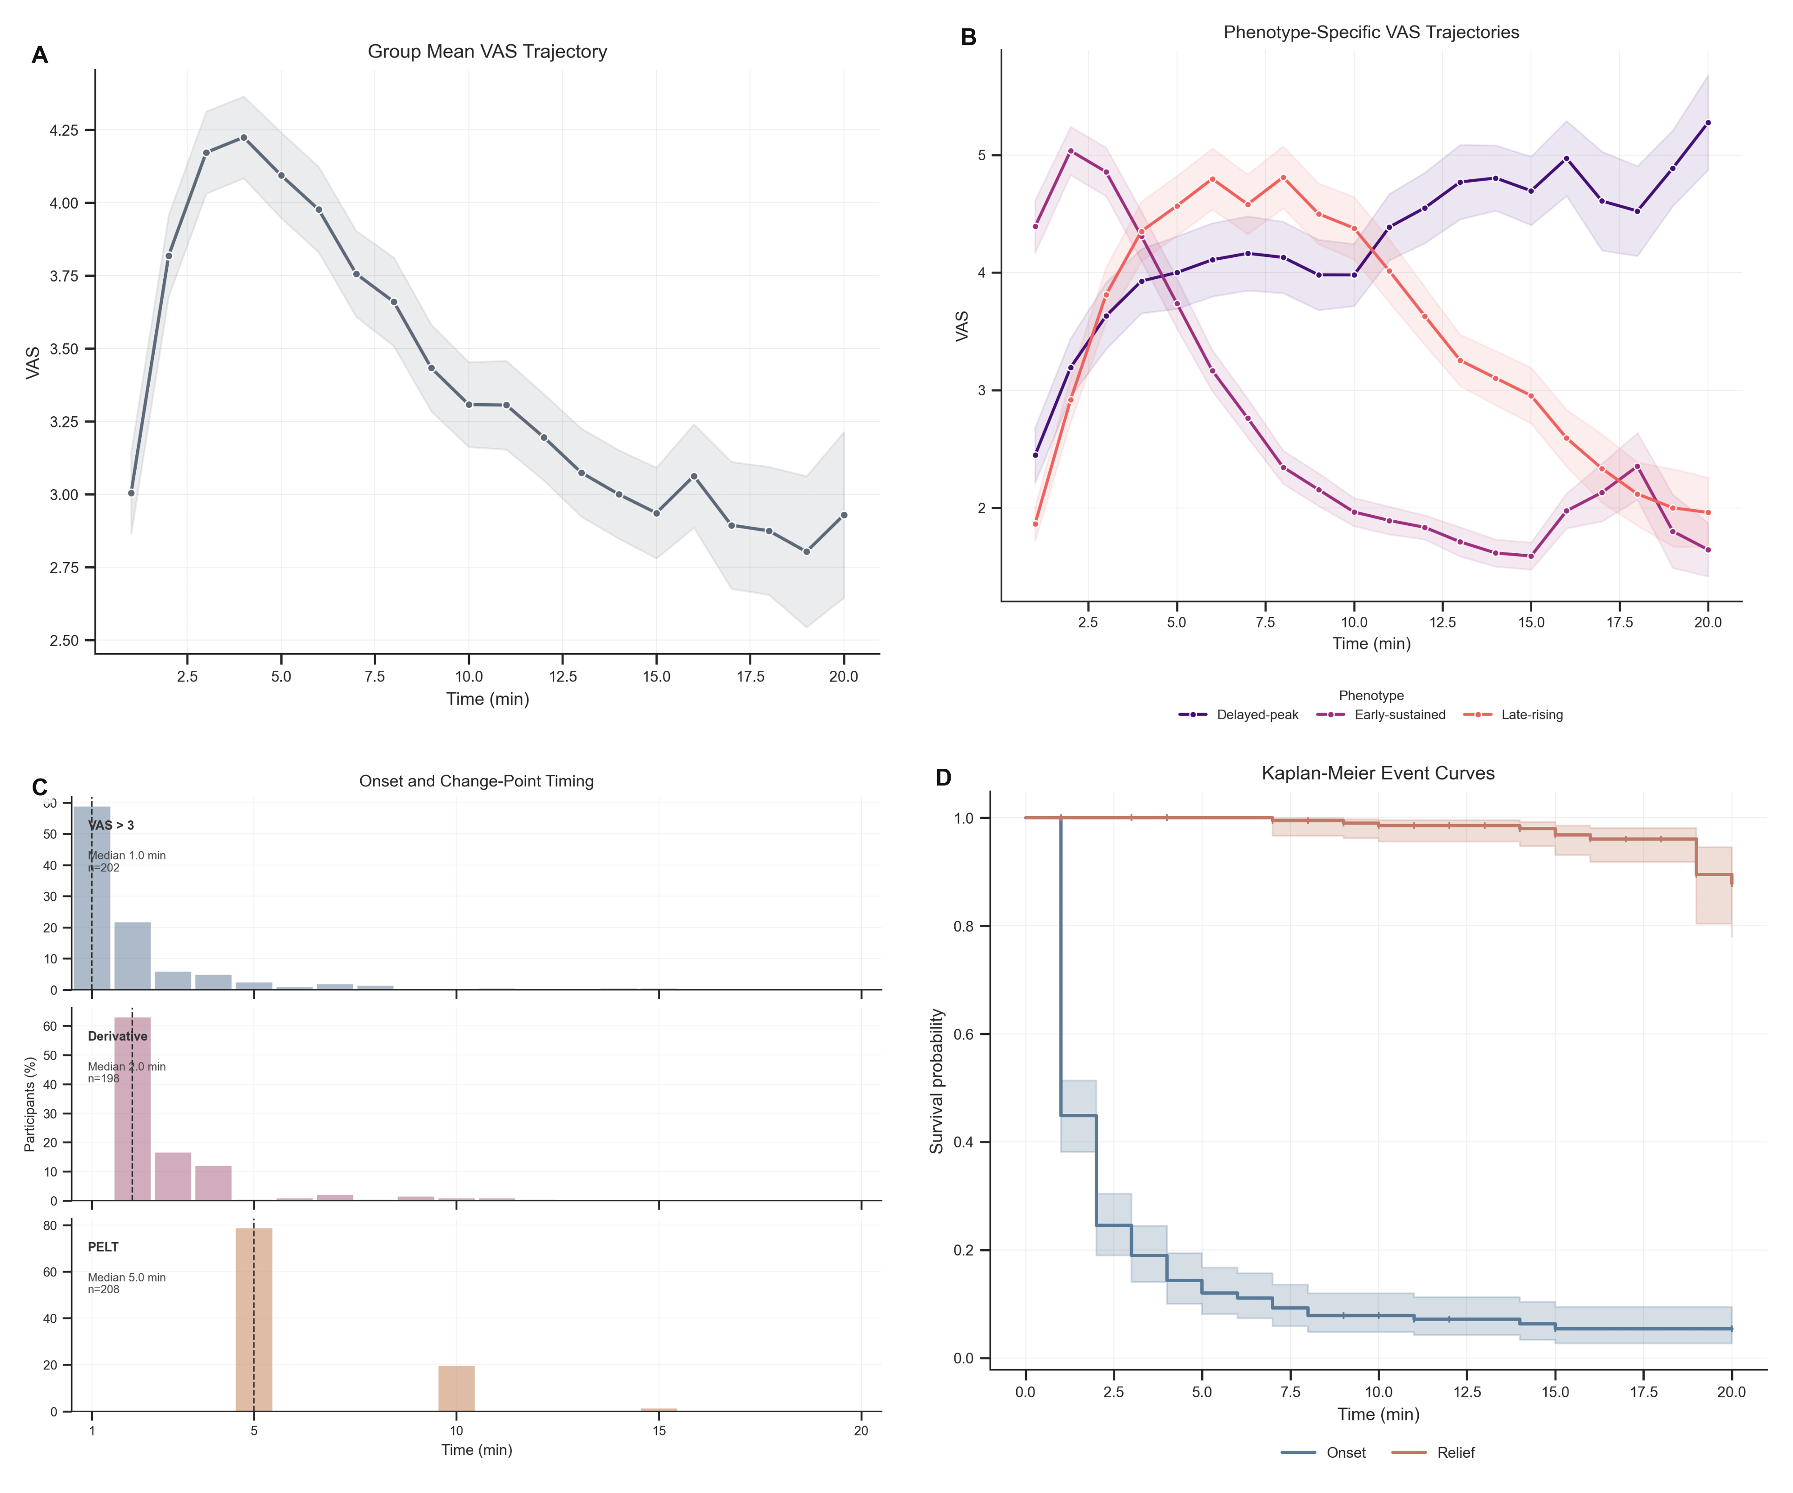
Caption: Panel A shows the group-level mean VAS trajectory during the 20-minute observation period, with SEM uncertainty. Panel B shows mean VAS trajectories stratified by DTW-derived temporal phenotype. Panel C shows the distributions of threshold-defined onset, derivative-defined onset, and PELT-derived change-point timing. Panel D shows Kaplan-Meier curves for time to pain onset and time to pain relief. Abbreviations: VAS, visual analog scale; SEM, standard error of the mean; DTW, dynamic time warping; PELT, pruned exact linear time.
The cohort mean VAS trajectory rose over the first 4 minutes, peaked at 4.22 at minute 4, and then declined while remaining above zero throughout follow-up (Figure 1A). Median threshold-defined onset occurred at 1.0 minute. The modal PELT change point occurred at minute 5 (Figure 1C), and the Kaplan-Meier median relief time was not reached within 20 minutes because only 12 of 216 participants met the relief criterion (Figure 1D). Among participants with calculable values, mean participant-level AUC was 53.17 VAS-minutes.

Temporal phenotypes
DTW-based clustering identified three temporal patterns: delayed-peak responders (n=58), early-sustained responders (n=84), and late-rising responders (n=74) (Figure 1B). The average silhouette score was 0.299, indicating moderate separation among overlapping classes. Fuzzy clustering and shapelet analysis followed the same pattern but did not support discrete subtypes.

Symptoms, anatomical regions, and Rome IV-informed mapping
Figure 2. Symptom and spatial burden of capsaicin-induced visceral pain.
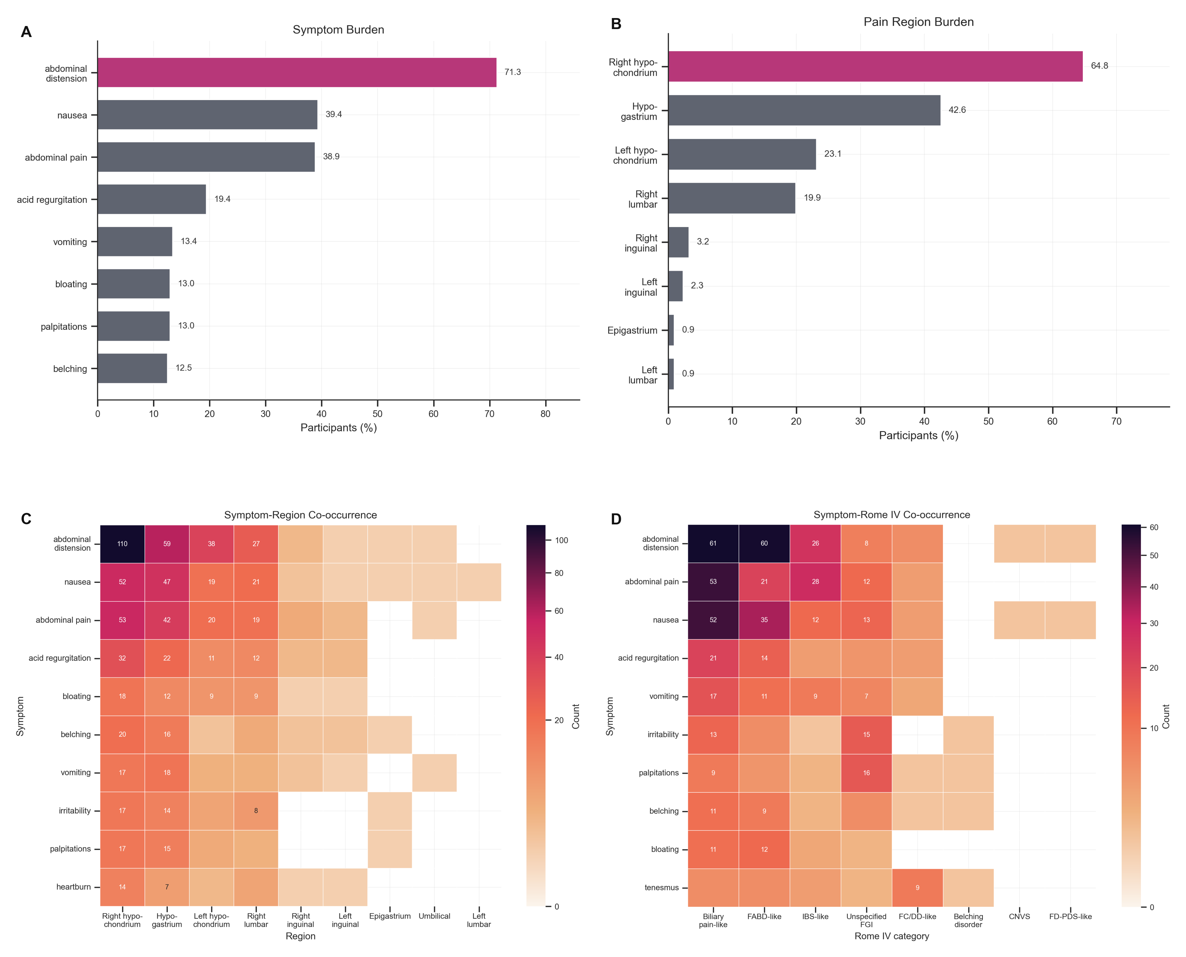
Caption: Panel A shows the ranked symptom burden across participants. Panel B shows the ranked burden of perceived anatomical regions. Panel C shows the symptom-region co-occurrence heatmap based on participant-level co-occurrence counts. Panel D shows the symptom-Rome IV-informed co-occurrence heatmap based on rule-mapped participant-level alignments. Abbreviations: CNVS, chronic nausea and vomiting syndrome; FABD-like, functional abdominal bloating/distension-like; FC/DD-like, functional constipation/defecatory disorder-like; FD-PDS-like, postprandial distress syndrome-like functional dyspepsia; IBS-like, irritable bowel syndrome-like; Unspecified FGI, unspecified functional gastrointestinal symptom pattern.
Across 216 participants, abdominal distension was the most frequent reported symptom (154/216, 71.3%), followed by nausea (85/216, 39.4%) and abdominal pain (84/216, 38.9%) (Figure 2A). The most frequently reported anatomical regions were the right hypochondrium (140/216, 64.8%) and hypogastrium (92/216, 42.6%) (Figure 2B).
Rome IV-informed mapping clustered around biliary pain-like (57/216, 26.4%), functional abdominal bloating/distension-like (35/216, 16.2%), and irritable bowel syndrome-like (25/216, 11.6%) patterns (Figure 2D). These categories describe symptom-pattern alignment, not formal DGBI diagnoses.

Symptom-region network structure
The symptom-region frequency matrix was spatially non-uniform (Figure 2C). The largest co-occurrence edge linked abdominal distension with the right hypochondrium (weight=110), and high-intensity cells remained concentrated in the right hypochondrium and hypogastrium. The right hypochondrium had the largest weighted degree (368), followed by the hypogastrium (267).
The tripartite network centered on the right hypochondrium and hypogastrium and connected most often to biliary pain-like, bloating/distension-like, and irritable bowel syndrome-like alignments. The grouped Sankey summary indicated that all three temporal phenotypes shared overlapping symptom-region hubs, especially abdominal distension, nausea, abdominal pain, the right hypochondrium, and the hypogastrium, while No Match remained a common terminal Rome IV-informed state. Because the analysis expanded participant-level co-occurrence patterns, these findings describe recurrent combinations rather than one-to-one anatomical localization.

Prediction and classification
Figure 3. Predictability of pain evolution and temporal phenotype.
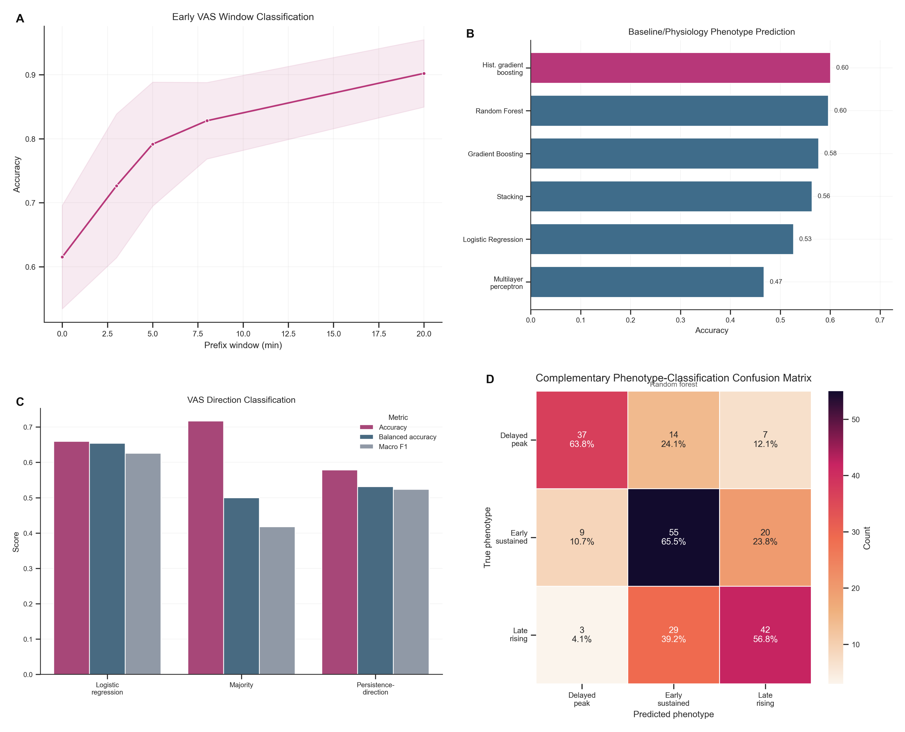
Caption: Panel A shows subject-level temporal phenotype classification as progressively longer early VAS windows are included. Panel B shows phenotype prediction performance from baseline demographic, questionnaire-derived, ECG, EGG, and coupling features. Panel C shows model performance for predicting whether the next VAS value will decrease. Panel D shows the confusion matrix from the best complementary baseline-plus-physiology classifier, annotated with counts and row-normalized percentages. Abbreviations: VAS, visual analog scale; ECG, electrocardiographic; EGG, electrogastrographic.
Temporal phenotype classification improved as the early VAS window length increased (Figure 3A): accuracy was 0.615 without post-capsaicin trajectory information, 0.828 with an 8-minute window, and 0.902 with the full 20-minute trajectory.
Short-term prediction of the direction of the next VAS change was moderate (Figure 3C). Logistic regression achieved balanced accuracy of 0.654 +/- 0.016 and macro F1 of 0.626 +/- 0.012, outperforming the majority baseline on class-balanced metrics. Recent trajectory history captured partial information about entry into the recovery phase.
Prediction from baseline demographic and questionnaire-derived exposure-history and symptom features, together with ECG, EGG, and ECG-EGG coupling features, remained modest (Figure 3B). In the primary model set, histogram-based gradient boosting achieved the highest mean accuracy (0.601), and random forest achieved the highest mean balanced accuracy (0.610). The complementary confusion matrix showed only partial separation across the three phenotypes (Figure 3D). These baseline and physiological features poorly separated phenotype membership.

Safety and adverse events
Nine participants (4.2%) experienced T-coded adverse events that ended the trial early. No serious adverse events occurred. All symptoms resolved within 30 minutes, and no participant developed a more severe condition.

Discussion
Oral capsaicin responses were temporally patterned and heterogeneous. The cohort-level VAS trajectory was biphasic, with rapid onset and slower resolution (Figure 1A,D). Participant-level responses separated into three partly overlapping temporal phenotypes instead of a single curve (Figure 1B). Symptom analyses added spatial and symptom-construct context: abdominal distension was common, the right hypochondrium carried the largest network burden, and Rome IV-informed mapping linked experimental symptom profiles to biliary pain-like, bloating/distension-like, and irritable bowel syndrome-like constructs (Figure 2A-D). Static intensity summaries provide an incomplete account of visceral pain across time, symptom quality, and perceived anatomical distribution [1-4,7,8].
The temporal findings favor response-shape analysis alongside conventional static summaries. Median onset occurred within 1 minute, the main change point clustered around minute 5, and median relief was not reached during the 20-minute observation period (Figure 1C,D). Peak VAS and AUC capture these features only partly, although such endpoints remain common in experimental pain studies and pain assessment frameworks [24-27]. In this model, onset, persistence, and recovery behaved as related phases of the same response [26,27].
The fixed administration protocol, early onset, clustered change-point timing, and recoverable phenotype structure gave the model clear cohort-level temporal landmarks.
The observed early rise followed by slower decline is physiologically plausible in light of prior capsaicin and TRPV1 literature. Capsaicin activates TRPV1-expressing visceral afferents and can evoke burning, cramping, nausea, and distension-like sensations in the upper gastrointestinal tract [12,14-18]. Prior work also indicates that TRPV1 signaling changes over time, with downstream modulation and calcium-dependent desensitization shaping responses after initial activation [15,16,20-22]. This study did not test receptor-level mechanisms. The combination of rapid onset, delayed recovery, and between-subject variability is consistent with a time-dependent sensory process rather than a brief impulse-like event [17,24,25].
The clustering results argue against treating oral capsaicin pain as a single canonical curve. DTW preserved shape information despite between-participant variation in peak timing, and fuzzy clustering showed blurred phenotype boundaries (Figure 1B). Investigators should interpret the three phenotypes as recurring response patterns rather than fixed biological subtypes. That interpretation agrees with prior work in which pain and DGBI-related symptom data contain structured heterogeneity rather than one homogeneous presentation [2,7,8,26,31]. The labels delayed-peak, early-sustained, and late-rising are descriptive. DTW clustering, fuzzy assignment, early-window classification, and shapelet motifs all recovered the same structure, which makes an analytic artifact less likely. Investigators still need independent replication and stronger physiological anchoring before treating these patterns as disease entities.
Symptom-region mapping showed that capsaicin-induced sensations were unevenly distributed across anatomical regions. In Figure 2A-C, abdominal distension, nausea, and abdominal pain clustered in the right hypochondrium and hypogastrium rather than spreading evenly across the abdominal map. The supplementary Sankey view showed that the temporal phenotypes did not branch into fully separate symptom repertoires; they shared symptom-region hubs and a small set of frequent Rome IV-informed endpoints, with a large No Match remainder that reflects the conservative rule-based mapping. This spatial concentration may inform region-aware symptom assessment, although readers should not treat it as an anatomical map of nociceptive origin. Network-based symptom analyses describe how complaints cluster across participants; they do not identify a single underlying organ source [29,30,37-39].
The Rome IV-informed categories require cautious interpretation. The mapping assessed symptom overlap with Rome IV constructs; it did not diagnose DGBIs or incorporate the chronicity requirements central to Rome IV classification [7,8,10,11]. The biliary pain-like, bloating/distension-like, and irritable bowel syndrome-like patterns in Figure 2D indicate that an acute provocation can generate symptom constellations that resemble clinically recognized constructs at the level of phenomenology. The model can be used to study symptom generation, but it remains distinct from patient diagnosis [7,8,10].
The prediction analyses separated trajectory information from pre-exposure information. Early VAS windows improved phenotype classification, indicating that trajectory shape became informative within the first minutes after exposure (Figure 3A). By 8 minutes, classification accuracy reached 0.828. By 20 minutes, phenotype membership was largely recoverable from the observed trajectory history, as expected because the clustering outcome was trajectory-derived. Baseline demographic and questionnaire-derived exposure-history and symptom features, together with ECG, EGG, and ECG-EGG coupling features, showed only modest discrimination (Figure 3B,D). In this experimental setting, the evolving pain signal carried more phenotype-specific information than the pre-exposure feature set. The observed signal anticipated near-term VAS direction and identified an emerging phenotype before the full trajectory unfolded. The analysis did not model treatment-related improvement, but the same framework can be extended once interventional trajectories are available.
This study has three main limitations. First, VAS remains a subjective self-report measure, and early terminations introduced censoring and informative missingness that may distort late-trajectory summaries. Second, the phenotype structure was analytically derived and therefore sensitive to preprocessing and modeling choices, with fuzzy assignments indicating boundary cases rather than discrete groups. Third, the Rome IV-informed mapping and ECG/EGG feature panel were limited proxies, supporting descriptive rather than diagnostic or biological interpretation. Future work should quantify the impact of missingness, test robustness across analytic pipelines and independent cohorts, and add stronger multimodal physiological measures for mechanistic anchoring and symptom mapping.
Within this protocol, the oral capsaicin model provided a controlled setting for studying heterogeneous visceral pain dynamics. Trajectory analysis, symptom-region structure, and Rome IV-informed mapping identified DGBI-relevant symptom patterns in addition to pain intensity. These response patterns may guide future studies that test dynamic phenotyping, short-horizon forecasting, and prospective prediction of intervention-related improvement. Investigators still need between-session stability data, external replication, and stronger biological anchoring before using the model as a surrogate for clinical disease [1,2,7,8,31].

Author disclosures

Ethics approval and consent to participate
The Medical Ethics Committee of the Affiliated Hospital of Chengdu University of Traditional Chinese Medicine approved the study under amendment approval No. 2024KL-044-02. All participants provided written informed consent.

Funding
The authors declare that financial support was received for this work and/or its publication. This study was supported by the National Outstanding Youth Science Fund Project of National Natural Science Foundation of China (grant number 82225050), the National Natural Science Foundation of China (grant number 82205285), Sichuan Provincial Natural Science Foundation Youth Fund Project (grant number 2024NSFSC11860), China Scholarship Council (grant number 202408730003), and Sichuan Province Tianfu Qingcheng Program (grant number 600008241023). The funding bodies provided financial support for the study and/or its publication. No funder had a direct role in data collection, data analysis, data interpretation, or drafting of the manuscript beyond the contributions of the funded authors described in the author-contributions statement. Fang Zeng, the corresponding author, contributed to funding acquisition, supervision, project administration, resources, and writing-review and editing as an author-investigator.

Competing interests
The authors declare no competing interests.

Author contributions
ZT: Conceptualization, methodology, formal analysis, data curation, visualization, writing-original draft, and writing-review and editing. JJ: Methodology, investigation, data curation, and writing-review and editing. CL: Investigation, data curation, validation, and writing-review and editing. JC: Investigation, data curation, and writing-review and editing. XY: Formal analysis, visualization, and writing-review and editing. SC: Data curation, investigation, project administration, and writing-review and editing. JL: Resources, validation, and writing-review and editing. TY: Methodology, supervision, validation, and writing-review and editing. FZ: Funding acquisition, resources, supervision, project administration, and writing-review and editing. All authors approved the final manuscript.

AI assistance disclosure
Generative AI-assisted language editing was used during manuscript revision. All authors are responsible for reviewing, verifying, and approving the final text. No AI tools were used for data collection, statistical analysis, or figure generation beyond language-editing support.

Acknowledgments
The authors thank all participants and study staff involved in the trial.

Data availability statement
The electrocardiographic and electrogastrographic datasets generated and/or analyzed during this study, together with the analysis code, will be made publicly available through the Open Science Framework (OSF) and the project’s GitHub repository.

Supplementary material
Detailed supplementary methods and results are provided in the Supplementary Appendix, including Supplementary Methods S1-S3, Figures S1-S5, and Tables S1-S4, with Tables S2b and S2c reported as supplementary network extensions. These materials expand the early-window classification details, ECG/EGG preprocessing and feature-derivation procedures, baseline-plus-physiology summaries, shapelet motifs, symptom-region and Rome IV-informed network summaries, short-term direction-prediction metrics, complementary feature-importance diagnostics, and adverse-event tabulations without duplicating the main-text figures and Table 1.

References
[1] Sperber AD, Bangdiwala SI, Drossman DA, et al. Worldwide prevalence and burden of functional gastrointestinal disorders, results of Rome Foundation global study. Gastroenterology. 2021;160(1):99-114.
[2] Ford AC, Sperber AD, Corsetti M, Camilleri M. Irritable bowel syndrome. Lancet. 2020;396(10263):1675-1688.
[3] Cervero F, Laird JMA. Visceral pain. Lancet. 1999;353(9170):2145-2148.
[4] Sikandar S, Dickenson AH. Visceral pain: the ins and outs, the ups and downs. Curr Opin Support Palliat Care. 2012;6(1):17-26.
[5] Dunckley P, Wise RG, Fairhurst M, Hobden P, Aziz Q, Chang L, et al. A comparison of visceral and somatic pain processing in the human brainstem using functional magnetic resonance imaging. J Neurosci. 2005;25(32):7333-7341.
[6] Vermeulen W, De Man JG, Pelckmans PA, De Winter BY. Neuroanatomy of lower gastrointestinal pain disorders. World J Gastroenterol. 2014;20(4):1005-1020.
[7] Drossman DA. Functional gastrointestinal disorders: history, pathophysiology, clinical features and Rome IV. Gastroenterology. 2016;150(6):1262-1279.
[8] Drossman DA, Hasler WL. Rome IV-functional GI disorders: disorders of gut-brain interaction. Gastroenterology. 2016;150(6):1257-1261.
[9] Black CJ, Ford AC. Global burden of irritable bowel syndrome: trends, predictions and risk factors. Nat Rev Gastroenterol Hepatol. 2020;17(8):473-486.
[10] Schmulson MJ, Drossman DA. What is new in Rome IV. J Neurogastroenterol Motil. 2017;23(2):151-163.
[11] Lacy BE, Mearin F, Chang L, Chey WD, Lembo AJ, Simren M, et al. Bowel disorders. Gastroenterology. 2016;150(6):1393-1407.e5.
[12] Hammer J, Vogelsang H. Characterization of sensations induced by capsaicin in the upper gastrointestinal tract. Neurogastroenterol Motil. 2007;19(4):279-287.
[13] Bortolotti M, Porta S. Effect of red pepper on symptoms of irritable bowel syndrome: preliminary study. Dig Dis Sci. 2011;56(11):3288-3295.
[14] Caterina MJ, Schumacher MA, Tominaga M, et al. The capsaicin receptor: a heat-activated ion channel in the pain pathway. Nature. 1997;389(6653):816-824.
[15] Holzer P. TRPV1 and the gut: from a tasty receptor for a painful vanilloid to a key player in hyperalgesia. Eur J Pharmacol. 2004;500(1-3):231-241.
[16] Szallasi A, Blumberg PM. Vanilloid (capsaicin) receptors and mechanisms. Pharmacol Rev. 1999;51(2):159-212.
[17] Hammer J. Characterization of a reproducible gastric pain model using oral capsaicin titration in healthy volunteers. Neurogastroenterol Motil. 2011;23(9):e399-e406.
[18] Reyes-Escogido ML, Gonzalez-Mondragon EG, Vazquez-Tzompantzi E. Chemical and pharmacological aspects of capsaicin. Molecules. 2011;16(2):1253-1270.
[19] Akbar A, Yiangou Y, Facer P, et al. Increased capsaicin receptor TRPV1-expressing sensory fibres in irritable bowel syndrome and their correlation with abdominal pain. Gut. 2008;57(7):923-929.
[20] Brederson JD, Kym PR, Szallasi A. Targeting TRP channels for pain relief. Eur J Pharmacol. 2013;716(1-3):61-76.
[21] Geppetti P, Nassini R, Materazzi S, Benemei S. The concept of neurogenic inflammation. BJU Int. 2008;101 Suppl 3:2-6.
[22] Vyklicky L, Novakova-Tousova K, Benedikt J, et al. Calcium-dependent desensitization of vanilloid receptor TRPV1. Physiol Res. 2008;57 Suppl 3:S115-S126.
[23] Singh Tahim A, Santha P, Nagy I. Inflammatory mediators convert anandamide into a potent activator of the vanilloid type 1 transient receptor potential receptor. Neuroscience. 2005;136(2):539-548.
[24] Farre R, Tack J. Food and symptom generation in functional gastrointestinal disorders: physiological aspects. Am J Gastroenterol. 2013;108(5):698-706.
[25] Feinle-Bisset C, Horowitz M. Dietary factors in functional dyspepsia. Neurogastroenterol Motil. 2006;18(8):608-618.
[26] Burns JW, Gerhart JI, Bruehl S, et al. Temporal dynamics of pain: an application of regime-switching models to ecological momentary assessment in chronic low back pain. Pain. 2018;159(5):968-976.
[27] Fillingim RB, Loeser JD, Baron R, Edwards RR. Assessment of chronic pain: domains, methods, and mechanisms. J Pain. 2016;17(9 Suppl):T10-T20.
[28] Aziz Q, Fass R, Gyawali CP, et al. Functional esophageal disorders. Gastroenterology. 2016;150(6):1368-1379.
[29] Bellala G, Ganesan A, Krishna R, Saxman P, Scott C, Silveira M, et al. The nested structure of cancer symptoms. Methods Inf Med. 2010;49(6):581-591.
[30] Zhu Z, Hu H, Wu B, Hu Y. Editorial: Mapping symptom networks among co-occurrence of psychological and somatic symptoms. Front Public Health. 2023;11:1210151.
[31] Park SY, Bae H, Jeong HY, Lee JY, Kwon YK, Kim CE, et al. Identifying novel subtypes of functional gastrointestinal disorder by analyzing nonlinear structure in integrative biopsychosocial questionnaire data. J Clin Med. 2024;13(10):2821.
[32] Killick R, Fearnhead P, Eckley IA. Optimal detection of changepoints with a linear computational cost. J Am Stat Assoc. 2012;107(500):1590-1598.
[33] Petitjean F, Ketterlin A, Gancarski P. A global averaging method for dynamic time warping, with applications to clustering. Pattern Recognit. 2011;44(3):678-693.
[34] Lai C-P, Chung P-CJ, Tseng H-C. Incremental fuzzy C medoids clustering of time series data using dynamic time warping distance. PLoS One. 2018;13(5):e0197344.
[35] Bezdek JC. Pattern Recognition with Fuzzy Objective Function Algorithms. New York: Plenum Press; 1981.
[36] Ye L, Keogh E. Time series shapelets: a new primitive for data mining. Proceedings of the 15th ACM SIGKDD International Conference on Knowledge Discovery and Data Mining. 2009:947-956.
[37] Zhou X, Menche J, Barabasi AL, Sharma A. Human symptoms-disease network. Nat Commun. 2014;5:4212.
[38] Hidalgo CA, Blumm N, Barabasi AL, Christakis NA. A dynamic network approach for the study of human phenotypes. PLoS Comput Biol. 2009;5(4):e1000353.
[39] Goh KI, Cusick ME, Valle D, et al. The human disease network. Proc Natl Acad Sci USA. 2007;104(21):8685-8690.

Supplementary Appendix
Supplementary Material for: “Temporal Dynamics and Phenotypic Heterogeneity in Oral Capsaicin-Induced Human Visceral Pain”
This appendix reports expanded methods, supplementary diagnostics, and supporting figures and tables beyond the composite main-text figures.
The appendix includes Supplementary Methods S1-S3, Figures S1-S5, and Tables S1-S4, with Tables S2b and S2c reported as supplementary network extensions.
Citation numbers in this appendix follow the main manuscript reference list.

Supplementary Methods

S1. Early-window temporal phenotype classification
The early-window analysis treated phenotype classification as a subject-level prediction task. The baseline-only matrix matched the baseline-plus-physiology matrix used in the main phenotype-prediction analysis and included demographic variables, questionnaire-derived exposure-history and symptom variables, and electrocardiographic (ECG), electrogastrographic (EGG), and ECG-EGG coupling features. Additional matrices appended the first 3, 5, 8, or 20 minutes of post-capsaicin visual analog scale (VAS) data.
For each early window, predictors included the raw minute-level VAS values and derived summary variables: mean, minimum, maximum, last value, prefix area under the curve, range, linear slope, early delta, and within-prefix peak time. The analysis treated values marked E or T as censored. Once either marker appeared, all later VAS values for that participant were set to missing before feature extraction.
Candidate classifiers included sparse logistic regression, standard logistic regression, radial and linear support vector machines, ridge classification, k-nearest neighbors, random forest, extra trees, histogram-based gradient boosting, and Gaussian naive Bayes. Stratified ten-fold cross-validation generated out-of-fold accuracy, balanced accuracy, macro F1, and weighted F1.
This prefix-based design restricted each model to information available up to the evaluated minute. It tested when trajectory information became informative enough to distinguish delayed-peak, early-sustained, and late-rising response patterns, not retrospective reconstruction of the full trajectory.

S2. ECG/EGG preprocessing and feature derivation
The physiology feature set came from raw ECG and EGG recordings processed with a standardized pipeline. The analysis treated both signal streams as 250 Hz recordings. ECG preprocessing selected the first non-flat channel when multiple leads were available, flagged flat-line segments, saturation-like outliers, and abrupt jumps, and summarized flagged samples as an artifact ratio.
The pipeline band-pass filtered the selected ECG lead with a fourth-order Butterworth filter from 0.5 to 40 Hz and a 50-Hz notch filter. Two complementary algorithms, a Pan-Tompkins-style detector and an amplitude-threshold peak finder, detected R peaks; detections were merged within an 80-ms tolerance. RR intervals were then edited when they fell outside 300 to 2,000 ms, changed by more than 25% from adjacent intervals, or deviated markedly from a local median trend. When sufficient neighboring intervals remained, linear interpolation replaced edited values. An ECG signal quality index (SQI; 0-100) combined artifact coverage, agreement between the two R-peak detectors, RR edit ratio, and high-frequency noise burden. ECG traces with SQI >=40 contributed heart-rate summaries, and traces with SQI >=60 contributed HRV summaries.
EGG preprocessing first evaluated each available channel separately. For multichannel recordings, the pipeline downsampled each channel to 4 Hz for quality assessment, detrended it, screened it for slow-wave artifacts, and assigned a channel-level SQI. The retained EGG signal used a quality-weighted combination of channels when stable weights were available, or the highest-scoring single channel otherwise. The pipeline then downsampled the combined EGG signal to 4 Hz, screened it again for artifacts, and filtered it with second-order Butterworth filters into a broad gastric band (0.0083-0.15 Hz) and a normogastric band (0.033-0.067 Hz). Additional SQI components quantified gastric spectral focus, spectral prominence, low-frequency drift, and ECG contamination estimated around ECG R peaks. EGG traces with SQI >=40 contributed to feature extraction.
Extracted ECG features included heart-rate and heart-rate-variability (HRV) summaries, time-domain HRV measures (SDNN, RMSSD, pNN50, pNN20, CVSD), frequency-domain HRV measures (LF power, HF power, LF/HF ratio, LFnu, HFnu), Poincare indices (SD1, SD2, SD1/SD2 ratio), and ECG quality metrics. Extracted EGG features included dominant, mean, and median frequency; dominant and total power; bradygastria, normogastria, and tachygastria power proportions; a normogastria-to-abnormal power ratio; spectral entropy; spectral flatness; dominant-frequency instability; signal energy; root-mean-square amplitude; and EGG quality metrics. ECG-EGG coupling features included heart rate-EGG correlation, maximal cross-correlation and its lag, mean coherence within 0.01 to 0.10 Hz, and an ECG-to-EGG energy ratio.

S3. Expanded baseline-plus-physiology phenotype prediction
The baseline phenotype-prediction matrix combined demographic variables, questionnaire-derived exposure-history and symptom variables, ECG features, EGG features, and ECG-EGG coupling features. Questionnaire-derived variables included age, sex, body mass index, height, weight, alcohol consumption, spicy food frequency, usual spiciness level, spicy food preference, maximum tolerable spiciness, Chronic Capsaicin Exposure Index (CCEI), Acute Exposure Score (AES), recent spicy food intake, time since last spicy intake, spicy episodes in the previous 24 hours, baseline gastrointestinal symptom burden, and time since last meal.
ECG-derived variables included heart-rate-variability and signal-quality measures. EGG-derived variables included dominant frequency, power, rhythm-band proportions, entropy, flatness, instability, and signal-quality indices. ECG-EGG coupling variables included cross-correlation, lag, coherence, energy ratio, and heart rate-EGG correlation summaries. Missing values were imputed with column medians.
The primary model set included class-balanced logistic regression, class-balanced random forest, gradient boosting, histogram-based gradient boosting, multilayer perceptron with early stopping, and a stacking ensemble. Stratified ten-fold cross-validation estimated model performance, with balanced accuracy and macro F1 as the primary metrics. A complementary classifier family used the same encoded matrix to generate supplementary feature-importance and confusion-matrix summaries.
These analyses asked whether pre-exposure trait-like information could predict temporal phenotype membership without access to the evolving pain trajectory. The resulting matrix represents a heterogeneous baseline descriptor set rather than a mechanistically unified biomarker panel. The supplementary feature-importance outputs identify variables that contributed within fitted models; they do not establish stable markers or causal determinants of phenotype membership.

Supplementary Results
The following sections add analyses that extend the main-text composite figures without duplicating them.

S4. Additional baseline-plus-physiology phenotype summaries
Figure S1. Age by Phenotype.
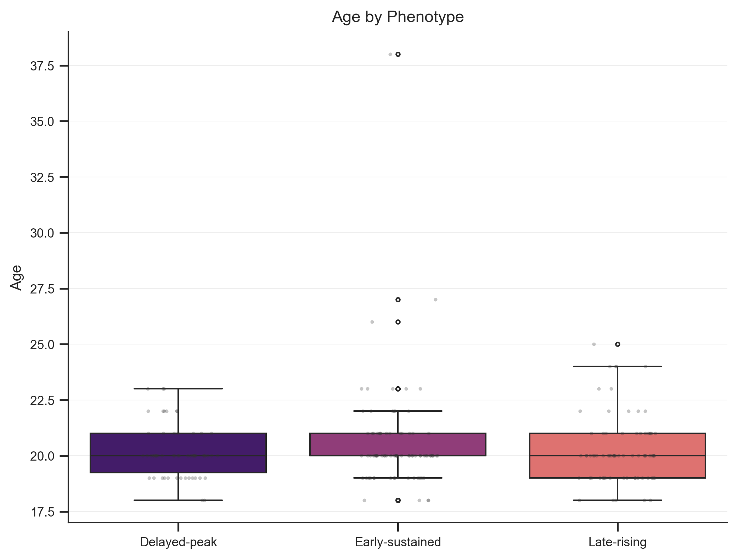
Caption: Age distributions stratified by temporal phenotype.
Age distributions overlapped across delayed-peak, early-sustained, and late-rising phenotypes. No phenotype had a separated age profile, and age alone did not organize the temporal phenotypes in this cohort.
Figure S2. Standardized ECG/EGG Feature Distributions.
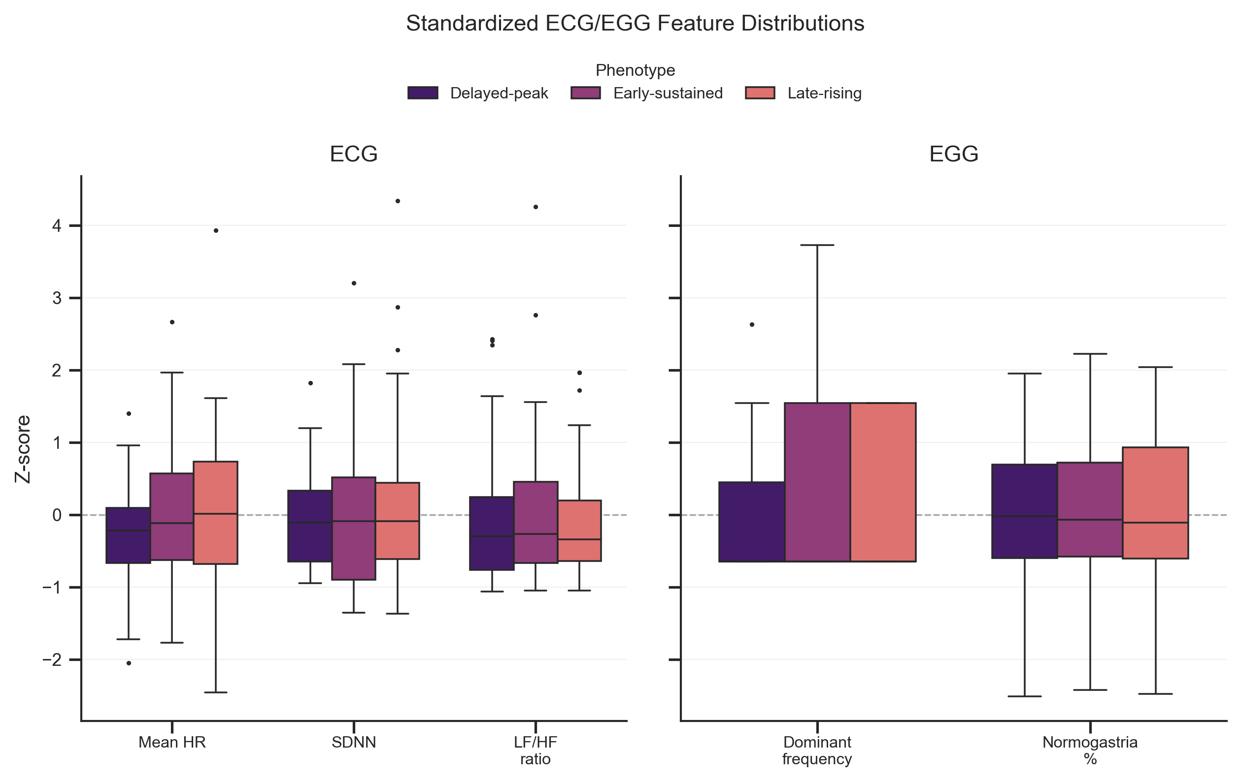
Caption: Standardized ECG and EGG feature distributions across temporal phenotypes for representative baseline physiological features. Abbreviations: ECG, electrocardiographic; EGG, electrogastrographic; HR, heart rate; SDNN, standard deviation of normal-to-normal intervals; LF/HF, low-frequency/high-frequency power ratio; normogastria, EGG power proportion within the normogastric frequency band.
Feature distributions showed partial between-phenotype separation, but most variables overlapped across phenotypes. The representative ECG and EGG features suggest limited group-level shifts, not clear baseline physiological separation, which is consistent with the modest baseline-plus-physiology prediction performance reported in the main text.

S5. Local temporal motifs
Figure S3. Cluster-specific shapelets.
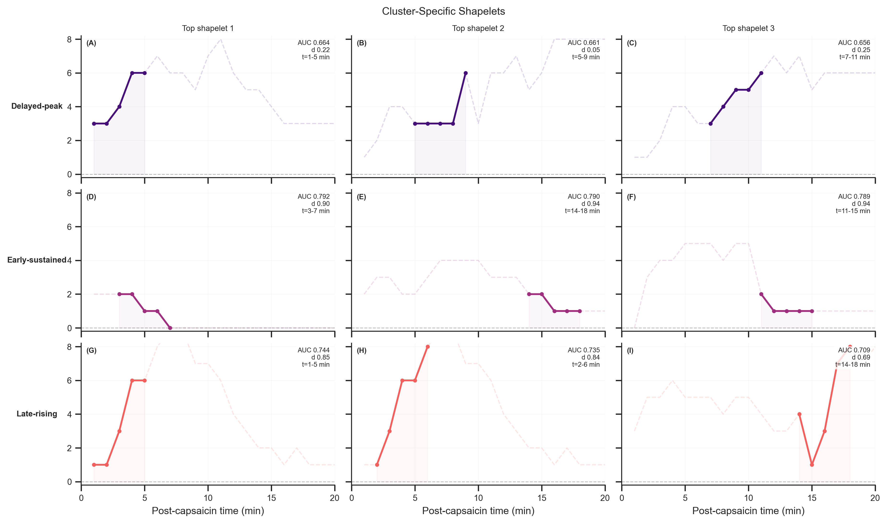
Caption: Sub-figures are arranged by phenotype in rows and by shapelet rank in columns. Each panel shows one cluster-discriminative shapelet, defined here as a short trajectory subsequence that helps distinguish one phenotype from the others. The solid line marks the highlighted shapelet, the dashed line shows the full source trajectory, and the shaded region marks the post-capsaicin time window spanned by the shapelet. AUC denotes the one-vs-rest area under the receiver operating characteristic curve, d denotes Cohen’s d effect size, and t denotes the post-capsaicin time window in minutes.
Delayed-peak responders showed motifs with deferred maxima followed by decline, early-sustained responders showed plateau-like motifs, and late-rising responders showed gradual upward fragments. These local motifs explain why DTW-based clustering separated the phenotypes even when full-length trajectories overlapped in absolute intensity at some time points. Short contiguous subsequences carried part of the phenotype signal beyond global peak value or total pain burden.

S6. Symptom-region and Rome IV-informed supplementary visualizations
Table S1. Top Symptom-Region Associations of the Overall Symptom-Region Network
Symptom | Region | Weight
abdominal distension | right hypochondrium | 110
abdominal distension | hypogastrium | 59
abdominal pain | right hypochondrium | 53
nausea | right hypochondrium | 52
nausea | hypogastrium | 47
Table S2. Top Network Nodes of the Overall Symptom-Region Network
Node | Type | Degree | Weighted Degree
right hypochondrium | region | 12 | 368
hypogastrium | region | 12 | 267
abdominal distension | symptom | 8 | 240
nausea | symptom | 9 | 145
abdominal pain | symptom | 7 | 143
Table S2b. Top Region-Disease Associations
Region | Disease | Weight
right hypochondrium | Biliary Pain-like | 86
hypogastrium | Functional Abdominal Bloating/Distension-like | 63
right hypochondrium | Functional Abdominal Bloating/Distension-like | 39
hypogastrium | Biliary Pain-like | 38
hypogastrium | Irritable Bowel Syndrome-like | 23
left hypochondrium | Biliary Pain-like | 22
hypogastrium | Unspecified Functional GI Symptom Pattern | 21
right lumbar | Functional Abdominal Bloating/Distension-like | 20
right hypochondrium | Irritable Bowel Syndrome-like | 17
right lumbar | Biliary Pain-like | 14
Table S2c. Top Symptom-Disease Associations
Symptom | Disease | Weight
abdominal distension | Biliary Pain-like | 61
abdominal distension | Functional Abdominal Bloating/Distension-like | 60
abdominal pain | Biliary Pain-like | 53
nausea | Biliary Pain-like | 52
nausea | Functional Abdominal Bloating/Distension-like | 35
abdominal pain | Irritable Bowel Syndrome-like | 28
abdominal distension | Irritable Bowel Syndrome-like | 26
acid regurgitation | Biliary Pain-like | 21
abdominal pain | Functional Abdominal Bloating/Distension-like | 21
vomiting | Biliary Pain-like | 17
Tables S1 and S2 complement the heatmaps by identifying the symptom-region pairs and nodes that accounted for the largest recurrent structure. The right hypochondrium and hypogastrium combined broad connectivity with high recurrence, while abdominal distension functioned as a symptom hub spanning multiple regions rather than remaining confined to a single location.
Tables S2b and S2c extend this summary into the Rome IV-informed layer. Region-disease links concentrated around biliary pain-like and bloating/distension-like patterns, and symptom-disease links were driven primarily by abdominal distension, abdominal pain, and nausea. Degree reflects the breadth of a node’s participation across pairings, whereas weighted degree reflects how often those pairings recurred in the cohort. A limited set of recurrent hubs drove the main network signal rather than a diffuse distribution across possible symptom-region or symptom-pattern combinations.
Figure S4. Temporal phenotype to symptom-region-Rome IV flow structure.
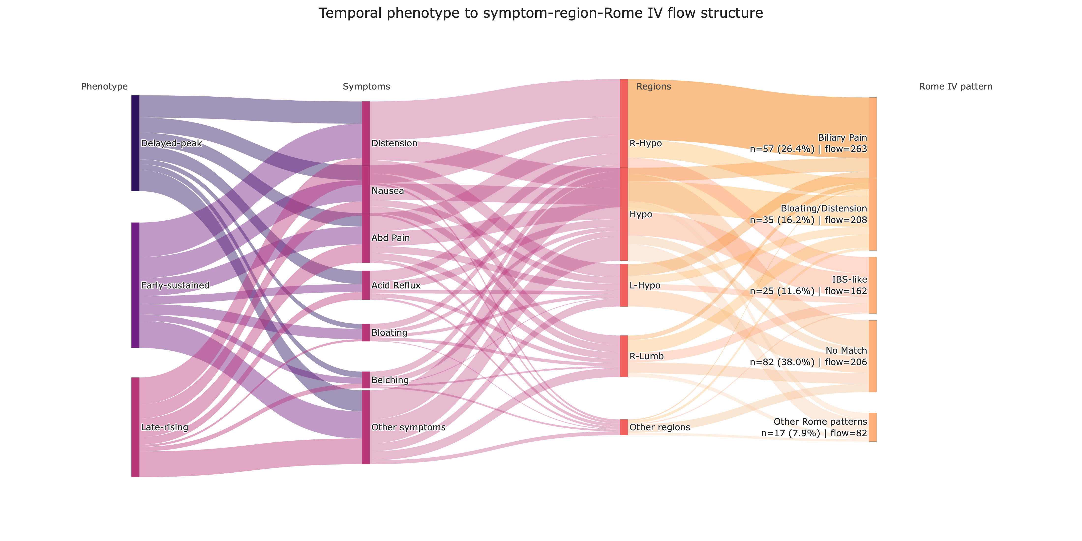
Caption: Flow widths represent participant-level symptom-region co-occurrence counts expanded within each temporal phenotype and linked to each participant’s top Rome IV-informed category. To preserve readability, lower-frequency symptoms, regions, and Rome-pattern categories were grouped into Other nodes. Rome-pattern labels report participant-level n (%) together with flow counts. Label abbreviations: Abd Pain, abdominal pain; R-Hypo, right hypochondrium; Hypo, hypogastrium; L-Hypo, left hypochondrium; R-Lumb, right lumbar; IBS-like, irritable bowel syndrome-like. Biliary Pain and Bloating/Distension are shortened display labels for the corresponding Rome IV-informed symptom-pattern alignments. No Match indicates that no Rome IV-informed category was assigned by the rule-based mapping.
The Sankey view shows that the temporal phenotypes differed in trajectory shape but shared a limited set of symptom, region, and Rome IV-informed pathways. Across phenotypes, abdominal distension, nausea, and abdominal pain contributed many flows, and downstream flow remained concentrated in the right hypochondrium, hypogastrium, biliary pain-like, bloating/distension-like, and irritable bowel syndrome-like pathways. The sizable No Match branch indicates that the conservative rule-based mapping left many participant symptom profiles uncategorized.

S7. Short-term VAS direction prediction
Table S3. Performance of Short-Term Direction Prediction Models
Model | Accuracy (mean +/- SD) | Balanced Accuracy | Macro F1 | Weighted F1
Majority | 0.717 +/- 0.016 | 0.500 +/- 0.000 | 0.418 +/- 0.005 | 0.599 +/- 0.021
Persistence-direction | 0.579 +/- 0.032 | 0.531 +/- 0.025 | 0.523 +/- 0.025 | 0.594 +/- 0.031
Logistic regression | 0.659 +/- 0.011 | 0.654 +/- 0.016 | 0.626 +/- 0.012 | 0.674 +/- 0.010
Abbreviations: SD, standard deviation; F1, harmonic mean of precision and recall; Macro F1, unweighted mean of class-specific F1 scores; Weighted F1, support-weighted mean of class-specific F1 scores. The persistence-direction model predicts decrease when the current local slope is sufficiently negative and otherwise predicts non-decrease.
The majority baseline achieved the highest raw accuracy but balanced accuracy of 0.500, indicating limited class-balanced discrimination despite favorable performance on the majority class. Logistic regression performed best on the class-balanced metrics, with the highest balanced accuracy, macro F1, and weighted F1 among the three models. Table S3 gives the metric breakdown summarized graphically in the main manuscript.

S8. Complementary classifier diagnostics
Figure S5. Complementary Phenotype-Classification Random Forest Feature Importance.
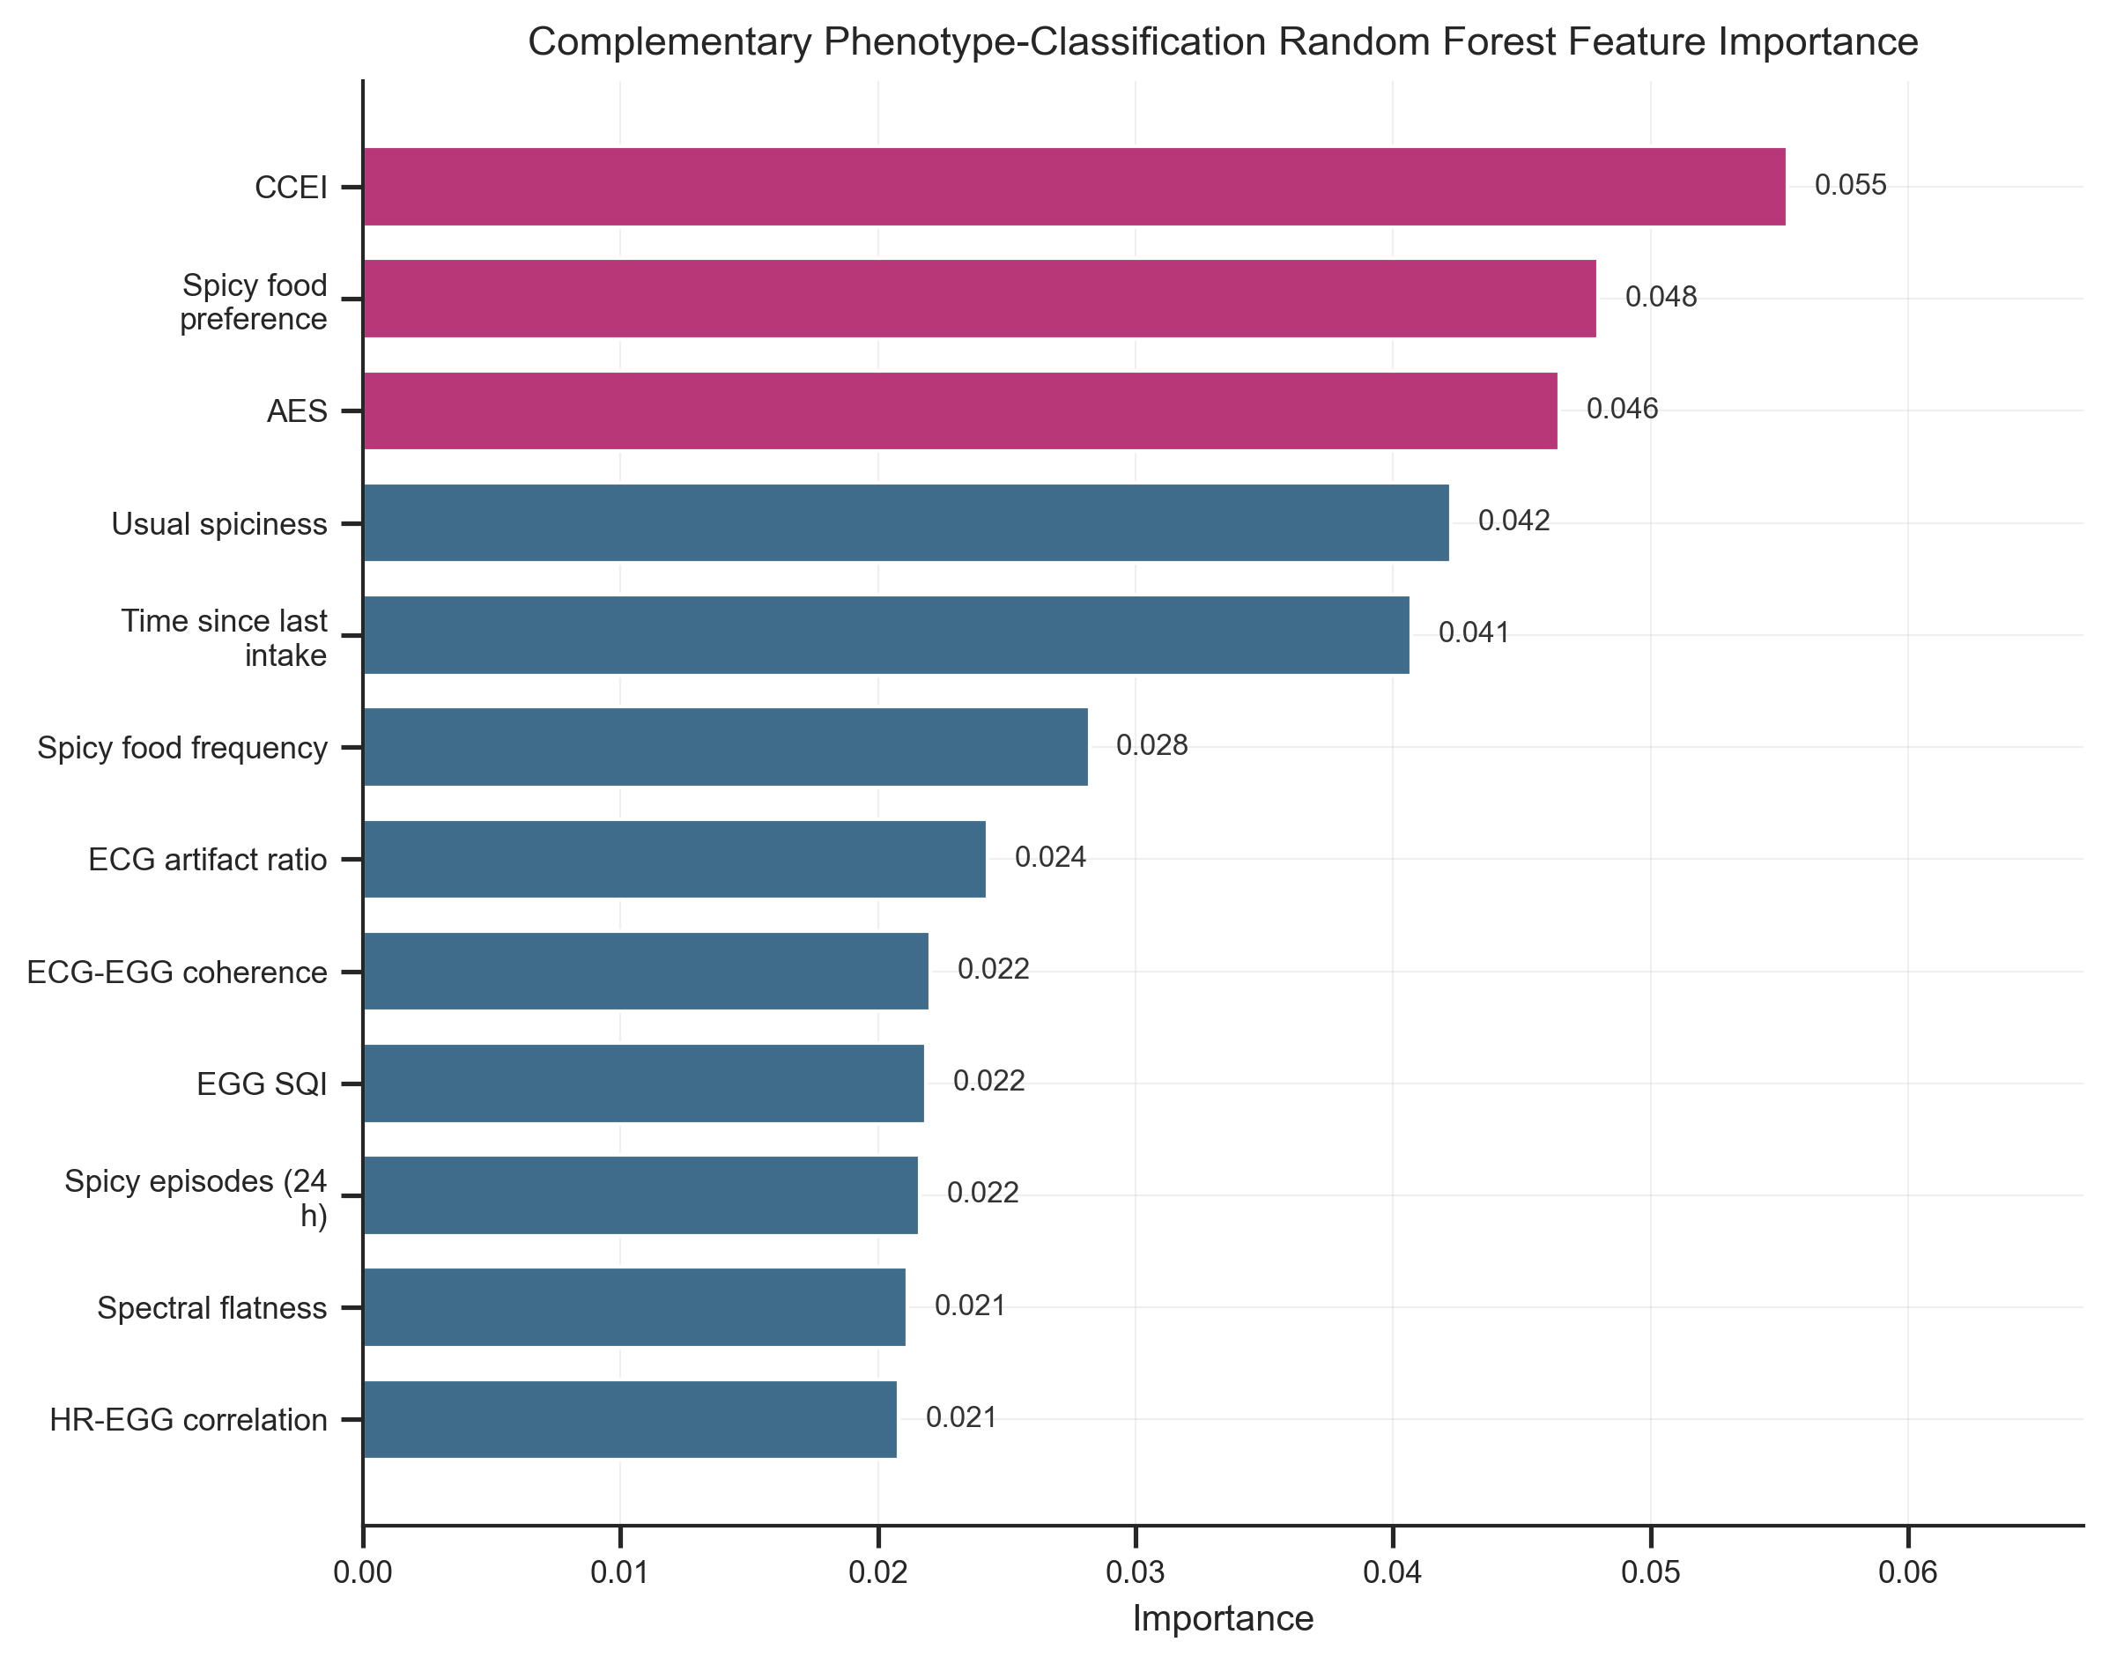
Caption: Random forest feature-importance values from the complementary baseline-plus-physiology phenotype-classification analysis. Horizontal bars show the top-ranked predictors and their model-specific importance values. Abbreviations: CCEI, Chronic Capsaicin Exposure Index; AES, Acute Exposure Score; ECG, electrocardiographic; EGG, electrogastrographic; HR, heart rate; SQI, signal quality index.
Questionnaire-derived exposure and preference measures ranked highest, including CCEI, spicy food preference, AES, usual spiciness level, time since last spicy intake, and spicy food frequency. A smaller subset of physiology-derived variables also ranked near the top, including ECG artifact ratio, ECG-EGG coherence, EGG signal quality, and heart rate-EGG correlation.
These rankings indicate which predictors contributed most within this fitted model family. They are model-specific importance scores, not stable standalone markers or causal determinants of phenotype membership.

S9. Safety
Table S4. Summary of Adverse Events
Safety outcome | Number of participants | Percentage
Any adverse event | 9 | 4.2%
Serious adverse event | 0 | 0.0%
Medical intervention required | 0 | 0.0%
Protocol discontinuation due to adverse event | 9 | 4.2%
Hospitalization | 0 | 0.0%
Nine participants (4.2%) experienced T-coded adverse events that ended the trial early. Staff recorded no serious adverse events, medical interventions, or hospitalizations, and all reported symptoms resolved within 30 minutes.

S10. Short supplementary interpretation
The supplementary materials add analytic detail, supplementary diagnostics, and additional network summaries without repeating the composite main-text panels. Supplementary Methods S1-S3 document the early-window classification design, the ECG/EGG preprocessing and feature-derivation workflow, and the expanded baseline-plus-physiology prediction framework.
Figures S1 and S2 show some between-phenotype structure in age and baseline physiology, although pre-exposure information alone did not classify temporal phenotypes with high accuracy. Figure S3 locates cluster-discriminative motifs in short subsequences of the VAS trajectories. Tables S1, S2, S2b, and S2c and Figure S4 show that symptom-region and Rome IV-informed structure clustered around recurrent hubs rather than spreading evenly across the cohort.
Table S3, Figure S5, and Table S4 set the limits for interpreting short-horizon forecasting, model-specific feature attribution, and safety. They document the derivation of the temporal phenotypes, symptom-pattern structure, and predictive analyses and provide the supporting evidence in full.

