**Programming Assignment 3**

**Step 1. feature extraction:**

The feature extraction I used for this programming assignment is Histogram of Gradient.

Parameters describing:

Preprocessing: Using Gamma Correction to reduce the effects of shadowing and illumination variations.

Size of image: the width and height I resize after crop image is 64 * 128

Cell: there are 8*8 pixels in a cell.

Block: there are 2*2 cells in a block.

Bin number: there are 9 bins (0° ~ 180°) to save the result of magnitude gradient.

Normalize: using L2 to normalize every block.

According to the parameters shown above, it will have 3780-dimensional vector per image. Later, I will put these vector into SVM as features (one dimensional vector as one feature, so that I will have 3780 features per raw)

**Step 2, 3. classifier design and evaluation:**

The classifier model for deep learning I used for this programming assignment is Support Vector Machines (SVM)

Parameters describing:

Data split: the ratio of training set to testing set is 7:3

Kernel: linear kernel

Decision function: one vs. one

Cross validation: 5-fold cross validation

Cost penalty testing: 9 cost penalty values being tested, 0.5, 1, 1.5, 2, 2.5, 3, 3.5, 4 and 4.5.

**Result:**

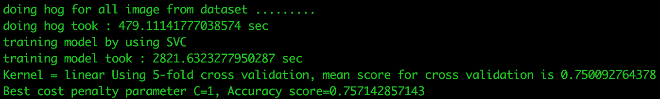

According to the screen shot shown above, we can see that the mean score of 5-fold cross validation is 0.7500927, the best parameter of cost penalty is 1. After training and testing this model, the accuracy to recognize the action is 0.7571428.