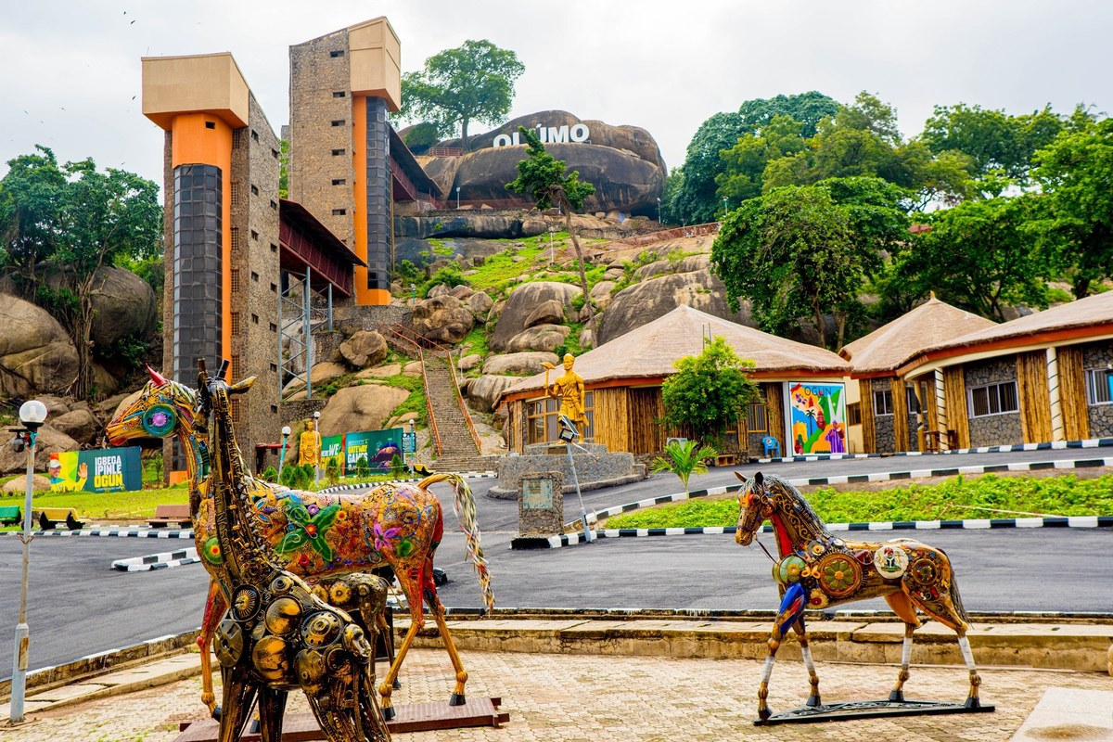

ISEYAA
Integrated State Experience, Economy & Automation Platform

PRODUCT REQUIREMENTS DOCUMENT
Version 3.0 · Ogun State Government Digital Transformation Programme
Document version | 3.0 — Approved for Engineering
Date | 25 April 2026
Prepared by | CTO · Solution Architect · COO · CIO
Status | Approved for engineering execution
Classification | Confidential

1. Product Overview
ISEYAA is Ogun State's state-wide digital super platform — a unified ecosystem bringing tourism, accommodation, events, transportation, commerce, sports, healthcare, utilities, and creative industries together under one cloud-native, AI-powered infrastructure built to serve 7 million+ citizens and visitors.
The platform operates as:
- A citizen super app for Ogun State residents and visitors
- A government digital operations system enabling data-driven governance across all MDAs
- A state revenue optimisation engine increasing internally generated revenue (IGR)
- A sports and cultural development infrastructure for state-wide competitions
- An AI-powered media, tourism, and commerce intelligence hub

1.1 Product Vision
To build Ogun State's digital operating system — a world-class super platform that drives economic growth, automates public services, and places Ogun State on the global digital map.

1.2 Version History
Version | Change
1.0 | Original PRD — initial specification
2.0 | Tech stack audit: microservices architecture adopted, 5 missing layers defined
3.0 | Phase restructure (tourism-first), real Ogun State photography added, Creative Economy module added, Design & Brand section added

2. Design & Brand Identity
ISEYAA's visual identity is rooted in Ogun State's natural landscape, cultural richness, and modern ambition. The design language balances heritage with innovation — bold, trustworthy, and distinctly Ogun.

2.1 Visual Inspiration — Ogun State
The platform's design draws directly from Ogun State's iconic landmarks. Below are the primary visual references from the ISEYAA mood board:
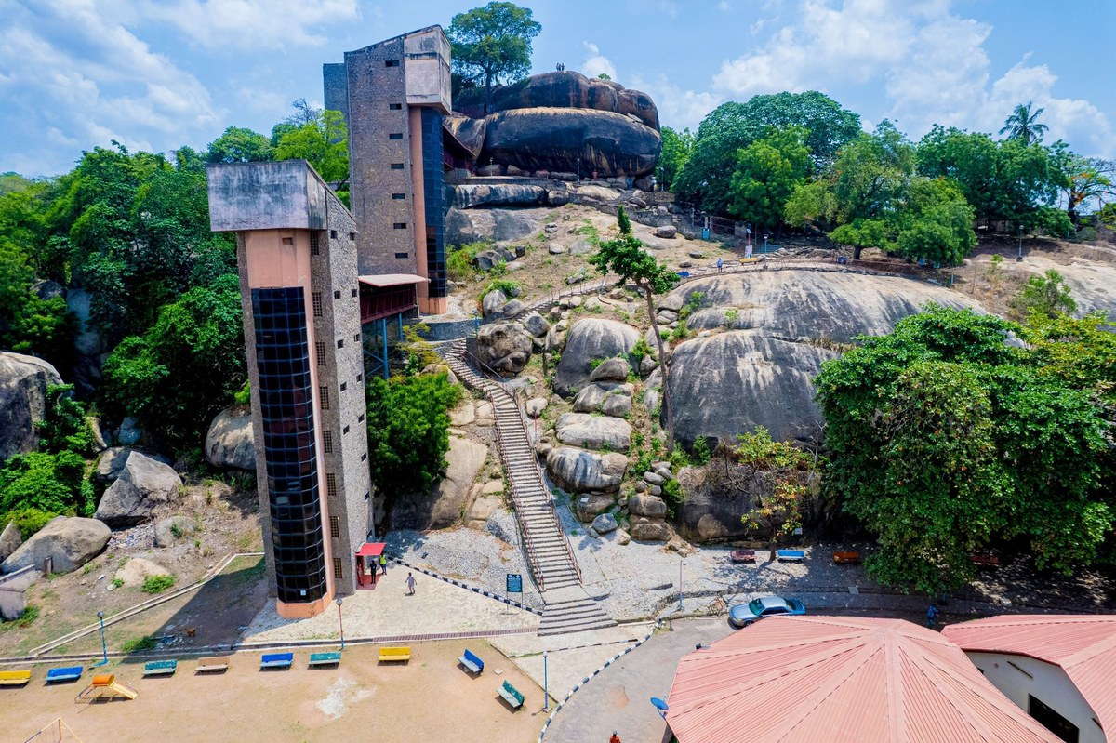 |  | 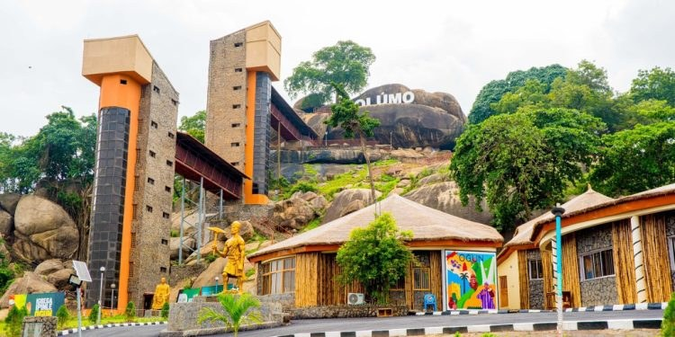
Olumo Rock, Abeokuta — aerial view |  | Olumo Rock Tourist Complex — new development

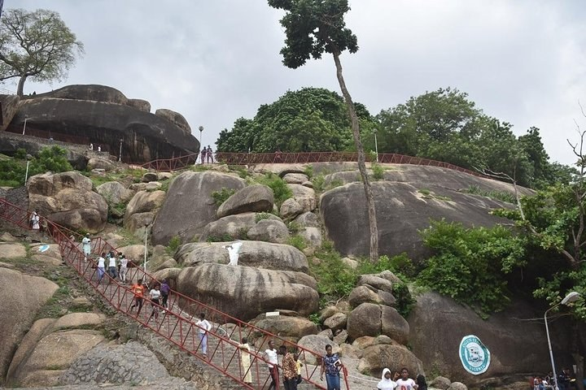 |  | 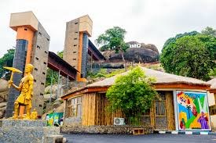 |  | 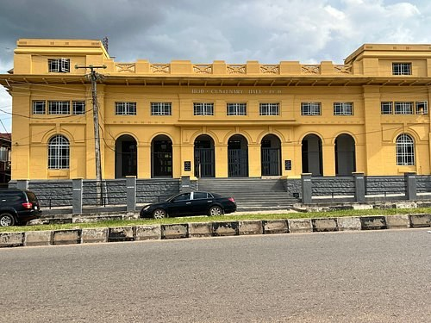
Visitors climbing Olumo Rock |  | Cultural village at the complex |  | Centenary Hall, Abeokuta

2.2 Pinterest Mood Board Reference
The ISEYAA website mood board curated by the team emphasises lush tropical greens, natural rock formations, rivers, and immersive nature — all found in Ogun State's landscape:
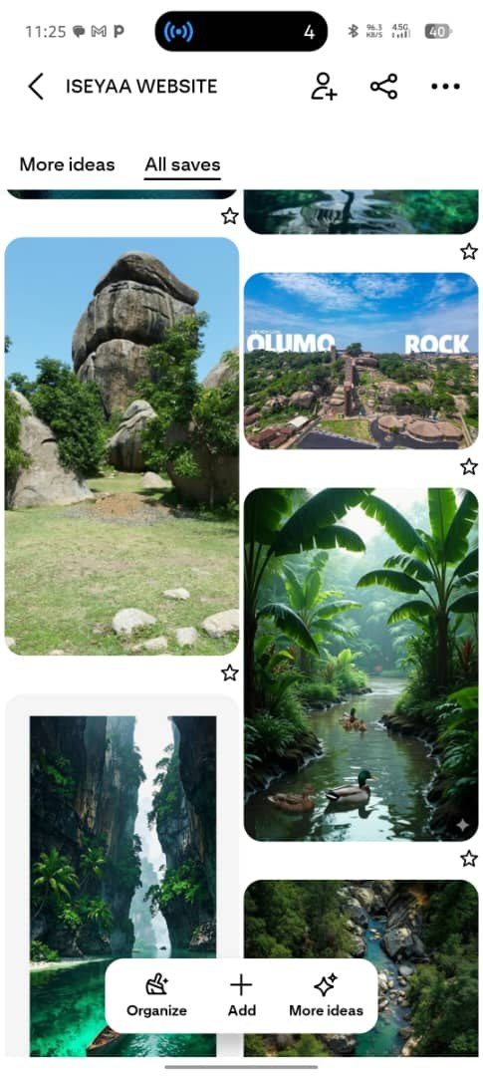
ISEYAA website mood board — lush nature, Olumo Rock, tropical rivers (source: Pinterest @ljentertainmentnow)

2.3 Colour Palette
Colour role | Hex | Inspired by | Usage
Primary — Deep Navy | #1A3C6E | Ogun River at dusk — authority and trust | Headers, navigation, primary CTAs
Accent — State Gold | #C9A227 | Sacred Egba brass, Lisabi Festival regalia | Highlights, icons, premium tier markers
Secondary — Forest Green | #0A3222 | Ogun State lush forests visible from Olumo Rock | Tourism, nature & wellness modules
Background — Warm White | #FAF8F4 | Abeokuta limestone rock surface texture | Page backgrounds, card surfaces
Text — Near Black | #1A1A1A | Ink on paper — clarity and readability | All body copy

2.4 Typography
- Display / Hero: Playfair Display Bold — serif gravitas for headlines and hero sections
- Body & UI: DM Sans — clean, modern, excellent multi-language support for Yoruba, Hausa, English
- Data & Numbers: JetBrains Mono — wallet amounts, dashboard metrics, and data displays

2.5 UX Design Principles
- Mobile-first always — design begins at 360px. Desktop is progressive enhancement
- Cultural familiarity — UI patterns reference local context: Naira symbols, Nigerian phone formats
- Low-bandwidth mode — all screens load meaningful content on 2G. Images lazy-load and compress on slow connections
- Language equality — Yoruba, Hausa, and English are first-class from day one
- Accessibility — WCAG 2.1 AA minimum across all modules

3. Target Users
User segment | Description | Primary modules
Citizens | Ogun State residents using platform daily | Wallet, utilities, transport, marketplace, HMO
Tourists | Domestic and international visitors | Tourism, accommodation, events, transport
Vendors & SMEs | Businesses selling goods and services | Marketplace, payments, storefront, logistics
Athletes & Clubs | Individuals and teams in state competitions | Sports, facility booking, performance analytics
Event Organisers | Promoters, cultural groups, corporate teams | Events, ticketing, sponsorship, livestream
Hotels & Hospitality | Accommodation providers on the platform | Accommodation marketplace, booking engine
Transport Operators | Drivers, fleet owners, logistics providers | Ride-hailing, routing, driver dashboard
Healthcare Providers | Hospitals, clinics, and HMO operators | HMO, telemedicine, appointments, claims
Creative Professionals | Artists, musicians, filmmakers, creators | Creative economy, bookings, digital store
Government MDAs | Ministries on the intelligence dashboard | Gov. dashboard, compliance, reporting
Corporate Sponsors | Businesses sponsoring events and sports | Sponsorship management, analytics

4. Phased Rollout Plan
Phase 1 leads with the five modules that generate the highest immediate citizen value and state revenue — tourism, accommodation, events, transportation, and marketplace. Phase 2 expands into sports, billing, HMO, and the creative economy. Phase 3 delivers full AI automation and AR/VR.
PHASE 1 — TOURISM-FIRST FOUNDATION
Months 1 – 4 · Tourism · Accommodation · Events · Transportation · Marketplace

Objective: Launch the five modules with the greatest immediate impact on Ogun State's economy and citizen experience. Tourism, accommodation, events, transport, and marketplace go live together as one integrated experience.

4.1.1 Tourism Module

Olumo Rock Tourist Complex — the crown jewel of Ogun State tourism and Phase 1 flagship destination

- Ogun State tourism portal: destination guides, heritage sites, attraction listings, and visitor tips
- Highlighted destinations: Olumo Rock, Olusegun Obasanjo Presidential Library, Ogun-Osun River Basin, Centenary Hall
- Tourism operator registration: guides, tour companies, and experience vendors
- Interactive map via Google Maps Platform: all tourism sites, routes, and nearby services
- AI itinerary planner (rule-based Phase 1, upgraded to Claude API in Phase 2)
- Multi-language: Yoruba, Hausa, and English content from launch
- Tourism analytics fed directly to Government Intelligence Dashboard

 |  |  |  | 
Visitors ascending Olumo Rock |  | Olumo fountain complex |  | Cultural village & murals

4.1.2 Accommodation Module

Traditional lodge accommodation — Ogun State's rich variety of stays from boutique heritage lodges to modern hotels

- Listing management: multi-photo upload, availability calendar, pricing tiers, and amenity tags
- Smart booking engine: instant and request-to-book modes with automated confirmation
- Host dashboard: earnings, calendar management, guest communication, and payout tracking
- Verified ratings and review system with host response capability
- Paystack payment integration with escrow held until check-in confirmation

4.1.3 Events, Culture & Entertainment Module
 |  | 
Olumo Rock Complex — premier event venue for state-scale cultural events |  | Centenary Hall, Abeokuta — historic venue for government and cultural events

- Event creation and government approval workflow with compliance gate
- Tiered ticketing: free, paid, VIP, early-bird, and group pricing with dynamic tiers
- QR code ticket generation and real-time scanner app for entry management
- Featured events: Lisabi Festival, Ijebu Cultural Festival, Ogun State Trade Fair
- Vendor booth management: floor plan allocation, stall fees, and sales tracking
- Artist and performer registry with booking request system
- Sponsorship management: package tiers, deliverables, and sponsor reporting
- Livestream integration for large-scale cultural events

4.1.4 Transportation Module
- Ride-hailing supporting motorcycle (okada), car, tricycle (keke), and bus categories
- Driver onboarding: licence verification, vehicle inspection workflow, and training
- Passenger app: real-time GPS tracking, ETA, fare estimate, and trip history
- Driver app (Flutter): turn-by-turn navigation, earnings dashboard, and ratings
- Route optimisation via Google Maps Platform
- Surge pricing engine based on demand and time-of-day
- Ably real-time WebSocket layer for live ride tracking

4.1.5 Marketplace Module
- Vendor storefronts: customisable branding, product listings, and inventory management
- Multi-category catalogue: food, fashion, electronics, artisan goods, and agri-products
- Order management: placement, fulfilment tracking, and delivery confirmation
- Logistics integration with third-party last-mile delivery providers
- Flash sales, voucher codes, and loyalty points engine
- Vendor KYC via Mono/Okra, business registration upload, and compliance check

4.1.6 Phase 1 Infrastructure Baseline
- AWS af-south-1 provisioned via Terraform: EKS, RDS PostgreSQL, ElastiCache Redis, S3, CloudFront
- NestJS microservices scaffold: Auth, Users, Payments, Tourism, Accommodation, Events, Transport, Marketplace, Notifications
- Go financial core: wallet engine, escrow, Paystack + Flutterwave integration, revenue split engine
- Next.js 14 web app: citizen portal, vendor dashboard, government dashboard (core metrics)
- Flutter mobile app (iOS + Android): citizen super app with all Phase 1 modules
- Termii SMS + SendGrid email + FCM push + Twilio WhatsApp notifications live
- GitHub Actions CI/CD and ArgoCD GitOps deployment from Sprint 1
- Datadog observability and Sentry error tracking before first user onboarded
- RBAC, KYC/NIN verification, and 2FA enforced before any financial transactions processed

PHASE 2 — EXPANSION
Months 5 – 10 · Sports · Billing & Utilities · Health / HMO · Creative Economy

Objective: Scale with four major new modules. Reach 250,000 MAU. Launch AI chatbot beta. Begin fraud ML model training on Phase 1 transaction data.

4.2.1 Sports Management Module
- League and tournament setup: single elimination, round robin, and group stage formats
- Athlete and club registration with eligibility verification and medical clearance upload
- Match scheduling with venue assignment and conflict detection
- Real-time score tracking and live match updates via Ably
- Referee assignment with availability calendar and performance ratings
- Sports facility booking: pitches, courts, gyms, and stadia — hourly slot management
- Performance analytics: match history, stats, and state ranking per athlete
- Ministry of Sports dashboard: LGA participation data, talent pipeline, funding reports

4.2.2 Billing & Utilities Module
- Power bill payment: IBEDC and EKEDC prepaid token purchase and postpaid settlement
- Water bill payment: Ogun State Water Corporation API integration
- Waste management levy payment via OGSROMA
- Tax and levy automation: direct OGIRS (Ogun State Internal Revenue Service) integration
- Business licensing and permits: digital application, fee payment, and certificate issuance
- Service request system: potholes, street lighting, and infrastructure fault reporting

4.2.3 Health & HMO Module
- HMO subscription management: plan selection, premium payment via Paystack, and renewal automation
- Appointment booking at registered hospitals and clinics with confirmation and reminders
- Telemedicine integration: video consultation via embedded SDK
- Claims processing: digital submission, status tracking, and settlement
- Hospital and pharmacy directory with location, speciality, and availability data
- Digital health card: proof of HMO coverage linked to citizen digital ID

4.2.4 Creative Economy Module
The Creative Economy module recognises Ogun State's extraordinary cultural output — Egba weavers, Nollywood productions, afrobeats artists, visual artists, and fashion designers. ISEYAA gives creatives a structured commercial platform.

- Creative professional registry: musicians, visual artists, filmmakers, fashion designers, content creators
- Portfolio and profile management: bio, works gallery, links, and booking contact
- Booking and commission system: clients request creative services; escrow protects both parties
- Digital product store: creatives sell beats, artwork, photography, digital prints, and e-courses
- Event performance bookings: artists listed as available performers for event organisers to book
- Creative grants tracker: Ogun State government creative funding applications and disbursement
- Analytics: plays, downloads, bookings, and revenue per creative professional
- Cross-module integration: creative content featured on tourism pages and event listings

4.2.5 Phase 2 AI Activations
- Claude API chatbot: citizen assistant in Yoruba, Hausa, and English — beta launch
- AWS Personalize: vendor, event, and tourism recommendations
- SageMaker: fraud detection model training begins on Phase 1 transaction data
- Government dashboard expansion: all 12 core ministries onboarded

PHASE 3 — ADVANCED AI & INNOVATION
Months 11 – 14 · Full AI automation · AR/VR · Predictive analytics · All-MDA adoption

Objective: Full AI automation across the platform. AR/VR tourism experiences live at Olumo Rock. All state MDAs on the intelligence dashboard. Platform at 750,000+ MAU.

- AI news agent: Claude API-powered aggregation, summarisation, and auto-publishing
- AI itinerary planner upgrade: personalised Ogun State journeys with live booking integration
- AR/VR digital experiences: Unity-based virtual tours of Olumo Rock and Ogun State heritage sites
- Predictive analytics: event attendance forecasting, transport demand, and revenue projection
- SageMaker fraud model: live inference replacing Phase 1 rule-based engine
- Advanced government reporting: multi-year trend analysis, inter-LGA comparisons
- Full MDA adoption: all state ministries, departments, and agencies on the dashboard
- Diaspora portal: USD payments, virtual event attendance, and Ogun State investment gateway

5. Key Performance Indicators
KPI | Phase 1 | Phase 2 | Phase 3
Monthly active users | 50,000 | 250,000 | 750,000
Tourist registrations | 5,000 | 25,000 | 80,000
Accommodation listings | 300 | 1,500 | 4,000
Event ticket revenue | ₦10M/month | ₦50M/month | ₦200M/month
Transport rides/day | 1,000 | 8,000 | 25,000
Vendor storefronts | 500 | 2,500 | 7,000
Platform transaction volume | ₦50M/month | ₦500M/month | ₦2B/month
Sports participants registered | — | 2,000 | 10,000
HMO enrolments | — | 10,000 | 50,000
Creative professionals registered | — | 1,000 | 5,000
Utility payments/month | — | 20,000 | 100,000
Gov. dashboard adoption | 5 ministries | 12 ministries | All MDAs
API uptime | 99.5% | 99.9% | 99.95%
App store rating | 4.2+ | 4.5+ | 4.6+

6. Technical Architecture
Architecture principle: API-first, cloud-native, microservices-based. Every module communicates via versioned REST or gRPC APIs. No module is tightly coupled. No legacy CMS in the stack.

6.1 Backend API Layer
Component | Technology | Rationale
Primary API services | NestJS (TypeScript) | Structured, modular microservices. Large Nigerian developer talent pool. No CMS.
Financial core | Go (Golang) | Sub-10ms latency for payments, wallet, and escrow. Handles 100k+ concurrent transactions.
Content service | Custom NestJS module | Tourism pages, news, and announcements — dedicated microservice with lightweight admin UI.
API gateway | AWS API Gateway | Single entry point. Rate limiting, auth routing, DDoS protection.
Service communication | gRPC + AWS SQS/SNS | Synchronous inter-service via gRPC; async events via SQS/SNS.

6.2 Frontend — Next.js 14+ · Mobile — Flutter
- Next.js 14+ with SSR (tourism/event SEO), SSG (static), and CSR (dashboards)
- React Query + Zustand · shadcn/ui component system · next-i18next for three languages
- Flutter (Dart) — single codebase for iOS and Android. Riverpod + Hive + Dio + FCM
- Offline mode: event tickets, HMO cards, ride history accessible without connectivity

6.3 Cloud Infrastructure — AWS af-south-1 (Cape Town)
AWS Service | Purpose
EKS (Kubernetes) | Container orchestration — all microservices with horizontal pod autoscaling
RDS PostgreSQL (Multi-AZ) | Transactional data: users, wallets, payments, bookings
ElastiCache Redis | Sessions, rate limiting, ride state, live scores, API caching
MongoDB Atlas | Events, vendor catalogues, tourism content — flexible schemas
AWS OpenSearch | Platform-wide full-text and geo-proximity search
ClickHouse (EC2) | Government intelligence dashboard OLAP queries
AWS SQS + SNS | Async: notifications, audit logs, payment webhooks, background jobs
S3 + CloudFront CDN | Media, images, AR assets, backups, and global static delivery
AWS Cognito | User identity and token management
AWS Secrets Manager | All credentials — automatic rotation, no secrets in code

6.4 Payments · Communications · AI Stack
Layer | Technology | Role
Payments — primary | Paystack | All NGN transactions. CBN-licensed.
Payments — secondary | Flutterwave + Mono + NIBSS | Cross-border, open banking, direct transfers
SMS | Termii | OTPs and alerts — Nigerian-first provider
Email / Push / WhatsApp | SendGrid · FCM · Twilio | Transactional email, mobile push, WhatsApp Business API
Real-time | Ably | Ride tracking, live scores, live dashboard data
AI — chatbot & news | Claude API (Anthropic) | Citizen assistant + news summarisation agent
AI — fraud / ML | AWS SageMaker | Rule-based Phase 1 → trained ML model Phase 2
AI — recommendations | AWS Personalize | Vendor, event, and tourism personalisation
Maps & routing | Google Maps Platform | Transport routing, tourism maps, facility finders
AR/VR (Phase 3) | Unity + ARCore / ARKit | Olumo Rock virtual tour and cultural heritage experiences

6.5 DevOps & Observability
- Terraform — all AWS infrastructure as code, version-controlled from day one
- GitHub Actions — automated CI/CD pipelines per microservice
- ArgoCD — GitOps Kubernetes deployments with zero-downtime rollouts
- Datadog — APM, infrastructure metrics, log aggregation, SLA monitoring
- Sentry — real-time error tracking for API, web, and Flutter mobile

7. Security & Compliance

7.1 Regulatory Requirements
- NDPA (Nigeria Data Protection Act) — DPO appointed, DPIA completed before Phase 1 launch
- PCI-DSS Level 2 — attested before payment module goes live. Card data tokenised via Paystack Vault only
- CBN Digital Finance Guidelines — all financial flows comply with e-money and consumer protection regulations
- NCC Regulations — all SMS and WhatsApp communications registered per NCC guidelines

7.2 Security Controls
Control | Implementation
AWS WAF | OWASP managed ruleset — blocks SQL injection, XSS, credential stuffing
DDoS protection | AWS Shield Standard included; Shield Advanced evaluated for Phase 2
Encryption | TLS 1.3 in transit; AWS KMS at rest for RDS, S3, ElastiCache, Secrets Manager
RBAC | Fine-grained role access at API Gateway and service level. Minimum-privilege principle.
API rate limiting | Per-user and per-IP limits enforced at API Gateway
Audit logging | CloudWatch — auth events, transactions, admin actions; 90-day retention for NDPA
Secrets management | AWS Secrets Manager with automatic rotation. No hardcoded secrets.
Pen testing | Third-party test commissioned before each phase go-live
Incident response | Documented runbook: breach detection, NDPA 72-hour notification, recovery steps

8. Non-Functional Requirements
Requirement | Specification | Notes
Availability | 99.9% uptime — all production services | Monthly measurement
API response time | P95 < 200ms · P99 < 500ms | Payment endpoints: P95 < 100ms
Mobile load time | Cold start < 3s on 4G MTN Nigeria | Mid-range Android, 2GB RAM
Scalability | Auto-scale to 10x baseline on EKS | Handles event on-sale traffic spikes
Real-time latency | Event updates < 500ms end-to-end | Ride tracking, live scores
Offline capability | Core functions without connectivity | Flutter + Hive: tickets, HMO cards, history
Multi-language | Yoruba, Hausa, English from Phase 1 | Persisted to user profile
Accessibility | WCAG 2.1 AA | Web and mobile. Screen reader compatible.
Data residency | All PII in AWS af-south-1 | No PII outside Africa without consent
Low-bandwidth mode | Functional on 2G/edge | Compressed images, progressive loading

9. Risks & Mitigation
Risk | Likelihood | Impact | Mitigation
Low citizen adoption | Medium | High | Incentive programme: cashback on first transaction, free event tickets. State government endorsement.
Regulatory delays | Medium | High | Engage CBN and NDPC in Phase 1. Legal counsel retained from project start.
Payment gateway downtime | Low | Critical | Paystack primary + Flutterwave failover at API Gateway. Circuit breaker pattern.
Infrastructure cost overrun | Medium | Medium | FinOps monthly review. Auto-scaling with spend alerts. Reserved instances for baseline.
Low connectivity users | High | Medium | Flutter + Hive offline mode. Low-bandwidth mode. Progressive loading.
Security breach | Low | Critical | WAF, PCI-DSS, NDPA, pen testing, incident response — all mandatory before launch.
Scope creep | High | Medium | Phase 1 scope frozen at PRD sign-off. All additions go to Phase 2 backlog.

10. Success Criteria
- ISEYAA becomes Ogun State's primary digital interface for tourism, commerce, events, and citizen services
- Platform transaction volume exceeds ₦2 billion per month by end of Phase 3
- Tourism arrivals and accommodation bookings increase by 40% within 18 months of launch
- Ogun State IGR increases measurably through platform commerce, events, and tax automation
- Sports and cultural administration fully centralised through the platform
- Creative economy module generates a new, trackable revenue stream for Ogun State creatives
- AI automation reduces manual government processing time by at least 60%
- Citizen satisfaction (CSAT) sustained above 4.5/5.0 across all modules
- All state MDAs adopted on the intelligence dashboard
- Zero critical security incidents in the first 12 months of operation

This document is approved for engineering execution. All vendor engagements, procurement decisions, and development contracts must reference PRD v3.0. Any deviation from the module phasing or technical stack requires written approval from the CTO.


Olumo Rock, Abeokuta — the foundation of ISEYAA's tourism vision for Ogun State

