# Have you have done any programming before and if so, in what language and what did you build?

No.

# Why are you doing computer science, what is your interest in programming?

It’s the future and provides the basis for the crucial technology we use on an everyday basis.

# What is your favourite Website, App and software –Why?

[Reddit](http://www.reddit.com) is my favourite website; it provides a collective image board of funny, controversial or topical posts

Favourite app is Pokémon Go; it gives me an excuse to get out of the house

Favourite software is Spotify, simple easy music streaming

# What piece of software, app or website do you wish you had created or would like to create?

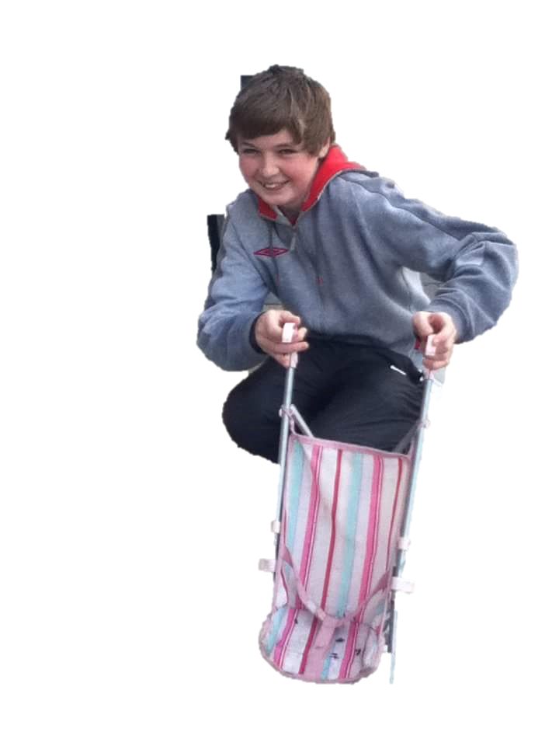 Spotify, makes life much easier with regards to streaming music. Provides well-constructed playlists and makes good suggestions based on the music you’ve been listening to recently

# Your hobbies and interests.

Gaming,Guitar,Gaelic Football

# An interesting fact about you

I enjoy chicken.

## Part 3 Problem 1 : How to make a cup of tea

1. Open lid of kettle
2. Turn tap on
3. Put water into kettle
4. Place lid back on kettle
5. Place kettle on its stand on countertop
6. Press lever on side of kettle
7. Wait for lever to go back up
8. Obtain a cup from cupboard
9. Place cup on countertop
10. Obtain teabag from box
11. Place teabag inside of cup
12. Pour water from kettle into cup
13. Obtain spoon from drawer
14. Place spoon in cup
15. Stir the liquid with spoon
16. Remove teabag using spoon
17. Place teabag in bin
18. Obtain milk from fridge
19. Remove lid from milk carton
20. Pour a small amount of milk into cup
21. Stir using spoon again
22. Using spoon take a spoonful of sugar
23. Place sugar in tea
24. Take another spoonful of sugar
25. Place spoonful in cup
26. Stir tea
27. Serve to individual

## Part 3 Problem 2 : 3 lights in a room

1. Turn the first 2 light switches on.
2. Wait a few minutes.
3. Turn one switch off.
4. Enter room.
5. Whichever bulb is still lit is linked to switch number 1.
6. Touch the remaining bulbs.
7. Whichever bulb is unlit but hot is connected to switch number 2.
8. Whichever bulb is unlit and cold is connected to the remaining switch which was not turned on.