SALES & BUSINESS ANALYTICS
Project Report
Sales performance, customer, product and time-series analysis of US order data, 2015–2018
Tools: Python (pandas, matplotlib, seaborn) · PostgreSQL · Power BI
Data: 9,800 order lines · 4,922 orders · 793 customers
Prepared: 19 October 2026

1. Executive Summary
This report consolidates the full Sales & Business Analytics project: data cleaning and feature engineering in Python, business and advanced queries in SQL (PostgreSQL), time-series work in notebooks, and a three-page Power BI dashboard. All figures were recomputed directly from Sales_data.csv (9,800 order lines), so they do not depend on the notebooks’ saved outputs.
Headline results
- Total sales of $2.26M across 4,922 orders, 793 customers and 1,861 products. Average order value is $459 and average sales per customer is $2,852.
- Growth is strong but not smooth. Sales fell 4.3% in 2016, then rose 30.6% in 2017 and 20.3% in 2018 to $722K. The 2015–2018 compound annual growth rate is 14.6%.
- Growth is volume-driven, not value-driven. Orders grew 75% (947 to 1,661) while average order value fell 14% ($507 to $435).
- Geographic concentration. California and New York produce 33% of sales and the top five states 52%. West and East together produce 61%.
- Heavy seasonality. Q4 delivers 38.5% of annual sales; September, November and December alone deliver 43%.
- Balanced category mix (Technology 36.6%, Furniture 32.2%, Office Supplies 31.2%), but Phones and Chairs are the two biggest sub-categories at about 14% each.
- Loyal customers. 98.4% of customers ordered more than once, averaging 6.2 orders each. The top 20% of customers generate 48% of sales.

Important limitation: the dataset contains sales only. It has no Profit, Quantity or Discount fields, so profitability, margin and discount conclusions cannot be drawn from this data (see Section 9).

2. Project Scope and Deliverables
Objective: turn raw order data into decisions about where sales come from, how they change over time, who the valuable customers are, and how well orders are fulfilled.
Component | Contents | Status
Data | Sales_data.csv and train.csv (byte-identical, 9,800 rows, 24 columns) | Complete
Notebook 1: Data_Cleaning | Quality checks, date conversion, feature engineering | Complete
Notebook 2: Sales_Analysis | KPIs, category, region, segment, state, yearly and monthly trends | Complete
Notebook 3: Product_Customer_Analysis | Top products, top customers, value tiers | Mostly complete (one broken cell)
Notebook 4: Time_Series_Analysis | Growth, rolling average, seasonality, shipping | Complete (one copy-paste error)
Notebook 5: Business_Insights | Intended synthesis notebook | Empty
SQL scripts 01–04 | Table setup, data quality, 25 business queries, window-function analysis, one view | Complete (stray text)
Power BI dashboard | 3 pages, 53 visuals, slicers on year, region, segment, category, ship mode | Complete
Screenshots | Empty folder | Missing

3. Data Description and Preparation
Source data: 9,800 order lines covering orders placed from 3 January 2015 to 30 December 2018, shipped to 49 states and 529 cities in the United States. Each row is one product line within an order.
Fields: order and ship dates, ship mode, customer ID and name, segment, geography (city, state, postal code, region), product ID, category, sub-category, product name and sales, plus engineered fields Year, Month, Month_Name, Quarter, Year_Month and Shipping_Days.
Data quality results
Check | Result
Exact duplicate rows | 0
Missing values | 11 postal codes, all for one city (Burlington); no other nulls
Sales ≤ 0 | 0 rows
Ship date earlier than order date | 0 rows
Repeated Order ID + Product ID pairs | 8 (likely separate line items with different values; not removed)
Sales range | $0.44 to $22,638; mean $231, median $54

Feature engineering: date columns were converted, then Year, Month, Quarter, Year_Month and Shipping_Days (ship date minus order date) were derived. Shipping_Days ranges from 0 to 7 with a mean of 3.96.
Interpretation: the data is clean and analysis-ready. Sales is strongly right-skewed (mean $231 versus median $54; the largest line is $22.6K), so medians are often more representative than averages, and a few large orders matter a great deal.

4. Overall Business KPIs
KPI | Value
Total sales | $2,261,537
Total orders | 4,922
Total customers | 793
Total products (IDs) | 1,861
Average order value | $459.48 (median $151.88)
Average sales per customer | $2,851.87
Average lines per order | 1.99
Average shipping time | 3.96 days

The gap between the mean and median order value ($459 versus $152) shows that a minority of large orders lifts the average. Most orders are small.

5. Sales Performance Analysis

5.1 Sales by category
Category | Sales | Share | Orders | Avg order value
Technology | $827,456 | 36.6% | 1,519 | $545
Furniture | $728,659 | 32.2% | 1,727 | $422
Office Supplies | $705,422 | 31.2% | 3,676 | $192

Technology earns the most revenue from the fewest orders. Office Supplies has more than twice the order count but the lowest order value, so it drives traffic and repeat purchasing while Technology drives revenue.
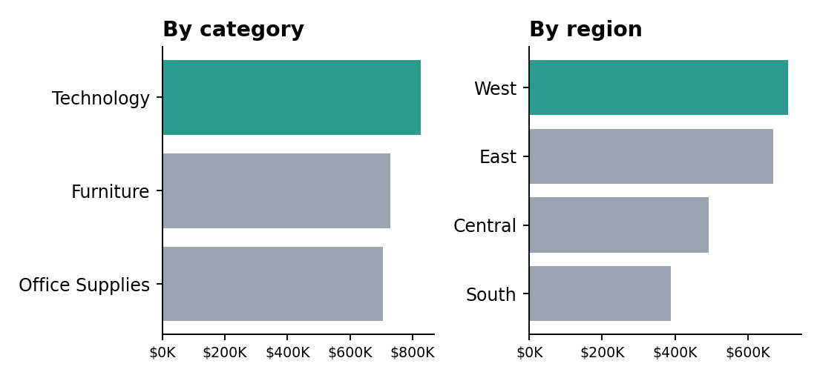
Figure 1. Sales by category and region

5.2 Sub-category contribution
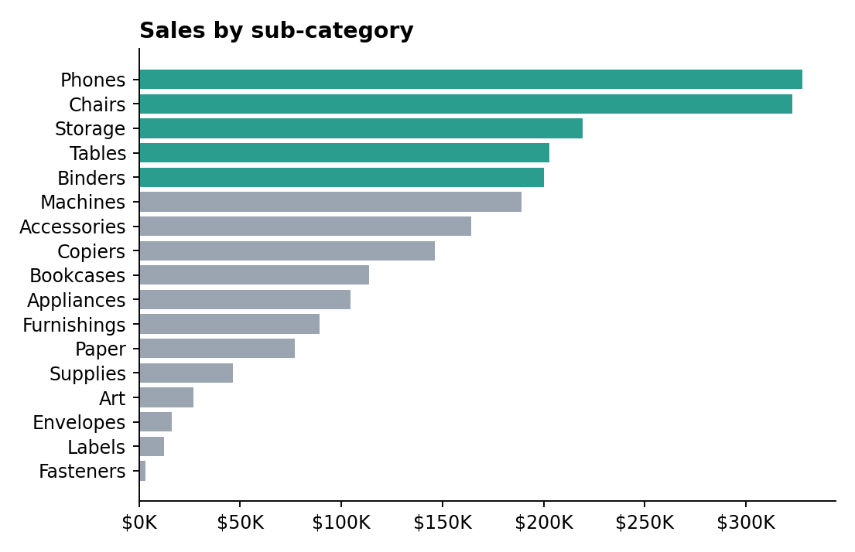
Figure 2. Sales by sub-category (highlighted: above $200K)
The top four sub-categories (Phones, Chairs, Storage, Tables) make up 47% of sales. The weakest are Fasteners ($3.0K), Labels ($12.3K), Envelopes ($16.1K) and Art ($26.7K), together under 3% of revenue.

5.3 Regional performance
Region | Sales | Share | Orders | Avg order value
West | $710,220 | 31.4% | 1,587 | $448
East | $669,519 | 29.6% | 1,369 | $489
Central | $492,647 | 21.8% | 1,156 | $426
South | $389,151 | 17.2% | 810 | $480

West leads on revenue and order volume. South is the smallest region with the fewest orders despite a healthy average order value ($480), which suggests a reach or coverage problem rather than a pricing problem.

5.4 Customer segments
Segment | Sales | Share | Customers | Sales per customer
Consumer | $1,148,061 | 50.8% | 409 | $2,807
Corporate | $688,494 | 30.4% | 236 | $2,917
Home Office | $424,982 | 18.8% | 148 | $2,872

Consumer is the largest segment by number of customers, but per-customer spend is almost identical across all three segments. Revenue differences come from how many customers each segment has, not how much each spends.

5.5 Geography: states and cities
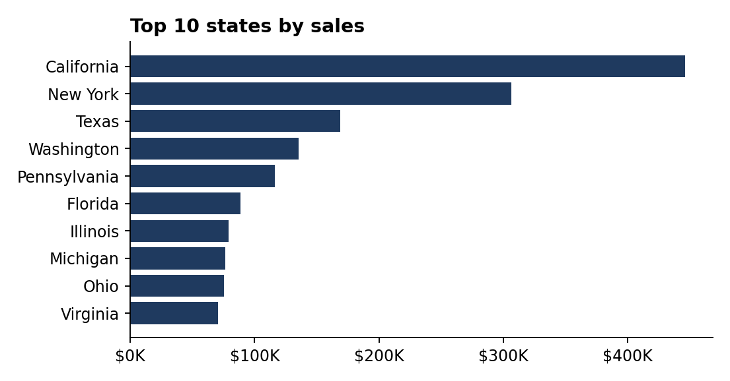
Figure 3. Top 10 states by sales
State | Sales | Share
California | $446,306 | 19.7%
New York | $306,361 | 13.5%
Texas | $168,573 | 7.5%
Washington | $135,207 | 6.0%
Pennsylvania | $116,277 | 5.1%

Top cities are New York City ($252K, 11.2% of all sales), Los Angeles ($173K), Seattle ($116K), San Francisco ($109K) and Philadelphia ($109K). The weakest states (Wyoming, South Dakota, Maine, West Virginia, North Dakota) each sell under $2K, so reach is very uneven.

5.6 Shipping performance
Ship mode | Share of sales | Orders | Avg days
Standard Class | 59.3% | 2,945 | 5.01
Second Class | 19.9% | 944 | 3.25
First Class | 15.3% | 772 | 2.18
Same Day | 5.5% | 261 | 0.04

Shipping speed is almost identical across regions (3.9 to 4.1 days average), so fulfilment is consistent. Most revenue ships by Standard Class, which averages five days and takes up to seven.

6. Time-Series and Seasonality Analysis

6.1 Yearly trend
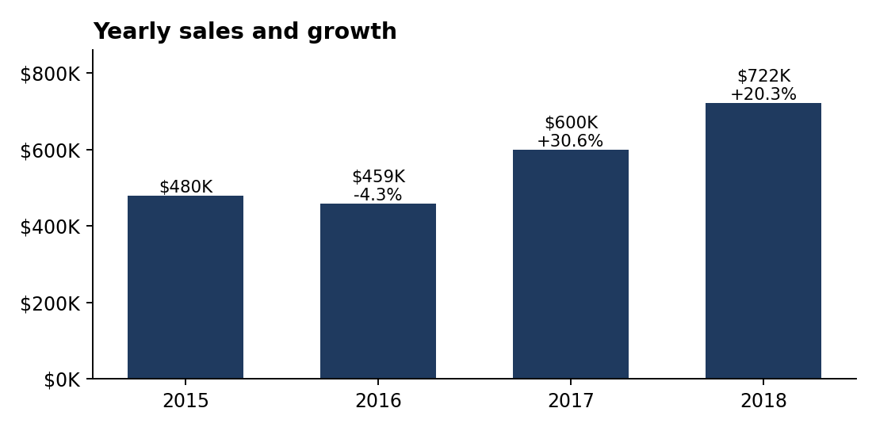
Figure 4. Yearly sales and growth
Year | Sales | Growth | Orders | Customers | Avg order value
2015 | $479,856 | n/a | 947 | 589 | $507
2016 | $459,436 | -4.3% | 1,019 | 567 | $451
2017 | $600,193 | +30.6% | 1,295 | 635 | $464
2018 | $722,052 | +20.3% | 1,661 | 690 | $435

Growth since 2016 has come mainly from more orders and more customers, not from larger baskets. Average order value fell in every year except 2017, so the business is winning volume at a lower value per order.
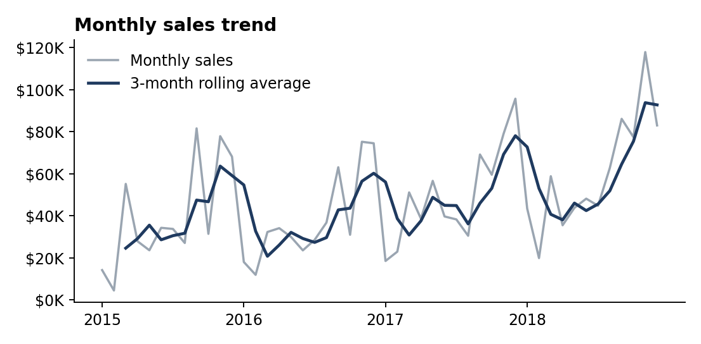
Figure 5. Monthly sales with 3-month rolling average

6.2 Who drove the growth (2015 to 2018)
Dimension | Group | 2015 | 2018 | Change
Region | West | $145.9K | $248.1K | +70%
Region | East | $127.7K | $210.1K | +65%
Region | Central | $102.9K | $141.6K | +38%
Region | South | $103.4K | $122.2K | +18%
Category | Office Supplies | $149.5K | $240.4K | +61%
Category | Technology | $173.9K | $269.4K | +55%
Category | Furniture | $156.5K | $212.3K | +36%
Segment | Corporate | $127.8K | $236.0K | +85%
Segment | Home Office | $89.1K | $157.4K | +77%
Segment | Consumer | $263.0K | $328.6K | +25%

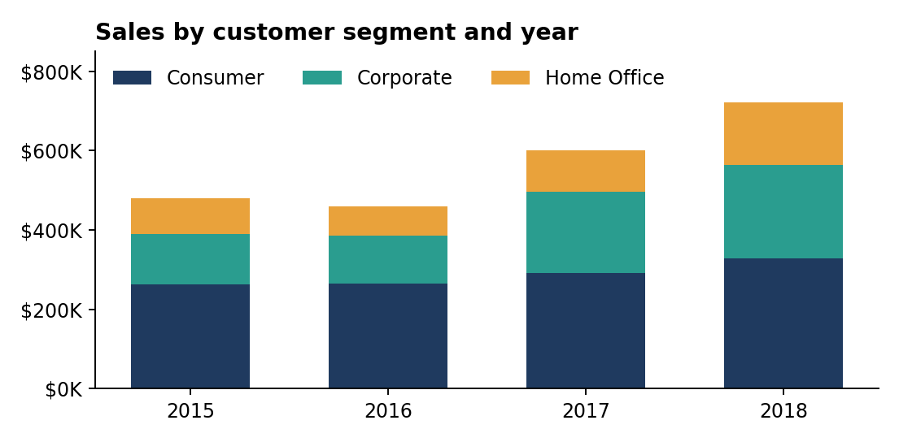
Figure 6. Sales by customer segment and year
Three shifts stand out. West and East are pulling away while South has barely grown (and fell 32% in 2016). Office Supplies overtook Furniture in 2018. Corporate and Home Office are growing far faster than Consumer, so Consumer’s share of sales fell from 54.8% to 45.5%.

6.3 Seasonality
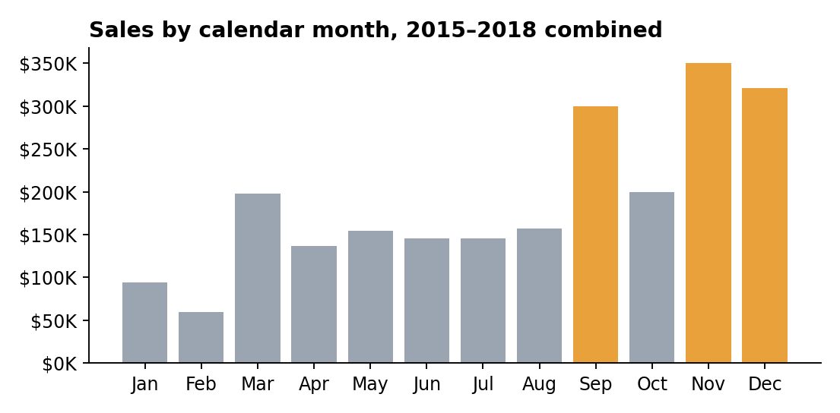
Figure 7. Sales by calendar month (highlighted: Sep, Nov, Dec)
Quarter | Sales | Share
Q1 | $351,236 | 15.5%
Q2 | $436,207 | 19.3%
Q3 | $602,955 | 26.7%
Q4 | $871,138 | 38.5%

The strongest months across all four years are November ($350K), December ($321K) and September ($300K), with a smaller March peak ($198K). The weakest are February ($59K) and January ($94K). The September jump (about double August) recurs in every year, which points to a recurring back-to-business or budget-cycle effect rather than a one-off.

7. Product and Customer Analysis

7.1 Top products
The top ten products account for only 10.8% of sales, so revenue is not dependent on a few items. The leader is the Canon imageCLASS 2200 Advanced Copier ($61.6K, 2.7% of all sales), followed by the Fellowes PB500 binding machine ($27.5K), Cisco TelePresence System EX90 ($22.6K), HON 5400 Series Task Chairs ($21.9K) and GBC DocuBind TL300 ($19.8K). Copiers, binding machines and large-format equipment dominate the top ten.

7.2 Customer concentration
Measure | Value
Average sales per customer | $2,852 (median $2,215)
Customers who ordered more than once | 98.4%
Average orders per customer | 6.2
Top 10% of customers (79) | 30.9% of sales
Top 20% of customers | 48.3% of sales

Top customers are Sean Miller ($25.0K), Tamara Chand ($19.1K), Raymond Buch ($15.1K), Tom Ashbrook ($14.6K) and Adrian Barton ($14.5K). Some high spenders buy rarely and in large lots (Sean Miller: 5 orders), while others are frequent buyers (Ken Lonsdale: 12 orders).

7.3 Customer value tiers
Using the project’s own thresholds (Low under $1K, Medium $1K to $5K, High $5K to $10K, VIP above $10K):
Tier | Customers | Sales share | Avg orders
Low value | 178 | 4.4% | 4.1
Medium value | 501 | 56.3% | 6.5
High value | 95 | 28.1% | 8.0
VIP | 19 | 11.3% | 7.7

The Medium tier is the real backbone: 63% of customers and 56% of revenue. Moving Medium customers up into High is a bigger prize than protecting the 19 VIPs alone.

8. Dashboard Summary (Power BI)
The sales_dashboard.pbix file has three pages built on a DateTable and the Sales_data table:
- Executive Dashboard: KPI cards (Total Sales, Total Products, Total Customers, Total Orders, Average Order Value), monthly sales trend, sales by category, region and customer segment, top 10 states, and slicers for year, region, segment, category and ship mode.
- Sales Performance: KPI cards, yearly and monthly trends, category and sub-category performance, regional and state sales, sales by ship mode.
- Customer & Product Analysis: top customers and products, segment, region, category and sub-category charts, plus detail tables for customer and product sales.

Small fixes to make: the first page is titled “Excutive Dashboard” (typo), and the “Yearly Sales Performance” chart on page two plots Year Month on its axis rather than Year.

9. Project Review: Issues Found
These are the problems found while reviewing the notebooks, SQL and files. Fixing them will make the project safer to present.
Content and logic issues
- No profit data exists. The cleaning notebook lists Quantity, Discounts and Profit as dataset contents, and the notebooks and recommendations discuss profit, margins and discounts, but the CSV has none of these columns. Business question 2 (“Which category generates the highest profit?”) cannot be answered. Either add the profit data or remove the profit claims.
- Wrong key finding. Sales_Analysis states “the most valuable customer segment was Phones.” Phones is a sub-category. The correct answer is Consumer by total sales ($1.15M) or Corporate by sales per customer ($2,917), a very small difference.
- “Monthly profit” is actually sales. In Time_Series_Analysis the monthly_profit cell sums the Sales column.
- Broken cell. The “High-Sales but Low-Profit Products” cell in Product_Customer_Analysis has an incomplete condition (a dangling &) and would error.
- Empty notebook. Business_Insights is blank, and Untitled1 and Untitled2 are empty checkpoints.
Engineering issues
- Notebooks use a hard-coded Windows path (C:\Users\USER\Downloads\...), so nobody else can run them without editing.
- The cleaning notebook overwrites its own input (train.csv), and train.csv and Sales_data.csv are byte-identical. Keep one raw file and write cleaned output to a separate name.
- 03_business_analysis.sql contains the stray text “Section J — Monthly Sales”, and 04_advanced_analysis.sql ends with the stray text “Then:”. Both will cause syntax errors if run as-is.
- The SQL table defines quarter and postal_code as VARCHAR, while the CSV holds integer quarters and decimal postal codes (for example 42420.0). Clean these on import.
- The .ipynb_checkpoints folder duplicates the notebooks and should be excluded from the repository. The screenshots folder is empty.

10. Business Insights
- Revenue is expanding through volume. More orders and customers are fuelling growth while order value shrinks. This is healthy only if margins hold, which this data cannot confirm.
- Seasonality dominates cash flow. Nearly 40% of sales land in Q4, and January and February are the trough. Inventory, staffing and promotions should be planned around this.
- Two regions carry the business. West and East generate 61% of sales and are growing fastest. South is stagnant and Central is mid-paced.
- Geographic concentration is a risk and an opportunity. California and New York are a third of sales; many states sell almost nothing.
- Corporate and Home Office are the growth segments. They grew 85% and 77% versus 25% for Consumer, at equal spend per customer.
- Office Supplies builds relationships, Technology builds revenue. Office Supplies has the most orders at the lowest value; Technology the highest value per order.
- Customer value sits in the middle. The Medium and High tiers deliver 84% of sales, so upgrade programmes there have the biggest impact.
- Fulfilment is consistent. Shipping speed is uniform across regions, and Standard Class is the dominant mode at five days.

11. Recommendations
Priority | Recommendation | Evidence
High | Capture profit, quantity and discount data and rebuild the profitability analysis | Dataset has sales only; current profit statements are unsupported
High | Plan inventory, staffing and campaigns around Sep, Nov and Dec peaks; run promotions to lift Jan and Feb | 43% of sales in three months; Feb is the weakest month
High | Reverse the fall in order value with bundles, cross-sell and minimum-spend offers | AOV down 14% from 2015 to 2018
Medium | Investigate South’s under-performance (coverage, delivery, local marketing) | 17% share; only +18% growth; -32% in 2016
Medium | Build account programmes for Corporate and Home Office customers | Fastest-growing segments
Medium | Run an upgrade campaign targeting Medium-tier customers | 501 customers, 56% of sales
Medium | Protect the top 20% of customers with loyalty and account management | 48% of sales
Low | Review tail sub-categories (Fasteners, Labels, Envelopes, Art) for bundling or rationalisation | Together under 3% of sales
Low | Expand marketing in low-sales states once margin data is available | Many states under $2K

12. Limitations and Next Steps
Limitations: sales is the only financial measure; the period is four years of US orders; there is no marketing, cost or inventory data; averages are distorted by a few very large orders; and the 8 repeated order-product pairs were kept without confirmation.
Next steps
- Fix the issues in Section 9 and complete the Business_Insights notebook using this report’s findings.
- Add profit, quantity and discount fields and extend the SQL and Power BI model.
- Build a simple sales forecast (seasonal naive or Holt-Winters), which the Time_Series notebook lists as optional future work.
- Add RFM (recency, frequency, monetary) customer segmentation to refine the value tiers.
- Add dashboard screenshots and a README so the project is reproducible and portfolio-ready.

13. Conclusion
The business grew from $480K to $722K a year between 2015 and 2018, driven by more orders, more customers, and strong gains in the West and East regions and in the Corporate and Home Office segments. Revenue is concentrated in a few states, a few seasonal months and a core group of repeat customers. The biggest gap in the project is profitability: with margin data added, the same framework would show which of these growth areas is actually worth investing in.

