Given the following ER diagram:

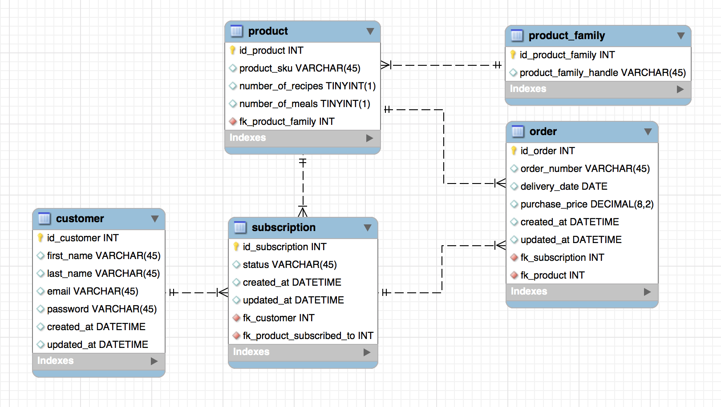

And given the following information:

* created_at fields have a timestamp of the time at which a row was inserted in a table for the first time.
* product_sku is unique for every product.
* product_family_handle is unique for every product family.
* Subscription status can be: ‘paused’, ‘cancelled’ or ‘active’.
* The fk_product field in the order table indicates the product that was purchased in an order. The fk_product_subscribed_to in the subscription table indicates the product a subscription is currently subscribed to. A subscription can change the product it is subscribed to at any moment.
* An order is generated when a box is shipped to a customer

Write SQL statements to retrieve the following information:

1. For the customer with email address ‘fancygirl83@hotmail.com’ show all product_skus the customer has an active subscription for.
2. Get all the customers that have an active subscription to a product that corresponds to a product family with product_family_handle = ‘classic-box’
3. Get all the paused subscriptions that have only received one box.
4. How many subscriptions do our customers have on average?
5. How many customers have ordered more than one product?
6. How many customers have ordered more that one product with the same subscription?
7. Get a list of all customers which got a box delivered to them two weeks ago, and the count of boxes that had been delivered to them up to that week (loyalty)
8. For all our customers, get the date of the latest order delivered to them and include associated product_sku, delivery_date and purchase price. If there were two orders delivered to the same customer on the same date, they should both appear.