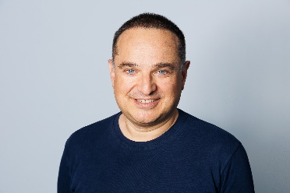
Title: Emerging Trends in Photonics: A Patent-Landscape Cartography of Eight Fast-Growing Domains
Name: Meletis Mexis
TechnoGenesis, Deep-Tech Patent Insight, 1 rue Marguerin, 75014, Paris, France

This presentation surveys eight of the fastest-emerging trends in photonics. They are silicon photonics and co-packaged optics; photonic computing for artificial intelligence; quantum photonics and quantum key distribution (QKD); metasurfaces and flat optics; automotive LIDAR and optical sensing; hollow-core fibre; augmented-reality (AR) waveguide displays; and biophotonics and optical coherence tomography (OCT). For each domain, TechnoGenesis examines the intellectual-property picture: who is filing patents, in which countries, how fast activity is growing, and where thinly-patented, high-value whitespace remains.
The trends are illustrated with preliminary patent-family data, drawn from TechnoGenesis analysis using Minesoft Origin and from published landscape reports. The figures are indicative, intended to convey direction and relative scale, not precise numbers.
Three cross-cutting signals emerge. First, filing volume has shifted toward China, which accounts for roughly 40–60% of published activity in several domains. Yet the United States and Europe still hold most international, multi-jurisdiction families — so filing volume and filing quality tell different stories. Second, artificial-intelligence infrastructure is the main demand engine. It pulls co-packaged optics, photonic computing and hollow-core fibre forward together. Third, the domains are converging: metasurfaces feed both LIDAR and AR, and silicon photonics underpins both quantum and computing.
Together, these eight trends form one clear, high-level map: where photonics is growing fastest, and where patent activity is concentrating. The aim is to help researchers, R&D teams and IP professionals see which domains are accelerating — and where room for new, protectable inventions remains.

Biography:

Dr. Meletis Mexis is a senior patent-information specialist and founder of TechnoGenesis (Paris), providing deep-tech patent insights for photonics, semiconductors and quantum technologies. He has published work on quantum-confined systems and optical resonators, with emission from deep ultraviolet to near infrared, including polariton lasing. He bridges device-level science and IP strategy, delivering patentability, freedom-to-operate, prior-art and patent-landscape analyses for R&D teams and patent attorneys. A Qualified Patent Information Professional (QPIP), he serves on the jury for QPIP examinations. His current work applies patent-family analytics and S-curve modelling to map emerging trajectories, from photonics to the thermal-insulation of the building envelope.

Name:Mexis
Email:contact@technogenesis.fr
Phone Number/ WhatsApp No: +33648938972

