*Rafael Tibães*

*Udacity Machine Learning Engineer Nanodegree*

*December 31, 2017*

*Fingerprint classification*

Capstone Report

## Definition

In biometrics there are two main operations: verification (1:1) and identification (1:N). Verification is the process that confirms a person’s identity based on their biometrics. Identification is the process to identify a person’s identity based on its biometrics, i.e. searching the correspondent biometric model in the database. A naive identification algorithm would perform the verification procedure for each person’s biometric model stored in the database. To reduce the computational costs, a clever approach would compute indexes for each biometric model in the database. With a properly indexed database, the identification process would require to perform the verification algorithm only in a reduced subset of the database.

There are a couple of biometrics modalities capable to accurately identify an individual, such as the face, fingerprint and iris. In this work we focus on fingerprints acquired by imaging sensors. Fingerprints are composed by ridges (darker pixels) and valleys (lighter pixels), where each fingerprint has an unique composition of ridges and valleys. Despite the unique composition, all fingerprints follow one of the five fundamental types, i.e. ridge patterns, described by *NIST* [2]: i) Arch, ii) Left Loop, iii) Right Loop, iv) Tented Arch, and v) Whorl. If we could compute the fundamental type of every fingerprint, this information could be used to perform the database indexation. Using just this indexation we would be able to perform the identification task (1:N) almost five times faster!

I am particularly interested in this problem because I need a solution for a complex newborn fingerprint identification platform that I’m working on. In a real world application it would be easy to have a huge database, which would take a very long time to compute a naive identification algorithm. Proprietary technology is capable to achieve a high speed identification feedback, however they are not suitable for our needs.

Inspired by the Udacity *dog breed* assignment and also by the work of Kai et Al. [1], which uses a Convolutional Neural Network (CNN) to identify the pattern of small fingerprint patches targeting forensics applications, in this work we trained a CNN to compute the most basic fingerprint indexation: the ridge pattern. The proposed network contains pairs of convolution and pooling layers, transforming the spatial information in a more abstract set of features capable to distinguish the ridge patterns.

This is a multi-class classification problem with well-established metrics for accuracy, as presented by Equation 1. Given a database of labeled fingerprint images, containing the fundamental type information, the algorithm should give the same answer as the database labels. Accuracy is a good measurement for our problem because every hit avoids a lookup in the entire database. High accuracy means less computing power needed to perform a biometric identification.

Equation : Accuracy definition for multi-class classification.

## Analysis

For this work, the ideal dataset should contain fingerprint images paired with notations about the fundamental type information. *NIST Special Database 4* [2][3] was developed for this purpose and is free for research. In this dataset all images are stored in grayscale *PNG* files having a dimension of *512 x 512* pixels. Figure 1 presents an example of how an image is represented digitally. The fingerprints images were acquired under varying conditions, so there are images with good and others with poor quality. The quality is affected mostly by the skin’s humidity and the pressure applied on sensor. As result, a poor quality image have blurred borders, making it harder to distinguish ridges from valleys.

The *NIST* dataset contains 4000 fingerprint images, uniformly distributed along the five fundamental types, i.e. there are 800 fingerprint images of each class: i) (A) Arch, ii) (L) Left Loop, iii) (R) Right Loop, iv) (T) Tented Arch, and v) (W) Whorl. This is an important feature, because for classification tasks it is fundamental to balance the dataset before training. Figure 2 to Figure 6 are fingerprints samples from this dataset, to present the characteristics of each fundamental type, and Figure 7 presents the data distribution.

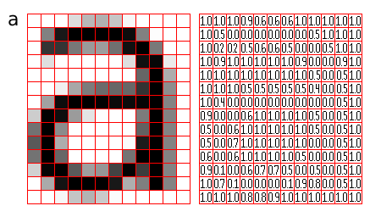

Figure : Digital image representation, example of the character 'a' representation [4].

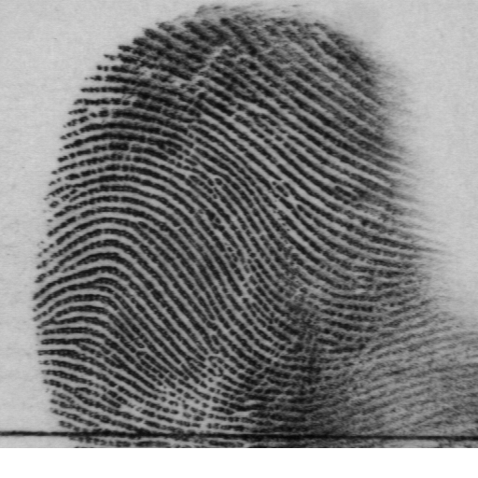

Figure 2: Fingerprint of type Arch (A). Notice that the central part of the fingerprint is composed by smooth lines. This sample also presents a partially occluded fingerprint, because it was not acquired with focus on its center.

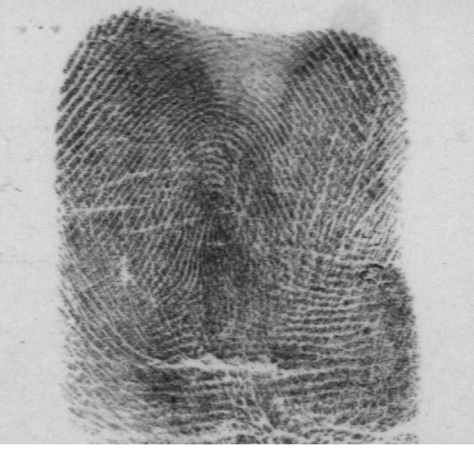

Figure 3: Fingerprint of type Tented Arch (T). Notice that the central part of the fingerprint is composed by a strong peak, in contrast to the Arch type. This sample also presents a poor quality image, as we can see that the ridges are blurred.

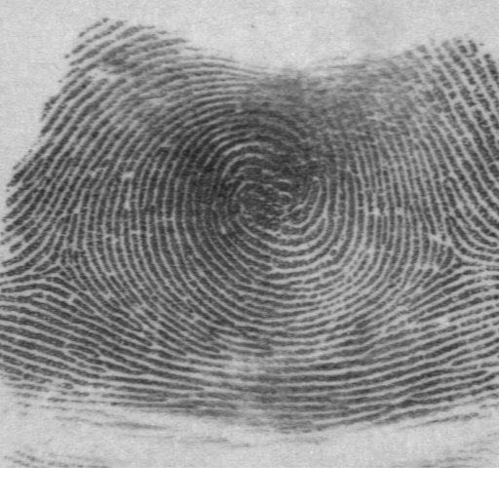

Figure 4: Fingerprint of type Whorl (W). Notice that the central part of the fingerprint is composed by a cyclic pattern.

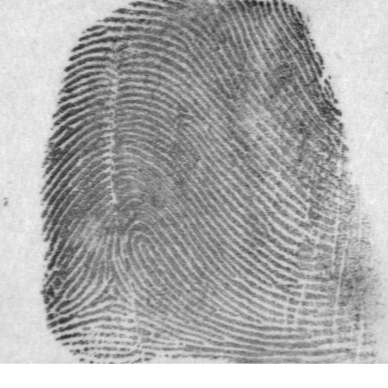

Figure 5: Fingerprint of type Right Loop (R). Notice that the central part of the fingerprint is composed by a curve on the right.

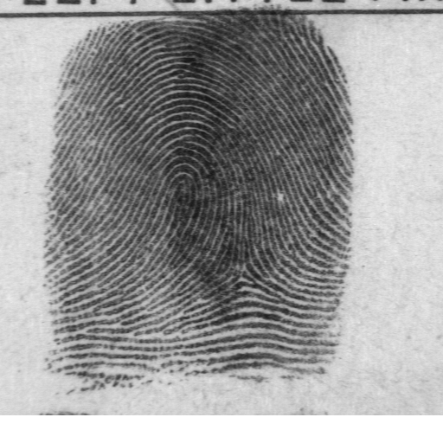

Figure 6: Fingerprint of type Left Loop (L). Notice that the central part of the fingerprint is composed by a curve on the left.

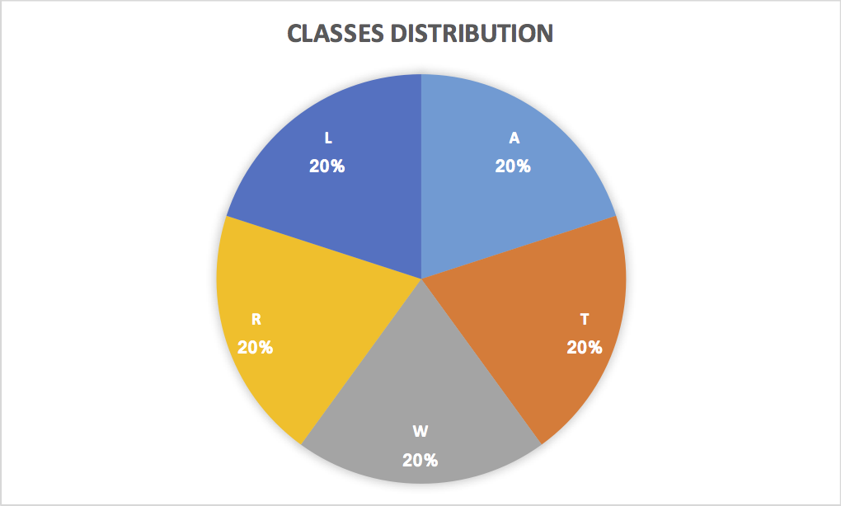

Figure 7: Graphic of classes distribution on NIST Dataset: all samples are evenly distributed among the five classes.

Image classification can be achieved by different algorithms, such as Perceptron, Support Vector Machines (SVM) and Convolutional Neural Networks (CNN). In recent competitions of image classification it is common for CNN to be ranked as the most accurate algorithm, using complex networks such as *AlexNet*, *Inception* and *ResNet*. In this work we adopted CNN for its robustness and accuracy, building a simple network inspired by the work of Kai et Al. [1].

A CNN can be composed by different kind of layers. The proposed network relies on these: convolutional, pooling, dropout and dense layers. Convolutional layers act like image processing filters, transforming the input to explore specific features, such as edges and corners. Pooling layers are another type of filters, but these focus on merging or reducing the data. The sequence of convolutional and pooling layers combined is capable to learn more abstracts features as longer the sequence gets. For instance, initial layers learn useful edge and corners filters, but last layers learn discriminant ridge patterns. Dropout layers are used to drop some features during training as a measure to avoid overfitting. Finally, dense layers are fully-connected nodes, where all features are combined to find the most discriminant combination. The output layer usually is a dense layer where each node represents one class.

The algorithm will be evaluated accordingly to its accuracy to correctly classify the fundamental type of each fingerprint image in the *NIST Dataset* [2]. To avoid overfitting, the dataset will be split in three subsets: training set, validation set and testing set. For the accuracy measurement it will be used the testing set. The accuracy represents the percentage of fingerprint fundamental type that were corrected labeled by the algorithm according the dataset labels, as described by Equation 1.

As I haven’t found in literature an algorithm for this exact purpose, I will compare the proposed approach with a random guess and a simple neural network. In this manner, giving that we have five classes, our approach must achieve an accuracy above 20%, otherwise it would perform worse than picking a random value. Also, it must beat the simple neural network to justify its complexity. The simple neural network is composed by the input layer, two dense layers and the output layer. The input layer uses the Flatten method to convert a 2D matrix (image) to a 1D vector, losing a lot about the pixels’ spatial relationship.

## Methodology

Usually, an image classification algorithm requires pre-processing of the image data. In this work, this pre-processing is composed by three modules: i. conversion of images to tensors, ii. conversion of database text to classification labels, and iii. database split of training and texting subsets.

The first module, conversion of images to tensors, is a simple procedure that read the dataset images and reorganize the information to be compatible with Keras/Tensorflow *Tensor* data structure, in the format *(512, 512, 1)*.

The second module, conversion of database text to classification labels, is based on a [script](parse.sh) that parses the dataset text to one of these five characters: ‘A’, ‘W’, ‘T’, ‘R’ and ‘L’. For example, the sample text: “Gender: M Class: W History: f0001_01.pct W a0591.pct” results to W. However, a character is not proper for classification, so we perform one hot encoding over these labels.

The last pre-processing module, database split, uses the keras function train_test_split to split the samples into 70% for training and 30% for testing, using a random factor for picking samples.

The proposed classification algorithm is a simple convolutional neural network, composed by three pairs of convolution and max-pooling layers, that transforms the spatial information to a more abstract feature space. These convolution layers are followed by a polling and a fully-connected layers to connect and select these features. A dropout layer is followed to avoid over-fitting. Finally, another fully-connected layer with only five nodes and a softmax activation is used to compute the final classification label. Follows the network summary from Keras:

Layer (type) Output Shape Param #   
=================================================================  
conv2d_4 (Conv2D) (None, 512, 512, 16) 160   
_________________________________________________________________  
max_pooling2d_4 (MaxPooling2 (None, 256, 256, 16) 0   
_________________________________________________________________  
conv2d_5 (Conv2D) (None, 256, 256, 32) 4640   
_________________________________________________________________  
max_pooling2d_5 (MaxPooling2 (None, 128, 128, 32) 0   
_________________________________________________________________  
conv2d_6 (Conv2D) (None, 128, 128, 64) 18496   
_________________________________________________________________  
max_pooling2d_6 (MaxPooling2 (None, 64, 64, 64) 0   
_________________________________________________________________  
global_average_pooling2d_2 ( (None, 64) 0   
_________________________________________________________________  
dense_3 (Dense) (None, 100) 6500   
_________________________________________________________________  
dropout_2 (Dropout) (None, 100) 0   
_________________________________________________________________  
dense_4 (Dense) (None, 5) 505   
=================================================================  
Total params: 30,301  
Trainable params: 30,301  
Non-trainable params: 0  
_________________________________________________________________

The convolutional patch size is illustrated by Figure 7, where the first pair of layers use the smallest patch (16x16), the second pair use the intermediate patch (32x32), and the third pair use the largest patch (64x64). The smallest patch has enough room for one or two ridges, so it is good to compute local information as ridge orientation and edges. The remaining patches are capable to compute more complex features necessary to classify the fundamental type of a fingerprint.

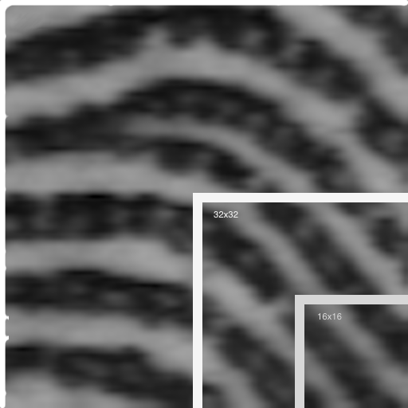

Figure 8: Convolutional patch size for the first layer pair (16x16), second layer pair (32x32) and third layer pair (64x64).

After compilation, the network was trained by multiple epochs (up to 50) using the checkpoint technique to store the best model, i.e. skipping the persistence of an epoch results when not achieving accuracy improvement. Also, 20% of the training set was used for validation to avoid overfitting. A graphic processing unit (GPU) was used to compute the training. Due to graphics memory limitations, the batch size was set to 16 instead of the default 32.

## Results

The proposed solution achieved 61% accuracy to classify the samples of the testing subset. This is three times better than random guess, which would have 20% accuracy. However, there is room for improvement. It worth noticing that initially it would be only 20 epochs, with 54% accuracy, but a more exhaustive run with 50 epochs was considered for the experiments and it performed better indeed.

With just 61% accuracy it is already a great improvement for the identification task. Given that the naive approach represents 100% of time, our algorithm takes (61% * 20%) + ((100% - 61%) * 100%) = 51.2% of time, which represents a speed up of 1.953 times, i.e. almost two times faster. In contrast, a random guess achieves speed up of just 1.19 times. The graphic of Figure 8 compares the identification using naive, random guess, CNN with 20 epochs and CNN with 50 epochs.

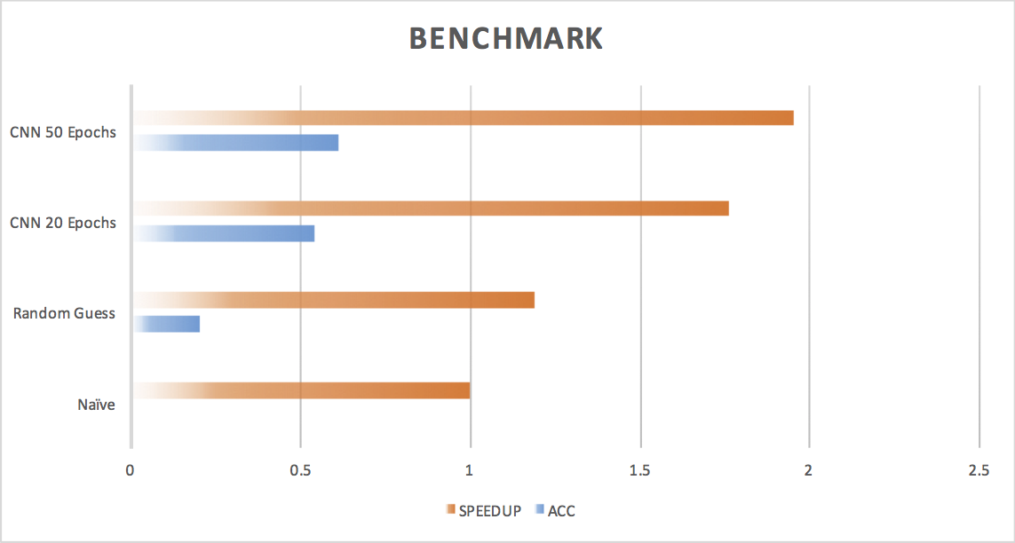

Figure 9: Identification performance using naive, random guess, CNN with 20 epochs and CNN with 50 epochs.

## Conclusion

In this work it was used a small convolutional neural network composed by few convolutional and max-pooling layers followed by fully-connected layers for the training of an image classifier, targeting the fingerprint image classification into one of the five fundamental types described by *NIST*. The proposed network was trained by 50 epochs achieving 61% accuracy, which is above the random guess of 20% as presented by Figure 8. I found interesting the fact that a very simple convolutional network is capable to achieve a decent classification accuracy. However, a more robust network requires a lot of ‘trial and error’, demanding a great amount of computing resources.

During the training I found some complications dealing with GPUs. The first limitation was the over-heating of my laptop that has a NVIDIA GTX 1070 and it was not capable of handling more than 20 epochs. To make it run longer, I switched the experiments to my workstation using a NVIDIA GTX 1060 and a far better cooling system. The 1060 has only half the memory of 1070 GPU, which was not enough to compute. The solution was reducing the bath_size to half, and then I was able to perform the experiments using 50 epochs. It can be observed that this network has a fast convergence, getting a high accuracy in a few epochs, but for each new epoch the improvement is smaller.

This project intents to be part of a proprietary fingerprint solution. For this reason I plan to keep working on improvements using different techniques such as increasing the network complexity or even by transfer-learning based on a robust network, i.e. AlexNet, Inception, ResNet, etc. For faster identification more complex classifiers needs to be used, as bag-of-features based on the most discriminant features, learned by unsupervised clustering.

# References

[1] Cao, Kai, and Anil K. Jain. “Latent orientation field estimation via convolutional neural network.” Biometrics (ICB), 2015 International Conference on. IEEE, 2015.

[2] <https://www.nist.gov/srd/nist-special-database-4> (31/12/17)

[3] <https://www.nist.gov/itl/iad/image-group/resources/biometric-special-databases-and-software> (31/12/17)

[4] <http://pippin.gimp.org/image_processing/chap_dir.html> (31/12/17)