# Tom Bales Style Frame

Below are examples, I won’t know what the exact style is until I test the system. However, these are GIS concepts of layering which my island will have. This is a world that I’m making so there is no scene mechanics. It is one layer to be viewed through augmented reality.

GIS Layering concept

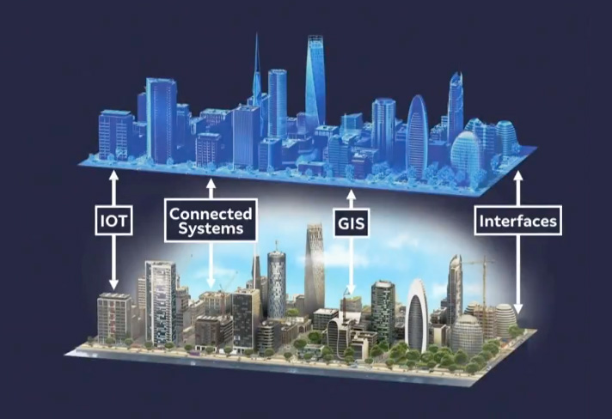

GIS Layering concept 2

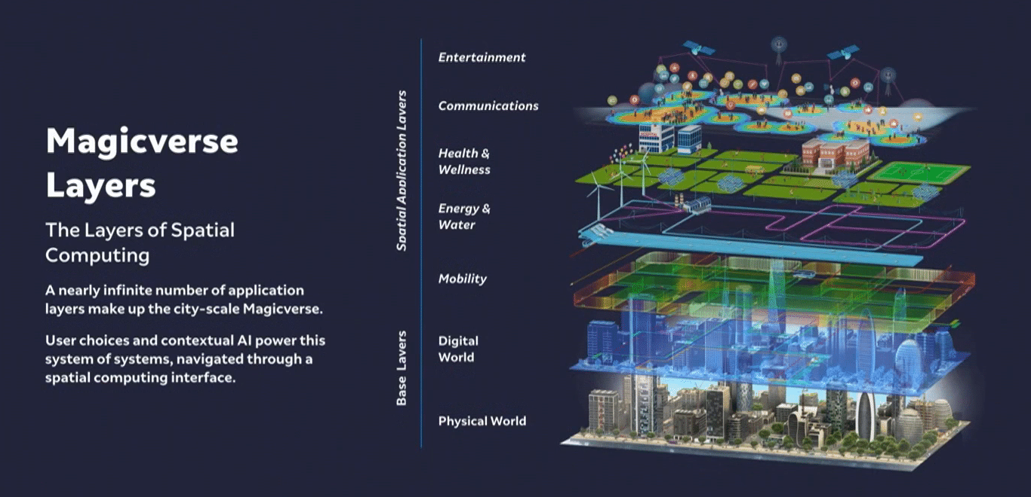

Island Style Gaia – Will likely have to convert to URP

