Mortalité Hospitaliere SIG

Dr R.TIBA MISP | DSP Wilaya de Djelfa

2022-08-01

Table of Contents

# load data deces

source("connection_db.R")  
#str(data)

# load data sig

source("sig.R")

# wilayas algerie

#str(w_algeria)  
#st_crs(w_algeria)  
mtq_w <- st_centroid(w_algeria)  
plot(st_geometry(w_algeria))  
plot(st_geometry(mtq_w), add=TRUE, cex=0.8, col="red", pch=20)

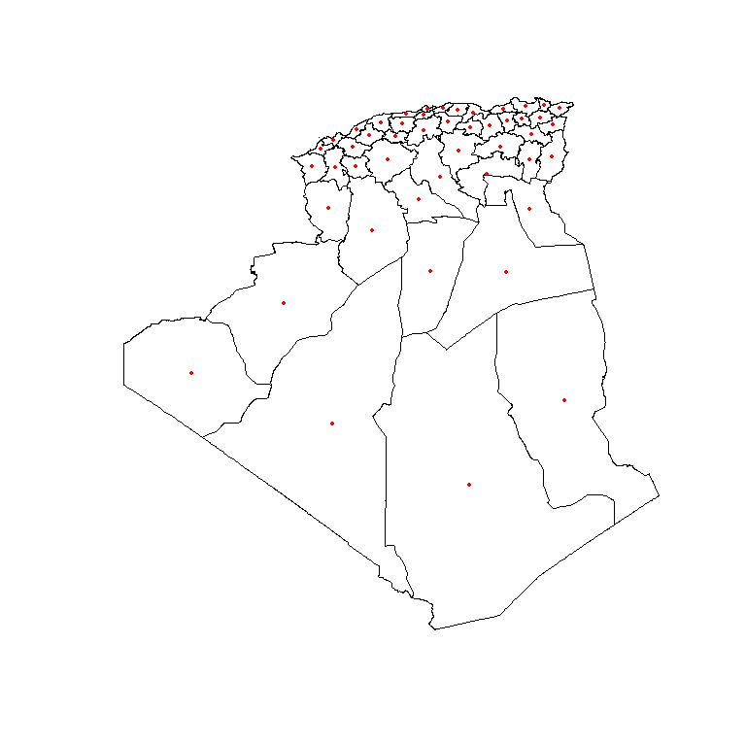

## wilayas algerie

ggplot()+  
 geom_sf(data = w_algeria,fill="lightgreen",color="black",size=0.25)+  
 theme_void()+  
 coord_sf(crs = "+proj=robin")

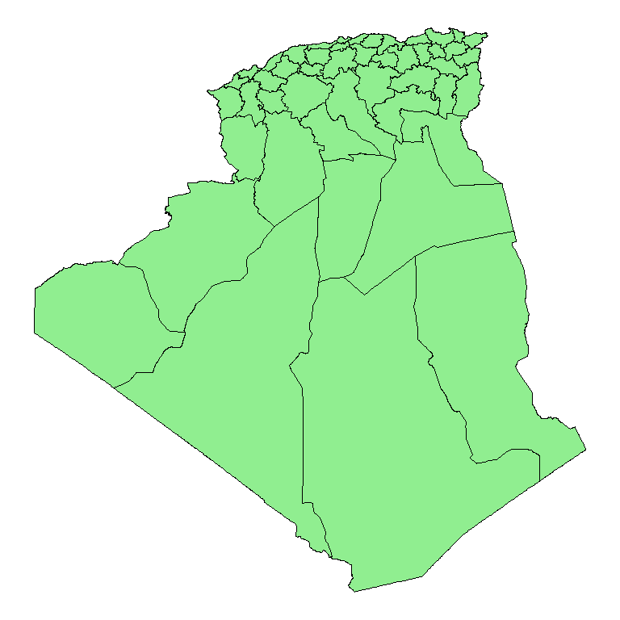

## wilayas algerie

st_geometry(w_algeria) %>%   
 plot()  
 w_algeria %>%   
 select(NAME_1) %>%   
 arrange(NAME_1) %>%   
 slice(1:15) %>%   
 plot(add = TRUE, col = 'lightgreen')  
 title("the ten counties with smallest area")

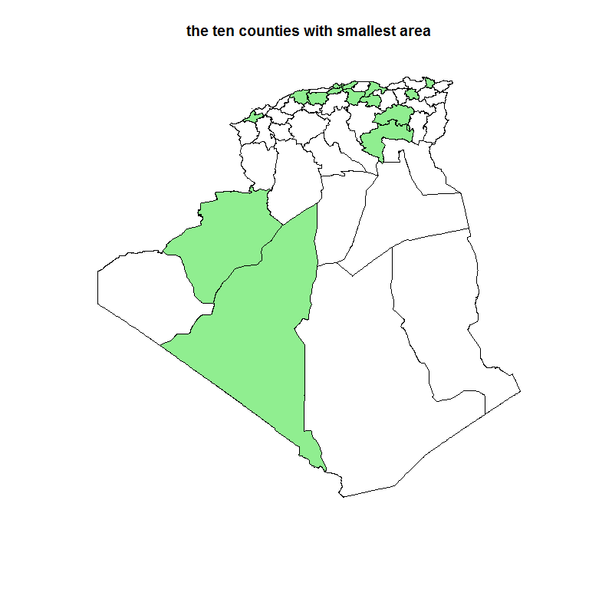

## wilayas algerie

plot(w_algeria["NAME_1"], axes = TRUE)

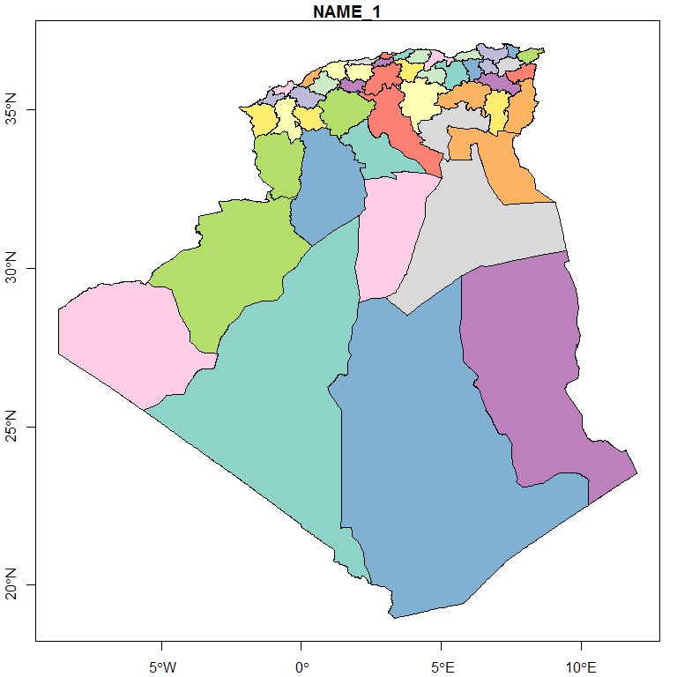

# wilaya de djelfa

#str(wc_algeria)  
#st_crs(wc_algeria)  
djelfa <- wc_algeria %>% filter(NAME_1=="Djelfa")  
mtq_d <- st_centroid(djelfa)  
plot(st_geometry(djelfa))  
plot(st_geometry(mtq_d), add=TRUE, cex=1, col="red", pch=20)

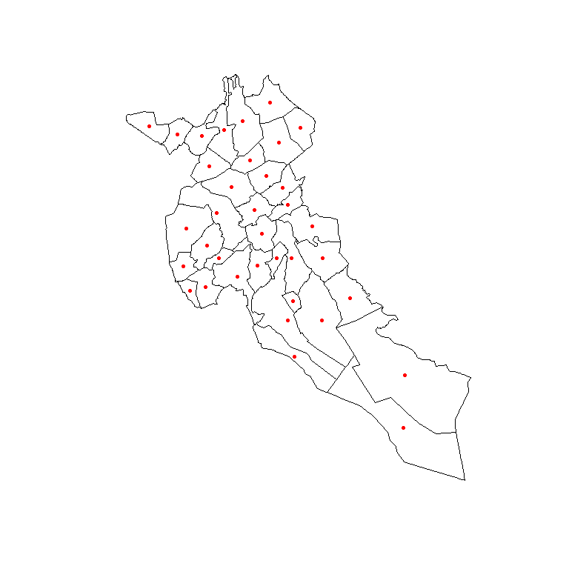

## wilaya de djelfa

ggplot()+  
 geom_sf(data = djelfa,fill="lightgreen",color="black",size=0.25)+  
 theme_void()+  
 coord_sf(crs = "+proj=robin")

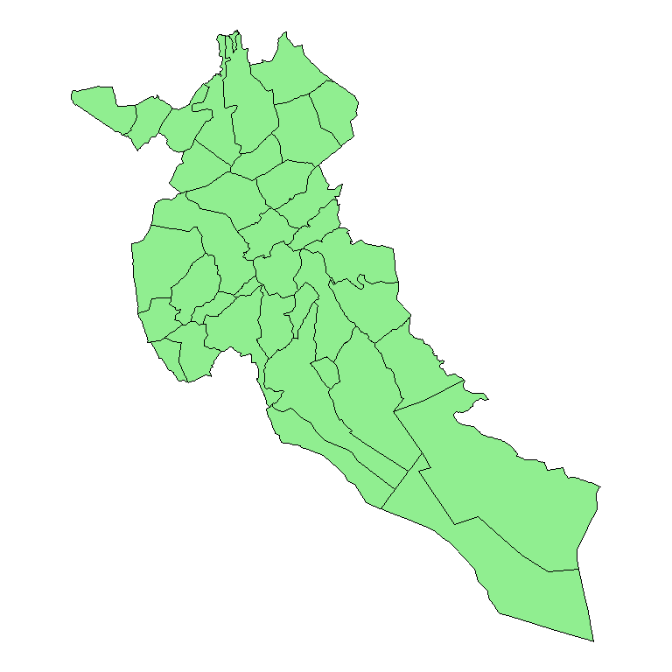

## wilaya de djelfa

st_geometry(djelfa) %>%   
 plot()  
 djelfa %>%   
 select(NAME_2) %>%   
 arrange(NAME_2) %>%   
 slice(1:15) %>%   
 plot(add = TRUE, col = 'lightgreen')  
 title("wilaya de djelfa")

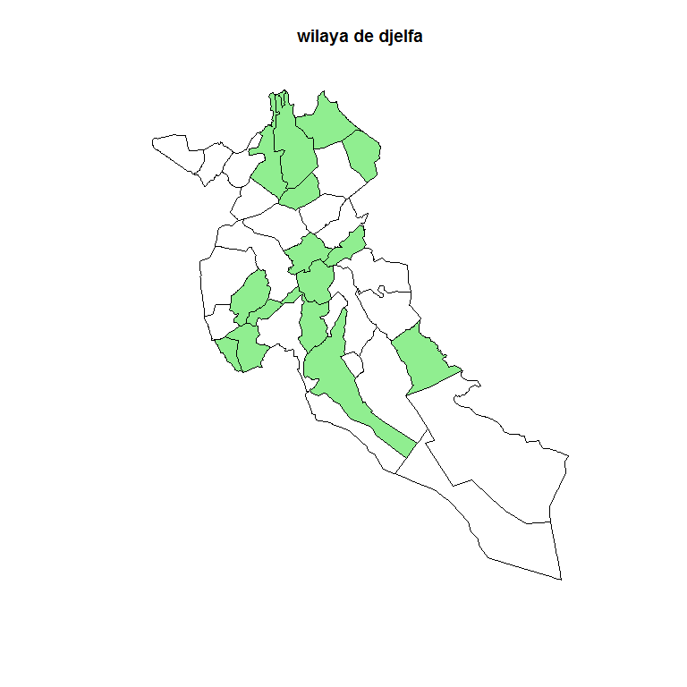

## wilaya de djelfa

plot(djelfa["NAME_2"], axes = TRUE)

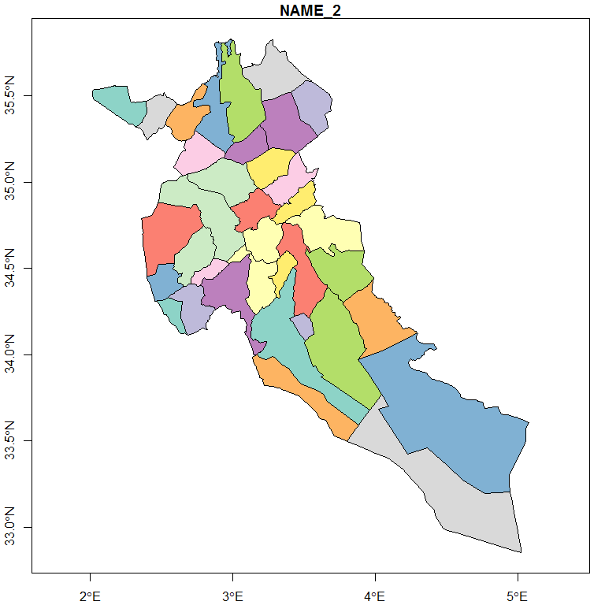

## wilaya de djelfa

pop <- read.csv(file = "djelfa.csv")  
pop_djelfa <- merge(x = djelfa, y = pop, by.x = "CC_2", by.y = "ID")

## wilaya de djelfa sup

plot(pop_djelfa["sup"])

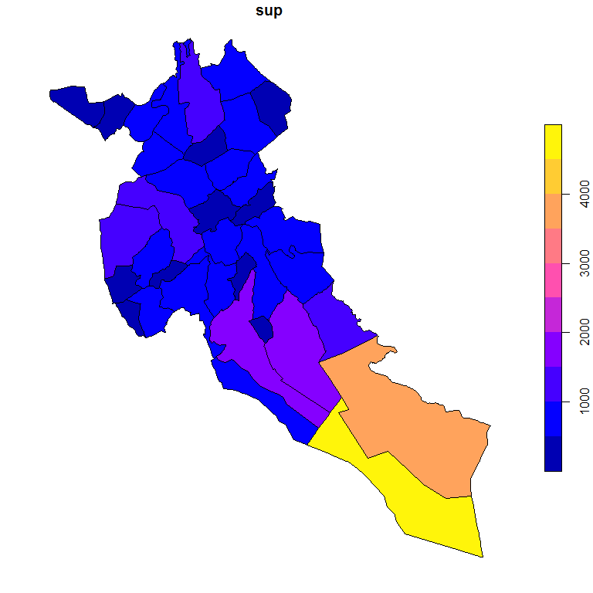

## wilaya de djelfa pop

plot(pop_djelfa["pop"])

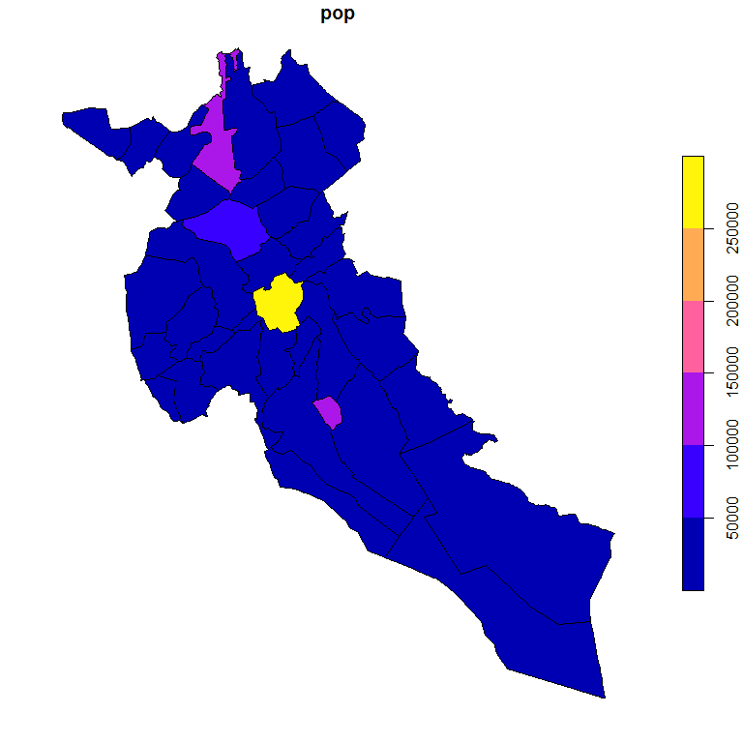

# mortalité hospitaliere

library(ggthemes)  
#library(RColorBrewer) # ColorBrewer Palettes  
#library(ggrepel) ## For displaying labels on ggplot2 object

## Décès par wilayas

### préprocessing data

data %>%  
 select(DINS,WILAYAR) %>%   
 filter(DINS >= dt1 & DINS >= dt2 ) %>%   
 group_by(WILAYAR) %>%   
 summarise(number_wil = n()) %>%   
 arrange(desc(number_wil)) %>%   
 mutate(CC_1=recode(WILAYAR,  
 "1000" = "1",  
 "2000" = "2",  
 "3000" = "3",  
 "4000" = "4",  
 "5000" = "5",  
 "6000" = "6",  
 "7000" = "7",  
 "8000" = "8",  
 "9000" = "9",  
 "10000" = "10",  
 "11000" = "11",  
 "12000" = "12",  
 "13000" = "13",  
 "14000" = "14",  
 "15000" = "15",  
 "16000" = "16",  
 "17000" = "17",  
 "18000" = "18",  
 "19000" = "19",  
 "20000" = "20",  
 "21000" = "21",  
 "22000" = "22",  
 "23000" = "23",  
 "24000" = "24",  
 "25000" = "25",  
 "26000" = "26",  
 "27000" = "27",  
 "28000" = "28",  
 "29000" = "29",  
 "30000" = "30",  
 "31000" = "31",  
 "32000" = "32",  
 "33000" = "33",  
 "34000" = "34",  
 "35000" = "35",  
 "36000" = "36",  
 "37000" = "37",  
 "38000" = "38",  
 "39000" = "39",  
 "40000" = "40",  
 "41000" = "41",  
 "42000" = "42",  
 "43000" = "43",  
 "44000" = "44",  
 "45000" = "45",  
 "46000" = "46",  
 "47000" = "47",  
 "48000" = "48"  
 ))-> df

### display map

deces_w_djelfa <-left_join(w_algeria, df, by='CC_1')  
wdjelfa <- deces_w_djelfa %>%   
 select(NAME_1,CC_1,number_wil) %>%   
 mutate(number_wil = log(number_wil))  
  
ggplot()+  
 geom_sf(data=wdjelfa,aes(fill=number_wil), color = "white", lwd = 0.05) +  
 scale_fill_viridis_c(option = "magma", name = "Nbr décès (log)") +  
 theme_map() +   
 theme(legend.direction="horizontal") +  
 labs(title = "Répartition des décès hospitalier par wilayas",   
 subtitle = "Wilayas algerie année 2020",   
 caption = "Source: Dr R.TIBA \n Praticien inspecteur santé publique \n DSP Wilaya de Djelfa")+  
 coord_sf(crs = "+proj=robin")

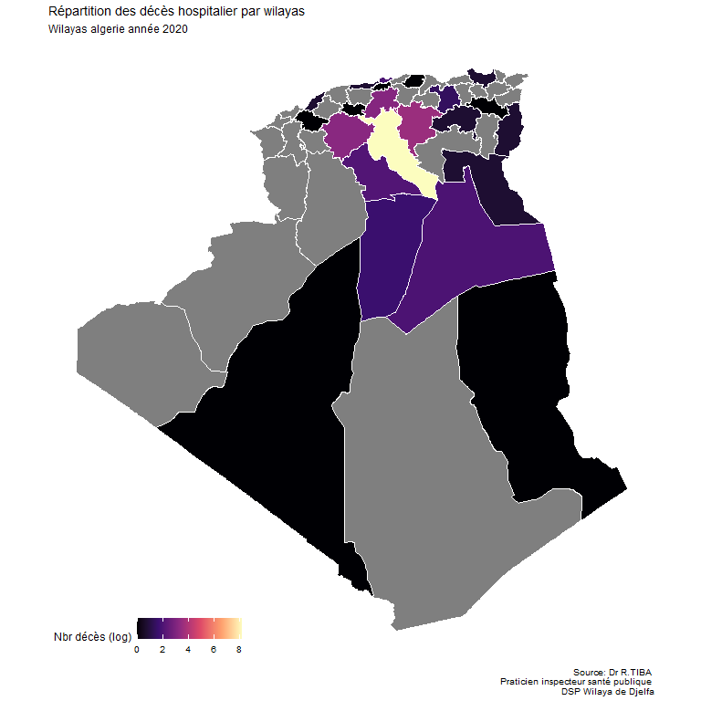

## Décès par communes wilaya de Djelfa

### préprocessing data

data %>%  
 select(DINS,WILAYAR,COMMUNER) %>%   
 filter(DINS >= dt1 & DINS >= dt2 & WILAYAR == 17000) %>%   
 group_by(COMMUNER) %>%   
 summarise(number_com = n()) %>%   
 arrange(desc(number_com)) %>%   
 mutate(CC_2=recode(COMMUNER,  
 "916" = "1701",#djelfa  
 "917" = "1714",#el idrissia  
 "919" = "1703",#919 El Guedid  
 "920" = "1726",#920 Charef  
 "923" = "1727",#923 Beni Yacoub  
 "924" = "1731",#924 Ain Oussera  
 "925" = "1721",#925 Guernini  
 "926" = "1719",#926 Sidi Ladjel  
 "927" = "1733",#927 Hassi Fedoul  
 "928" = "1711",#928 El Khemis  
 "929" = "1708",#929 Birine  
 "931" = "1732",#931 Benhar  
 "932" = "1720",#932 Had-Sahary  
 "933" = "1709",#933 Bouira Lahdab  
 "934" = "1735",#934 Ain Fekka  
 "935" = "1704",#935 Hassi Bahbah  
 "939" = "1728",#939 Zaafrane  
 "940" = "1716",#940 Hassi el Euch  
 "941" = "1705",#941 Ain Maabed  
 "942" = "1725",#942 Dar Chioukh  
 "946" = "1713",#946 MLiliha  
 "947" = "1712",#947 Sidi Baizid  
 "948" = "1717",#948 Messad  
 "951" = "1718",#951 Guettara  
 "952" = "1729",#952 Deldoul  
 "953" = "1706",#953 Sed Rahal  
 "954" = "1722",#954 Selmana  
 "956" = "1724",#956 Oum Laadham  
 "957" = "1702",#957 Mouadjebar  
 "958" = "1730",#958 Ain el Ibel  
 "962" = "1710",#962 Zaccar  
 "963" = "1715",#963 Douis  
 "964" = "1723",#964 Ain Chouhada  
 "965" = "1736",#965 Tadmit  
 "967" = "1707",#967 Faidh el Botma  
 "968" = "1734" #968 Amourah  
 ))-> dfc

### display map

deces_c_djelfa <-left_join(wc_algeria, dfc, by='CC_2')  
cdjelfa <- deces_c_djelfa %>%   
 filter(NAME_1=="Djelfa") %>%   
 select(NAME_1,CC_2,number_com) %>%   
 mutate(number_com = log(number_com))  
  
ggplot()+  
 geom_sf(data=cdjelfa,aes(fill=number_com), color = "white", lwd = 0.05) +  
 scale_fill_viridis_c(option = "magma", name = "Nbr Deces (log)") +  
 theme_map() +   
 theme(legend.direction="horizontal") +  
 labs(title = "Répartition des décès hospitalier par communes",   
 subtitle = "Communes Wilaya de djelfa année 2020",   
 caption = "Source: Dr R.TIBA \n Praticien inspecteur santé publique \n DSP Wilaya de Djelfa")+  
 coord_sf(crs = "+proj=robin")

